Exciton splitting in 2D layered metal-halide perovskites SUPPORTING INFORMATION
Angelica Simbula^{1,*}, Luyan Wu¹, Federico Pitzalis¹, Riccardo Pau^{1,2}, Stefano Lai¹, Fang Liu³, Selene Matta¹, Daniela Marongiu¹, Francesco Quochi¹, Michele Saba^{1,*}, Andrea Mura¹, Giovanni Bongiovanni¹
¹Dipartimento di Fisica, Università degli Studi di Cagliari, Monserrato (CA), I-09042, Italy
² Zernike Institute for Advanced Materials, University of Groningen, Nijenborgh 4,09747 AG Groningen, The Netherlands
³ School of Environmental Science and Engineering, Frontiers Science Center for Transformative Molecules, Shangai Jiao Tong University, Shangai 200240, China

Contents

- Fig. S1 Photoluminescence intensity of thin films at time delay t=0 versus excitation fluence
- Fig. S2 DT/T spectra of thin films after initial transient (different laser fluences and condition)
- Fig. S3 DT/T spectral features decay profiles of thin film with different excitation condition
- Fig. S4 DT/T spectral features decay profiles of crystal on nanosecond timescale
- Fig. S5 DT/T decay profiles from thin crystal with two-photon resonant excitation
- Fig. S6 DT/T spectrograms of thin crystals under two-photon non-resonant excitation
- Fig. S7 DT/T spectrograms of thin films under two-photon resonant excitation at low temperatures
- Fig. S8 DT/T, DT/T² and PL decay profiles for thin film at different power and excitation condition
- Fig. S9 DT/T, DT/T² and PL decay profiles for thin film and thin crystals at different temperature.
- Fig. S10 DT/T and PL power laws at cryogenic and room temperature

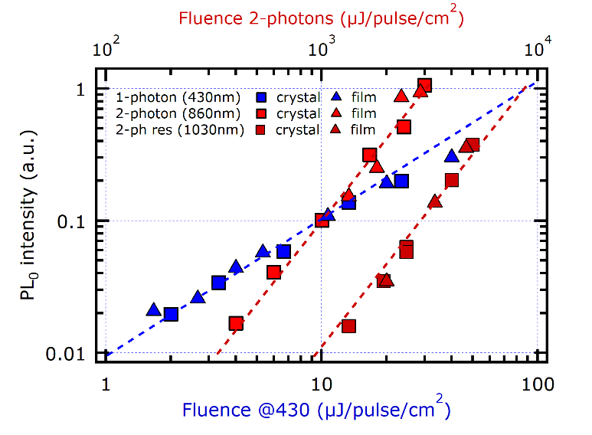
Fig. S1 Photoluminescence intensity at time delay t=0 versus excitation fluence, as measured from a thin crystal (squares) or thin films (triangles). One-photon non-resonant is shown in blue, two-photon non-resonant in red and two-photon resonant in amaranth red. The Blue and red dashed lines are a guide to the eye for linear and quadratic trend, respectively.

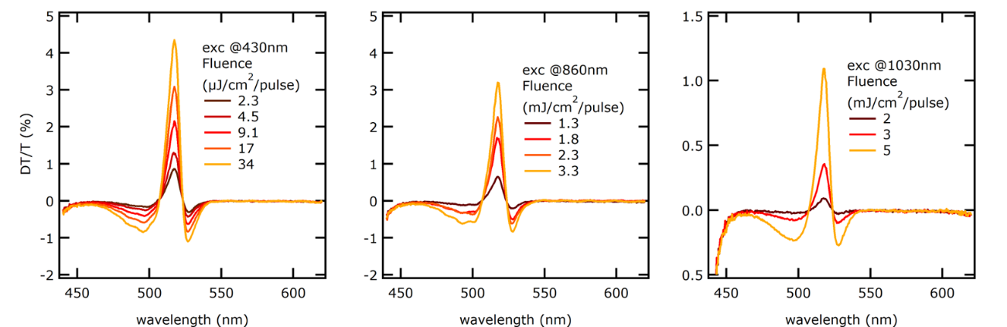
Fig. S2 DT/T spectra integrated after 40ps at different laser fluences for three different excitation configurations: a) one-photon non-resonant, b) two-photon non-resonant and c) two-photon resonant. The spectra are confirming that after the initial ultrafast transient the behavior is always compatible with broadening feature, as sketched in Fig. 2C in main text.

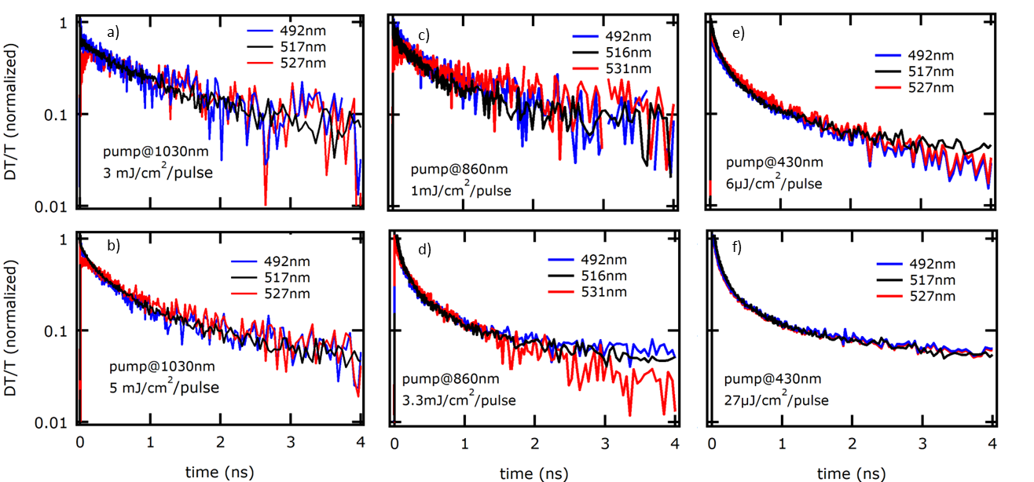
Fig. S3 DT/T decay profiles (in absolute value) obtained from thin film with two-photon resonant (a-b), two-photon non-resonant (c-d) and 1- photon non-resonant (e-f) excitation, reported for two different excitation fluences. The traces are obtained integrating the positive peak at central wavelength (black lines), negative lobe at longer wavelength (red lines) and at shorter wavelength (blue lines).

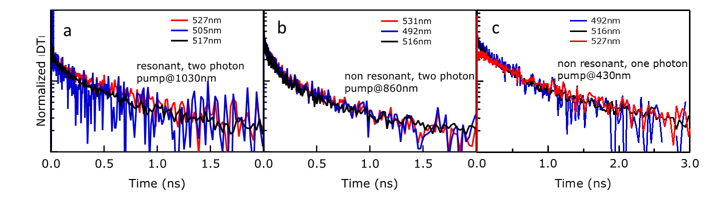
Fig. S4 DT/T decay profiles (in absolute value) obtained from thin crystal with two-photon resonant (a), two-photon non-resonant (b) and 1- photon non-resonant (c) excitation, on a nanosecond timescale, from the same set of data as what reported in Fig. 3 in the main text. The traces are obtained integrating the positive peak at central wavelength (black lines), negative lobe at longer wavelength (red lines) and at shorter wavelength (blue lines).

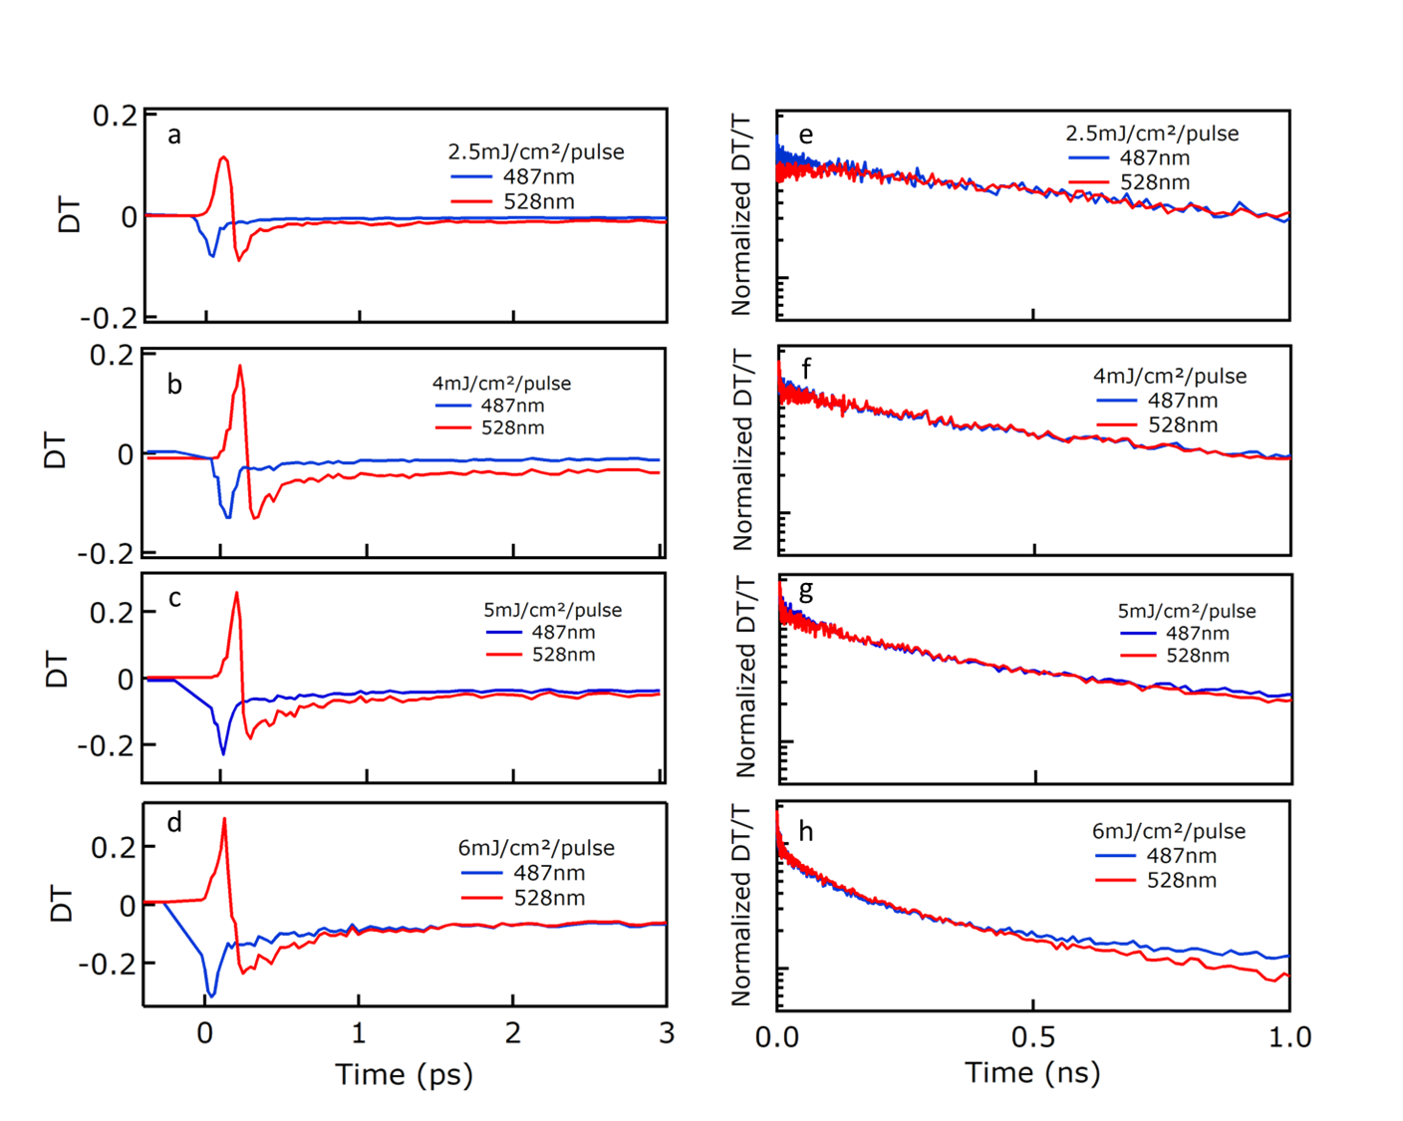
Fig. S5 DT/T decay profiles obtained from thin crystal with two-photon resonant excitation (1030nm) at the high energy lobe (487nm) and low energy lobe (528nm), reported with blue and red line respectively. Left side plots (a-d) report the picosecond scale initial transient, while right side plots (e-h) report the normalized absolute values of decay profiles on a log scale, on a nanosecond timescale. Profiles are extracted at different excitation fluences.

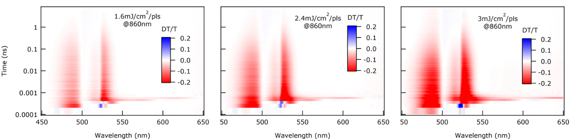

Fig. S6 DT/T spectrograms of PEA₂PbI₄ thin crystals under two-photon non-resonant (860nm) excitation at 300K at different excitation fluences.

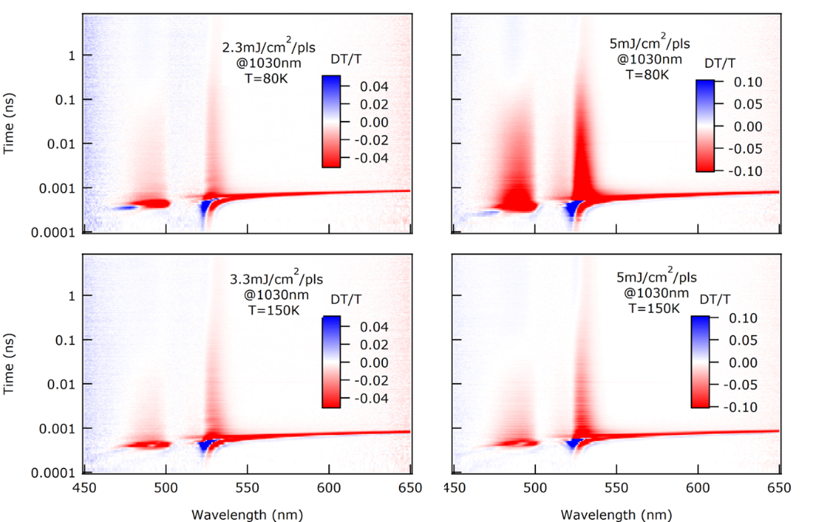
Fig. S7 DT/T spectrograms of PEA₂PbI₄ thin crystals under two-photon resonant excitation at low temperatures (upper plots at 80K, lower plots at 150K) at two different fluences, showing a trend similar to what reported at 300K.

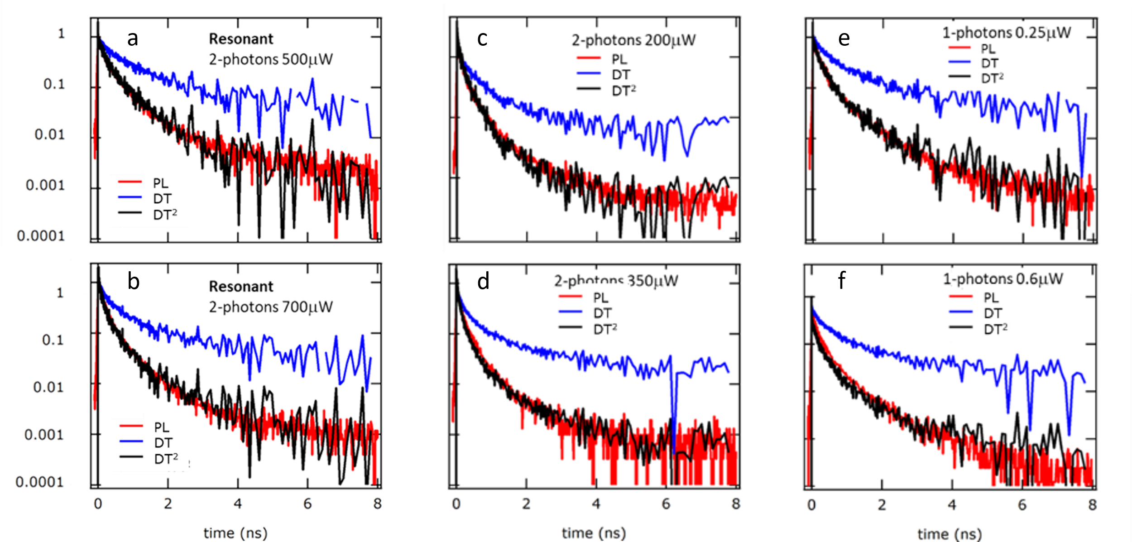
Fig. S8 Comparative plot with DT/T (blue lines), DT/T² (black lines) and PL (red lines) from thin films showing that in different excitation conditions the PL decay overlaps with that of DT/T² in the case of two-photon resonant (a-b), two-photon non-resonant (c,d) and one-photon non-resonant (e,f) excitation.

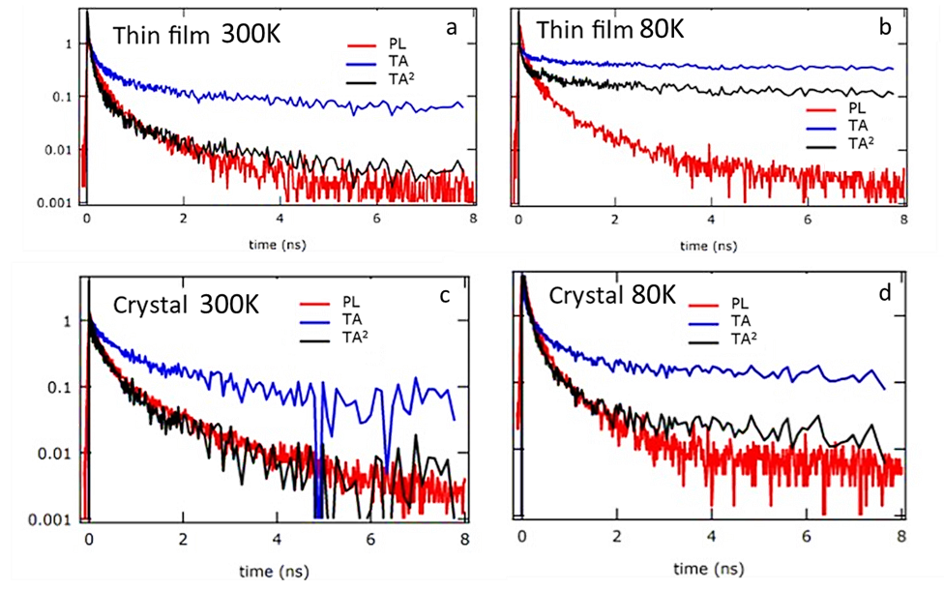
Fig. S9 Comparative plot with DT/T (blue lines), DT/T² (black lines) and PL (red lines) on thin film (a, b) and crystal (c, d) at different temperatures. In the case of thin film, the correspondence between PL and DT/T² is lost at lower temperature, which can be attributed to temperature-activated traps, likely due to grain boundaries and surface defects with resonant excitation. In the case of low temperature measurements in the crystal, the correspondence between PL and DT/T² is confirmed even at 80K, as a sign of the lower defect amount in the crystal.

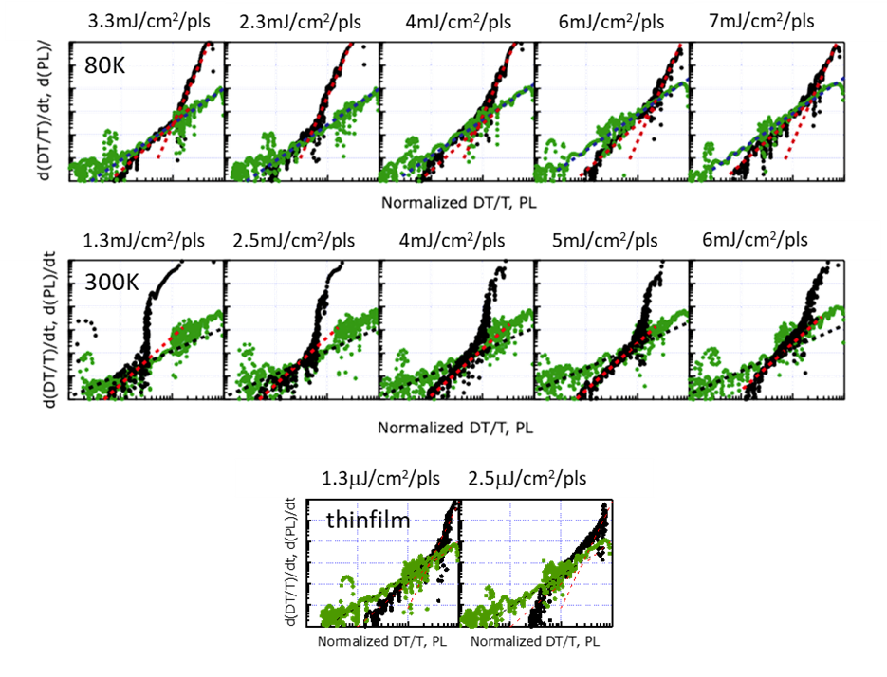
Fig. S10 Time derivative of DT/T versus DT/T (black dots) and time derivative of PL versus PL (green dots). Upper row is for thin crystal at 80K, mid row for thin crystal at 300K, lower row for thin film at 300K, with two-photon resonant excitation, at difference fluences.

