Supplementary Information

Supplementary Method. In-house bioinformatics analysis of targeted NGS data for T-LGL and/or PRCA cohort (page 2)

Supplementary Figure 1. Lollipop plot of signal transducer and activator of transcription 3 (STAT3) gene (page 3)
Supplementary Figure 2. Proportions of signal transducer and activator of transcription 3 (STAT3) mutation type in terms of variant allele frequency (VAF) of STAT3 (page 4)

Supplementary Table 1. Two custom targeted sequencing panels (page 5-6)
Supplementary Table 2. Mutations identified in three T-LGL patients with concomitant MDS (page 7)
Supplementary Table 3. 65 mutations of 28 genes identified in 32 patients with T-LGL or T-LGL+PRCA (page 7)
Supplementary Table 4. List of genes (n=56) in which no mutation was detected in patients with T-LGL or T-LGL+PRCA (page 8)

Supplementary Method. In-house bioinformatics analysis of targeted NGS data for T-LGL and/or PRCA cohort
Analysis of the FASTQ files generated from the customized panel sequencing was performed using the SNUH FiRST Panel Analysis Pipeline. The alignment to the hg19 reference genome was performed using BWA-mem (v0.7.17) and GATK Best Practice. Variants including single-nucleotide variants (SNVs) and small insertions-deletions (InDels) were subsequently identified using HaplotypeCaller, SNVer, and LoFreq. Annotation of the detected variants was then performed using SnpEff (v5.0) and various databases including RefSeq, COSMIC (v96), dbSNP (build 155), ClinVar (last accessed Nov 13, 2022), and gnomAD (v2.1.1). To identify and remove possible germline variants, SNVs and InDels commonly detected (≥0.1%) in population databases such as the 1000 genomes project version and gnomAD were filtered for detection of possible germline variants. In addition, mutations detected in healthy controls and most mutations that showed 40~60 % VAF were excluded as potential germline mutations.

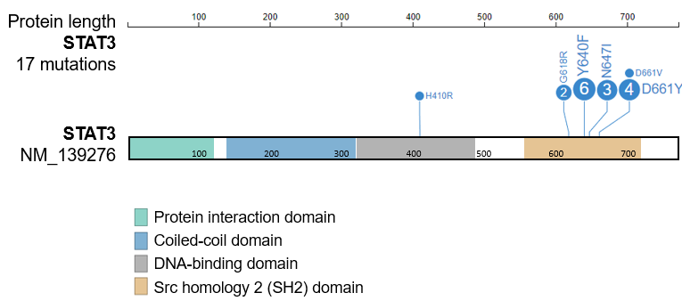
Supplementary Figure 1. Lollipop plot of signal transducer and activator of transcription 3 (STAT3) gene. Of total 17 STAT3 mutations detected, 94.1% (16/17) were located in the src homology 2 domain. Annotations for each domain were described at the bottom.

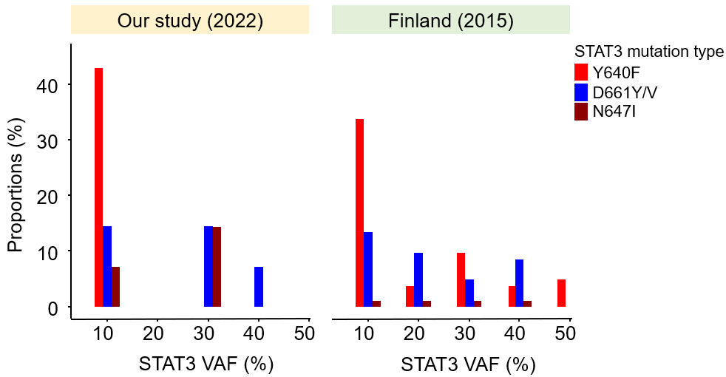
Supplementary Figure 2. Proportions of signal transducer and activator of transcription 3 (STAT3) mutation type in terms of variant allele frequency (VAF) of STAT3. The levels of VAF were stratified according to each 10% increment. Results of our study and those of the Finland study (Rajala et al, Haematologica, 2015 Jan;100:91-9) are shown together. The most common mutation was Y640F marked in the red bar in both studies. The Y640F showed highest proportions in <10% VAF of STAT3 mutation both in our study (66.7%, 6/9) and in the Finland study (59.6%, 28/47).

Supplementary Table 1. Two custom targeted sequencing panels
Panel including mutated genes  in PRCA or aplastic anemia or myeloid neoplasm (n=84)ª |  | Hematologic malignancies-related  panel (n=103)^{b}
ABL1 | MPL | APC | ABL1 (hot spot)
ASXL1 | MYD88 | ARID1B | ANKRD26 (hot spot)
ATM | NOTCH1 | ARID2 | ATRX (hot spot)
ATRX | NF1 | ASXL1 | BIRC3 (hot spot)
BCOR | NPM1 | ATM | BRAF (hot spot)
BCORL1 | NRAS | B2M | BTK (hot spot)
BRAF | PDGFRA | BCOR | CALR (hot spot)
BRCC3 | PEG3 | BCORL1 | CBL (hot spot)
CALR | PHIP | CARD11 | CBLB (hot spot)
CBL | PHF6 | CCND1 | CBLC (hot spot)
CBLB | PIGA | CD28 | CCND2 (hot spot)
CBLC | POT1 | CD58 | CDC25C (hot spot)
CDKN2A | PPM1D | CD79A | CDKN2A (hot spot)
CEBPA | PRPF8 | CHD8 | CEBPA (hot spot)
CSF3R | PTEN | CREBBP | CSF3R (hot spot)
CSMD1 | PTPN11 | CUX1 | CXCR4 (hot spot)
CUX1 | RAD21 | DDX41 | DCK (hot spot)
DIS3 | RAP1A | DIS3 | DHX15 (hot spot)
DNMT3A | RBBP4 | DNMT3A | ETNK1 (hot spot)
EED | RIT1 | EP300 | FLT3 (hot spot)
ETV6 | RUNX1 | ETV6 | FOXO1 (hot spot)
EZH2 | SETBP1 | EZH2 | GATA1 (hot spot)
FBXW7 | SF3B1 | FBXW7 | GNAS (hot spot)
FLT3 | SH2B3 | GATA2 | HRAS (hot spot)
GATA1 | SLC20A1 | GNA13 | IDH1 (hot spot)
GATA2 | SMC1A | IKZF1 | IDH2 (hot spot)
GNAS | SMC3 | KDM6A | JAK2 (hot spot)
GNB1 | SRCAP | KIT | JAK3 (hot spot)
HRAS | SRSF2 | KMT2A | KMT2C (hot spot)
IDH1 | STAG2 | KMT2D | KRAS (hot spot)
IDH2 | STAT3 | LUC7L2 | MAP2K1 (hot spot)
IKZF1 | STAT5B | MYC | MEF2B (hot spot)
JAK1 | SUZ12 | NF1 | MPL (hot spot)
JAK2 | TERT | NRAS | MYD88 (hot spot)
JAK3 | TET2 | PHF6 | NOTCH1 (hot spot)
KDM3B | TNFAIP3 | PTEN | NOTCH2 (hot spot)
KDM6A | TP53 | RAD21 | NPM1 (hot spot)
KIT | U2AF1 | RB1 | PDGFRA (hot spot)
KMT2A | WT1 | RUNX1 | PPM1D (hot spot)
KMT2D | ZRSR2 | SH2B3 | PTPN11 (hot spot)
KRAS | MSR1 | SMC1A | RBBP6 (hot spot)
LAMB4 | HOXC9 | SMC3 | RHOA (hot spot)
 |  | SRSF2 | RPS14 (hot spot)
 |  | STAG2 | SETBP1 (hot spot)
 |  | TET2 | SF3B1 (hot spot)
 |  | TNFAIP3 | SLC29A1 (hot spot)
 |  | TNFRSF14 | STAT3 (hot spot)
 |  | TP53 | STAT5B (hot spot)
 |  | TRAF3 | U2AF1 (hot spot)
 |  | U2AF2 | XPO1 (hot spot)
 |  | WT1
 |  | ZAP70
 |  | ZRSR2
ª 84 genes included genes reported to be once mutated in PRCA or aplastic anemia or recurrently mutated genes in myeloid neoplasm in terms of the following six studies reported in the literature (Sci Rep 2021;11:1-7, Ann Hematol 2020;99:1749-1754, N Engl J Med 2012;366:1905-13, N Engl J Med 2015;373:35-47, Lancet Oncol 2017;18:100-111, Biol Blood Marrow Transplant 2019;25:2517-2521).
^{b} 103 genes known as recurrent mutated genes in hematologic malignancies were designed in the clinical laboratory at Seoul National University Hospital.
Supplementary Table 2. Mutations identified in three patients with T-LGL with concomitant MDS

All mutations are listed in separated files
“Supplementary_table_mutation_lists.xlsx”

Supplementary Table 3. 65 mutations of 28 genes identified in 32 patients with T-LGL or T-LGL+PRCA

All mutations are listed in separated files
“Supplementary_table_mutation_lists.xlsx”

Supplementary Table 4. List of genes (n=56) in which no mutation was detected in patients with T-LGL or T-LGL+PRCA
ABL1 | KIT
ASXL1 | MPL
ATRX | MYD88
BCORL1 | NOTCH1
BRAF | NRAS
BRCC3 | PDGFRA
CALR | PEG3
CBL | PHF6
CBLB | PHIP
CDKN2A | PIGA
CSF3R | POT1
DIS3 | PPM1D
ETV6 | PRPF8
EZH2 | PTPN11
FBXW7 | RAD21
FLT3 | RAP1A
GATA1 | RBBP4
GATA2 | RIT1
GNAS | SETBP1
GNB1 | SF3B1
HOXC9 | SLC20A1
HRAS | SMC1A
IDH2 | SMC3
IKZF1 | SRCAP
JAK1 | SRSF2
JAK2 | TET2
JAK3 | WT1
KDM3B | ZRSR2

