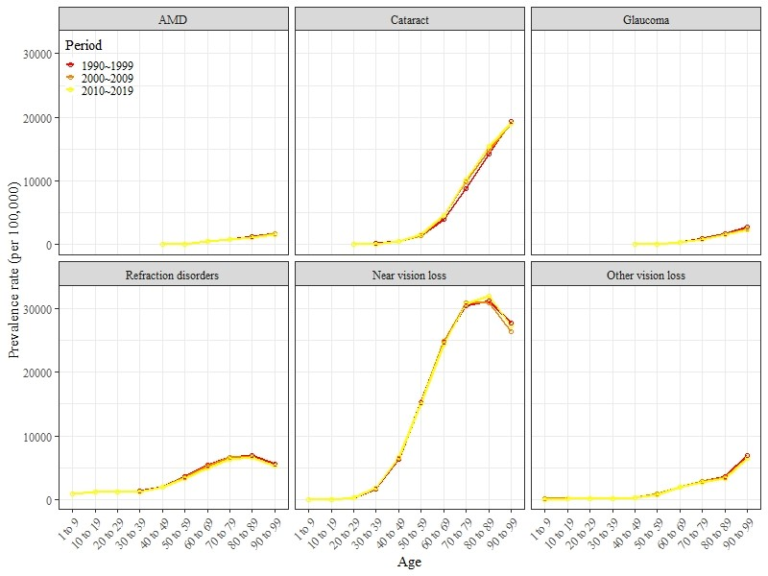
Additional file 1 Global prevalence of cause-specific blindness and vision loss with age.
The overall upward trend was observed in all cause-specific prevalence with age, and the upward trend varies throughout periods.

