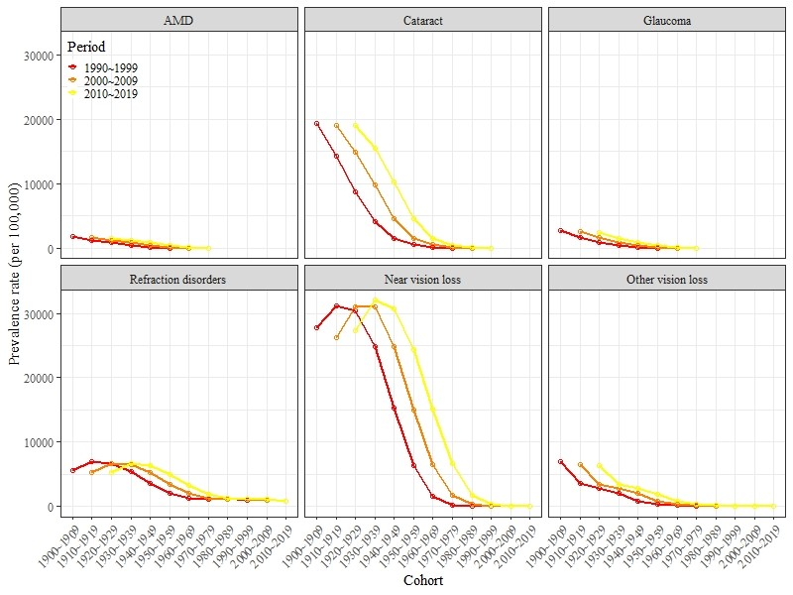
Additional file 3 Global prevalence of cause-specific blindness and vision loss with cohort.
The overall downward trend was observed in all cause-specific prevalence within the cohort, and the downward trend varies throughout periods.

