Figure S1. a) Water vapor δD difference between the average over randomly chosen clear-sky pixels and the domain-mean, for two simulations : one without any large-scale vertical velocity (black) and one with large-scale ascent (red). (b) Same for the relative difference in specific humidity. For the case without any large-scale vertical velocity, the fraction of pixels that were diagnosed as clear sky is 22% and the average is calculated over 107 pixels. For the case with large-scale ascent, the fraction of pixels that were diagnosed clear sky is 10 % and the average is calculated over 50 pixels.

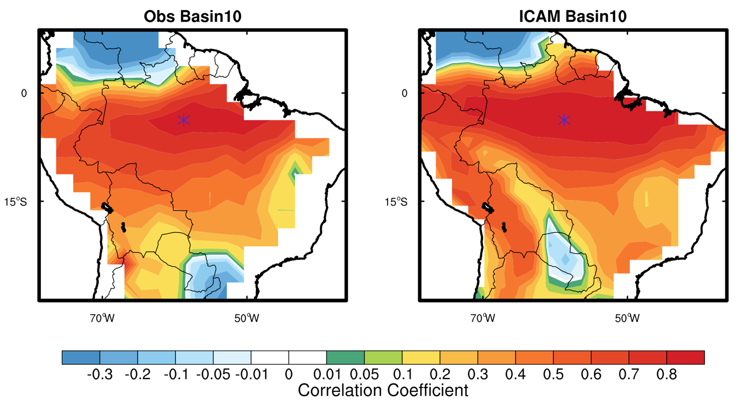
Figure S2. The spatial pattern of the correlation coefficient (a) between δD_004 from AIRS and ET-P obtained from PT-JPL ET and GPCP and (b) between δD_004 and ET-P from iCAM. The blue star represents the center of the selected ~2° ×2° region, which is in Basin 10. The correlations between δD_004 in that region and ET-P in other regions of the Amazon are calculated.

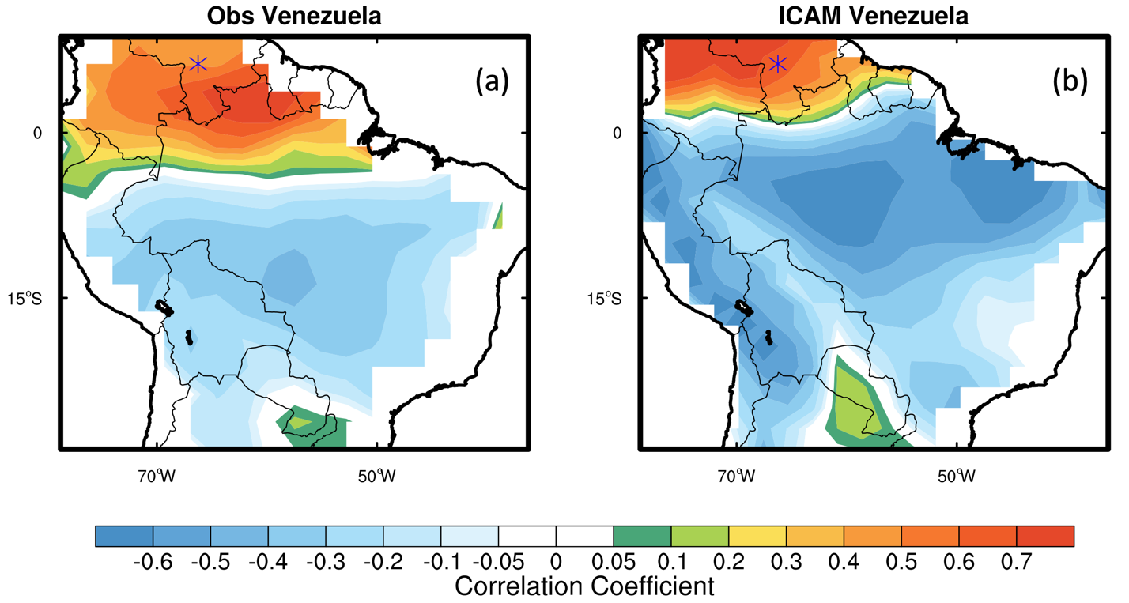
Figure S3. The spatial pattern of the correlation coefficient (a) between δD_004 from AIRS and ET-P obtained from PT-JPL ET and GPCP and (b) between δD_004 and ET-P from iCAM. The blue star represents the center of the selected ~2° ×2° region, which is in Venezuela. The correlations between δD_004 in that region and ET-P in other regions of the Amazon are calculated.

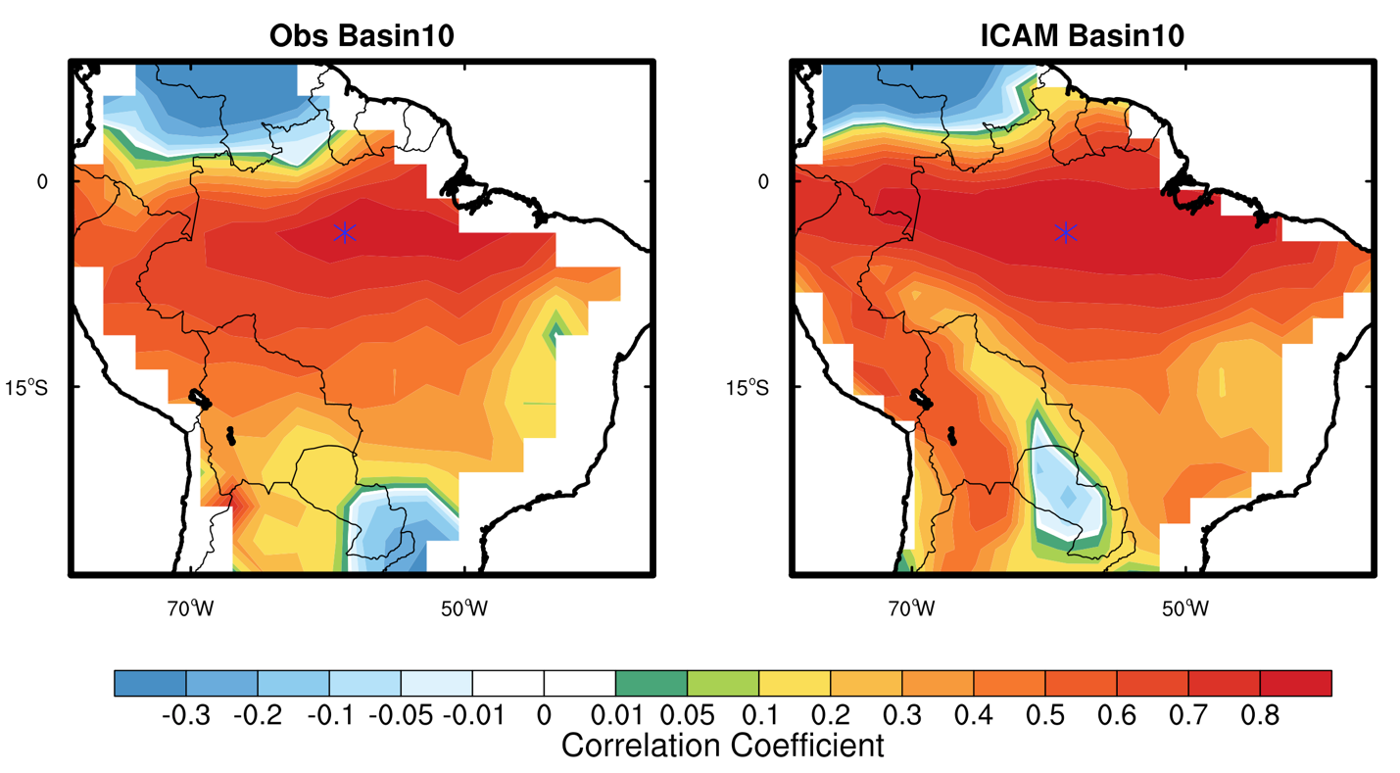
Figure S4. The spatial pattern of the correlation coefficient (a) between δD_004 from AIRS and ET-P obtained from PT-JPL ET and GPCP and (b) between δD_004 and ET-P from iCAM. The blue star represents the center of the selected ~2° ×2° region, which is in Basin 6. The correlations between δD_004 in that region and ET-P in other regions of the Amazon are calculated.

Tables.

Table S1. The regression coefficient and standard error of the regression coefficient, intercept,
correlation coefficient, and the error in fit between (mm month⁻¹) ET-P and δD_004 over the 14 Amazon basins. The calculations are based on GRACE TWS and river discharge (mm month⁻¹) estimated ET-P and δD_004 (per mil) from AIRS.
Basin Number | Regression coefficient ± standard error of the regression coefficient | Intercept | Correlation  coefficient | Error in  the Fit  (mm month⁻¹)
1 | 1.75 ± 0.13 | 181.09 ± 23.86 | 0.77 | 43.77
2 | 2.84 ± 0.22 | 387.16 ± 33.92 | 0.75 | 76.52
3 | 2.59 ± 0.30 | 380.19 ± 52.36 | 0.57 | 77.54
4 | 2.26 ± 0.16 | 321.68 ± 27.37 | 0.76 | 72.86
5 | 2.02 ± 0.14 | 292.69 ± 26.72 | 0.78 | 65.91
6 | 1.40 ± 0.10 | 187.90 ± 16.66 | 0.75 | 45.39
7 | 2.67 ± 0.19 | 347.27 ± 29.84 | 0.76 | 84.84
8 | 2.04 ± 0.11 | 291.07 ± 20.17 | 0.83 | 60.12
9 | 1.75 ± 0.15 | 180.21 ± 28.09 | 0.71 | 69.07
10 | 3.01 ± 0.16 | 431.74 ± 27.46 | 0.84 | 56.98
11 | 2.21 ± 0.13 | 289.29 ± 22.64 | 0.81 | 62.01
12 | 1.70 ± 0.16 | 147.34 ± 28.81 | 0.65 | 54.24
13 | 1.85 ± 0.14 | 140.21 ± 26.09 | 0.76 | 59.59
14 | 1.57 ± 0.09 | 177.71 ± 17.49 | 0.80 | 42.08

Table S2. The regression coefficient and standard error of the regression coefficient, intercept,
correlation coefficient, and the error in fit (mm month⁻¹) between ET-P and δD_004 over the 14 Amazonian basins. The calculations are based on ET-P (mm month⁻¹) and δD_004 (per mil) from iCAM.

Basin Number | Regression coefficient ± standard error of the regression coefficient | Intercept | Correlation  coefficient | Error in  the Fit  (mm month⁻¹)
1 | 3.89 ± 0.16 | 669.30 ± 32.17 | 0.87 | 42.34
2 | 2.62 ± 0.13 | 454.21 ± 24.05 | 0.83 | 45.45
3 | 4.85 ± 0.32 | 912.24 ± 61.39 | 0.74 | 54.71
4 | 1.88 ± 0.09 | 343.48 ± 16.63 | 0.85 | 35.28
5 | 1.78 ± 0.08 | 317.42 ± 16.27 | 0.84 | 34.10
6 | 1.07 ± 0.08 | 185.28 ± 14.87 | 0.70 | 34.14
7 | 1.96 ± 0.10 | 350.85 ± 18.93 | 0.82 | 40.68
8 | 0.80 ± 0.07 | 152.05 ± 14.15 | 0.63 | 33.71
9 | 2.01 ± 0.09 | 368.73 ± 17.61 | 0.85 | 37.72
10 | 3.70 ± 0.11 | 664.02 ± 22.33 | 0.92 | 35.10
11 | 2.39 ± 0.13 | 398.88 ± 24.65 | 0.80 | 58.32
12 | 4.60 ± 0.17 | 819.48 ± 32.74 | 0.89 | 40.07
13 | 1.84 ± 0.09 | 345.45 ± 18.02 | 0.83 | 35.42
14 | 1.96 ± 0.11 | 340.11 ± 22.01 | 0.78 | 45.07

Table S3. Error in fit (mm month⁻¹) between monthly ET-P estimations from AIRS δD_004 and different ET and precipitation combinations (one of the ET-P products is derived from GRACE TWS and river discharge) for the 14 basins in Figure 1b.

Basin | TWS&  discharge | 1 | 2 | 3 | 4 | 5 | 6 | 7 | 8
1 | 43.77 | 70.55 | 150.00 | 55.11 | 59.13 | 66.08 | 52.81 | 53.35 | 56.86
2 | 76.52 | 66.75 | 112.67 | 94.05 | 75.81 | 69.57 | 82.96 | 98.20 | 79.37
3 | 77.54 | 104.79 | 121.51 | 101.81 | 134.47 | 100.27 | 92.85 | 97.24 | 134.18
4 | 72.86 | 68.25 | 92.76 | 78.85 | 72.73 | 78.27 | 75.09 | 85.99 | 76.13
5 | 65.91 | 52.20 | 113.74 | 62.12 | 74.61 | 57.64 | 66.78 | 66.68 | 76.02
6 | 45.39 | 60.14 | 128.13 | 54.60 | 60.30 | 59.95 | 50.47 | 52.17 | 49.75
7 | 84.84 | 77.22 | 129.96 | 85.13 | 77.93 | 82.46 | 81.91 | 90.59 | 81.97
8 | 60.12 | 64.22 | 125.98 | 63.70 | 77.13 | 69.86 | 67.81 | 67.95 | 80.57
9 | 69.07 | 59.92 | 125.64 | 64.19 | 83.45 | 53.20 | 61.63 | 60.31 | 73.06
10 | 56.98 | 56.44 | 101.73 | 61.44 | 61.25 | 54.25 | 47.41 | 61.71 | 58.14
11 | 62.01 | 66.03 | 144.80 | 74.31 | 72.70 | 62.24 | 62.73 | 69.99 | 68.86
12 | 54.24 | 86.04 | 127.56 | 71.25 | 80.61 | 79.01 | 56.38 | 64.67 | 73.62
13 | 59.59 | 76.20 | 186.89 | 99.72 | 118.64 | 68.24 | 79.68 | 93.22 | 110.20
14 | 42.08 | 38.24 | 96.92 | 62.14 | 72.49 | 38.27 | 42.31 | 53.08 | 59.07

1 = ERAET-GPCP, 2 = ERAET-TRMM, 3 = ERAET-PENNSIANN, 4 = ERAET-CRU, 5 = JPLET-GPCP, 6 = JPLET -TRMM, 7 = JPLET -PENNSIANN, 8 = JPLET-CRU.

Table S4. Error in fit (mm month⁻¹) based on IAV of monthly ET-P estimations from AIS δD_004 and that of different ET and precipitation combinations (one of the ET-P products is derived from GRACE TWS and river discharge) for the 14 basins in Figure 1b. Similar to Table S3, de-seasonalized ET-P and δD_004 are used for the calculation in this table.

Basin | TWS&  discharge | 1 | 2 | 3 | 4 | 5 | 6 | 7 | 8
1 | 32.34 | 39.01 | 99.69 | 42.20 | 53.24 | 38.49 | 41.21 | 42.91 | 53.85
2 | 25.77 | 37.68 | 84.37 | 45.15 | 24.46 | 35.64 | 33.86 | 46.22 | 24.19
3 | 43.23 | 57.31 | 108.97 | 55.20 | 85.79 | 55.32 | 51.27 | 52.43 | 84.97
4 | 29.46 | 33.44 | 70.13 | 32.57 | 35.69 | 33.16 | 34.02 | 33.32 | 35.80
5 | 27.81 | 35.68 | 91.61 | 32.39 | 53.50 | 36.14 | 37.91 | 33.35 | 53.19
6 | 22.15 | 32.45 | 96.84 | 27.22 | 33.46 | 31.26 | 30.88 | 27.67 | 33.27
7 | 24.12 | 41.86 | 85.91 | 37.41 | 24.87 | 39.77 | 34.44 | 38.28 | 25.53
8 | 22.33 | 33.97 | 107.53 | 30.38 | 55.70 | 34.88 | 38.00 | 30.78 | 56.07
9 | 62.91 | 38.52 | 90.92 | 38.67 | 46.69 | 37.43 | 38.06 | 38.96 | 45.33
10 | 50.43 | 40.98 | 79.83 | 44.34 | 47.90 | 42.35 | 40.83 | 45.89 | 48.54
11 | 28.89 | 28.63 | 86.45 | 29.74 | 47.31 | 28.90 | 33.66 | 30.62 | 47.86
12 | 36.12 | 49.02 | 103.10 | 45.97 | 66.41 | 47.86 | 46.63 | 47.41 | 66.54
13 | 41.13 | 48.13 | 117.85 | 39.09 | 64.97 | 45.19 | 43.74 | 39.91 | 62.38
14 | 25.01 | 27.94 | 80.15 | 29.45 | 37.33 | 26.52 | 23.72 | 30.35 | 35.85

1 = ERAET-GPCP, 2 = ERAET-TRMM, 3 = ERAET-PENNSIANN, 4 = ERAET-CRU, 5 = JPLET-GPCP, 6 = JPLET -TRMM, 7 = JPLET -PENNSIANN, 8 = JPLET-CRU.

Table S5. iCAM suggested error in fit (mm month⁻¹) between monthly ET-P and monthly ET-P obtained from δD_004 for the 14 basins.
Basin | δD_004 vs ET-P | δD_004 vs ET-P  IAV
1 | 42.34 | 31.15
2 | 45.45 | 22.29
3 | 54.71 | 30.94
4 | 35.28 | 17.42
5 | 34.10 | 17.37
6 | 34.14 | 20.17
7 | 40.68 | 19.39
8 | 33.71 | 18.47
9 | 37.72 | 21.39
10 | 35.10 | 25.63
11 | 58.32 | 28.48
12 | 40.07 | 30.78
13 | 35.42 | 19.91
14 | 45.07 | 17.40

