Appendix 3

Results of direct ordination analyses of vascular plant species composition on decaying logs in the study sites (species data) and light as an explanatory variable.

Lowland alluvial forest

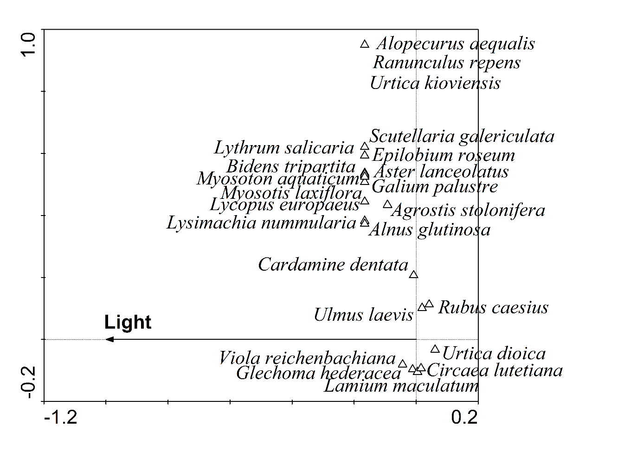

Fig. S17. CCA ordination diagram for the lowland alluvial forest (Ranšpurk). Species with a fit of at least 5% are displayed.

Table S18. Lowland alluvial forest species’ scores from CCA with light as an explanatory variable

Species species score_light
Acer campestre -0.0664
Aegopodium podagraria 1.2909
Agrostis stolonifera -0.4304
Ajuga reptans 0.2581
Alliaria petiolata 1.2909
Alnus glutinosa -0.7746
Alopecurus aequalis -0.7746
Anthriscus sylvestris -0.7746
Aristolochia clematitis 1.2909
Aster lanceolatus -0.7746
Athyrium filix-femina -0.0861
Bidens tripartita -0.7746
Brachypodium sylvaticum -0.7746
Cardamine dentata -0.0369
Cardamine impatiens 0.0516
Carex remota 0.4057
Carpinus betulus -0.1671
Chaerophyllum temulum -0.7746
Chelidonium majus -0.7746
Circaea lutetiana 0.0759
Conyza canadensis -0.7746
Crataegus sp. -0.0861
Dactylis polygama 0.2581
Deschamsia cespitosa 1.2909
Dryopteris carthusiana agg. 0.1342
Dryopteris filix-mas 0.5163
Epilobium roseum -0.7746
Euonymus europaeus 0.2581
Fallopia dumetorum 0.2581
Festuca gigantea 0.6024
Fraxinus angustifolia -0.1586
Galium odoratum 0.6024
Galium palustre -0.7746
Geranium robertianum -0.1255
Geum urbanum 0
Glechoma hederacea -0.0529
Hedera helix 0.2581
Impatiens parviflora -0.0596
Lamium maculatum 0.0226
Lapsana communis 0.2581
Lycopus europaeus -0.7746
Lysimachia nummularia -0.7746
Lythrum salicaria -0.7746
Maianthemum bifolium 1.2909
Milium effusum 0.4057
Moehringia trinervia -0.0369
Mycelis muralis 1.2909
Myosoton aquaticum -0.7746
Myosotis laxiflora -0.7746
Oxalis fontana -0.7746
Paris quadrifolia -0.7746
Parthenocissus inserta -0.7746
Persicaria hydropiper -0.7746
Poa nemoralis -0.7746
Pulmonaria obscura 0.1513
Quercus robur -0.7746
Ranunculus repens -0.7746
Rhamnus cathatrica 1.2909
Rosa canina 0.0516
Rubus caesius 0.1974
Sambucus nigra 0.1721
Scutellaria galericulata -0.7746
Senecio ovatus 1.2909
Stachys sylvatica -0.7746
Stellaria media 0.0516
Symphytum officinale -0.7746
Taraxacum sect. Ruderalia 0.2581
Tilia cordata 0.2154
Ulmus laevis 0.0916
Urtica dioica 0.2861
Urtica kioviensis -0.7746
Veronica chamaedrys -0.7746
Viola reichenbachiana -0.2033

Beech-fir forest

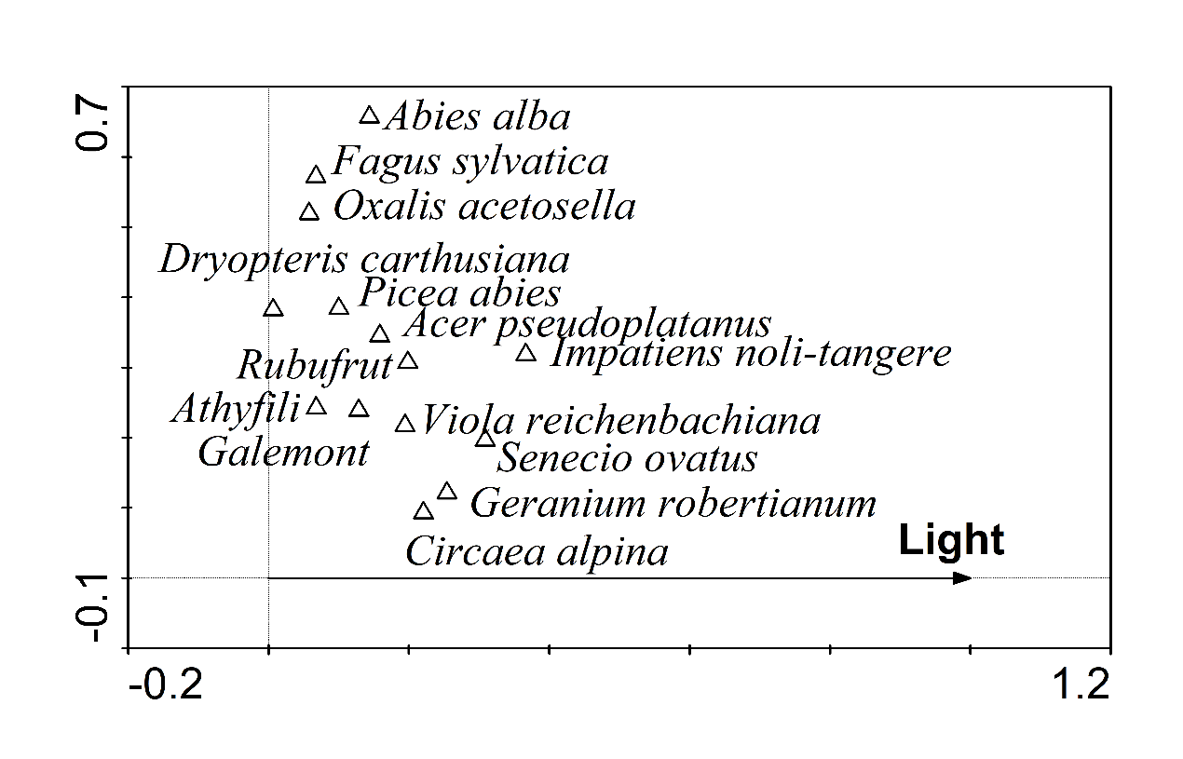

Fig. S19. RDA ordination diagram for the beech-fir forest (Salajka). Species with a fit of at least 5% are displayed. Species abbreviations: Athyfili – Athyrium filix-femina, Galemont – Galeobdolon montanum, Rubufrut – Rubus fruticosus agg.

Table S20. Beech-fir forest species’ scores from RDA with light as an explanatory variable

Species species score_light
Abies alba 0.1438
Acer pseudoplatanus 0.1586
Ajuga reptans 0.1107
Athyrium filix-femina 0.0681
Cardamine amara 0.058
Carex remota 0.0608
Carex sylvatica 0.0308
Chrysosplenium alternifolium 0.167
Circaea lutetiana 0.136
Dentaria bulbifera 0.1107
Dyopteris carthusiana agg. 0.0068
Dryopteris filix-mas 0.0296
Epilobium sp. 0.1107
Fagus sylvatica 0.0677
Fraxinus excelsior 0.0308
Galeobdolon montanum 0.1285
Galium odoratum 0.156
Geranium robertianum 0.2543
Gymnocarpium dryopteris -0.0408
Impatiens noli-tangere 0.3667
Lysimachia nemorum 0.1115
Oxalis acetosella 0.0579
Petasites albus 0.1568
Picea abies 0.1001
Platanthera bifolia 0.1107
Ranunculus repens 0.1568
Rubus fruticosus agg. 0.1985
Salvia glutinosa 0.058
Senecio ovatus 0.3088
Sorbus aucuparia 0.0419
Stellaria nemorum 0.1107
Taraxacum sect. Ruderalia 0.1568
Tilia sp. -0.0288
Urtica dioica 0.1107
Vaccinium myrtillus 0.1241
Veronica montana 0.1235
Viola reichenbachiana 0.1946

Beech-spruce-fir forest

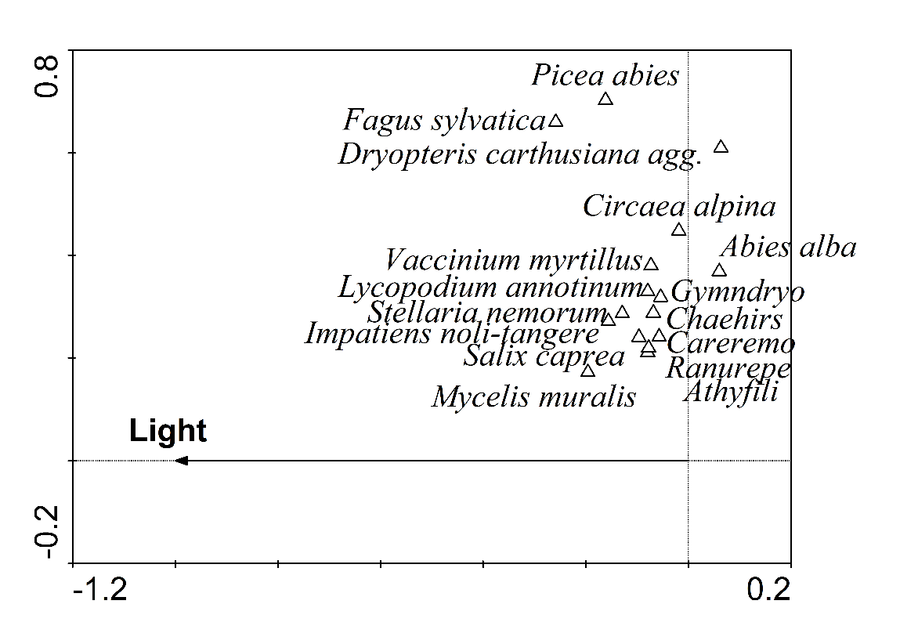
Fig. S21. RDA ordination diagram for the beech-spruce-fir forest (Žofín). Species with a fit of at least 5% are displayed. Species abbreviations: Athyfili = Athyrium filix-femina, Careremo = Carex remota, Chaehirs = Chaerophyllum hirsutum, Gymndryo = Gymnocarpium dryopteris, Ranurepe = Ranunculus repens.

Table S22. Beech-spruce-fir forest species’ scores from RDA with light as an explanatory variable

Species species score_light
Abies alba 0.0599
Acer sp. -0.0633
Actaea spicata -0.0633
Agrostis stolonifera -0.0447
Ajuga reptans -0.0777
Athyrium filix-femina -0.0791
Avenella flexuosa -0.0447
Betula pendula -0.0899
Cardamine trifolia -0.031
Carex muricata -0.0447
Carex remota -0.057
Carex sp. -0.0447
Chaerophyllum hirsutum -0.0685
Chrysosplenium alternifolium -0.0175
Circaea alpina -0.0187
Cirsium palustre -0.0447
Crepis paludosa -0.0633
Dactylis polygama -0.0633
Daphne mezereum -0.0447
Dentaria enneaphyllos 0.0721
Deschampsia cespitosa -0.0447
Dryopteris carthusiana agg. 0.0634
Epilobium angustifolium -0.1359
Epilobium montanum -0.0447
Equisetum sylvaticum -0.0633
Fagus sylvatica -0.2584
Festuca gigantea -0.0899
Fragaria vesca -0.0447
Galeobdolon montanum -0.0159
Galium odoratum 0.0827
Galium palustre -0.0899
Geranium robertianum -0.1006
Gymnocarpium dryopteris -0.0542
Hieracium murorum -0.0447
Impatiens noli-tangere -0.1561
Juncus effusus -0.0447
Luzula sylvatica 0.1022
Lycopodium annotinum -0.0791
Lysimachia nemorum -0.0447
Maianthemum bifolium -0.01
Mycelis muralis -0.1958
Myosotis sylvatica -0.0447
Oxalis acetosella 0.0548
Paris quadrifolia -0.0447
Phegopteris connectilis 0.0194
Picea abies -0.1617
Poa nemoralis -0.0861
Prenanthes purpurea -0.0633
Ranunculus repens -0.0777
Rubus fruticosus agg. -0.0447
Rubus idaeaus -0.0433
Salix caprea -0.0964
Sanicula europaea 0.0721
Senecio ovatus -0.0868
Sorbus aucuparia -0.0312
Stellaria media -0.0633
Stellaria nemorum -0.129
Taraxacum sect.Ruderalia -0.0983
Tephroseris crispa -0.0749
Ulmus glabra -0.0447
Urtica dioica -0.1417
Vaccinium myrtillus -0.0729
Veronica officinalis -0.0777
Vicia tetrasperma -0.0447
Viola palustris -0.0447
Viola reichenbachiana -0.01

Mountain spruce forest

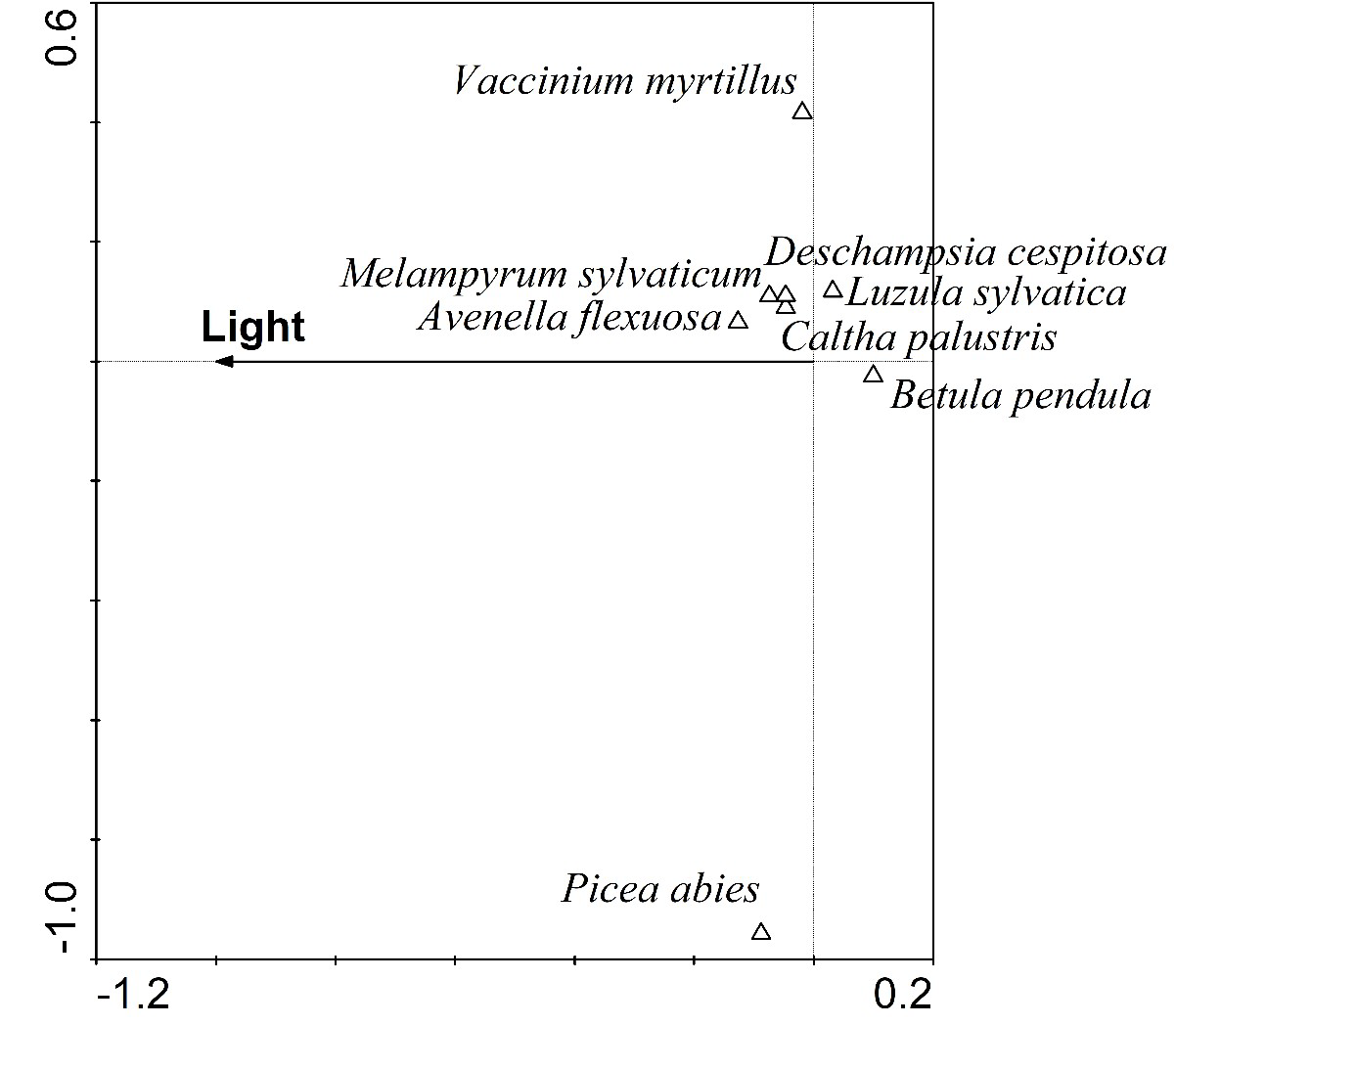
Fig. S23. RDA ordination diagram for the mountain spruce forest (Eustaška). Species with a fit of at least 1% are displayed.

Table S24. Mountain spruce forest species’ scores from RDA with light as an explanatory variable

Species species score_light
Athyrium filix-femina -0.033
Avenella flexuosa -0.1267
Betula pendula 0.0996
Calamagrostis villosa 0.0004
Caltha palustris -0.0468
Cardamine amara -0.033
Chaerophyllum hirsurum -0.033
Deschapsia cespitosa -0.0468
Dryopteris carthusiana agg. 0.0252
Equisetum sylvaticum 0.0471
Luzula sylvatica 0.032
Lycopodium annotinum -0.033
Melampyrum sylvaticum -0.0744
Oxalis acetosella -0.0515
Picea abies -0.0878
Sorbus aucuparia -0.0147
Stellaria nemorum -0.033
Vaccinium myrtillus -0.019
Vaccinium vitis-idaea -0.027
Viola biflora -0.033

