Appendix 2

Results of direct ordination analyses of vascular plant species composition on decaying logs in the study sites (species data) and log decay class as an explanatory variable.

Lowland alluvial forest
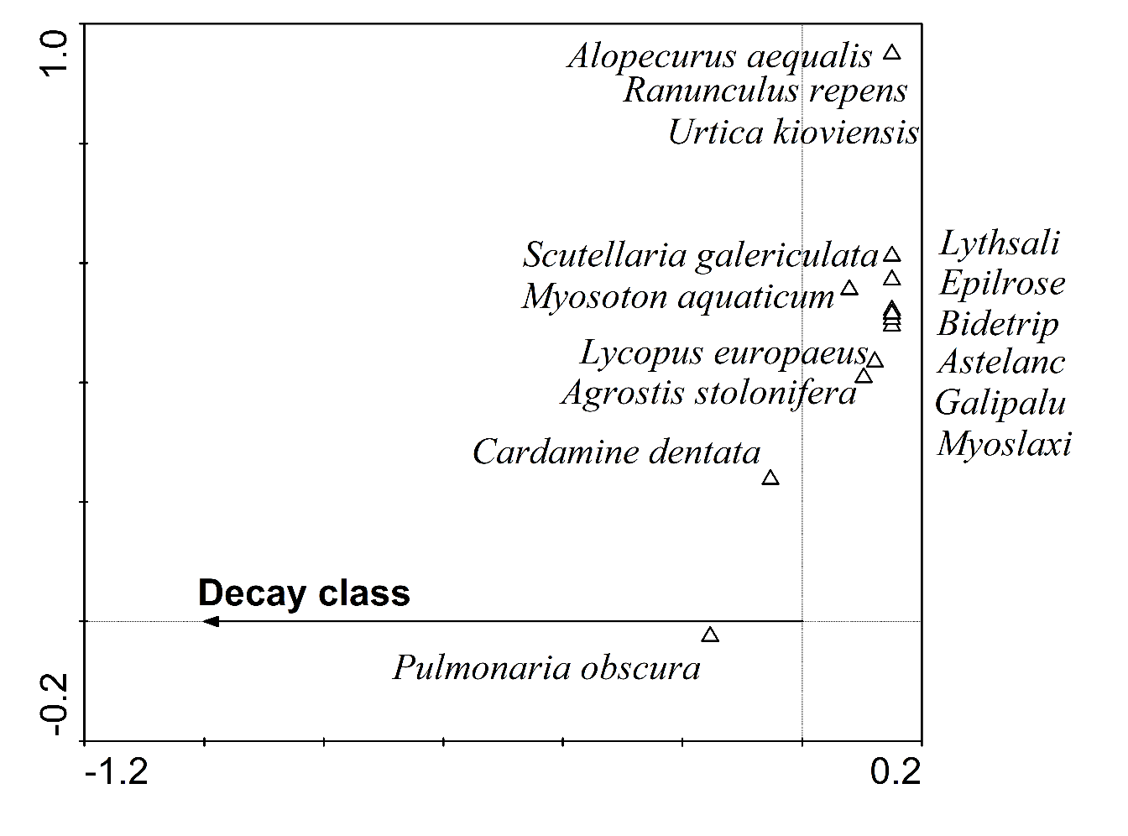
Fig. S9. CCA ordination diagram for the lowland alluvial forest (Ranšpurk). Species with a fit of at least 10% are displayed. Species abbreviations: Astelanc = Aster lanceolatus, Bidetrip = Bidens tripartita, Epilrose = Epilobium roseum, Galipalu = Galium palustre, Lythsali = Lythrum salicaria, Myoslaxi = Myosotis laxiflora.

Table S10. Lowland alluvial forest species’ scores from CCA with log decay class as an explanatory variable
Species species score_decay class
Acer campestre -0.3335
Aegopodium podagraria -0.6472
Agrostis stolonifera 0.4966
Ajuga reptans -0.1897
Alliaria petiolata -2.0198
Alnus glutinosa 0.7254
Alopecurus aequalis 0.7254
Anthriscus sylvestris -0.6472
Aristolochia clematitis 0.7254
Aster lanceolatus 0.7254
Athyrium filix-femina -1.1047
Bidens tripartita 0.7254
Brachypodium sylvaticum -0.6472
Cardamine dentata -0.255
Cardamine impatiens 0.3136
Carex remota -0.8433
Carpinus betulus 0.0794
Chaerophyllum temulum 0.7254
Chelidonium majus 0.7254
Circaea lutetiana -0.4454
Conyza canadensis 0.7254
Crataegus sp. 0.2678
Dactylis polygama -0.3041
Deschamsia cespitosa -0.6472
Dryopteris carthusiana agg. 0.094
Dryopteris filix-mas 0.3822
Epilobium roseum 0.7254
Euonymus europaeus -0.9217
Fallopia dumetorum 0.7254
Festuca gigantea 0.7254
Fraxinus angustifolia 0.1956
Galium odoratum -0.1897
Galium palustre 0.7254
Geranium robertianum 0.2548
Geum urbanum 0.3822
Glechoma hederacea -0.2834
Hedera helix 0.0391
Impatiens parviflora -0.1721
Lamium maculatum 0.003
Lapsana communis 0.7254
Lycopus europaeus 0.5881
Lysimachia nummularia 0.7254
Lythrum salicaria 0.7254
Maianthemum bifolium -0.6472
Milium effusum -0.059
Moehringia trinervia 0.1044
Mycelis muralis -0.6472
Myosoton aquaticum 0.3822
Myosotis laxiflora 0.7254
Oxalis fontana 2.0979
Paris quadrifolia -0.6472
Parthenocissus inserta -1.1047
Persicaria hydropiper 0.7254
Poa nemoralis 0.7254
Pulmonaria obscura -0.7419
Quercus robur -1.1047
Ranunculus repens 0.7254
Rhamnus cathatrica 0.7254
Rosa canina 0.1763
Rubus caesius 0.0794
Sambucus nigra 0.325
Scutellaria galericulata 0.7254
Senecio ovatus 0.7254
Stachys sylvatica -0.6472
Stellaria media 0.4509
Symphytum officinale -0.6472
Taraxacum sect. Ruderalia 0.7254
Tilia cordata -0.2497
Ulmus laevis 0.3712
Urtica dioica 0.0391
Urtica kioviensis 0.7254
Veronica chamaedrys 0.7254
Viola reichenbachiana -0.1507

Beech-fir forest
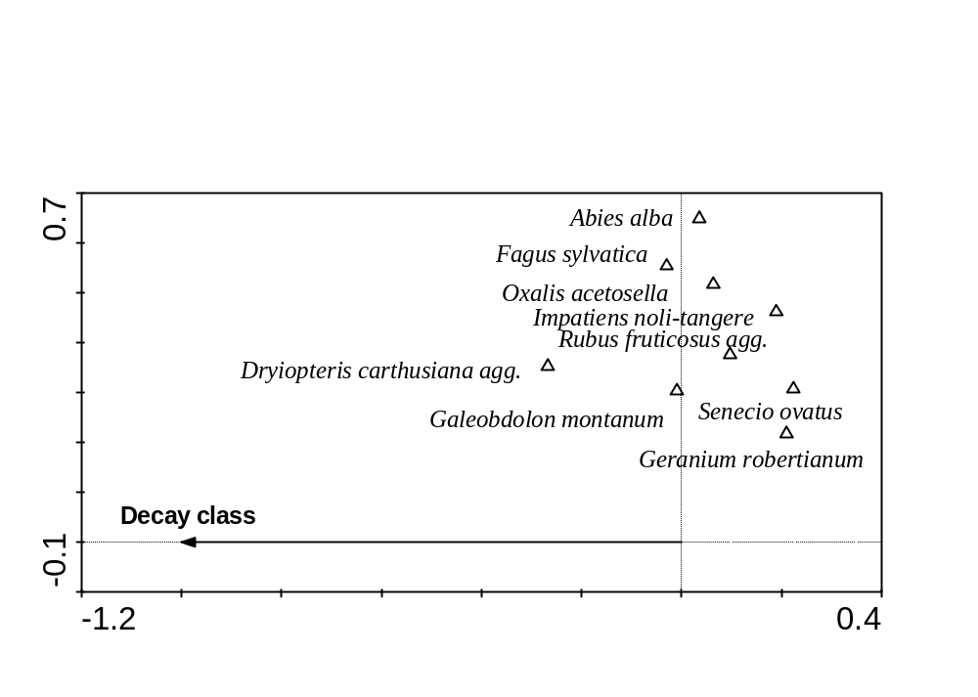
Fig. S11. RDA ordination diagram for the beech-fir forest (Salajka). Species with a fit of at least 9% are displayed.

Table S12. Beech-fir forest species’ scores from RDA with log decay class as an explanatory variable

Species species score_decay class
Abies alba 0.0357
Acer pseudoplatanus 0.0203
Ajuga reptans 0.053
Athyrium filix-femina -0.0887
Cardamine amara 0.0751
Carex remota -0.0212
Carex sylvatica 0.0017
Chrysosplenium alternifolium 0.0401
Circaea alpina 0.1201
Circaea lutetiana 0.0523
Dentaria bulbifera 0.053
Dyopteris carthusiana agg. -0.2674
Dryopteris filix-mas -0.0371
Epilobium sp. 0.053
Fagus sylvatica -0.0295
Fraxinus excelsior 0.0017
Galeobdolon montanum -0.0093
Galium odoratum -0.0088
Geranium robertianum 0.2101
Gymnocarpium dryopteris 0.0198
Impatiens noli-tangere 0.1897
Lysimachia nemorum -0.0435
Oxalis acetosella 0.0638
Petasites albus 0.0751
Picea abies 0.0529
Platanthera bifolia 0.1311
Ranunculus repens -0.0355
Rubus fruticosus agg. 0.0972
Salvia glutinosa 0.0751
Senecio ovatus 0.224
Sorbus aucuparia 0.0449
Stellaria nemorum 0.053
Taraxacum sect. Ruderalia 0.1857
Tilia sp. -0.1031
Urtica dioica 0.053
Vaccinium myrtillus -0.026
Veronica montana 0.0842
Viola reichenbachiana 0.1387

Beech-spruce-fir forest

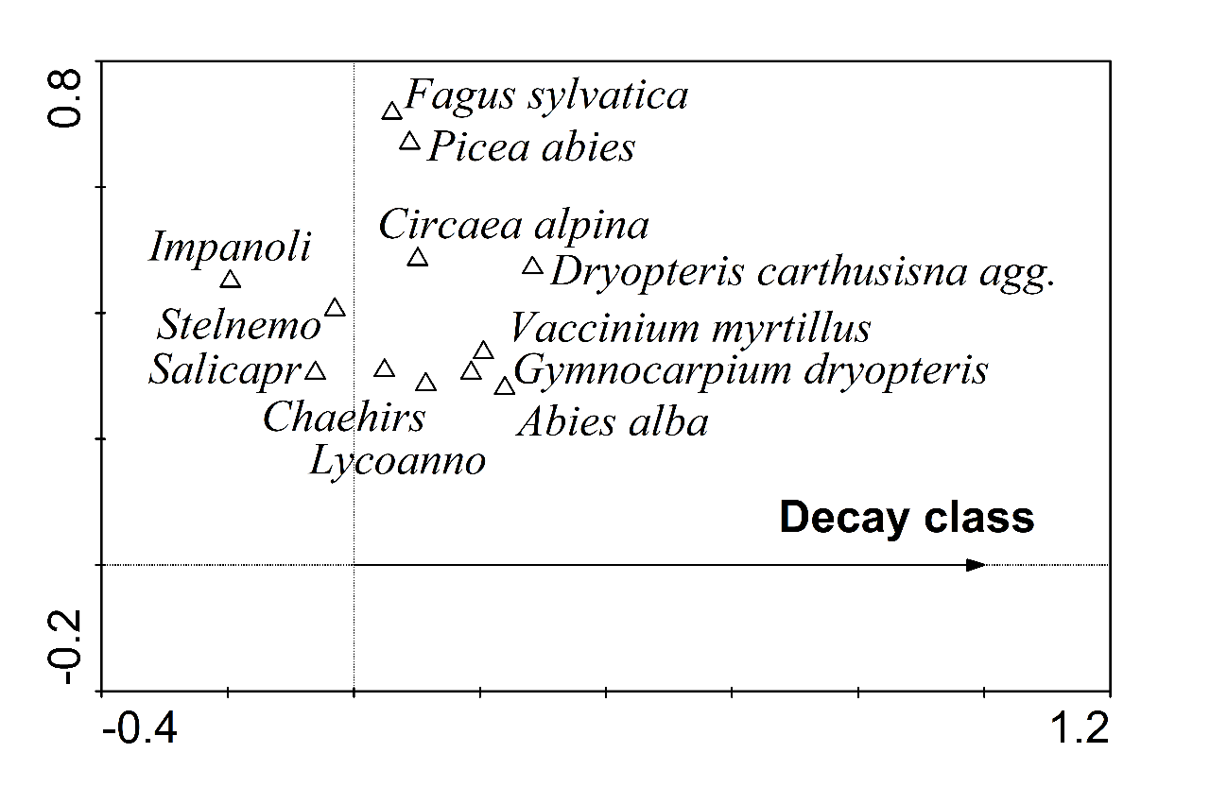
Fig. S13. RDA ordination diagram for the beech-spruce-fir forest (Žofín). Species with a fit of at least 9% are displayed. Species abbreviations: Chaehirs = Chaerophyllum hirsutum, Impanoli = Impatiens nolitangere, Lycoanno = Lycopodium annotinum, Salicapr = Salix caprea, Stelnemo = Stellaria nemorum.

Table S14. Beech-spruce-fir forest species’ scores from RDA with log decay class as an explanatory variable

Species species score_decay class
Abies alba 0.2394
Acer sp. 0.0033
Actaea spicata 0.1123
Agrostis stolonifera -0.0244
Ajuga reptans -0.0114
Athyrium filix-femina 0.0396
Avenella flexuosa 0.029
Betula pendula -0.0222
Cardamine trifolia -0.0075
Carex muricata 0.029
Carex remota -0.0019
Carex sp. 0.029
Chaerophyllum hirsutum 0.0487
Chrysosplenium alternifolium -0.0494
Circaea alpina 0.1012
Cirsium palustre -0.0778
Crepis paludosa -0.0345
Dactylis polygama -0.0345
Daphne mezereum -0.0244
Dentaria enneaphyllos 0.0825
Deschampsia cespitosa -0.0244
Dryopteris carthusiana agg. 0.2836
Epilobium angustifolium -0.074
Epilobium montanum -0.0778
Equisetum sylvaticum 0.079
Fagus sylvatica 0.0606
Festuca gigantea -0.0789
Fragaria vesca -0.0345
Galeobdolon montanum -0.0174
Galium odoratum 0.038
Galium palustre -0.0758
Geranium robertianum -0.0855
Gymnocarpium dryopteris 0.1861
Hieracium murorum -0.0778
Impatiens noli-tangere -0.1959
Juncus effusus -0.0778
Luzula sylvatica 0.1168
Lycopodium annotinum 0.1141
Lysimachia nemorum 0.0825
Maianthemum bifolium 0.0195
Mycelis muralis -0.1267
Myosotis sylvatica -0.0244
Oxalis acetosella -0.0336
Paris quadrifolia 0.029
Phegopteris connectilis 0.079
Picea abies 0.0885
Poa nemoralis 0.029
Prenanthes purpurea 0.0033
Ranunculus repens 0.0505
Rubus fruticosus agg. 0.0411
Rubus idaeaus -0.0964
Salix caprea -0.061
Sanicula europaea -0.0778
Senecio ovatus -0.106
Sorbus aucuparia 0.016
Stellaria media 0.0411
Stellaria nemorum -0.03
Taraxacum sect.Ruderalia -0.0593
Tephroseris crispa -0.0447
Ulmus glabra -0.0778
Urtica dioica -0.072
Vaccinium myrtillus 0.2056
Veronica officinalis -0.1042
Vicia tetrasperma 0.029
Viola palustris 0.029
Viola reichenbachiana -0.1352

Mountain spruce forest

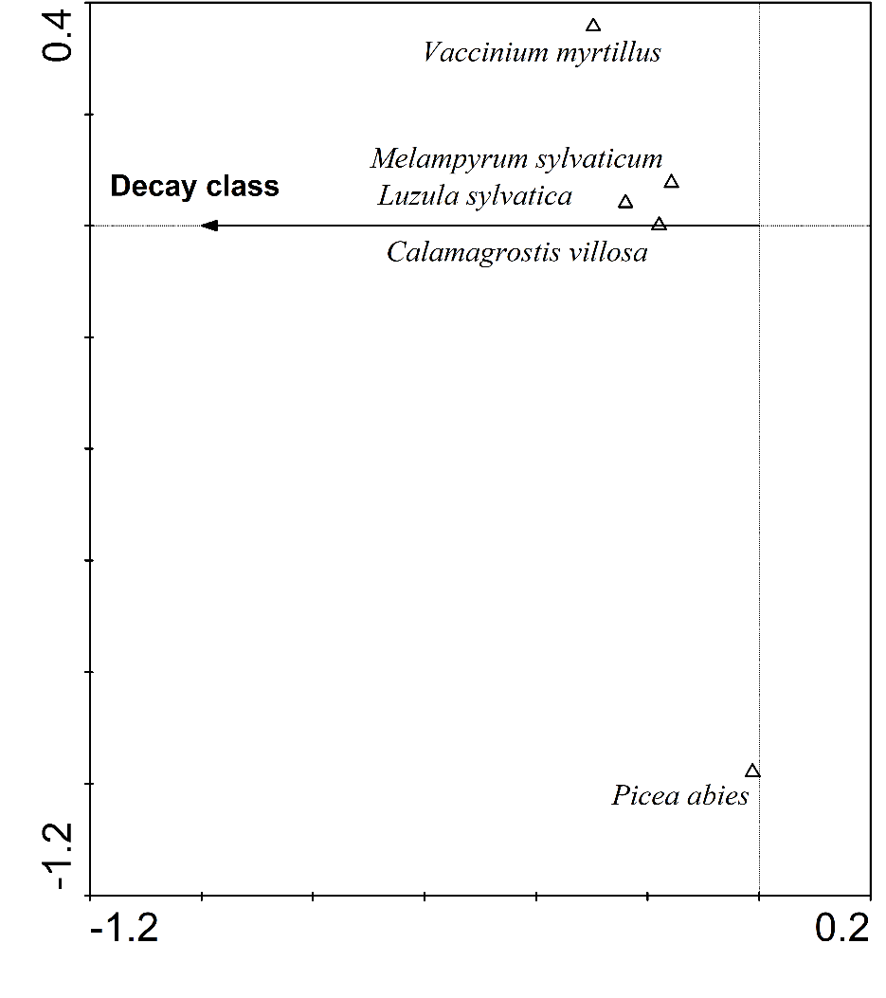
Fig. S15. RDA ordination diagram for the mountain spruce forest (Eustaška). Species with a fit of at least 3% are displayed.

Table S16. Mountain spruce forest species’ scores from RDA with log decay class as an explanatory variable

Species species score_decay class
Athyrium filix-femina -0.0986
Avenella flexuosa -0.1118
Betula pendula 0.0446
Calamagrostis villosa -0.1795
Caltha palustris -0.089
Cardamine amara -0.027
Chaerophyllum hirsurum -0.027
Deschapsia cespitosa -0.089
Dryopteris carthusiana agg. -0.1144
Equisetum sylvaticum -0.089
Luzula sylvatica -0.2396
Lycopodium annotinum -0.0986
Melampyrum sylvaticum -0.1575
Oxalis acetosella -0.0621
Picea abies -0.0118
Sorbus aucuparia -0.0285
Stellaria nemorum -0.027
Vaccinium myrtillus -0.2973
Vaccinium vitis-idaea -0.0077
Viola biflora -0.027

