High throughput metabolomics in vitro platform for the identification of hepatotoxicity modes of action
Cell Biology and Toxicology
Sabina Ramirez-Hincapie¹, Barbara Birk¹, Philipp Ternes² , Varun Giri¹, Volker Haake², Michael Herold², Franziska Maria Zickgraf¹ Andreas Verlohner¹, Hans-Albrecht Huener¹, Hennicke Kamp², Peter Driemert², Robert Landsiedel^{1,3}, Elke Richling³, Dorothee Funk-Weyer¹, Bennard van Ravenzwaay¹
¹ BASF SE, Experimental Toxicology and Ecology, Ludwigshafen, Germany
² BASF Metabolome Solution GmbH, Berlin, Germany
³ Free University of Berlin, Pharmacy, Pharmacology and Toxicology, Berlin, Germany.
⁴ Food Chemistry and Toxicology, Department of Chemistry, University of Kaiserslautern -Landau, Kaiserslautern, Germany
E-mail corresponding author: sabina.ramirez-hincapie@basf.com
Supplementary information
Suppl Fig.1. Metabolomics analysis quality control thresholds.
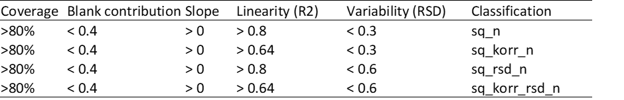

Suppl Fig. 2 Cytotoxicity and cell viability range finder for dose selection. Cell viability assay (CellTiter-Glo®) and Cytotoxicity assay (CellTox™ Green) n=6.a) Acifluorfen, b) Wy-14643, c) β Naphthoflavone, d) Aroclor 1254, e) Pendimethalin, f) Ketoconazole. Values are presented as percentage of vehicle controls for CellTiter-Glo® and as percentage of positive control (lysis buffer) for CellTox™ Green.
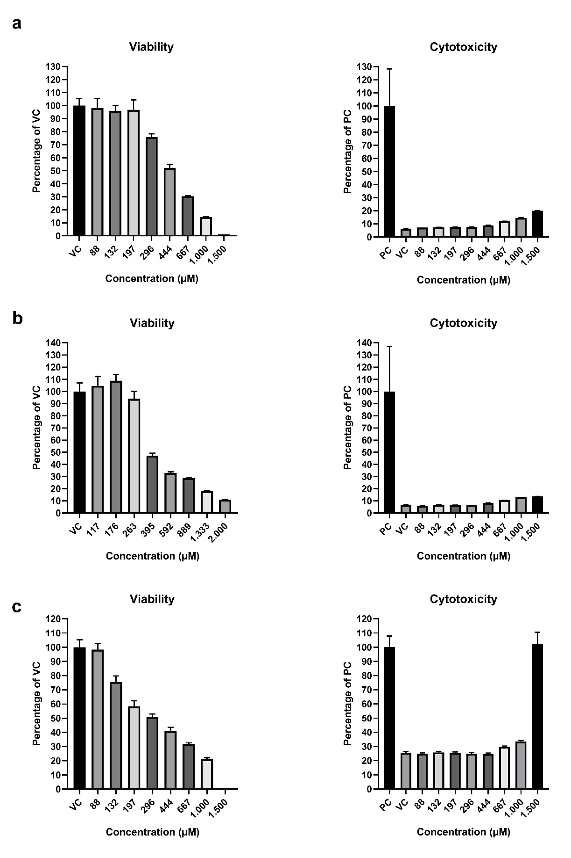

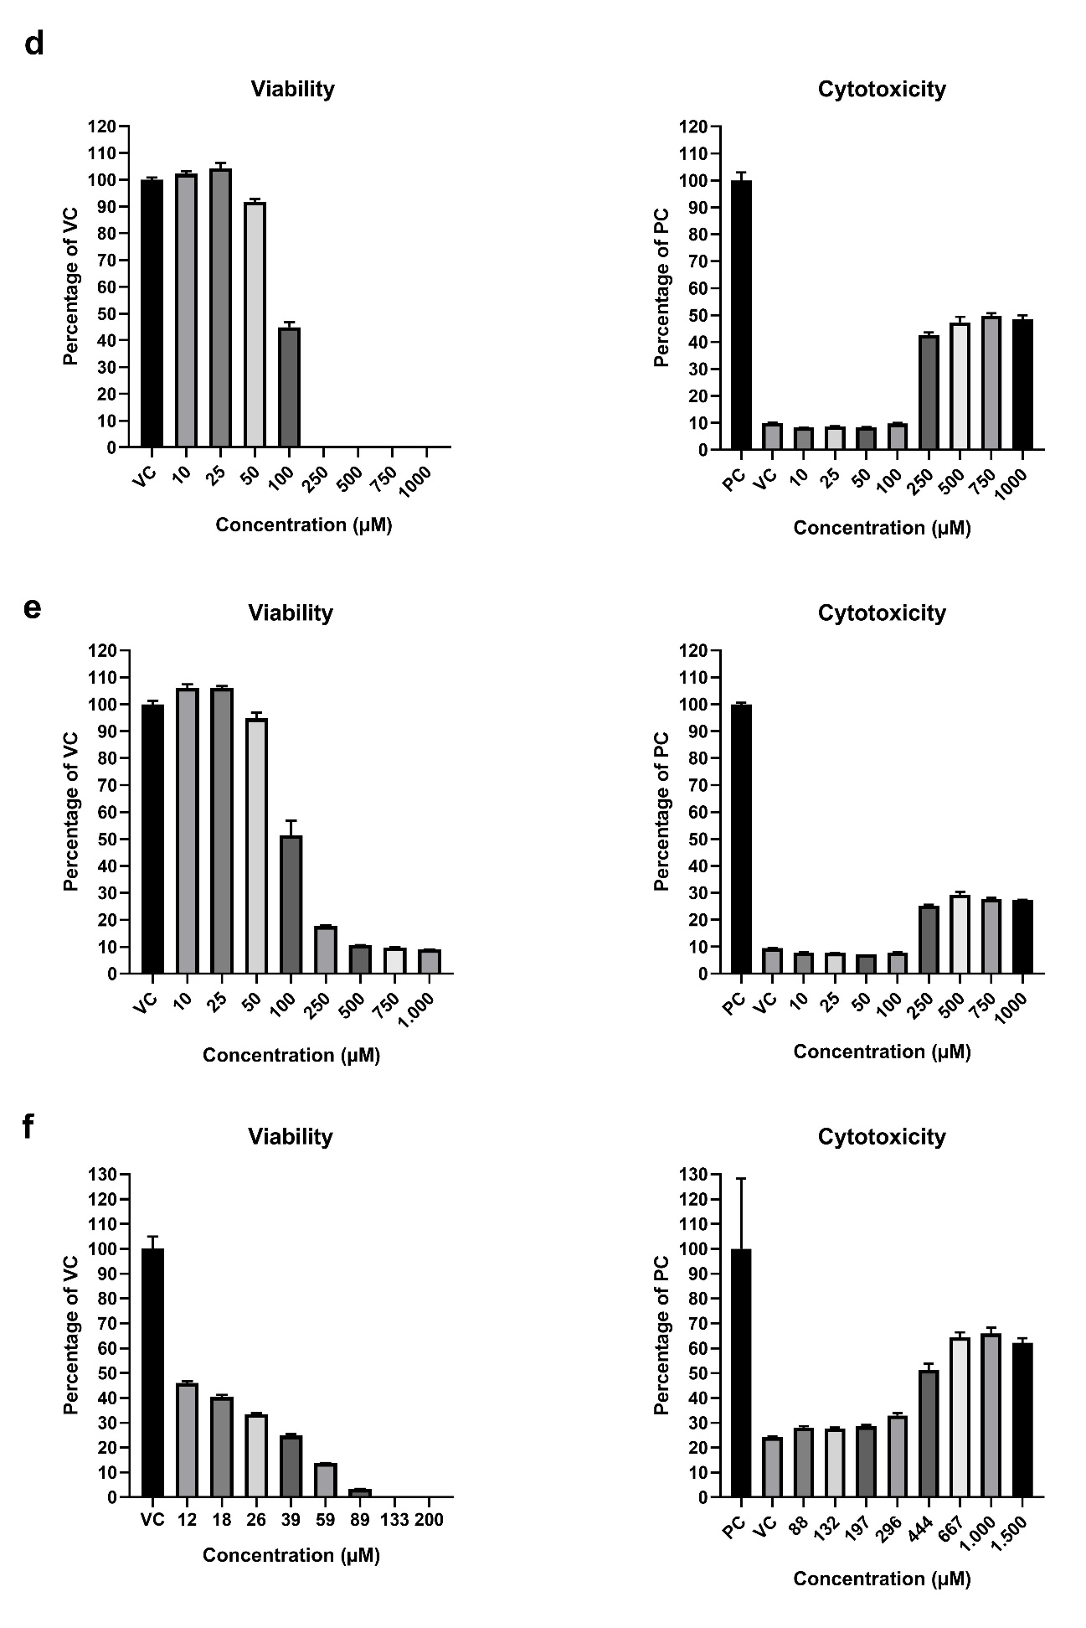

Suppl Fig. 3 Dose response curves for dose selection. Dose response curves were built with the ATP measurement (CellTiter-Glo®) in the range finder experiments (see Suppl. Figure 2) and used to derive effective concentration (EC) for the metabolomics dose setting. Acifluorfen, b) Wy-14643, c) β-Naphthoflavone, d) Aroclor 1254, e) Pendimethalin, f) Ketoconazole.
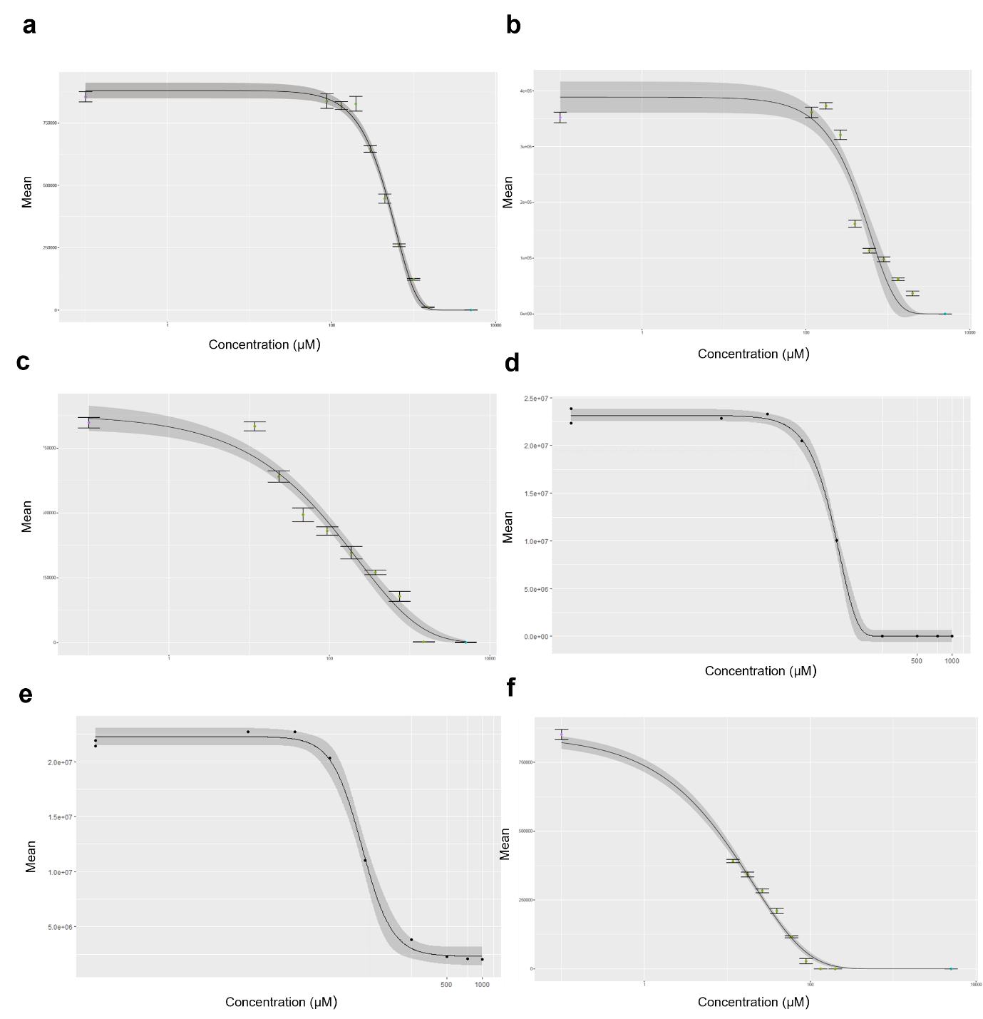

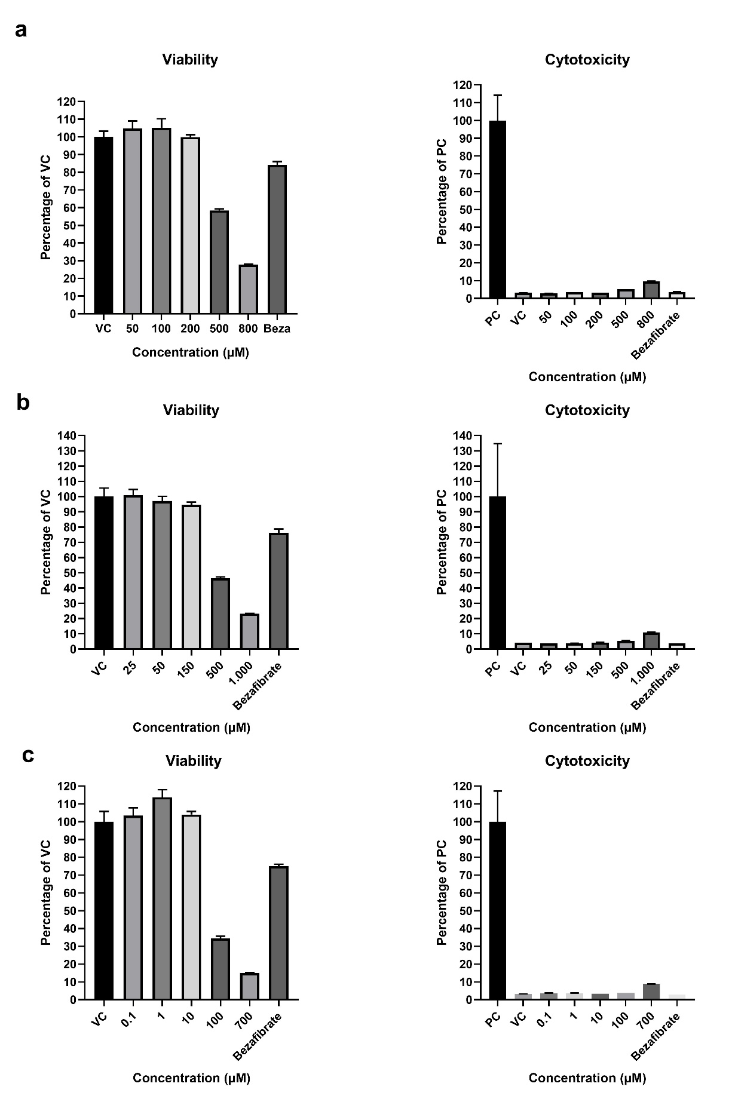
Suppl Fig.4 Metabolomics experiment cell viability and cytotoxicity testing. Cell viability assay (CellTiter-Glo®) and Cytotoxicity assay (CellTox™ Green) n=6 were carried out in parallel with metabolomics experiments in plates handled and treated exactly as the ones used for metabolite profiling. a) Acifluorfen, b) Wy-14643, c) β-Naphthoflavone, d) Aroclor 1254, e) Pendimethalin, f) Ketoconazole.

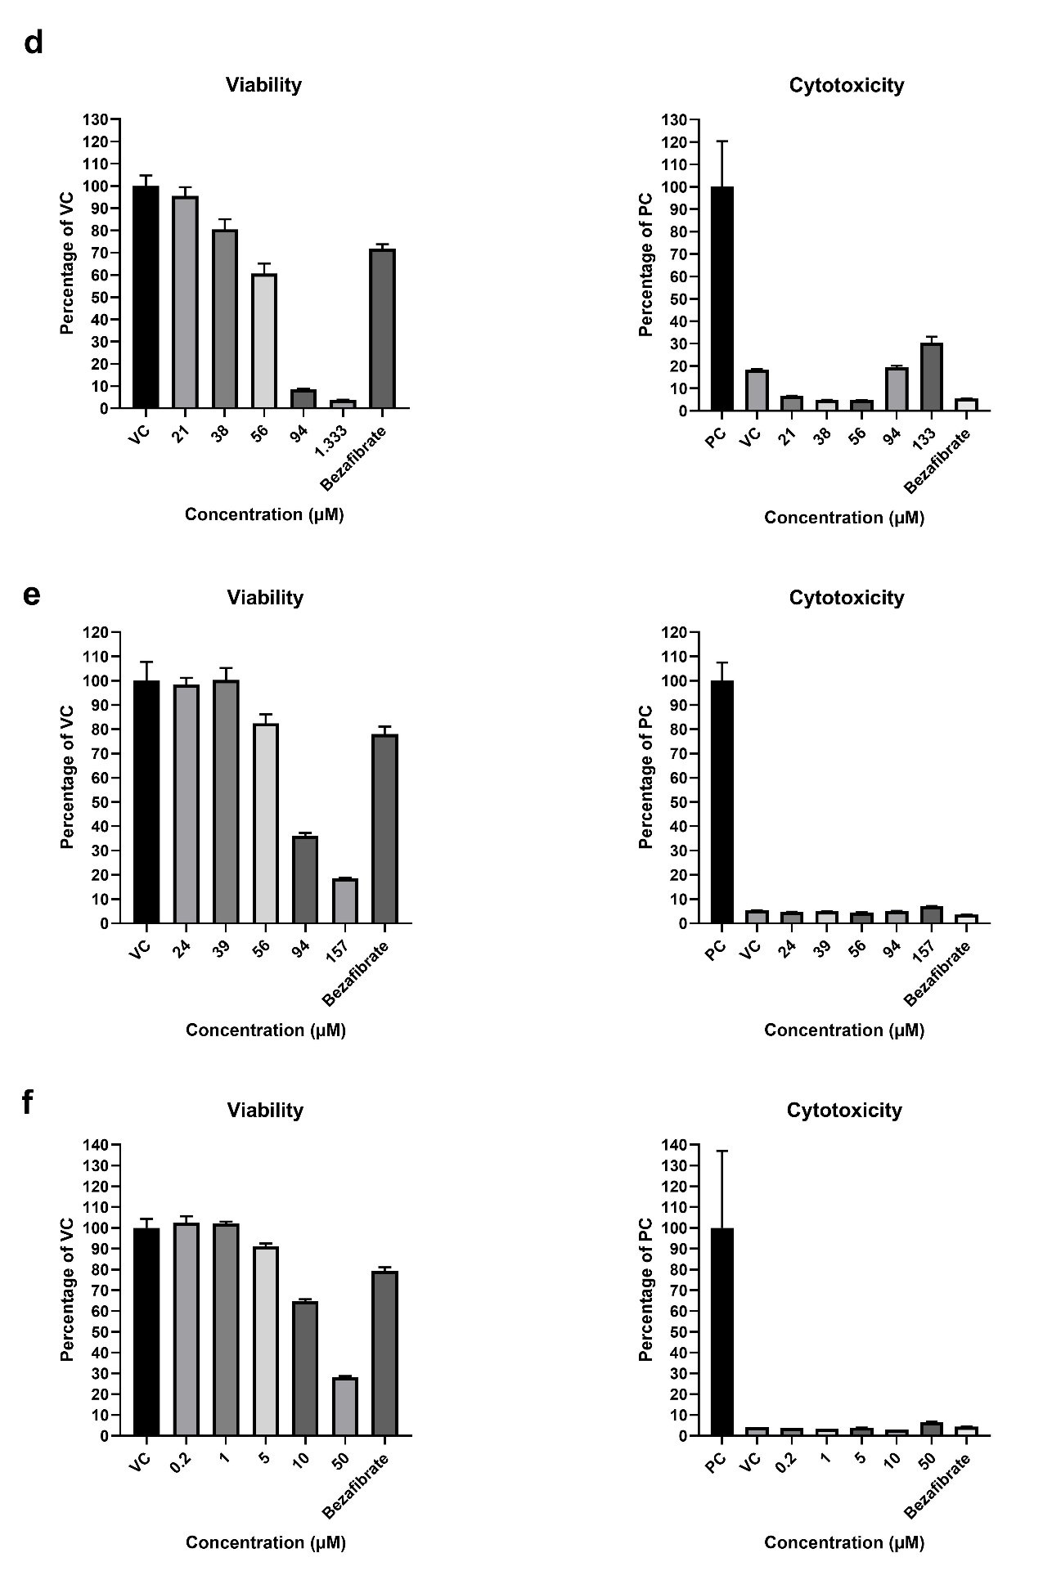

Suppl Fig 5. Enrichment analysis of significantly altered metabolites by ontology class after substance treatment. The distribution of the 241measured metabolites across the ontology classes is provided in the column “measured metabolites”. The number of metabolite changes are shown for each metabolite ontology class. Numbers yellow represent that a treatment caused a significant (p-value<0.05) enrichment in an ontology class. C1 to C5: substance concentrations. Acifluorfen, b) Wy-14643, c) β-Naphthoflavone, d) Aroclor 1254, e) Pendimethalin, f) Ketoconazole.
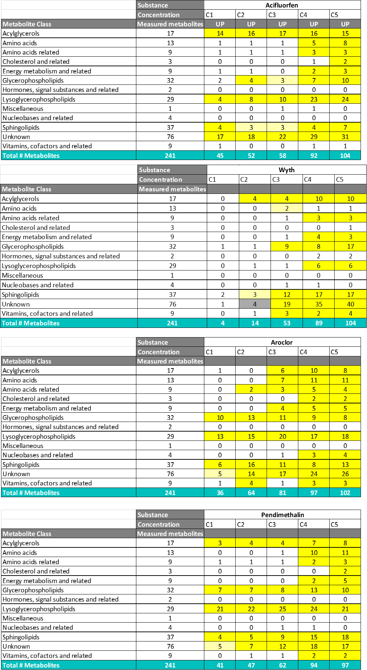
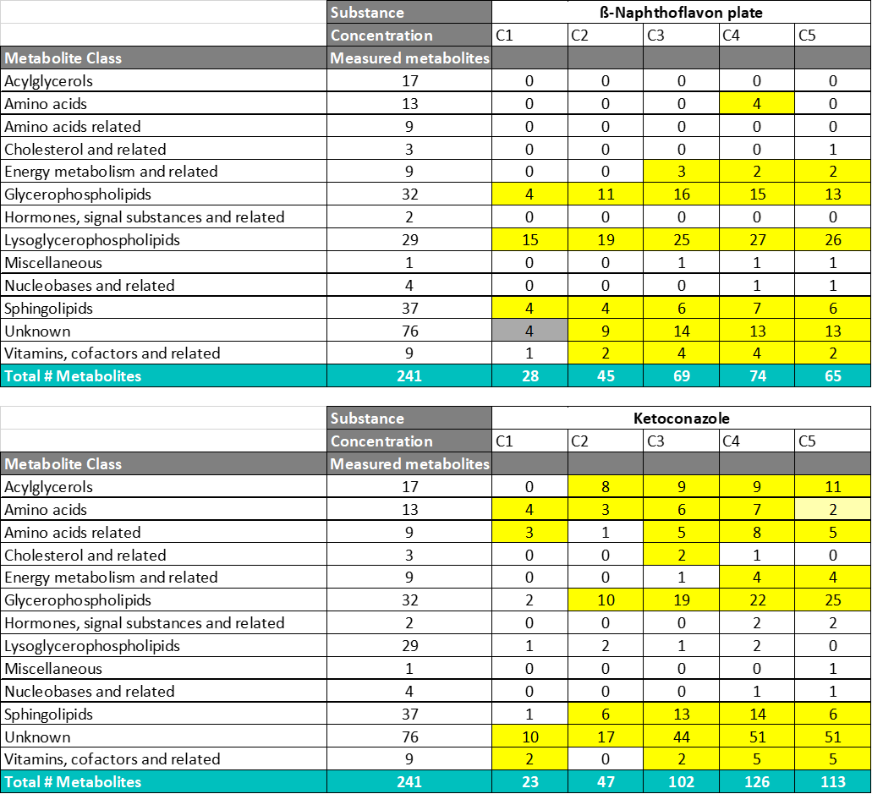

Suppl Fig 6. Experimental variability and reproducibility. the variance of every log-transformed metabolite for both pooled samples (technical replicates) and control samples was calculated. These variances were back transformed to linear scale, yielding a relative standard deviation (RSD).
Plate | RSD Pool | RSD Controls
Acifluorfen | 0.10 | 0.11
Aroclor 1254 | 0.10 | 0.11
Ketoconazole | 0.09 | 0.09
Naphthoflavone | 0.10 | 0.09
Pendimethalin | 0.08 | 0.11
Wy-14643 | 0.10 | 0.10

Suppl Fig. 7 3D-PCA of metabolic profiles shows a MoA-specific clustering of liver toxicants. PCA of metabolite profiles of HepG2 cells treated for 48h with three liver enzyme inducers (Pendimethalin, Aroclor, β-Naphthoflavone), three peroxisome proliferators (Bezafibrate, Acifluorfen, Wy-14643) and one liver enzyme inhibitor (Ketoconazole) allows to discriminate between the different mode of actions of these substances. Intermediate concentrations (C3 for Pendimethalin, B-naphthoflavone, acifluorfen, Wy-14643, and Ketoconazole and C2 for Aroclor) were selected for the analysis.
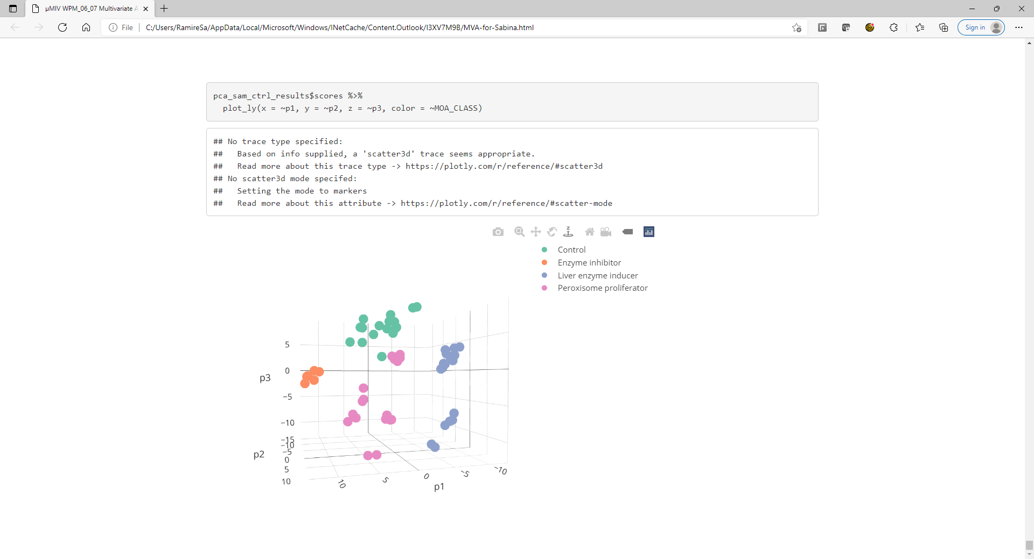
13.9%
21.2%
16.6%

Suppl Fig.8 Metabolome changes induced by peroxisome proliferators. Heatmap of common statistically significantly (p<0.05) altered metabolites after Bezafibrate, Acifluorfen and Wy -14643 treatment. Red represents significantly upregulated metabolites and blue represents significantly downregulated metabolites as compared to controls. C3 equivalent to EC15ATP was used for the analysis. Bezafibrate was used as a positive control in each of the 6 plates of the experiment (n=6 per condition).
Metabolite | Bezafibrate Plate 1 | Bezafibrate Plate 2 | Bezafibrate Plate 3 | Bezafibrate Plate 4 | Bezafibrate Plate 5 | Bezafibrate Plate 6 | Wy-14643 | Acifluorfen | Metabolite class
Taurine | 0.93 | 0.92 | 0.68 | 0.93 | 0.90 | 0.88 | 0.97 | 0.61 | Amino acids
5-Hydroxytryptophan | 0.85 | 0.74 | 0.65 | 0.84 | 0.77 | 0.76 | 0.85 | 0.74 | Amino acids related
Creatine | 0.80 | 0.82 | 0.73 | 0.78 | 0.67 | 0.66 | 0.85 | 0.87
Ketoleucine | 0.73 | 0.72 | 0.74 | 0.73 | 0.77 | 1.10 | 0.86 | 0.80
N-Acetylaspartate | 1.54 | 1.49 | 1.66 | 1.48 | 1.41 | 1.25 | 1.22 | 1.50
S-Adenosylhomocysteine | 0.92 | 0.98 | 0.70 | 0.93 | 0.78 | 0.79 | 1.03 | 0.84
Carnitine | 0.72 | 0.74 | 0.84 | 0.72 | 0.77 | 0.80 | 0.99 | 0.98 | Energy metabolism and related
Glycerol-3-phosphate | 0.68 | 0.43 | 0.45 | 0.54 | 0.44 | 0.39 | 0.72 | 0.90
Hexanoylcarnitine | 0.65 | 0.54 | 0.50 | 0.59 | 0.59 | 0.62 | 0.93 | 0.70
Propionylcarnitine | 0.66 | 0.78 | 0.40 | 0.58 | 0.54 | 0.57 | 0.97 | 0.79
2'-Deoxycytidine | 0.37 | 0.42 | 0.16 | 0.27 | 0.22 | 0.21 | 0.75 | 0.56 | Nucleobases and related
Pantothenic acid | 0.68 | 0.77 | 0.59 | 0.72 | 0.70 | 0.76 | 0.74 | 0.68 | Vitamins. cofactors and related
Triacylglycerol (C34:1.C18:3) | 1.57 | 2.06 | 2.37 | 1.58 | 1.93 | 2.00 | 1.01 | 1.73 | Acylglycerols
Triacylglycerol (C34:2.C18:0) | 1.63 | 1.54 | 1.78 | 1.17 | 1.31 | 1.39 | 1.14 | 2.66
Triacylglycerol (C34:2.C18:1) | 1.40 | 1.62 | 1.81 | 1.26 | 1.79 | 1.43 | 1.01 | 2.04
Triacylglycerol (C36:4.C16:0) | 1.74 | 2.34 | 2.73 | 1.73 | 1.97 | 2.11 | 1.09 | 1.86
Triacylglycerol (C36:4.C18:0) | 2.15 | 2.38 | 2.26 | 1.72 | 1.82 | 2.28 | 1.18 | 2.14
Choline plasmalogen (C36:4) | 0.65 | 0.80 | 0.68 | 0.69 | 0.73 | 0.72 | 1.00 | 0.75 | Glycerophospholipids
Choline plasmalogen (C36:5) | 0.78 | 0.90 | 0.80 | 0.83 | 0.82 | 0.79 | 1.03 | 0.70
Phosphatidylcholine (C32:0) | 0.82 | 0.70 | 0.79 | 0.88 | 0.83 | 0.76 | 0.81 | 0.82
Phosphatidylcholine (C34:1) | 0.83 | 0.75 | 0.78 | 0.82 | 0.82 | 0.74 | 0.91 | 0.81
Phosphatidylcholine (C34:3) | 1.02 | 1.18 | 1.17 | 1.09 | 1.15 | 1.04 | 1.04 | 1.23
Phosphatidylcholine (C36:1) | 0.86 | 0.88 | 0.73 | 0.84 | 0.79 | 0.90 | 0.96 | 0.76
Phosphatidylcholine (C36:2) | 0.66 | 0.71 | 0.62 | 0.69 | 0.71 | 0.65 | 0.86 | 0.78
Phosphatidylcholine (C36:3) | 0.90 | 1.03 | 0.84 | 0.96 | 0.97 | 0.89 | 0.93 | 0.82
Phosphatidylcholine (C36:4) | 1.00 | 0.93 | 0.81 | 0.98 | 0.95 | 0.94 | 0.98 | 0.66
Phosphatidylcholine (C36:5) | 0.78 | 0.81 | 0.63 | 0.76 | 0.72 | 0.75 | 0.92 | 0.71
Phosphatidylethanolamine (C36:3) | 0.90 | 0.87 | 0.87 | 0.90 | 0.87 | 0.84 | 0.82 | 0.86
Phosphatidylethanolamine (C38:3) | 0.72 | 0.70 | 0.64 | 0.75 | 0.68 | 0.66 | 0.92 | 1.05
Phosphatidylethanolamine (C38:5) | 0.90 | 1.00 | 0.86 | 0.98 | 0.87 | 0.90 | 0.89 | 0.82
Phosphatidylethanolamine (C38:6) | 0.92 | 0.91 | 0.95 | 1.01 | 0.98 | 0.92 | 0.96 | 0.91
Phosphatidylethanolamine (C40:7) | 0.79 | 0.81 | 0.75 | 0.88 | 0.82 | 0.88 | 0.92 | 0.68
Lysophosphatidylcholine (C14:0) | 2.27 | 1.82 | 2.09 | 1.97 | 1.85 | 1.87 | 1.51 | 1.75 | Lysoglycerophospholipids
Lysophosphatidylcholine (C16:0) | 1.86 | 1.92 | 1.98 | 2.08 | 1.93 | 2.14 | 1.26 | 1.17
Lysophosphatidylcholine (C16:1) | 1.95 | 2.13 | 2.01 | 2.17 | 1.86 | 1.72 | 1.06 | 1.22
Lysophosphatidylcholine (C20:4) | 1.22 | 1.67 | 1.47 | 1.90 | 1.86 | 1.44 | 1.28 | 0.94
Lysophosphatidylcholine (C24:0) | 1.01 | 1.18 | 1.11 | 1.20 | 1.21 | 1.29 | 1.50 | 1.25
Lysophosphatidylcholine (C24:1) | 1.10 | 1.03 | 1.13 | 1.26 | 1.10 | 1.12 | 1.20 | 1.00
Lysophosphatidylethanolamine (C16:0) | 2.47 | 2.37 | 2.23 | 2.12 | 2.10 | 2.19 | 1.18 | 1.67
Lysophosphatidylethanolamine (C18:0) | 2.21 | 2.07 | 1.76 | 2.07 | 1.77 | 2.04 | 1.26 | 1.69
Lysophosphatidylethanolamine (C18:1) | 2.45 | 2.31 | 1.97 | 2.19 | 2.11 | 2.16 | 1.12 | 1.09
Ceramide (d18:1.C20:0) | 0.63 | 0.66 | 0.56 | 0.62 | 0.64 | 0.59 | 0.66 | 0.74 | Sphingolipids
Ceramide (d18:1.C24:1) | 0.80 | 0.85 | 0.68 | 0.66 | 0.91 | 0.98 | 0.92 | 0.72
Ceramide (d18:1.C24:2) | 0.83 | 1.08 | 1.11 | 0.89 | 0.90 | 0.91 | 0.71 | 0.68
Ceramide (d18:2.C24:1) | 0.56 | 0.62 | 0.68 | 0.68 | 0.89 | 0.63 | 0.97 | 0.64
Sphingomyelin (d32:2) | 0.49 | 0.71 | 0.69 | 0.75 | 0.59 | 0.78 | 0.79 | 0.65
Sphingomyelin (d33:1) | 1.19 | 1.34 | 1.15 | 1.32 | 1.18 | 1.20 | 1.13 | 0.93
Sphingomyelin (d34:0) | 0.96 | 1.09 | 1.25 | 1.15 | 1.11 | 1.11 | 1.04 | 1.12
Sphingomyelin (d35:1) | 0.86 | 0.95 | 0.86 | 0.88 | 0.85 | 0.92 | 0.99 | 0.85
Sphingomyelin (d36:1) | 0.86 | 0.96 | 0.86 | 0.90 | 0.82 | 0.84 | 0.90 | 0.84
Sphingomyelin (d36:2) | 0.73 | 0.90 | 0.90 | 0.85 | 0.87 | 0.88 | 0.97 | 0.76
Sphingomyelin (d37:1) | 0.70 | 0.80 | 0.79 | 0.80 | 0.76 | 0.80 | 0.81 | 0.89
Sphingomyelin (d38:1) | 0.88 | 0.84 | 0.85 | 0.87 | 0.87 | 0.91 | 0.84 | 0.89
Sphingomyelin (d38:2) | 0.61 | 0.66 | 0.64 | 0.67 | 0.71 | 0.66 | 0.74 | 0.83
Sphingomyelin (d39:1) | 0.77 | 0.77 | 0.83 | 0.87 | 0.81 | 0.86 | 0.94 | 1.01
Sphingomyelin (d40:2) | 0.73 | 0.83 | 0.81 | 0.87 | 0.78 | 0.84 | 0.81 | 0.87
Sphingomyelin (d41:2) | 0.78 | 0.79 | 0.82 | 0.88 | 0.77 | 0.80 | 0.79 | 0.90
Sphingomyelin (d42:2) | 0.86 | 0.95 | 0.81 | 0.98 | 0.89 | 0.91 | 0.79 | 0.85
Phosphocholine | 0.78 | 0.69 | 0.56 | 0.69 | 0.63 | 0.63 | 0.91 | 0.79 | Miscellaneous lipids

Suppl Fig. 9 Metabolome changes induced by liver enzyme inducers. Heatmap of common statistically significantly (p<0.05) altered metabolites after Pendimethalin, Aroclor and β-naphthoflavone treatment. Red represents significantly upregulated metabolites and blue represents significantly downregulated metabolites as compared to controls. C3 for β-naphthoflavone and Pendimethalin and C2 for Aroclor (equivalent to EC15ATP) was used for the analysis (n=6 per condition).
Metabolite | Aroclor 1254 | ß-Naphthoflavone | Pendimethalin | Metabolite class
Proline | 0.54 | 0.64 | 0.89 | Amino acids
Tyrosine | 1.13 | 1.14 | 1.14
N-Acetylserine | 1.07 | 1.03 | 1.47 | Amino acids related
Cysteinylglycine | 1.52 | 3.16 | 1.14
myo-Inositol-2-phosphate | 0.83 | 0.65 | 0.76 | Carbohydrates and related
N-Acetylglucosamine | 0.92 | 0.79 | 0.93
Carnitine | 0.68 | 0.88 | 0.76 | Energy metabolism and related
O-Acetylcarnitine | 0.81 | 0.87 | 1.02
Propionylcarnitine | 0.75 | 1.03 | 0.65
Hexanoylcarnitine | 0.68 | 1.02 | 0.69
Pantothenic acid | 0.76 | 0.96 | 0.78 | Vitamins. cofactors and related
Flavin adenine dinucleotide (FAD) | 1.11 | 1.63 | 1.14
Glutathione (GSH) | 1.16 | 2.59 | 1.12
Triacylglycerol (C32:1.C16:1) | 0.46 | 0.26 | 0.58 | Acylglycerols
Triacylglycerol (C30:0.C18:1) | 0.72 | 0.36 | 0.81
Triacylglycerol (C32:0.C16:1) | 0.58 | 0.41 | 0.66
Triacylglycerol (C34:1.C16:0) | 0.70 | 0.39 | 0.79
Triacylglycerol (C34:2.C18:1) | 0.49 | 0.24 | 0.44
Triacylglycerol (C34:2.C18:0) | 0.67 | 0.40 | 0.87
Triacylglycerol (C34:1.C18:1) | 0.82 | 0.47 | 0.71
Triacylglycerol (C34:0.C18:1) | 0.91 | 0.47 | 0.96
Triacylglycerol (C36:3.C18:1) | 0.65 | 0.38 | 0.78
Triacylglycerol (C36:2.C18:1) | 0.67 | 0.41 | 0.49
Triacylglycerol (C36:1.C18:2) | 0.82 | 0.46 | 0.83
Triacylglycerol (C36:1.C18:1) | 0.70 | 0.35 | 0.65
Triacylglycerol (C36:1.C18:0) | 0.78 | 0.46 | 0.86
Phosphatidylethanolamine (C32:0) | 2.54 | 1.63 | 3.04 | Glycerophospholipids
Phosphatidylethanolamine (C34:2) | 0.76 | 0.93 | 0.68
Phosphatidylethanolamine (C34:1) | 1.36 | 1.38 | 1.48
Phosphatidylethanolamine (C34:0) | 2.09 | 1.79 | 2.78
Phosphatidylethanolamine (C36:3) | 0.83 | 0.84 | 0.82
Phosphatidylethanolamine (C36:1) | 1.65 | 1.81 | 1.46
Phosphatidylethanolamine (C36:0) | 2.75 | 2.10 | 3.98
Phosphatidylethanolamine (C38:5) | 0.84 | 0.93 | 0.79
Phosphatidylethanolamine (C40:7) | 0.84 | 0.79 | 0.57
Phosphatidylcholine (C32:0) | 2.06 | 1.16 | 1.93
Phosphatidylcholine (C34:3) | 0.71 | 0.60 | 0.79
Phosphatidylcholine (C34:2) | 0.74 | 0.77 | 0.64
Phosphatidylcholine (C34:0) | 1.79 | 1.39 | 1.83
Phosphatidylcholine (C36:4) | 1.27 | 1.08 | 1.10
Phosphatidylcholine (C36:3) | 0.81 | 0.87 | 0.73
Phosphatidylcholine (C36:2) | 0.66 | 0.80 | 0.52
Phosphatidylcholine (C36:1) | 1.20 | 1.21 | 0.93
Phosphatidylcholine (C36:0) | 2.17 | 1.62 | 2.49
Phosphatidylcholine (C38:6) | 1.31 | 1.09 | 1.15
Choline plasmalogen (C36:5) | 0.86 | 0.84 | 0.68
Choline plasmalogen (C36:4) | 0.78 | 0.82 | 0.63
Lysophosphatidylethanolamine (C16:0) | 1.12 | 1.77 | 1.81 | Lysoglycerophospholipids
Lysophosphatidylethanolamine (C18:0) | 1.26 | 2.25 | 2.07
Lysophosphatidylcholine (C14:0) | 1.20 | 1.48 | 2.28
Lysophosphatidylcholine (C16:0) | 1.50 | 2.15 | 2.37
Lysophosphatidylcholine (C20:4) | 1.34 | 1.68 | 2.32
Lysophosphatidylcholine (C20:1) | 1.05 | 2.23 | 1.47
Lysophosphatidylcholine (C20:0) | 1.67 | 2.34 | 2.37
Lysophosphatidylcholine (C22:0) | 1.76 | 1.99 | 3.44
Lysophosphatidylcholine (C24:1) | 2.03 | 2.34 | 3.59
Lysophosphatidylcholine (C24:0) | 1.92 | 2.67 | 4.49
Sphingomyelin (d32:1) | 0.94 | 0.84 | 0.92 | Sphingolipids
Sphingomyelin (d34:2) | 1.22 | 1.05 | 1.11
Sphingomyelin (d35:1) | 1.17 | 1.06 | 1.07
Sphingomyelin (d38:2) | 0.85 | 0.94 | 0.76
Sphingomyelin (d40:2) | 0.98 | 0.77 | 0.93
Sphingomyelin (d41:2) | 0.88 | 0.85 | 0.79
Sphingomyelin (d42:2) | 0.84 | 0.74 | 0.73
Sphingomyelin (d34:2) | 1.35 | 1.07 | 1.27
Ceramide (d18:2.C16:0) | 2.15 | 1.48 | 2.06
Ceramide (d18:1.C20:0) | 0.97 | 0.73 | 0.81
Ceramide (d18:1.C22:1) | 0.75 | 0.65 | 0.43
Ceramide (d16:1.C24:0) | 1.58 | 1.20 | 1.35
Ceramide (d18:2.C23:0) | 1.29 | 1.56 | 1.14
Ceramide (d17:1.C24:0) | 1.42 | 1.24 | 1.40
Ceramide (d18:2.C24:1) | 1.18 | 1.23 | 1.17
Ceramide (d18:2.C24:0) | 1.91 | 1.41 | 1.87
Ceramide (d18:1.C24:1) | 0.75 | 0.64 | 0.54
Isopentenyl pyrophosphate (IPP) | 1.37 | 2.43 | 2.79 | Cholesterol and related

Suppl Fig. 10 Metabolome changes induced by a liver enzyme inhibitor. Heatmap of statistically significantly (p<0.05) altered metabolites after Ketoconazole treatment. Red represents significantly upregulated metabolites and blue represents significantly downregulated metabolites as compared to controls. C3 (equivalent to EC15ATP) was used for the analysis (n=6 per condition).
Metabolite | Ketoconazole | Metabolite class
Threonine | 0.85 | Amino acids
Proline | 0.79
Glutamate | 0.92
Taurine | 1.32
Pipecolic acid | 0.86 | Amino acids related
N-Acetylserine | 0.84
N-Acetylaspartate | 0.69
S-Adenosylhomocysteine | 0.69
5-Hydroxytryptophan | 0.87
myo-Inositol-2-phosphate | 0.50 | Carbohydrates and related
Tetradecanoylcarnitine | 2.20 | Energy metabolism and related
Hexadecenoylcarnitine | 3.61
Hexadecanoylcarnitine | 1.97
Octadecenoylcarnitine | 3.35
Carnitine | 0.77
2'-Deoxycytidine | 0.76 | Nucleobases and related
Coenzyme Q10 | 0.65 | Vitamins. cofactors and related
Pyridoxal | 0.82
Pantothenic acid | 0.85
Glutathione (GSH) | 0.90
Triacylglycerol (C30:0.C18:1) | 0.61 | Acylglycerols
Triacylglycerol (C32:0.C16:1) | 0.51
Triacylglycerol (C32:0.C16:0) | 0.23
Triacylglycerol (C34:1.C16:0) | 0.44
Triacylglycerol (C34:0.C16:0) | 0.16
Triacylglycerol (C34:0.C17:0) | 0.34
Triacylglycerol (C34:1.C18:3) | 1.33
Triacylglycerol (C36:4.C16:0) | 1.15
Triacylglycerol (C34:2.C18:1) | 1.31
Triacylglycerol (C34:2.C18:0) | 0.68
Triacylglycerol (C34:1.C18:1) | 0.83
Triacylglycerol (C34:0.C18:1) | 0.31
Triacylglycerol (C34:0.C18:0) | 0.14
Triacylglycerol (C36:3.C18:2) | 2.03
Triacylglycerol (C36:4.C18:0) | 1.19
Triacylglycerol (C36:3.C18:1) | 1.57
Triacylglycerol (C36:2.C18:1) | 1.14
Triacylglycerol (C36:1.C18:1) | 0.61
Triacylglycerol (C36:1.C18:0) | 0.27
Phosphatidylethanolamine (C32:0) | 0.86 | Glycerophospholipids
Phosphatidylethanolamine (C34:1) | 0.82
Phosphatidylethanolamine (C34:0) | 0.73
Phosphatidylethanolamine (C36:4) | 0.96
Phosphatidylethanolamine (C36:2) | 0.93
Phosphatidylethanolamine (C36:1) | 0.78
Phosphatidylethanolamine (C36:0) | 0.70
Phosphatidylethanolamine (C38:6) | 0.86
Phosphatidylethanolamine (C38:5) | 1.10
Phosphatidylethanolamine (C38:4) | 1.10
Phosphatidylethanolamine (C38:3) | 0.90
Phosphatidylethanolamine (C40:7) | 1.09
Phosphatidylcholine (C32:0) | 0.81
Phosphatidylcholine (C34:3) | 1.19
Phosphatidylcholine (C34:2) | 0.89
Phosphatidylcholine (C34:1) | 0.79
Phosphatidylcholine (C34:0) | 0.81
Phosphatidylcholine (C36:5) | 0.66
Phosphatidylcholine (C36:4) | 0.67
Phosphatidylcholine (C36:3) | 0.89
Phosphatidylcholine (C36:2) | 0.64
Phosphatidylcholine (C36:1) | 0.77
Phosphatidylcholine (C38:6) | 0.74
Phosphatidylcholine (C38:4) | 1.06
Phosphatidylcholine (C40:8) | 1.11
Phosphatidylcholine (C40:7) | 1.16
Phosphatidylcholine (C40:6) | 1.10
Choline plasmalogen (C36:5) | 1.44
Choline plasmalogen (C36:4) | 1.23
Lysophosphatidylethanolamine (C16:0) | 0.82 | Lysoglycerophospholipids
Lysophosphatidylethanolamine (C18:0) | 1.22
Lysophosphatidylethanolamine (C20:4) | 4.71
Lysophosphatidylethanolamine (C22:6) | 4.79
Lysophosphatidylcholine (C14:0) | 1.21
Lysophosphatidylcholine (C16:1) | 2.67
Lysophosphatidylcholine (C16:0) | 1.96
Lysophosphatidylcholine (C20:4) | 6.43
Lysophosphatidylcholine (C20:1) | 1.07
Lysophosphatidylcholine (C20:0) | 1.34
Lysophosphatidylcholine (C22:0) | 1.53
Lysophosphatidylcholine (C24:1) | 2.21
Sphingomyelin (d32:2) | 1.28 | Sphingolipids
Sphingomyelin (d32:1) | 1.49
Sphingomyelin (d33:1) | 1.18
Sphingomyelin (d34:2) | 1.31
Sphingomyelin (d34:1) | 1.40
Sphingomyelin (d34:0) | 2.87
Sphingomyelin (d35:2) | 1.71
Sphingomyelin (d35:1) | 1.86
Sphingomyelin (d36:3) | 1.48
Sphingomyelin (d36:2) | 1.45
Sphingomyelin (d36:1) | 1.62
Sphingomyelin (d37:1) | 1.49
Sphingomyelin (d38:2) | 1.21
Sphingomyelin (d38:1) | 1.42
Sphingomyelin (d39:1) | 1.79
Sphingomyelin (d40:2) | 1.67
Sphingomyelin (d40:1) | 1.85
Sphingomyelin (d41:2) | 1.88
Sphingomyelin (d41:1) | 1.75
Sphingomyelin (d42:2) | 1.83
Sphingomyelin (d42:1) | 1.54
Sphingomyelin (d34:1) | 1.16
Ceramide (d18:2.C16:0) | 0.55
Ceramide (d18:1.C16:0) | 0.74
Ceramide (d18:2.C18:0) | 0.38
Ceramide (d18:1.C18:0) | 0.58
Ceramide (d18:1.C20:0) | 0.38
Ceramide (d18:1.C21:0) | 0.64
Ceramide (d18:2.C22:0) | 0.39
Ceramide (d16:1.C24:0) | 0.48
Ceramide (d18:1.C22:0) | 0.54
Ceramide (d18:2.C23:0) | 0.49
Ceramide (d18:1.C23:0) | 0.50
Ceramide (d17:1.C24:0) | 0.40
Ceramide (d18:2.C24:2) | 0.36
Ceramide (d18:2.C24:1) | 0.66
Ceramide (d18:2.C24:0) | 0.48
Ceramide (d18:1.C24:1) | 0.70
Ceramide (d18:1.C24:0) | 0.60
Cholesterylester (C20:2) | 0.58 | Cholesterol and related
Isopentenyl pyrophosphate (IPP) | 0.50
Phosphocholine | 0.82 | Miscellaneous lipids

