SUPPLEMENTAL INFORMATION

LIST OF SUPPLEMENTAL TABLES AND FIGURES
Supplemental Table 1: Weight and height modeling
Supplemental Table 2: RMSE and non-linear least squares (NLS) failure when 1 to 3 time points are removed for STARR subject weights and heights
Supplemental Table 3: RMSE values (kg) for predicted weights
Supplemental Table 4: RMSE values (cm) for predicted heights

Supplemental Fig 1: Sample sizes for different analyses
Supplemental Fig 2: Weight modeling: Distribution of parameter values (STORK and STARR)
Supplemental Fig 3: Weight modeling for subjects with high RMSE values (>1kg)
Supplemental Fig 4: Weight and height RMSE values by ethnicity and race
Supplemental Fig 5: RMSE versus age in days
Supplemental Fig 6: Weight over time values for NLS fitting failures
Supplemental Fig 7: Height modeling NLS parameter values (STARR only)
Supplemental Fig 8: Height modeling of subjects with high RMSE values (>3.0cm)
Supplemental Fig 9: Height over time values for NLS fitting failures
Supplemental Fig 10: Weight prediction: Fitted curves for 10 randomly selected children (50% boys) using models fit from early time frames (STARR only)
Supplemental Fig 11: Height prediction: Fitted curves for 10 randomly selected children (50% boys) using models fit from early time frames (STARR only)

SUPPLEMENTAL OTHER INFORMATION
R Session Data:
https://www.dropbox.com/s/mdmuslppiaog0bp/session_info_R.txt?dl=0.

Supplemental Data Tables: Anonymized STORK infant weights and STARR heights and weight, sex, and age data in tab-delimited format (zip archive).
https://drive.google.com/file/d/11drCISTed9PnZk5AX90Y-lmicUIKEqtz/view?usp=sharing

Supplemental Table 1: Weight and height modeling. Distribution of parameters a1, b1, c1 and birth weight or length for STORK and STARR infants, by sex, with goodness of fit. Parameters for a1 and b1 are not normally distributed, so median and IQR values are more appropriate. Birth weights/heights and c1 parameters are normally distributed, so mean and standard deviations values are appropriate. All values are shown for sake of completeness.
Study N= numbers indicate total subjects who fit the model without error.
 |  | STORK (N=93) |  |  |  | STARR (N=14,596 with weights, N=11,626 with heights)
WEIGHT |  | a1 | b1 | c1 | BW (kg) | a1 | b1 | c1 | BW (kg)
Boys | Mean | 18.9 | 885 | 3.80 | 3.50 | 16.0 | 531 | 3.40 | 3.34
 | sd | 11.0 | 1175 | 0.49 | 0.41 | 16.3 | 1104 | 0.58 | 0.50
 | Median | 15.5 | 567 | 3.72 | 3.45 | 14.1 | 393 | 3.40 | 3.35
 | IQR | 6.89 | 450 | 0.67 | 0.62 | 5.77 | 327 | 0.75 | 0.63
 | Range | 9.84 - 72.2 | 151 - 7964 | 2.82 - 4.81 | 2.73 - 4.38 | 4.34 - 709 | 73.1 -  56713 | 1.04 - 5.90 | 1.11 - 5.41
 | RMSE (kg)  Mean (sd)  Median (IQR) | 0.475 (0.177)  0.467 (0.201) |  |  |  | 0.245 (0.139)  0.222 (0.187)
Girls | Mean | 34.6 | 1608 | 3.48 | 3.34 | 18.1 | 741 | 3.28 | 3.23
 | sd | 108 | 5578 | 0.57 | 0.48 | 47.6 | 2962 | 0.54 | 0.48
 | Median | 16.3 | 707 | 3.42 | 3.39 | 14.7 | 499 | 3.28 | 3.24
 | IQR | 9.52 | 540 | 0.66 | 0.56 | 6.77 | 425 | 0.68 | 0.61
 | Range | 7.99 - 746 | 117 - 38407 | 1.87 - 4.87 | 1.97 - 4.58 | 4.53 -  3330 | 33.5 -  199562 | 0.92 - 6.02 | 1.10 - 5.95
 | RMSE (kg)  Mean (sd)  Median (IQR) | 0.459 (0.221)  0.434 (0.324) |  |  |  | 0.221 (0.130)  0.198 (0.171)

HEIGHT* |  |  |  |  |  | a1 | b1 | c1 | BL  (m)
Boys | Mean* |  |  |  |  | 61.4 | 469 | 51.1 | 50.8
 | sd* |  |  |  |  | 15.8 | 243 | 2.50 | 2.58
 | Median |  |  |  |  | 62.0 | 502 | 51.0 | 50.6
 | IQR |  |  |  |  | 17.7 | 266 | 3.23 | 3.05
 | Range |  |  |  |  | 23.6 - 349 | 53.7 - 4761 | 38.6 - 59.0 | 38.1 - 58.4
 | RMSE (cm)  Mean (sd)  Median (IQR) |  |  |  |  | 0.962 (0.388)  0.932 (0.532)
Girls | Mean* |  |  |  |  | 66.1 | 596 | 50.3 | 49.9
 | sd* |  |  |  |  | 27.2 | 403 | 2.40 | 2.52
 | Median |  |  |  |  | 64.5 | 547 | 50.5 | 50.0
 | IQR |  |  |  |  | 19.6 | 320 | 3.03 | 3.05
 | Range |  |  |  |  | 22.7 - 882 | 54.0 - 12557 | 38.9 - 57.8 | 38.6 - 58.4
 | RMSE (cm)  Mean (sd)  Median (IQR) |  |  |  |  | 0.933 (0.373)  0.910 (0.495)
BW: birthweight; BL: birth length; IQR: interquartile range; RMSE: root mean squared error; sd: standard deviation
* Height information was not available for STORK babies

Supplemental Table 2: RMSE and NLS failure when 1 to 3 time points are removed for STARR subject weights and heights. This is tested for year 1 data (visits 1-7) and year 1-3 data (visits 1-12). Date ranges for the visits are indicated in the table. “fulldata” indicates that no visits were dropped, and is the baseline in the RMSE imputation. Numbers after the visit indicate which visit(s) were removed, and the RMSE statistics under each visit reflect the impact on accuracy of the imputations due to the missing visit(s).

Supplemental_Table2.xlsx

Supplemental Table 3: RMSE values (kg) for predicted weights. Mean, median, IQR, and range of RMSE for STARR predicted data. The RMSE for model fitted to all years of data, as well as the RMSE calculated for the time window subsets are shown (i.e. the model is fit to the full data, but the RMSE is only calculated with the predicted values versus true values for Y2-3 or Y3).
 | Mean | sd | Median | IQR | Range
Male model fit timepoints, RMSE timepoints
Y1-3, Y1-3 | 0.347 | 0.132 | 0.333 | 0.168 | 0.083-1.57
Y1-3, Y3 | 0.371 | 0.194 | 0.345 | 0.241 | 0.026-2.38
Y1-2, Y3 | 1.13 | 0.613 | 1.05 | 0.827 | 0.051-4.57
Y1-3, Y2-3 | 0.352 | 0.150 | 0.333 | 0.177 | 0.073-1.91
Y1, Y2-3 | 1.37 | 0.765 | 1.25 | 0.976 | 0.107-6.89
Female model fit timepoints, RMSE timepoints
Y1-3, Y1-3 | 0.312 | 0.123 | 0.296 | 0.160 | 0.058-1.08
Y1-3, Y3 | 0.340 | 0.182 | 0.313 | 0.225 | 0.025-1.79
Y1-2, Y3 | 1.08 | 0.187 | 1.03 | 0.840 | 0.046-4.17
Y1-3, Y2-3 | 0.319 | 0.623 | 0.298 | 0.168 | 0.045-1.45
Y1, Y2-3 | 1.34 | 0.810 | 1.19 | 1.04 | 0.131-6.63
IQR: interquartile range; RMSE: root mean squared error

Supplemental Table 4: RMSE values (cm) for predicted heights. Mean, median, IQR, and range of RMSE for STARR predicted data. The RMSE for model fitted to all years of data and subsets of data (Y1 or Y1+Y2) as well as the RMSE calculated for the time window subsets are shown (i.e. the model is fit to the full data, but the RMSE is only calculated with the predicted values versus true values for Y2+Y3 or Y3 time windows).
 | Mean | sd | Median | IQR | Range
Male model fit timepoints, RMSE timepoints
Y1-3, Y1-3 | 1.16 | 0.342 | 1.14 | 0.455 | 0.259-3.58
Y1-3, Y3 | 1.12 | 0.533 | 1.05 | 0.690 | 0.068-5.42
Y1-2, Y3 | 3.16 | 1.71 | 2.91 | 2.52 | 0.222-9.61
Y1-3, Y2-3 | 1.13 | 0.394 | 1.09 | 0.506 | 0.155-3.87
Y1, Y2-3 | 5.57 | 2.82 | 5.38 | 4.28 | 0.518-21.2
Female model fit timepoints, RMSE timepoints
Y1-3, Y1-3 | 1.11 | 0.315 | 1.08 | 0.429 | 0.326-2.42
Y1-3, Y3 | 1.06 | 0.494 | 0.991 | 0.647 | 0.085-3.12
Y1-2, Y3 | 2.94 | 1.64 | 2.68 | 2.22 | 0.133-11.8
Y1-3, Y2-3 | 1.07 | 0.360 | 1.04 | 0.456 | 0.187-2.42
Y1, Y2-3 | 5.76 | 2.99 | 5.64 | 4.56 | 0.447-21.0
IQR: interquartile range; RMSE: root mean squared error; SD: standard deviation

Supplemental Figure 1: Sample sizes for different analyses

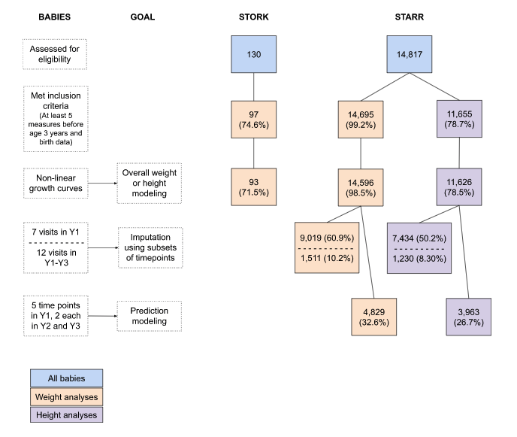

Supplemental Figure 2: Weight modeling: Distribution of parameter values (STORK and STARR). Histogram of weight parameter values, by STORK and STARR study and sex as calculated by the modified Michaelis-Menten NLS function. STORK female: A: a1, B: b1, and C. c1 parameters, STORK male: D: a1, E: b1, and F: c1 parameters, STARR female: G: a1, H: b1, and I: c1 parameters and STARR male J: a1, K: b1, and L: c1 parameters. For a1 and b1 parameters, the bottom 95% of the data are shown.
See PDF: parameters_histograms_weights.pdf (image inserted below for ease of reading)

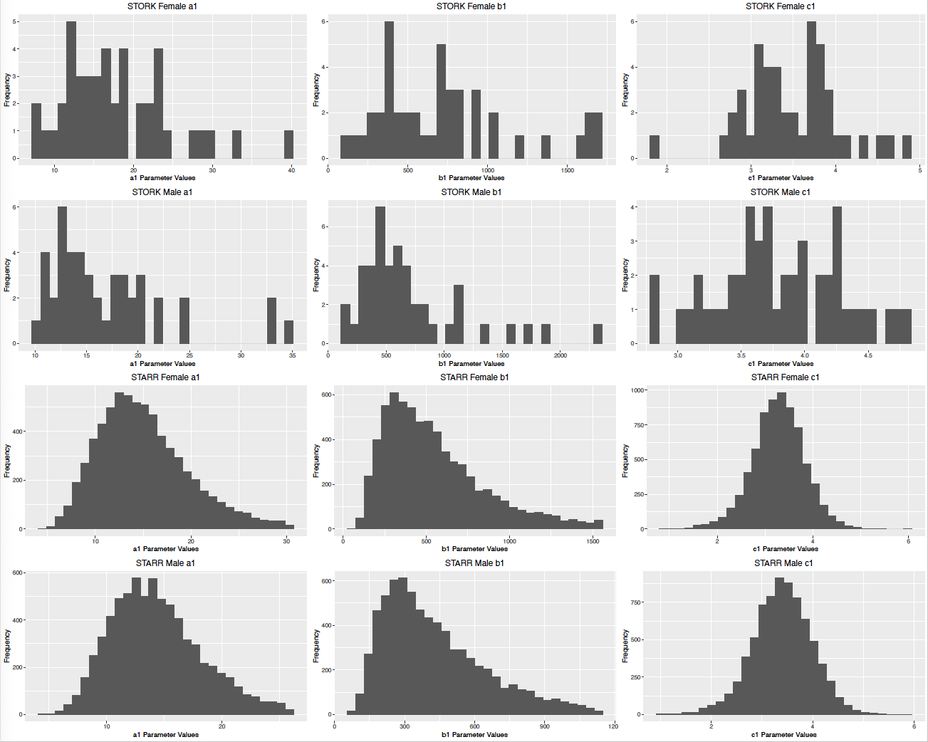
Supplemental Figure 3: Weight modeling for subjects with high RMSE values (>1kg) One STORK subject (2694) is shown; remaining subjects are from STARR. Black dots indicate the weight values and the fitted equation line is shown in red.

See PDF: combined_data_weights_highrmse.pdf (image inserted below for ease of reading)

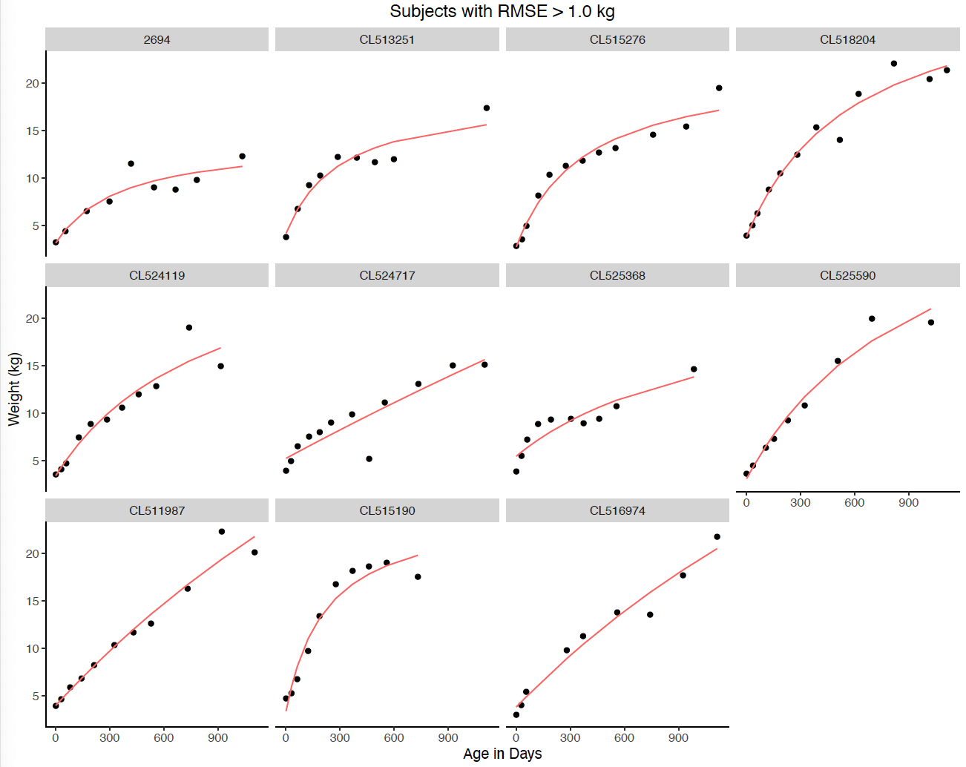

Supplemental Figure 4: Weight and height RMSE values by ethnicity and race. RMSE values for weight by (A) ethnicity and (B) race. RMSE values for height by (C) ethnicity and (D) race.

See PDF: supplemental_fig_raceethnicity_rmse.pdf (image inserted below for ease of reading)

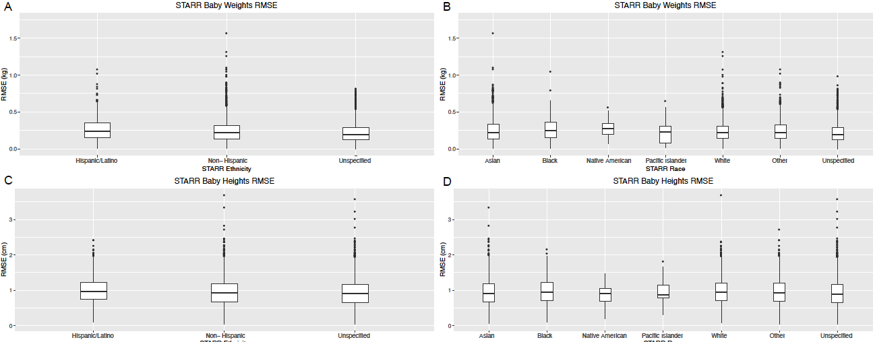

Supplemental Figure 5: RMSE versus age in days. A. RMSE of weight in kg vs age in days. B. RMSE of height in cm vs age in days.

See PDF: STARR_weightandheight_RMSE_vs_age.pdf (image inserted below for ease of reading)

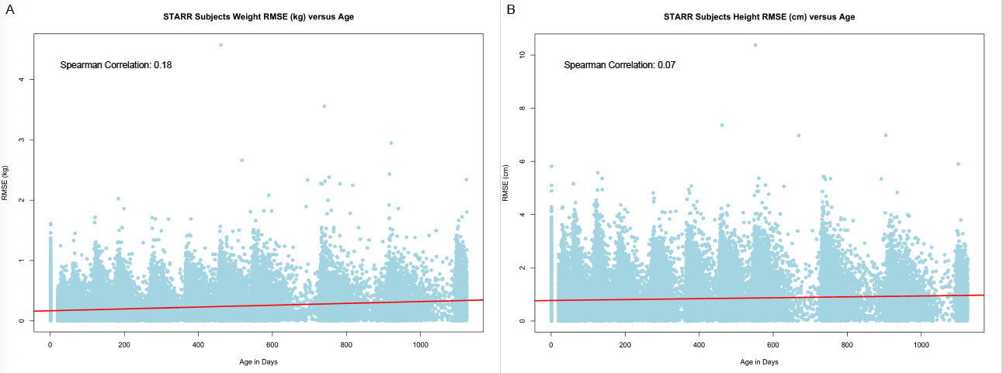

Supplemental Figure 6: Weight over time values for NLS fitting failures. Weight over time data for four STORK (2274, 2335, 2507, and 2729) and STARR subjects are shown for subjects that failed to return a non-linear fit with the nls() function.
See PDF: error_fitting_all_weights.pdf (image inserted below for ease of reading)

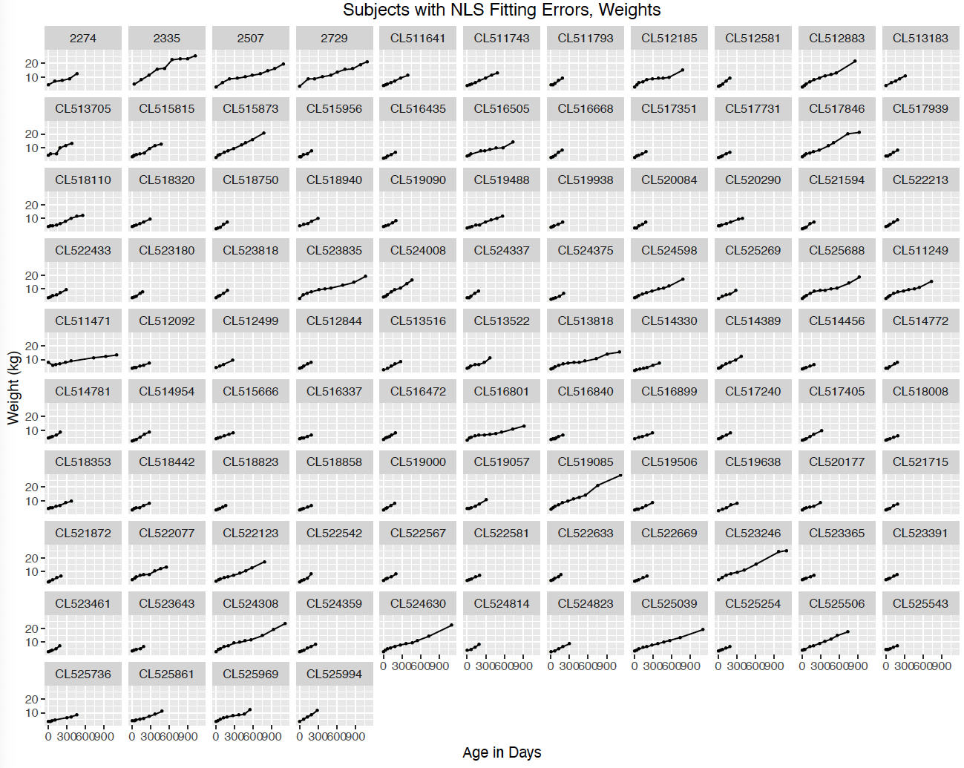
Supplemental Figure 7: Height modeling NLS parameter values (STARR only). Columns indicate parameter: A: female a1, B: female b1, C. female c1, D: male a1, E: male b1 and F: male c1. For a1 and b1 parameters, the bottom 95% of the data are shown.

See PDF: parameters_histograms_STARR_height.pdf (image inserted below for ease of reading)

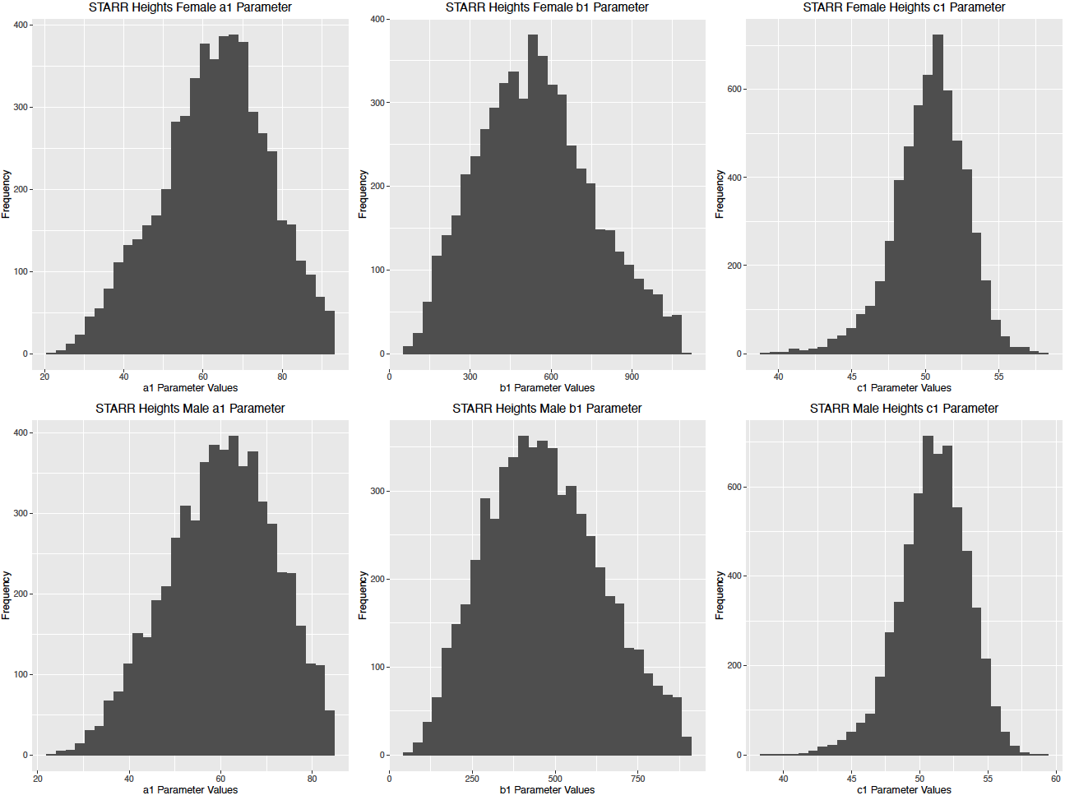

Supplemental Figure 8: STARR subjects with high RMSE for fitting heights (>3.0 cm). Black dots indicate the weight values and the fitted equation line is shown in red.

See PDF: combined_data_heights_highrmse.pdf (image inserted below for ease of reading)

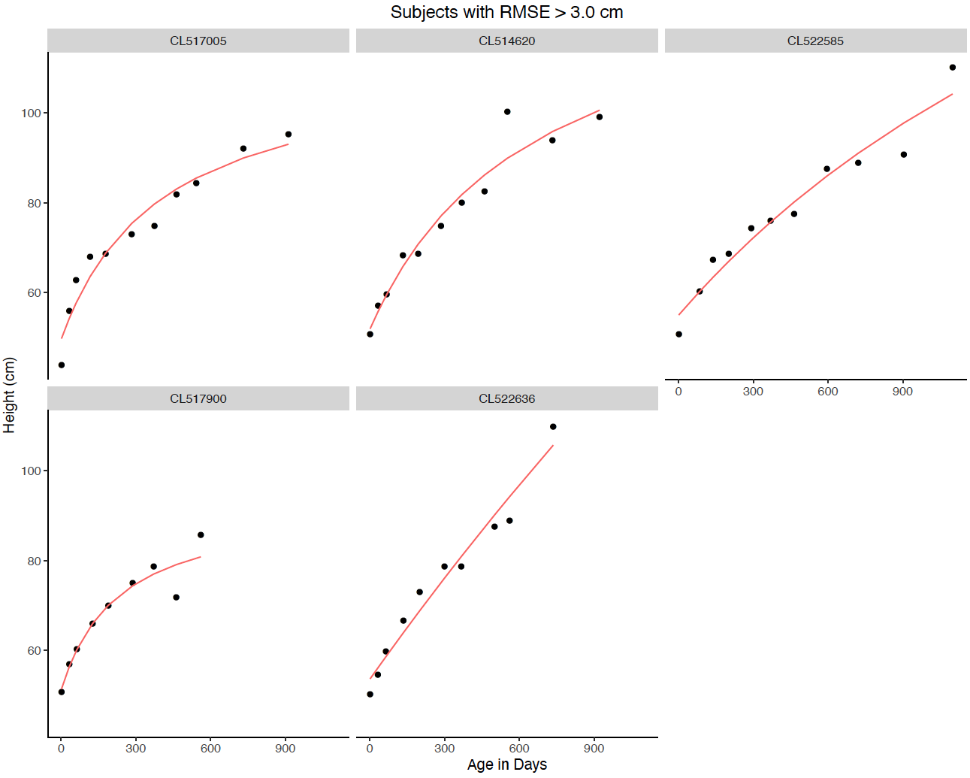

Supplemental Figure 9: All non-linear NLS for height fitting. Height over time data for STARR subjects are shown for subjects that failed to return a non-linear fit with the nls() function.

See PDF: error_fitting_all_heights.pdf (image inserted below for ease of reading)

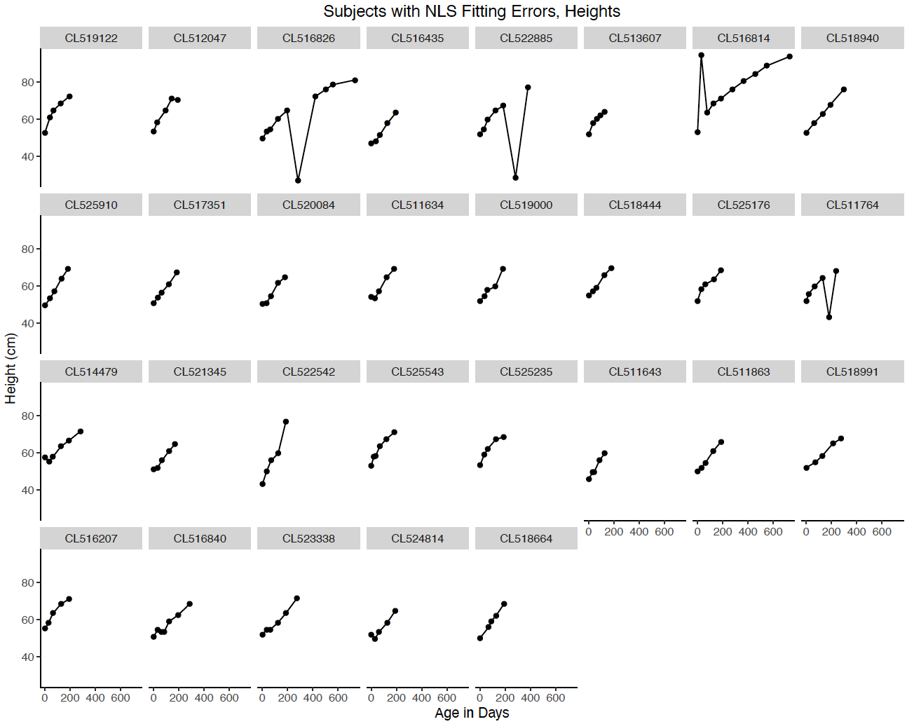

Supplemental Figure 10: Weight prediction: Fitted curves for 10 randomly selected children (50% boys) using models fit from early time frames (STARR only). Black dots indicate actual weights, Models were fit for the full data (black), years 1 and 2 (blue), and year 1 alone (orange).
See PDF: combined_data_weight_predictions.pdf (image inserted below for ease of reading)

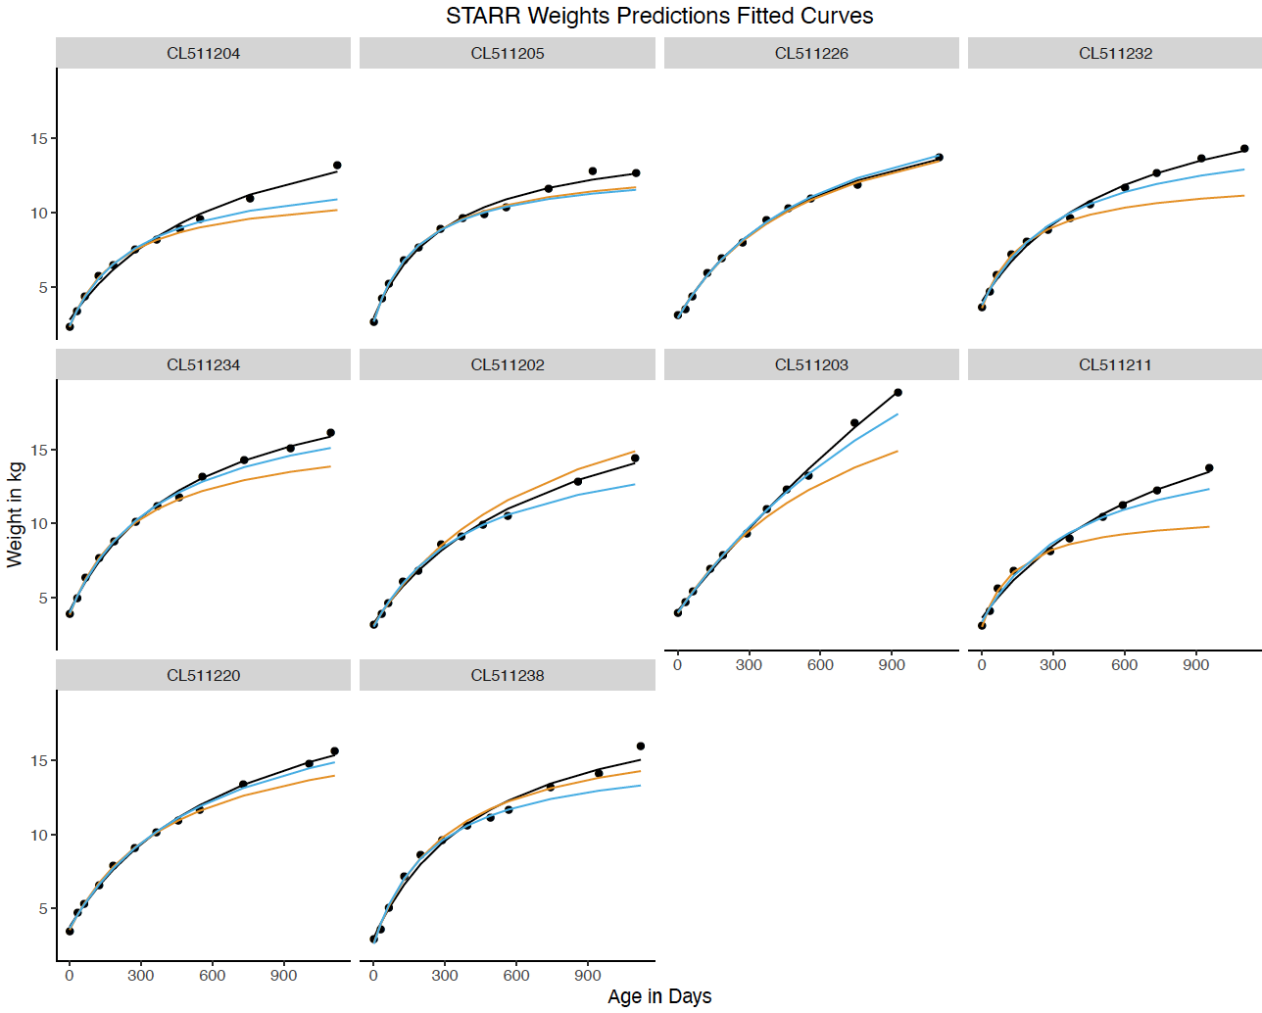

Supplemental Figure 11: Height prediction: Fitted curves for 10 randomly selected children (50% boys) using models fit from early time frames (STARR only). Black dots indicate actual heights. Models were fit for the full data (black), years 1 and 2 (blue), and year 1 alone (orange).

See PDF: combined_data_height_predictions.pdf (image inserted below for ease of reading)

