Supplementary Information

Methods
Alignment of disability groups between HILDA and SDAC
We classified participants with disability into the six disability groups by matching disability-related questions asked within the HILDA Survey to those asked within the SDAC. Table 1 demonstrates how the HILDA variables (as coded within the dataset) map to the SDAC 2018 Household Survey Questionnaire modules [1] and how they were classified into the six disability groups [2].

Prior to 2015, the SDAC included a disability group termed ‘psychological’ [3], which is consistent with the term (and disability group) used in the present study. However, in 2015 the SDAC introduced the ‘psychosocial’ disability group, which is an expansion of the ‘psychological’ disability group to also include ‘memory problems or periods of confusion’ and ‘social or behavioural difficulties’ that restrict everyday activities [2]. Given that it is not possible to match the HILDA Survey variables to the SDAC ‘psychosocial’ disability group, and that three-quarters of the data used in the present study was obtained prior to the SDAC classification change, we have used the ‘psychological’ disability group in this study.

Analysis of missing data
Of the 278,057 observations obtained during 2003 to 2020 from people aged 15 years and over who responded to the disability question, 10.7% (n = 29,832) had missing values for MHI scores. Across the 18 waves, the proportion of observations with missing values for MHI scores varied from 8.3% to 14.0%. Stratification of missing MHI scores by disability, demographic and socio-economic characteristics can be seen in Table 2. Participants with missing MHI scores were more likely to be under 35 years or 75 years and above, male and unemployed, but were less likely to have a Bachelor’s degree or higher education. Furthermore, MHI scores were more likely to be missing for participants who had intellectual or learning disabilities, or who had experienced a brain injury or stroke. However, it should be noted that 94.9% of the observations with missing values for the MHI scores occurred because participants did not return the Self-Completion Questionnaire that contained the questions for the SF-36 from which the MHI scores were derived. The remaining 5.1% of observations with missing MHI values resulted from participants either refusing to answer or providing invalid responses for more than 2 of the 5 questions in the MHI subscale, given that MHI scores can only be derived if 3 or more questions are answered.

Multiple imputation
The imputation model included the variables listed in Table 2 using predictive mean matching based on the 5 nearest neighbours (closest observations), with the observations subsampled by survey wave. This ensured that the values for MHI scores were limited to the observed range of the scale (i.e. between 0 and 100), while preserving the non-normal distribution of the observed values. Imputation using subsamples for each wave of the survey accommodated for potential effects that may have been caused by changes to mental health (and its determinants) over the 18 years of data collection. The population-weighted estimates for each wave of the HILDA Survey were determined for each of the 50 imputed datasets, from which an overall estimate of the mean MHI scores were obtained. Standard errors were derived using Rubin rules for combining the between-imputation and within-imputation variance, obtained from the Taylor Series linearisation standard errors of the mean MHI estimates.

Results
Age distribution
Given the considerable difference in the population-weighted proportions between age groups of people with and without disability (shown in Table 1), further analysis of the age distributions of these two subpopulations was undertaken. The population pyramids for unweighted sample proportions for 2003 and 2020 (Figure 1a and 1b, respectively) demonstrate a mostly consistent pattern over time such that people with disability were more likely to be older than people without disability; this pattern was similar across all 18 waves of the HILDA Survey (data not shown). Furthermore, except for people aged 80 years and above, the age distribution of people with and without disability within the analytic sample was consistent with that observed in the Australian population aged 15 years and over, as determined by the 2018 SDAC (Figure 1c).

Mental health inequalities by sex
Figure 2a shows that when stratified by sex, the mean MHI score was consistently lower for people with disability than for people without disability, regardless of sex. There was however little variation between males and females with regards to the disability-related inequality in mental health (Figure 2b).

Sensitivity analysis for impact of psychological disability on MHI scores
Given that psychological disability includes mental illness or nervous or emotional conditions, which will impact on MHI scores, we conducted a sensitivity analysis to determine whether psychological disability was underlying the difference in MHI scores between people with and without disability. Figure 3a shows that the age-standardised population-weighted mean MHI scores were considerably lower for people with psychological disability when compared to people with disability but without psychological disability, and when compared to people without disability. In 2020, people with disability but without psychological disability had a mean MHI score of 68.7 (95% CI: 67.9, 69.5), which had decreased compared to the mean MHI score in 2003 (70.7; 95% CI: 69.9, 71.6), consistent to the pattern observed for people without disability. This is in contrast to the mean MHI scores for people with psychological disability, which were largely unchanged over the 18 years examined. Figure 3b shows that the mental health inequalities for people with disability but without psychological disability, when compared to people without disability, were largely unchanged over the 18 years; however, the size of the inequality was approximately 3 points smaller when compared to that for the whole disability sample versus people without disability.

References
1. Australian Bureau of Statistics (2018) Survey of Disability, Ageing and Carers (SDAC 18) - Household Survey Questionnaire [Excel file]. https://www.abs.gov.au/statistics/health/disability/disability-ageing-and-carers-australia-summary-findings/2018/4430.0%20-%20Household%20Questionnaire.xlsx. Accessed 1 Aug 2022
2. Australian Bureau of Statistics (2019) Disability, Ageing and Carers, Australia: Summary of Findings methodology. Appendix - disability groups. ABS. https://www.abs.gov.au/methodologies/disability-ageing-and-carers-australia-summary-findings/2018#appendix-disability-groups. Accessed 24 Apr 2022
3. Australian Bureau of Statistics (2013) 4430.0 - Disability, Ageing and Carers, Australia: Summary of Findings, 2012. Appendix 2 - Disability Groups. ABS. https://www.abs.gov.au/ausstats/abs@.nsf/Previousproducts/4430.0Appendix902012?opendocument&tabname=Notes&prodno=4430.0&issue=2012&num=&view=. Accessed 24 Apr 2022
4. Australian Bureau of Statistics (2019) Disability, Ageing and Carers, Australia. 2018 Disability Tables [Dataset]. ABS. https://www.abs.gov.au/statistics/health/disability/disability-ageing-and-carers-australia-summary-findings/latest-release#data-download. Accessed 4 Apr 2022

Table 1 Mapping of HILDA Survey variables to SDAC disability groups and the SDAC Household Survey Questionnaire modules
SDAC disability group | HILDA question | HILDA variable | SDAC Module ª
Sensory or speech | Sight problems not corrected by glasses/lenses | hespnc | 2.1
Sensory or speech | Hearing problems | hehear | 2.2
Sensory or speech | Speech problems | hespch | 2.3
Physical | Blackouts, fits or loss of consciousness | hebflc | 2.6
Physical | Limited use of arms or fingers | heluaf | 2.8
Physical | Difficulty gripping things | hedgt | 2.9
Physical | Limited use of feet or legs | helufl | 2.10
Physical | Any condition that restricts physical activity or physical work (e.g. back problems, migraines) | hecrpa | 2.12
Physical | Any disfigurement or deformity | hedisf | 2.13
Physical | Shortness of breath or difficulty breathing | hesbdb | 2.4
Physical | Chronic or recurring pain | hecrp | 2.5
Intellectual or learning | Difficulty learning or understanding things | heslu | 2.7
Psychological | A nervous or emotional condition which requires treatment | henec | 2.11
Psychological | Any mental illness which requires help or supervision | hemirh | 2.14
Brain injury or stroke | Long term effects as a result of a head injury, stroke or other brain damage | hehibd | 2.17
Other | Long-term condition or ailment which is still restrictive even though it is being treated | hemed | 2.18
Other | Any other long-term condition such as arthritis, asthma, heart disease, Alzheimer’s, dementia, etc | heoth | 2.19 & 2.20
Other | Refused to answer | herf
Other | Don’t know | hedk
ª SDAC Module relates to the module within the SDAC 2018 Household Survey Questionnaire that asks disability-specific questions [1]. Note that SDAC Modules 2.15 (memory problems or periods of confusion) and 2.16 (social or behavioural difficulties), which were added to SDAC in 2015 to extend the ‘psychological’ disability group into the ‘psychosocial’ disability group, do not map to any HILDA Survey questions associated with disability or impairment type.

Table 2 Observations that had missing values for MHI scores, stratified by disability, demographic and socio-economic characteristics
 | Number of observations with missing values for MHI scores | % of observations with missing values
Analytic sample ª | 29,832 | 10.7%
Disability
No disability | 21,210 | 10.6%
Any disability | 8,652 | 11.0%
Age (years)
15-24 | 7,208 | 14.6%
25-34 | 7,016 | 14.3%
35-44 | 4,952 | 10.6%
45-54 | 3,924 | 8.5%
55-64 | 2,524 | 6.5%
65-74 | 1,643 | 5.9%
75+ | 2,595 | 12.7%
Sex
Male | 15,551 | 11.8%
Female | 14,311 | 9.8%
Education
Bachelor’s degree or higher | 5,100 | 7.8%
Year 12, Advanced Diploma, Diploma, Certificate | 13,775 | 10.9%
Year 11 or below | 10,987 | 12.8%
Employment
Employed | 18,808 | 10.7%
Unemployed | 1,627 | 15.0%
Not in labour force | 9,427 | 10.4%
Disability group ^{b}
Sensory and speech | 2,317 | 12.1%
Physical | 5,160 | 10.8%
Intellectual and learning | 896 | 21.9%
Psychological | 1,745 | 12.7%
Brain injury and stroke | 515 | 16.7%
Other/type not specified | 4,958 | 10.9%
ª Includes people aged 15 years and over, who responded to the disability question, who were interviewed during in waves 3 to 20 (2003 to 2020).
^{b} Only available for people with disability, who may be included in more than one disability group.

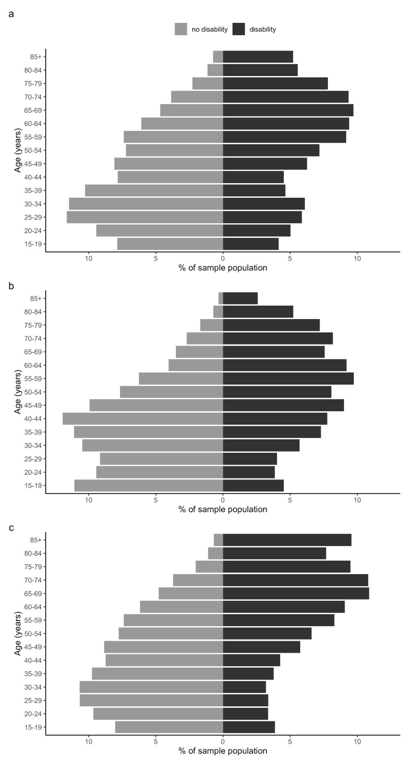
Fig. 1 Population pyramids comparing the age distributions for people with and without disability, aged 15 years and over. a: HILDA sample population in 2003 (wave 3). b: HILDA sample population in 2020 (wave 20). c: Australian population obtained from the 2018 Survey of Disability, Ageing and Carers [4]
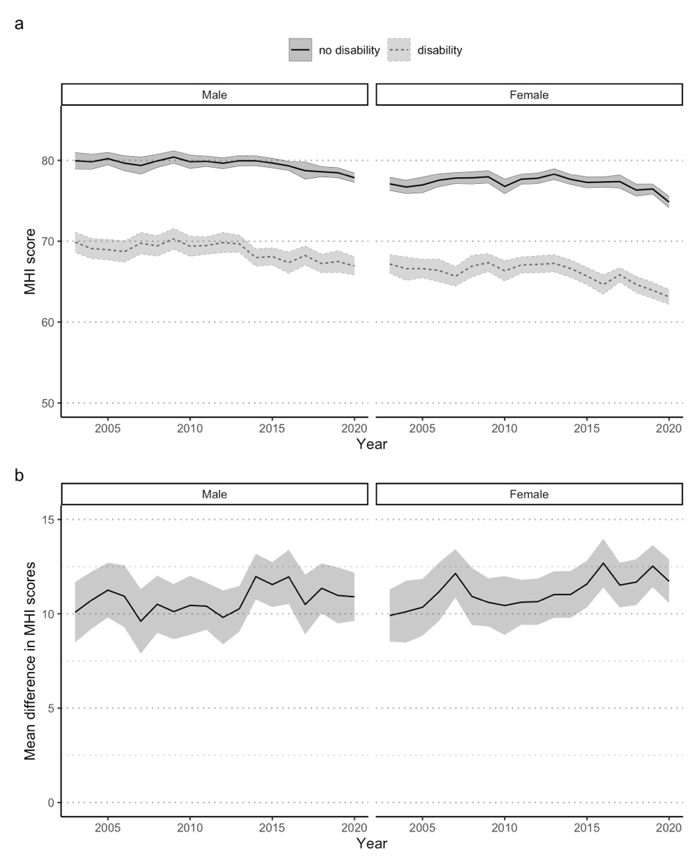
Fig. 2 Mental health over time for Australians aged 15 years and over with and without disability, 2003-2020, stratified by sex. a: Age-standardised population-weighted mean MHI scores over time, with 95% confidence intervals. b: Mean difference in MHI scores over time, with 95% confidence intervals

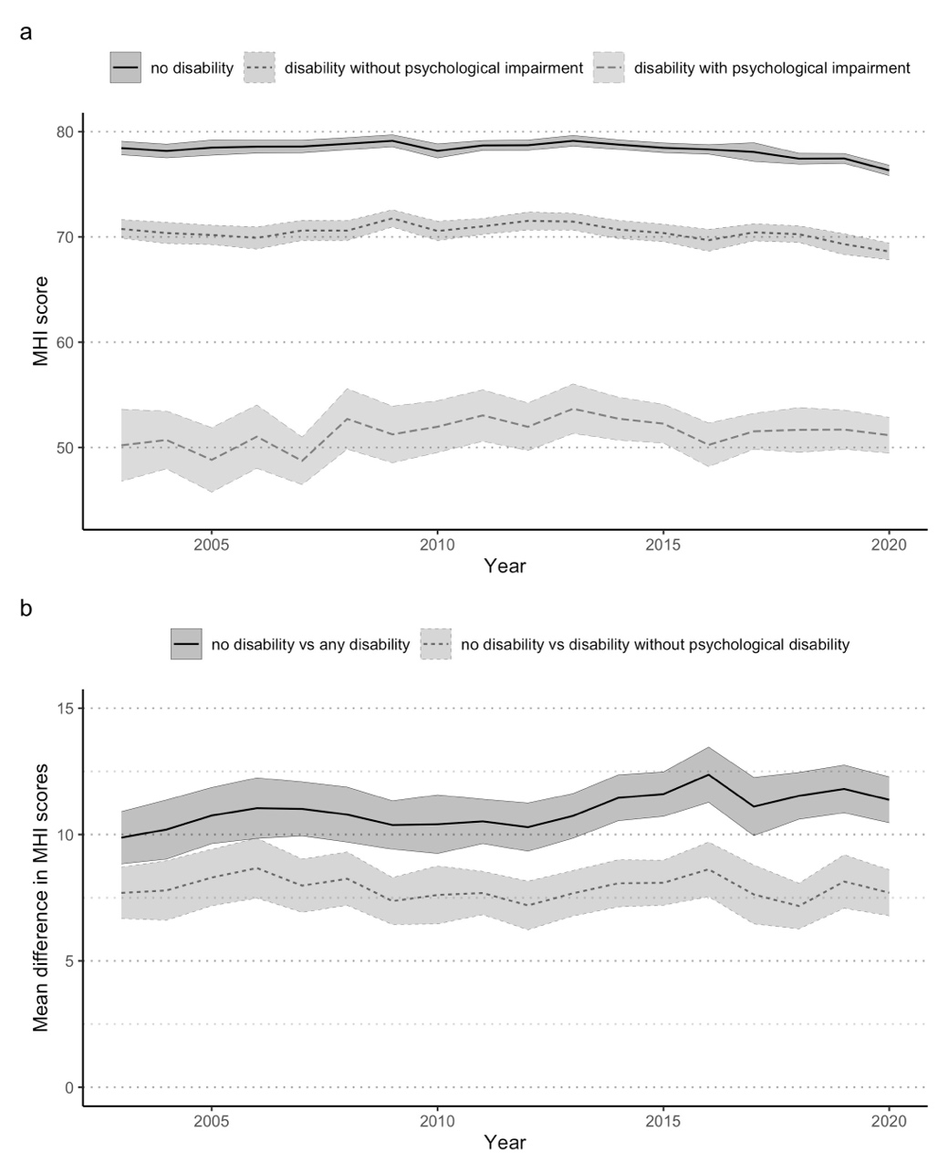
Fig. 3 Sensitivity analysis for people with disability who did or did not have a psychological disability. a: Age-standardised population-weighted mean MHI scores over time, with 95% confidence intervals. b: Mean difference in MHI scores over time, with 95% confidence intervals

