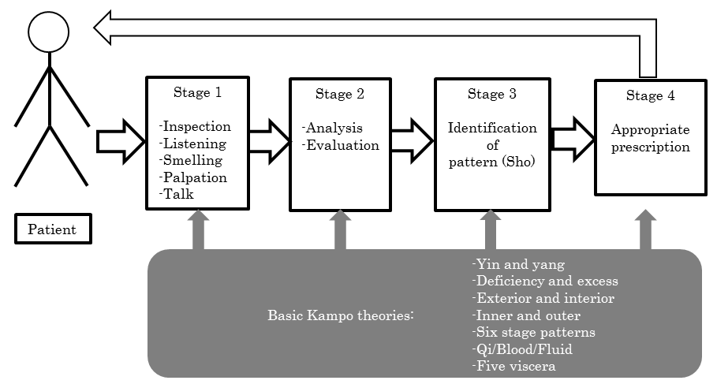
Figure 1 Process of Kampo examination and identification of pattern.

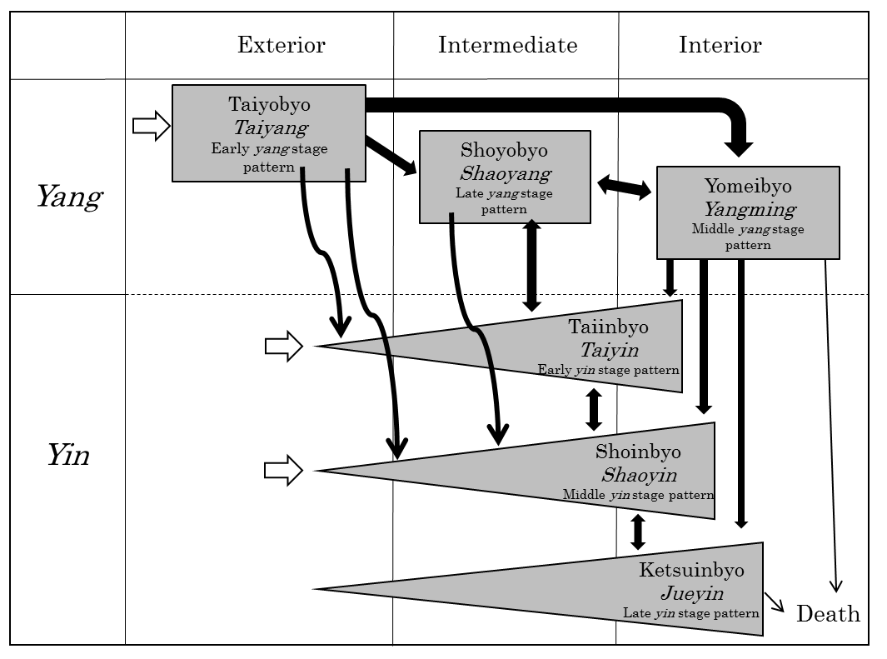
Figure 2 Overview of six stage patterns.

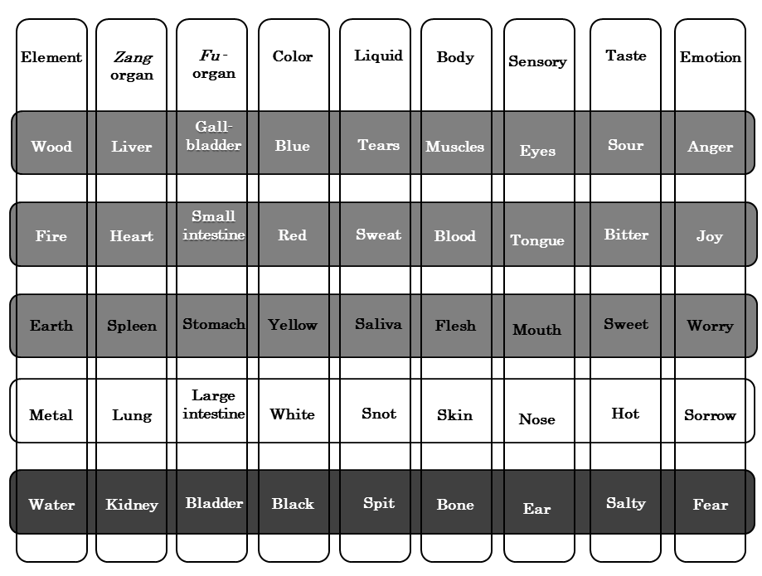
Figure 3 Representative five elements.

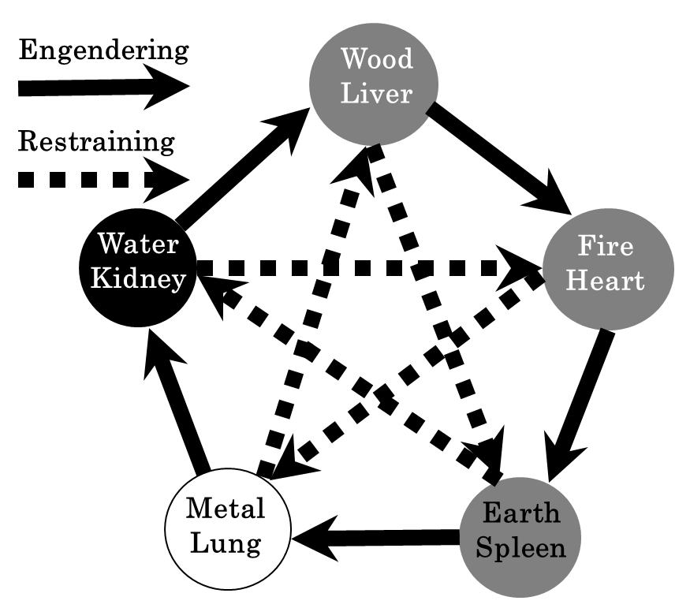
Figure 4 Each relationship between five zang - organs.
Table 1 Yin and yang theory in nature
 | Yang | Yin
Cosmos | Heaven | Earth
Cosmos | Sun | Moon
Circadian | Day | Night
Seasons | Spring / Summer | Fall / Winter
Temperature | Heat | Cold
Sex | Male | Female
Movement | Ascent | Descent
Movement | Extroversion | Introversion
Movement | Expansion | Convergence
Movement | Motion | Stationary

