Supplementary Figures
Supplemental Figure 1: Further comparison of the effects of pTau and aging on Tb bathyphase and LMA acrophase. a,b. In a subset of 7-9mo male TAPP mice delayed Tb bathyphase and the total amount of pTau filled neurons in the LPB are positively correlated with each other [simple linear regression, β=0.0514 and β=8.677, p=0.0347 and p=0.0347]. c,d. Neither female WT or TAPP mice experience a delay in Tb bathyphase from aging [unpaired T-tests, two tailed, t₍₂₉₎=0.5285 and t₍₁₇₎=0.7366, ^{ns}p=0.6012 and ^{ns}p=0.4714]. e,f. Female WT but not TAPP mice experience a delay in LMA acrophase as a result of aging [unpaired T-tests, two-tailed, t₍₂₉₎ = 2.667 and t₍₁₇₎ =0.7260, *p=0.0124 and ^{ns}p=0.4777]. g,h. Male TAPP, but not WT mice, display a delay in Tb bathyphase corresponding to the consistent appearance of pTau in the LPB. Red stars in (g) correspond to 3-5mo male TAPP mice with pTau accumulation in the LPB [unpaired T-tests, two -tailed, t₍₃₆₎ = 1.394 and t₍₃₈₎ = 2.880, ^{ns}p=0.1718 and **p=0.0065]. i,j. Male TAPP, but not WT mice, display a delay in LMA acrophase corresponding to the consistent appearance of pTau in the LPB. Red stars in (j) correspond to 3-5mo male TAPP mice with pTau accumulation in the LPB [unpaired T-tests, two-tailed, t₍₃₆₎ = 1.150 and t₍₃₈₎ = 2.408, ^{ns}p=0.2579 and *p=0.0210]. Notice how aging does not produce a delay in either Tb bathyphase or LMA acrophase for female TAPP mice who have reliable pTau accumulation in the LPB at both ages (d,f). However, in male TAPP mice there is a delay with aging that corresponds to the time course of development of consistent pTau in the LPB (h,j). Notice also how the 3-5mo male TAPP mice who do have pTau accumulation in the LPB (red stars in h and j) have later Tb bathyphase and LMA acrophase as do 7-9mo male TAPP mice.

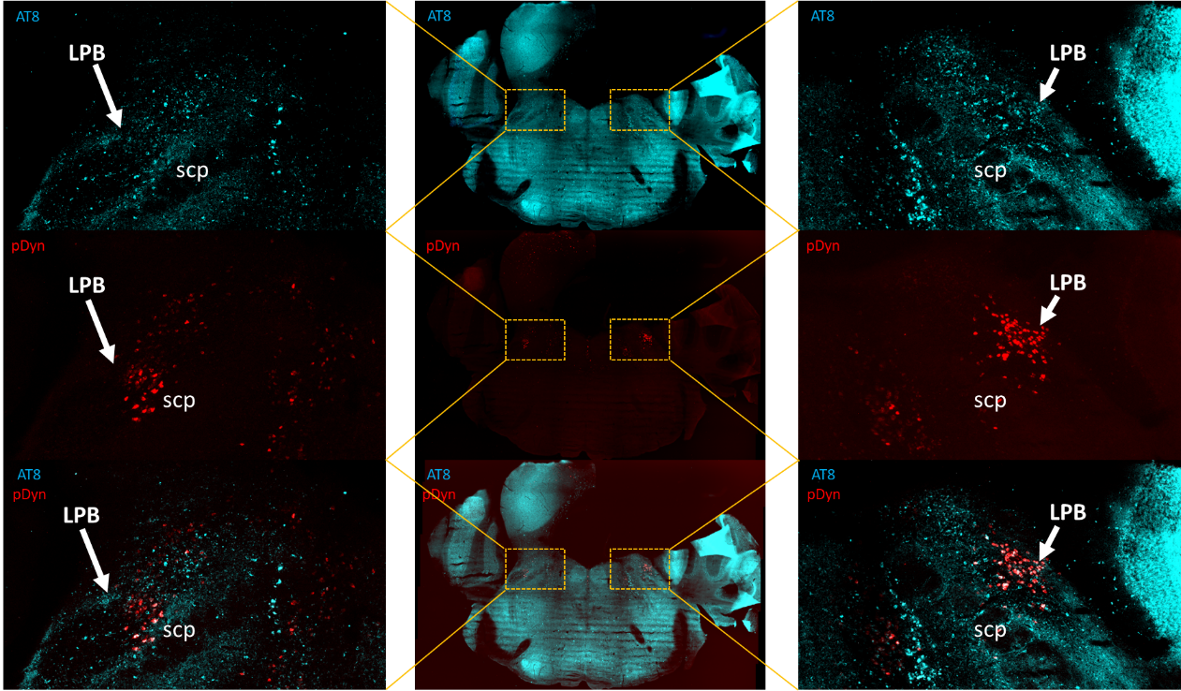
Supplemental Figure 2: Bilateral pTau colocalization with LPBdyn cells in a 7–9mo male TAPP mouse. (Top row) pTau immunohistochemical staining (turquoise=AT8 antibody) to show numerous pTau-filled neurons in the bilateral LPB (marked by white arrow). (Middle row) Prodynorphin (pDyn, red) in situ hybridization to show anatomical location of pDyn neurons in the bilateral LPB (marked by white arrow). (Bottom row) Colocalization of pTau and pDyn neurons in the bilateral LPB (marked by white arrow). This is the same mouse shown in Fig 5a. LPB: lateral parabrachial, scp: superior cerebellar peduncle.

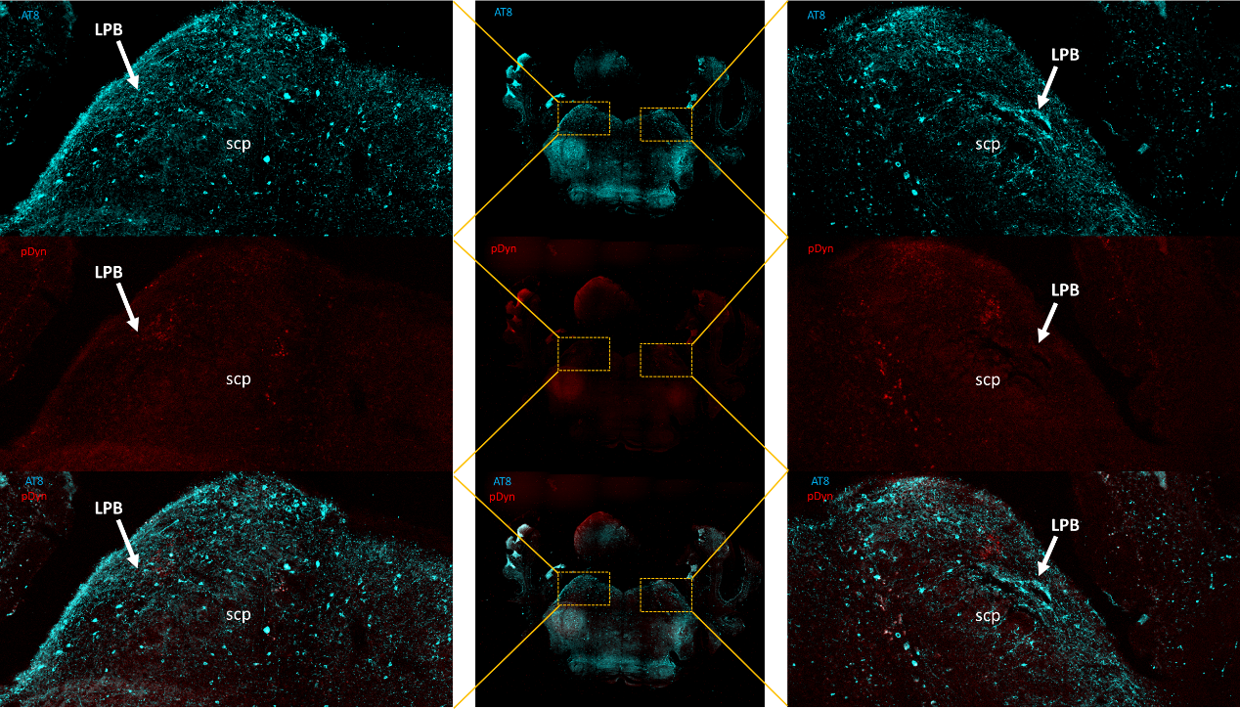
Supplemental Figure 3: Bilateral pTau and pDyn staining in the LPB of a 13-month-old male TAPP mouse. (Top row) pTau immunohistochemical staining (turquoise=AT8 antibody) shows numerous pTau-filled neurons in the bilateral LPB (marked with white arrow). (Middle row) Prodynorphin (pDyn, red) in situ hybridization to show anatomical location of pDyn neurons in the bilateral LPB (marked by white arrow). Notice the stark reduction in labelling from LPB^{dyn} neurons corresponding to the neurodegeneration of these LPB^{dyn} cells. (Bottom row) Colocalization of pTau and pDyn neurons in the bilateral LPB (marked by white arrow). Compare this to Supp Fig 2 (Bottom row) to see time course of pTau filling numerous LPB^{dyn} neurons to the degeneration of these LPB^{dyn} neurons here. This is the same mouse shown in Fig 5d. LPB: lateral parabrachial, scp: superior cerebellar peduncle.

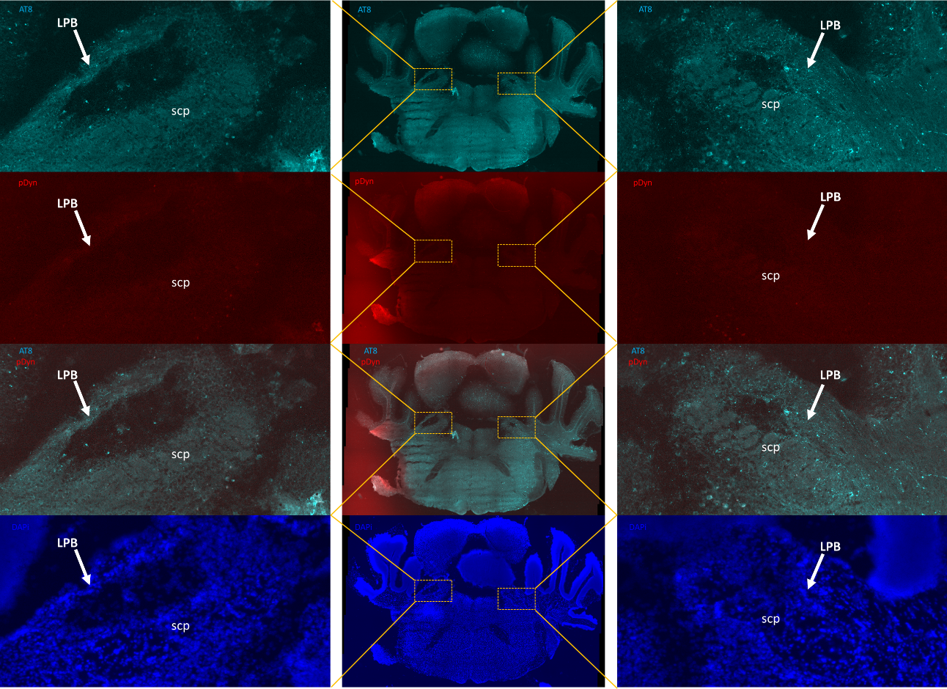
Supplemental Figure 4: Bilateral pTau and pDyn staining in the LPB of a 13-month-old female TAPP mouse. (First row) pTau immunohistochemical staining (turquoise=AT8 antibody) to show numerous pTau-filled neurons in the bilateral LPB (marked with white arrow). (Second row) Prodynorphin (pDyn, red) in situ hybridization to show anatomical location of pDyn neurons in the bilateral LPB (marked by white arrow). Notice the stark reduction in labelling from LPB^{dyn} neurons corresponding to neurodegeneration of these LPB^{dyn} cells. (Third row) Colocalization of pTau and pDyn neurons in the bilateral LPB (marked by white arrow). Compare this to Supp Fig 3 (Bottom row) to see that this neurodegeneration of LPB^{dyn} neurons happens in both sexes. (d) DAPI staining (blue, labeling nuclei) to show striking neurodegeneration in the bilateral LPB. Notice how there is a clear bilateral lesion in the LPB region in each of the three channels shown (First row, Second row, Fourth row). Compare this to Supp Fig 3 (Top and Middle rows) to see that neurodegeneration appears to have affected the 13mo female more drastically. This is likely due to cell death beginning earlier in TAPP females compared to TAPP males. This also follows the same pattern of earlier phase delays and the earlier appearance of pTau in the LPB in TAPP females compared to TAPP males. This is the same mouse shown in Fig 5e. LPB: lateral parabrachial, scp: superior cerebellar peduncle.

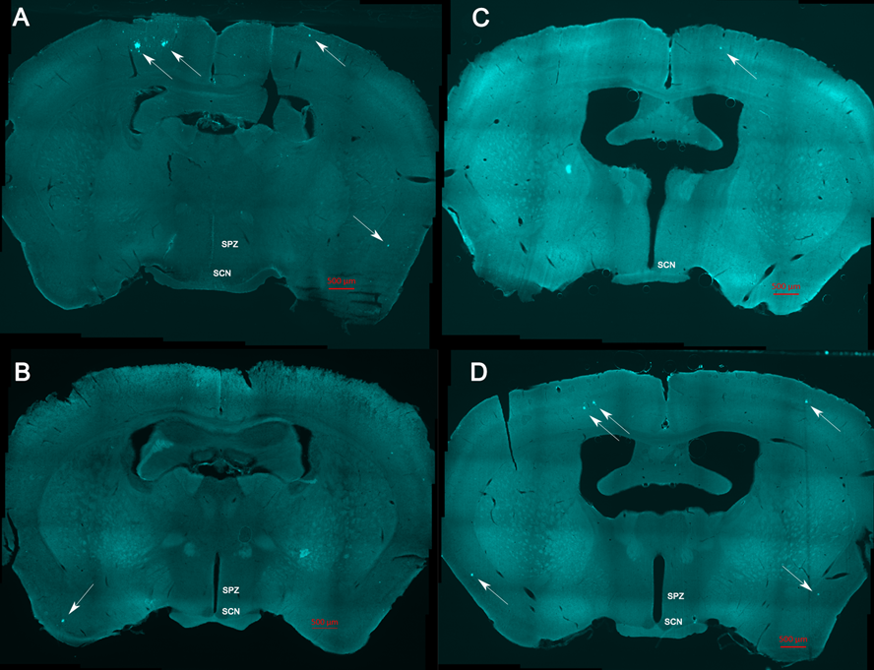
Supp Figure 5. TAPP mice show similar sex differences in the development of Aβ pathology, but less consistent labelling in specific brain areas. A-B. 7-9mo male TAPP mice show Aβ pathology (turquoise=6E10 antibody) in cortical areas but not consistently in the same regions (white arrows). No Aβ pathology was detected in 3-5mo TAPP males (data not shown). C. Aβ pathology was detected in cortical areas in 3-5mo female TAPP mice (white arrow), as well as in 7-9mo TAPP females (D), but not consistently in the same areas.

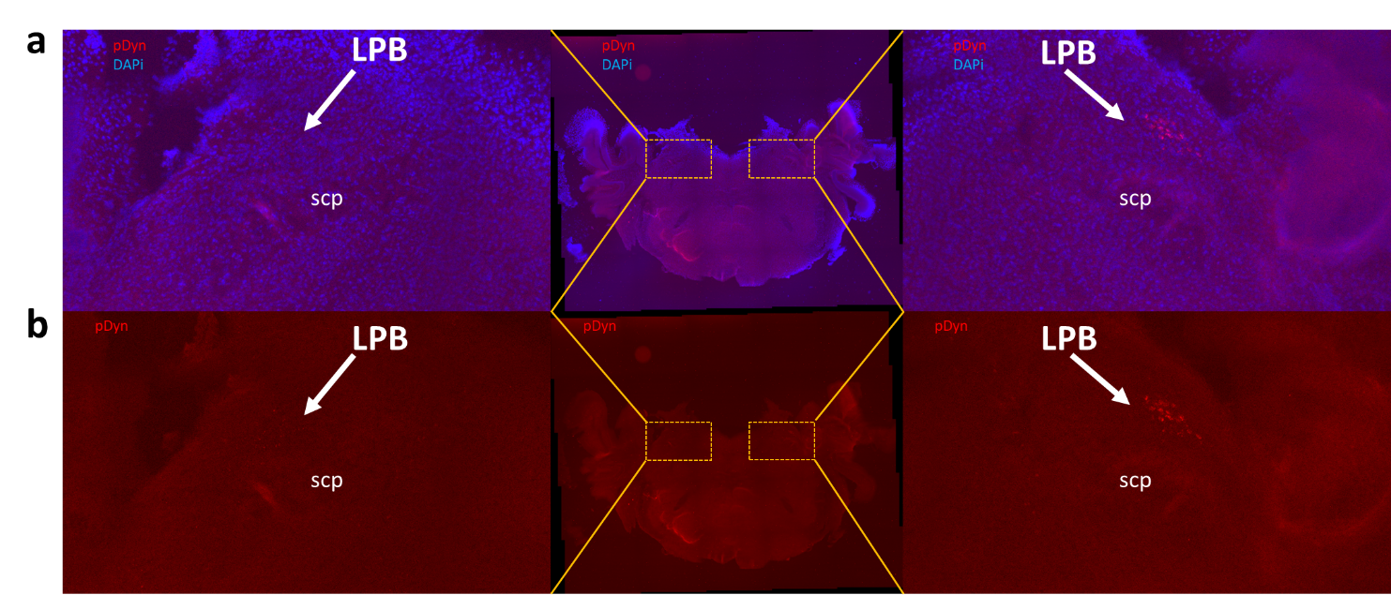
Supplemental Figure 6: Bilateral pDyn and DAPI staining in a pDyn-cre mouse with successful ablation of LPBdyn cells unilaterally as verification of in situ process. (a) prodynorphin (pDyn, red) in situ hybridization along with DAPI staining (blue, nuclei) in the bilateral LPB (marked by white arrow). (b) pDyn in situ hybridization in bilateral LPB (marked by white arrow). Notice how we successfully ablated all LPB^{dyn} cells in the left LPB but we had an incomplete ablation on the right side. This is included to verify our in-situ process in caspase ablated pDyn-cre mice. LPB: lateral parabrachial, scp: superior cerebellar peduncle.

