Supplementary Information for:

North African Humid Periods over the past 800000 years – Timing, Amplitude and Forcing

Edward Armstrong¹, Miikka Tallavaara¹, Peter O. Hopcroft², Paul J. Valdes^{3,4}

1. Department of Geosciences and Geography, University of Helsinki, Finland
2. School of Geography, Earth and Environmental Sciences, University of Birmingham, UK
3. School of Geographical Sciences, University of Bristol, UK
4. Cabot Institute, University of Bristol

Corresponding author: Edward Armstrong; ORCID: 0000-0001-9561-0159

Contents:

Model Validation
Supplementary Figure 1
Supplementary Figure 2
Supplementary Figure 3
Thermodynamic vs Topographic forcing of the Ice sheet on the NAHPs
Supplementary Figure 4
Supplementary Figure 5

Model Validation

A broad validation of the HadCM3B model against a range of observational datasets is provided in section 5 of Valdes, et al. ¹. Their analysis shows that the model accurately reproduces key aspects of the climate system, including surface air temperatures (SATs), sea surface temperatures (SSTs), ocean circulation patters and precipitation. Valdes, et al. ¹ also shows that HadCM3B outperforms many of the CMIP5 models particularly with respect to surface air temperatures (see their Figure 2).

The snapshot modelling approach has previously been shown to accurately simulate Quaternary palaeoclimate^{2,3}, however there are a number of limitations. Firstly, the approach assumes that the climate system is in equilibrium at each time period and that these simulations are a reasonable approximation of the climate at each time period. This assumption has been justified in previous studies³⁻⁵. Alternative methodologies, such as transient simulations with accelerated forcing, face similar assumptions. The model biases that might affect our simulated climatology are outlined in Valdes, et al. ¹, and are comparable to other models. The methodology does not capture millennial scale climate variability, specifically the Dansgaard–Oeschger and Heinrich events which are evident in North Atlantic climate over the Quaternary⁶. In Armstrong, et al. ², millennial scale variability was added in post processing, by scaling the results of a North Atlantic freshwater hosing experiment with the Greenland Ice core temperature record in order to determine the amplitude and spatial pattern of the DO/HE events. However, the uncertainty associated with this methodology increases with locations further away from Greenland as it utilises the Greenland Ice core record, and so we do not include that methodology here. The model also does not incorporate atmospheric aerosol/dust feedbacks. Despite the uncertainties, our approach is highly efficient as the model simulations can be run simultaneously. A fully continuous simulation would have taken many years to complete on a high-performance computer.

In order to validate the HadCM3BB-v1.0 model, we first compare modelled pre-industrial (0kyr BP, equivalent to the year 1950 without anthropogenic greenhouse gas emissions) precipitation and wind vectors against ERA-5 reanalysis data⁷ (Supplementary Figure 1). Although the data is not directly comparable as it represents different time periods, past work has shown that these biases are small compared to the model biases¹. Note that the model data has been downscaled to 1° resolution via bilinear interpolation. Broadly, the model accurately reproduces synoptic-scale wind patterns, the position of the winter and summer ITCZ, and the spatial pattern/intensity of the West African Monsoon (WAM) over land. In the summer, the model simulates too much precipitation across the Sahara. This is because the model is prone to drizzle like many GCMs¹, which has a relatively large impact in hyper-arid regions such as the Sahara. Outside of the Sahara, both summer and winter precipitation is of comparable magnitude across tropical and subtropical Africa. This is except for precipitation in the region of the Gulf of Guinea which is too high in the model. This may be a result of the stronger simulated regional summer westerlies, which may reflect inaccurate SAT/SSTs in a climatologically complex region which experience strong upwelling. However, over land the spatial imprint and intensity of the WAM is comparable to observations.

Validating palaeo-model data is challenging due to the lack of reliable observational datasets which are themselves subject to extensive uncertainties and biases. This is particularly the case when validating palaeo-precipitation, which is more challenging than surface air temperatures (SAT) and sea-surface temperatures due to the lack of comparable observational datasets. Precipitation is also more problematic due to its significant spatial heterogeneity, and so observational records may reflect localised trends which may not be captured by a coarse scale model. Therefore here we compare the model timeseries for SATs and SSTs against numerous global proxy datasets covering the past 0-800kyr (Supplementary Figures 2-4) in order to validate in the temporal domain. The associated references are labelled in the Figure captions.

Supplementary Figure 2 shows 12 land-based temperature records including five Greenland ice-core records (b-f), two Antarctic ice core records (k, l) one of which is a pan-Antarctic records comprised of 5 stacked cores (k), and five records from locations away from the ice sheets (g – j, m). Note that because our modelling approach does not incorporate millennial scale variability, the DO events that dominate the Greenland ice core records are not represented in our simulated dataset. This is particularly evident for the Bolling-Allerod/Younger Dryas interstadial/stadial transition in panels d-f. Despite this, there is generally good agreement in the broad scale patterns in modelled climate with the scale of temperature change in Greenland. However the modelled temperatures are generally too cold during the Holocene and warm beyond. The lack of a Holocene Climatic Optimum in the model has also been shown in a number of other climate models⁸, and may reflect biases across the current generation of models used and/or biases with the reconstructions themselves. In Antarctica, there is good agreement with the ice core datasets with regards to absolute temperatures, the timing of the glacial/interglacial cycles, and the scale of temperature change throughout the past 800kyrs. In Africa, the model does relatively well at recreating the observed temperature in Lake Malawi and the Limpopo basin, particularly with regards to the timing of the glacial/interglacial changes. In Lake Tanganyika however the modelled temperatures are apparently too cold. Similarly in the Albanian Lake Ohrid, the timing of large-scale temperature changes is well represented, however absolute temperatures are too warm. Note however that lake derived temperature reconstructions are subject to a range of uncertainties.

Supplementary Figure 3 shows a range of SST records with a wide spatial coverage, albeit generally focused at lower latitudes. In the North Atlantic (b-f), the model does generally well at simulating absolute temperatures and the broad scale timing of large-scale temperature changes. However, variability in the observational data is generally greater than that simulated due to the lack of millennial scale variability in the model dataset. There is good agreement with timing of the glacial/interglacial cycles and the extent of temperature change in panels d and f. In the South Atlantic and off Angola (g-i), modelled temperatures are too warm, but again the timing of temperature change is consistent. The west coast of Africa is a complex region climatologically due to the presence of strong regional upwelling which may not be properly resolved. In the Indian and Arabian ocean (j-l) there is good agreement with modelled absolute temperatures and the patterns of temperature change, albeit with too little variability. There is very good agreement in the SST records in the South China Sea and off Australia (m-o). In the Pacific (p-q) modelled temperature are generally too warm, however the patterns of temperature change are broadly consistent with the observations.
In summary, the HadCM3BB-v1.0 model accurately simulates present-day precipitation and wind patterns over Africa, including the position of the ITCZ and WAM. Temporally, the model and the snapshot modelling approach that we utilise is shown to produce a climatology that is comparable to proxy datasets for SATs and SSTs, in terms of absolute values and patterns of change over the past 800kyr. This model/data agreement lends support to the overall approach that we have employed.

Supplementary Figure 1. A comparison of pre-industrial (0 kyr BP) and downscaled (to 1° resolution) HadCM3BB-v1.0 model output (top panels) with ERA-5 reanalysis data⁷ averaged over the period 1951-2020 (bottom panels) for precipitation, wind and the position of the ITCZ. For winter (December, January and February; left panels) and summer (June, July and August; right panels).

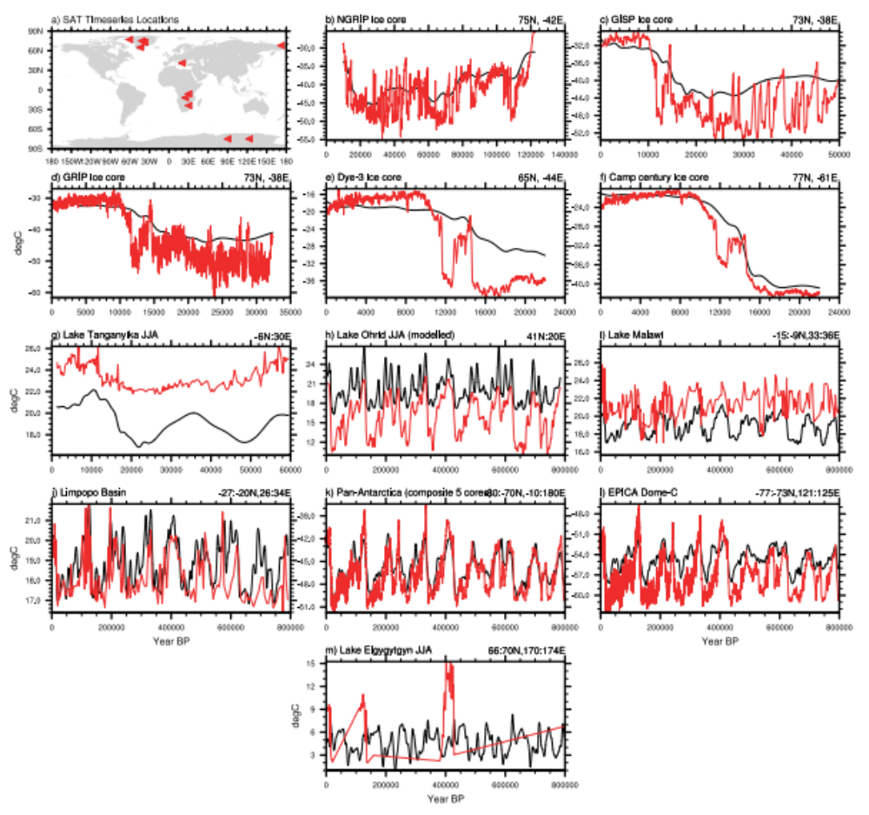
Supplementary Figure 2. Validation timeseries plots for surface air temperatures (°C). Simulated temperatures (black) are shown with a range of observational datasets (red). Millennial scale variability (i.e. the DO/HE events) are absent from the model data due to the snapshot approach that we use. All locations are shown in panel a, and the specific lat/lon position for each dataset is given above each panel. Note the changes in the x-axis. The associated references are: b⁹, c¹⁰, d¹¹, e¹², f¹², g¹³, h¹⁴, i¹⁵, j¹⁶, k¹⁷, l¹⁸, m¹⁹.
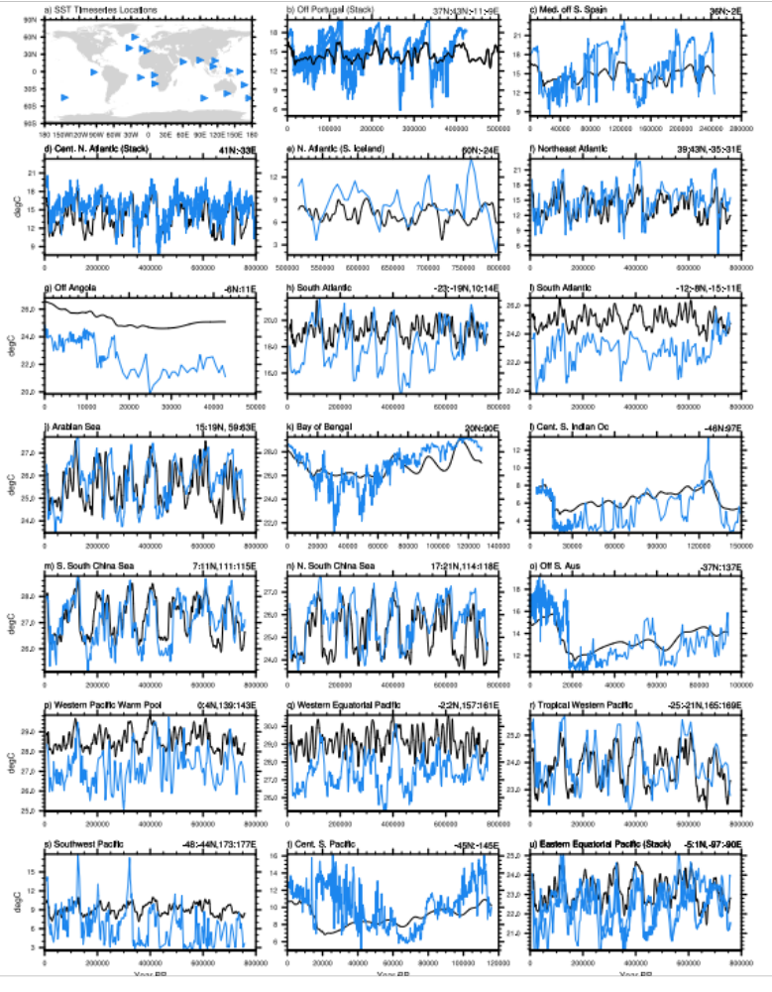
Supplementary Figure 3. The same as Supplementary Figure 2 but for sea surface temperatures (°C). The associated references are: b²⁰⁻²², c²², d^{23,24}, e²⁴, f²⁵, g²⁶, h²⁷, i²⁸, j²⁹, k³⁰, l³¹, m³², n²⁹, o³³ ,p³⁴, q³⁵, r³⁶, s³⁷, t³⁸, u^{29,39,40}.

Thermodynamic vs Topographic forcing of the Ice sheet on the NAHPs

Our results show that during glacial periods, extensive ice sheets act to suppress the NAHPs during periods of precession minima. The impact of the ice sheets may be both a thermodynamic and/or topographic forcing. The thermodynamic mechanism reflects the increase in the surface albedo due to the ice sheet which this reduces surface air temperatures (SATs) and/or sea surface temperatures (SSTs). This may alter the position of the ITCZ and reduce the strength and northward propagation of the African monsoon systems during precession minima. The topographic effect reflects the impact of the ice sheet elevation on large-scale wind patterns, which might impact ITCZ/monsoon positioning and/or intensity.

In order to identify whether the thermodynamic or topographic mechanism is dominant, we performed additional sensitivity experiments as outlined in the Methods. We focus on one time period (176kyr BP) due to computation limitations, the mechanism that we identify at this time is assumed to be the case for each of the skipped beats. We have taken the glacial simulation with the ice sheet; we have then successively altered specific glacial forcings associated with the ice sheet – SSTs, ice sheet albedo, and ice sheet topography (see methods).

Extended Figure 7 shows the average annual Saharan precipitation for the Control HadAM3BB-v1.0 simulation (i.e. the atmosphere only version of the model with all glacial forcings), the 176kyr HadCM3BB-v1.0 Orb_GHG simulation (i.e. no ice sheet forcings), the glacial_noSST simulation (i.e. glacial forcings except for non-glacial SSTs prescribed from the 176kyr Orb_GHG experiment), the glacial_noAlb simulation (i.e. glacial forcings except for pre-industrial albedo), and the glacial_noTopo simulation (i.e. glacial forcings except for pre-industrial topography). The results show that the inclusion of the ice sheet results in a decrease in Saharan precipitation at 176kyr BP by approximately 65% as indicated by the difference between Orb_GHG and Control. When removing the influence of glacial SSTs (glacial_noSST), this precipitation decrease is approximately 39%. When removing the influence of glacial albedo (glacial_noAlb), precipitation decreases by only approximately 5%. When removing the influence of glacial topography (glacial_noTopo), precipitation decreases by 58%. It is evident therefore that it is the impact of glacial albedo change and its influence on the atmosphere that is the dominant driver of reduced precipitation during glacial periods. There is a smaller but still significant contribution from SST changes. The topographic impact is minimal in comparison. Note that the impact of these three forcings is non-linear, and when combined do not produce the overall ice sheet anomaly.

Supplementary Figure 5 shows the spatial pattern of African summer precipitation for the 176kyr NAHP_All and Orb_GHG snapshot simulations (panel a) and the HadAM3BB-v1.0 sensitivity experiments (panels b-e). The anomalies represent the change in precipitation due to the inclusion of the ice sheet (a-b), or the inclusion of the specific ice sheet forcings (SST, albedo, topography; panels c-e). We show the NAHP_All climatology and anomaly with Orb_GHG (panel a) in order to confirm that the Control HadAM3BB simulation is producing a very similar climatology to the coupled climate model (panel b). The spatial plots confirm the findings in Extended Figure 7, showing that the inclusion of glacial albedo and its impact on the atmosphere has a dominant impact in reducing glacial precipitation, with a secondary impact from glacial sea-surface temperatures. The impact of glacial SSTs primarily reduces precipitation between 10-20°N whereas the impact of albedo change is primarily between 10-35°N.

Latitude/height plots (Extended Figure 6, Supplementary Figure 6a-b) indicate that during glacial precession minima periods, the ice sheets cool the atmosphere, weaken the West African Monsoon (WAM), strengthen (weaken) the African Easterly Jet (Tropical Easterly Jet), and cause the sub-tropical westerly jet (STWJ) to descend which inhibits precipitation. This is similar to the mechanism of precipitation suppression during precession maxima (Figure 2b).

The contribution of glacial SSTs (Supplementary Figure 6c-d) primarily weakens the WAM and alters the position of the African/Tropical Easterly jets, which decreases uplift and precipitation between 10-20°N (Supplementary Figure 6c). There is little impact on the dynamics of the sub-tropical westerly jet and only a small cooling impact on atmospheric temperatures (Supplementary Figure 6d). The broad impact of the ice sheets is to cool SSTs, specifically in the North Atlantic, sub-tropical gyre and the Mediterranean. This may influence the land-sea thermal contrast around West Africa and the Gulf of Guinea, which consequently influences the strength of the WAM. However the direct mechanism by which this occurs, and which oceanic regions are responsible for this, is beyond the scope of this study.

The atmospheric anomalies due to the impact of glacial albedo (Supplementary Figure 6e-f) is very similar to that shown by the overall addition of the ice sheets (Supplementary Figure 6a-b). Albedo change weakens the WAM, alters the position and strength of the African/Tropical Easterly jets, and causes a northward shift, strengthening, and descending sub-tropical westerly jet. This inhibits uplift and convective rainfall between 10-35°N. This is due to the widespread cooling of the troposphere north of 10°N. This indicates that it is albedo change and the resultant tropospheric cooling which is responsible for much of the suppression of Saharan precipitation during glacials (Supplementary Figure 6f).

In summary, ice sheets suppress the NAHPs during period of precession minima primarily due to the thermodynamic impact of albedo change. This cools the atmosphere which weakens the WAM and alters the dynamic of the sub-tropical westerly jet which inhibits uplift. In addition, glacial SSTs suppress precession-induced strengthening of the WAM.

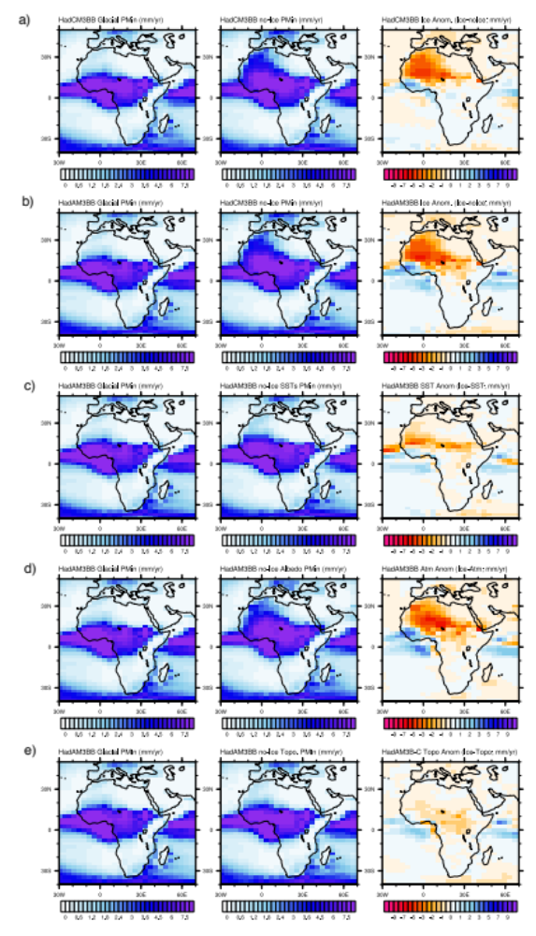
Supplementary Figure 4. Thermodynamic and topographic Impacts of ice sheet addition on JJA precipitation (mm/day) at 176kyr BP for; a) HadCM3BB-v1.0 NAHP_All, HadCM3BB-v1.0 Orb_GHG , and the anomaly which represents the change in precipitation due to the addition of the ice sheet. b) same as above but utilising the Control HadAM3BB simulation to confirm the precipitation anomaly for the atmosphere only model, c) precipitation for Control, glacial_noSST and the anomaly representing change in precipitation due to addition of glacial SSTs, d) precipitation for control, glacial_noAlb and the anomaly representing change in precipitation due to addition of glacial albedo and its effect on the atmosphere, and e) precipitation for control, glacial_noTopo and the anomaly representing change in precipitation due to addition of glacial topography.
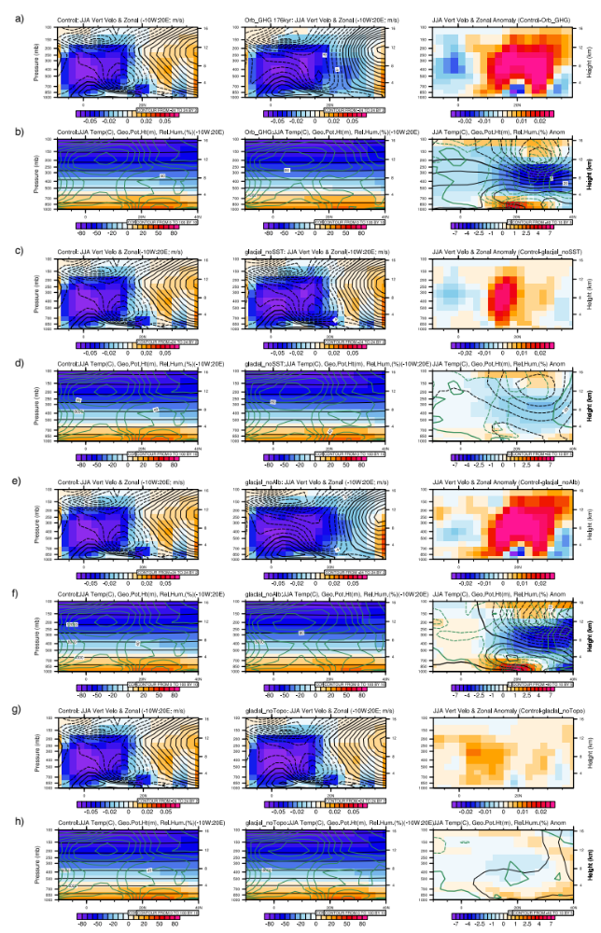
Supplementary Figure 5. West Saharan JJA latitude/height climatologies at 176kyr BP for the region identified in pink in Figure 2, for the Control simulation (right panels), the thermodynamic/topographic sensitivity experiments (middle panels, from top to bottom; Orb_GHG, glacial_noSST, glacial_noAlb, and glacial_noTopo), and the anomaly between the two (sensitivity experiment - Control). See panel label for experiment name. Panels a, c, e, g) the lagrangian tendency of air pressure for (filled contours; pa/s) where negative (positive) values represent upward (downward) motion, and zonal wind (contours; m/s) where solid/positive (dashed/negative) contours represent westward (eastward) air flow. The major components of the WAM are identified in Figure 2b. Panels b, d, f, h) temperature (filled contours; °C), geopotential height (black contours; m) and relative humidity (green contours; %). Solid (dashed) contours represent positive (negative) anomalies. Anomalies are 95% confident according to a student t-test.

Supplementary References

1 Valdes, P. J. et al. The BRIDGE HadCM3 family of climate models: HadCM3@Bristol v1.0. Geoscientific Model Development 10, 3715-3743, doi:10.5194/gmd-10-3715-2017 (2017).
2 Armstrong, E., Hopcroft, P. O. & Valdes, P. J. A simulated Northern Hemisphere terrestrial climate dataset for the past 60,000 years. Scientific Data 6, doi:10.1038/s41597-019-0277-1 (2019).
3 Singarayer, J. S. & Valdes, P. J. High-latitude climate sensitivity to ice-sheet forcing over the last 120 kyr. Quaternary Science Reviews 29, 43-55, doi:10.1016/j.quascirev.2009.10.011 (2010).
4 Armstrong, E., Valdes, P., House, J. & Singarayer, J. The Role of CO2 and Dynamic Vegetation on the Impact of Temperate Land-Use Change in the HadCM3 Coupled Climate Model. Earth Interactions 20, 1-20, doi:10.1175/ei-d-15-0036.1 (2016).
5 Davies-Barnard, T., Ridgwell, A., Singarayer, J. & Valdes, P. Quantifying the influence of the terrestrial biosphere on glacial-interglacial climate dynamics. Climate of the Past 13, 1381-1401, doi:10.5194/cp-13-1381-2017 (2017).
6 Dansgaard, W. et al. EVIDENCE FOR GENERAL INSTABILITY OF PAST CLIMATE FROM A 250-KYR ICE-CORE RECORD. Nature 364, 218-220, doi:10.1038/364218a0 (1993).
7 Hersbach, H. et al. The ERA5 global reanalysis. Quarterly Journal of the Royal Meteorological Society 146, 1999-2049, doi:10.1002/qj.3803 (2020).
8 Liu, Z. Y. et al. The Holocene temperature conundrum. Proceedings of the National Academy of Sciences of the United States of America 111, E3501-E3505, doi:10.1073/pnas.1407229111 (2014).
9 Kindler, P. et al. Temperature reconstruction from 10 to 120 kyr b2k from the NGRIP ice core. Climate of the Past 10, 887-902, doi:10.5194/cp-10-887-2014 (2014).
10 Cuffey, K. M. & Clow, G. D. Temperature, accumulation, and ice sheet elevation in central Greenland through the last deglacial transition. Journal of Geophysical Research-Oceans 102, 26383-26396, doi:10.1029/96jc03981 (1997).
11 Rasmussen, S. O. et al. A new Greenland ice core chronology for the last glacial termination. Journal of Geophysical Research-Atmospheres 111, doi:10.1029/2005jd006079 (2006).
12 Buizert, C. et al. Greenland-Wide Seasonal Temperatures During the Last Deglaciation. Geophysical Research Letters 45, 1905-1914, doi:10.1002/2017gl075601 (2018).
13 Tierney, J. E. et al. Northern hemisphere controls on tropical southeast African climate during the past 60,000 years. Science 322, 252-255, doi:10.1126/science.1160485 (2008).
14 Wagner, B. et al. Mediterranean winter rainfall in phase with African monsoons during the past 1.36 million years. Nature 573, 256-+, doi:10.1038/s41586-019-1529-0 (2019).
15 Johnson, T. C. et al. A progressively wetter climate in southern East Africa over the past 1.3 million years. Nature 537, 220-+, doi:10.1038/nature19065 (2016).
16 Chevalier, M., Chase, B. M., Quick, L. J., Dupont, L. M. & Johnson, T. C. Temperature change in subtropical southeastern Africa during the past 790,000 yr. Geology 49, 71-75, doi:10.1130/g47841.1 (2021).
17 Parrenin, F. et al. Synchronous Change of Atmospheric CO2 and Antarctic Temperature During the Last Deglacial Warming. Science 339, 1060-1063, doi:10.1126/science.1226368 (2013).
18 Jouzel, J. et al. Orbital and millennial Antarctic climate variability over the past 800,000 years. Science 317, 793-796, doi:10.1126/science.1141038 (2007).
19 Melles, M. et al. 2.8 Million Years of Arctic Climate Change from Lake El'gygytgyn, NE Russia. Science 337, 315-320, doi:10.1126/science.1222135 (2012).
20 Rodrigues, T., Voelker, A. H. L., Grimalt, J. O., Abrantes, F. & Naughton, F. Iberian Margin sea surface temperature during MIS 15 to 9 (580-300 ka): Glacial suborbital variability versus interglacial stability. Paleoceanography 26, doi:10.1029/2010pa001927 (2011).
21 Hodell, D. et al. Response of Iberian Margin sediments to orbital and suborbital forcing over the past 420 ka. Paleoceanography 28, doi:10.1002/palo.20017 (2013).
22 Martrat, B. et al. Four climate cycles of recurring deep and surface water destabilizations on the Iberian margin. Science 317, 502-507, doi:10.1126/science.1139994 (2007).
23 Naafs, B. D. A., Hefter, J. & Stein, R. Millennial-scale ice rafting events and Hudson Strait Heinrich(-like) Events during the late Pliocene and Pleistocene: a review. Quaternary Science Reviews 80, 1-28, doi:10.1016/j.quascirev.2013.08.014 (2013).
24 Bahr, A. et al. Oceanic heat pulses fueling moisture transport towards continental Europe across the mid-Pleistocene transition. Quaternary Science Reviews 179, 48-58, doi:10.1016/j.quascirev.2017.11.009 (2018).
25 Ruddiman, W. F., Raymo, M. E., Martinson, D. G., Clement, B. M. & Backman, J. PLEISTOCENE EVOLUTION: NORTHERN HEMISPHERE ICE SHEETS AND NORTH ATLANTIC OCEAN. Paleoceanography 4, 353-412, doi:10.1029/PA004i004p00353 (1989).
26 Rampen, S. W. et al. Long chain 1,13-and 1,15-diols as a potential proxy for palaeotemperature reconstruction. Geochimica Et Cosmochimica Acta 84, 204-216, doi:10.1016/j.gca.2012.01.024 (2012).
27 Etourneau, J., Schneider, R., Blanz, T. & Martinez, P. Intensification of the Walker and Hadley atmospheric circulations during the Pliocene-Pleistocene climate transition. Earth and Planetary Science Letters 297, 103-110, doi:10.1016/j.epsl.2010.06.010 (2010).
28 McIntyre, A., Ruddiman, W. F., Karlin, K. & Mix, A. C. SURFACE WATER RESPONSE OF THE EQUATORIAL ATLANTIC OCEAN TO ORBITAL FORCING. Paleoceanography 4, 19-55, doi:10.1029/PA004i001p00019 (1989).
29 Herbert, T. D., Peterson, L. C., Lawrence, K. T. & Liu, Z. H. Tropical Ocean Temperatures Over the Past 3.5 Million Years. Science 328, 1530-1534, doi:10.1126/science.1185435 (2010).
30 Lauterbach, S. et al. An similar to 130 kyr Record of Surface Water Temperature and delta O-18 From the Northern Bay of Bengal: Investigating the Linkage Between Heinrich Events and Weak Monsoon Intervals in Asia. Paleoceanography and Paleoclimatology 35, doi:10.1029/2019pa003646 (2020).
31 Rickaby, R. E. M. & Elderfield, H. Planktonic foraminiferal Cd/Ca: Paleonutrients or paleotemperature? Paleoceanography 14, 293-303, doi:10.1029/1999pa900007 (1999).
32 Li, L. et al. A 4-Ma record of thermal evolution in the tropical western Pacific and its implications on climate change. Earth and Planetary Science Letters 309, 10-20, doi:10.1016/j.epsl.2011.04.016 (2011).
33 De Deckker, P. et al. Climatic evolution in the Australian region over the last 94 ka - spanning human occupancy -, and unveiling the Last Glacial Maximum. Quaternary Science Reviews 249, doi:10.1016/j.quascirev.2020.106593 (2020).
34 de Garidel-Thoron, T., Rosenthal, Y., Bassinot, F. & Beaufort, L. Stable sea surface temperatures in the western Pacific warm pool over the past 1.75 million years. Nature 433, 294-298, doi:10.1038/nature03189 (2005).
35 Medina-Elizalde, M. & Lea, D. W. The mid-Pleistocene transition in the tropical Pacific. Science 310, 1009-1012, doi:10.1126/science.1115933 (2005).
36 Russon, T. et al. Inter-hemispheric asymmetry in the early Pleistocene Pacific warm pool. Geophysical Research Letters 37, doi:10.1029/2010gl043191 (2010).
37 Schaefer, G. et al. Planktic foraminiferal and sea surface temperature record during the last 1 Myr across the Subtropical Front, Southwest Pacific. Marine Micropaleontology 54, 191-212, doi:10.1016/j.marmicro.2004.12.001 (2005).
38 Harada, N. et al. Rapid fluctuation of alkenone temperature in the southwestern Okhotsk Sea during the past 120 ky. Global and Planetary Change 53, 29-46, doi:10.1016/j.gloplacha.2006.01.010 (2006).
39 Barth, A. M., Clark, P. U., Bill, N. S., He, F. & Pisias, N. G. Climate evolution across the Mid-Brunhes Transition. Climate of the Past 14, 2071-2087, doi:10.5194/cp-14-2071-2018 (2018).
40 Liu, Z. H. & Herbert, T. D. High-latitude influence on the eastern equatorial Pacific climate in the early Pleistocene epoch. Nature 427, 720-723, doi:10.1038/nature02338 (2004).

