Table S1. Proteins identified by non-targeted data-dependent acquisition and database search using Spectrum Mill
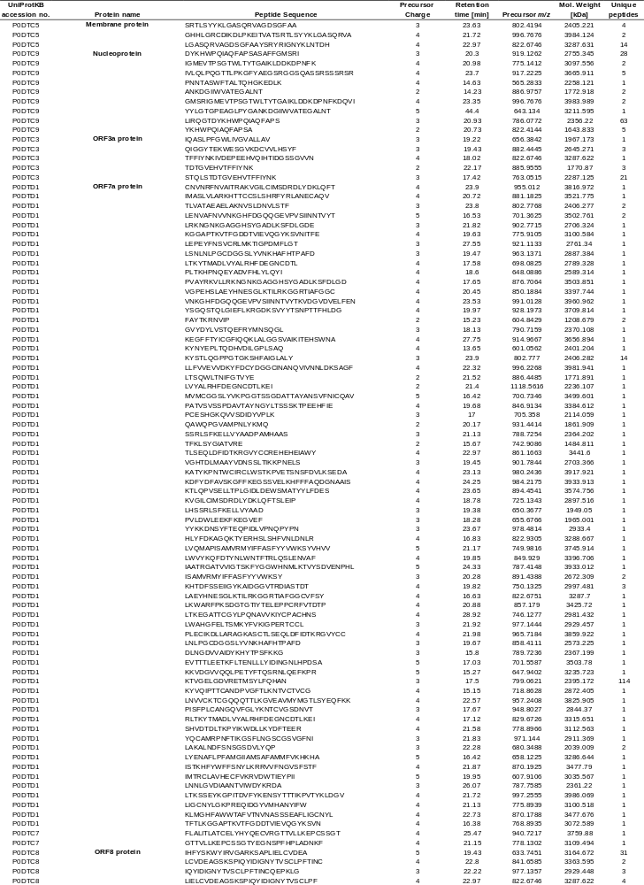
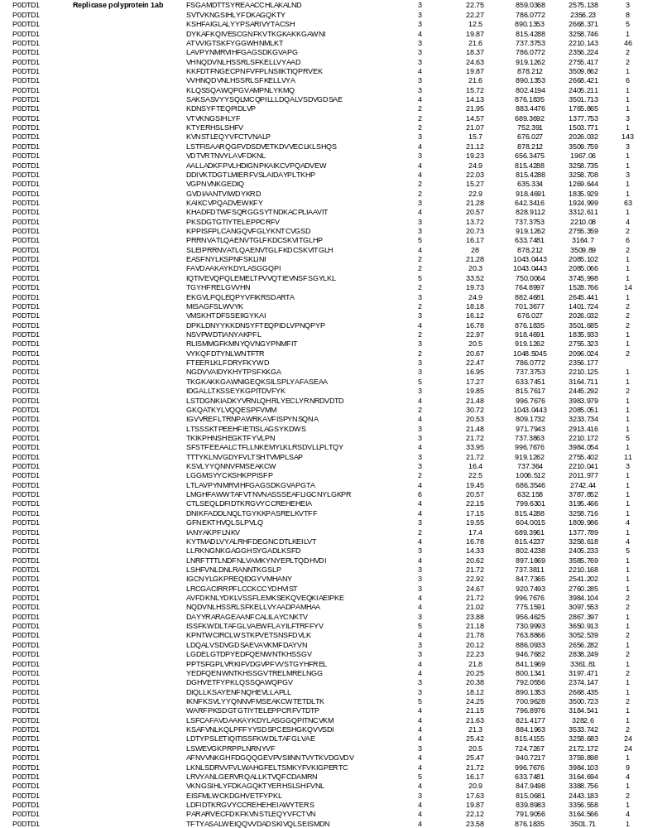
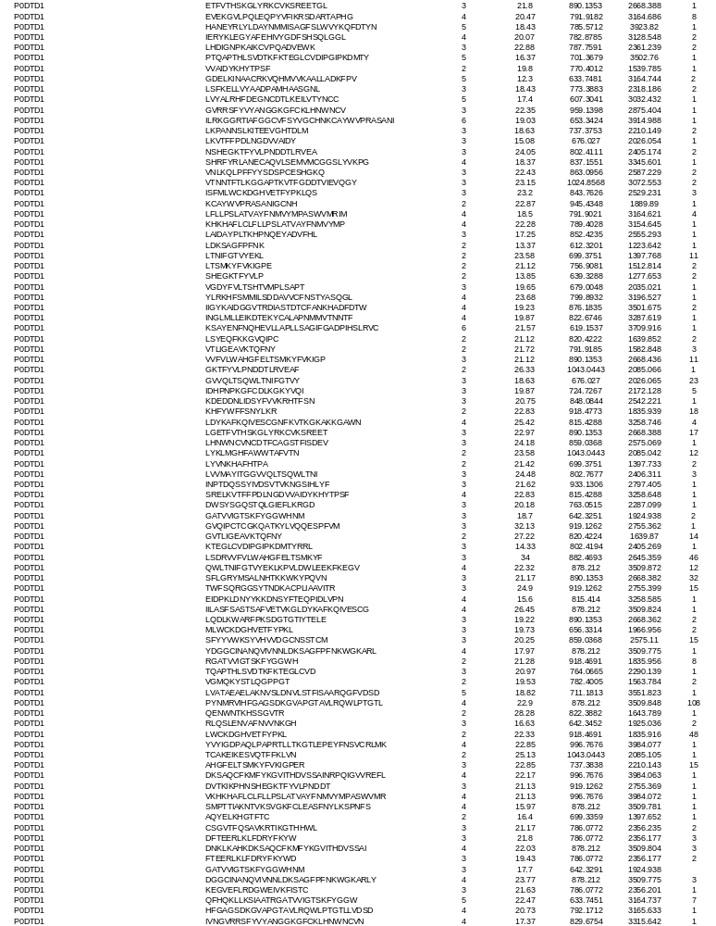

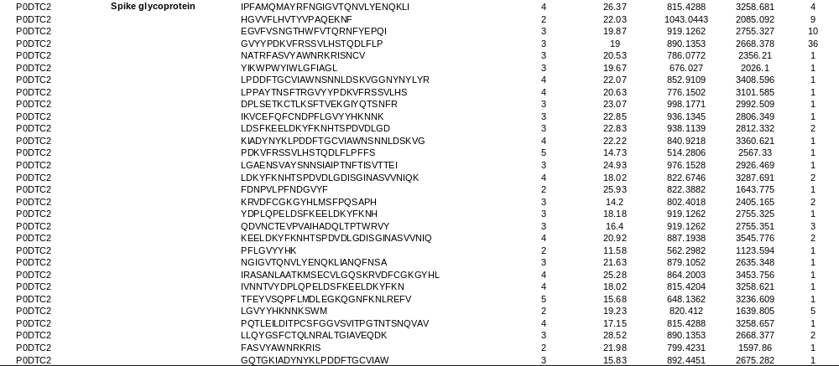

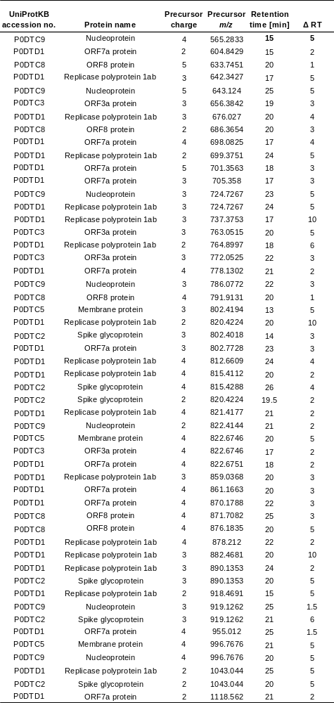
Table S2. Target list for targeted MS/MS data acquisition.

Acquisition Method Info

Method Name Method Path Method Description Device List
Multisampler
Binary Pump Column Comp. Q-TOF
Agilent_training_peptides_slope4_it_5uL.m D:\MassHunter\Methods\peptides\Agilent_training_peptides_slope4_it_5uL.

TOF/Q-TOF Mass Spectrometer

Component Name  Ion Source  Can wait for temp. | MS Q-TOF  Dual AJS ESI  Enable | Component Model  Stop Time (min)  Fast Polarity | G6545A  No Limit/As Pump  False
MS Abs. threshold | 200 | MS Rel. threshold(%) | 0.010
MS/MS Abs. threshold | 5 | MS/MS Rel. threshold(%) | 0.010
Time Segments
Time Segment #  1 | Start Time (min) Diverter Valve State  0 MS | Storage Mode Ion Mode  Both Dual AJS ESI

Time Segment 1

Acquisition Mode AutoMS2
MS Min Range (m/z) |  |  | 100
MS Max Range (m/z) |  |  | 1700
MS Scan Rate (spectra/sec) |  |  | 3.00
MS/MS Min Range (m/z) |  |  | 50
MS/MS Max Range (m/z) |  |  | 1700
MS/MS Scan Rate (spectra/sec)  Isolation Width MS/MS Decision Engine |  |  | 2.00  Medium (~4 amu) Adv
Ramped Collision Energy
Charge Slope  All 4  Auto MS/MS Preferred/Exclude Tabl |  | Offset  2  e
Mass Delta  921.9686 | Mass (ppm) 100 | Charge  1 | Type  Exclude | Retention Time (min)  0 | Delta Ret. Time (min) | Isolation  Width  Narrow (~1.3 | Collision Energy
 |  |  |  |  |  | amu)
Precursor Selection
Max Precursors Per Cycle 10
Threshold (Abs) 500
Threshold (Rel)(%) 0.010
Precursor abundance-based scan speed Yes
Target (counts/spectrum) 25000.000
Use MS/MS accumulation time limit Yes
Use dynamic precursor rejection No
Purity Stringency (%) 100.000
Purity Cutoff (%) 30.000
Isotope Model Peptides
Active exclusion enabled Yes
Active exclusion excluded after (spectra) 2
Active exclusion released after (min) 0.20
Sort precursors By abundance only
Static Exclusion Ranges
StartMZ EndMZ
25 300
Charge State Preference
Selected Charges
2
3
>3
Instrument Parameters

Parameter | Value
Gas Temp (°C) | 325
Gas Flow (l/min) | 8
Nebulizer (psig) | 35
SheathGasTemp | 350
SheathGasFlow | 11
Scan Segments
Scan Seg # Ion Polarity
1 Positive
Scan Segment 1
Scan Source Parameters

Parameter | Value
VCap | 4500
Nozzle Voltage (V) | 1000
Fragmentor | 180
Skimmer1 | 65
OctopoleRFPeak | 750

ReferenceMasses

Ref Mass Enabled  Ref Nebulizer (psig) | Disabled
Chromatograms
Chrom Type | Label | Offset | Y-Range
TIC | TIC | 15 | 10000000
TIC | TIC | 15 | 10000000

Name: Multisampler Sampling Speed Module: G7167A

Draw Speed 100.0 µL/min
Eject Speed 400.0 µL/min
Wait Time After Drawing 1.2 s
Injection
Needle Wash Mode Standard Wash
Injection Volume 5.00 µL
Standard Needle Wash
Needle Wash Mode Flush Port
Duration 10 s
High Throughput
Injection Valve to Bypass for Delay Volume Reduction No
Sample Flush-Out Factor 5.0 Overlapped Injection
Overlap Injection Enabled No
Needle Height Position
Draw Position Offset -1.0 mm
Use Vial/Well Bottom Sensing No
Stop Time
Stoptime Mode No Limit
Post Time
Posttime Mode Off

Name: Binary Pump Module: G7112B
Flow 0.100 mL/min
Use Solvent Types Yes
Low Pressure Limit 0.00 bar
High Pressure Limit 400.00 bar
Maximum Flow Gradient 100.000 mL/min²
Stroke A
Automatic Stroke Calculation A Yes
Stroke B
Automatic Stroke Calculation B Yes
Stop Time
Stoptime Mode Time set
Stoptime 50.00 min
Post Time
Posttime Mode Off
Solvent Composition
 | Channel | Solvent 1 | Name 1 | Solvent 2 | Name 2 | Selected | Used | Percent (%)
1 | A | H20 |  | IPA |  | Ch. 1 | Yes | 98.0 %
2 | B | premixed ACN(95%) - H2O(5%) |  | IPA |  | Ch. 1 | Yes | 2.0 %
Timetable
 | Time (min) | A (%) | B (%) | Flow (mL/min)
1 | 0.00 min | 98.0 % | 2.0 % | 0.100 mL/min
2 | 2.00 min | 98.0 % | 2.0 % | 0.100 mL/min

 | Pressure (bar)
1 | 400.00 bar
2 | 400.00 bar

 | Time (min) | A (%) | B (%) | Flow (mL/min)
3 | 27.00 min | 60.0 % | 40.0 % | 0.100 mL/min
4 | 32.00 min | 40.0 % | 60.0 % | 0.100 mL/min
5 | 32.01 min | 15.0 % | 85.0 % | 0.100 mL/min
6 | 37.00 min | 15.0 % | 85.0 % | 0.100 mL/min
7 | 37.01 min | 98.0 % | 2.0 % | 0.100 mL/min

Name: Column Comp. Left Temperature Control
Module: G7116A
Temperature Control Mode Temperature Set
Temperature 40.0 °C
Enable Analysis Left Temperature
Enable Analysis Left Temperature On Yes
Enable Analysis Left Temperature Value 1.0 °C
Left Temp. Equilibration Time 0.0 min
Right Temperature Control
Right temperature Control Mode Not Controlled
Enable Analysis Right Temperature
Enable Analysis Right Temperature On Yes
Enable Analysis Right Temperature Value 0.8 °C
Right Temp. Equilibration Time 0.0 min
Enforce column for run
Enforce column for run enabled No
Stop Time
Stoptime Mode As pump/injector
Post Time
Posttime Mode Off
Timetable
Valve Position Position 2 (Port 1 -> 2)
Position Switch After Run Do not switch

 | Pressure (bar)
3 | 400.00 bar
4 | 400.00 bar
5 | 400.00 bar
6 | 400.00 bar
7 | 400.00 bar

Acquisition Method Info

Method Name Method Path Method Description Device List
Multisampler
Binary Pump Column Comp. Q-TOF
targetted_slope4_WW_test2.m D:\MassHunter\Methods\peptides\targetted_slope4_WW_test2.m

TOF/Q-TOF Mass Spectrometer

Component Name  Ion Source  Can wait for temp. | MS Q-TOF  Dual AJS ESI  Enable | Component Model  Stop Time (min)  Fast Polarity | G6545A  No Limit/As Pump  False
MS Abs. threshold | 200 | MS Rel. threshold(%) | 0.010
MS/MS Abs. threshold | 5 | MS/MS Rel. threshold(%) | 0.010
Time Segments
Time Segment #  1 | Start Time (min) Diverter Valve State  0 MS | Storage Mode Ion Mode  Both Dual AJS ESI
Time Segment 1
Acquisition Mode TargetedMS2

MS Min Range (m/z) |  | 100
MS Max Range (m/z) |  | 1700
MS Scan Rate (spectra/sec) |  | 3.00
MS/MS Min Range (m/z) |  | 50
MS/MS Max Range (m/z) |  | 1700
MS/MS Scan Rate (spectra/sec)  Max Time Between MS (sec) Decision Engine |  | 2.00  Disabled Native
Ramped Collision Energy
Charge Slope  All 4 | Offset  2

Targeted Mass Table  Start Mass | Z | Ret. Time | Delta Ret. | Isolation | Collision | Acq. Time
 |  | (min) | Time (min) | Width | Energy | (ms/spec)
604.8429 | 2 | 15 | 2 | Medium (~4 |  | 1000
 |  |  |  | amu)
633.7451 | 5 | 19 | 3 | Medium (~4 |  | 1000
 |  |  |  | amu)
633.7451 | 5 | 20 | 1 | Medium (~4 |  | 1000
 |  |  |  | amu)
633.7451 | 5 | 20 | 1 | Medium (~4 |  | 1000
 |  |  |  | amu)
642.3427 | 3 | 17 | 5 | Medium (~4 |  | 1000
 |  |  |  | amu)
676.027 | 3 | 20 | 4 | Medium (~4 |  | 1000
 |  |  |  | amu)
676.027 | 3 | 21 | 4 | Medium (~4 |  | 1000
 |  |  |  | amu)
737.3753 | 3 | 17 | 10 | Medium (~4 |  | 1000
 |  |  |  | amu)
737.3753 | 3 | 18 | 3 | Medium (~4
 |  |  |  | amu)
737.3753 | 3 | 13 | 5 | Medium (~4 |  | 1000
 |  |  |  | amu)
786.0772 | 3 | 22 | 3 | Medium (~4 |  | 1000
 |  |  |  | amu)
802.4194 | 3 | 13 | 5 | Medium (~4 |  | 1000
 |  |  |  | amu)
820.4224 | 2 | 20 | 10 | Medium (~4 |  | 1000
 |  |  |  | amu)
878.212 | 4 | 22 | 2 | Medium (~4 |  | 1000
 |  |  |  | amu)
878.212 | 4 | 26 | 2 | Medium (~4 |  | 1000
 |  |  |  | amu)
882.4681 | 3 | 26 | 2 | Medium (~4 |  | 1000
 |  |  |  | amu)
890.1353 | 3 | 20 | 5 | Medium (~4 |  | 1000
 |  |  |  | amu)
890.1353 | 3 | 24 | 2 | Medium (~4 |  | 1000
 |  |  |  | amu)
918.4691 | 2 | 15 | 5 | Medium (~4 |  | 1000
 |  |  |  | amu)
919.1262 | 3 | 25 | 1.5 | Medium (~4 |  | 1000
 |  |  |  | amu)
919.1262 | 3 | 21 | 6 | Medium (~4 |  | 1000
 |  |  |  | amu)
955.012 | 4 | 25 | 1.5 | Medium (~4 |  | 1000
 |  |  |  | amu)
996.7676 | 4 | 21 | 5 | Medium (~4
 |  |  |  | amu)
996.7676 | 4 | 50 | 5 | Medium (~4
 |  |  |  | amu)
996.7676 | 4 | 24 | 4 | Medium (~4
 |  |  |  | amu)
1043.0443 | 2 | 25 | 25 | Medium (~4 |  | 1000
 |  |  |  | amu)
1086.4947 | 2 | 25 | 25 | Medium (~4 |  | 1000
 |  |  |  | amu)

Instrument Parameters

Parameter | Value
Gas Temp (°C) | 325
Gas Flow (l/min) | 8
Nebulizer (psig) | 35
SheathGasTemp | 350
SheathGasFlow | 11
Scan Segments
Scan Seg # Ion Polarity
1 Positive

Scan Segment 1
Scan Source Parameters

Parameter | Value
VCap | 4500
Nozzle Voltage (V) | 1000
Fragmentor | 180
Skimmer1 | 65
OctopoleRFPeak | 750
ReferenceMasses

Ref Mass Enabled  Ref Nebulizer (psig) | Disabled
Chromatograms
Chrom Type | Label | Offset | Y-Range
TIC | TIC | 15 | 10000000
TIC | TIC | 15 | 10000000

Name: Multisampler Sampling Speed
Module: G7167A

Draw Speed 100.0 µL/min
Eject Speed 400.0 µL/min
Wait Time After Drawing 1.2 s
Injection
Needle Wash Mode Standard Wash
Injection Volume 5.00 µL
Standard Needle Wash
Needle Wash Mode Flush Port
Duration 10 s
High Throughput
Injection Valve to Bypass for Delay Volume Reduction No
Sample Flush-Out Factor 5.0 Overlapped Injection
Overlap Injection Enabled No
Needle Height Position
Draw Position Offset -1.0 mm
Use Vial/Well Bottom Sensing No
Stop Time
Stoptime Mode No Limit
Post Time
Posttime Mode Off

Name: Binary Pump Module: G7112B
Flow 0.100 mL/min
Use Solvent Types Yes
Low Pressure Limit 0.00 bar
High Pressure Limit 400.00 bar
Maximum Flow Gradient 100.000 mL/min²
Stroke A
Automatic Stroke Calculation A Yes
Stroke B
Automatic Stroke Calculation B Yes
Stop Time
Stoptime Mode Time set
Stoptime 50.00 min
Post Time
Posttime Mode Off
Solvent Composition
 | Channel | Solvent 1 | Name 1 | Solvent 2 | Name 2 | Selected | Used | Percent (%)
1 | A | H20 |  | IPA |  | Ch. 1 | Yes | 98.0 %

 | Channel | Solvent 1 | Name 1 | Solvent 2 | Name 2 | Selected | Used | Percent (%)
2 | B | premixed ACN(95%) - H2O(5%) |  | IPA |  | Ch. 1 | Yes | 2.0 %
Timetable
 | Time (min) | A (%) | B (%) | Flow (mL/min)
1 | 0.00 min | 98.0 % | 2.0 % | 0.100 mL/min
2 | 2.00 min | 98.0 % | 2.0 % | 0.100 mL/min
3 | 27.00 min | 60.0 % | 40.0 % | 0.100 mL/min
4 | 32.00 min | 40.0 % | 60.0 % | 0.100 mL/min
5 | 32.01 min | 15.0 % | 85.0 % | 0.100 mL/min
6 | 37.00 min | 15.0 % | 85.0 % | 0.100 mL/min
7 | 37.01 min | 98.0 % | 2.0 % | 0.100 mL/min

Name: Column Comp. Left Temperature Control
Module: G7116A

Temperature Control Mode Temperature Set
Temperature 40.0 °C
Enable Analysis Left Temperature
Enable Analysis Left Temperature On Yes
Enable Analysis Left Temperature Value 1.0 °C
Left Temp. Equilibration Time 0.0 min
Right Temperature Control
Right temperature Control Mode Not Controlled
Enable Analysis Right Temperature
Enable Analysis Right Temperature On Yes
Enable Analysis Right Temperature Value 0.8 °C
Right Temp. Equilibration Time 0.0 min
Enforce column for run
Enforce column for run enabled No
Stop Time
Stoptime Mode As pump/injector
Post Time
Posttime Mode Off
Timetable
Valve Position Position 2 (Port 1 -> 2)
Position Switch After Run Do not switch

 | Pressure (bar)
1 | 400.00 bar
2 | 400.00 bar
3 | 400.00 bar
4 | 400.00 bar
5 | 400.00 bar
6 | 400.00 bar
7 | 400.00 bar

