2D and 3D molecular docking data (Cypermethrin and Human-Iron transporter protein)
Fig 4a. Ceruloplasmin (1KCW)
The active site amino acid residues, LYS 288.A, ASN 289.A, ILE 292.A, THR 294.A, ILE 295.A, ASN 296.A, LEU 297.A, PHE 298.A, LEU 302.A, PHE 303.A, THR 304.A, TRP 648.A, ARG 649.A, ALA 656.A, ASN 657.A, LEU 658.A, PHE 659.A, THR 662.A, SER 663.A, LEU 664.A, VAL 996.A, PHE 997.A, ASP 998.A, ILE 999.A, PHE 1000.A, THR 1003.A, and GLN 1005.Aof 1KCW were involved in the interaction with cypermethrin. The dimension of the grid box was 76 × 80 × 80 with the spacing of 1 Å and x-, y-, and z-center values as 136.409, 34.206, and 0.746 respectively. Despite having the best binding energy with the ligand (cypermethrin) there was no H-bond interaction found in between them. The 2D representation shows different types of interactions between the receptor and the ligand. The light green color indicates the van der Waals interaction which is provided by the amino acid residues PHE A.997, ASP A.998, TYR A. 986, THR A. 301, PHE A.303, SER A.663, THR A.662, PHE A.1000, ASN A.657, ASN A.296, and PHE A.659. The alkyl and π-alkyl interaction (pink) were seen between the ligand and the amino acid residues TRP A.648, and LEU A.664. Also, the aromatic ring of the ligand formed π-cation interaction (orange) with the amino acid residue LYS A.288 of the receptor.

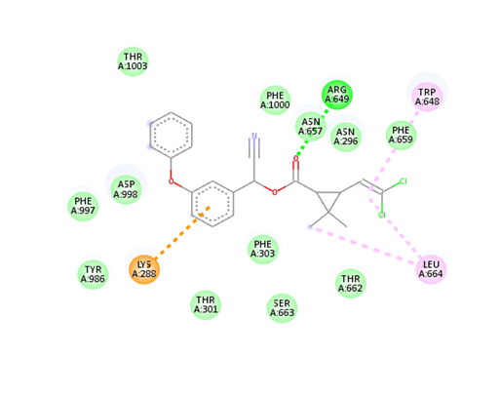
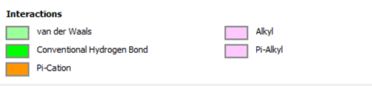
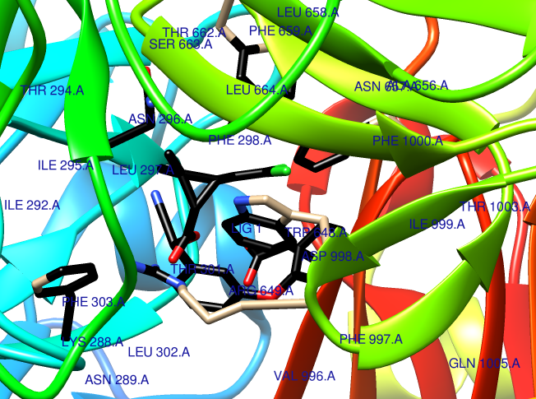

Fig 4b. Transferrin (4XID)
The active site amino acid residues involved in interaction with the ligand (cypermethrin) consisted of ARG 5.D, THR 7.D, TYR 8.D, THR 9.D, GLN 12.D,THR 13.D, GLU 15.D, LEU 16.D, GLU 17.D, LYS 18.D, PHE 20.D, HIS 21.D, PHE 22.D, ARG 24.D, TYR 25.D, LEU 26.D, GLN 44.D, ILE 45.D, LYS 46.D, ILE 47.D, TRP 48.D, GLN 50.D, ASN 51.D, ARG 52.D, ARG 53.D, MET 54.D, LYS 55.D, TRP 56.D, LYS 57.D, GLU 59.D. The dimension of the grid box was 66 × 66 × 66 with the spacing of 1 Å and x-, y-, and z-center values as -15.867, -23.693, and 26.68 respectively. In this one H-bond interaction was found between THR13.D of the receptor and O of the ligand with the bond distance of 3.468 Å. The 2D representation shows different types of interactions between the receptor and the ligand. The light green color indicates the van der Waals interaction which is provided by the amino acid residues ILE D.47, GLN D.6, THR D.7, THR D.13, ARG D.5 and LYS D.55. The π-H donor bond is shown in light blue between the aromatic ring of the ligand and the amino acid residue TYR D.8 of the receptor. Some other interactions like, alkyl and π-alkyl (pink) were shown between the ligand and the amino acid residue ARG D.52.

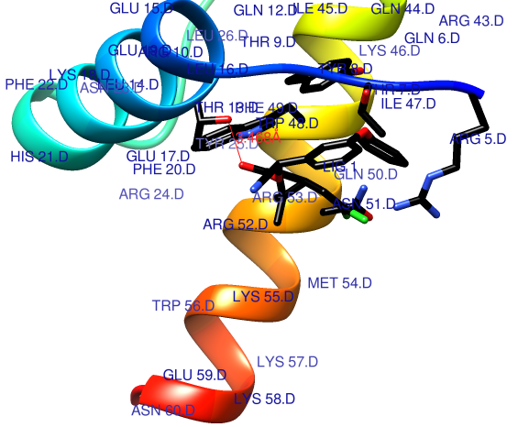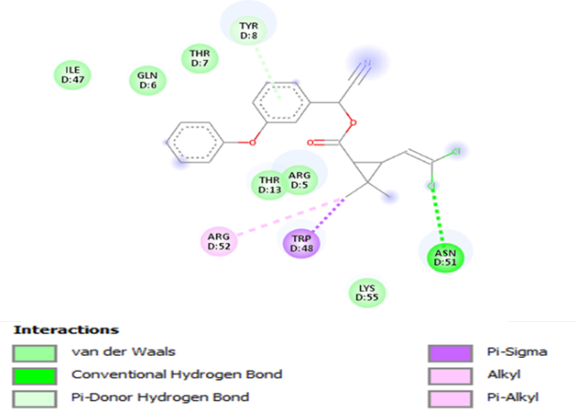

Fig 4c. Ferroportin (6W4S)
The active site consisted SER 71.F, LEU 75.F, ILE 78.F, ILE 79.F, TRP 82.F, THR 94.F, SER 95.F, VAL 98.F, ASN 141.F, ILE 142.F, ALA 143.F, LEU 145.F, ALA 146.F, SER 147.F, ALA 149.F, THR 150.F. The dimension of the grid box was 88 × 80 × 94 with the spacing of 1 Å and x-, y-, and z-center values as 121.85, 122.626, and 128.980 respectively. No H-bonding was found between the receptor and the ligand. The 2D representation shows the different types of interactions between the ligand and the receptor. The light green color indicates the van der Waals interaction which is provided by the amino acid residues SER 95.F, THR 94.F, ILE 78.F, LEU 75.F. The dark pink color shows the π-stacking interaction. Here it can be seen that TRP 82.F of the receptor is involved in the π-stacking interaction with the aromatic ring of cypermethrin.
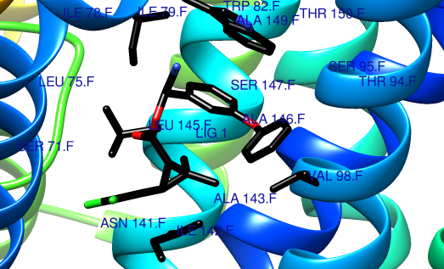
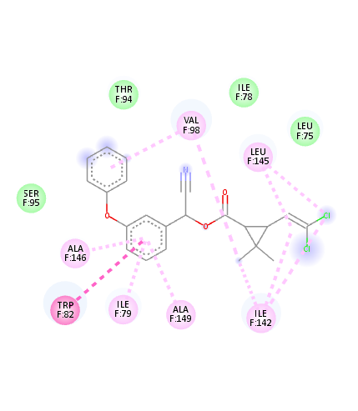
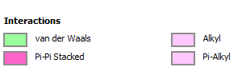

Fig 4d. Hepcidin (1M4E)
The active site consisted CYS 2.A, PHE 4.A, CYS 5.A, CYS 6.A, GLY 7.A, HIS 10.A, ARG 11.A, SER 12.A, LYS 13.A, CYS 14.A, GLY 15.A, MET 16.A, CYS 17.A, CYS 18.A, LYS 19.A. The dimension of the grid box was 40 × 40 × 40 with the spacing of 0.667 Å and x-, y-, and z-center values as 2.703, 0.674, and 0.12 respectively. Here, one H-bonding interaction was seen between H of ARG 11.A of the receptor and O of the ligand with bond distance of 2.074 Å. The 2D representation shows different types of interactions between the receptor and the ligand. The light green color indicates the van der Waals interaction which is provided by the amino acid residues LYS A.13, CYS A.14, LYS A.19, CYS A.18, and MET A.16. The π-interaction was seen between the aromatic rings of the ligand and the amino acid residue HIS A.10 of the receptor. The π-sulfur interaction was found between the aromatic rings of the ligand and the amino acid residue CYS A.17, and the π-alkyl interaction was in between the ligand and CYS A.5 residue.

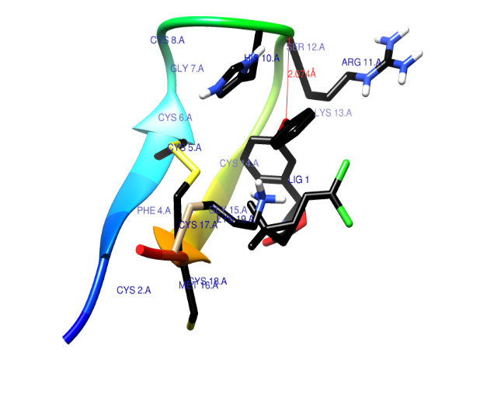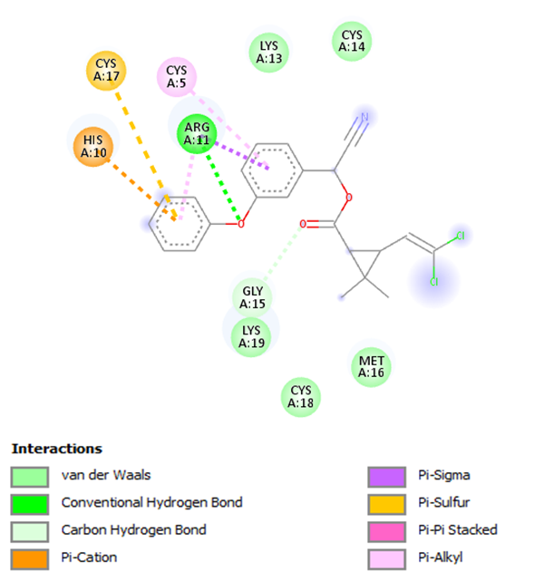

Fig 4e. DMT-1 (5F0L)
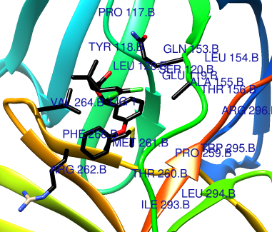
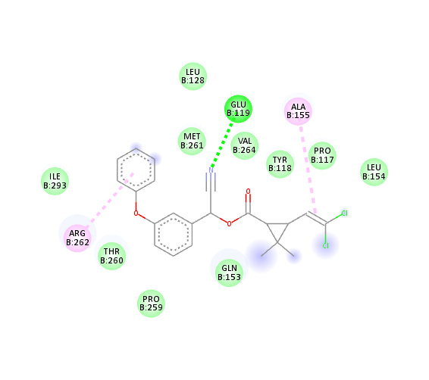
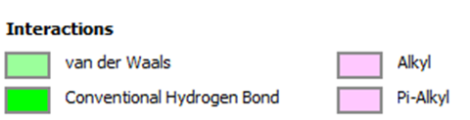
The active site consisted of PRO 117.B, TYR 118.B, GLU119.B, SER 120.B, LEU 128.B, GLN 153.B, LEU 154.B, ALA 155.B, THR 156.B, PRO 259.B, THR 260.B, MET 261.M, ARG 262.B, VAL 264.B, PHE 268.B, ILE 293.B, TRP 295.B, ARG 296.B. The dimension of the grid box was 126 × 126 × 126 with the spacing of 1 Å and x-, y-, and z-center values as 71.902, 1.128, and 9.079 respectively.No H-bonding interaction was seen here. The 2D representation of the ligand with the receptor shows different interactions. Green color indicates the van der Waals interactions of the amino acid residues LEU 128.B, MET 261.B, ILE 293.B, THR 260.B, PRO 259.B, GLN 153.B, VAL 264.B, TYR 118.B, PRO 117.B, LEU 154.B with the ligand. An interesting thing to note here is the conventional H-bond which is seen to be formed between GLU 119.B of the receptor and N of the receptor. Also, ALA 155.B shows π-alkyl interaction with the ligand.

