2D and 3D molecular docking studies (Cypermethrin and Rat iron transporter receptor)
Fig 5a. Ceruloplasmin (5N0K)
The active site consisted of VAL 791.A, GLU 838.A, ARG 876.A, LYS 877.A, SER 878.A, TYR 879.A, VAL 880.A. The dimension of the grid box was 80 × 76 × 78 with the spacing of 1 Å and x-, y-, and z-center values as 31.137, -5.725, and -25.737 respectively. Here, one H-bond was seen between LYS 877.A residue of the receptor and O atom of the ligand with the bond distance of 2.913 Å. Analysis of the 2D representation of the ligand with the receptor shows van der Waals interaction between the amino acid residues GLU 838.A, SER 878.A, and VAL 880.A and the ligand. Here, two π-alkyl interactions were also seen between the ligand and the amino acid residues ARG 876.A, and VAL 791.A.
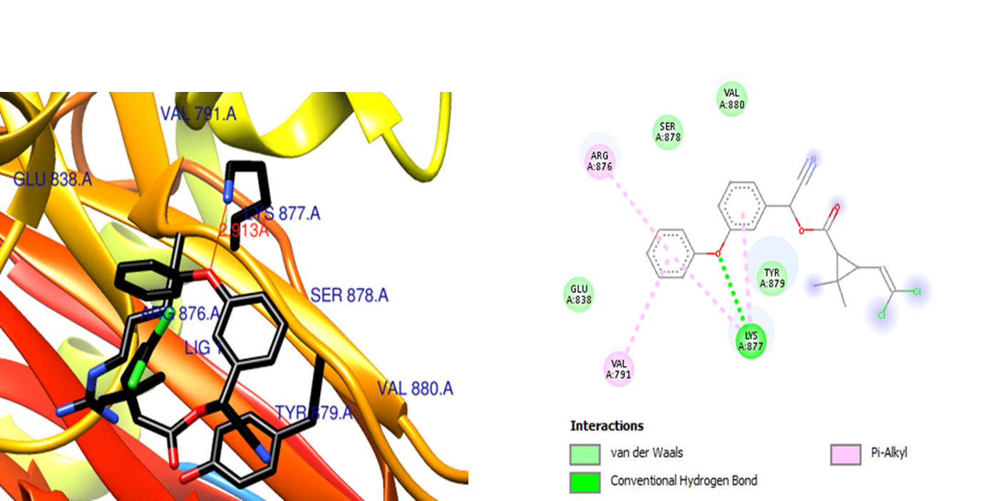
Fig 5b. Transferrin (AF-P12346-F1)
The active site consisted of ASP 441.A, VAL 442.A, PHE443.A, PRO444.A, LYS 445.A, GLY 446.A, GLN 600.A, ALA 601.A, PRO 602.A, ASN 603.A, GLU 667.A, GLU 668.A, TYR 669.A, LEU 670.A, GLY 671.A, ALA 672.A, GLU 673.A, TYR 674.A, LEU 675.A. The dimension of the grid box was 80 × 80 × 82 with the spacing of 1 Å and x-, y-, and z-center values as -5.097, 9.48, and -3.779 respectively. No H-bonding interaction was found between the receptor and the ligand. The 2D representations of the ligand with the receptor show different interactions. The van der Waals interaction was found between the ligand and the amino acid residues ASP 441.A, VAL 442.A, PHE443.A, PRO444.A, LYS 445.A, GLY 446.A, GLN 600.A, ALA 601.A, PRO 602.A, ASN 603.A, GLU 667.A, GLU 668.A, TYR 669.A, LEU 670.A, GLY 671.A, ALA 672.A, GLU 673.A, TYR 674.A, LEU 675.A.
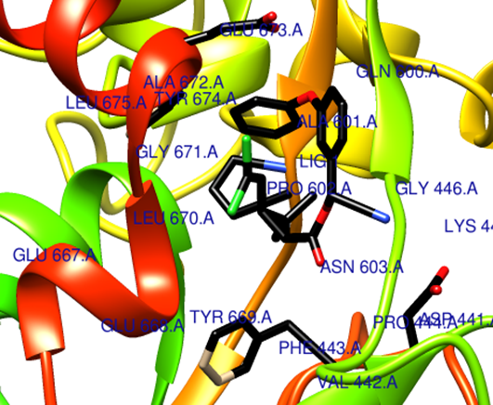
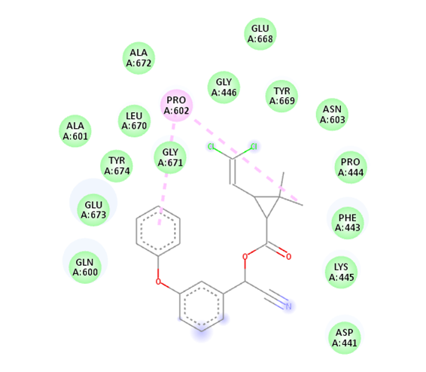
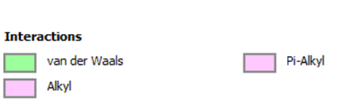

Fig 5c. Ferroportin (AF-Q923U9-F1)
The active site consisted of GLN 182.A, ILE 186.A, LEU 317.A, TYR 318.A, THR 320.A, VAL 321.A, LEU 322.A, GLY323.A, PHE 324.A, ASP 325.A, MET 346.A, SER 349.A, ALA 350.A, ARG 465.A, LEU 468.A, TRP 469.A, ASP 472.A, ASP 503.A, HIS 506.A, and PHE 507.A. The dimension of the grid box was 110 × 88 × 86 with the spacing of 1 Å and x-, y-, and z-center values as -1.59, 4.286, and -3.006 respectively. The receptor and the ligand show two hydrogen bonds. One H- bond is in between one NH of ARG 465.A of the receptor and O atom of the ligand with the bond distance of 2.875 Å, and the other H- bond was seen between other NH of ARG 465.A of the receptor and O atom of the ligand with the bond distance of 2.905 Å. The 2D representation of the ligand with the receptor show interactions like van der Waals, π-alkyl, C-H bond etc. The van der Waals interaction was seen between the ligand and the amino acid residues PHE 324.A, SER 349.A, ASP 325.A, THR 320.A, ASP 503.A, ILE 186.A. The π-alkyl interaction was seen in between amino acid residues MET 346.A, PRO 189.A, TYR 318.A, and HIS 506.A.

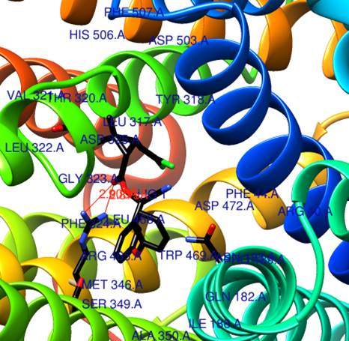
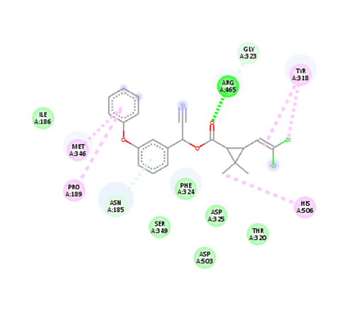
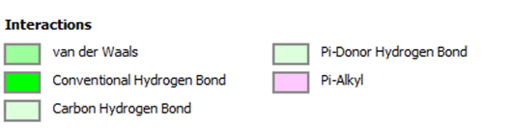

Fig 5d. Hepcidin (AF-Q99MH3-F1)
The active site consisted of SER 49.A, ALA 50.A, LEU 51.A, LEU 52.A, MET 53.A, LEU 54.A, LYS 55.A, ARG 56.A, and ARG 57.A. The dimension of the grid box was 80 × 50 × 60 with spacing 1 Å and x, y and z- center is 6.159, -2.179 and 7.126 respectively. Here the receptor and the ligand show three H-bonding interaction. One with the one NH of ARG 57.A and O atom of the ligand with the bond distance of 3.522 Å. The other H-bond was formed between NH of ARG 57.A and the O atom of ligand with the bond distance of 3.276 Å. The third H-bond was seen between the second NH of ARG 57.A and the O atom of ligand with the bond distance of 3.460 Å. The 2D representation of ligand with the receptor show different interactions like van der Waals, π-sulfur, alkyl, π-alkyl etc. The van der Waals interaction was due to amino acid residues LEU 50.A, LEU 51.A, and ARG 56.A. The π-sulfur interaction was seen between MET 53.A and aromatic ring of the ligand.
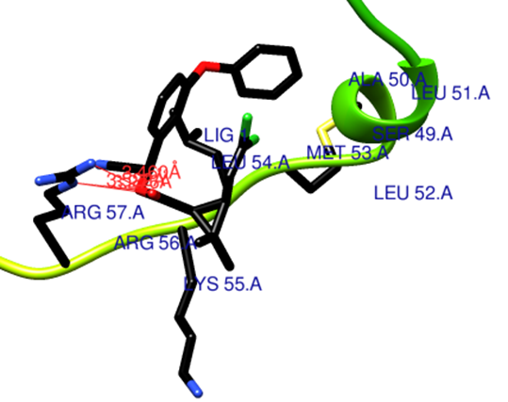
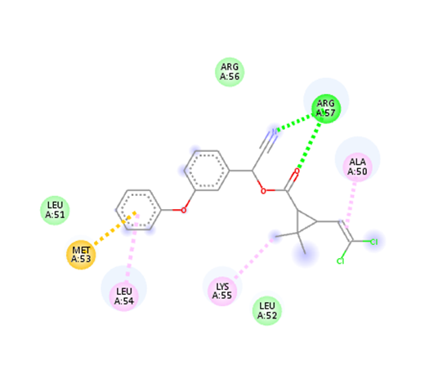
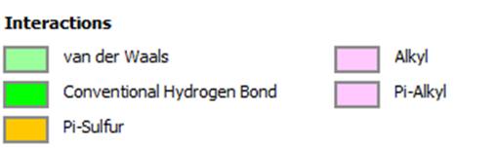

Fig 5e. DMT-1 (AF-O54902-F1)
The active site consisted of GLU 45.A, PRO 46.A, PHE 47.A, THR 48.A, THR 193.A, PHE 198.A, LEY 197.A, PHE 198.A, LYS 201.A, TRP 406.A, SER 407.A, ARG 408.A, and PHE 409.A. The chosen grid box dimension was 68 × 80 × 86 with spacing 1 Å and x, y and z- center is -1.591, -15,258 and 4.987 respectively. Here, two H-bonds were formed between the receptor and the ligand. One of the H-bond was in between NH of LYS 201.A and O atom of the ligand with bond distance of 3.159 Å. The other H- bond was formed between SER 407.A and O atom of ligand with the bond distance of 3.338Å. The 2D representation of ligand with the receptor show van der Waals interaction due to THR 48.A, SER 407.A, ARG 408.A, PHE 198.A, and PHE 194.A. The other interaction seen was π-alkyl interaction which was due to LEU 197.A, and PHE 409.A. An interesting thing seen was π-anion and π-π-T shaped interactions which were seen in between GLU 145.A and the two aromatic rings of the ligand and between PHE 47.A residue and the aromatic ring of the ligand respectively.

