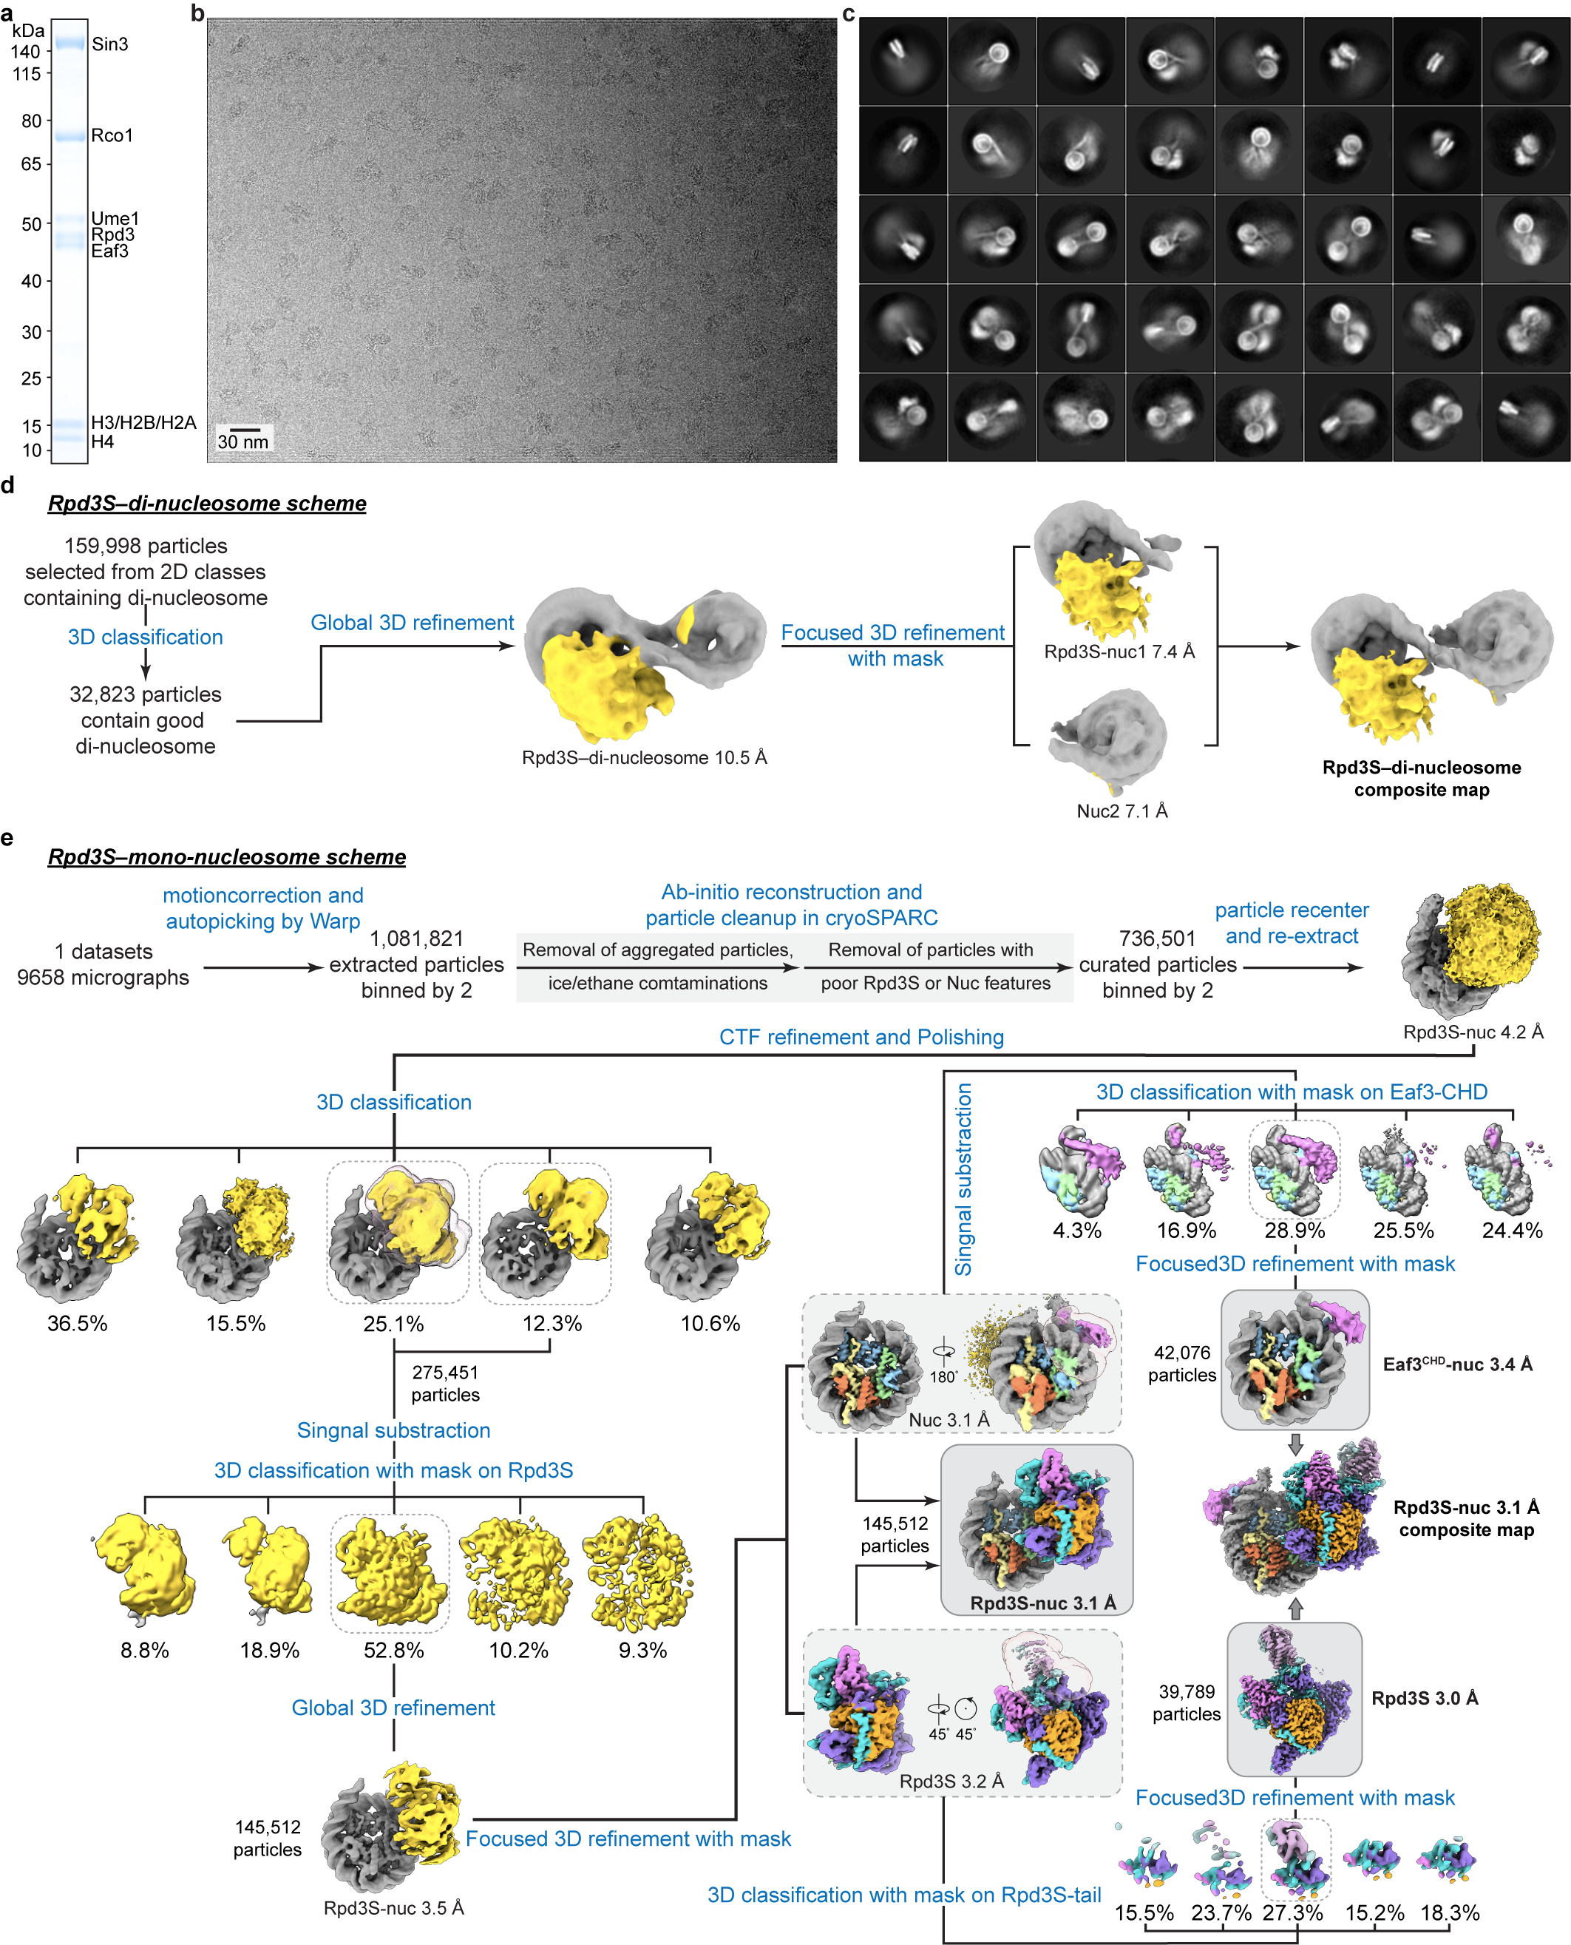
Extended Data Figure 1 | Cryo-EM structure determination of Rpd3S-nucleosome complex.
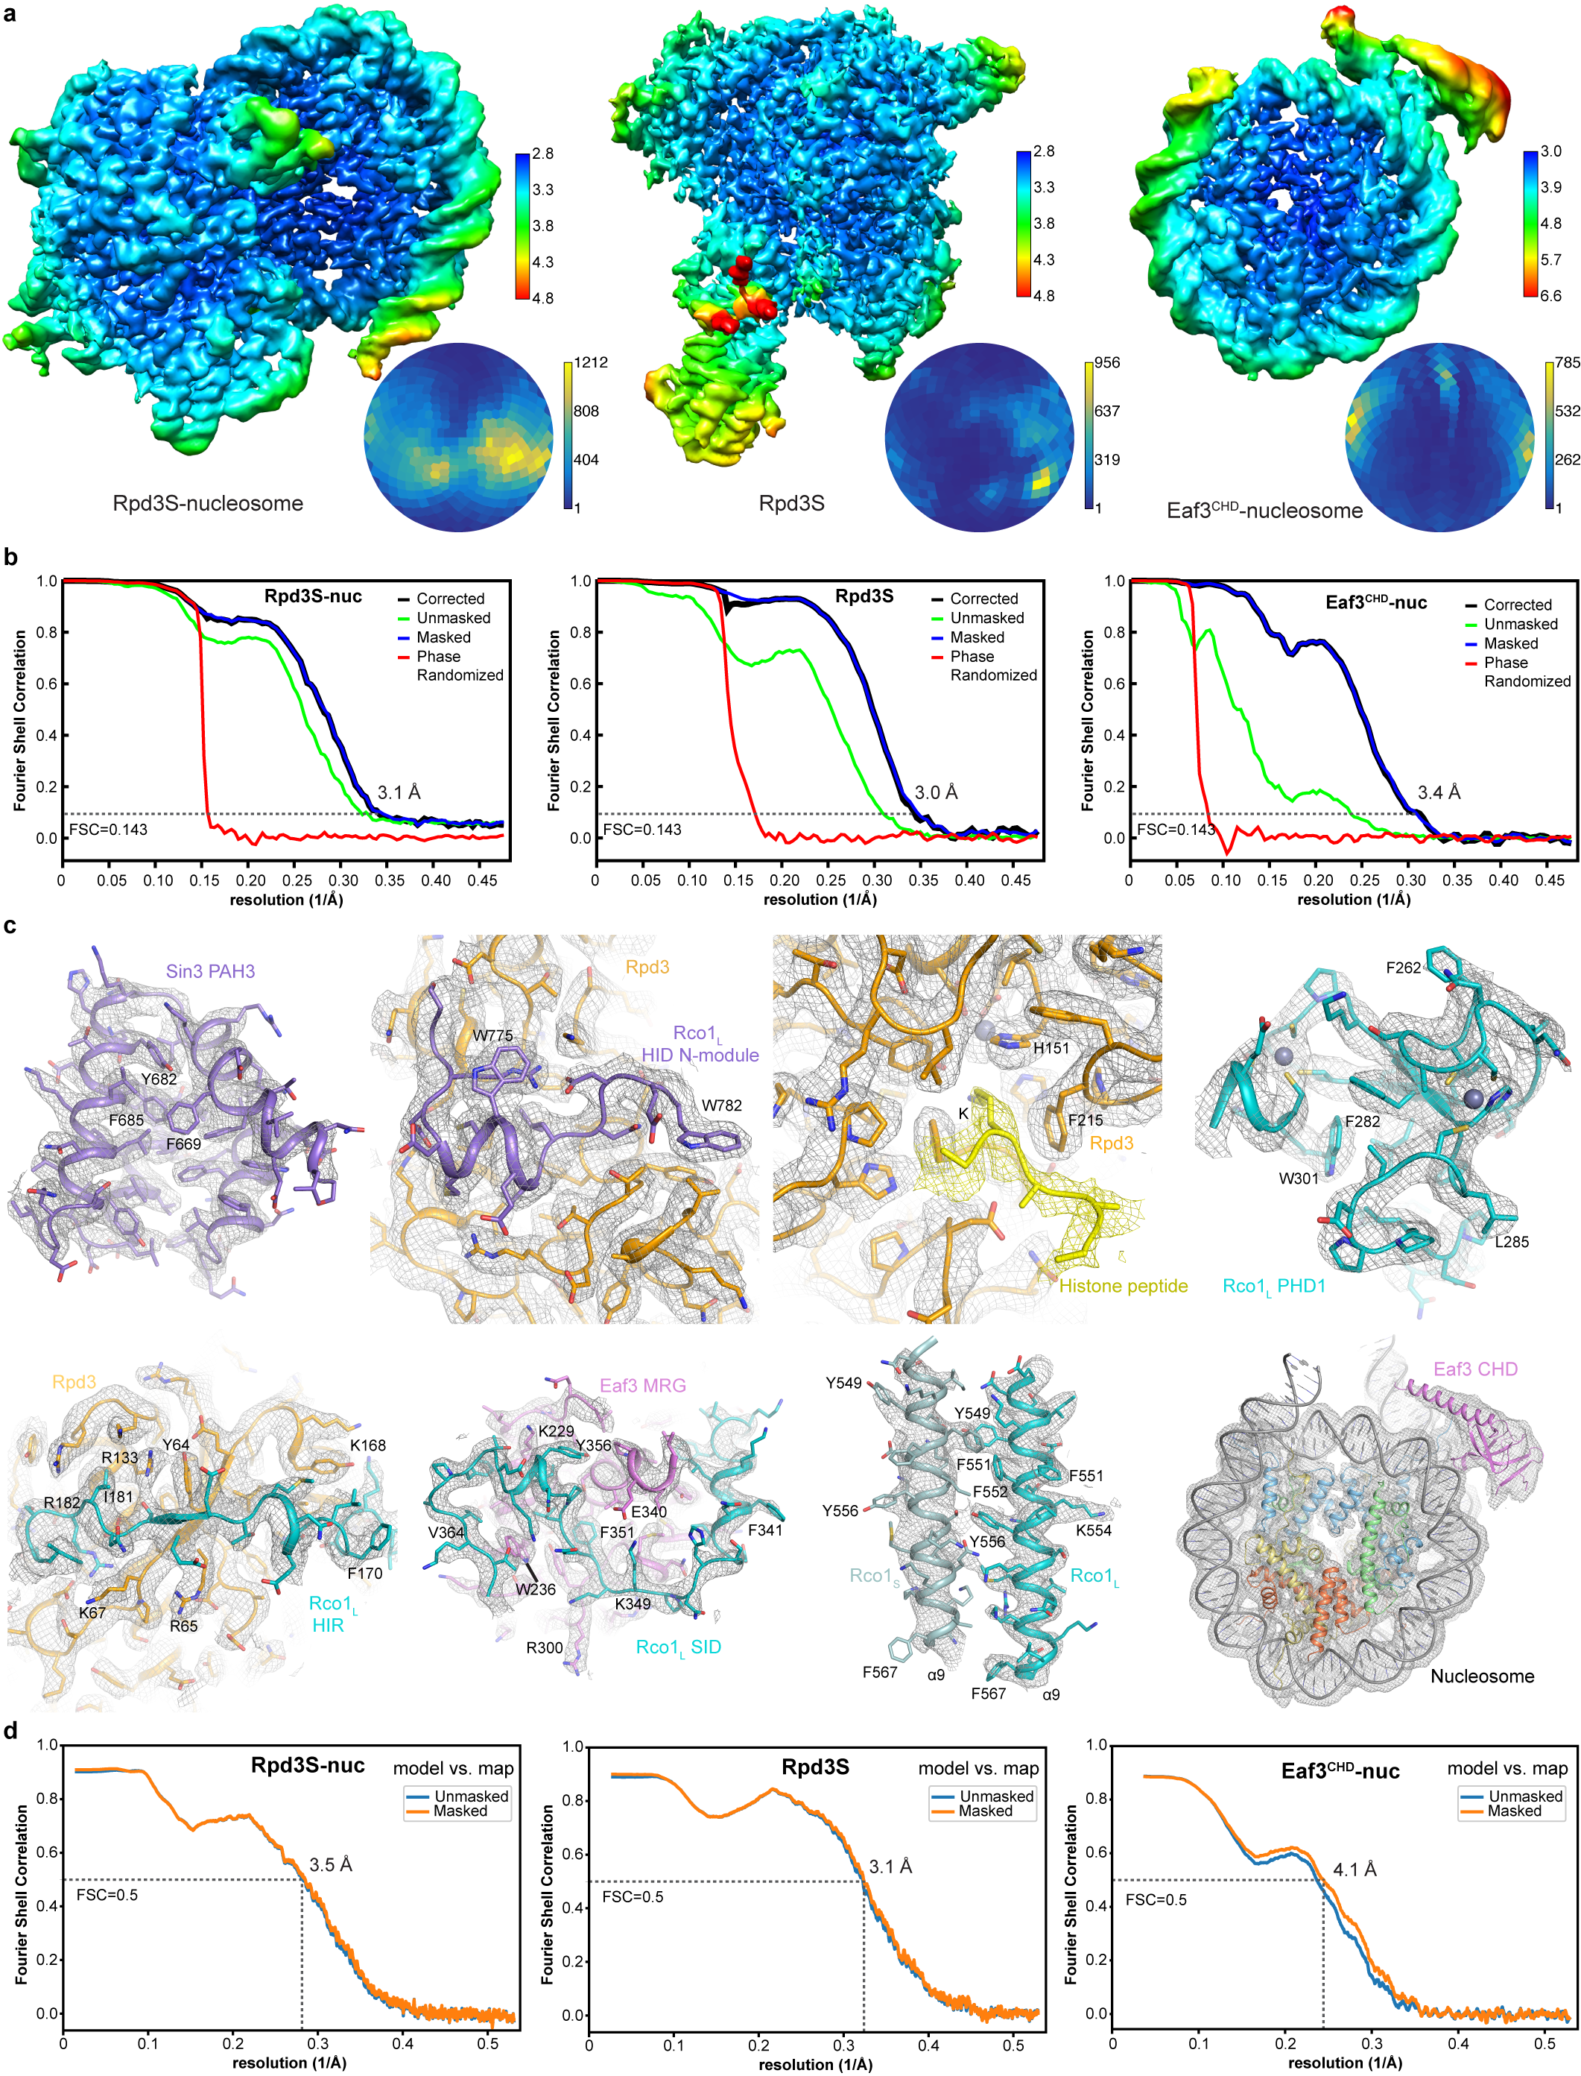
Extended Data Figure 2 | Quality of cryo-EM reconstructions.

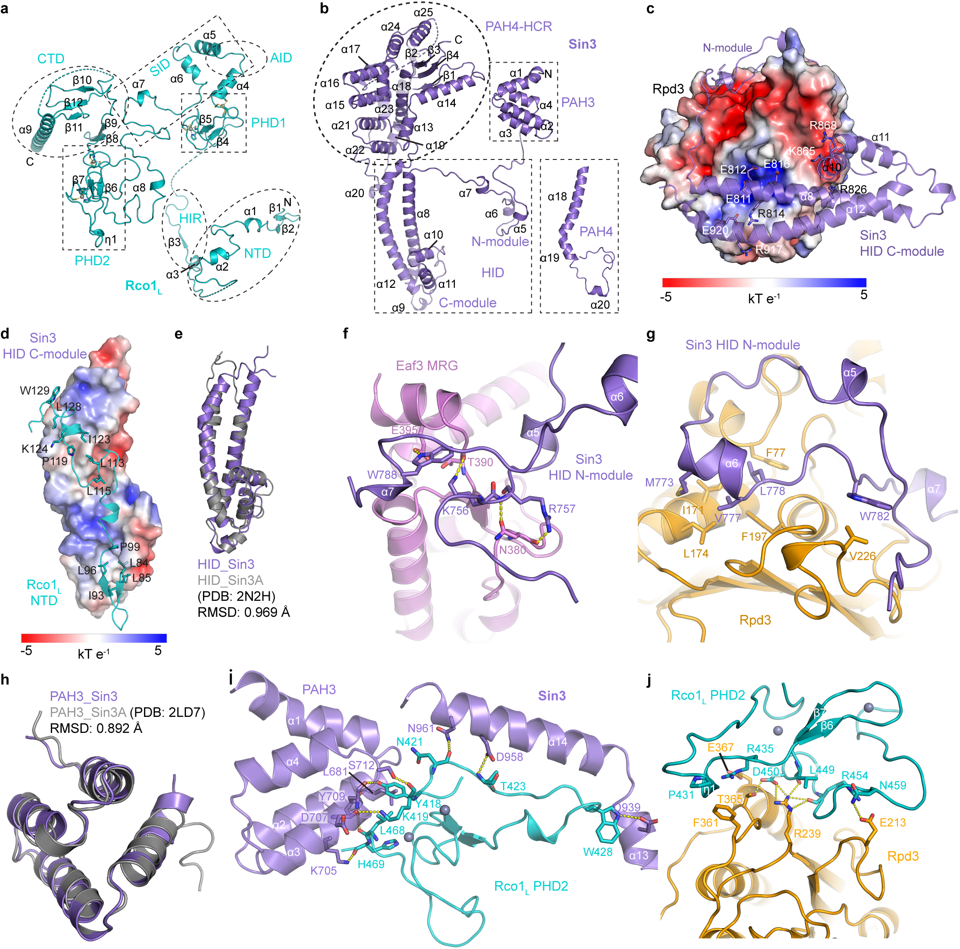
Extended Data Figure 3 | Subunit domain structures and their inter-molecular interactions.

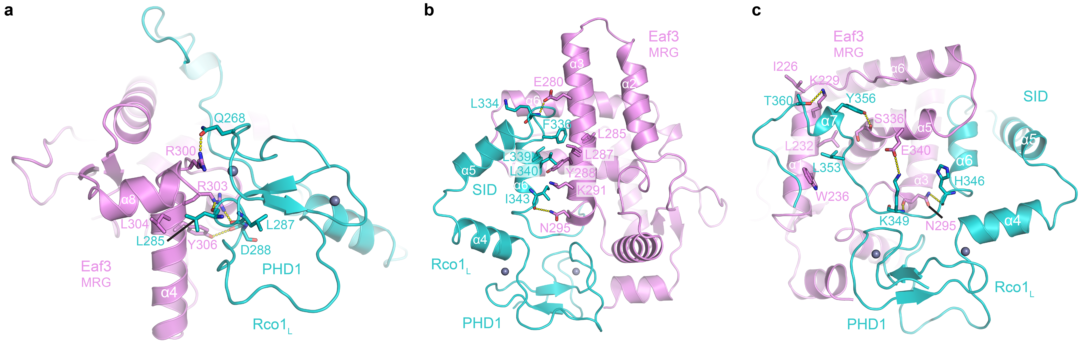
Extended Data Figure 4 | Detailed interactions between the MRG domain of Eaf3 and Rco1_{L}.

Extended Data Figure 5 | Structural comparison between Rpd3 and HDACs.

