Supplementary Figure 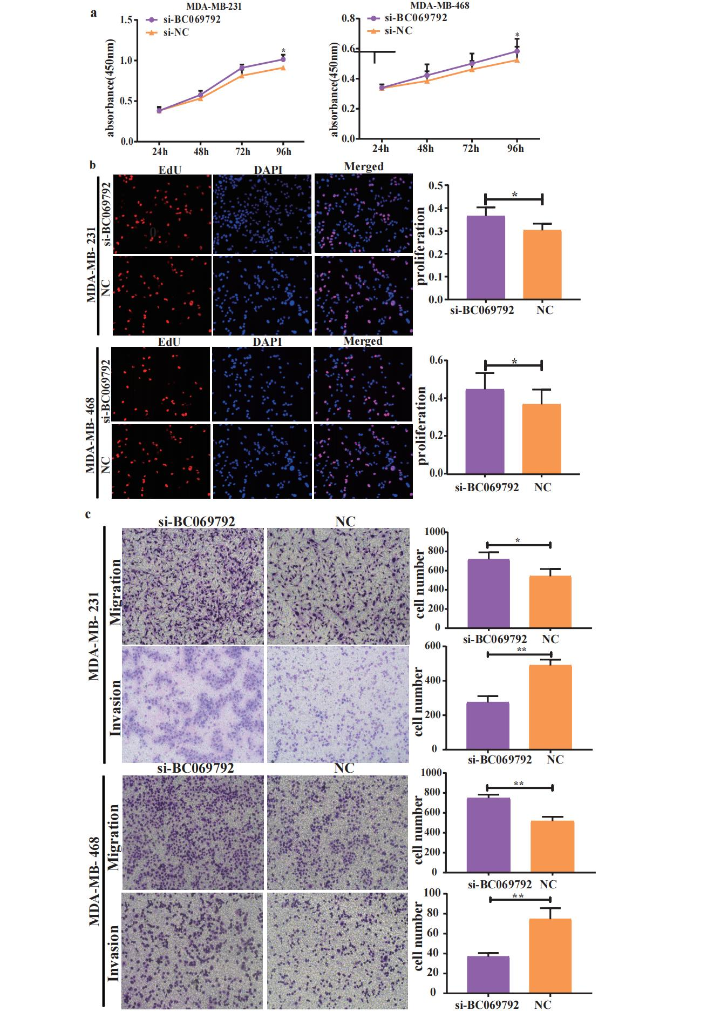
Supplementary Fig. 1 Cell function experiments
a CCK-8 experiments showed that si-BC069792 can promote the proliferation of MDA-MB-231 cells (*P=0.43) and MDA-MB-468 (*P=0.026) cells. b The results of EdU experiments showed that si-BC069792 promoted the proliferation ability of breast MDA-MB-231 (*P=0.042) and MDA-MB-468 (*P=0.050) cancer cells. c Compared with the control group, the si-BC069792 knockdown group can effectively promote the migration (P=0.044) and invasion ability (P=0.002) of MDA-MB-231 cells, while the si-BC069792 knockdown group can effectively promote the migration (P=0.002) and invasion (**P=0.005) of MDA-MB-468 cells, and the number of cells passing through the underfloor membrane of the chamber is significantly increased。*P< 0.05，**P< 0.01，***P< 0.001.
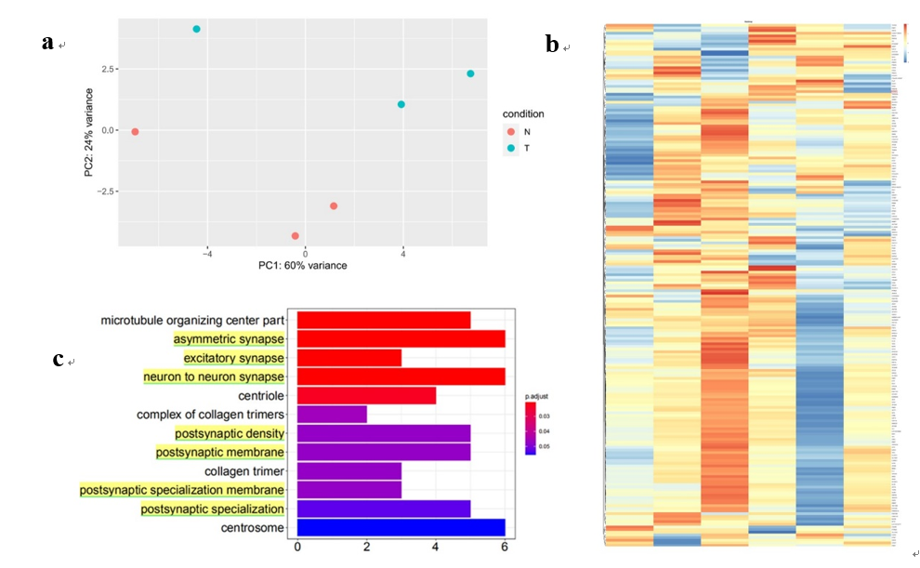
Supplementary Fig. 2 Gene differential expression results after breast cancer cells overexpressed BC069792
a The results of principal component analysis showed that the consistency within the two sample groups was good and had certain differentiation. b The results of gene difference analysis showed that the BC069792 overexpression group could cause differential expression of 1209 downstream genes. c The differential expression pathway shown in the figure related to the transduction function of synaptic transmission signal.
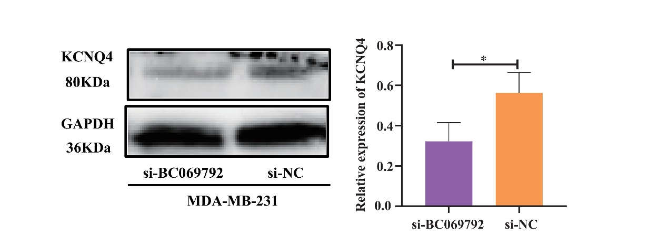
Supplementary Fig. 3 The expression of KCNQ4 protein in the knockdown BC069792 group was significantly reduced（*P=0.0114)。

