Appendix S1
High-throughput sequencing analysis
Total genomic DNA samples were extracted by an PowerSoil DNA Isolation Kit (12888-50, MO BIO Laboratories, USA) from 0.25 g sediment samples, and 3 μL of the extracted DNA were detected by 1.2% agarose gel electrophoresis. High-quality DNA with clear and bright bands (approximately 30 ng/μL DNA content) was used as the template for polymerase chain reaction (PCR). The V3-V4 regions of 16S rRNA were amplified by PCR. The target fragment was amplified with specific primers (F specific primer: 5'-TTCCCTACACGACGCTCTTCCGATCT -barcodeF1 specific primer-3', R specific primer: 5'-GAGTTCCTTGGC ACCCGAGAATTCCA-barcodeR1specific primer-3'), and the target fragment was recovered, then the recovered product was used as a template for secondary PCR amplification: (F primer: 5'-AATGATACGGCGACCACCGAGATCTACAC -TCTTTCCCTACACGACGCTC-3', R primer: 5'CAAGCAGAAGACGG CATACGAGAT-barcodeR2-GTGACTGGAGTTCCTTGGCACCCGAGA-3'). The PCR amplification conditions were as follows: predenaturation for 5 minutes at 98 ℃, 25 cycles of denaturation for 30 s at 98 ℃, annealing for 30 s at 53 ℃, extension for 45 s at 72 ℃, and final extension for 5 min at 72 ℃. The PCR amplicons were purified by Vazyme VAHTSTM DNA Clean Beads (Vazyme, China) and quantified by a Quant-iT PicoGreen dsDNA Assay Kit (Invitrogen, USA). The sequencing was performed using the Illumina MiSeq platform.
Table S1. Analysis methods and their resources, equipment, and detection limits for water quality parameters
Project | Methods | Resources | Equipment | Detection limit
pH | Measured in situ | / | pH meter (PHSJ-5, China) | 0
DO | Measured in situ | / | Portable meter (Hach HQ30D, USA) | 0 mg/L
Salinity | Gravimetric method | Water and Wastewater Monitoring and Analysis Methods (4th Edition) | Electronic balance (BSA-224CW, Germany) | 0 mg/L
COD | Titrimetric method | HJ 828-2017 | COD digestion (HCA-100, China) | 4 mg/L
TP | Spectrophotometry | GB 11893-1989 | Spectrophotometer (UV-2550, Japan) | 0.01 mg/L
NH₄⁺–N | Spectrophotometry | HJ 535-2009 | Spectrophotometer (UV-2550, Japan | 0.025 mg/L
TN | Spectrophotometry | GB 11894-1989 | Spectrophotometer (UV-2550, Japan) | 0.05 mg/L
NO₃––N | Spectrophotometry | HJ/T 346-2007 | Spectrophotometer (UV-2550, Japan) | 0.08 mg/L
K⁺ | Ion chromatography | American Public Health Association ^{[1]} | Ion chromatograph (CS–2100, USA) | 0.001 mg/L
Ca²⁺ | Ion chromatography | American Public Health Association | Ion chromatograph (CS–2100, USA) | 0.001 mg/L
Na⁺ | Ion chromatography | American Public Health Association | Ion chromatograph (CS–2100, USA) | 0.0007 mg/L
Mg²⁺ | Ion chromatography | American Public Health Association | Ion chromatograph (CS–2100, USA) | 0.002 mg/L
Cl– | Ion chromatography | American Public Health Association | Ion chromatograph (Advanced IC, Switzerland) | 0.04 mg/L
SO₄^{2–} | Ion chromatography | American Public Health Association | Ion chromatograph (Advanced IC, Metrohm, Switzerland) | 0.1 mg/L
Reference: [1] American Public Health Association, 2012. Standard methods for the examination of water & wastewater, 22nd end. American Public Health Association, Washington.
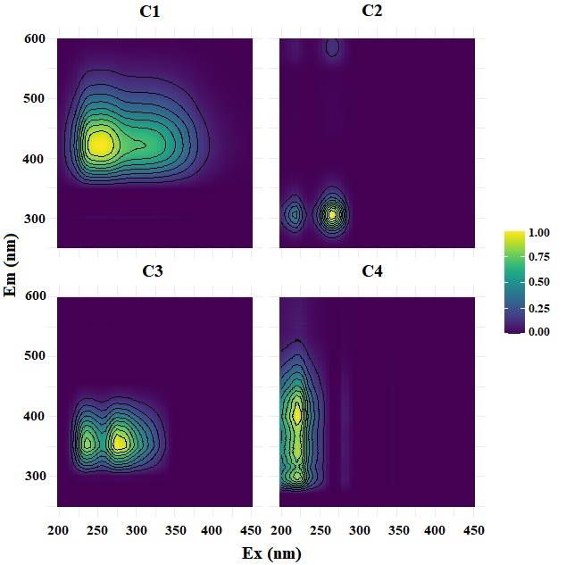
Fig. S1. PARAFAC of DOM in period A
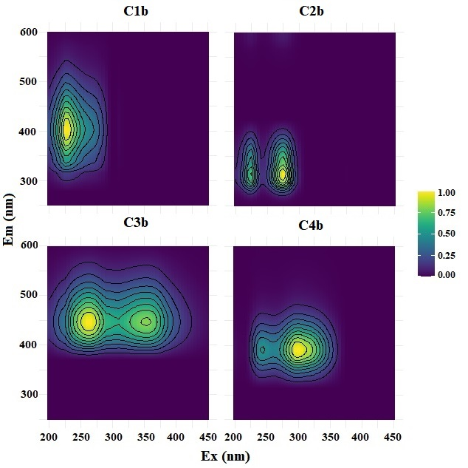
Fig. S2. PARAFAC of DOM in period B
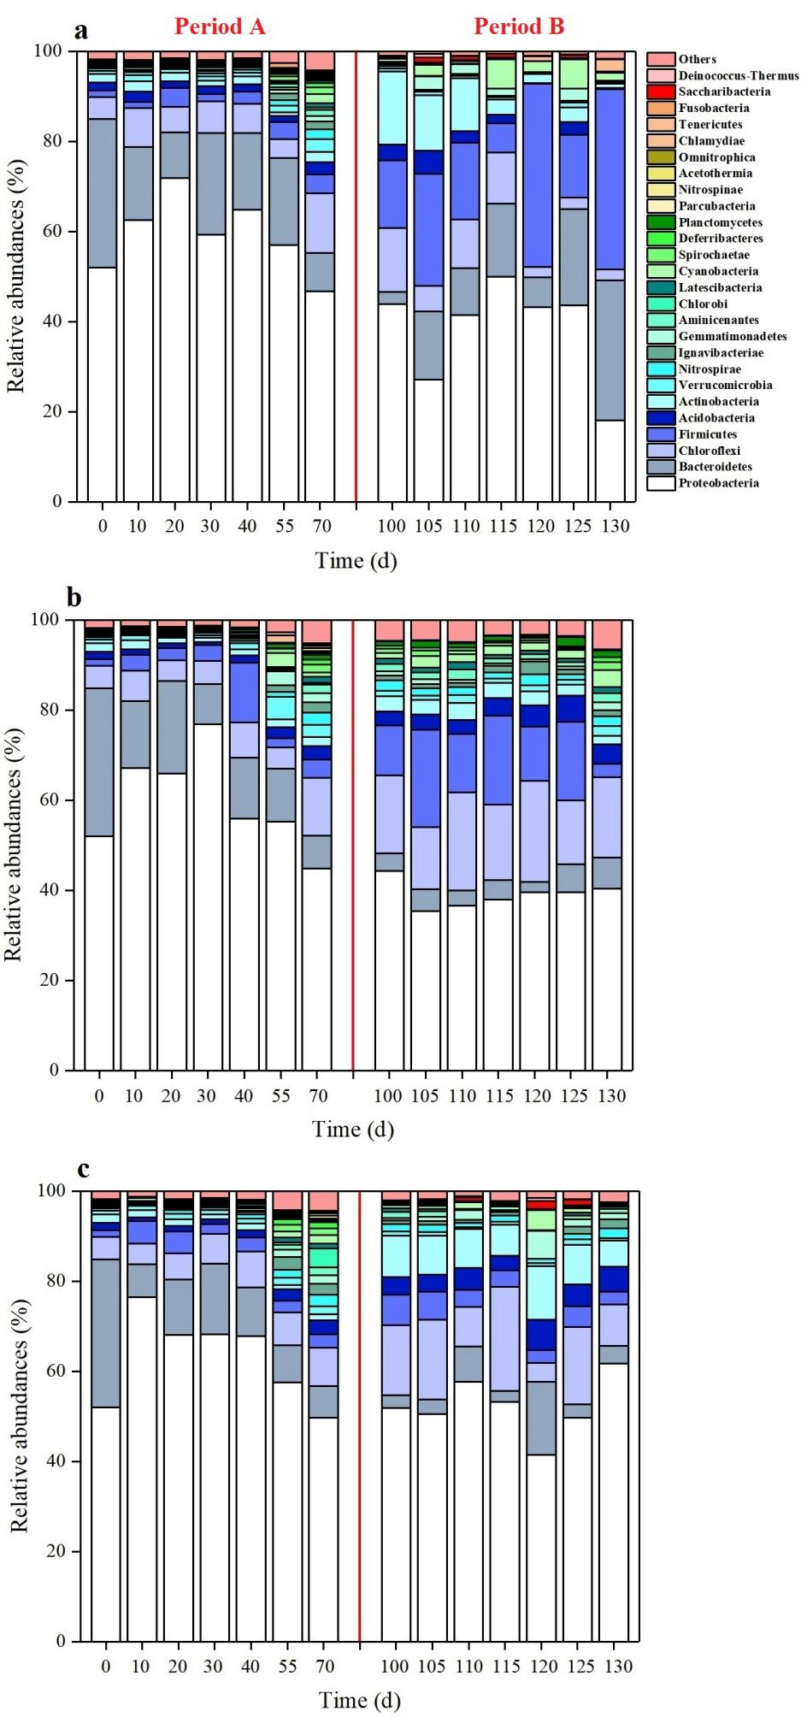
Fig. S3. Bacterial community compositions at phylum level: (a) S1, (b) S2, (c) S3
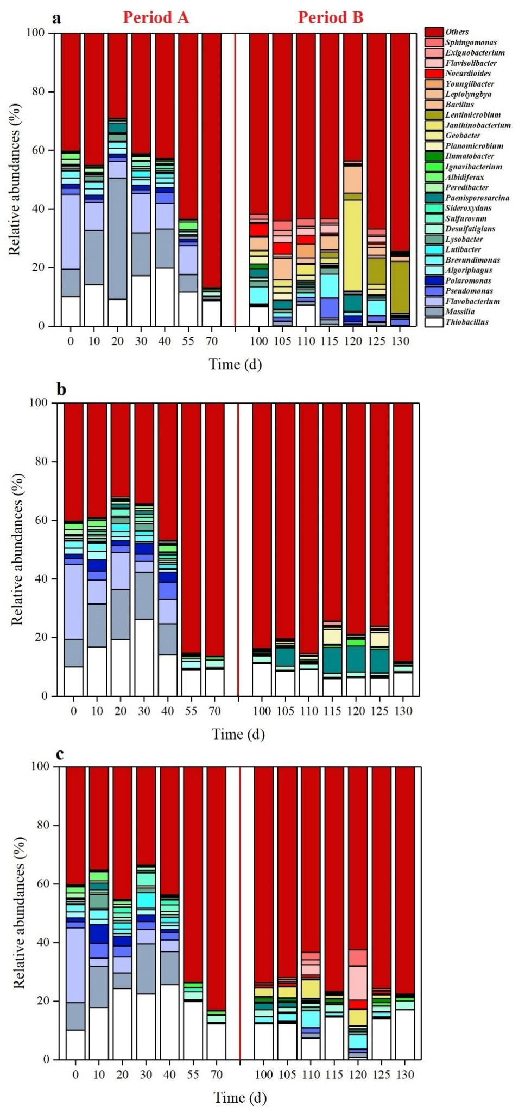
Fig. S4. Bacterial community compositions at genus level: (a) S1, (b) S2, (c) S3
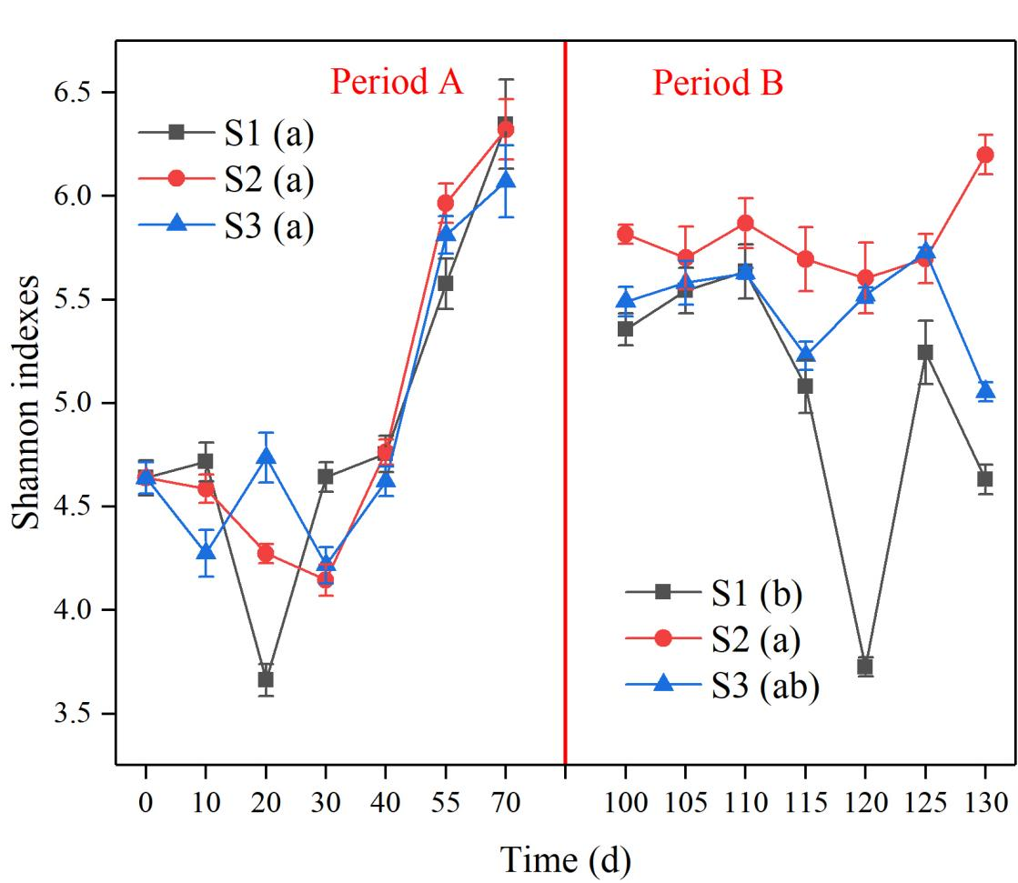
Fig. S5. Shannon indexes of sediment bacteria; different letters in brackets indicate significant differences at P<0.05 according to Tukey’s test
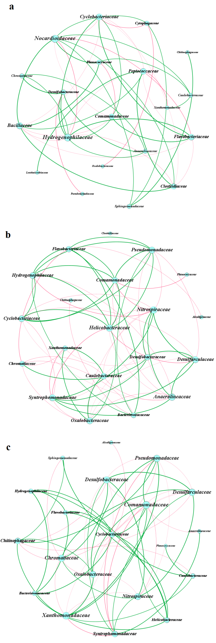
Fig. S6. Network constructed around main bacterial families based on Spearman rank correlation coefficients under salinity gradient: (a) S1, (b) S2, (c) S3. Green indicates a significant positive correlation (P<0.05), and red indicates a significant negative correlation (P<0.05); size of each node is proportional to number of connections.

