Supporting Information

Glycosylation of the antimicrobial peptide LL-III: Effects on membrane perturbation, protease stability, and biological activity
Attila Tortorella^{1,#}, Linda Leone¹, Angelina Lombardi¹, Elio Pizzo², Andrea Bosso², Roland Winter³, Luigi Petraccone¹, Pompea Del Vecchio^{1,}* and Rosario Oliva^{1,}*
¹ Department of Chemical Sciences, University of Naples Federico II, Via Cintia 4, I-80126, Naples, Italy
² Department of Biology, University of Naples Federico II, Via Cintia 4, I-80126, Naples, Italy
³ Department of Chemistry and Chemical Biology, Biophysical Chemistry, TU Dortmund University, Otto-Hahn-Str. 4a, D-44227, Dortmund, Germany
# Present address: Scuola Superiore Meridionale (SSM), Largo San Marcellino 10, I-80138, Naples, Italy

Corresponding authors: pompea.delvecchio@unina.it (P.D.V.), rosario.oliva2@unina.it (R.O.)

Figure S1 RP-HPLC chromatogram at l = 210 nm of crude LL-III peptide. The desired product is eluted at R_{T} = 25.80 min (yield = 58%).
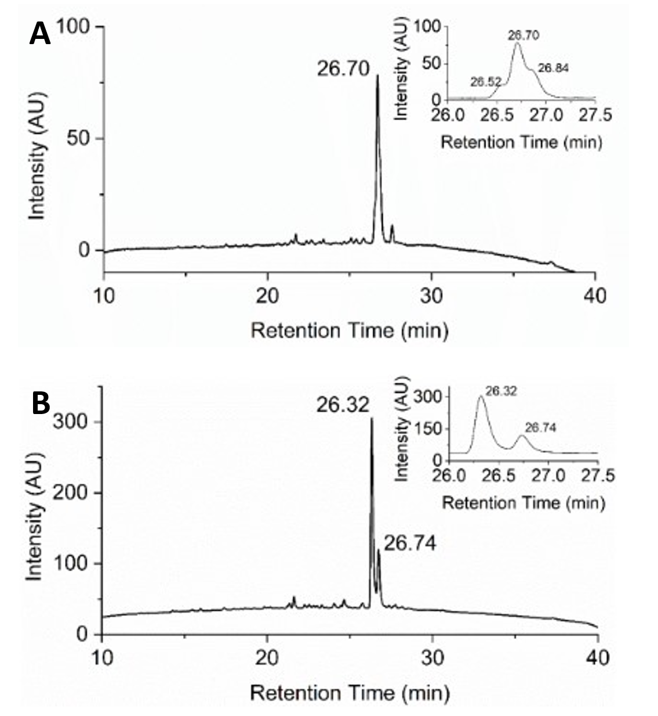

Figure S2 RP-HPLC chromatograms at l = 210 nm of crude g-LL-III peptide before (A) and after (B) sugar deprotection. The insets show the main peaks in detail. The fully deprotected product is eluted at R_{T} = 26.32 min (yield = 63%).

Figure S3 RP-HPLC chromatograms at l = 210 nm of pure LL-III peptide.

Figure S4 ESI-MS spectrum of LL-III peptide. The signal at m/z = 589.4 Th corresponds to the [M+3H⁺]³⁺ ion and the signal at m/z = 883.0 Th corresponds to the [M+2H⁺]²⁺ ion. The derived experimental isotopic mass (1764.6 ± 0.6 Da) is in agreement with the theoretical value of 1764.2 Da.

Figure S5 RP-HPLC chromatograms at l = 210 nm of pure g-LL-III peptide.

Figure S6 ESI-MS spectrum of g-LL-III peptide. The signal at m/z = 657.1 Th corresponds to the [M+3H⁺]³⁺ ion and the signal at m/z = 985.3 Th corresponds to the [M+2H⁺]²⁺ ion. The derived experimental isotopic mass (1968.4 ± 0.2 Da) is in agreement with the theoretical value of 1968.3 Da.

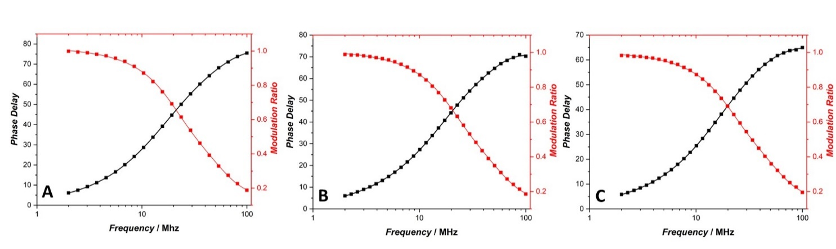
Figure S7 Frequency responses (phase and modulation) of DPH (1.4 µM) embedded in POPC/POPG LUVs (50 µM), in the absence (A) and in the presence of (B) g-LL-III and (C) LL-III, at L/P = 10. The excitation was from a 370-nm LED laser. The emission was collected through a 395 nm long-pass filter. Dimethyl-POPOP was used as standard (τ = 1.45 ns). The data are best fitted with two decay times (with χ² equals to 0.456, 0.901 and 1.464 for the experiments carried out in the absence of peptides, in the presence of g-LL-III and in the presence of LL-III, respectively).

Figure S8 Kinetics of the hydrolysis of the substrate AAF-AMC performed by the enzyme α-chymotrypsin. Black line is the hydrolysis of AAF-AMC in neat buffer. The red and blue lines are instead the reaction carried in the presence of and g-LL-III, respectively. All the experiments were performed at 25°C in 10 mM phosphate buffer, pH 7.4.

