Supplementary Figures

Supplementary Figure 1: Subgroup analysis: Sensitivity of all viruses combined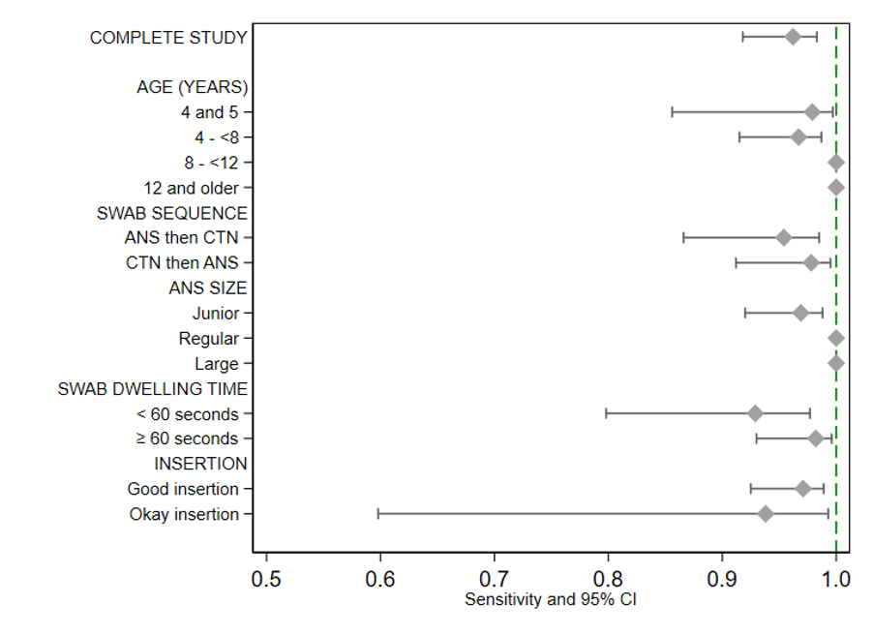

Supplementary Figure 2: Subgroup analysis for specificity
