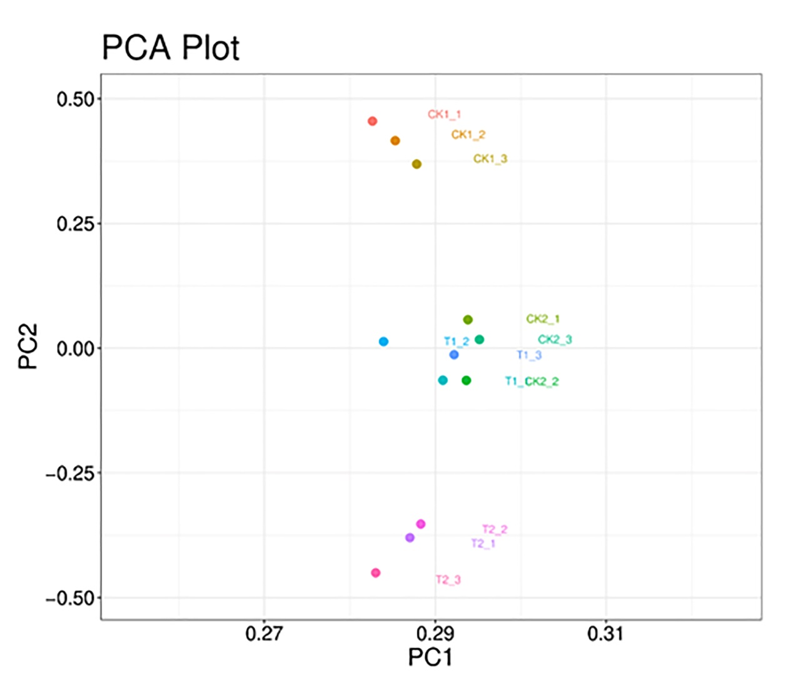
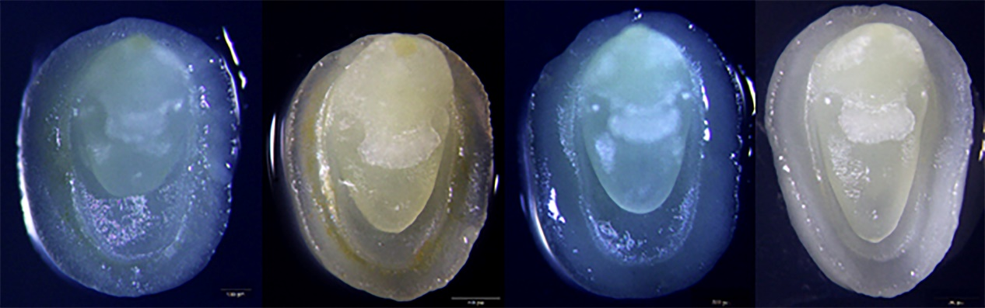Figure S1. Wheat immature embryo of 2-2.5 mm in length used in the study
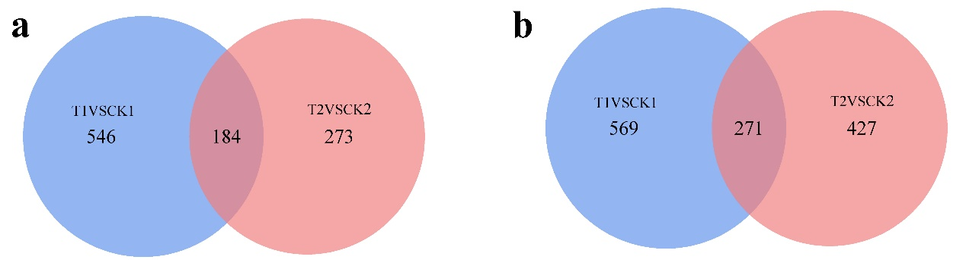
Figure S2. The PCA analysis of RNA-seq data
Figure S3. (a) Venn diagram of upregulated DEGs revealed in pair-wise comparisons; (b)Venn diagram of downregulated DEGs revealed in pair-wise comparisons

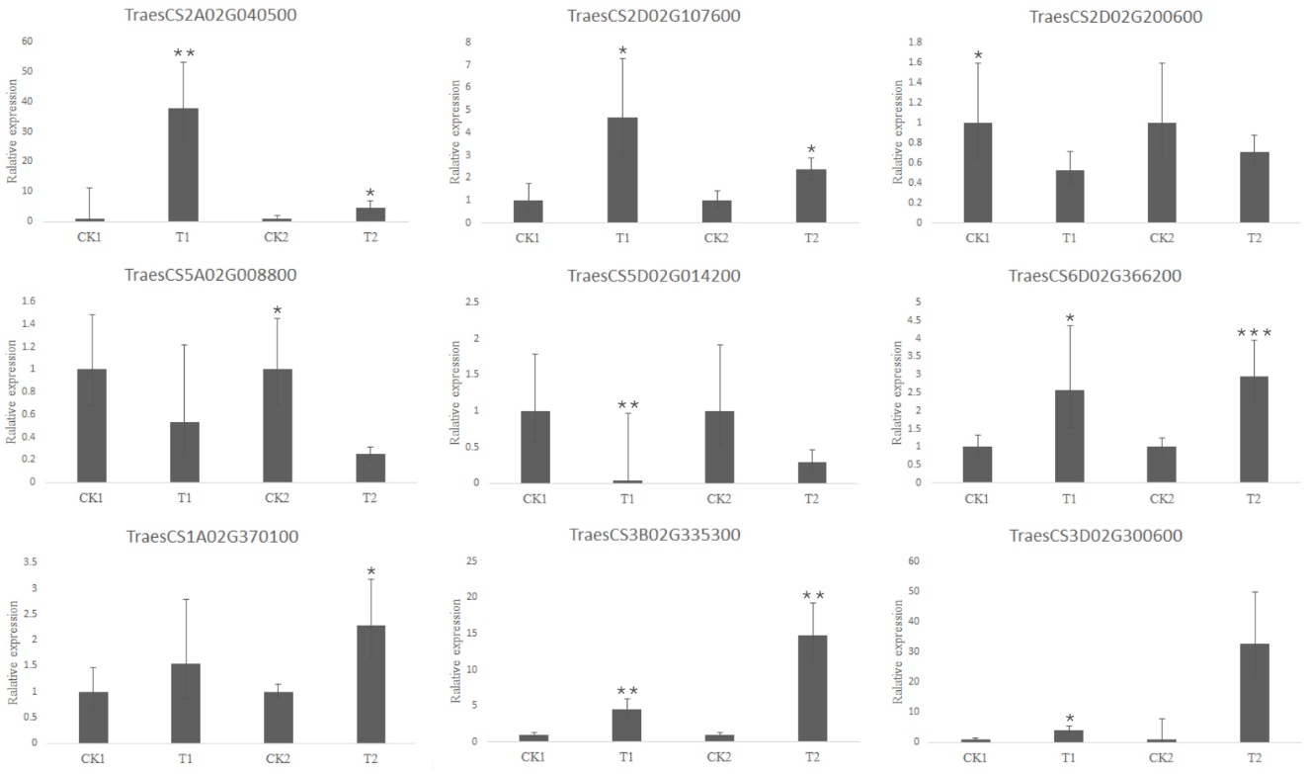
Figure S4. qRT-PCR validation of the DEGs of young embryos infected with Agrobacterium tumefaciens

