List of Tables
Table 1Purification table for LAAO enzyme extracted from Aspergillus terreusMZ769058
Step | Total Activity (U) | Total Protein (mg) | S. Activity (U/mg) | Yield (%) | Purification Fold
Crude | 289.63 | 5.57 | 51.9 | 100 | 1
ASF | 242.8 | 2.76 | 87.9 | 83.8 | 1.69
DEAE | 212 | 1.61 | 132.5 | 73.2 | 2.55

Table 2List of fragments for protonated amino acids after MALDI TOF/TOF tandem mass spectroscopy of tryptic digested LAAO enzyme (Gogichaeva and Alterman, 2019).
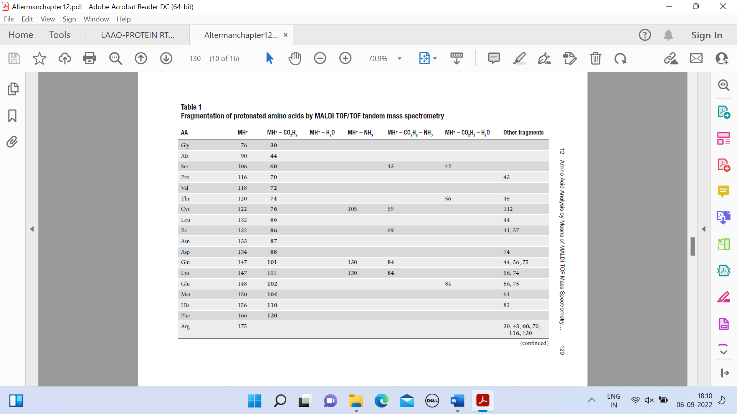
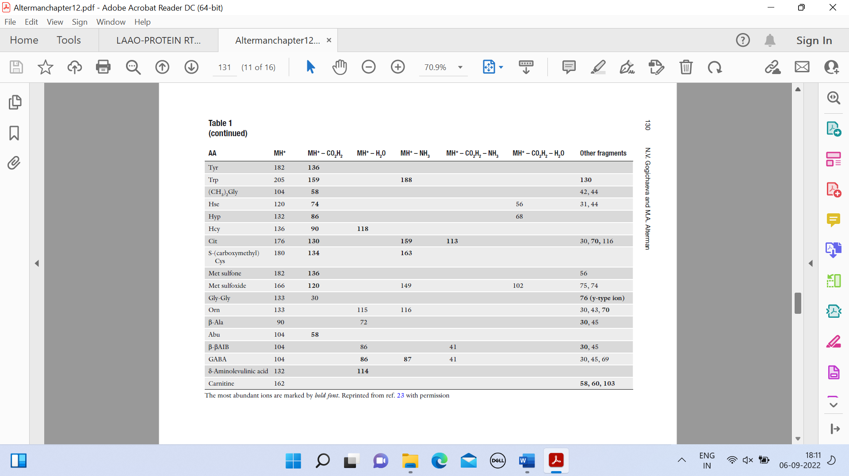

Table 3Substrate specificity of LAAO enzyme purified from Aspergillus terreusMZ769058
Substrate | Relative activity, %
L-alanine | 62.6
L-leucine | 32.2
L-methionine | 56.6
L-cysteine | 21.1
L-phenylalanine | 62.5
L-tryptophan | 72.5
L-serine | 31.3
L-threonine | 38
L-aspartic acid | 59.2
L-glutamic acid | 50
L-arginine | 43.9
L-histidine | 39.3
L-tyrosine | 100
L-isoleucine | 69.1
L-valine | 26
L-lysine | 47

Table 4 Effect of different metal ions and inhibitors on LAAO activity
Compound | Relative activity, %
MgSO₄ | 82.8
CaCl₂ | 100
H₃BO₃ | 45.7
FeSO₄ | 85.4
Na₂SO₄ | 81.2
CuSO₄ | 84.1
ZnSO₄ | 68.1
α-napthol | 34.4
EDTA | 34.2
Glycine | 39
Sodium azide | 41.4
Riboflavin | 85.3

