Supplementary Material

Supplementary Figure S1 APR-246 can kill Eµ-Myc mouse lymphoma cells irrespective of their TRP53 status.
a Diagram showing the generation of isogenic background Eµ-Myc mouse lymphoma cell lines with four different TRP53 states: parental wt TRP53, wt TRP53 plus mutant TRP53, TRP53 deficient and TRP53 deficient plus mutant TRP53. b Western blot analysis showing TRP53 expression in each variant of the isogenic Eµ-Myc lymphoma cell lines. Probing for β-actin was used as a loading control. c The Eµ-Myc lymphoma cell lines with the four different TRP53 states were treated for 24 h with the MDM2 inhibitor, nutlin-3a (10 μM), a potent activator of wt TRP53. Cell viability was measured by staining cells with PI followed by flow cytometric analysis. d The Eµ-Myc lymphoma cell lines with the four different TRP53 states were treated for 48 h with the indicated concentrations of APR-246. Cell viability was measured by staining cells with PI followed by flow cytometric analysis. N= 3 independent experiments per cell line. Data are presented as mean ± S.D.
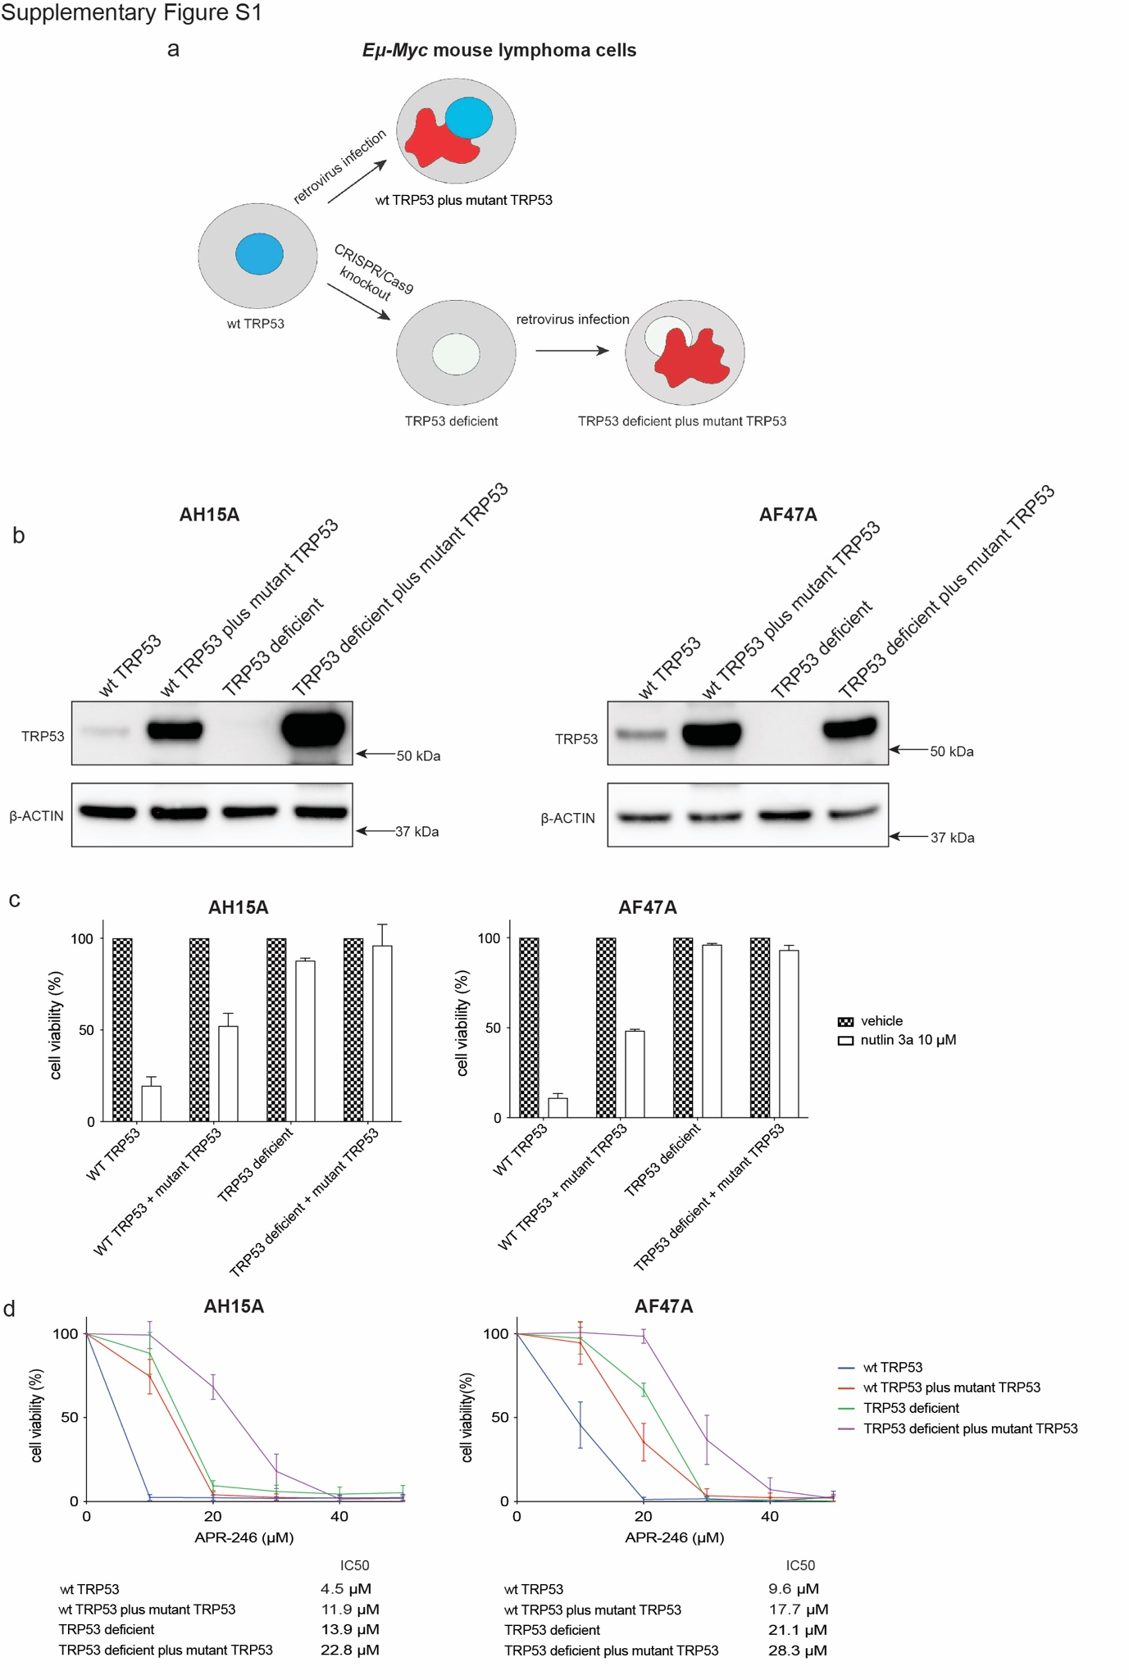
Supplementary Figure S2 APR-246 induces the expression of the same gene sets in Eμ-Myc mouse lymphoma cells of all four possible TRP53 states: wt TRP53 (parental), wt TRP53 alongside mutant TRP53, TRP53 knockout and TRP53 knockout alongside mutant TRP53.
a Glimma interactive MD plot showing that Trp53 mRNA expression was not altered upon APR-246 treatment. b Glimma interactive MD plot showing the top differentially expressed genes in Eμ-Myc lymphoma cells of each of the four possible TRP53 states: wt TRP53 (parental), wt TRP53 plus mutant TRP53. TRP53 knockout and TRP53 knockout plus mutant TRP53. c The genes for the BH3-only proteins Puma, Bim and Noxa, but not the genes for Bid, Bad, Bik and Bmf, are induced in Eμ-Myc lymphoma cells of all possible TRP53 states upon treatment with APR-246.
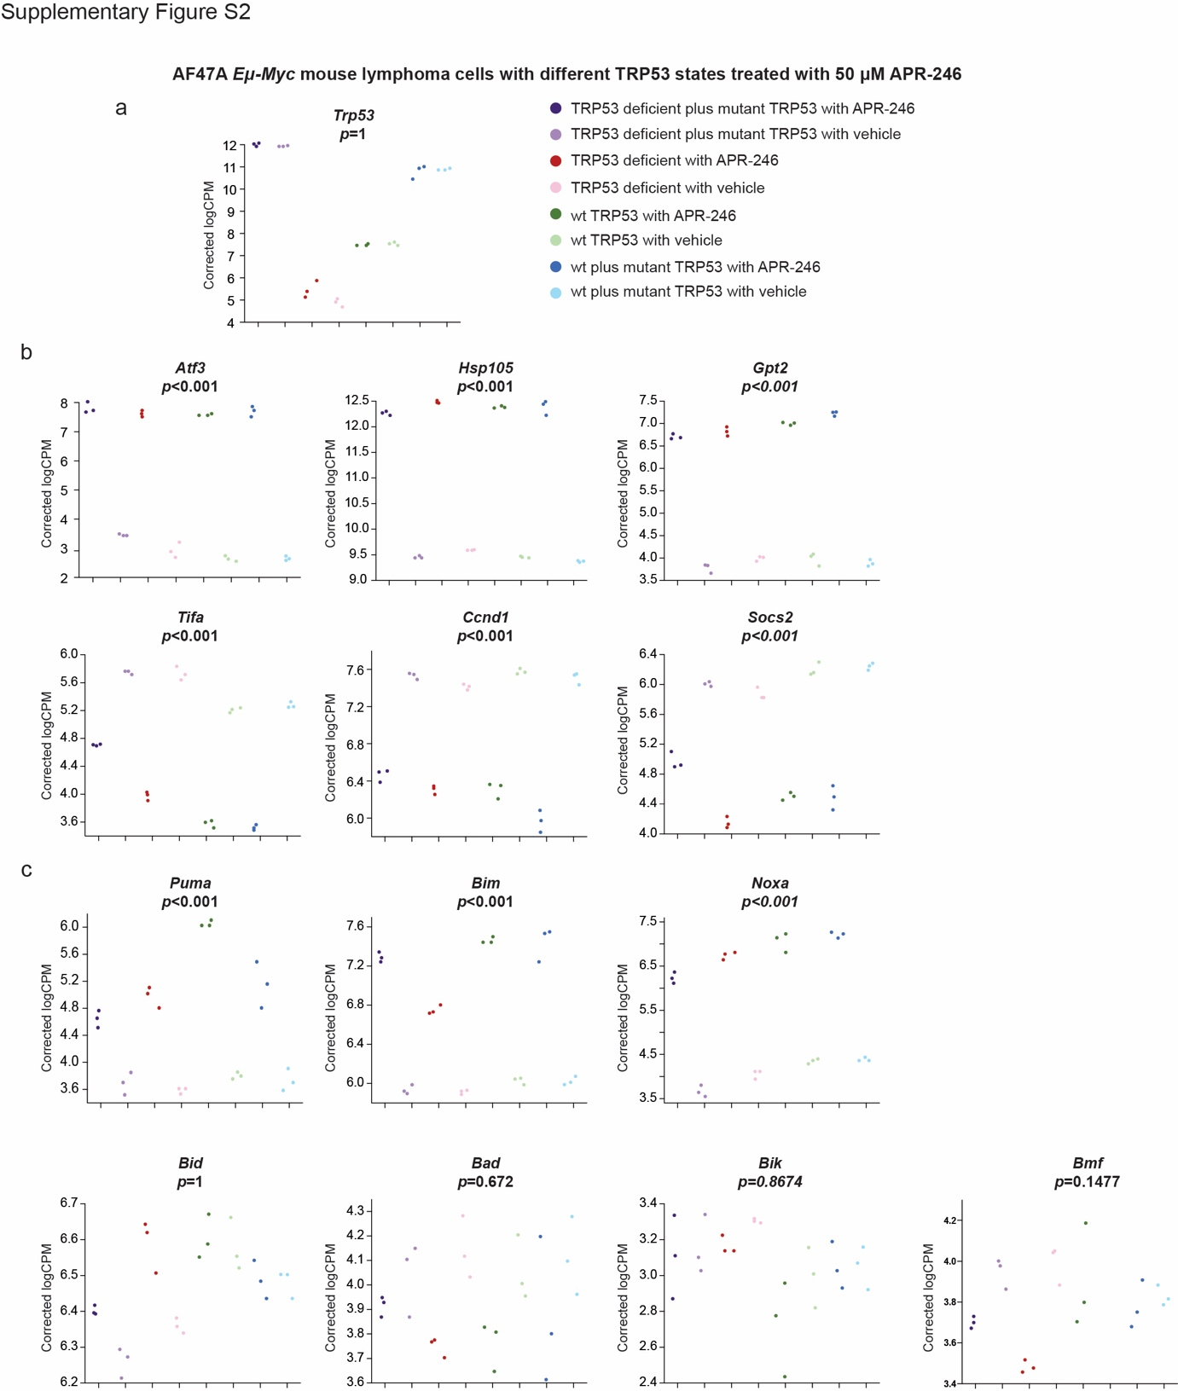

Supplementary Figure S3 Low doses of APR-246 induce apoptosis in wt Eμ-Myc mouse lymphoma cells.
Parental Eμ-Myc lymphoma cells expressing wt TRP53 were treated with a relatively low dose (15 μM) of APR-246. Nuclear fragmentation as well as shrinkage of cells, both hallmarks of apoptosis, were detected by microscopy. Arrows point to cells undergoing apoptosis.
Green: GFP; Red: PI; White: Annexin V. Magnification: 1000x;
scale bar: 10 μm.
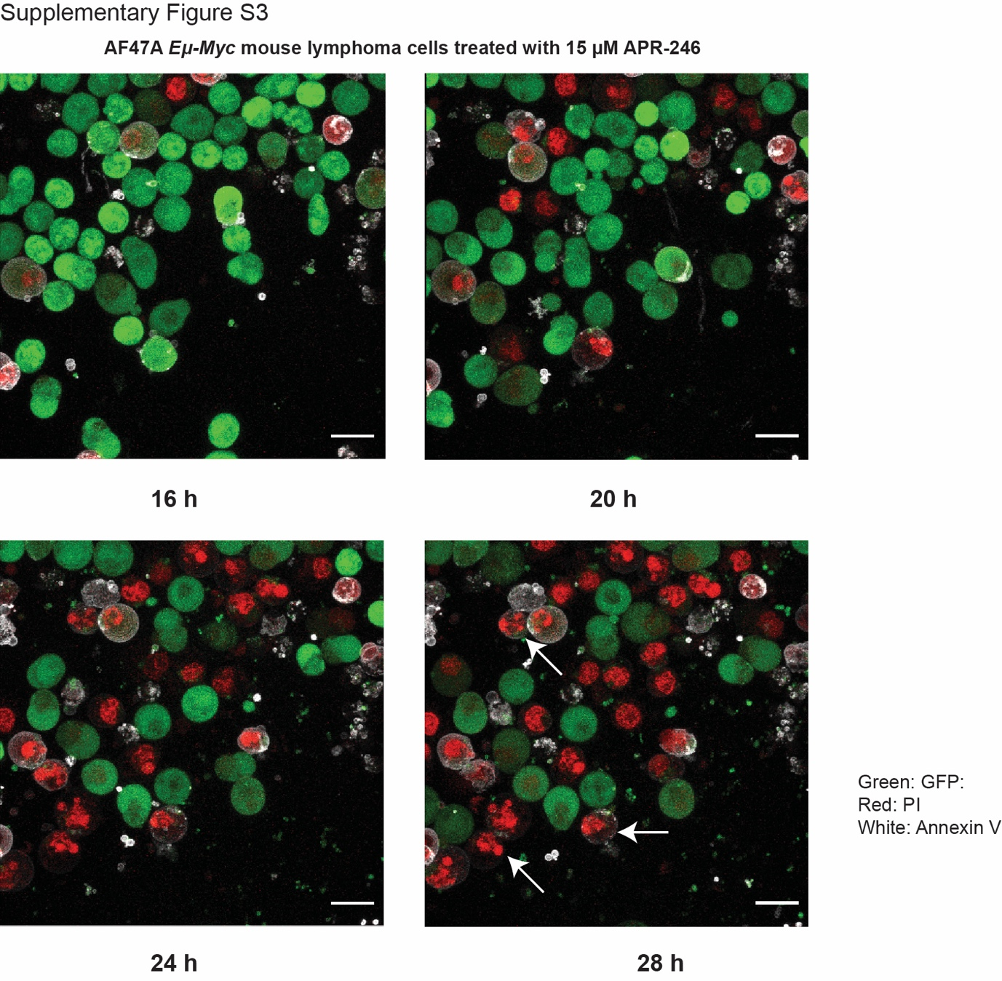

Supplementary Figure S4 APR-246 can kill A549 human lung cancer and HCT116 human colon cancer derived cell lines independent of the activation of the intrinsic apoptosis pathway.
A549 and HCT116 human lung and colon cancer cells, respectively, either parental or their BAX/BAK double knockout derivatives, were treated for 48 h with APR-246. Cell viability was measured by PI staining and flow cytometric analysis. N= 3 independent experiments for all cell lines and genotypes. Data are presented as mean ± S.D.
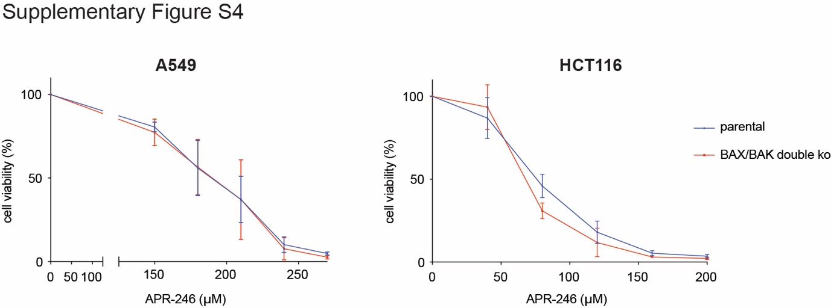

Supplementary Figure S5 Verification of effective inhibition of apoptosis and necroptosis in U937 human histiocytic lymphoma and HT29 human colon cancer cell lines afforded by the combined deletion of BAX, BAK and MLKL.
a U937 human histiocytic lymphoma cells and HT29 human colon cancer cells, parental or their BAX/BAK/MLKL triple knockout derivatives, were treated for 24 h with either vehicle or a cocktail of three BH3 mimetic compounds: 1 μM ABT-737 (targets BCL-2, BCL-XL and BCL-W) + 1 μM A1331852 (targets BCL-XL) + 1 μM S63845 (targets MCL-1). Cell viability was measured by staining cells with PI followed by flow cytometric analysis. b U937 and HT29 cells, parental or their BAX/BAK/MLKL triple knockout derivatives, were treated for 24 h with either vehicle or TSI (100 ng/mL TNFα + 0.5 μM SMAC mimetic Compound A + 5 μM IDN-6556 (broad spectrum caspase inhibitor)). Cell viability was measured by staining cells with PI followed by flow cytometric analysis. N= 3 independent experiments for each cell line and genotype. Data are presented as mean ± S.D.
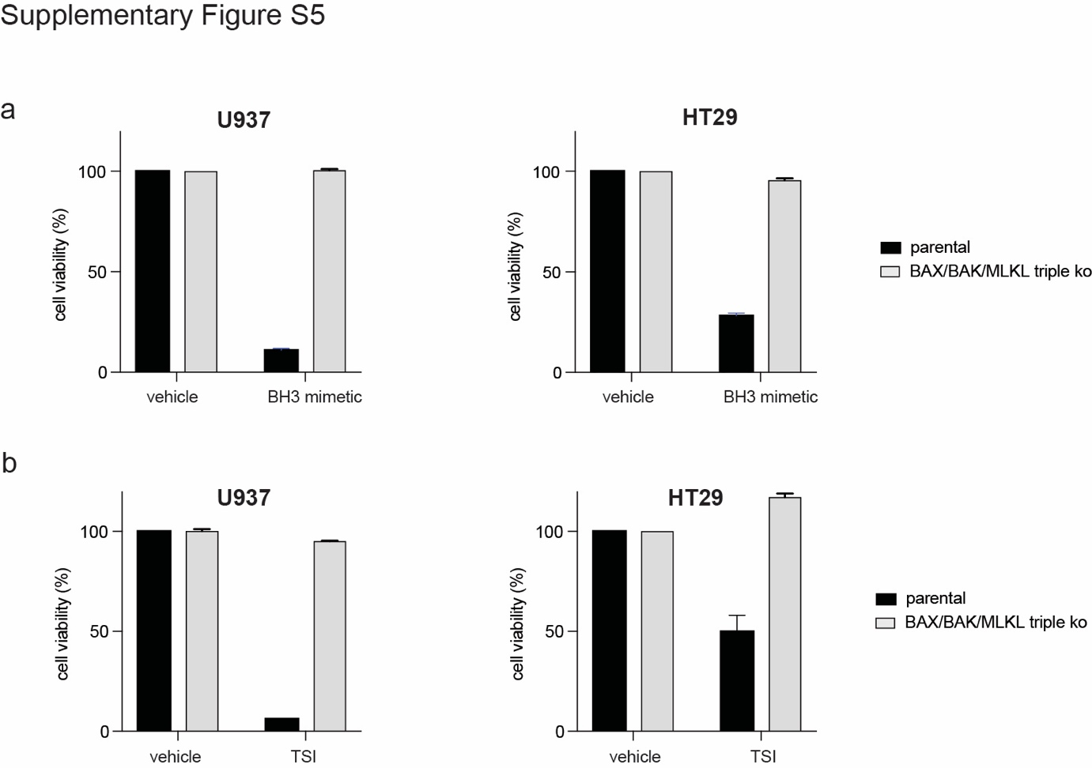

Supplementary Figure S6 Necroptosis and ferroptosis do not contribute to APR-246 induced killing of Eµ-Myc mouse lymphoma cells.

a Western blot analysis showing the deletion of MLKL in BAX/BAK double knockout Eµ-Myc lymphoma cells. Probing for β-actin was used as a loading control. The loss of MLKL did not protect these cells from killing by APR-246. b Ferrostatin-1 did not protect BAX/BAK/MLKL triple knockout Eµ-Myc lymphoma cells from killing by APR-246 although these cells were sensitive to the ferroptosis inducer RSL-3 (1 μM). N= 3 independent experiments. Data are presented as mean ± S.D.
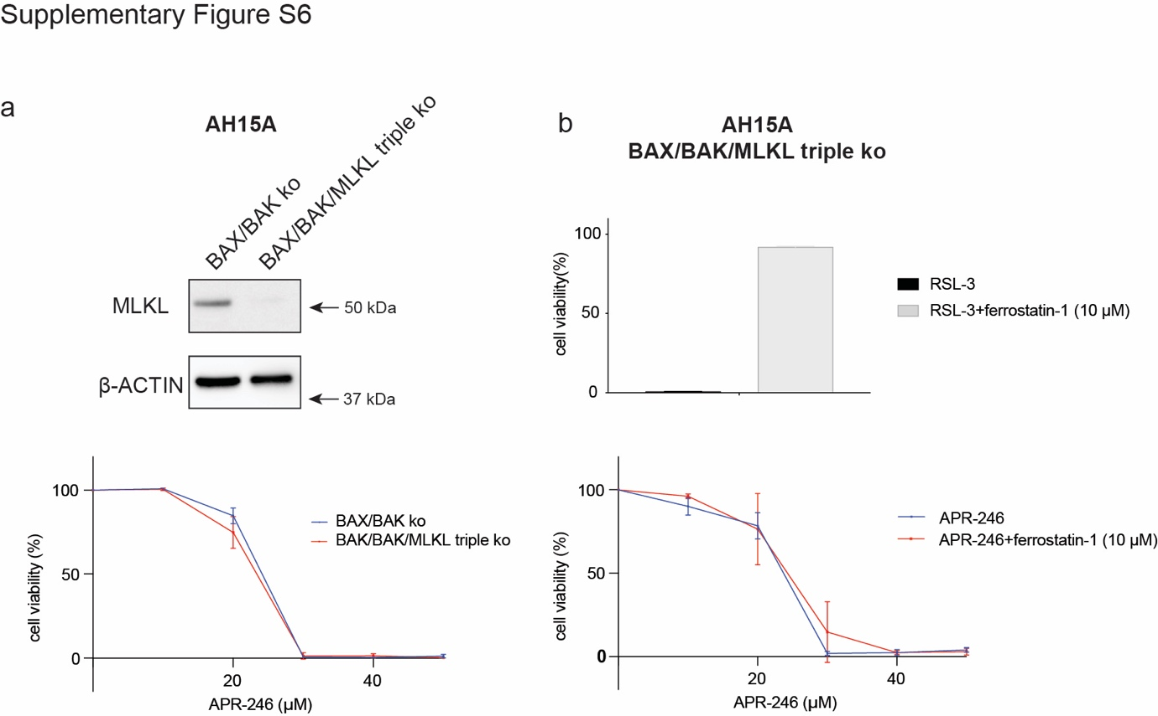

Supplementary Figure S7 Verification of effective inhibition of ferroptosis in U937 human histiocytic lymphoma and HT29 human colon cancer cell lines by ferrostatin-1.
BAX/BAK/MLKL triple knockout derivatives of U937 human histiocytic lymphoma cells and HT29 human colon cancer cells were treated for 6 h with either 1 μM RSL-3 (inducer of ferroptosis) alone or 1 μM RSL-3 plus 10 μM ferrostatin-1 (inhibitor of ferroptosis). Cell viability was measured by staining cells with PI followed by flow cytometric analysis. N= 3 independent experiments. Data are presented as mean ± S.D.
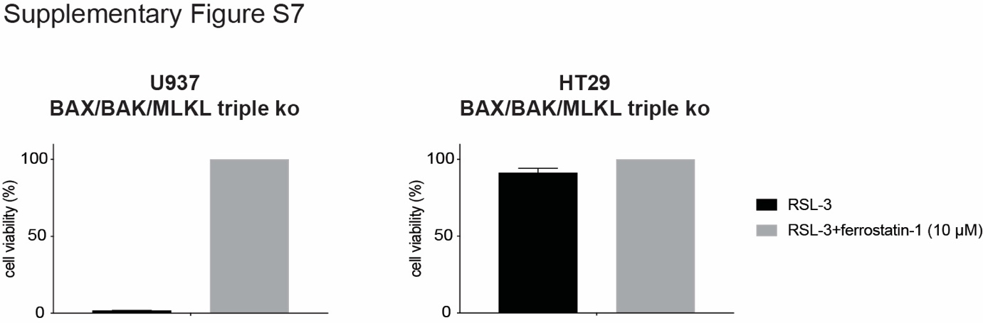

Supplementary Figure S8 BAX/BAK-mediated apoptosis and ferroptosis cooperate in APR-246 induced killing of U937 human histiocytic lymphoma cells.
U937 human histiocytic lymphoma cells, parental, BAX/BAK double knockout and MLKL knockout, were treated for 48 h with the indicated concentrations of APR-246, either alone or plus the inhibitor of ferroptosis, 10 μM ferrostatin-1. Cell viability was measured by staining cells with PI followed by flow cytometric analysis. N= 3 independent experiments for each cell line and genotype. Data are presented as mean ± S.D.

Supplementary Figure S9 Impact of loss of NINJ1 on the nature of cell death induced by APR-246 in Eμ-Myc mouse lymphoma cells
a NINJ1 knockout AF47A Eμ-Myc mouse lymphoma cells expressing wt TRP53 were treated with a relatively low dose (20 μM) of APR-246 that causes apoptosis in the parental Eμ-Myc mouse lymphoma cells. b NINJ1/BAX/BAK triple knockout AF47A Eμ-Myc mouse lymphoma cells expressing wt TRP53 were treated with a relatively high dose (50 μM) of APR-246 that causes non-apoptotic lytic cell death in the Eμ-Myc mouse lymphoma cells. Green: GFP; Red: PI. Magnification: 630X; Scale bar: 10 μm.
White arrows point to cells undergoing swelling after treatment with APR-246.

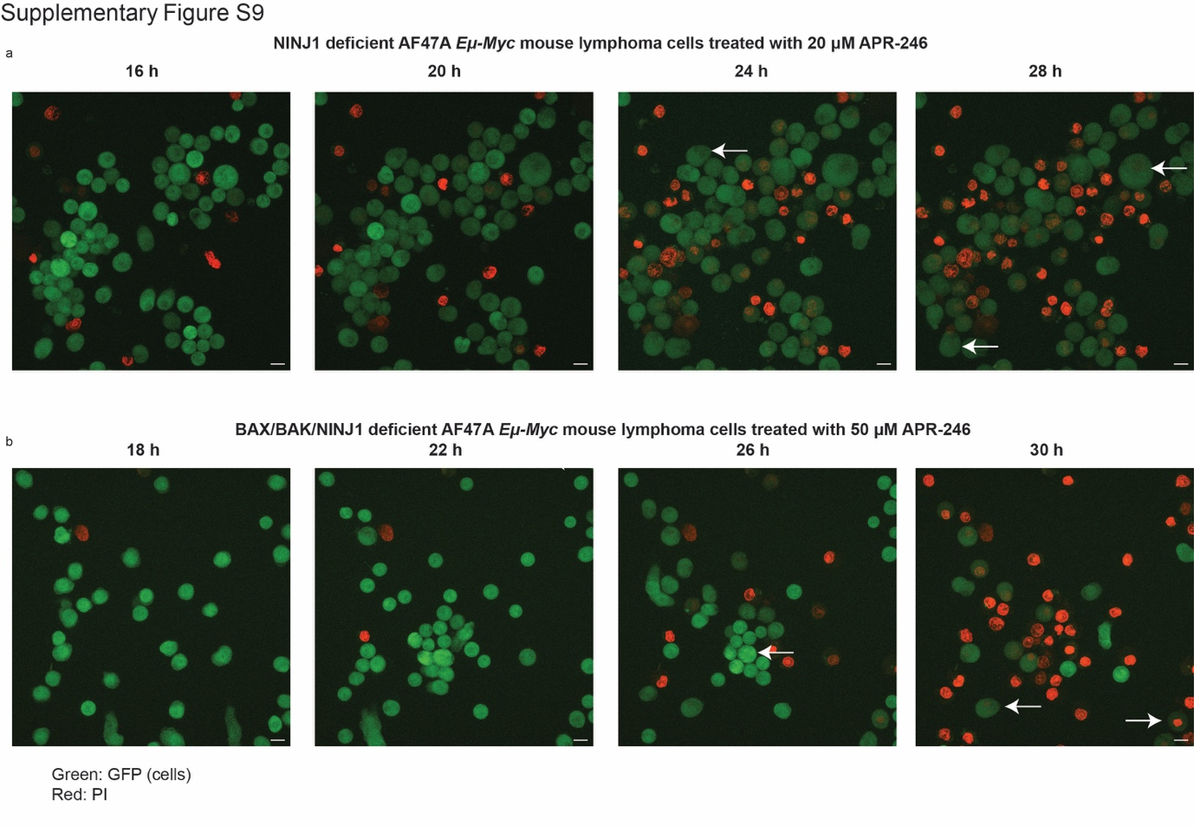

Supplementary Figure S10 NINJ1 mediates APR-246 induced lytic cell death in U937 human histiocytic lymphoma cells and HT29 human colon cancer cells.
a NGS sequencing showing the deletion of NINJ1 in U937 human histiocytic lymphoma cells and HT29 human colon cancer cell lines, either parental or their BAX/BAK double knockout derivatives. b U937 and HT29 cells of the indicated genotypes (parental; parental with NINJ1 knockout; BAX/BAK double knockout; BAX/BAK double knockout with additional knockout of NINJ1) were treated for 48 h with the indicated concentrations of APR-246. Cell viability was measured by staining cells with PI followed by flow cytometric analysis. c U937 and HT29 cells of the indicated genotypes (see above) were treated for 24 h or 48 h with the indicated concentrations of APR-246. LDH release was measured using the CytoTox Non-Radioactive Cytotoxicity assay. N= 3 independent experiments for each cell line and cell variant. Data are presented as mean ± S.D.

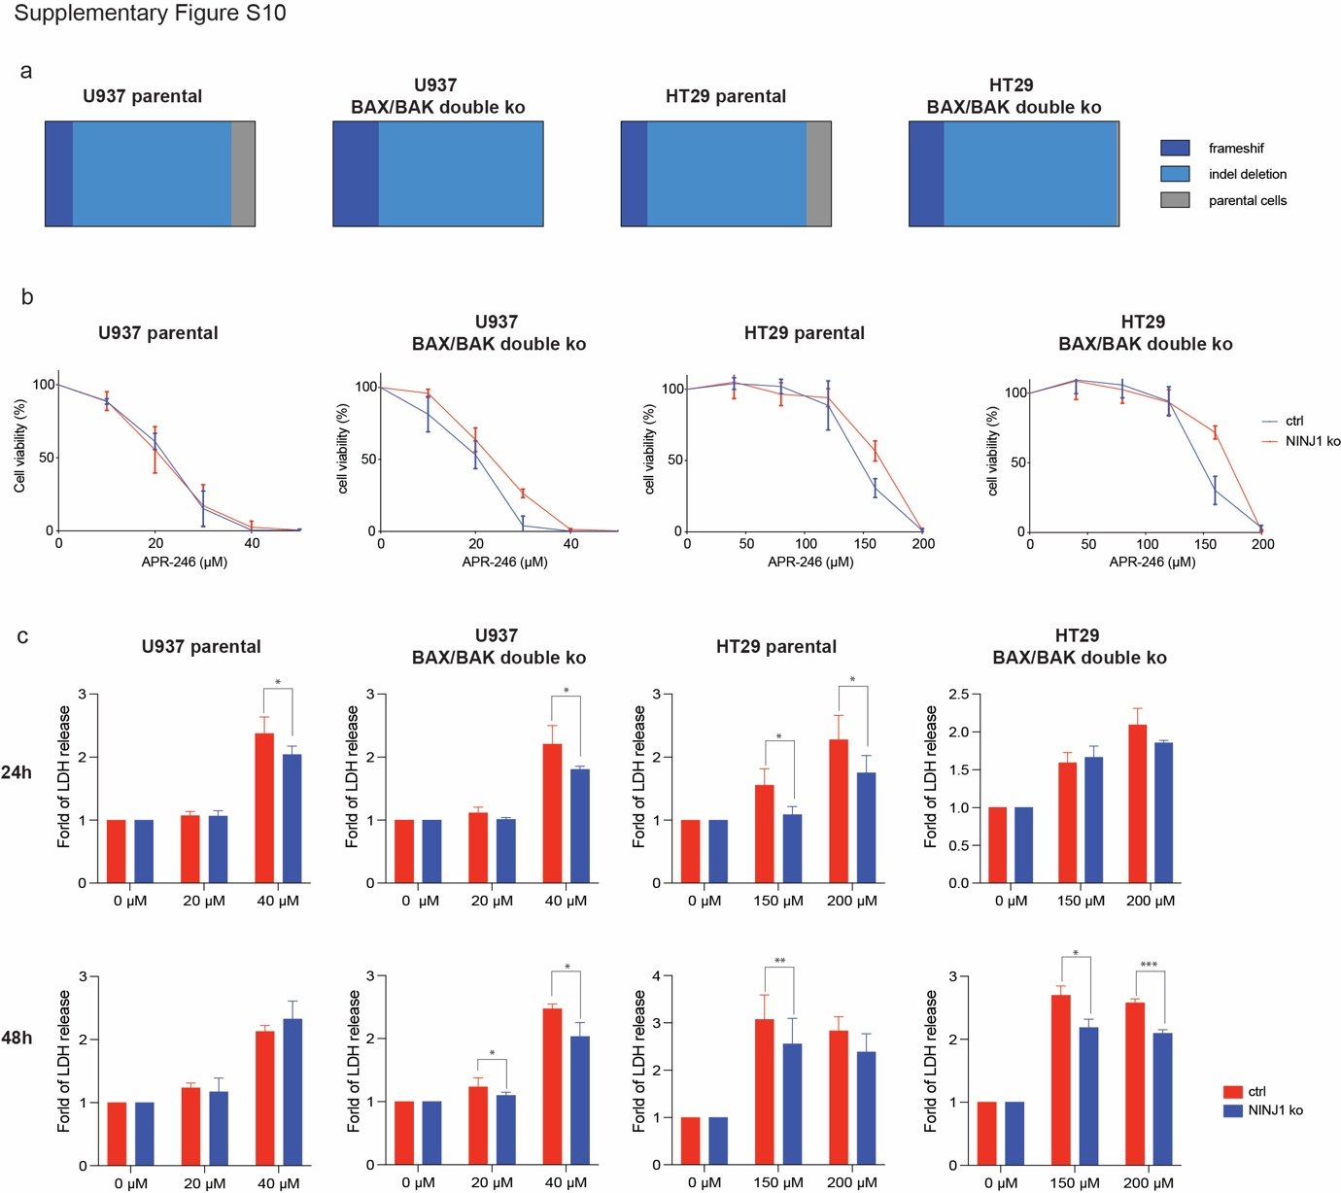

Supplementary Table S1 Cancer derived cell lines used in this study.
Cell lines | Malignancies | TP53  states | Organism
MDA-MB-231 | Breast cancer | R280K | Human
HT29 | Colorectal cancer | R273H | Human
SW620 | Colorectal cancer | R273H+P309S | Human
Rael.BL | Burkitt lymphoma | R282W | Human
A549 | Lung cancer | wt | Human
HCT116 | Colorectal cancer | wt | Human
SJSA-1 | Osteosarcoma | wt | Human
U937 | Histiocytic Lymphoma | null | Human
EMRK1172 | Eμ-Myc lymphoma | D278N | Mouse
MRE412 | Eμ-Myc lymphoma | R246Q | Mouse
AH15A | Eμ-Myc lymphoma | wt | Mouse
AF47A | Eμ-Myc lymphoma | wt | Mouse

Supplementary Table S2 Primers used to sequence mouse Trp53 exons
Primer name | Sequences
EX4_1 Forward | 5’-GTGACCTATGAACTCAGGAGTCCAGAGCAGAAAGGGACTTGG
EX4_1 Reverse | 5’-CTGAGACTTGCACATCGCAGCGCCATAGTTGCCCTGGTAAG
EX4_2 Forward | 5’-GTGACCTATGAACTCAGGAGTCTTTTGAAGGCCCAAGTGAAG
EX4_2 Reverse | 5’-CTGAGACTTGCACATCGCAGCAGGCATTGAAAGGTCACACG
EX5 Forward | 5’-GTGACCTATGAACTCAGGAGTCCGACCTCCGTTCTCTCTCC
EX5 Reverse | 5’-CTGAGACTTGCACATCGCAGCGAGGCTGCCAGTCCTAACC
EX6 Forward | 5’-GTGACCTATGAACTCAGGAGTCCGGCTTCTGACTTATTCTTGC
EX6 Reverse | 5’-CTGAGACTTGCACATCGCAGCCCCTTCTCCCAGAGACTGC
EX7 Forward | 5’-GTGACCTATGAACTCAGGAGTCGTAGGGAGCGACTTCACCTG
EX7 Reverse | 5’-CTGAGACTTGCACATCGCAGCCCCTAAGCCCAAGAGGAAAC
EX8 Forward | 5’-GTGACCTATGAACTCAGGAGTCTCTTACTGCCTTGTGCTGGTC
EX8 Reverse | 5’-CTGAGACTTGCACATCGCAGCTGTGGAAGGAGAGAGCAAGA
EX9 Forward | 5’-GTGACCTATGAACTCAGGAGTCCCCAAAGTCACCTCTTGCTC
EX9 Reverse | 5’-CTGAGACTTGCACATCGCAGCGAGAACCACTGTCGGAGGAG
EX10 Forward | 5’-GTGACCTATGAACTCAGGAGTCGGTTGTGTGACCTTGTCCAG
EX10 Reverse | 5’-CTGAGACTTGCACATCGCAGCAGCAGGGTGGGGTTTTTATC
EX11 Forward | 5’-GTGACCTATGAACTCAGGAGTCCCAAACTGCTAGCTCCCATC
EX11 Reverse | 5’-CTGAGACTTGCACATCGCAGCGGCCAGGAACCACTACTCAG

