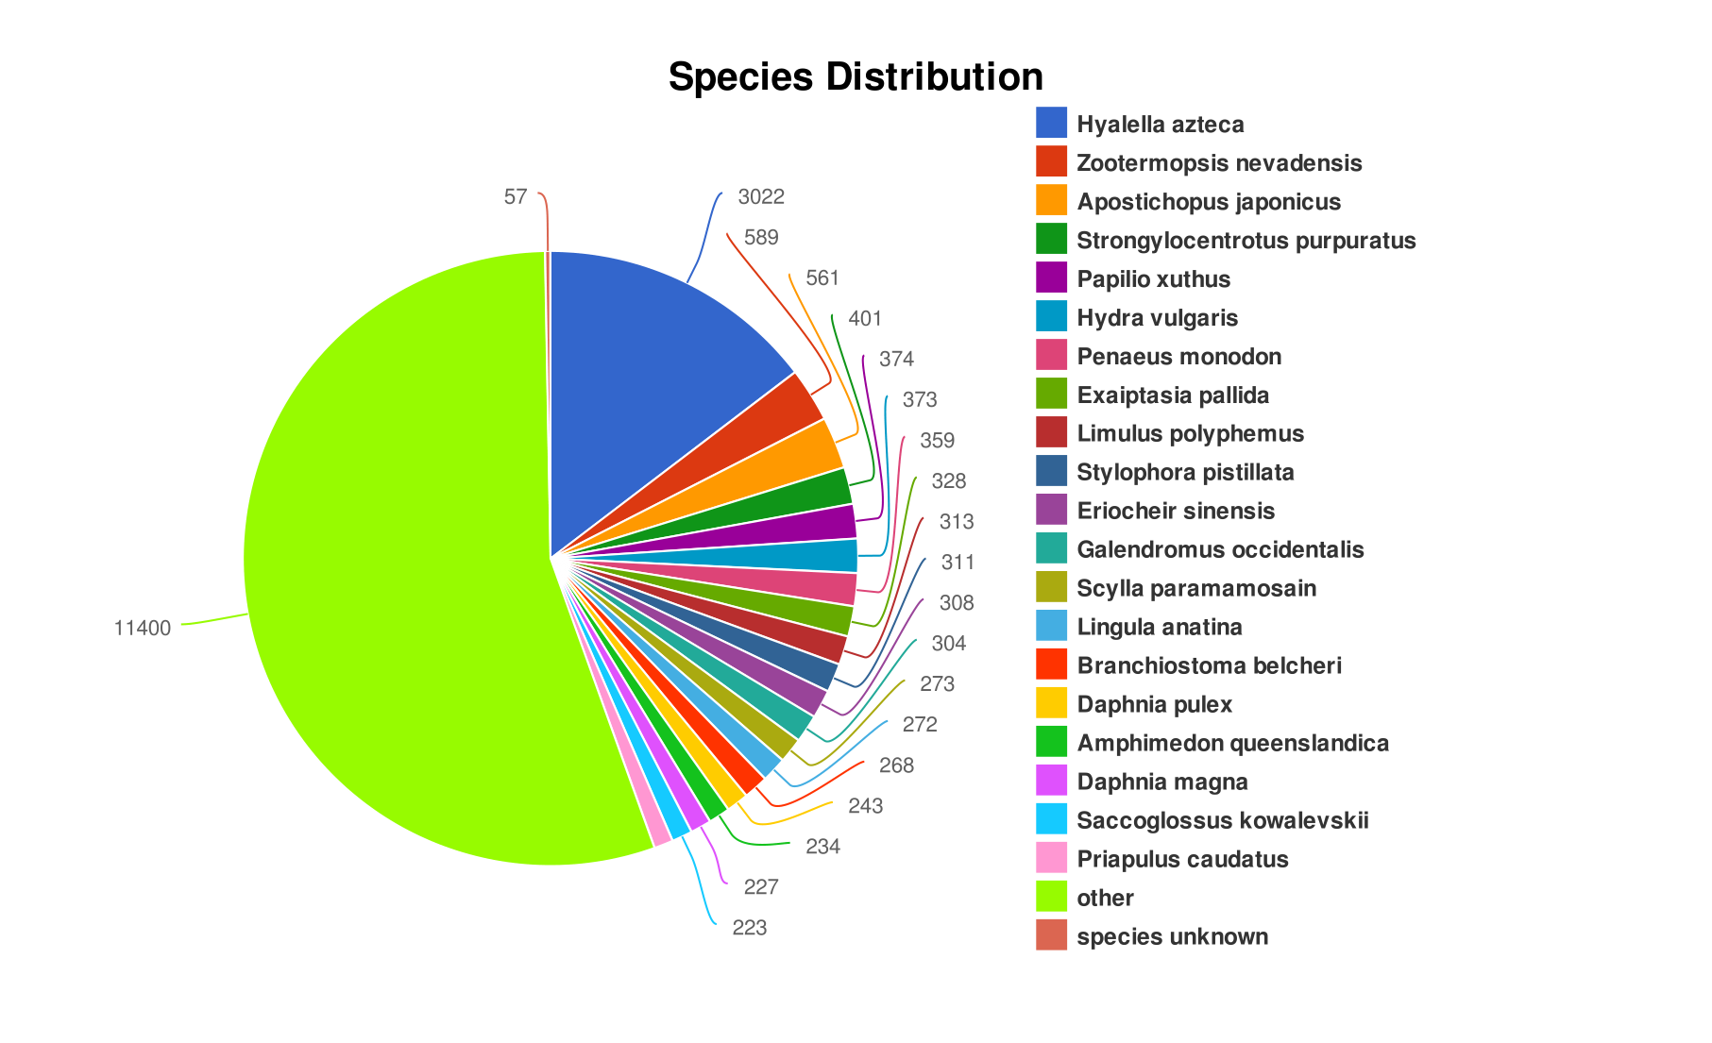
Fig. S1 The comparison of species distribution map reflects the near source species of sequenced sample species. Each fan represents a species. The larger the fan area, the greater the number of sequences aligned to the species

