Supporting Information for:
Toehold switch-based genetic modulator for tuning of riboswitch sensor

Yunhee Hwang ^{a,1}, Seong Gyeong Kim^{a,1}, Sungho Jang^{a,1}, Jongmin Kim^{b,*},
Gyoo Yeol Jung^{a,c,**}

ª Department of Chemical Engineering, Pohang University of Science and Technology, 77 Cheongam-ro, Nam-gu, Pohang, Gyeongbuk 37673, Korea
^{b} Integrative Biosciences and Biotechnology, Pohang University of Science and Technology, 77 Cheongam-ro, Nam-gu, Pohang, Gyeongbuk 37673, Korea
^{c} School of Interdisciplinary Bioscience and Bioengineering, Pohang University of Science and Technology, 77 Cheongam-ro, Nam-gu, Pohang, Gyeongbuk 37673, Korea
* Corresponding author: Jongmin Kim, Mailing address: Division of Integrative Biosciences and Biotechnology, Pohang University of Science and Technology, 77 Cheongam-ro, Nam-gu, Pohang, Gyeongbuk 37673, Korea.
** Corresponding author: Gyoo Yeol Jung, Mailing address: Department of Chemical Engineering, Pohang University of Science and Technology, 77 Cheongam-ro, Nam-gu, Pohang, Gyeongbuk 37673, Korea.
E-mail address: jongmin.kim@postech.ac.kr (J. Kim); gyjung@postech.ac.kr (G. Y. Jung)
Telephone: +82-54-279-2322 (J. Kim); +82-54-279-2391 (G. Y. Jung)
¹ These authors contributed equally to this work.

Contents:
Table S1, S2, and S3
Figure S1, S2, and S3

Table S1. Strains and plasmids used in this study
Name | Relevant characteristics | Source
Strains
Mach-T1^{R} | F⁻ φ80(lacZ)ΔM15 ΔlacX74 hsdR(r_{K}-mK+) ΔrecA1398 endA1 tonA | Invitrogen
BL21(DE3) | F– ompT gal dcm hsdS_{B}(r_{B}–m_{B}–) (DE3) | Invitrogen
BL21 Star (DE3) | F– ompT gal dcm hsdS_{B}(r_{B}–m_{B}–) rne131 (DE3) | Invitrogen
W3110 | F⁻ λ⁻ rph-1 IN(rrnD, rrnE) | ATCC27325
P100 | W3110/pB12ribo-J23100-PhlF | Jang, S et al., 2018
trN1-swN1 | BL21 Star (DE3)/pACYC-B12ribo-PhlF-trN1/ pCOLA-swN1-GFP | This study
trN1-swN1_J23106 | BL21 Star (DE3)/pACYC-B12ribo-PhlF-trN1-J23106-trN1/pCOLA-swN1-GFP | This study
trN1-swN1_J23101 | BL21 Star (DE3)/pACYC-B12ribo-PhlF-trN1-J23101-trN1/pCOLA-swN1-GFP | This study
trN1-swN1_J23100 | BL21 Star (DE3)/pACYC-B12ribo-PhlF-trN1-J23100-trN1/pCOLA-swN1-GFP | This study
BL21-trN1-swN1 | BL21(DE3)/pACYC-B12ribo-PhlF-trN1/  pCOLA-swN1-GFP | This study
trN3-swN3 | BL21 Star (DE3)/pACYC-B12ribo-PhlF-trN3/ pCOLA-swN3-GFP | This study
tr1N2-sw1N2 | BL21 Star (DE3)/pACYC-B12ribo-PhlF-tr1N2/pCOLA-sw1N2-GFP | This study
trN2-swN2 | BL21 Star (DE3)/pACYC-B12ribo-PhlF-trN2/pCOLA-swN2-GFP | This study
trN6-swN6 | BL21 Star (DE3)/pACYC-B12ribo-PhlF-trN6/pCOLA-swN6-GFP | This study
swN1 | BL21 Star (DE3)/pACYC-B12ribo-PhlF-deltr/ pCOLA-swN1-GFP | This study
swN3 | BL21 Star (DE3)/pACYC-B12ribo-PhlF-deltr/ pCOLA-swN3-GFP | This study
trN1-swN3 | BL21 Star (DE3)/pACYC-B12ribo-PhlF-trN1/ pCOLA-swN3-GFP | This study
trN3-swN1 | BL21 Star (DE3)/pACYC-B12ribo-PhlF-trN3/ pCOLA-swN1-GFP | This study
Plasmids
pACYCDuet | Expression vector, Cm^{R}, p15A ori | Novagen
pCOLADuet | Expression vector, Km^{R}, ColA ori | Novagen
pB12ribo-J23100-PhlF | pACYCDuet-P_{BBa_J23100}-cbiA_rib-phlF-P_{PhlF}-tetAsgfp | Jang, S. et al., 2018
pET-trN1 | pET-P_{T7}-trigger_TypeII_N1 | Green, A.A. et al., 2017
pCOLA-swN1-GFP | pCOLA-P_{T7}-switch_TypeII_N1-gfpmut3b-asv | Green, A.A. et al., 2017
pACYC-dT7 | pACYCDuet-ΔT7 | This study
pACYC-B12ribo-PhlF-trN1 | pACYCDuet-P_{BBa_J23100}-cbiA_rib-phlF-P_{PhlF}-trigger_TypeII_N1 | This study
pACYC-B12ribo-PhlF-trN1-J23106-trN1 | pACYCDuet- P_{BBa_J23100}-cbiA_rib-phlF-P_{PhlF}-trigger_TypeII_N1-P_{BBa_J23106}-trigger_TypeII_N1 | This study
pACYC-B12ribo-PhlF-trN1-J23101-trN1 | pACYCDuet- P_{BBa_J23100}-cbiA_rib-phlF-P_{PhlF}-trigger_TypeII_N1-P_{BBa_J23101}-trigger_TypeII_N1 | This study
pACYC-B12ribo-PhlF-trN1-J23100-trN1 | pACYCDuet- P_{BBa_J23100}-cbiA_rib-phlF-P_{PhlF}-trigger_TypeII_N1-P_{BBa_J23100}-trigger_TypeII_N1 | This study
pCOLA-swN3-GFP | pCOLA-P_{T7}-switch_TypeII_N3-gfpmut3b-asv | Green, A.A. et al., 2017
pCOLA-sw1N2-GFP | pCOLA-P_{T7}-switch_TypeI_N2-gfpmut3b-asv | Green, A.A. et al., 2017
pCOLA-swN2-GFP | pCOLA-P_{T7}-switch_TypeII_N2-gfpmut3b-asv | Green, A.A. et al., 2017
pCOLA-swN6-GFP | pCOLA-P_{T7}-switch_TypeII_N6-gfpmut3b-asv | Green, A.A. et al., 2017
pACYC-B12ribo-PhlF-trN3 | pACYCDuet-P_{BBa_J23100}-cbiA_rib-phlF-P_{PhlF}-trigger_TypeII_N3 | This study
pACYC-B12ribo-PhlF-tr1N2 | pACYCDuet-P_{BBa_J23100}-cbiA_rib-phlF-P_{PhlF}-trigger_TypeI_N2 | This study
pACYC-B12ribo-PhlF-trN2 | pACYCDuet-P_{BBa_J23100}-cbiA_rib-phlF-P_{PhlF}-trigger_TypeII_N2 | This study
pACYC-B12ribo-PhlF-trN6 | pACYCDuet-P_{BBa_J23100}-cbiA_rib-phlF-P_{PhlF}-trigger_TypeII_N6 | This study
pACYC-B12ribo-PhlF-deltr | pACYCDuet-P_{BBa_J23100}-cbiA_rib-phlF | This study

Table S2. Oligonucleotides used in this study
Name | Sequence (5′-3′)ª
T7-1-remove-F | CCTGTAGAAATAATTTTGTTTAACTTTAATAAGG
T7-1-remove-R | ATTTCCTAATGCAGGAGTCGC
T7-2-remove-F | CCATCTTAGTATATTAGTTAAGTATAAGAAGGAG
T7-2-remove-R | ATTTCGATTATGCGGCC
pACYC-gibson-In-F | TCACCACAGCCAGGATCCGAATTCGAGCTCTTGACGGCTAGCTCAGTCCTAG
pACYC-gibson-In-trN1-R | TGAAGGTAGGTATGTTCGTCTCGATCAGATTAGTGATCGAGCACCTTAACGATACGGTACGTTTCG
pACYC-gibson-Ve-trN1-F | ATCTGATCGAGACGAACATACCTACCTTCATTATCTTACTTGTCTAGCATAACCCCTTGGGGC
pACYC-gibson-Ve-R | GAGCTCGAATTCGGATCCTG
ConstP-Vec-F | AATCCTGTAGAAATAATTTTGTTTAACTTTAATAAG
ConstP-Vec-R | TCCTAATGCAGGAGTCGCATAAG
ConstP-In-F | CTTATGCGACTCCTGCATTAGGACAAAAAACCCCTCAAGACCCGTTTAGAGGCCCCAAGGGGTTATGCTAGACAAGTAAG
ConstP-106-In-R | CAAAATTATTTCTACAGGATTTTTACGGCTAGCTCAGTCCTAGGTATAGTGCTAGCGCTCGATCACTAATCTGATCGAGACGAAC
ConstP-101-In-R | CAAAATTATTTCTACAGGATTTTTACAGCTAGCTCAGTCCTAGGTATTATGCTAGCGCTCGATCACTAATCTGATCGAGACGAAC
ConstP-100-In-R | CAAAATTATTTCTACAGGATTTTGACGGCTAGCTCAGTCCTAGGTACAGTGCTAGCGCTCGATCACTAATCTGATCGAGACGAAC
Tri-over-trN3-F | TACTAAACTTCTATCATATTCAATCACCTAGCATAACCCCTTGGGGCCTC
Tri-over-trN3-R | GTGTTATACACATGATTCTATGTGTATCACCTTAACGATACGGTACGTTTCGTATC
Tri-over-tr1N2-F | AATAGAATTGAACATAGATAAGCTAGCATAACCCCTTGGGGCCTC
Tri-over-tr1N2-R | CGTCGTCTCTACACCGGTCTCTGCAAAGACCGGTCACCTTAACGATACGGTACGTTTCGTATC
Tri-over-trN2-F | TAGAACGTATTACACTCATAAGATACTAGCATAACCCCTTGGGGCCTC
Tri-over-trN2-R | TGTCCAGAGTCTTCATTATCTTGAAGACTCACCTTAACGATACGGTACGTTTCGTATC
Tri-over-trN6-F | CACTAACTACTTTCGCATGTCTCATCTTCTAGCATAACCCCTTGGGGCCTC
Tri-over-trN6-R | TTCGTAGACTCAGGCCAGTGAGTCTACACCTTAACGATACGGTACGTTTCGTATC
del-tr-F | GGTCTTGAGGGGTTTTTTGC
del-tr-R | GAGAGCGTTCACCGACAAAC
ª Underlined letters indicate the homology sequence used for Gibson Assembly

Table S3. GFP fluorescence measurements at different concentrations of IPTG with and without coenzyme B₁₂
Strains | IPTG (µM) | GFP fluorescence  at 0 µM coenzyme B₁₂ | GFP fluorescence  at 30 µM coenzyme B₁₂
Figure 2
trN1-swN1 | 100 | 88912 ± 11651 | 1605390 ± 67525
Figure 3a
trN1-swN1 | 0.1 | 3104 ± 230 | 191916 ± 3561
trN1-swN1 | 1 | 2632 ± 185 | 228500 ± 25953
trN1-swN1 | 10 | 4571 ± 447 | 1145234 ± 62837
trN1-swN1 | 100 | 88912 ± 11651 | 1605390 ± 67525
Figure 3c
trN1-swN1 | 10 | 3632 ± 636 | 959554 ± 103356
trN1-swN1_J23106 | 10 | 3791 ± 667 | 1151683 ± 95763
trN1-swN1_J23101 | 10 | 4248 ± 306 | 1120730 ± 81446
trN1-swN1_J23100 | 10 | 4922 ± 820 | 1458284 ± 41423
Figure 4b
trN1-swN1 | 10 | 3834 ± 97 | 1329866 ± 36383
trN3-swN3 | 10 | 3919 ± 352 | 708100 ± 8336
tr1N2-sw1N2 | 10 | 3391 ± 184 | 881859 ± 1431
trN2-swN2 | 10 | 3354 ± 317 | 303907 ± 27057
trN6-swN6 | 10 | 2531 ± 214 | 370805 ± 14115

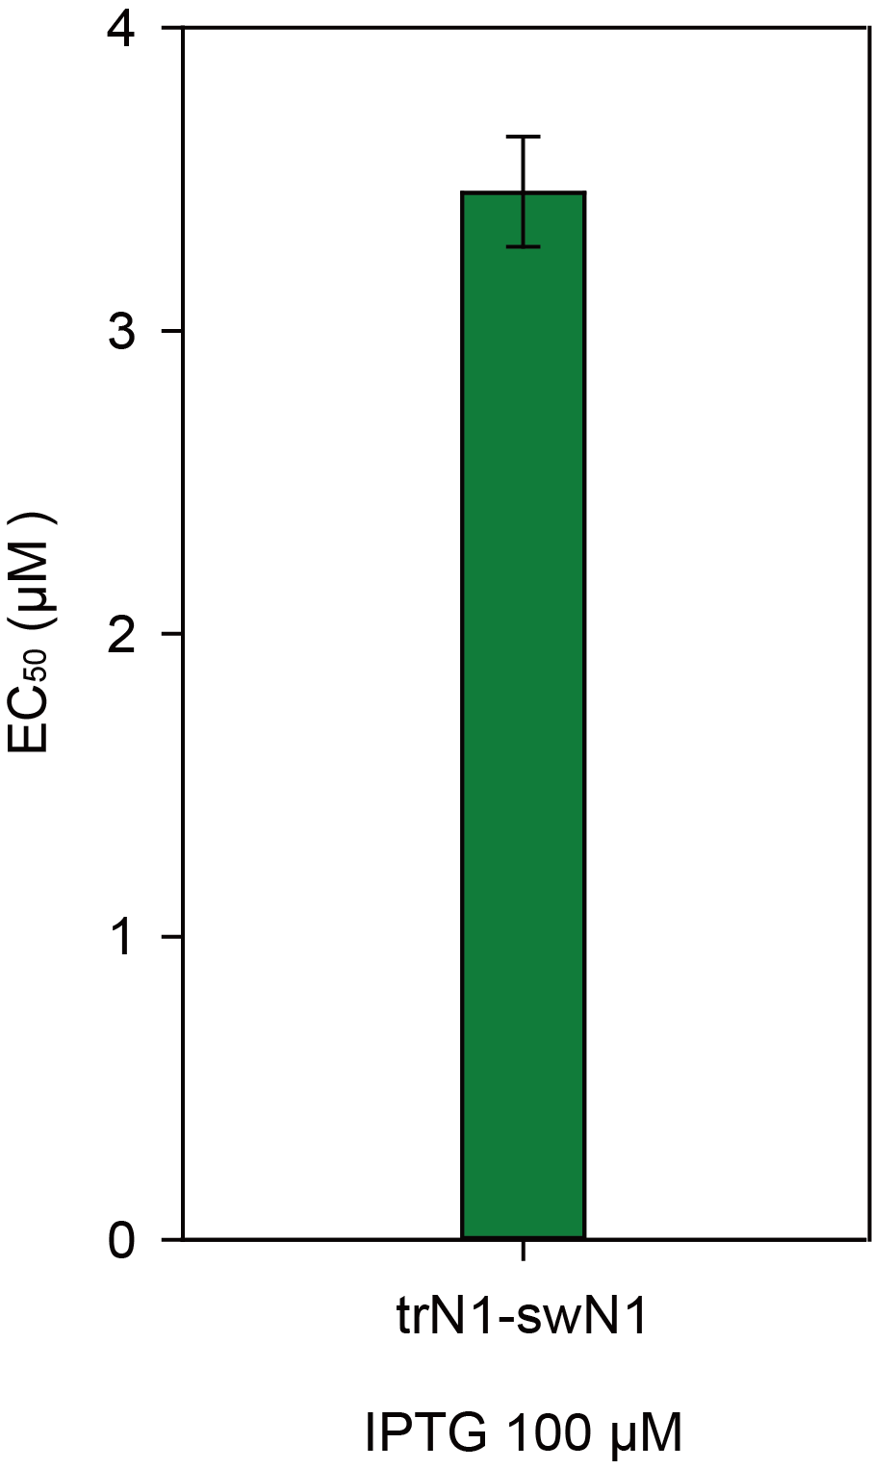
Figure S1. Half-maximal effective concentration (EC₅₀) value of trN1-swN1 with IPTG 100 µM. Error bars indicate standard deviations from biological triplicate measurements.

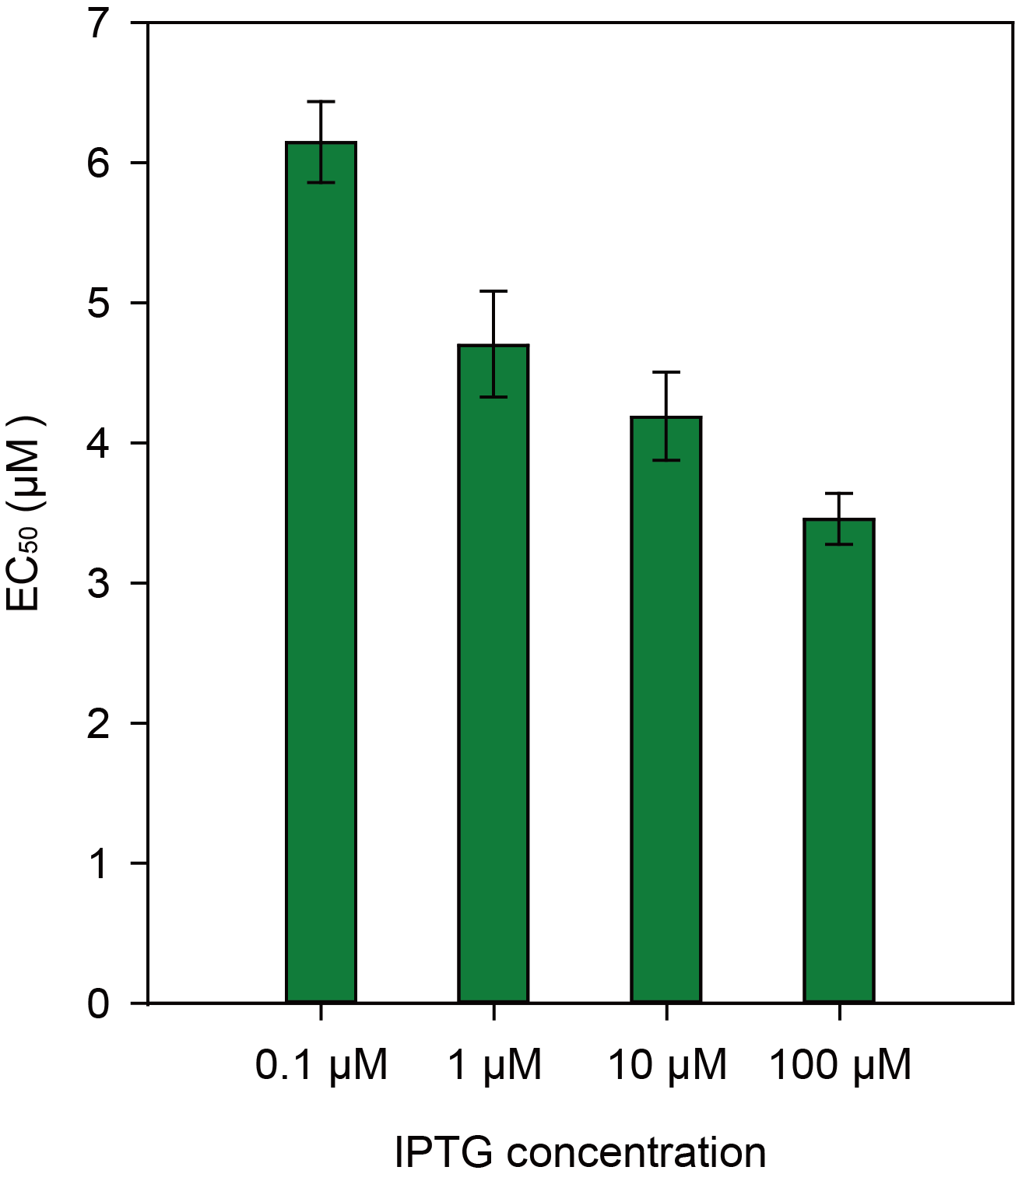
Figure S2. Half-maximal effective concentration (EC₅₀) values of trN1-swN1 with various IPTG concentrations (0.1, 1, 10, 100 µM). Error bars indicate standard deviations from biological triplicate measurements.

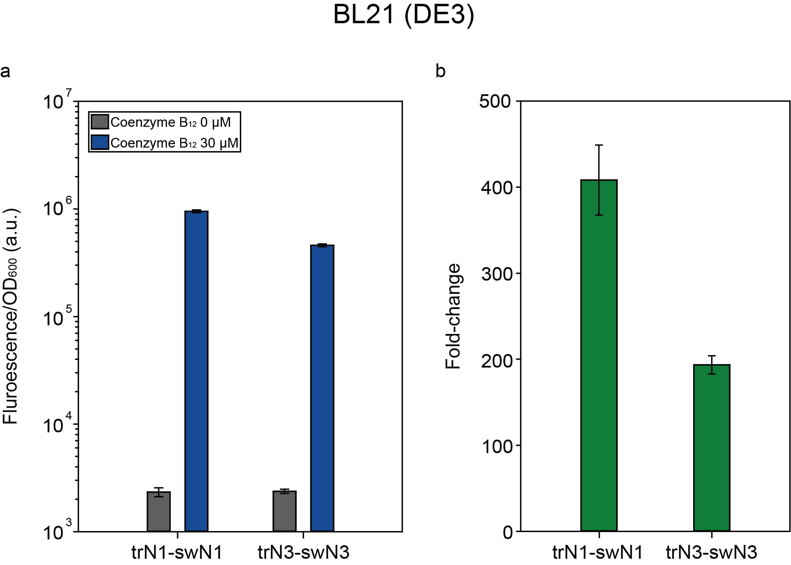
Figure S3. Performance of toehold switch-based modulator in E. coli BL21(DE3). (a) Fluorescence measurements for BL21-trN1-swN1 and BL21-trN3-swN3 with and without coenzyme B₁₂ (30 μM was added). (b) Fold-change of GFP reporters for BL21-trN1-swN1 and BL21-trN3-swN3. Error bars indicate standard deviations from biological triplicate measurements.

References
Jang S, Jang S, Noh MH, Lim HG, Jung GY. Novel Hybrid Input Part Using Riboswitch and Transcriptional Repressor for Signal Inverting Amplifier. ACS Synth Biol. 2018;7:2199–204.
Green AA, Kim J, Ma D, Silver PA, Collins JJ, Yin P. Complex cellular logic computation using ribocomputing devices. Nature. 2017;548:117-121.

