Supp Fig.1 Quality Assessment for Protein Mass Spectrometry Results
(A-B) Protein coverage figure showing protein number and protein coverage for PRPF6 binding mass spectrometry (A) and AR-V7 binding mass spectrometry (B).
(C-D) Precursor ion coverage for PRPF6 binding mass spectrometry (C) and AR-V7 binding mass spectrometry (D).
(E-F) Protein mass distribution figure showing protein number and protein mass for PRPF6 binding mass spectrometry (E) and AR-V7 binding mass spectrometry (F).

Supp Fig.2 Supplemental Information for Protein Mass Spectrometry Results
- COG functional classification for the binding proteins from the 22RV1 cell-line for PRPF6.
- COG functional classification for the binding proteins from the 22RV1 cell-line for AR-V7.
- Venn figure illustrating the number of intersected proteins from mass spectrometry results for PRPF6 binding proteins with expression >0 and AR-V7 binding proteins with expression > 0.
- Pie plot showing the percentage of the candidate driver genes both passing PRPF6 and AR-V7 mass spectrometry filtering (1.46%) and not passing mass spectrometry filtering (98.54%).
- Pie plot showing the percentage of the selected driver genes without the mass spectrometry filtering step which both passed PRPF6 and AR-V7 mass spectrometry filtering (62.5%) and not matching mass spectrometry results (37.5%).

Supp Fig.3 Supplemental Information for Migration and STRING Protein-Protein Interaction
- Migrating results illustrating the relationship between marker genes with high connectivity and selected genes after correlation and association rules filtering. Red indicated strong relationship, and blue indicated weak relationship.
- STRING protein-protein network for indicating the known interactions within the 5 selected driver genes and the 40 castration resistance marker genes. Different colors for the interaction showed different type of the interaction.
- STRING protein-protein network for indicating the known interactions within the 5 selected driver genes and the most driving marker genes. Different colors for the interaction showed different type of the interaction.

Supp Fig.4 Supplemental Information for Selected Driver Gene Validation
(A-B) The Scatter Plot for the number of selected markers for filtering (randomly chosen with different times and shown as different blue nodes) on the basis of high expression (>4th quantile, or 75% of all expression) against the percentage of the selected driver genes passing mass spectrometry filtering for PRPF6 (A) and AR-V7 (B).
(C) Barplot showing the number of co-occurrence counts with castration resistance for interacting drugs for each driver gene.
- Barplot showing the percentage of the drugs with castration resistance co-occurrence counts for the gene bulk for each driver gene.

Supp Table.1 The Downloaded Datasets used for Integration and Driver Genes Identification
Supp Table.2 Targeting Sequences for shRNAs
Supp Table.3 Primers for Real-time PCR

Supp Fig.1 Quality Assessment for Protein Mass Spectrometry Results

Supp Fig.2 Supplemental Information for Protein Mass Spectrometry Results

Supp Fig.3 Supplemental Information for Migration and STRING Protein-Protein Interaction

Supp Fig.4 Supplemental Information for Selected Driver Gene Validation

Supp Table.1 The Downloaded Datasets used for Integration and Driver Genes Identification
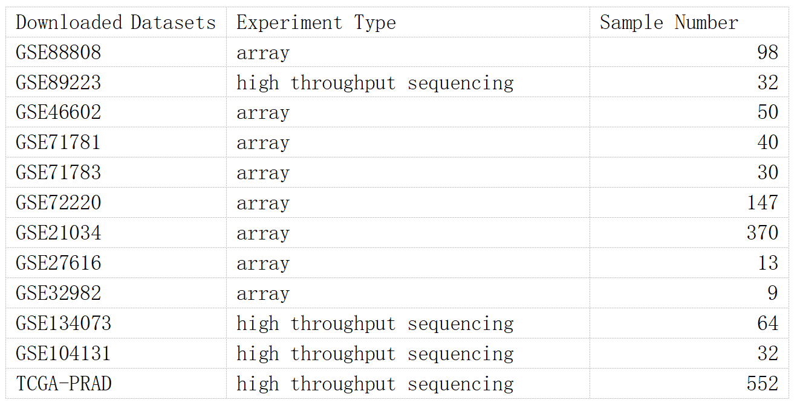

Supp Table.2 Targeting Sequences for shRNAs
Name | Number | Sequence
RPL28 | 119 | 5’-GCACTGAGCCCAATAACTT-3’
 | 156 | 5’-CCGCTACAACGGACTGATT-3’
 | 278 | 5’-GGACCACCATCAACAAGAA-3’
RPS4X | 101 | 5’-GCATTGGATGCTGGATAAA-3’
 | 274 | 5’-GCAAGGTCCGAACTGATAT-3’
 | 606 | 5’-GGAGGTGCTAACCTAGGAA-3’
RPL11 | 69 | 5’-GCGGGAGTATGAGTTAAGAAA-3’
 | 285 | 5’-GGATCATCCTTCCTGGCAA-3’
 | 533 | 5’-CCGCAAACTCTGTCTCAACAT-3’
RPL23A | 27 | 5’-GCCGAAAGCGAAGAAGGAA-3’
 | 332 | 5’-CCAACAAGCACCAGATTAA-3’
 | 442 | 5’-GCTCCTGATTACGATGCTT-3’
RPSA | 117 | 5’-GGATGTCCTTAAGTTCCTT-3’
 | 383 | 5’-GCTTCACTCCTGGAACCTT-3’
 | 946 | 5’-GCAACCACTGACTGGTCTT-3’

Supp Table.3 Primers for Real-time PCR
Name | Forward primer | Reverse primer
18S | 5’-TTGACGGAAGGGCACCACCAG-3’ | 5’-GCACCACCACCCACGGAATCG-3’
RPL28 | 5’-GCATCTGCAATGGATGGTCG-3’ | 5’-GTCCGTTGTAGCGGAAGGAA-3’
RPS4X | 5’-GAGGAGGCCAAGTACAAGTTG-3’ | 5’-CACAGGTTACCAGTGTCGAAC-3’
RPL11 | 5’-AAAGGTGCGGGAGTATGAGTT-3’ | 5’-TCCAGGCCGTAGATACCAATG-3’
RPL23A | 5’-AACACCCTGATTCGGCCTG-3’ | 5’-GGCAACATCCAAAGCATCGT-3’
RPSA | 5’-GTGGCACCAATCTTGACTTCC-3’ | 5’-GCAGGGTTTTCAATGGCAACAA-3’

