Supplementary Table 1
Abbreviation and acronyms.
Acronym | Meaning
CCV | Compaction Control Value
CMV | Compaction Meter Value
CPU | Central Processing Unit
DAQ | Data Acquisition
DFT | Discrete Fourier Transform
GPR | Ground Penetrating Radar
GPU | Graphics Processing Unit
GNSS | Global Navigation Satellite System
HDMI | High-Definition Multimedia Interface
HPA | Horizontal Position Accuracy
IEPE | Integrated Electronics Piezo-Electric
IC | Intelligent Compaction
ICA | Intelligent Compaction Analyzer
ICM | Intelligent Compaction Mete
ICMV | Intelligent Compaction Measurement Values
IR | Infrared
SK_{b} | Stiffness
LGPL | LESSER GENERAL PUBLIC LICENSE
MFD | Modified Fundamental Distortion
NTRIP | Networked Transport of RTCM via Internet Protocol
PCB | Printed Circuit Board
PPM | Pixels Per Meter
RAM | Random Access Memory
ROI | Region of Interest
RTK | Real-Time Kinematic
RTCM | Radio Technical Commission for Maritime
SBC | Single Board Computer
SE_{vib} | SPARC Vibratory Modulus
SSID | Service Set Identifier
SSS | Solid-State Storage
THD | Total Harmonic Distortion
UI | User Interfaces
USB | Universal Serial Bus
VNC | Virtual Network Computing

Supplementary Table 2
Software library dependencies.
Library | Description/Purpose | License
PySide2 | GUI library used for interface development | Lesser General Public License (LGPL)
PyQtGraph | Graphics library used for developing visualization tools | MIT License (MIT)
Numpy | Array library used for 2D pixel array manipulation | BSD License (BSD)
Pillow | Image Manipulation | Historical Permission Notice and Disclaimer (HPND)
SciPy | Mathematical Functions library | BSD License (BSD)
Matplotlib | Visualization library used here for color maps | Python Software Foundation License (PSF)
pymea2 | library for parse NMEA sentences | MIT License (MIT)
daqhats | drivers for MCC172 DAQ | NA
ads1015 | Reading analog data | MIT License (MIT)
Pickle | Saving and opening byte data | Python Software Foundation License (PSF)

Supplementary Figure 1
Preliminary experiments were carried out on an outdoor test pit for the ICA device.
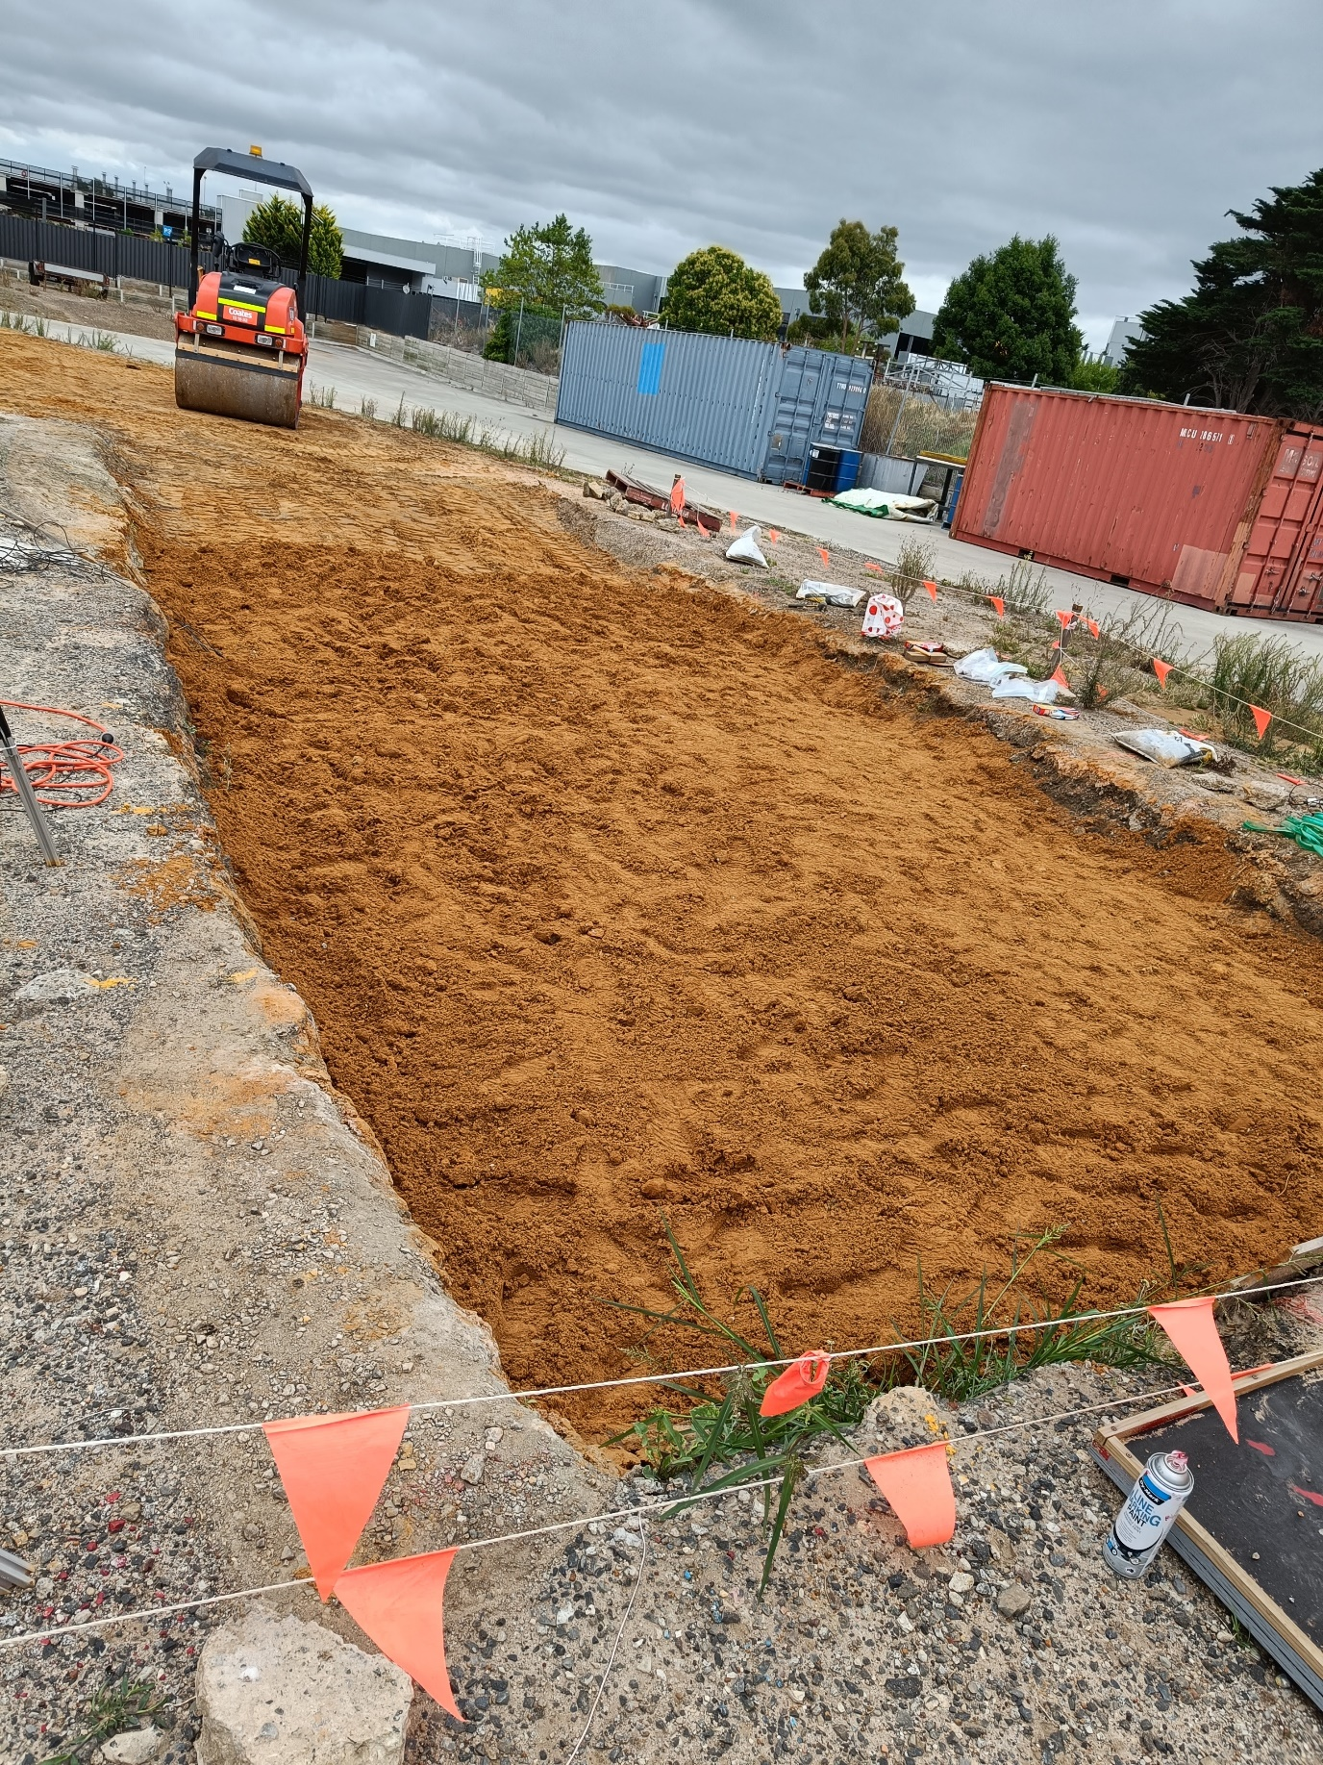

Supplementary Figure 2
Different parameters of ICA device collected for a soil layer over 10m length. The peaks at the beginning and end refers the starting and stopping of the compaction roller.
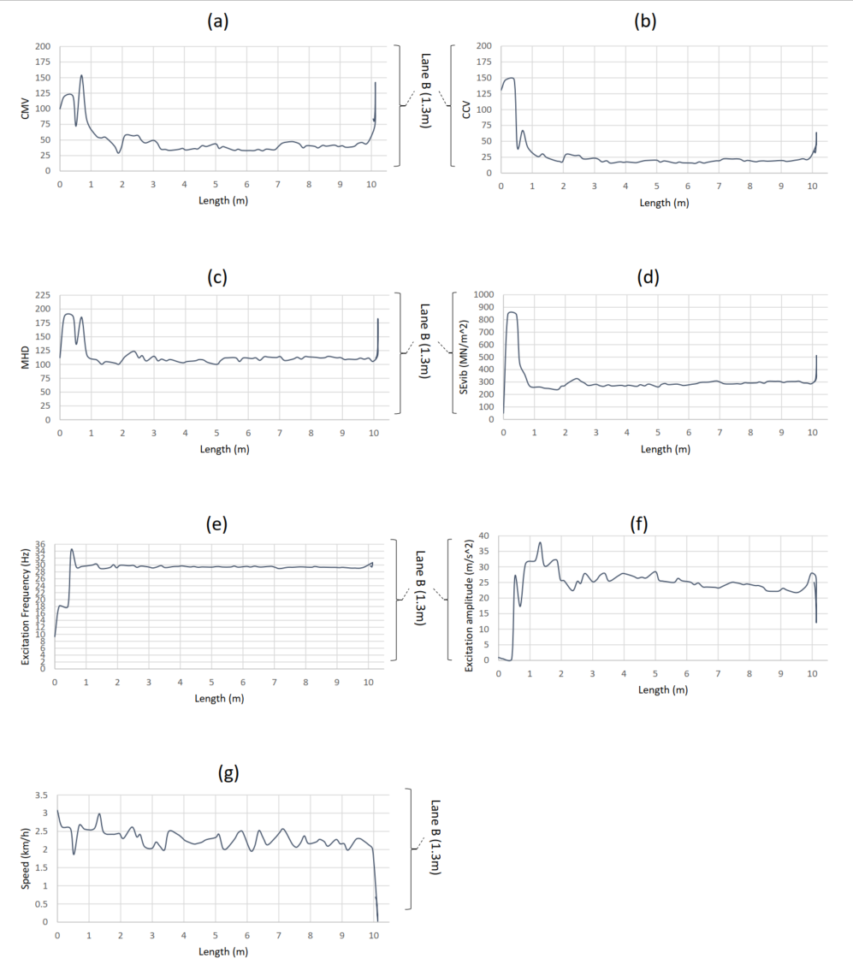

Supplementary Figure 3
Different parameters of ICA device collected for a unbound granular material (UGM) layer over 10m length. The peaks at the beginning and end refers the starting and stopping of the compaction roller.
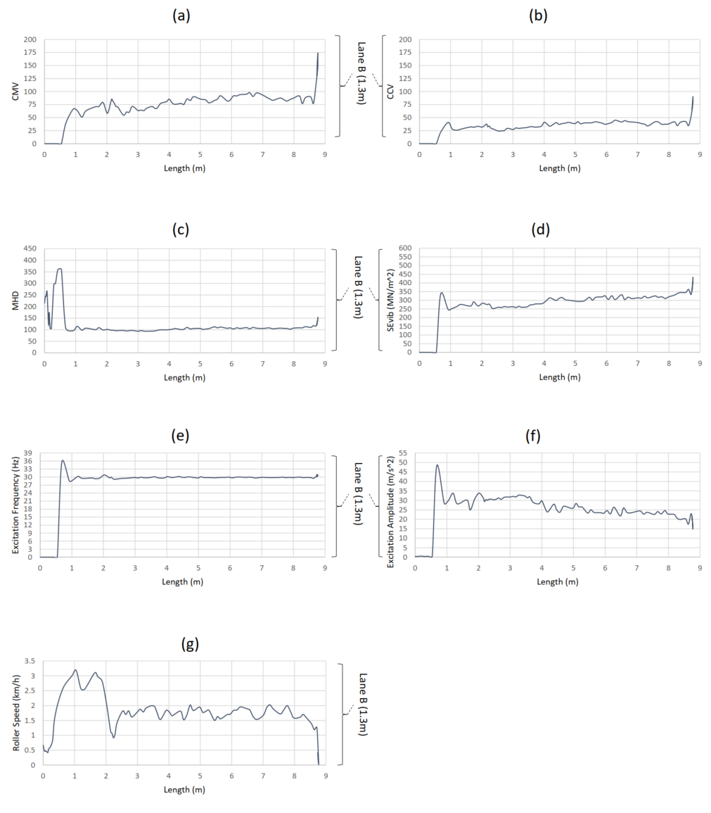

Supplementary Figure 4
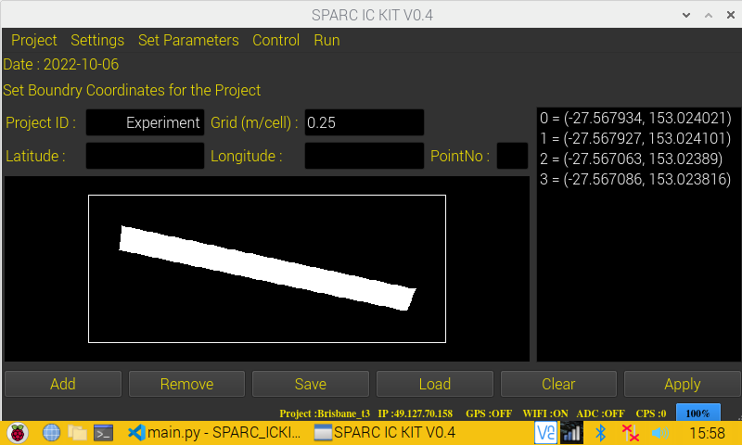
All user interfaces (UI) of ICA device.

(a) Project User Interface

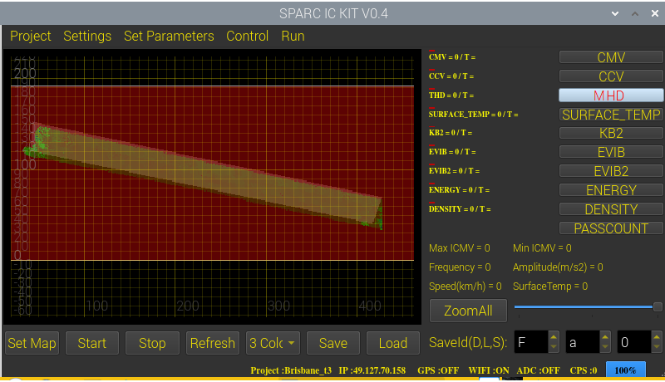

(b) Mapping User Interface

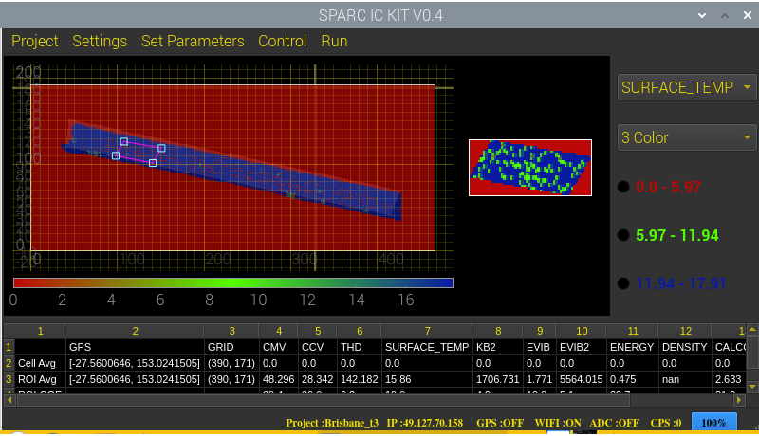

(c) Data Analyzing User Interface

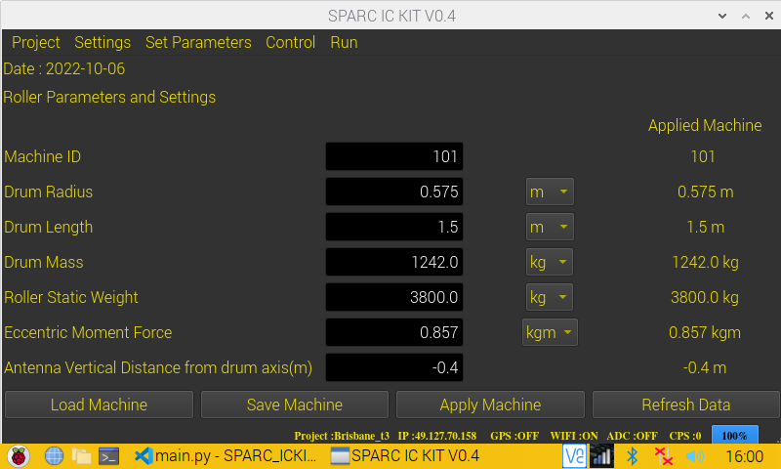

(d) Roller data User Interface

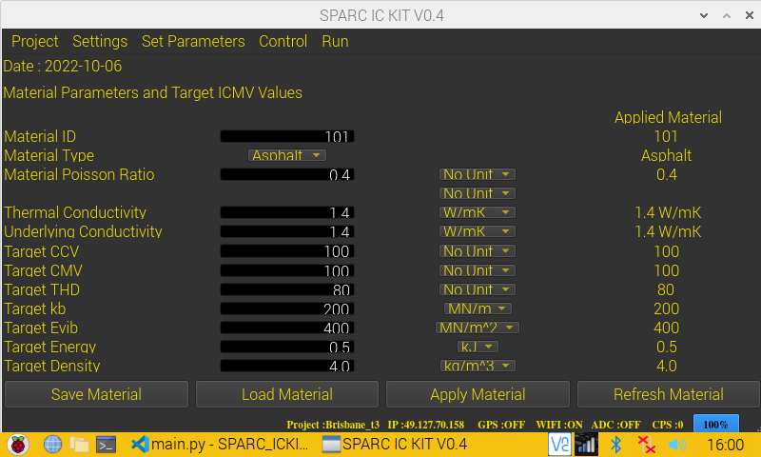

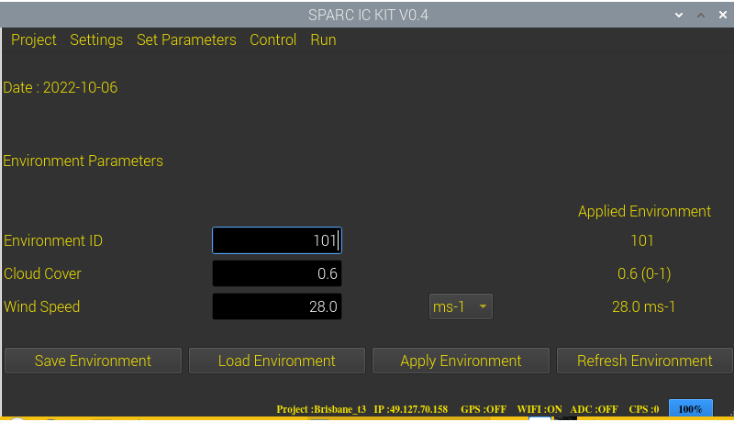
(e) Material data User Interface
(f) Environment data User Interface
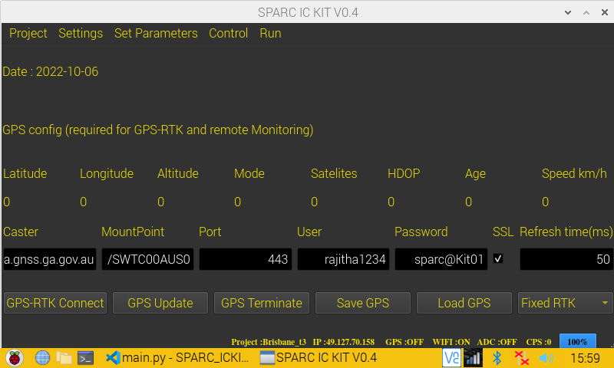
(g) GPS-RTK settings User Interface

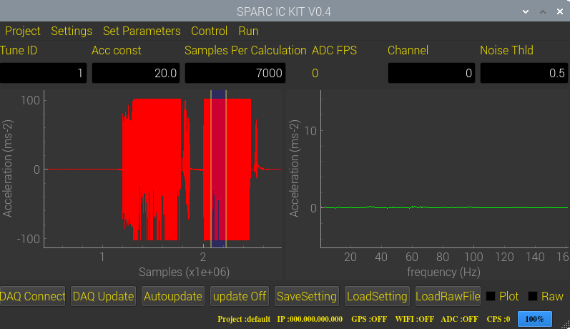

(h) DAQ data settings User Interface

