Expression and localization of MUC1 modified with sialylated core 2 O-glycans in mucoepidermoid carcinoma

Supplemental Table and Figures

Table S1. Summary of MUC1, sialyl-Tn and C2GnT-1 expression in the mucoepidermoid carcinoma lesion and the surrounding normal salivary tissue in each sample.

 |  |  | MUC1 |  |  |  | sialyl-Tn |  |  |  | C2GnT-1
Sample number |  |  | 1 | 2 | 3 |  | 1 | 2 | 3 |  | 1 | 2 | 3
Normal salivary glands | Mucous acini |  | － | － | － |  | － | － | － |  | － | － | －
 | Serous acini |  | － | － | － |  | － | － | － |  | － | － | －
 | Ducts |  | ＋ | － | ＋ |  | － | － | － |  | － | － | －
MEC tissue | Mucous cells |  | ＋ | ＋ | ＋ |  | － | ＋ | － |  | ＋ | ＋ | ＋
 | Non-mucous cells |  | ＋ | ＋ | ＋ |  | － | ＋ | － |  | ＋ | ＋ | ＋
 | ＋：Positive, －: Negative

Fig. S1. Expression patterns of MUC1, Sialy-Tn, and C2GnT-1 in surrounding normal salivary gland of sample 1. The representative images (original magnification, ×400) of H&E staining (A), staining with anti-MUC1 antibody (B), staining with anti-Sialyl-Tn antibody (C), and ISH of C2GnT-1 (D) are shown. Scale bars indicate 100 µm.

Fig. S2. Expression patterns of MUC1, Sialy-Tn, and C2GnT-1 in MEC of sample 1. The representative images (original magnification, ×400) of H&E staining (A), staining with anti-MUC1 antibody (B), staining with anti-Sialyl-Tn antibody (C), and ISH of C2GnT-1 (D) are shown. Scale bars indicate 100 µm.

Fig. S3. Expression patterns of MUC1, Sialy-Tn, and C2GnT-1 in surrounding normal salivary gland of sample 2. The representative images (original magnification, ×400) of H&E staining (A), staining with anti-MUC1 antibody (B), staining with anti-Sialyl-Tn antibody (C), and ISH of C2GnT-1 (D) are shown. Scale bars indicate 100 µm.

Fig. S4. Expression patterns of MUC1, Sialy-Tn, and C2GnT-1 in MEC of sample 2. The representative images (original magnification, ×400) of H&E staining (A), staining with anti-MUC1 antibody (B), staining with anti-Sialyl-Tn antibody (C), and ISH of C2GnT-1 (D) are shown. Scale bars indicate 100 µm.

Fig. S5. Expression patterns of MUC1, Sialy-Tn, and C2GnT-1 in surrounding normal salivary gland of sample 3. The representative images (original magnification, ×400) of H&E staining (A), staining with anti-MUC1 antibody (B), staining with anti-Sialyl-Tn antibody (C), and ISH of C2GnT-1 (D) are shown. Scale bars indicate 100 µm.

Fig. S6. Expression patterns of MUC1, Sialy-Tn, and C2GnT-1 in MEC of sample 3. The representative images (original magnification, ×400) of H&E staining (A), staining with anti-MUC1 antibody (B), staining with anti-Sialyl-Tn antibody (C), and ISH of C2GnT-1 (D) are shown. Scale bars indicate 100 µm.

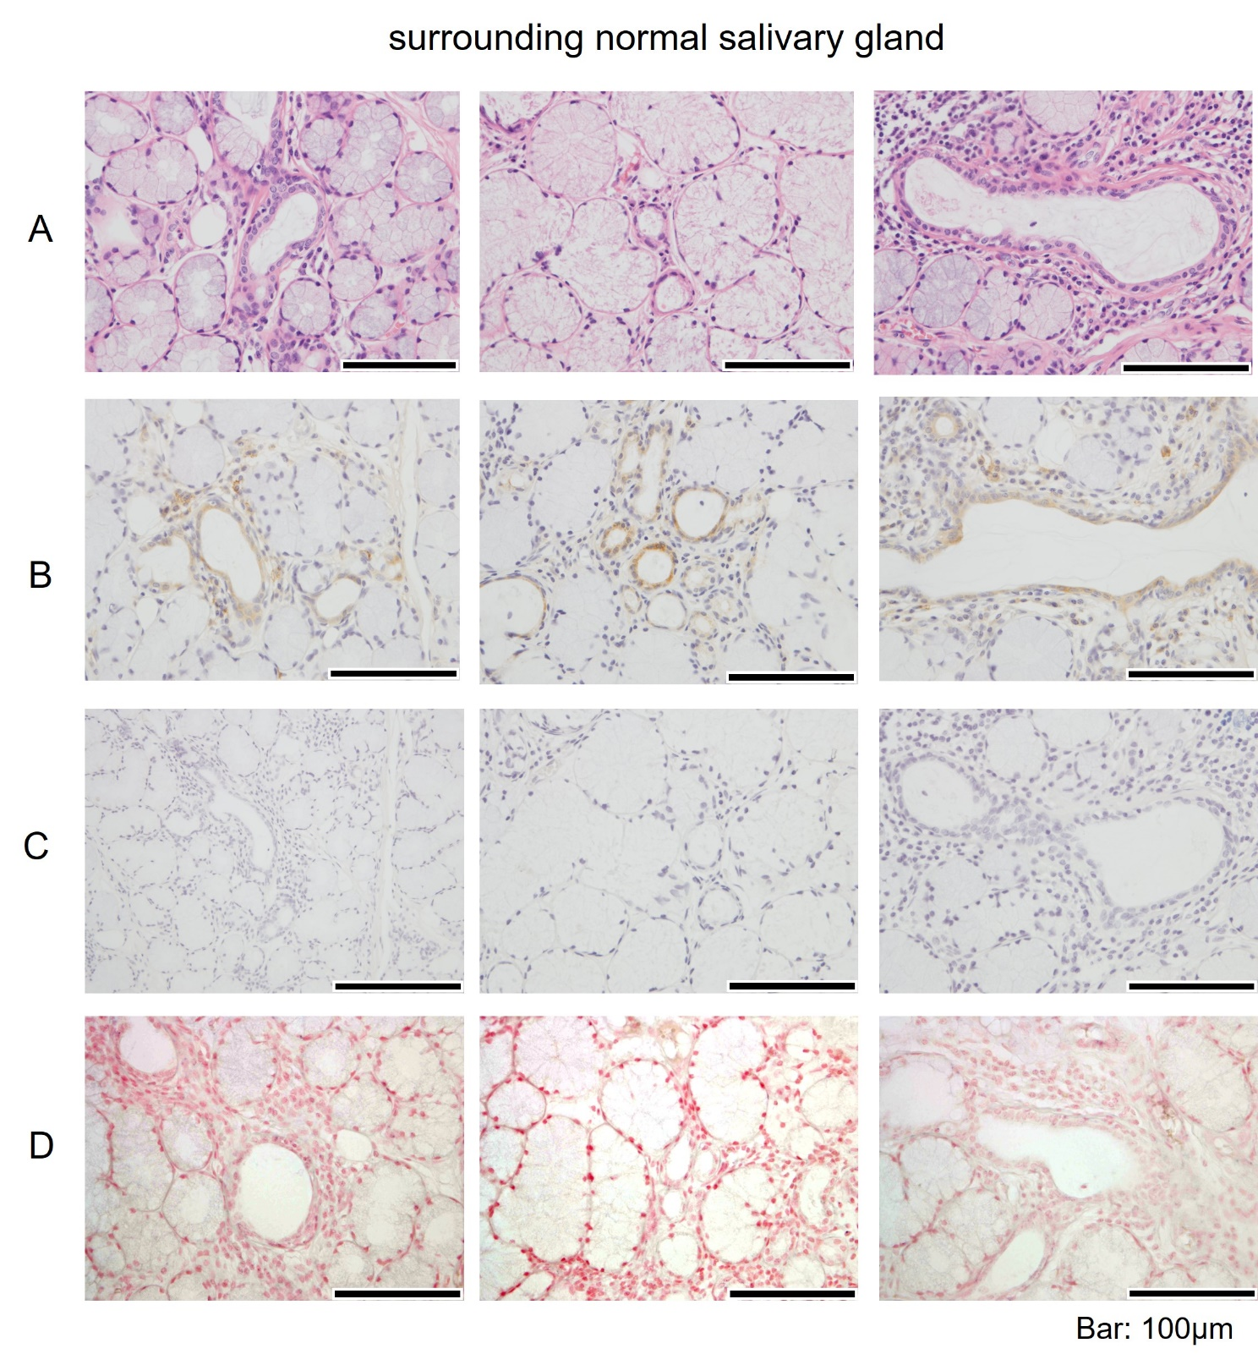

Fig. S1

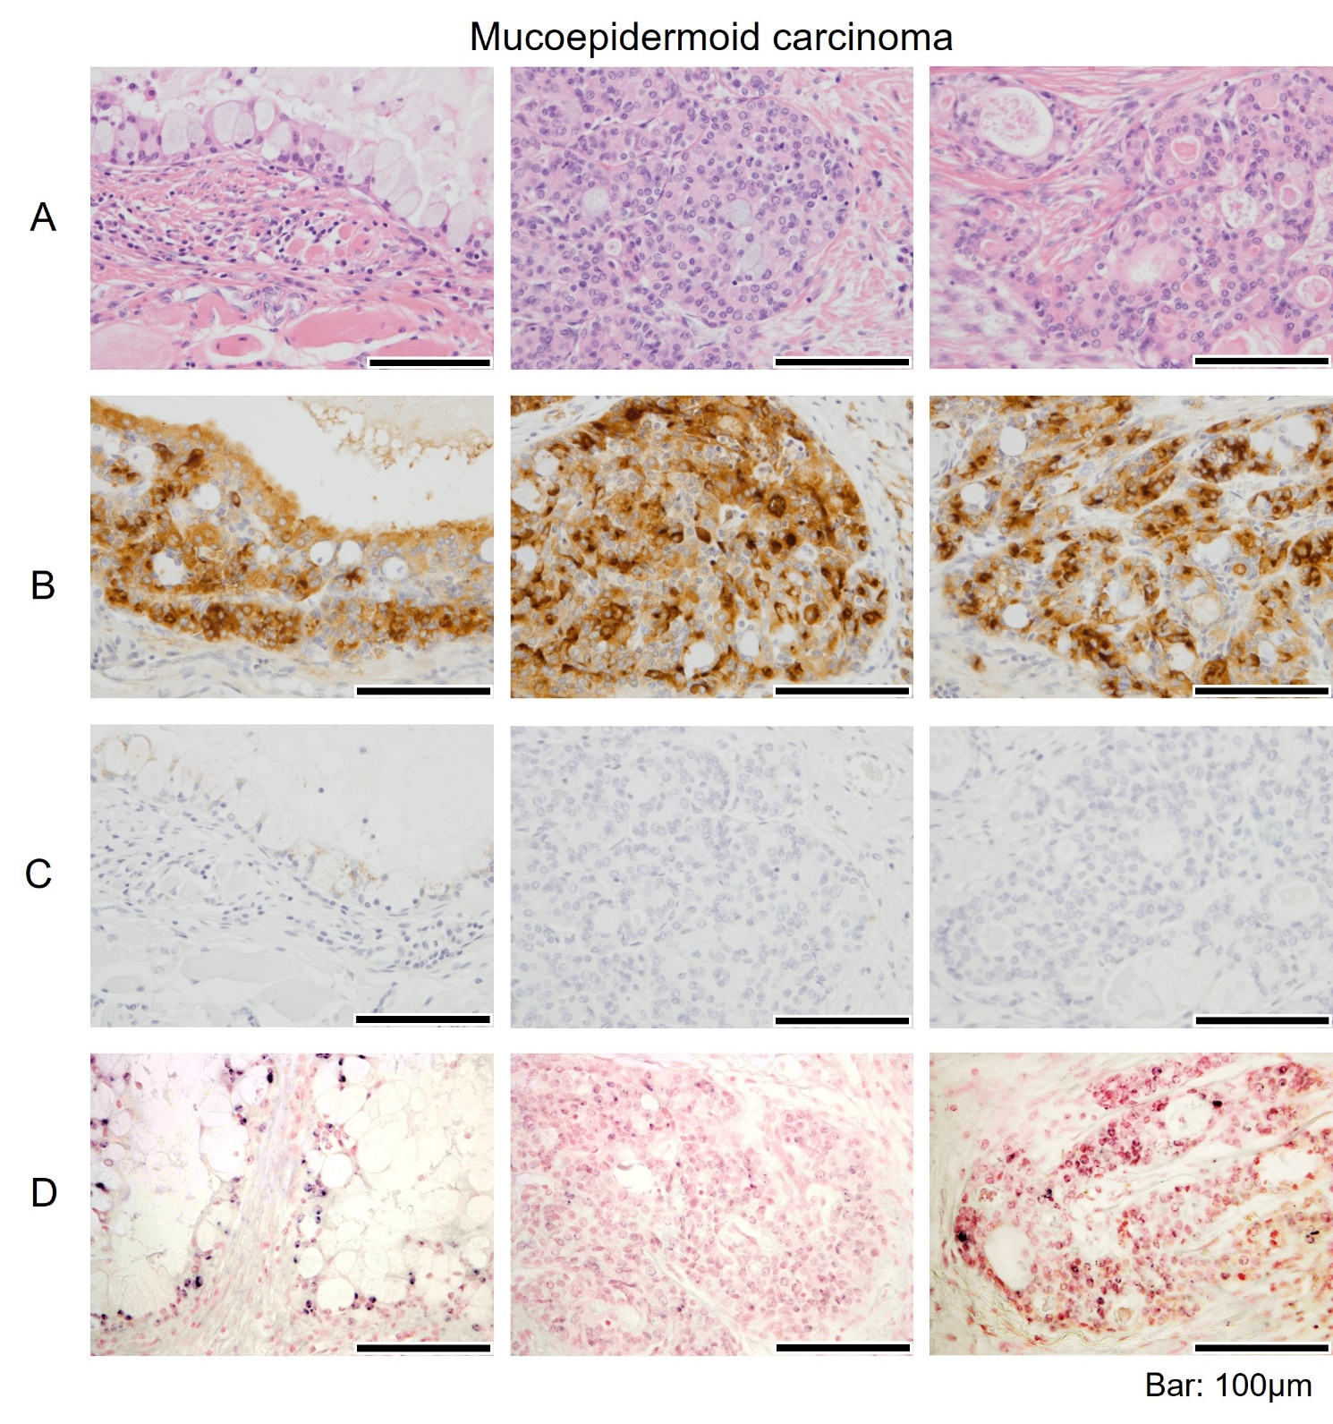

Fig. S2

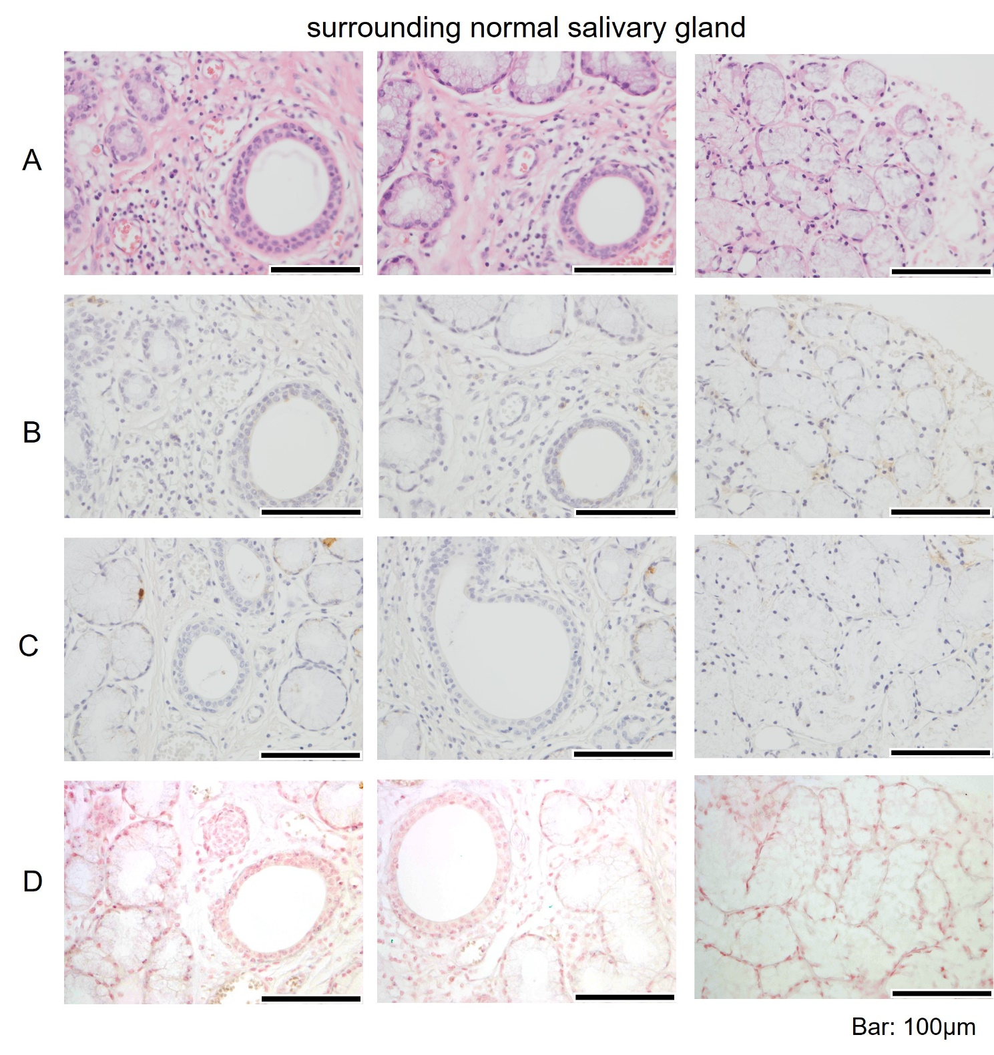

Fig. S3

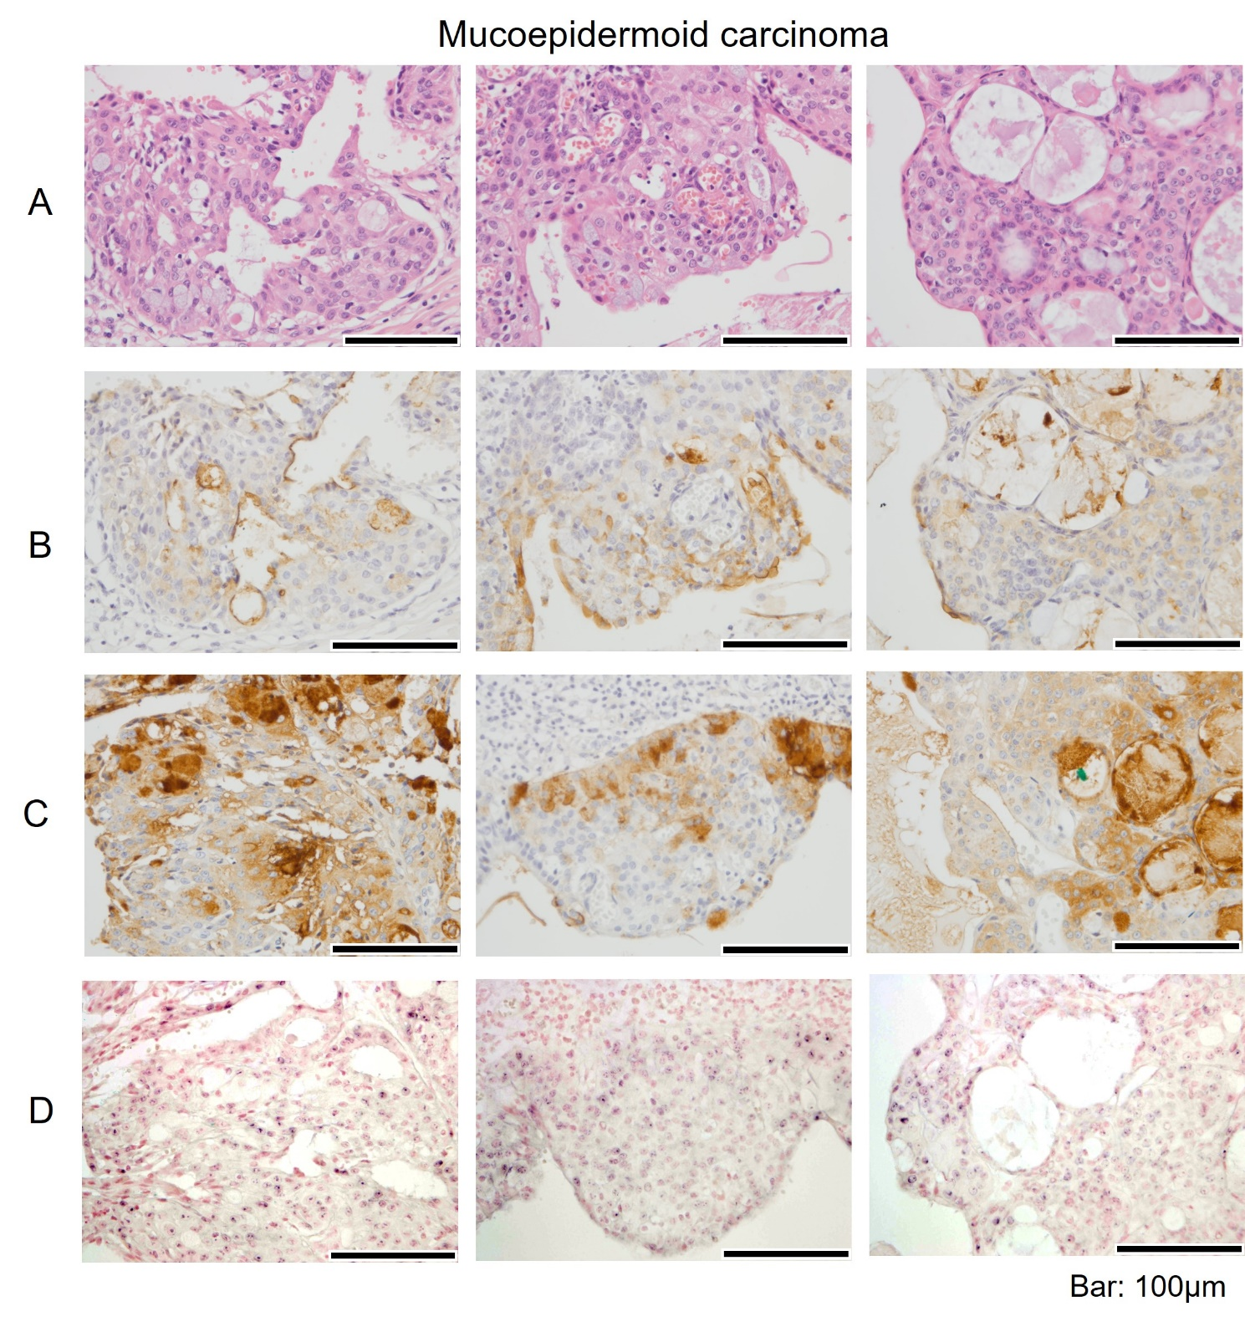

Fig. S4

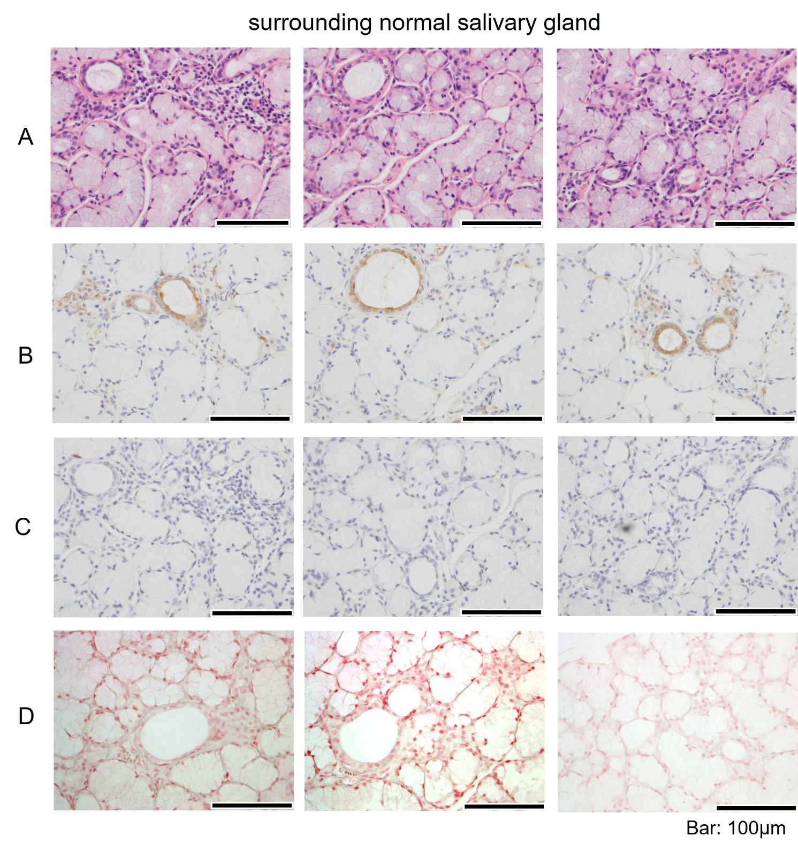

Fig. S5

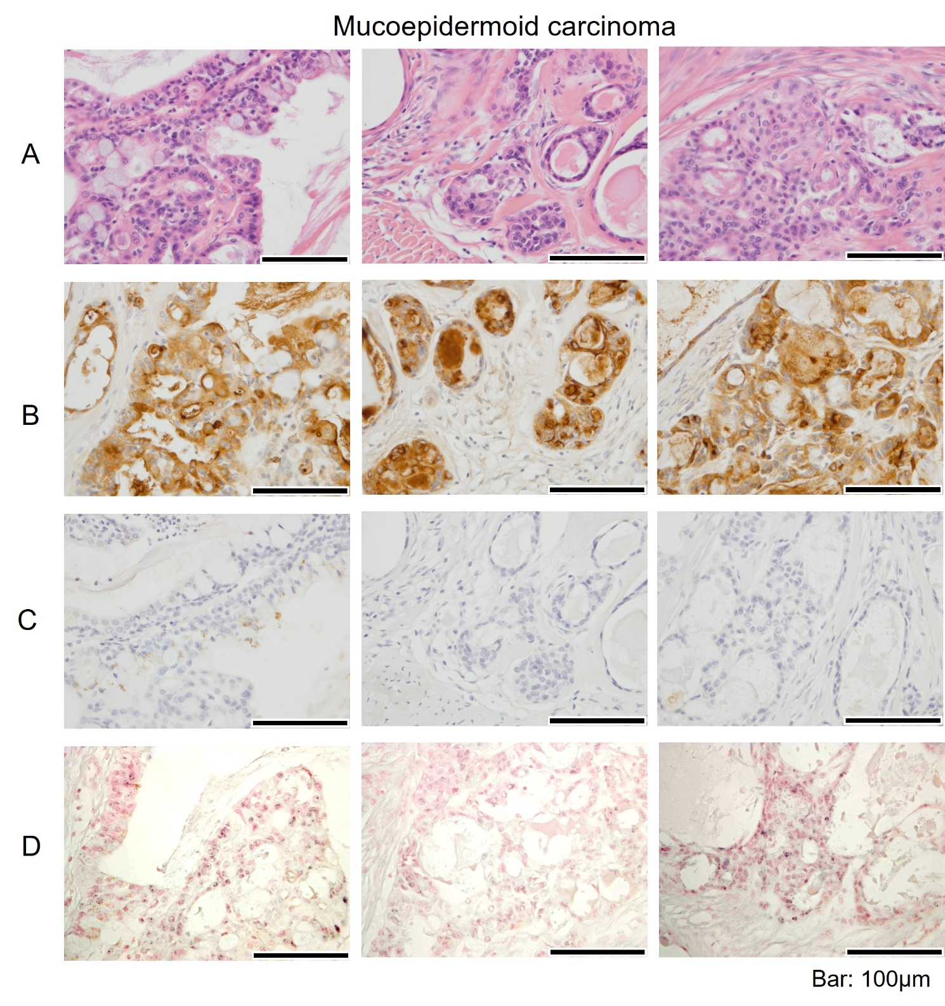

Fig. S6

