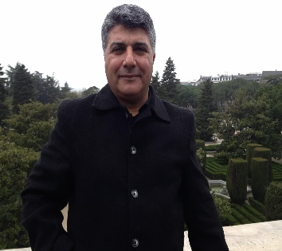

Ibrahim M. Obeidat is a Professor, working in Prince Al-Hussein Bin
Abdullah II Faculty of Information Technology; Hashemite University, Jordan since
2008, his interest is in networking and cyber security.

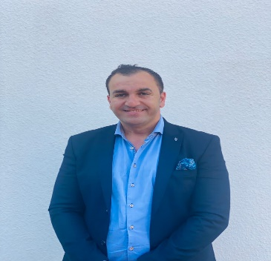

Ala Mughaid was born in Irbid, Jordan, in 1984. He received the BSC degree in Computer Science from Jordan University of Science and Technology (JUST), Jordan, in 2006, and the MSC in Engineering degree in engineering Computer Network from the Western Sydney University, Sydney, Australia, in 2010. Dr. Mughaid received the Ph.D. degree in Computer Science from Newcastle University – Sydney, Australia, in 2018. In 2018, Dr. Mughaid joined the Department of Computer Science, The Hashemite University, as an assistant professor, Zarqa, Jordan. Dr. Mughaid current research interests include but not limited to Cyber Security, Cloud Computing, Network Security, Artificial Intelligence, Virtual reality, Data ining. He is working voluntarily in many social services.



Osama Alofishat is a master in cyber security program, working at the Jordanian army and his research interests include cyber security, networking, AI.

