SUPPORTING INFORMATION
Generating Antiaromaticity: Thermally-selective Skeletal Rearrangements at Interfaces
Elena Pérez-Elvira°¹, Ana Barragán°¹, Qifan Chen°^{2,3}, Diego Soler-Polo², Ana Sánchez-Grande^{1,2,4}, Diego J. Vicent⁵, Koen Lauwaet¹, José Santos⁵, Pingo Mutombo², Jesús I. Mendieta-Moreno², Bruno de la Torre⁶, José M. Gallego⁷, Rodolfo Miranda^{1,4}, Nazario Martín*^{1,5}, Pavel Jelínek*^{2,6}, José I. Urgel*¹, and David Écija*¹
¹IMDEA Nanoscience, C/ Faraday 9, Campus de Cantoblanco, 28049 Madrid, Spain
²Institute of Physics of the Czech Academy of Science, CZ-16253 Praha, Czech Republic
³Faculty of Mathematics and Physics, Charles University, V Holešovičkách 2, 180 00 Praha, Czech Republic
⁴Departamento de Física de la Materia Condensada, Universidad Autónoma de Madrid, 28049 Madrid, Spain
⁵Departamento de Química Orgánica, Facultad de Ciencias Químicas, Universidad Complutense de Madrid, 28040 Madrid, Spain
⁶Regional Centre of Advanced Technologies and Materials, Czech Advanced Technology and Research Institute (CATRIN), Palacký University Olomouc, 771 46 Olomouc, Czech Republic
⁷Instituto de Ciencia de Materiales de Madrid, CSIC, Cantoblanco, 28049 Madrid, Spain
° These authors contributed equally
* Address correspondence to these authors
- 1. Fluorine-functionalized anthracene molecules adsorbed on an Au(111) substrate kept at 200 ºC.
- 2. Lateral manipulation of a fluorinated-functionalized Br−Au−dibenzo[a,e]pentalene molecule.
- 3. Dibenzo[a,e]pentalene organometallic complexes (2b)
- 4. Statistics of the length of the diindeno[2,1-a:2',1'-g]-s-indacene derivatives.
- 5. Free energy calculation of surface-catalyzed reaction pathways for breaking the C-Br bond with the assistance of gold adatom.
- 6. Free molecular dynamics of the initial and final states of second debromination.
- 7. Free molecular dynamics of IM1 and IM2.
- 8. Free energy calculation of reactions pathways from IM2 to FS1/FS2 without QM surface.
- 9. Free energy calculation of reactions pathways from IM2 to FS1/FS2 with QM surface.
- 10. Pentalene-linked indeno[1,2-b]fluorene polymers achieved by RT deposition and subsequent annealing to 350 ºC.
- 11. Free energy calculation for the insertion of the 6-membered ring.
- 12. Dibenz[a,h]anthracene units connected by five-membered ring bridges (8b).
1. Fluorinated-functionalized anthracene molecules adsorbed on an Au(111) substrate kept at 200 ºC
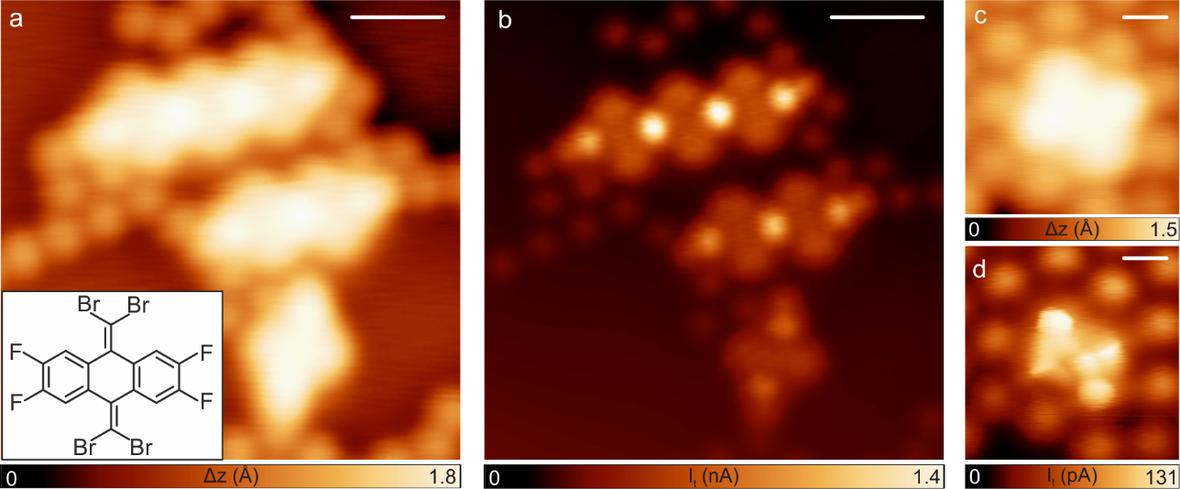Fig. S1 | F-functionalized anthracene molecules deposited on a hot Au(111) surface. a, Overview STM image of the Au(111) surface after deposition of F-functionalized anthracene molecules showing the formation of individual and organometallic structures, as well as individual Br atoms. V_{b} = -0.5 V, I_{t} = 40 pA, scale bar: 9 Å. The inset depicts the chemical structure of the molecular precursor. b, Corresponding constant-height STM image obtained with a CO-functionalized tip. V_{b} = 5 mV, I_{t} = 40 pA, scale bar: 9 Å. c-d, Constant-current (V_{b} = -0.5 V, I_{t} = 40 pA, scale bar: 3 Å) and constant-height (V_{b} = 5 mV, I_{t} = 40 pA, scale bar: 3 Å) STM images of an individual structure, respectively.

9,10-bis(dibromomethylene)-2,3,6,7-tetrafluoro-9,10-dihydroanthracene molecules were sublimed at 95 ºC on a hot Au(111) surface kept at 200 ºC and the result of the deposition is shown in Figure S1. STM constant height images acquired with a CO-functionalized tip allow us to resolve the structure of the molecules and organometallic complexes, which follow the same intramolecular reaction than the one explained in the main text for 1 and 3 molecular precursors. Both isolated cross-like species and organometallic chains are obtained without noticing any influence of the fluorinated functionalization in the observed intramolecular reaction.

2. Lateral manipulation of the asymmetric cross-like species
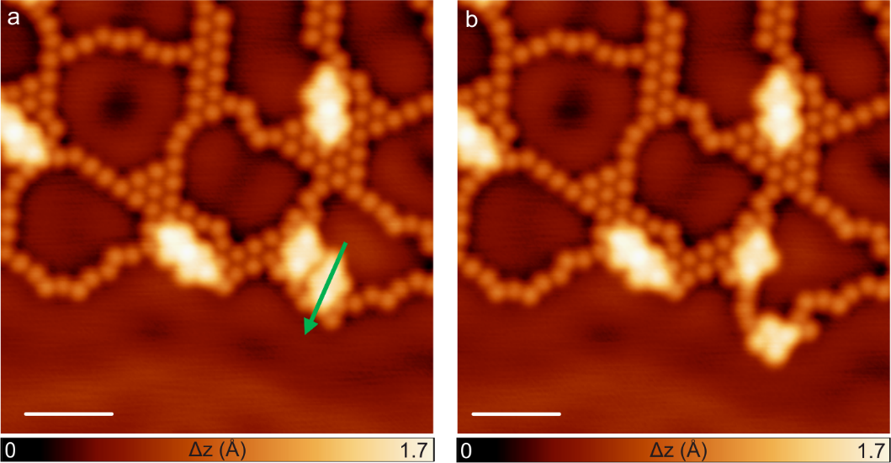
Fig. S2 | Lateral manipulation performed at a fluorinated-functionalized Br-Au-dibenzo[a,e]pentalene molecule. a, STM image showing an area, before performing the lateral manipulation, with different individual molecules, as well as a few short organometallic segments and individual Br atoms. The green arrow indicates the direction of the manipulation. V_{b} = 0.2 V, I_{t} = 20 pA, scale bar: 2 nm. b, STM image displaying the same area after the lateral manipulation event. Clearly an individual fluorinated Br-Au-dibenzo[a,e]pentalene molecule is displaced and rotated on the Au(111) surface by such lateral manipulation experiments highlighting the robustness of the Br-Au interaction with the molecular backbone. V_{b} = 0.2 V, I_{t} = 20 pA, scale bar: 2 nm.

In order to perform the lateral manipulation experiements, the tip is located at the side of the molecule that wants to be displaced, with scanning parameters V_{b} = 0.2 V, I_{t} = 20 pA. Then, the feedback loop is opened and the tip is approached to the substrate until you get a current of around 0.5 nA. At that point, the tip is laterally moved along the direction of the manipulation (see green arrow in figure S2). After coming back to the scanning conditions, the result of the manipulation can be observed (panel b).

3. Dibenzo[a,e]pentalene organometallic complexes (2b)
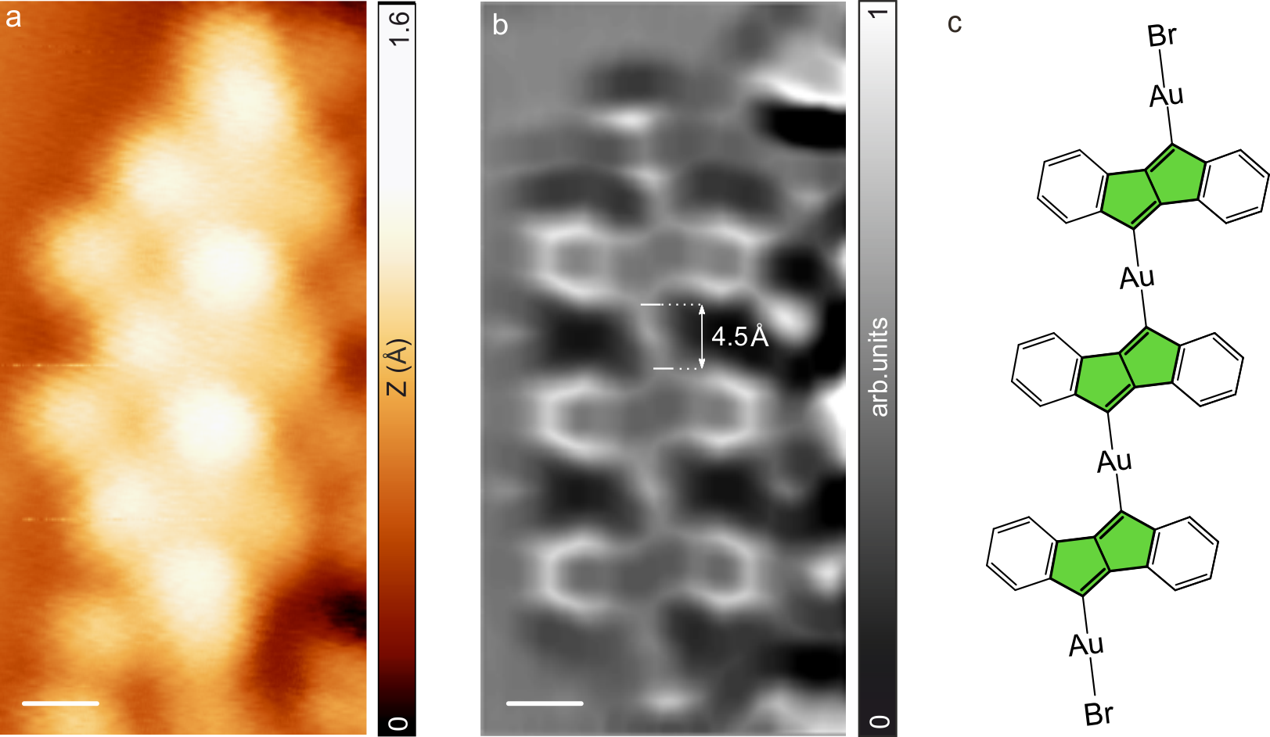
Fig. S3 | 2b organometallic complexes. a, STM image of a 2b organometallic complex obtained after the deposition of molecular precursor 1 on the Au(111) surface kept at 240 ºC. V_{b} = 5 mV, I_{t} = 50 pA, scale bar: 3 Å. b-c, Corresponding nc-AFM Laplace filtered image (z-offset 90 pm above STM set point: 5 mV, 50 pA, scale bar: 3 Å.) and chemical sketch.

In addition to isolated 2a species, which have been presented in Figure 2 of the main text, dibenzo[a,e] pentalene organometallic complexes were also obtained after the sublimation of molecular precursor 1 on the Au(111) surface kept at 240 ºC. nc-AFM images acquired on these chains allow us to resolve the C−Au−C organometallic structure, as well as the Au−Br terminations.

4. Statistics of the length of the diindeno[2,1-a:2',1'-g]-s-indacene derivatives
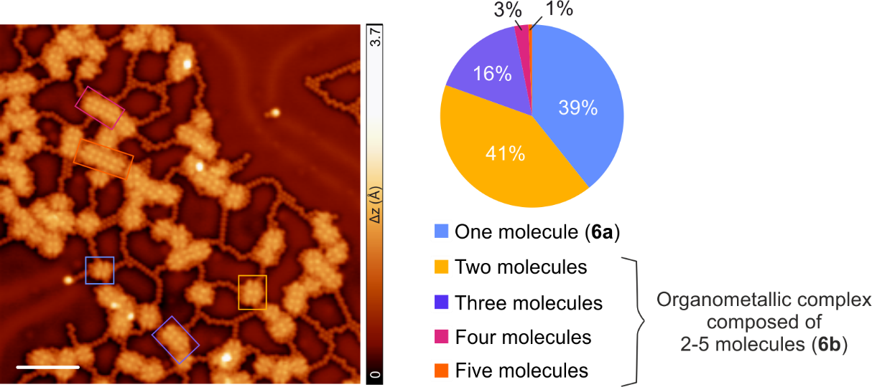
Fig. S4 | Statistics of the diindeno[2,1]-1:2’1’-g.-s-indacene derivatives´ length. a, Long-range STM image of the surface after deposition of molecular precursor 5 on the Au(111) kept at 200 ºC. V_{b} = 0.5 V, I_{t} = 40 pA, scale bar: 5 nm. b, Statistic out of 300 molecules.

As it can be observed in Figure S4, the statistic out of around 300 molecules shows that 80% of the measured derivatives found on the Au(111) surface after the deposition of molecular precursor 5 on the gold surface kept at 200 ºC, are one or two units’ length.

5. Free energy calculation of the surface-catalyzed reaction pathways for breaking the C-Br bond with the assistance of gold adatom
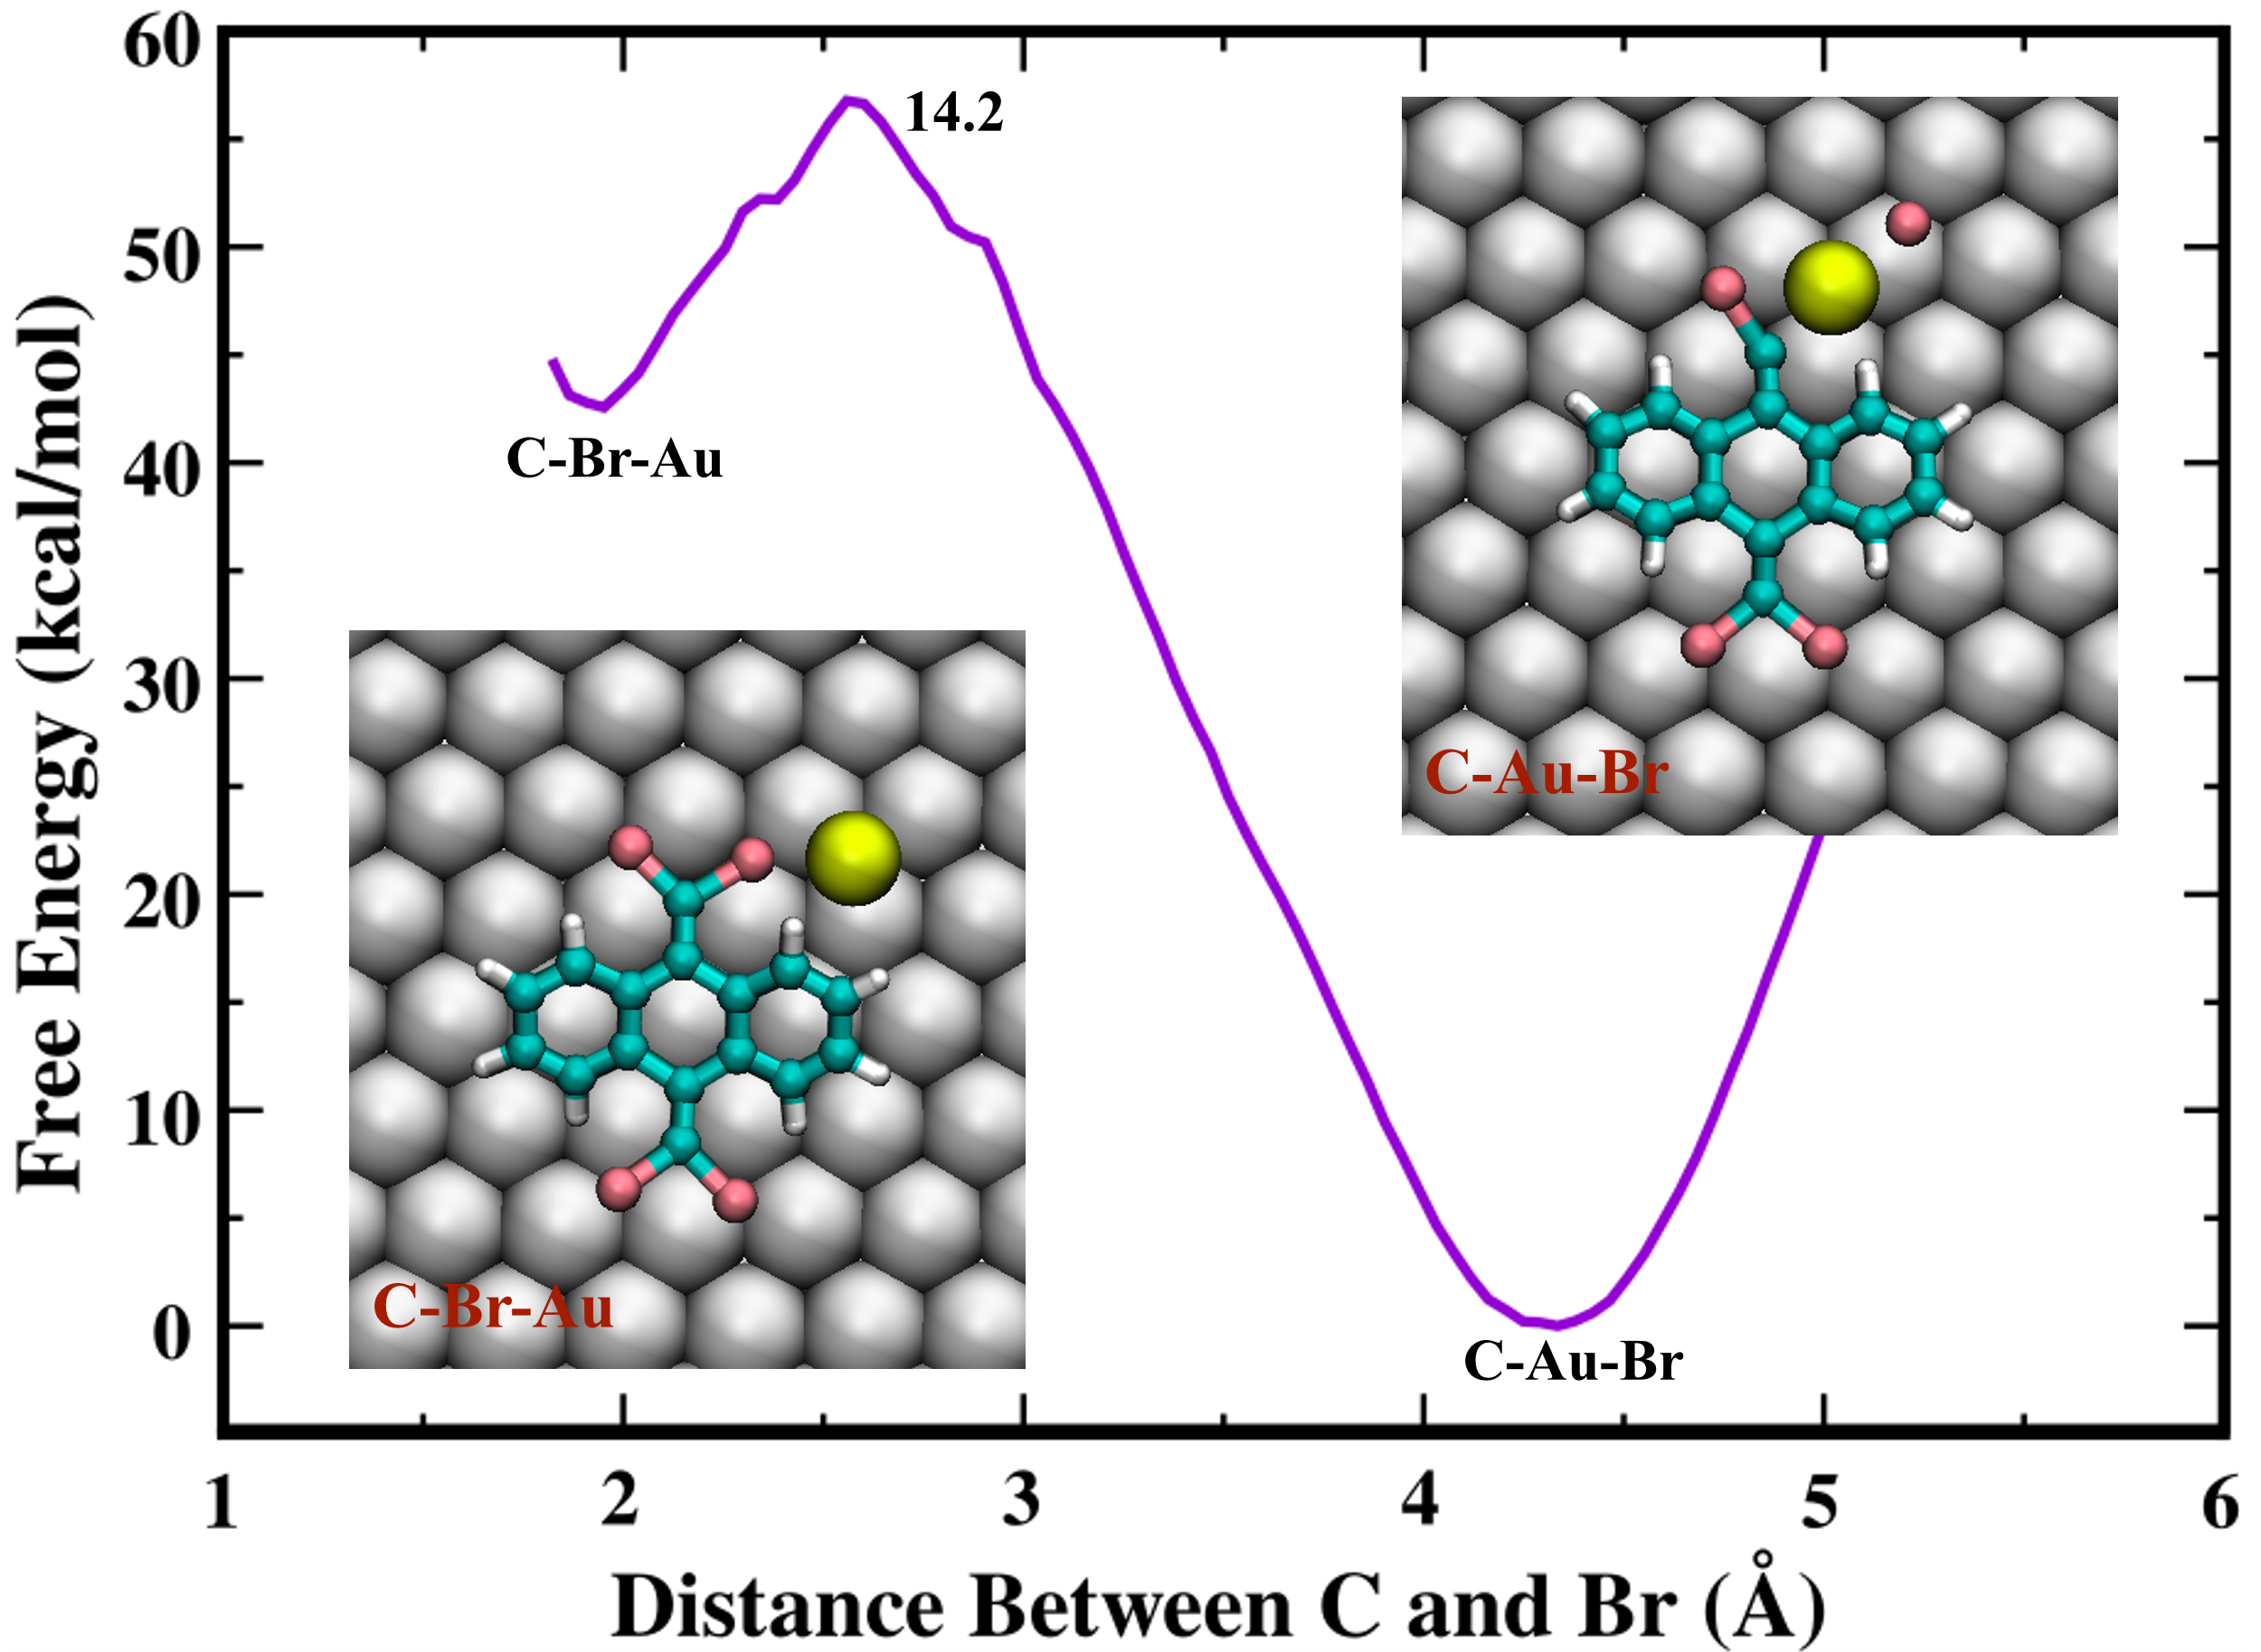
Fig. S5 | Free Energy calculation of breaking the C-Br bond and insert with the snapshots of initial (C-Br-Au) and final (C-Au-Br) states. The C, H, Br, Au adatom, and Au surface are represented by blue, white, pink, yellow, and gray balls, respectively.

6. Free molecular dynamics of the initial and final states of second debromination
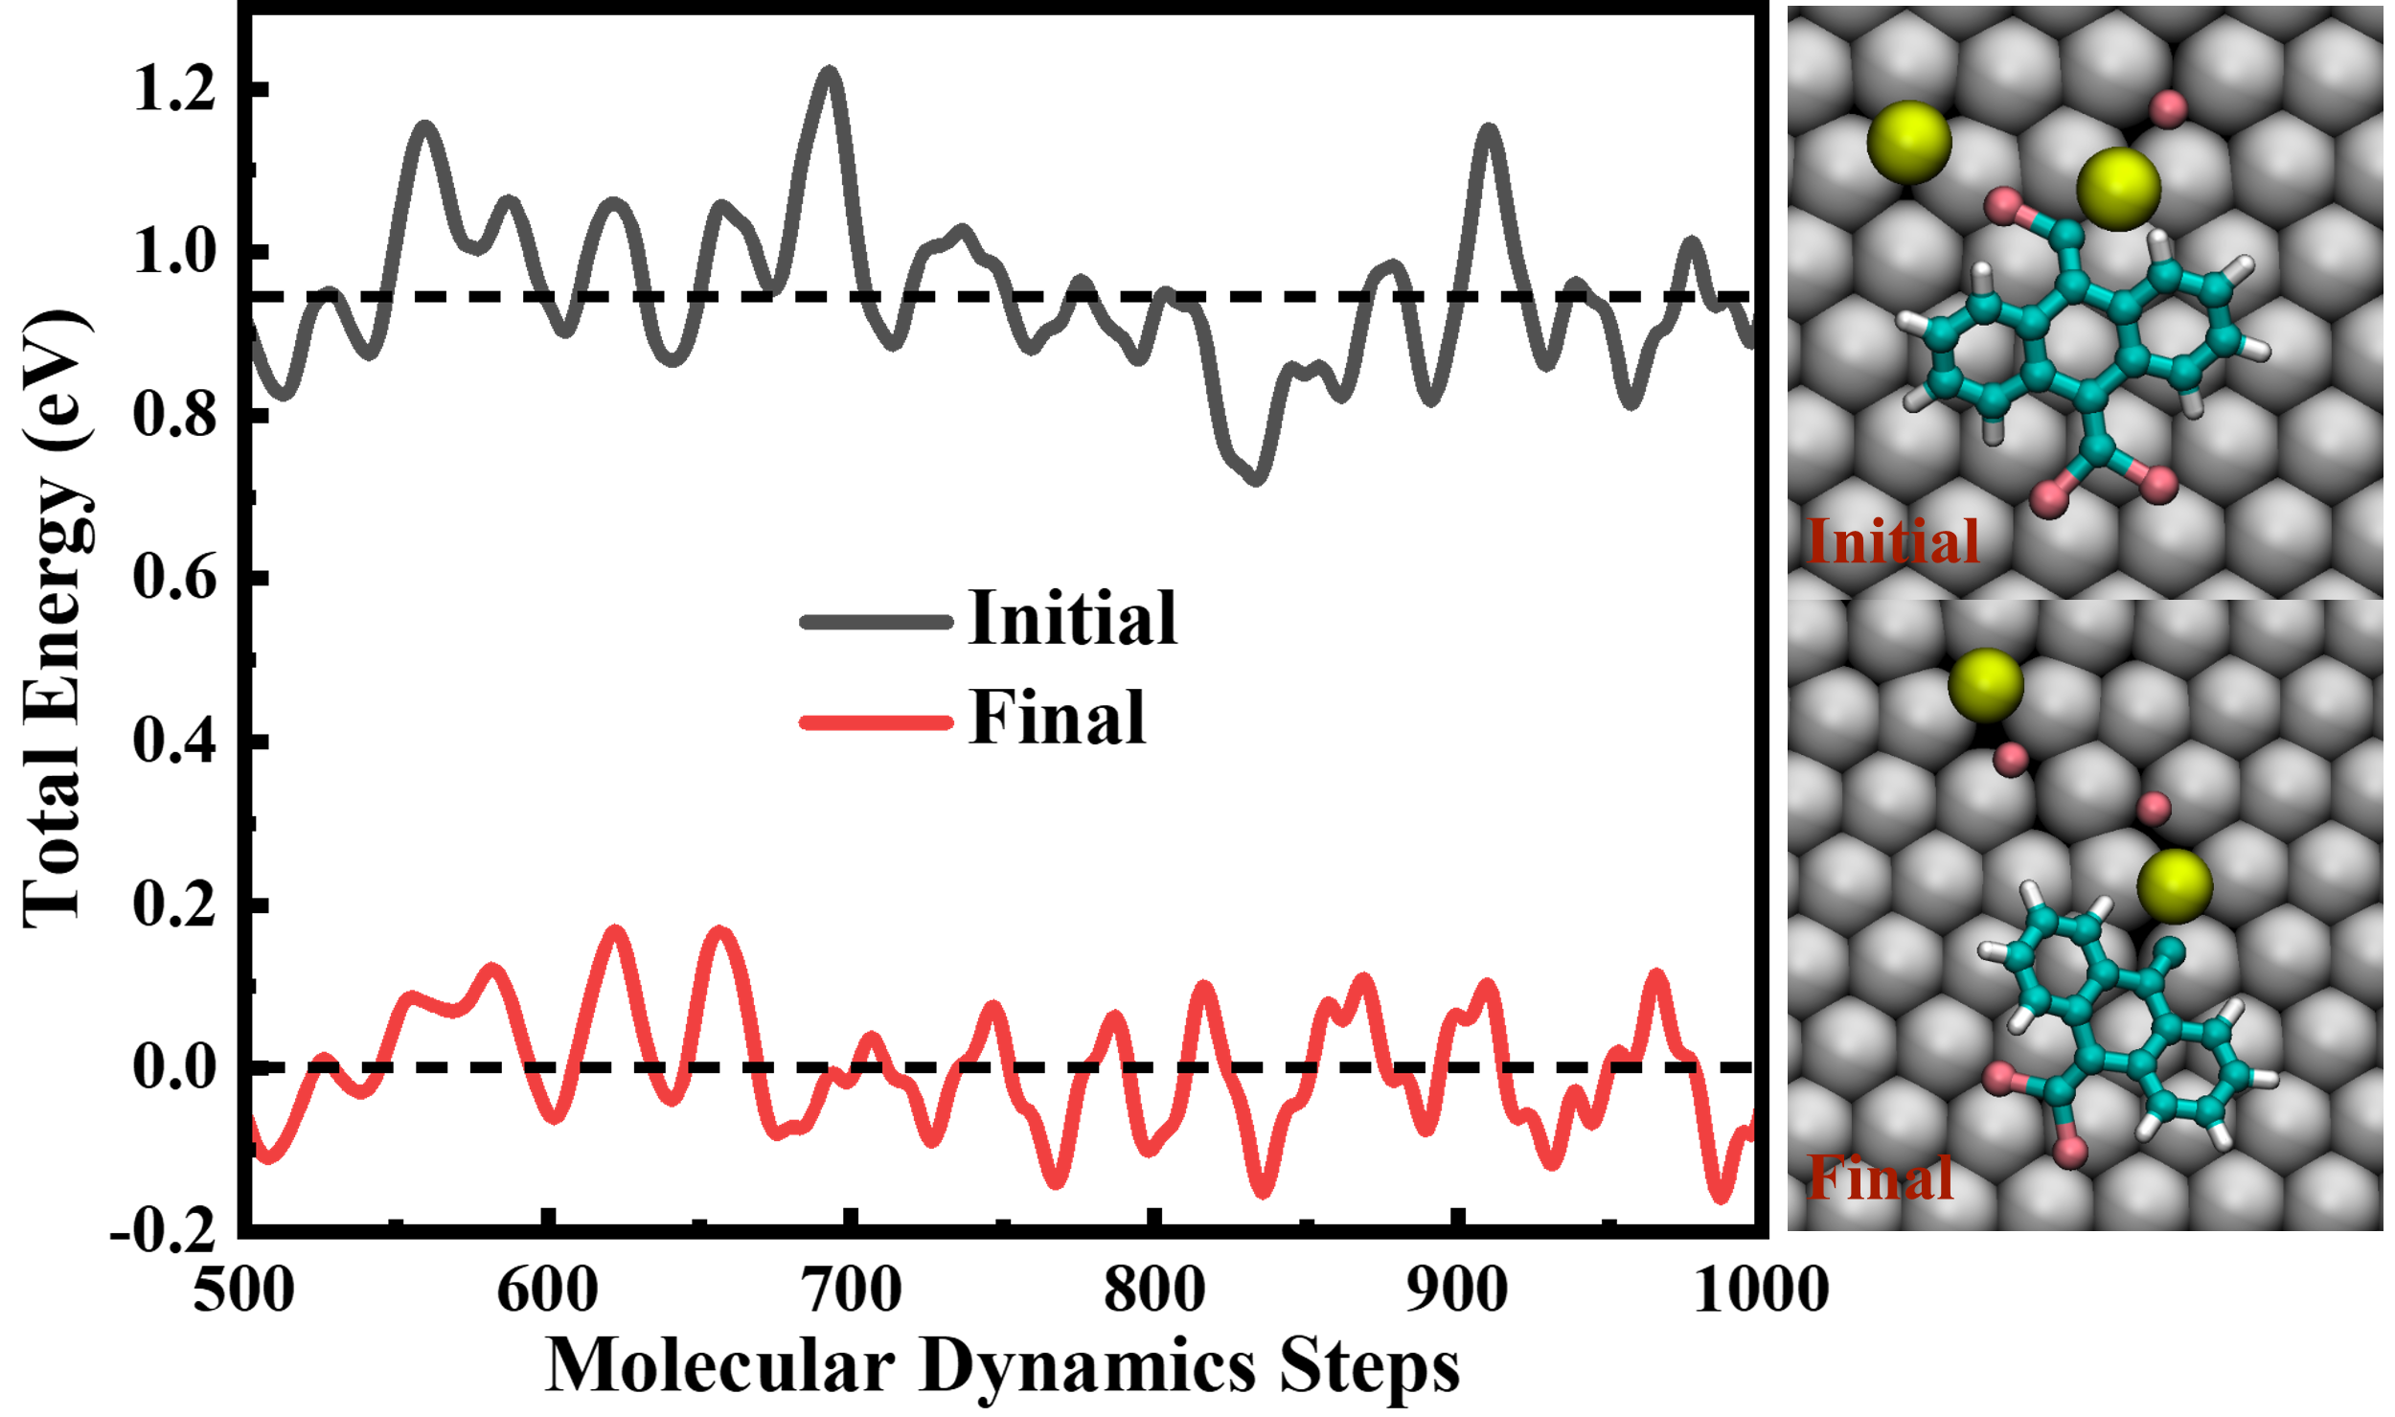
Fig. S6 | Total energy comparison of the initial and final states of second debromination and the snapshots of initial and final states can be seen in the left side. The C, H, Br, Au adatoms, and Au surface are represented by blue, white, pink, yellow, and gray balls, respectively. The total energy of the Initial state is higher than that of the final state by about 0.95 eV.

7. Free molecular dynamics of IM1 and IM2.
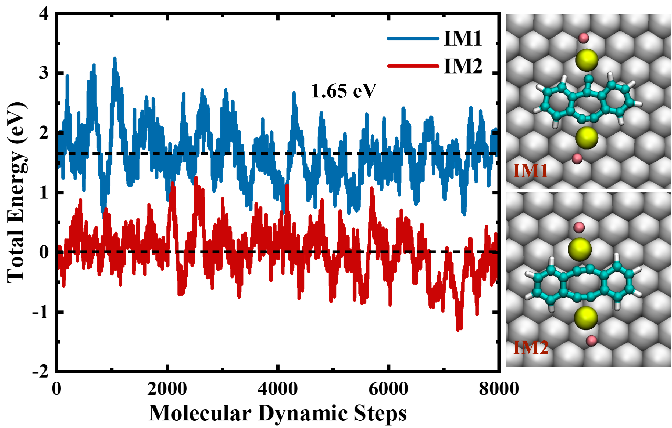
Fig. S7 │Total energy comparison of the IM1 and IM2 and the snapshots of IM1 and IM2 can be seen in the left side. The C, H, Br, Au adatoms, and Au surface are represented by blue, white, pink, yellow, and gray balls, respectively. The total energy of IM1 is higher than that of IM2 by about 1.65 eV.

8. Free energy calculation of reactions pathways from IM2 to FS1/FS2 without the QM surface
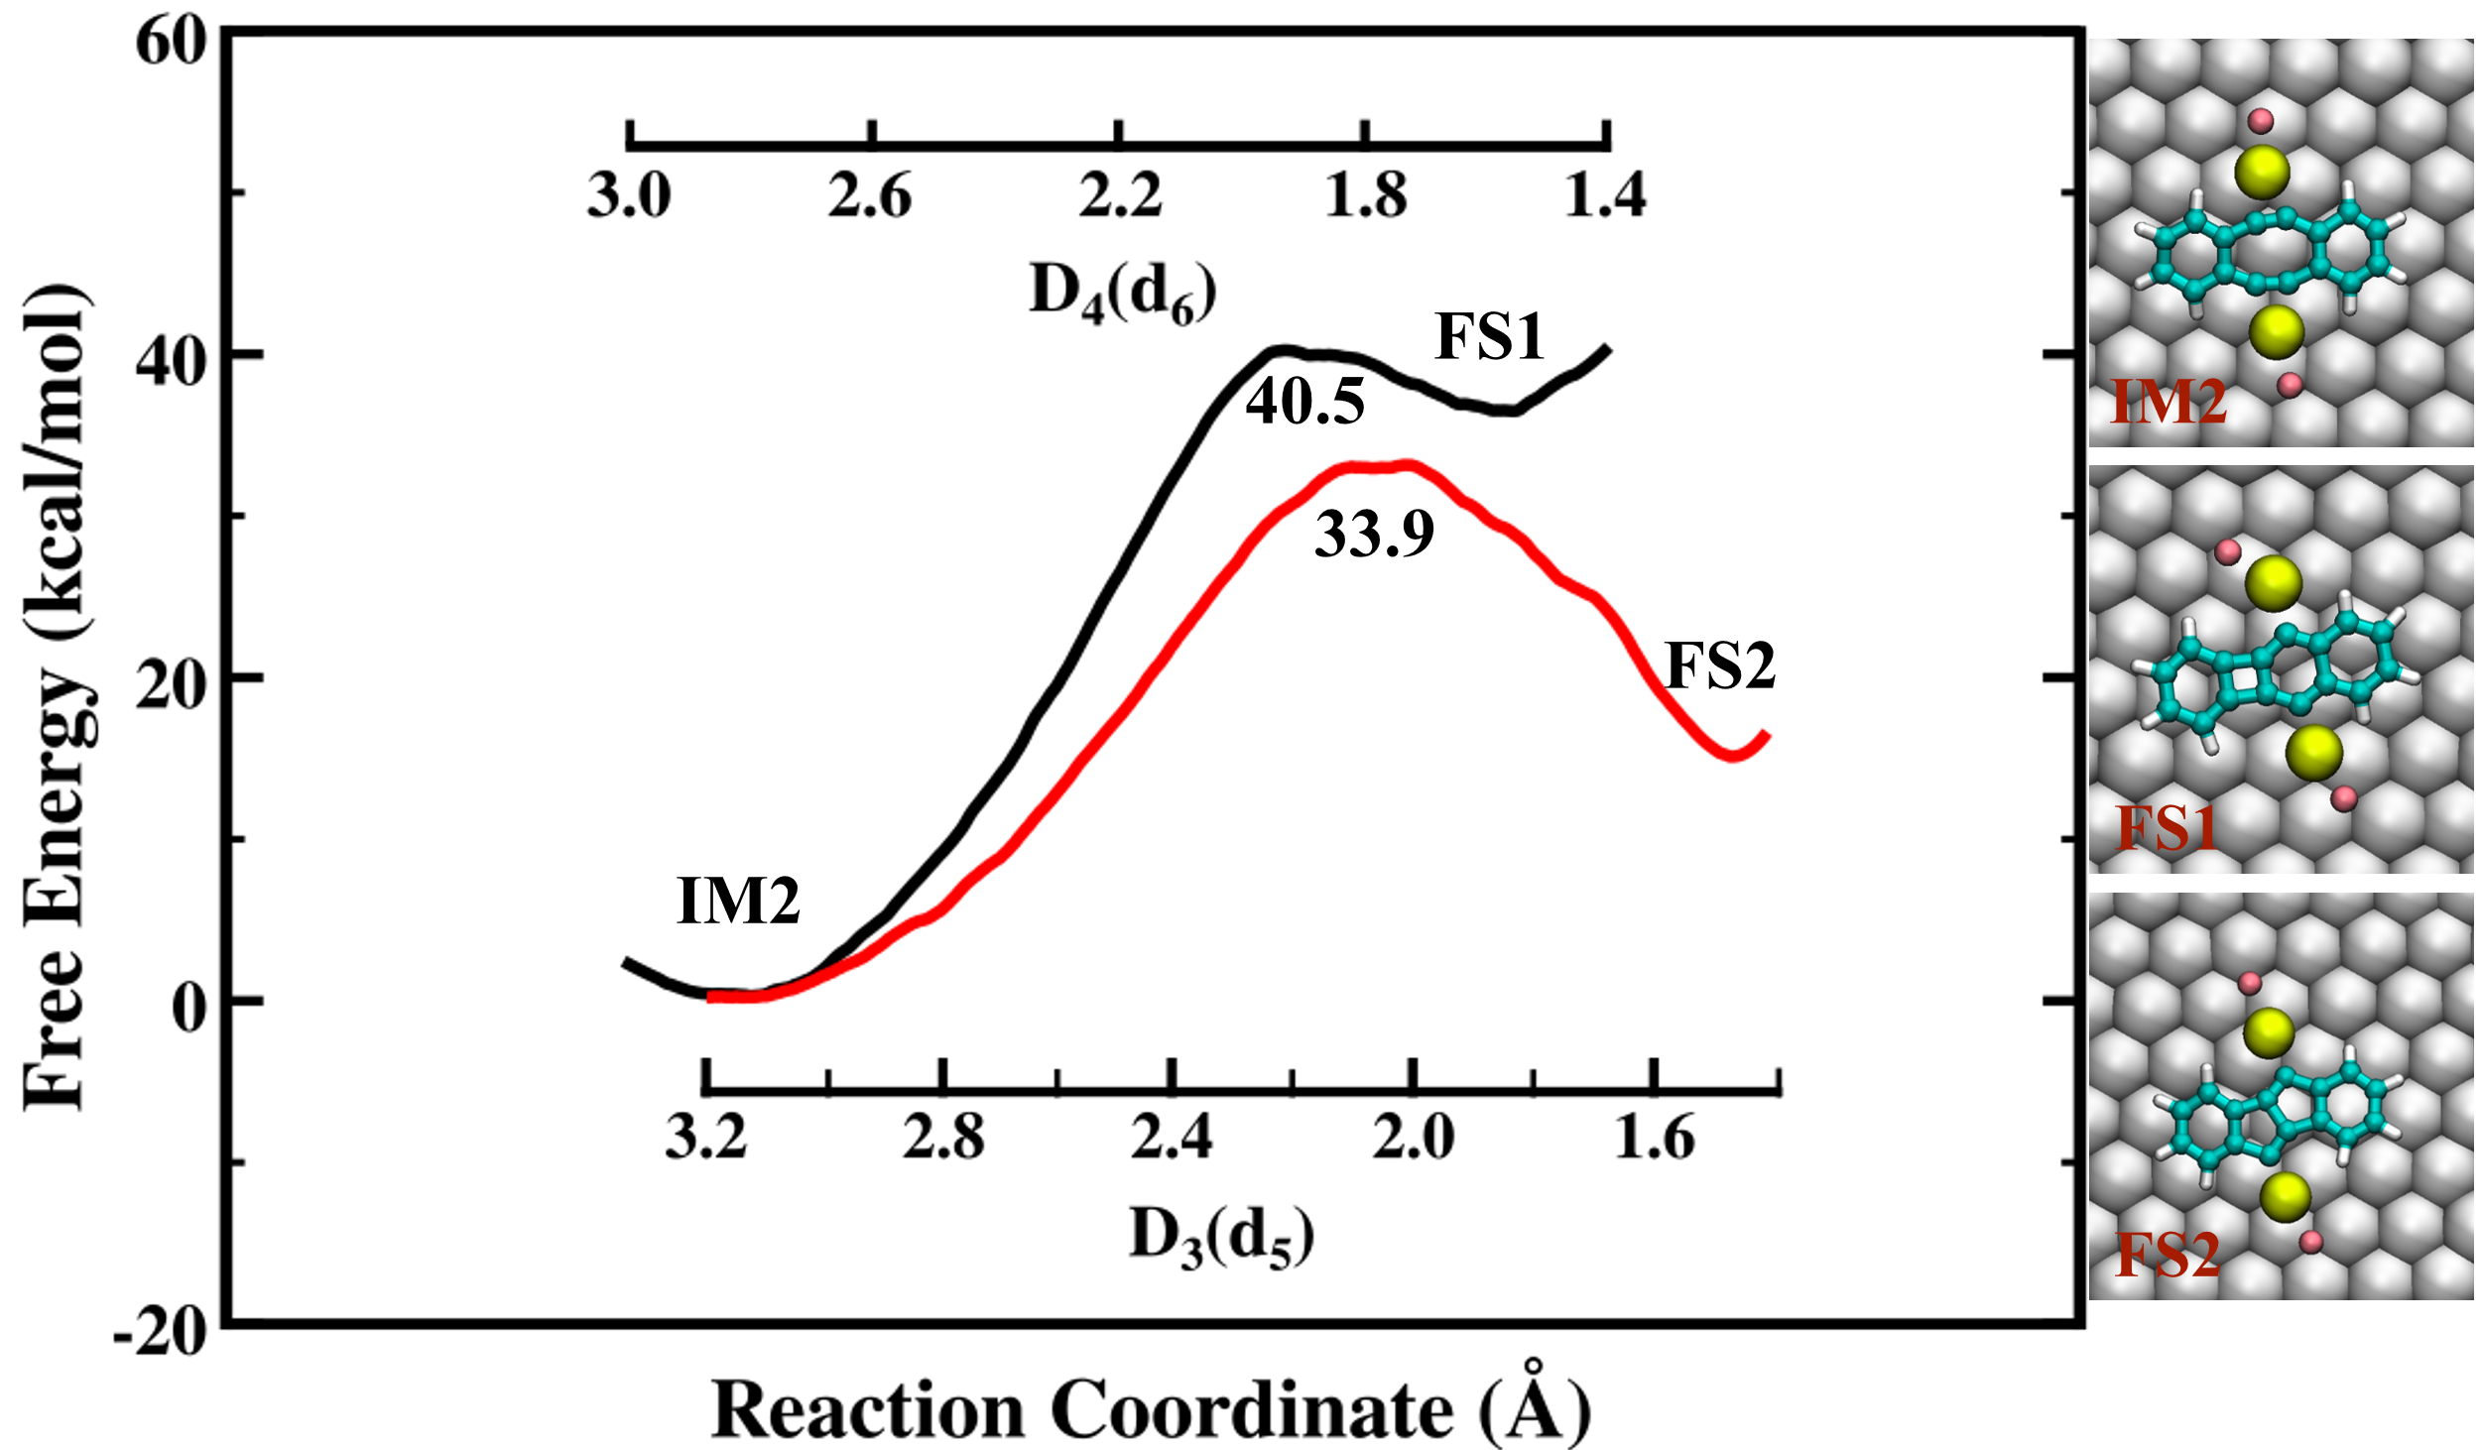
Fig. S8 │Free energy calculation of reaction pathways from IM2 to FS1/FS2. The left part is the comparison of free energy profiles from IM2 to FS1/FS2, while the right part are the structures of IM2/FS1/FS2. The C, H, Br, Au adatom, and Au surface are shown in blue, white, pink, yellow, and gray balls, respectively.

9. Free energy calculation of reactions pathways from IM2 to FS1/FS2
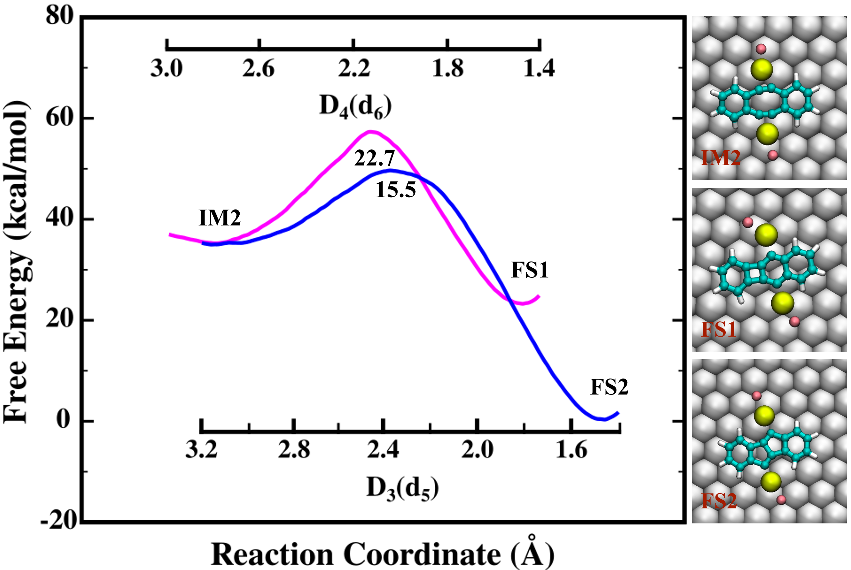
Fig. S9 │Free Energy calculation of reaction pathways from IM2 to FS1/FS2. The left part is the comparison of the free energy profiles from IM2 to FS1/FS2, while the right part are the structures of IM2/FS1/FS2. The C, H, Br, Au adatom, and Au surface are shown by blue, white, pink, yellow, and gray balls, respectively.

10. Pentalene-linked indeno[1,2-b]fluorene polymers achieved by RT deposition and subsequent annealing to 350 ºC
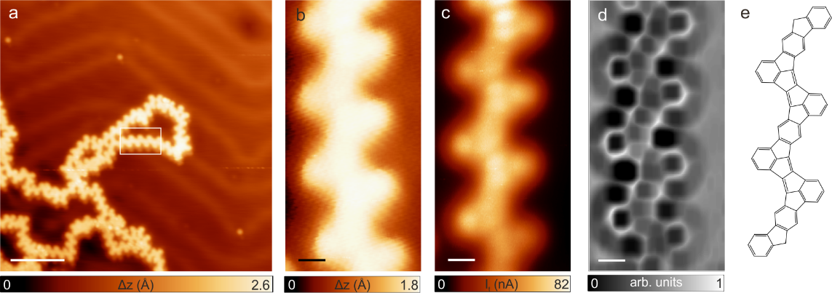
Fig. S10 | Formation of pentalene-linked indeno[1,2-b]fluorene polymers. a, Long-range STM image that shows the formation of chains coexisting with some ill-defined segments after deposition of the molecular precursor 7 on the Au(111) kept at RT subsequently annealed at 350 ºC. V_{b} = -0.5 V, I_{t} = 40 pA, scale bar: 5 nm. b-c, Constant-current and constant-height high-resolution STM images of a segment composed by three units. V_{b} = -0.5 V, I_{t} = 40 pA and V_{b} = -5 mV, I_{t} = 40 pA respectively, scale bars: 0.5 nm. d, Corresponding nc-AFM Laplace filtered image of (b,c) where the pentalene units formed between indeno[1,2-b]fluorene molecular backbones are clearly discerned, in contrast to the 8a segments obtained after deposition of 7 on the Au(111) substrate kept at 300 °C.

11. Free Energy Calculation for the insertion of the 6-membered ring
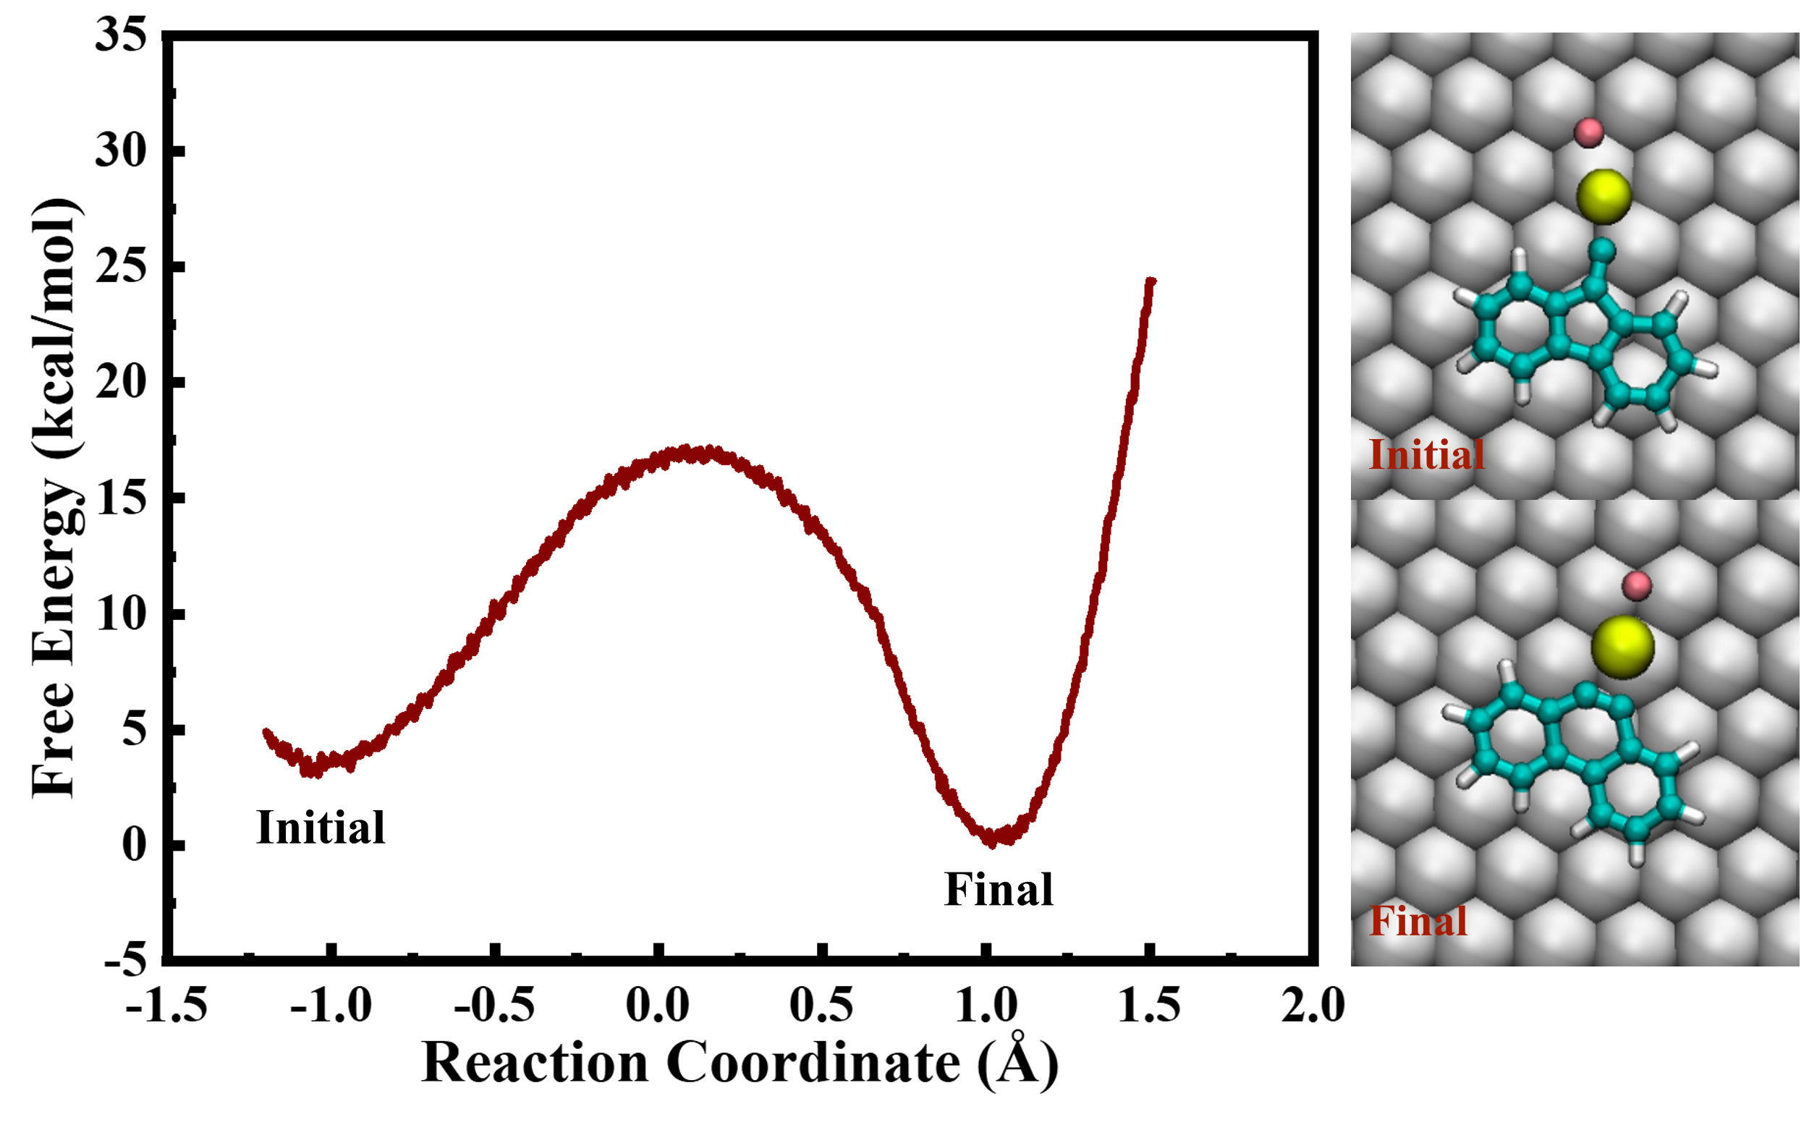
Fig. S11 │Free Energy profile for the insertion of the 6-membered ring. The result shows not only that such ring rearrangement is thermodynamically spontaneous, but also yields a low energy barrier.

12. Dibenz[a,h]anthracene units connected by five-membered ring bridges (8b)
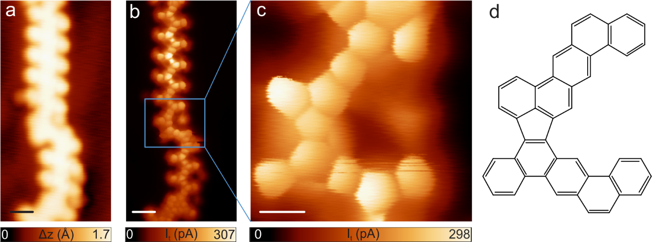Fig. S12 | Residual dibenz[a,h]anthracene units connected by pentagons (8b). a, STM of a one-dimensional polymer obtained after the deposition of molecular precursor 7 with the Au(111) substrate kept at 300 ºC. V_{b} = 0.5 V, I_{t} = 40 pA, scale bar: 7 Å. b, Constant-height STM image of (a) acquired with a CO-functionalized tip. V_{b} = 5 mV, I_{t} = 40 pA, scale bar: 7 Å. c, Zoomed-in constant-height image of the indicated area in panel (b). V_{b} = 5 mV, I_{t} = 40 pA, scale bar: 4 Å. d, Chemical sketch of the segment shown in (c).
Most of the structures obtained after depositing the molecular precursor 7 on the Au(111) substrate kept at 300 ºC are 8a (85%), as explained in the main text. However, a residual amount of dibenz[a,h]anthracene units connected by five membered ring bridges (15%), called 8b are also obtained, as presented in Figure S12.
Fig. S13 │Tentative mechanism for the five-membered ring formation side-reaction.

