Supplementary Figures

Figure S1. SNP-density plot of the eight chromosomes of Medicago sativa; colors represent number of SNPs within 1 megabase (Mb) window size.

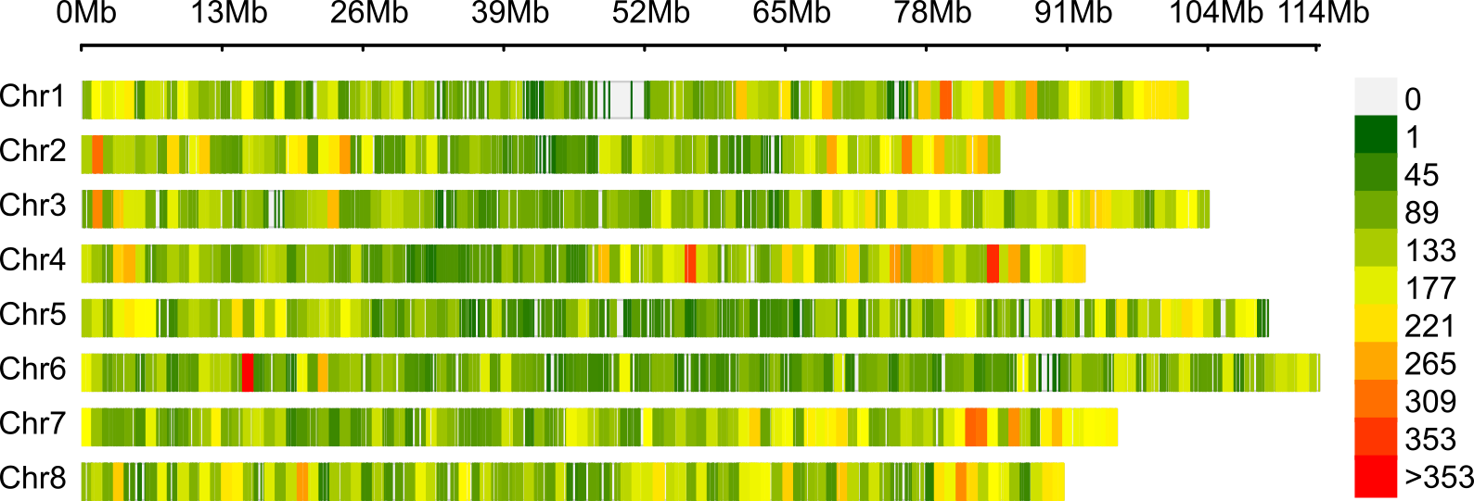

Figure S2. Manhattan plots of forage yield (Yi) by single harvest with significantly associated markers. Datasets analyzed correspond to single-trail analysis (ST0) or stagewise analysis grouped by cut by year by location (ST1) or by location (ST3) in Idaho (ID), Oregon (OR), and Washington (WA).

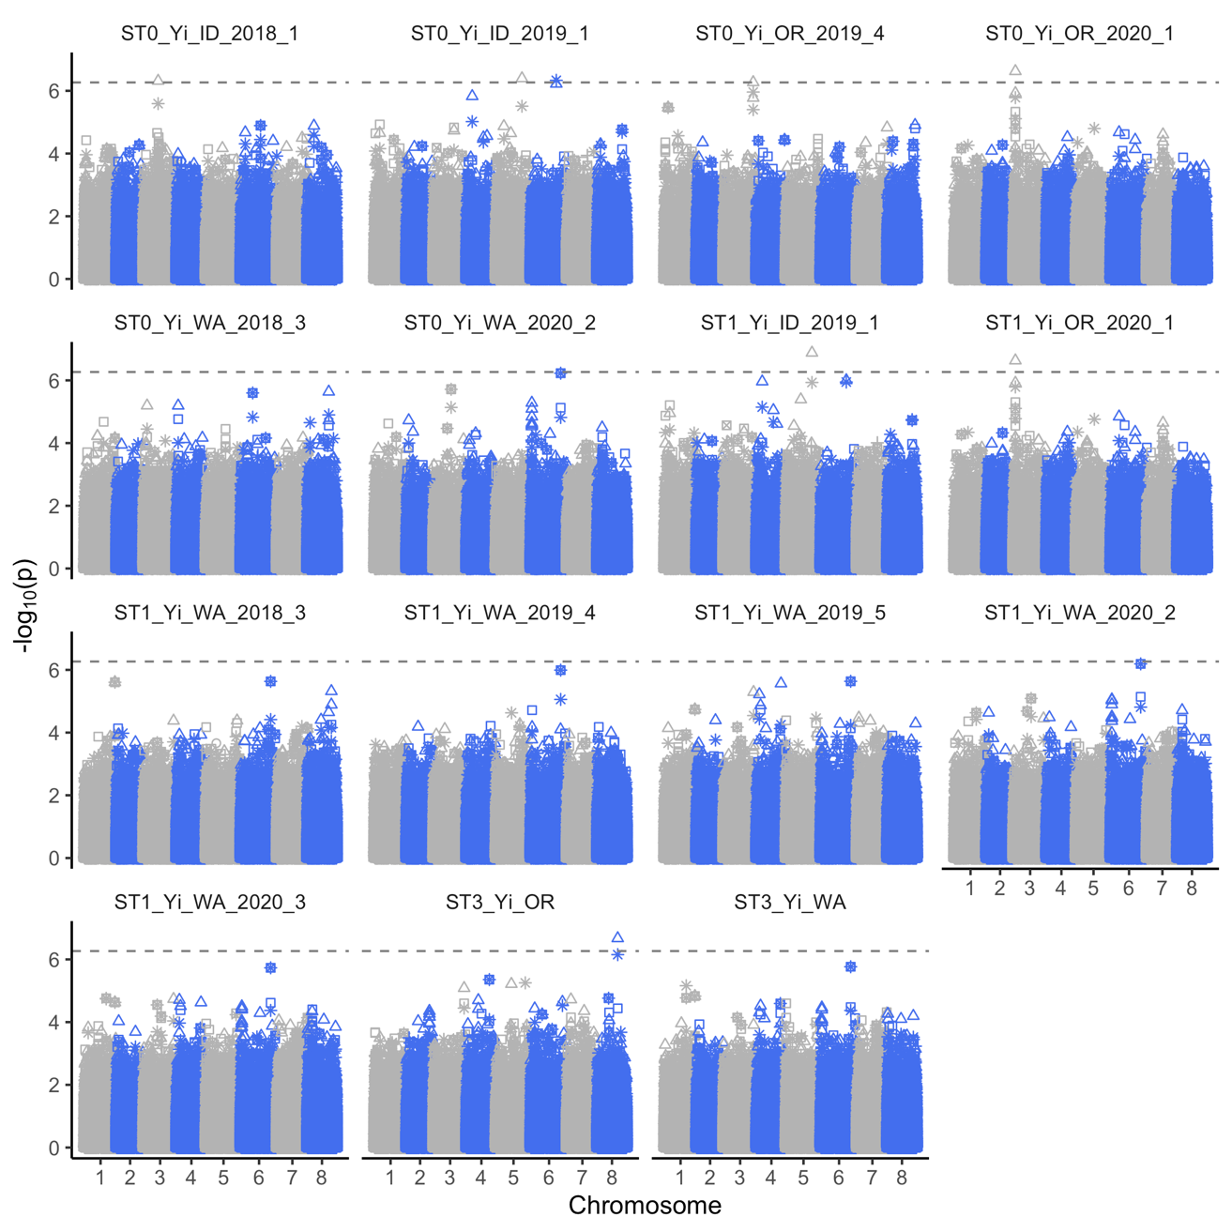

Figure S3. Manhattan plots of annual forage yield with significantly associated markers. Annual forage yield was obtained as the sum of all harvests by year by location. Datasets analyzed correspond to single-trail analysis (ST0) or stagewise analysis grouped by year (ST1) in Idaho (ID), Oregon (OR), or Washington (WA).
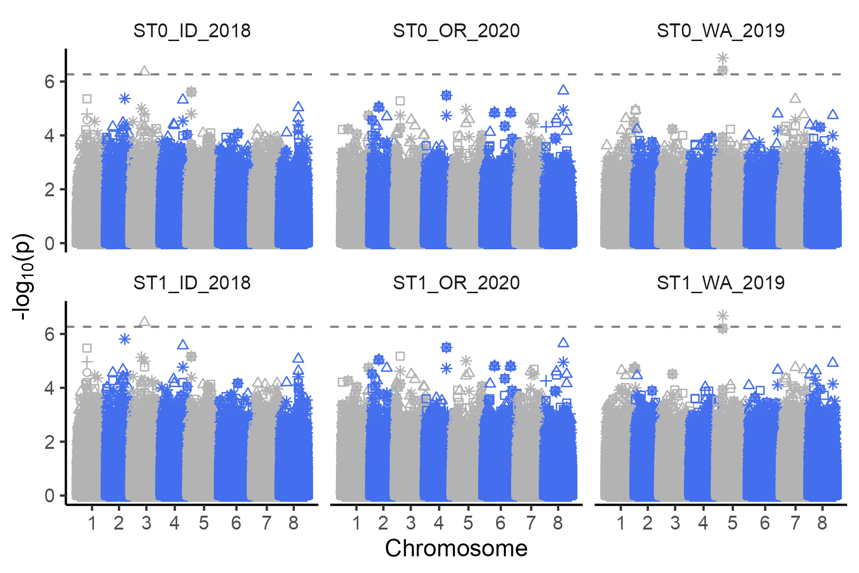

Figure S4. Manhattan plots of plant height (PH) with significantly associated markers. Datasets analyzed correspond to single-trail analysis (ST0) or stagewise analysis grouped by cut by year by location (ST1) or by location (ST3) in Idaho (ID), Oregon (OR), and Washington (WA).

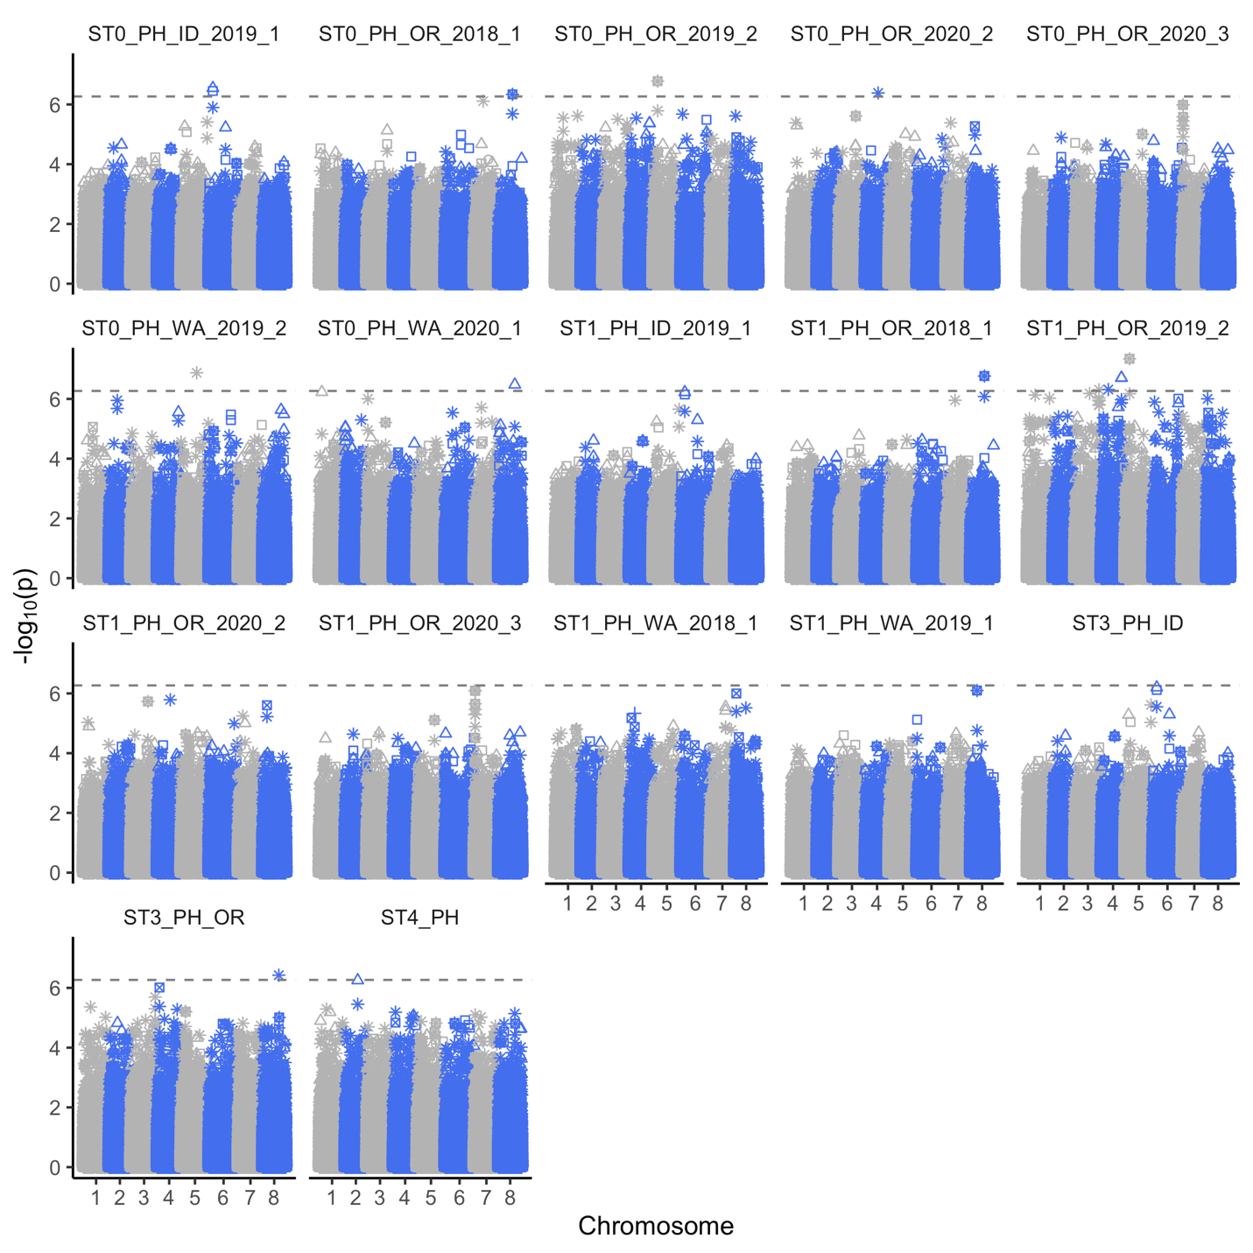

Figure S5. Manhattan plots of dry matter (DM) with significantly associated markers. Datasets analyzed correspond to single-trail analysis (ST0) or stagewise analysis grouped by cut by year by location (ST1) or by location (ST3) in Idaho (ID), Oregon (OR), and Washington (WA).

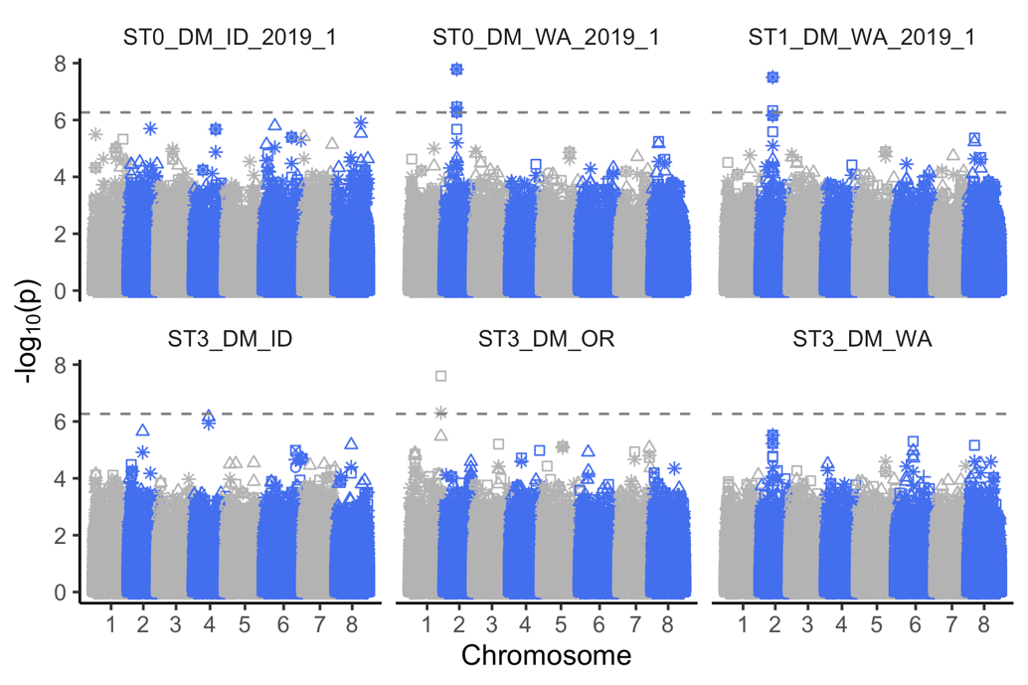

Figure S6. Manhattan plots of maturity measured as mean stage by count (MSC) with significantly associated markers. Datasets analyzed correspond to single-trail analysis (ST0) or stagewise analysis grouped by cut by year by location (ST1) or by location (ST3) in Idaho (ID), Oregon (OR), and Washington (WA).

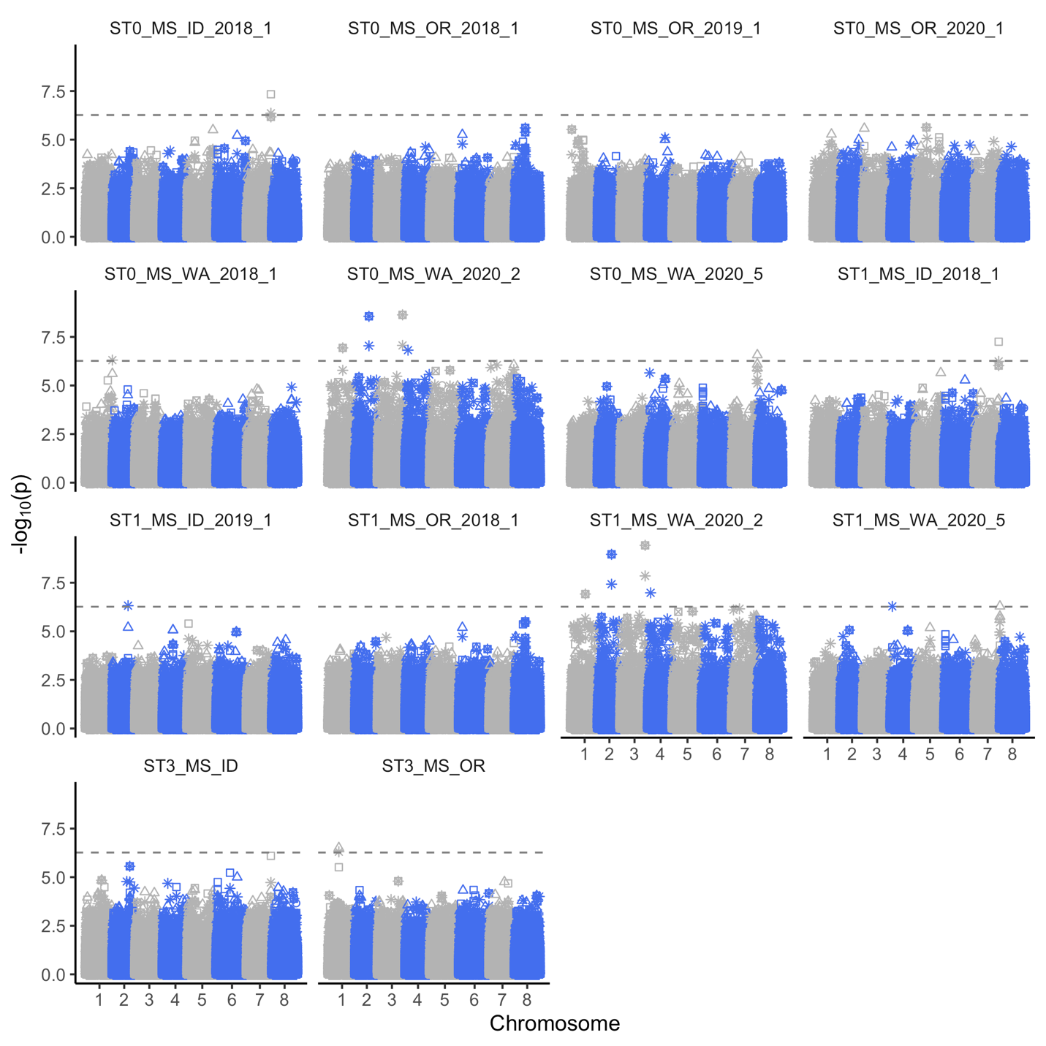

Figure S7. Manhattan plots of fall dormancy (FD) with significantly associated markers. Natural plant height datasets were analyzed in single-trail (ST0) or stagewise analysis grouped by year by locations (ST1) or by location (ST3) in Oregon (OR) and Washington (WA).

