Supplementary Table 1. Items and scoring scheme for the frailty index
 | Sub-section | Item | Response | Score
 | Diagnosed Health Conditions | Stroke | No | 0
 | Diagnosed Health Conditions | Stroke | Yes | 1
 | Diagnosed Health Conditions | Parkinson | No | 0
 | Diagnosed Health Conditions | Parkinson | yes | 1
 | Diagnosed Health Conditions | Memory problems | No | 0
 | Diagnosed Health Conditions | Memory problems | Yes | 1
 | BLESSED Test (Part 2) | Eating | Feeding self without assistance | 0
 | BLESSED Test (Part 2) | Eating | Feeds self with assistance (include minor/much) | 0.5
 | BLESSED Test (Part 2) | Eating | Has to be fed | 1
 | BLESSED Test (Part 2) | Toilet | Clean, care for self | 0
 | BLESSED Test (Part 2) | Toilet | Incontinence (include occasional and frequent) | 0.5
 | BLESSED Test (Part 2) | Toilet | Little or no control | 1
 | BLESSED Test (Part 2) | Dressing | Unaided | 0
 | BLESSED Test (Part 2) | Dressing | Some difficulty (occasional misplace buttons, wrong sequence) | 0.5
 | BLESSED Test (Part 2) | Dressing | Unable to dress | 1
 | Everyday Activities | Able to travel | Yes | 0
 | Everyday Activities | Able to travel | No | 1
 | Everyday Activities | Daily activities | No change | 0
 | Everyday Activities | Daily activities | Slowing down | 0.5
 | Everyday Activities | Daily activities | Activities decrease or discontinue | 1
 | Cognitive Activity Score (CSI) | General decline in mental functioning | No | 0
 | Cognitive Activity Score (CSI) | General decline in mental functioning | Yes | 1
 | Blood Pressure Measurements | High blood pressure (systolic mean >140 mmHg) | No | 0
 | Blood Pressure Measurements | High blood pressure (systolic mean >140 mmHg) | Yes | 1
 | Anthropometry | Body mass index, Kg/m² | 18.5 to <25 | 0
 | Anthropometry | Body mass index, Kg/m² | 25 to <30 | 0.50
 | Anthropometry | Body mass index, Kg/m² | <18.5 or ≥30 | 1
 | Anthropometry | Whether able to stand for measurements | Yes | 0
 | Anthropometry | Whether able to stand for measurements | No | 1
 | Activities of daily living (ADLs): Some difficulty | Difficulty walking across room (ADL) | No difficulty | 0
 | Activities of daily living (ADLs): Some difficulty | Difficulty walking across room (ADL) | Any difficulty | 1
 | Activities of daily living (ADLs): Some difficulty | Bathing | No difficulty | 0
 | Activities of daily living (ADLs): Some difficulty | Bathing | Any difficulty | 1
 | Instrumental activities of daily living (IADLs): Some difficulty | Use of telephone | No difficulty | 0
 |  | Use of telephone | Any difficulty | 1
 |  | Take medication | No difficulty | 0
 |  | Take medication | Any difficulty | 1
 |  | Doing household chores | No difficulty | 0
 |  | Doing household chores | Any difficulty | 1
 |  | Getting around | No difficulty | 0
 |  | Getting around | Any difficulty | 1
 | Mental Health (CESD Score) | Felt depressed | Rarely or never | 0
 | Mental Health (CESD Score) | Felt depressed | Sometimes/often | 0.5
 | Mental Health (CESD Score) | Felt depressed | Most or all the time | 1
 | Mental Health (CESD Score) | Felt tired | Rarely or never | 0
 | Mental Health (CESD Score) | Felt tired | Sometimes/often | 0.5
 | Mental Health (CESD Score) | Felt tired | Most or all the time | 1
 | Mental Health (CESD Score) | Everything was an effort | Rarely or never | 0
 | Mental Health (CESD Score) | Everything was an effort | Sometimes/often | 0.5
 | Mental Health (CESD Score) | Everything was an effort | Most or all the time | 1
 | Anxiety Inventory | Fear of dying (anxiety) | Never | 0
 | Anxiety Inventory | Fear of dying (anxiety) | Hardly/some of the time | 0.5
 | Anxiety Inventory | Fear of dying (anxiety) | Most of the time | 1
 | Mini-Nutritional assessment (MNA) | Decrease in food intake last 3 months | No decrease | 0
 | Mini-Nutritional assessment (MNA) | Decrease in food intake last 3 months | Moderate decrease | 0.5
 | Mini-Nutritional assessment (MNA) | Decrease in food intake last 3 months | Severe decrease | 1
 | Mini-Nutritional assessment (MNA) | Weight loss | No loss/ 1-3kg/does not know | 0
 | Mini-Nutritional assessment (MNA) | Weight loss | >3kg | 1
 | Mini-Nutritional assessment (MNA) | Mobility | Goes out | 0
 | Mini-Nutritional assessment (MNA) | Mobility | Able to get out of bed/chair but does not go out | 0.5
 | Mini-Nutritional assessment (MNA) | Mobility | Bed or chair bound | 1
 | Mini-Nutritional assessment (MNA) | >3 prescription drugs | No | 0
 | Mini-Nutritional assessment (MNA) | >3 prescription drugs | Yes | 1
 | Mini-Nutritional assessment (MNA) | Pressure sore/skin ulcer | No | 0
 | Mini-Nutritional assessment (MNA) | Pressure sore/skin ulcer | Yes | 1
 | Mini-Nutritional assessment (MNA) | Self-viewed nutrition status | Views no nutritional/uncertain problem | 0
 | Mini-Nutritional assessment (MNA) | Self-viewed nutrition status | Views self as being malnourished | 1
 | Mini-Nutritional assessment (MNA) | Self-rated health status | Better/ As good / Does not know | 0
 | Mini-Nutritional assessment (MNA) | Self-rated health status | Not as good | 1
 | Mini-Nutritional assessment (MNA) | Mid-arm circumference | >22 cm | 0
 | Mini-Nutritional assessment (MNA) | Mid-arm circumference | 0-22 cm | 1
 | Mini-Nutritional assessment (MNA) | Calf circumference | >31 cm | 0
 | Mini-Nutritional assessment (MNA) | Calf circumference | 0-31 cm | 1
 | Hearing Tests | Hearing test | Good (good acuity in both ears) or Mild difficulty (mild difficulty in both or either ear) | 0
 | Hearing Tests | Hearing test | Moderate to severe difficulty  (moderate to severe difficulty in both or either ear) | 1

Supplementary Table 2. The frailty index and its components in high-performing, intermediate-performing, and low-performing states
 | High Performing states – n (%) | Intermediate Performing states – n (%) | Low Performing states – n (%) | p-value
Frailty Index (Mean ± SE)* | 20.9 ± 0.4 | 24.9 ± 0.4 | 26.0 ± 0.5 | <0.001
Frail* | 558 (34.5) | 628 (46.8) | 583 (49.7) | <0.001
Frailty Components
Stroke | 66 (4.39) | 94 (7.13) | 69 (6.17) | 0.007
Parkinson | 27 (1.80) | 24 (1.83) | 89 (7.91) | <0.001
Memory problems | 82 (5.46) | 197 (15.04) | 176 (15.74) | <0.001
Eating, has to be fed | 7 (0.47) | 47 (3.56) | 2 (0.18) | <0.001
Toilet, little or no control | 14 (0.93) | 8 (0.61) | 1 (0.09) | 0.001
Dressing, unable to dress | 14 (0.93) | 12 (0.91) | 9 (0.80) | 0.002
Able to travel | 510 (33.95) | 559 (42.32) | 441 (39.23) | <0.001
Daily activities, activities decrease or discontinue | 156 (10.38) | 189 (14.36) | 180 (16.04) | <0.001
General decline in mental functioning | 300 (20.00) | 390 (29.66) | 423 (37.90) | <0.001
High blood pressure (systolic mean >140 mmHg) | 710 (47.65) | 597 (45.75) | 460 (41.97) | 0.016
Body mass index, <18.5 or ≥30 Kg/m² | 355 (25.56) | 408 (33.33) | 366 (34.76) | <0.001
Not able to stand for measurements | 42 (2.82) | 43 (3.33) | 30 (2.69) | 0.608
Difficulty Walking across room (ADL) | 306 (20.36) | 380 (28.77) | 328 (29.05) | <0.001
Bathing | 203 (13.51) | 257 (19.45) | 208 (18.42) | <0.001
Use of telephone | 562 (37.82) | 477 (37.50) | 613 (55.23) | <0.001
Take medications | 188 (12.52) | 241 (18.24) | 229 (20.30) | <0.001
Doing household chores | 476 (31.69) | 407 (30.93) | 432 (38.54) | <0.001
Getting around | 581 (38.68) | 538 (41.01) | 540 (48.04) | <0.001
Felt depressed, Most or all the time | 137 (9.13) | 90 (6.83) | 115 (10.29) | 0.008
Felt tired, Most or all the time | 203 (13.51) | 160 (12.11) | 253 (22.51) | <0.001
Everything was an effort, Most or all the time | 167 (11.17) | 117 (8.92) | 86 (7.73) | 0.009
Fear of dying(anxiety), Most of the time | 24 (1.6) | 61 (4.63) | 35 (3.13) | <0.001
Decrease in food intake last 3 months, Severe decrease | 172 (11.44) | 183 (13.87) | 124 (11.02) | <0.001
Weight loss | 115 (7.68) | 134 (10.20) | 98 (8.74) | 0.063
Mobility, bed or chair bound | 31 (2.06) | 66 (5.00) | 14 (1.24) | <0.001
>3 prescription drugs | 363 (24.22) | 321 (24.32) | 128 (11.36) | <0.001
Pressure sore/skin ulcer | 180 (11.98) | 88 (6.67) | 86 (7.64) | <0.001
Self-viewed nutrition status | 234 (15.61) | 330 (25.10) | 317 (28.23) | <0.001
Self-rated health status | 331 (22.05) | 377 (28.71) | 342 (30.48) | <0.001
Mid-arm circumference ≤ 22 cm | 291 (19.57) | 304 (23.05) | 242 (21.49) | 0.079
Calf circumference ≤ 31 cm | 868 (58.14) | 819 (62.09) | 834 (74.46) | <0.001
Hearing | 675 (45.89) | 655 (51.86) | 502 (46.14) | 0.003
*Weighted values; SE- Standard Error

85 duplicate variables excluded
Final constructed LASI-FI:
32 health deficits
36 LASI-DAD variables considered for frailty index
260 LASI-DAD variables to be converted into health deficits

345 health-related variables
All LASI-DAD variables
(n = 392)
25 Demographic variables and 22 food-related variables excluded

260 LASI-DAD variables combined to create 36 health deficits

4 excluded due to missing data

Supplementary Figure 1. Flow diagram describing the construction of frailty index.

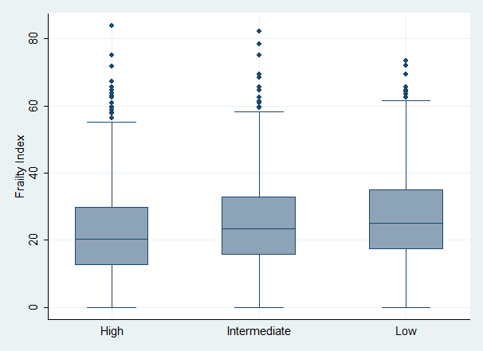

Supplementary Figure 2. Distribution of frailty index in high-, intermediate-, and low-performing states.
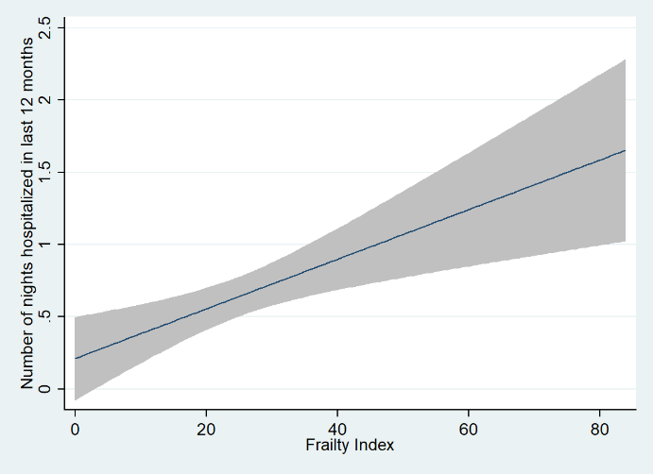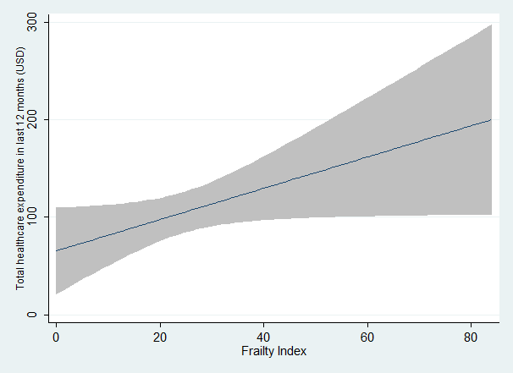

Supplementary Figure 3. Fit-line plot showing the relationship between frailty index and A. total healthcare expenditure in last one year and B. number of nights spent in the hospital in last one year
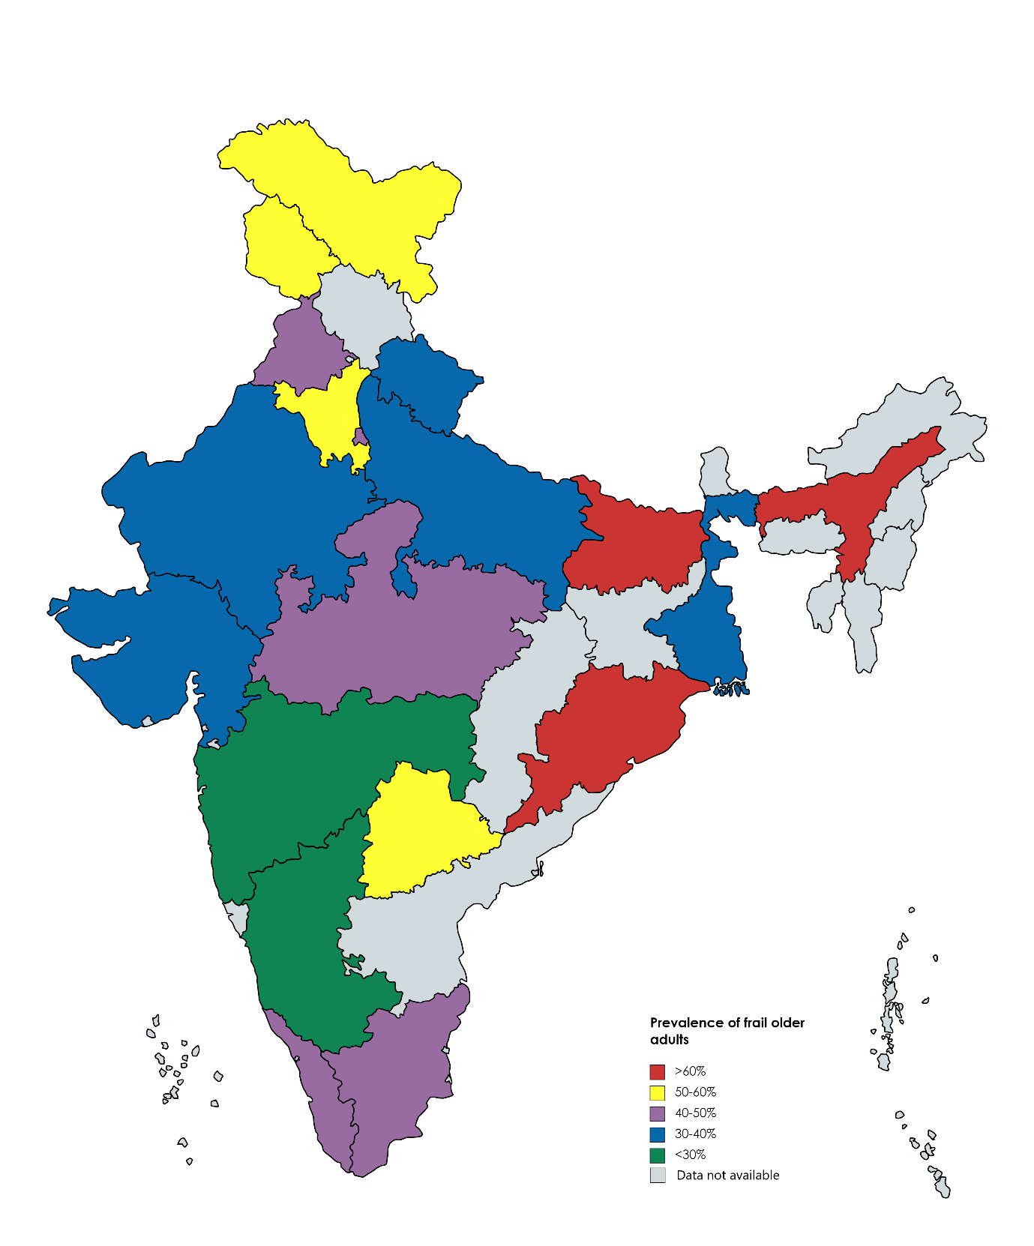
Supplementary Figure 4. The prevalence of frailty in older adults (≥60 years) in different states of India

