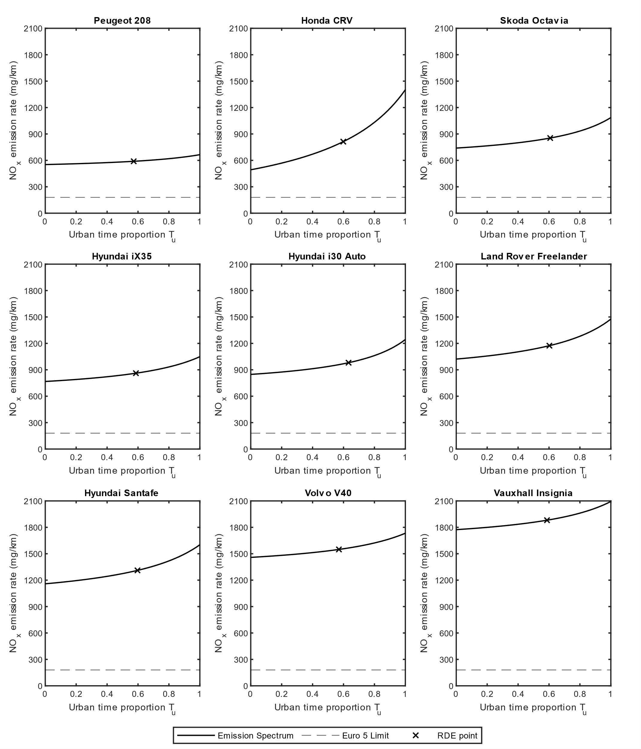
Supplementary Fig. 1 – RLE NO_{x} emissions spectrum for Euro 5 Vehicles under Group 1: Increasing NO_{x} emission rate with greater urban time proportion. a-i, Peugeot 208 (a), Honda CRV (b), Skoda Octavia (c), Hyundai iX35 (d), Hyundai i30 Auto (e), Land Rover Freelander (f), Hyundai Santafe (g), Volvo V40 (h), Vauxhall Insignia (i). The solid lines represent variation of the NO_{x} emission rate with increasing urban time proportion (for $T_{u}∈[0,1]$), the dashed lines represent the Euro 5 NO_{x} limit at 180 mg/km, and the cross-scatter points represent the recorded value at the RDE time proportion, where $T_{u}≈0.6$.

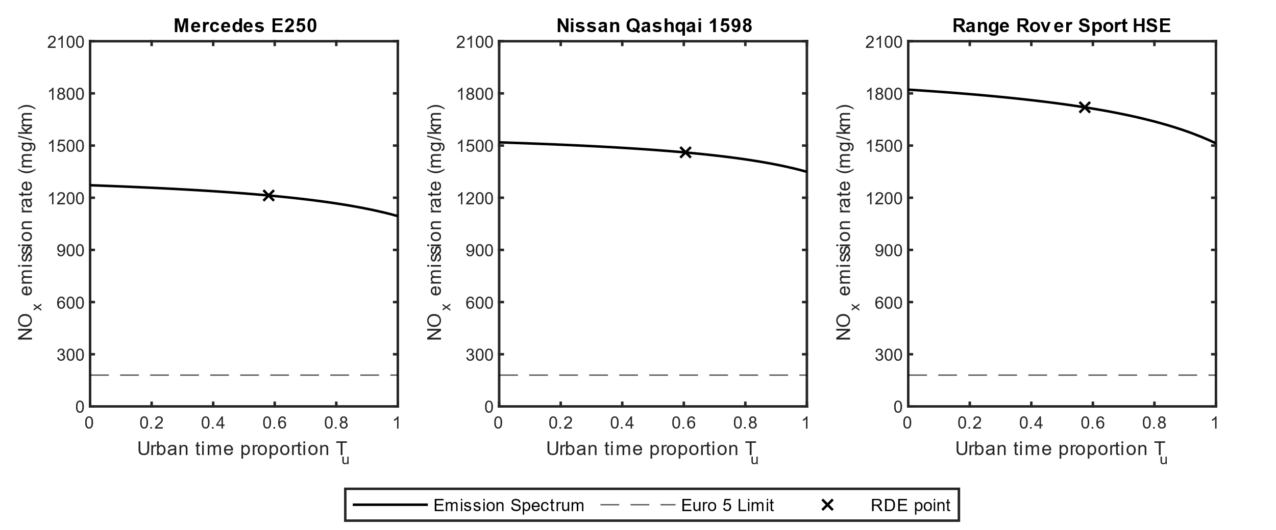
Supplementary Fig. 2 – RLE NO_{x} emissions spectrum for Euro 5 Vehicles under Group 2: Decreasing NO_{x} emission rate with greater urban time proportion. a-c, Mercedes E250 (a), Nissan Qashqai 1598 (b), Range Rover Sport HSE (c). The solid lines represent variation of the NO_{x} emission rate with increasing urban time proportion (for $T_{u}∈[0,1]$), the dashed lines represent the Euro 5 NO_{x} limit at 180 mg/km, and the cross-scatter points represent the recorded value at the RDE time proportion, where $T_{u}≈0.6$.
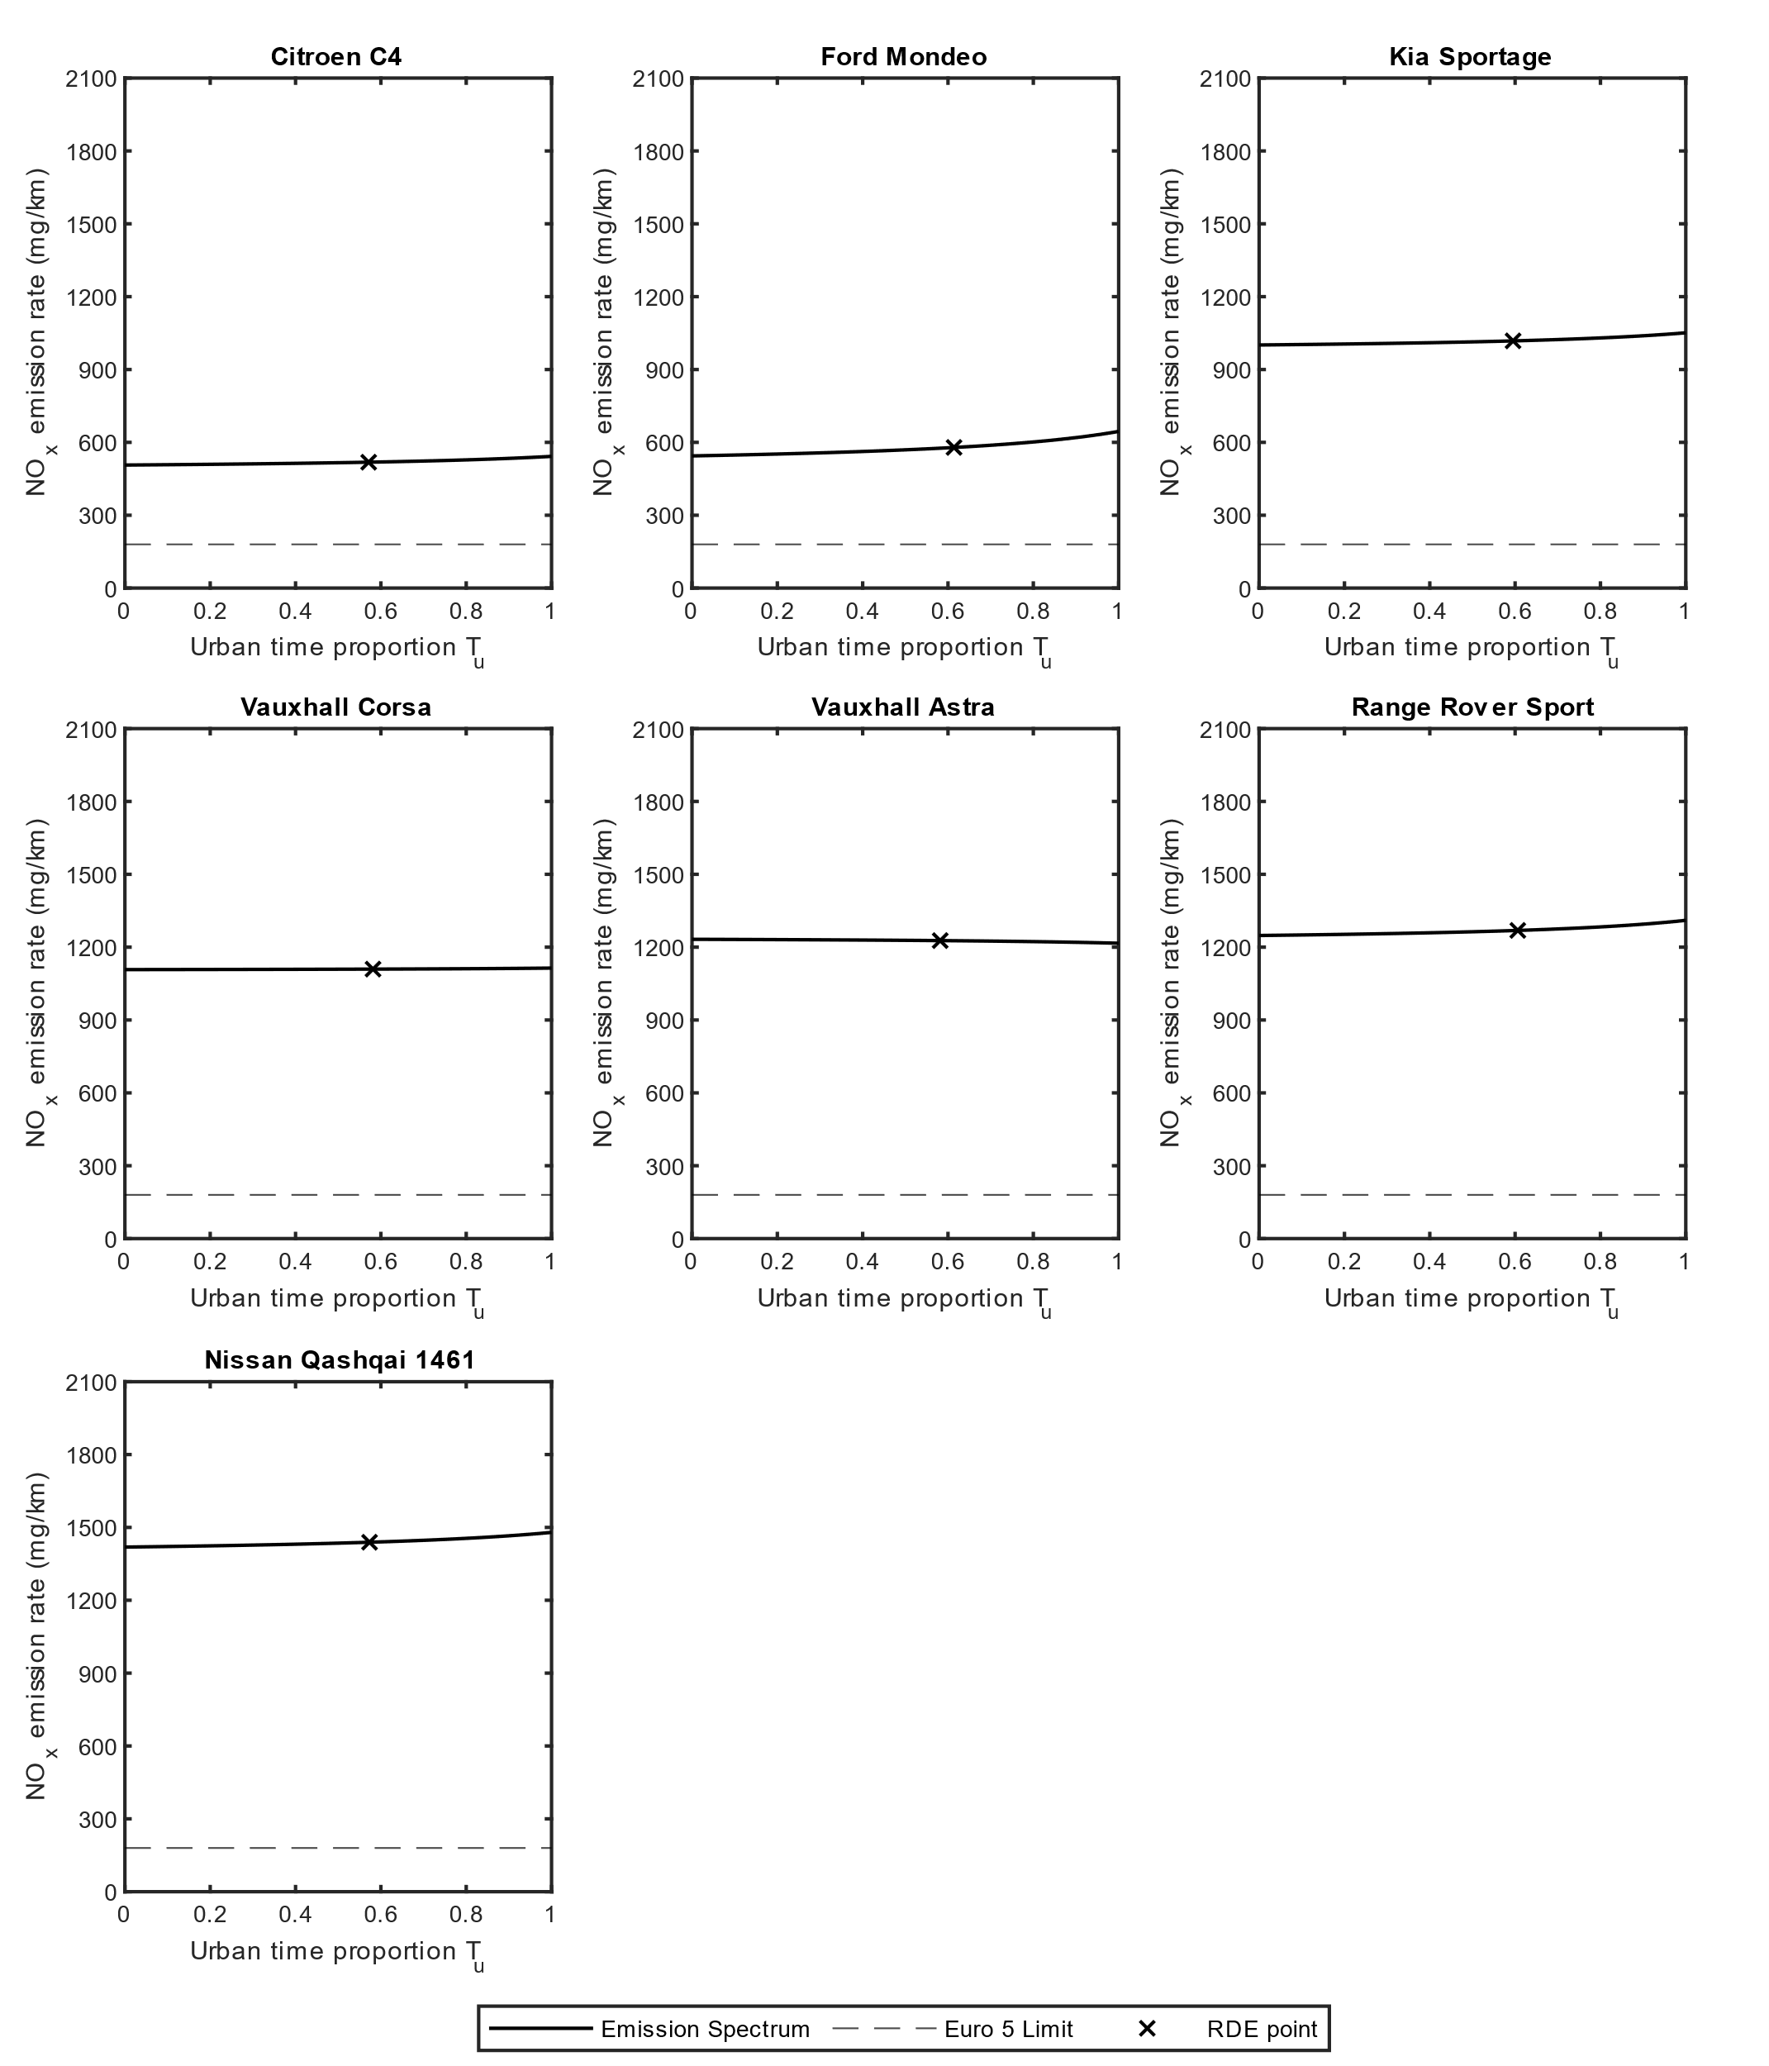
Supplementary Fig. 3 – RLE NO_{x} emissions spectrum for Euro 5 Vehicles under Group 3: NO_{x} emission rate independent of urban time proportion (with less than 100 mg/km difference). a-g, Citroen C4 (a), Ford Mondeo (b), Kia Sportage (c), Vauxhall Corsa (d), Vauxhall Astra (e), Range Rover Sport (f), Nissan Qashqai 1461 (g). The solid lines represent variation of the NO_{x} emission rate with increasing urban time proportion (for $T_{u}∈[0,1]$), the dashed lines represent the Euro 5 NO_{x} limit at 180 mg/km, and the cross-scatter points represent the recorded value at the RDE time proportion, where $T_{u}≈0.6$.

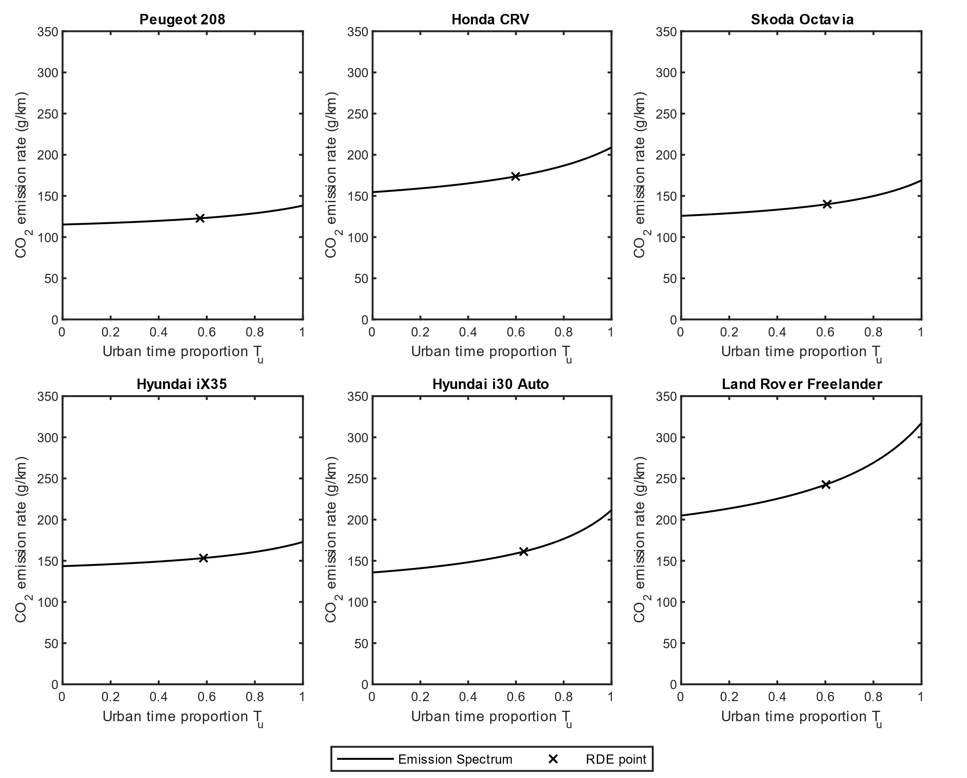
Supplementary Fig. 4 – RLE CO₂ emissions spectrum for Euro 5 Vehicles (Part 1). a-f, Peugeot 208 (a), Honda CRV (b), Skoda Octavia (c), Hyundai iX35 (d), Hyundai i30 Auto (e), Land Rover Freelander (f). The lines represent variation of the CO₂ emission rate with increasing urban time proportion (for $T_{u}∈[0,1]$), and the cross-scatter points represent the recorded value at the RDE time proportion, where $T_{u}≈0.6$.
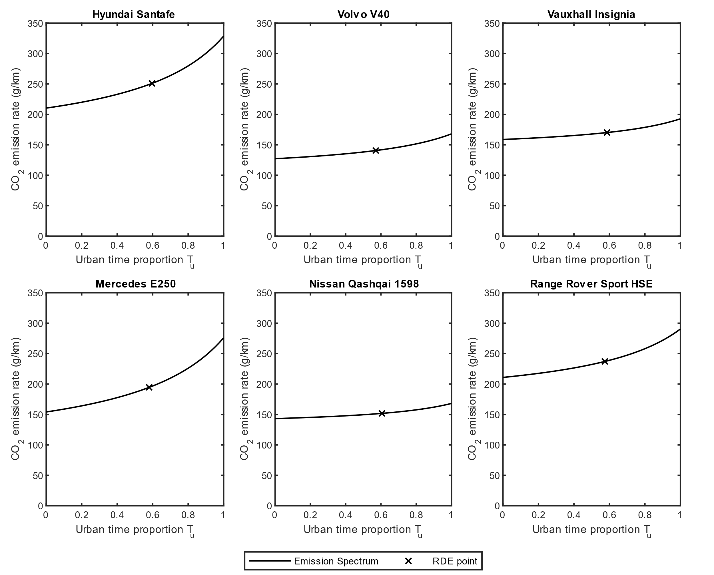 Supplementary Fig. 5 – RLE CO₂ emissions spectrum for Euro 5 Vehicles (Part 2). a-f, Hyundai Santafe (a), Volvo V40 (b), Vauxhall Insignia (c), Mercedes E250 (d), Nissan Qashqai 1598 (e), Range Rover Sport HSE (f). The lines represent variation of the CO₂ emission rate with increasing urban time proportion (for $T_{u}∈[0,1]$), and the cross-scatter points represent the recorded value at the RDE time proportion, where $T_{u}≈0.6$.

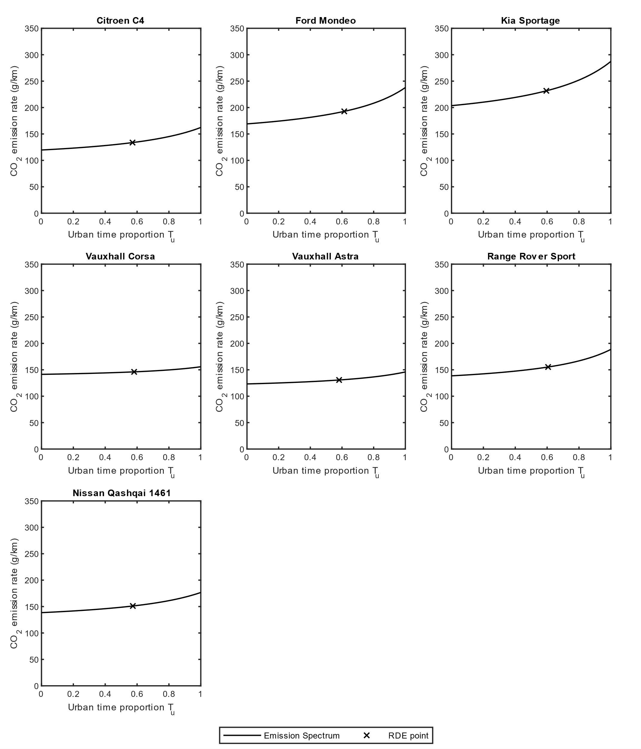
Supplementary Fig. 6 – RLE CO₂ emissions spectrum for Euro 5 Vehicles (Part 3). a-g, Citroen C4 (a), Ford Mondeo (b), Kia Sportage (c), Vauxhall Corsa (d), Vauxhall Astra (e), Range Rover Sport (f), Nissan Qashqai 1461 (g). The lines represent variation of the CO₂ emission rate with increasing urban time proportion (for $T_{u}∈[0,1]$), and the cross-scatter points represent the recorded value at the RDE time proportion, where $T_{u}≈0.6$.
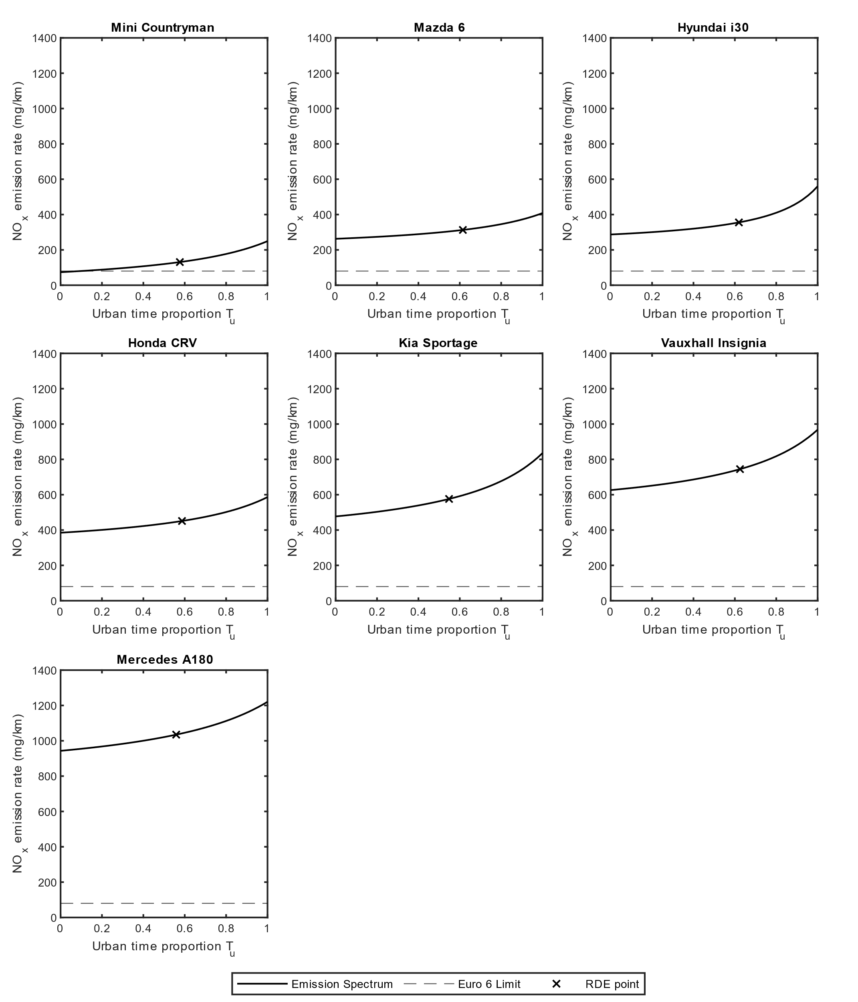
Supplementary Fig. 7 – RLE NO_{x} emissions spectrum for Euro 6 Vehicles under Group 1: Increasing NO_{x} emission rate with greater urban time proportion. a-g, Mini Countryman (a), Mazda 6 (b), Hyundai i30 (c), Honda CRV (d), Kia Sportage (e), Vauxhall Insignia (f), Mercedes A180 (g). The solid lines represent variation of the NO_{x} emission rate with increasing urban time proportion (for $T_{u}∈[0,1]$), the dashed lines represent the Euro 6 NO_{x} limit at 80 mg/km, and the cross-scatter points represent the recorded value at the RDE time proportion, where $T_{u}≈0.6$.

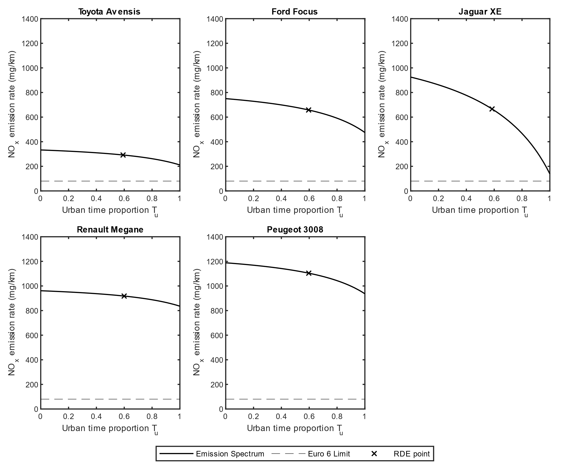
Supplementary Fig. 8 – RLE NO_{x} emissions spectrum for Euro 6 Vehicles under Group 2: Decreasing NO_{x} emission rate with greater urban time proportion. a-e, Toyota Avensis (a), Ford Focus (b), Jaguar XE (c), Renault Megane (d), Peugeot 3008 (e). The solid lines represent variation of the NO_{x} emission rate with increasing urban time proportion (for $T_{u}∈[0,1]$), the dashed lines represent the Euro 6 NO_{x} limit at 80 mg/km, and the cross-scatter points represent the recorded value at the RDE time proportion, where $T_{u}≈0.6$.
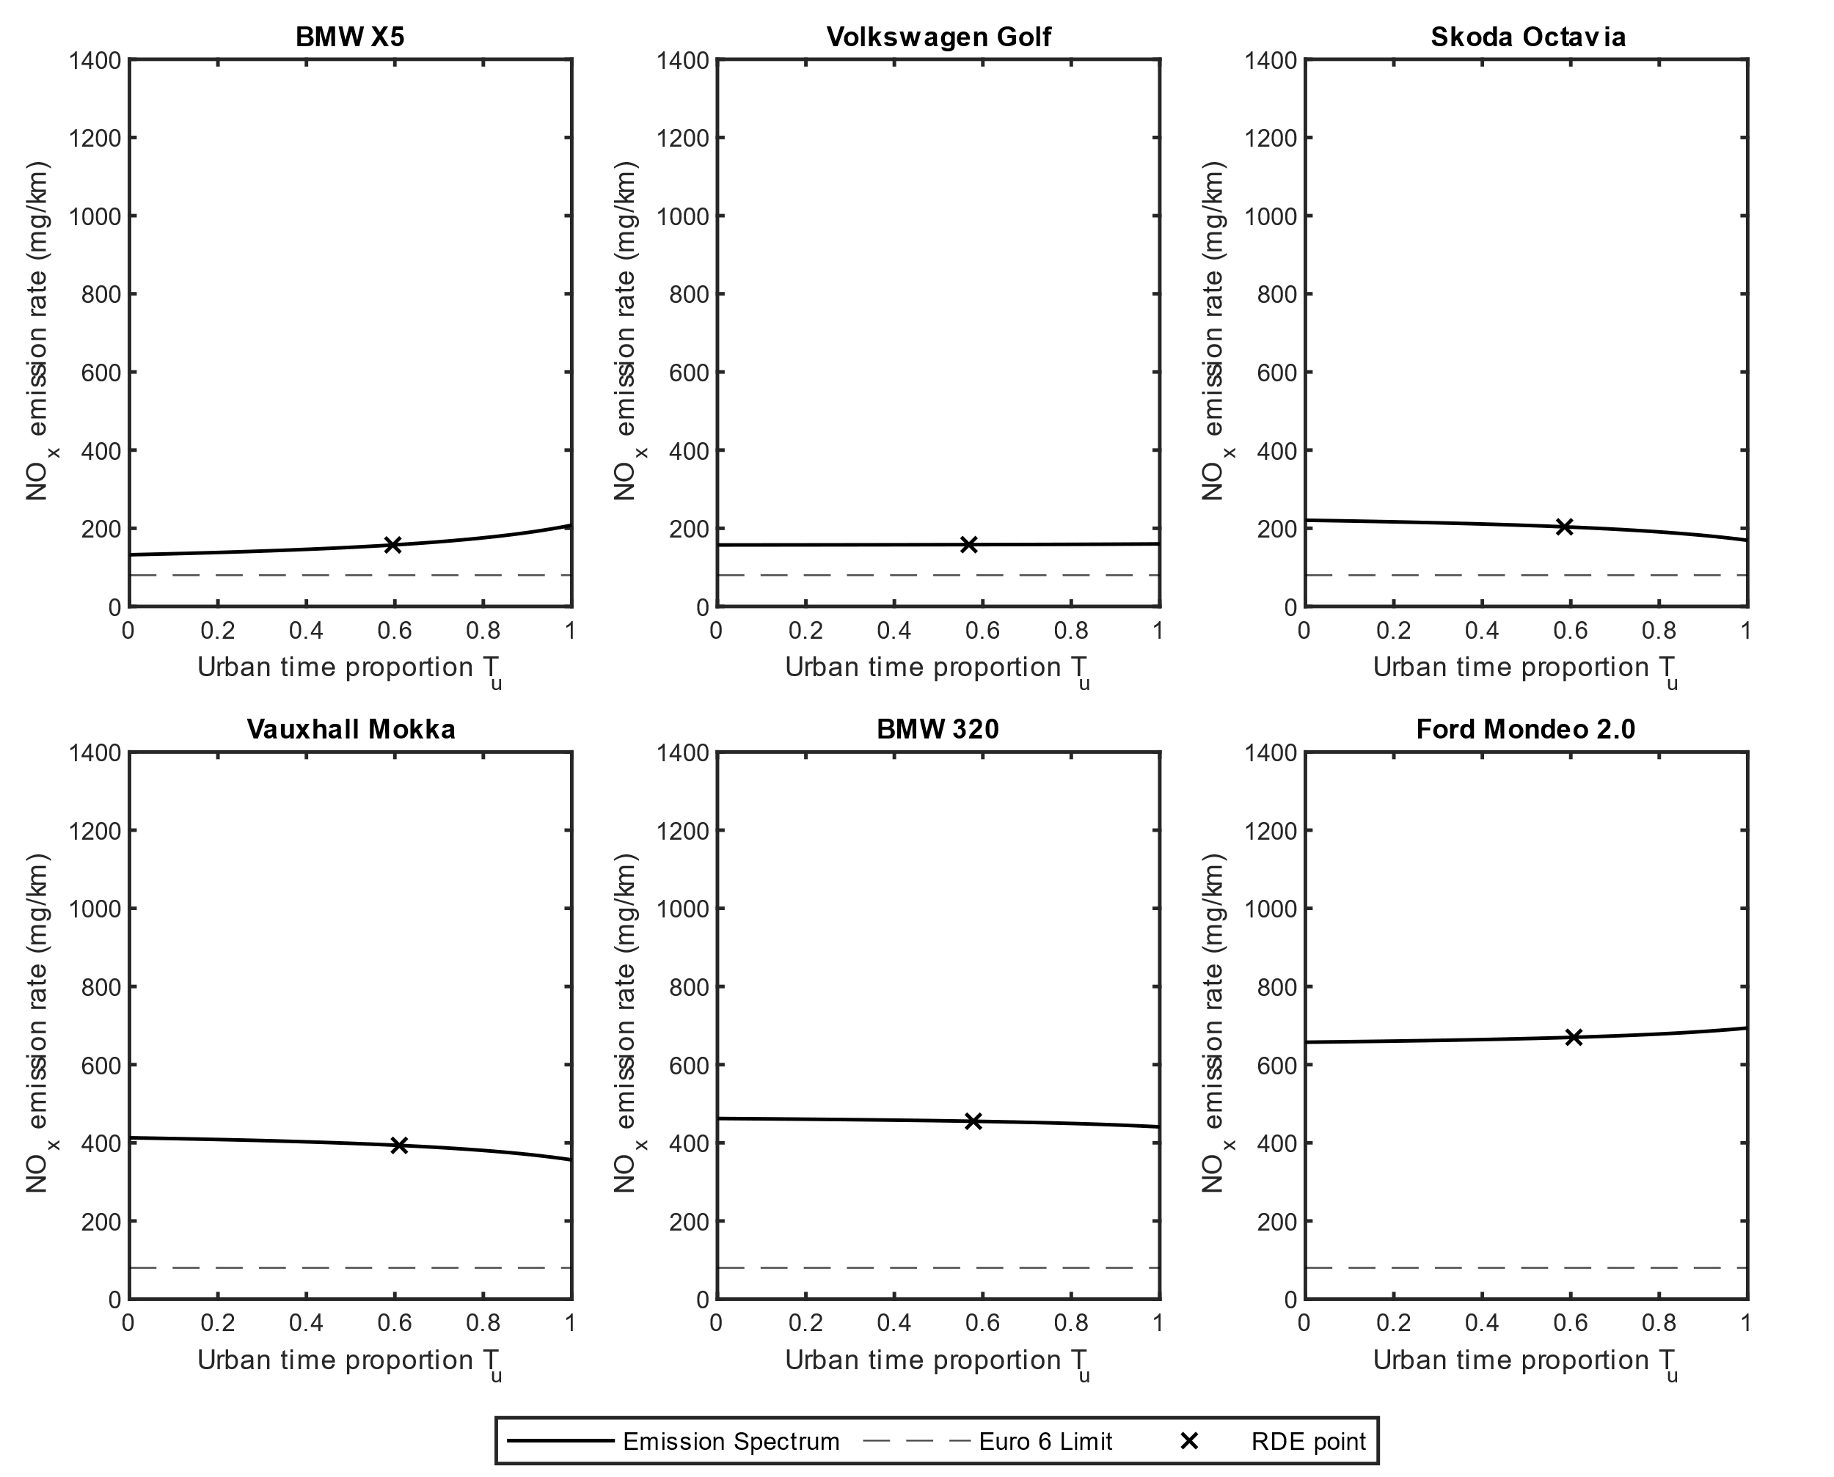
Supplementary Fig. 9 – RLE NO_{x} emissions spectrum for Euro 6 Vehicles under Group 3: NO_{x} emission rate independent of urban time proportion (with less than 100 mg/km difference). a-f, BMW X5 (a), Volkswagen Golf (b), Skoda Octavia (c), Vauxhall Mokka (d), BMW 320 (e), Ford Mondeo 2.0 (f). The solid lines represent variation of the NO_{x} emission rate with increasing urban time proportion (for $T_{u}∈[0,1]$), the dashed lines represent the Euro 6 NO_{x} limit at 80 mg/km, and the cross-scatter points represent the recorded value at the RDE time proportion, where $T_{u}≈0.6$.

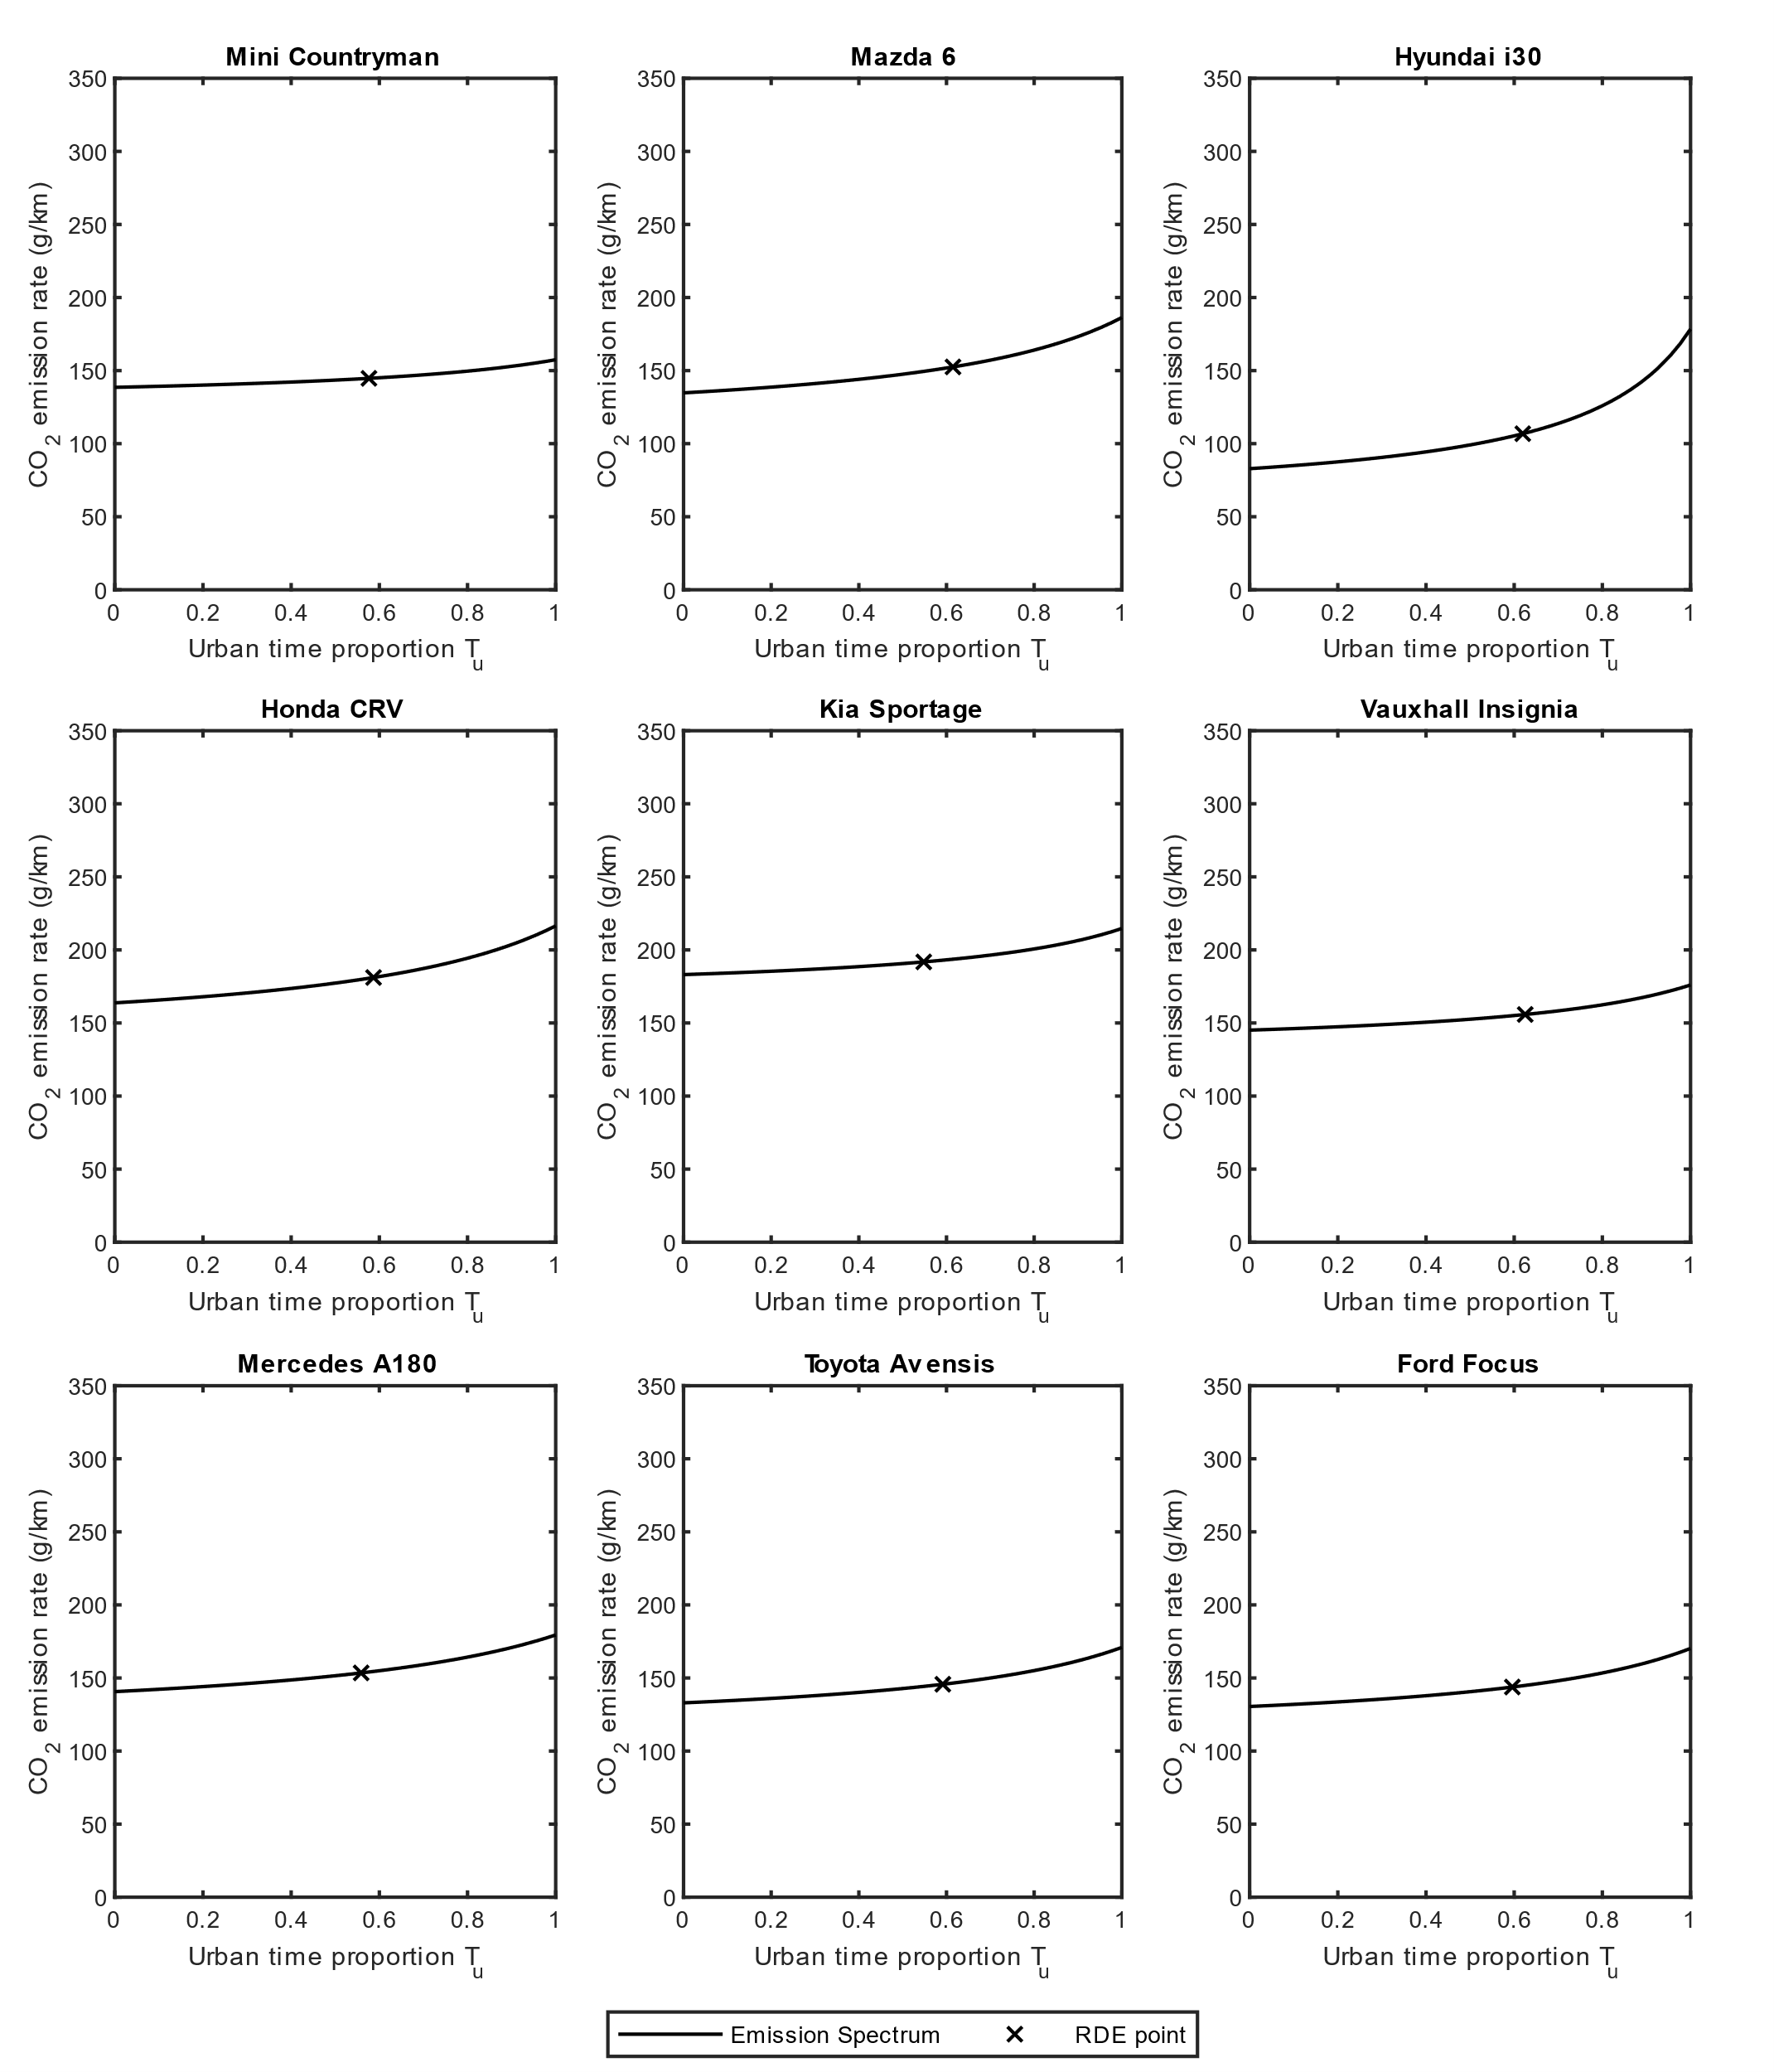
Supplementary Fig. 10 – RLE CO₂ emissions spectrum for Euro 6 Vehicles (Part 1). a-i, Mini Countryman (a), Mazda 6 (b), Hyundai i30 (c), Honda CRV (d), Kia Sportage (e), Vauxhall Insignia (f), Mercedes A180 (g), Toyota Avensis (h), Ford Focus (i). The lines represent variation of the CO₂ emission rate with increasing urban time proportion (for $T_{u}∈[0,1]$), and the cross-scatter points represent the recorded value at the RDE time proportion, where $T_{u}≈0.6$.
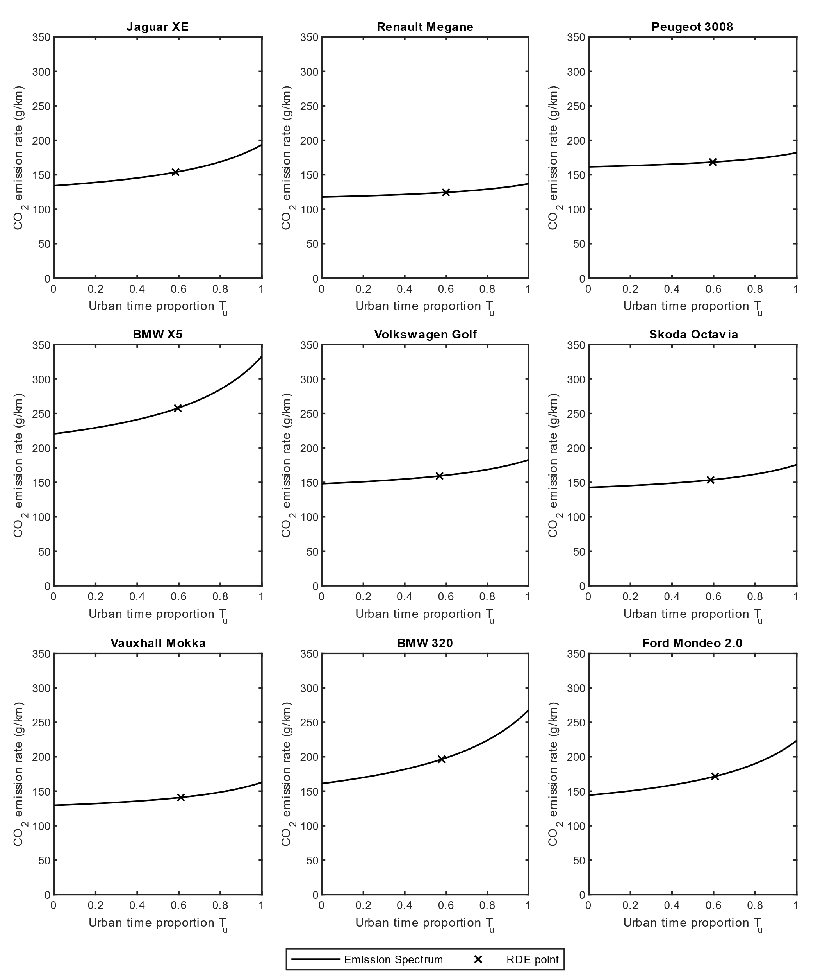
Supplementary Fig. 11 – RLE CO₂ emissions spectrum for Euro 6 Vehicles (Part 2). a-i, Jaguar XE (a), Renault Megane (b), Peugeot 3008 (c), BMW X5 (d), Volkswagen Golf (e), Skoda Octavia (f), Vauxhall Mokka (g), BMW 320 (h), Ford Mondeo 2.0 (i). The lines represent variation of the CO₂ emission rate with increasing urban time proportion (for $T_{u}∈[0,1]$), and the cross-scatter points represent the recorded value at the RDE time proportion, where $T_{u}≈0.6$.

