TMED9 is a Predictive Marker Transition from Monoclonal Gammopathy of Undetermined Significance to Multiple Myeloma

Table of Contents

Supplementary Table 1 (Table S1) | Nucleotide sequences of primer sets used in qRT-PCR
Supplementary Table 2 (Table S2) | The statistical relationship between clinical characteristic and candidate genes expressions of among MM-MGUS-Control groups
Supplementary Table 3 (Table S3) | Odds ratio (OR) and 95% confidence intervals (CI) for the association of clinical parameters and risk of MM and MGUS
Supplementary Table 4 (Table S4) | Univariate analysis of prognostic factors with 10 genes in MM
Supplementary Table 5 (Table S5) | Logistic regression analysis of prognostic factors with 10 genes in MGUS
Supplementary Table 6 (Table S6) | Multivariate analysis for genes with prognostic factors in 37 patients with MM-Control groups
Supplementary Table 7 (Table S7) | Durie Salmon Stages in Myeloma groups and 10 genes relations.
Supplementary Table 8 (Table S8) | ROC analyzes of 10 genes in Control-MGUS-MM groups and AUC values
Supplementary Figure 1 (Figure S1) | ROC analyzes of 10 genes in Control-MGUS-MM groups.
Supplementary Figure 2 (Figure S2) | Gene expression levels that TMED9 gene is high or normal compared with overall survival on MM and MGUS patients

Supplementary Table 1. Nucleotide sequences of primer sets used in qRT-PCR
Primer Name | Primer Sequence | Base
KDELR1 FORWARD | 5’- GTC GTT CCC ACA GCC ATT CT -3’ | 20
KDELR1 REVERSE | 5’- AAG CCC TCG AAA TGG TAG CG -3’ | 20
DNAJC1 FORWARD | 5’- GGA TGC TGG GCA GTT TTA TGC-3’ | 21
DNAJC1 REVERSE | 5’- TGT GTT CGG TTC CTG TTT TCC -3’ | 21
ISG20 FORWARD | 5’- TCA TGA CCT GAA GCA CGA CT -3’ | 20
ISG20 REVERSE | 5’- ATC GTT GCC CTC GCA TCT TC -3’ | 20
COPE FORWARD | 5’- AGA CGA GCT GTT CGA CGT AA -3’ | 20
COPE REVERSE | 5’- GAG GTA GTC AGC AAA CAT GCG -3’ | 21
HYOU1 FORWARD | 5’- CAG CAC CGT ATG CAC CAT TG -3’ | 20
HYOU1 REVERSE | 5’- AGG ACG GTT TTG AGC CGA TT -3’ | 20
RRBP1 FORWARD | 5’- TGC CAA GAA GAA GTC TGG TTC A -3’ | 22
RRBP1 REVERSE | 5’- TTC AGA ATC GCC ACA GGG TC -3’ | 20
EEF2 FORWARD | 5’- GGG AGA CAC GCT TCA CTG AT -3’ | 20
EEF2 REVERSE | 5’- GCA GTC CAC CAC CAC CAA TG -3’ | 20
LMAN2 FORWARD | 5’- AGG GCT CTA TCT GGA ACC AC -3’ | 20
LMAN2 REVERSE | 5’- GGT CTC ATC ATT GGG GTA GGT G -3’ | 22
TRİB1 FORWARD | 5’- TTG GGG ACA TGC ACT CCT ATG -3’ | 21
TRİB1 REVERSE | 5’- GAG GAT CTC AGG GCT CAC GTA -3’ | 21
TMED9 FORWARD | 5’- CAC ATC GGA GAG ACG GAG AA -3’ | 20
TMED9 REVERSE | 5’- CCA GGG GTA TGG GAA GTG AA -3’ | 20
TBP-FORWARD | 5’-ACT TGA CCT AAA GAC CAT TGC AC-3’ | 23
TBP-REVERSE | 5’-CTT GAA GTC CAA GAA CTT AGC TGG-3’ | 24
Primers of the 10 candidate genes and housekeeping were designed using bioinformatics tools such as
Ensemble, NCBI, Primer3, Primer Blast, UCSC. Particular attention was paid to prevent primer pairs
from forming self/heterodimers. During the in-Silico primer design, the accuracy of the forward and
reverse primers were checked in the BLAST program.

Supplementary Table 2. The Statistical relationship between, clinical characteristic and candidate
genes expressions of among MM-MGUS-Control Groups
 | Multiple Myeloma  n=38 |  | MGUS  N=23 |  | Control  N=16 |  | P Value
 | Median | Std Deviation ± | Median | Std Deviation ± | Median | Std Deviation  ±
Age | 63.57 | 11.6 | 64.22 | 13.0 | 50.56 | 17.1 | .003
Clinical Features
Red blood Cell Count 10^/6 ul | 3.56 | 0.75 | 4.09 | 0.89 | 4.42 | 1.13 | .004
Hemoglobin g/dL | 10.6 | 2.16 | 11.50 | 2.39 | 12.4 | 2.84 | .048
Hematocrit % | 32.05 | 6.32 | 34.2 | 6.8 | 36.8 | 8.68 | .074
B2M mg/L | 1.66 | 2.3 | 2.40 | 2.20 | 1.68 | 2.4 | .623
Urea  mg/dl | 68.4 | 49.9 | 64.6 | 29.6 | 45.4 | 26.4 | .164
Albumin  g/dl | 3.46 | 0.65 | 5.24 | 7.61 | 3.57 | 0.76 | .266
Calcium | 9.54 | 1.2 | 9.17 | 0.92 | 8.8 | 1.2 | .119
LDH U/L | 193.39 | 60.9 | 206.3 | 102.5 | 176.4 | 88.1 | .536
CRP mg/L | 20.3 | 34.7 | 48.7 | 82.7 | 10.4 | 24.0 | .055
eGFR ml/dk/173 | 62.80 | 32.4 | 52.9 | 26.4 | 85.06 | 37.6 | .011
Bone Marrow Plasma Cell % | 21.8 | 22.2 | 5.91 | 12.0 | 1.43 | 1.5 | .000
*CK U/L | 144.20 | 22.0 | 61.0 | 44.88 | 49.0 | 20.2 | .266
*Creatinine mg/dl | 1.80 | 1.87 | 1.92 | 1.67 | 1.17 | 0.88 | .348
IGA mg/dl | 0.90 | 0.76 | 0.84 | 0.95 | 0.30 | 0.75 | .083
IGG mg/dl | 1.11 | 0.94 | 0.44 | 0.85 | 0.30 | 0.75 | .006
IGM mg/dl | 0.79 | 0.53 | 0.47 | 0.51 | 0.15 | 0.55 | .001
Lytic bone lesion | 0.16 | 0.37 | 0.08 | 0.288 | 0.00 | 0.00 | .239
Candidate Gene Expression
DPP7 | 9.81 | 11.0 | 3.97 | 3.29 | 4.35 | 3.67 | .013
KDELR1 | 15.27 | 12.43 | 5.66 | 5.27 | 4.79 | 3.80 | .000
COPE | 9.19 | 6.52 | 4.63 | 3.87 | 5.20 | 4.54 | .004
TMED9 | 9.35 | 9.16 | 3.04 | 2.22 | 3.68 | 3.08 | .001
LMAN2 | 4.38 | 2.98 | 2.14 | 1.48 | 2.09 | 1.63 | .000
ISG20 | 8.92 | 6.65 | 4.44 | 3.32 | 2.71 | 2.27 | .000
RRBP1 | 10.42 | 14.42 | 3.77 | 2.98 | 6.82 | 10.7 | .015
*EEF2 | 9.69 | 16.9 | 3.71 | 2.49 | 3.86 | 4.18 | .008
*DNAJC1 | 17.5 | 17.9 | 3.71 | 3.03 | 2.38 | 1.93 | .000
*TRIB1 | 19.66 | 19.31 | 9.39 | 10.4 | 6.30 | 6.37 | .005

B2M: Beta-2microglobulin, CK: creatine kinase, CRP C-reactive protein,
eGFR: estimated glomerular filtration rate, IgG: Immunoglobulin G;
IgA: Immunoglobulin A; IgM: Immunoglobulin M, LDH: lactate dehydrogenase.
p < 0.05 was considered statistically significant and are represented in bold.
*Mann Whitney-U and student’s t-test.

Supplementary Table 3. Odds ratio (OR) and 95% confidence intervals (CI) for the association of clinical parameters and risk of MM and MGUS
Clinical Parameter | MM Cases (%100) | Control  (%) | OR (95% CI) * | P Value | MGUS Cases (%100) | OR (95% CI) * | P Value
RBC | 29(78%) | 6(37%) | 6.0 [1.6-21.7] | 0.005 | 11 (50%) | 1.6[0.4-6.1] | 0.520
B2M | 22(95%) | 5(31%) | 48.4 [5.0-466.5] | 0.000 | 12(92%) | 26.4[2.6-262] | 0.001
HGB | 29(78%) | 6(37%) | 6.0 [1.6-21.7] | 0.005 | 14(60%) | 2.5 [0.6-9.6] | 0.200
Urea | 25(67%) | 6(37%) | 3.4 [1.0-11.8] | 0.067 | 16(69%) | 3.8[0.9-14] | 0.058
Creatinine | 21(56%) | 6(37%) | 2.1 [0.6-7.2] | 0.240 | 16(69%) | 3.8 [0.9-14] | 0.058
Albumin | 16(44%) | 6(37%) | 1.3 [0.3-4.4] | 0.764 | 7(30%) | 0.7 [0.18-2.8] | 0.736
Calcium | 3(9%) | 2(12%) | 0.7 [0.1-5.0] | 1 | 3(13%) | 1.05[0.1-7.1] | 1
eGFR | 16(44%) | 4(25%) | 2.4 [0.7-8.6] | 0.228 | 14(60%) | 4.6 [1.14-19.0] | 0.049
CRP | 25(67%) | 5(31%) | 4.5 [0.6-8.8] | 0.018 | 13(59%) | 3.1[0.8-12.3] | 0.111
LDH | 5(13%) | 2(12%) | 1.1 [0.1-6.5] | 1 | 2(9%) | 0.7[0.08-5.5] | 1
HCT | 30(81%) | 5(31%) | 9.2 [24-35.9] | 0.000 | 14(60%) | 3.4 [0.8-13.1] | 0.105
IGA | 9(42%) | 3(23%) | 2.5 [0.5-11.8] | 0.291 | 15(78%) | 12.5[2.2-68.2] | 0.003
IGG | 17(58%) | 3(23%) | 4.7 [1.0-20.8] | 0.047 | 10(55%) | 4.16 [0.8-20.4] | 0.139
IGM | 3(30%) | 4(30%) | 0.9 [0.16-5.7] | 1 | 9(52%) | 2.5 [0.5-11.0] | 0.282
RBC: Red Blood Cell (10/6 ul), B2M: Beta -2microglobulin (mg/L); HGB: Hemoglobin (g/dl);
eGFR: Estimated Glomerular Filtration Rate (ml/dk/173), CRP: C-Reactive Protein (mg/L);
LDH: Lactate Dehydrogenase(U/L), HCT: Hematocrit (%), IGA: Immunoglobulin A (mg/dl), IGG: Immunoglobulin G (mg/dl), IGM: Immunoglobulin M (mg/dl), MM: Multiple Myeloma,
MGUS: Monoclonal Gammopathy of Undetermined Significance, CI: Confidence Interval;
*Fisher Exact Test

Supplementary Table 4. Univariate analysis of prognostic factors with 10 genes in MM
Variables (MM) | Genes | P value (MM)
RBC | DNAJC1  TMED9 | .017  .023
B2M | RRBP1  TRIB1 | .045  .039
HBG | DNAJC1  TMED9 | .010  .017
HCT | DNAJC1  TMED9 | .013  .015
Urea | DPP7  DNAJC1 | .033  .026
Albumin | TMED9 | .043
Calcium | DPP7  DNAJC1  TMED9  LMAN2  EEF2 | .022  .016  .013  .044  .050
LDH | TMED9 | .021
IGA | TMED9  ISG20 | .021  .006
Cytogenetic Karyotype | TRIB1 | .030
Monosomy 7 | DPP7 | .009
RBC: Red Blood Cell, B2M: Beta-2microglobulin; HGB: Hemoglobin (g/dl); LDH: Lactate Dehydrogenase, HCT: Hematocrit, IGA: Immunoglobulin A, MM: Multiple Myeloma, CI: Confidence Interval. P <0.05 significant variables are included in the analyzes in the Table S4.
Supplementary Table 5. Logistic regression analysis of prognostic factors with 10 genes in MGUS
Variables (MGUS) | Genes | P value
HGB | TMED9  ISG20 | .019  .012
HCT | TMED9  ISG20 | .035  .023
RBC | ISG20 | .037
Albumin | KDELR1  TRIB1 | .002  .002
Creatinine | ISG20 | .049
Calcium | TRIB1 | .033
Age | KDELR1 | .026
eGFR | TMED9 | .003
HGB: Hemoglobin(g/dl); HCT: Hematocrit, CRP: C-Reactive Protein; LDH: Lactate Dehydrogenase, eGFR: Estimated Glomerular Filtration Rate, MGUS: Monoclonal Gammopathy of Undetermined Significance, %95 CI: Confidence Interval. P <0.05 significant variables are included in the analyses in the Table S5.

Supplementary Table 6. Multivariate analysis for genes with prognostic factors in 37 patients with MM-control groups
Genes | Coefficients %95 CI  Lower- Upper | P value (MM)
DPP7 | -3.332 [-5.98 to -0.65]  -0.096 [-0.192 to 0.001] | 0.016  0.052
Calcium  eGFR | -3.332 [-5.98 to -0.65]  -0.096 [-0.192 to 0.001] | 0.016  0.052
KDELR1 | -0.164 [-0.283 to -0.045] | 0.008
eGFR | -0.164 [-0.283 to -0.045] | 0.008
COPE | -1.813[-1.74 to -0.014]  -0.869[-1.724 to-0.014] | 0.032  0.047
Calcium  HGB | -1.813[-1.74 to -0.014]  -0.869[-1.724 to-0.014] | 0.032  0.047
DNAJC1 | -1.077[-1.822 to -0.333] | 0.006
HCT | -1.077[-1.822 to -0.333] | 0.006
TMED9 | -0.678[-1.048 to -0.307]  4.790[0.252-9.686] | 0.001  0.040
HCT  AGE <65 | -0.678[-1.048 to -0.307]  4.790[0.252-9.686] | 0.001  0.040
LMAN2 | 0.075[0.036 to 0.113]  -0.700[-1.562 to 0.101]  1.080[-0.209 to 2.369] | 0.000  0.085  0.098
Plasma Cell%  Calcium  Albumin |  | 0.000  0.085  0.098
ISG20 | -0.028[-0.045 to -0.011]  0.114 [0.033 to 0.194]  -1.890[-3.369 to -0.412]  4.430[0.659 to 8.201]  3.505[-0.000 to 7.011] | 0.002  0.007  0.014  0.023  0.50
CK  Plasma Cell %  Calcium  IGA  Lytic lesion |  | 0.002  0.007  0.014  0.023  0.50
RRBP1 | -6.466[-9.564 to -3.369]  0.303 [0.120 to 0.487]  8.066[1.740 to 14.392]  3.042[0.446 to 5.638] | 0.000  0.002  0.014  0.023
Creatinine  Plasma Cell %  IGG  B2M |  | 0.000  0.002  0.014  0.023
TRIB1 | 26.121[9.755 to 42.486] | 0.003
Karyotype | 26.121[9.755 to 42.486] | 0.003

Supplementary Table 7. Durie Salmon Stages in Myeloma Groups and 10 genes relations.
Characteristic | N | DS-I  N = 19 (50%) | DS-II  N = 17 (45%) | DS-III  N = 2 (5.3%) | P-Value *
DPP7 | 38 | 6 (3, 9) | 8 (5, 20) | 10 (10, 11) | 0.22
KDELR1 | 38 | 9 (7, 13) | 18 (6, 29) | 19 (19, 19) | 0.086
COPE | 38 | 8 (4, 12) | 11 (5, 14) | 13 (12, 13) | 0.62
DNAJC1 | 38 | 6 (4, 12) | 20 (10, 31) | 28 (17, 39) | 0.024
TMED9 | 38 | 4 (4, 8) | 9 (6, 16) | 7 (7, 8) | 0.22
LMAN2 | 38 | 2.89 (2.23, 4.40) | 5.17 (3.41, 7.06) | 3.43 (3.02, 3.83) | 0.15
ISG20 | 38 | 5.7 (3.0, 10.3) | 12.5 (4.0, 18.6) | 6.6 (6.0, 7.1) | 0.22
RBBP1 | 38 | 4 (3, 8) | 6 (4, 10) | 37 (20, 53) | 0.62
EEF2 | 38 | 5 (4, 8) | 6 (4, 10) | 19 (12, 26) | 0.54
TRIB1 | 38 | 10 (4, 21) | 18 (9, 53) | 38 (31, 45) | 0.063
DS-I: Durie Salmon I, DS-II: Durie Salmon II, DS-III: Durie Salmon III. Median (IQR),
*Kruskal Wallis rank sum test.

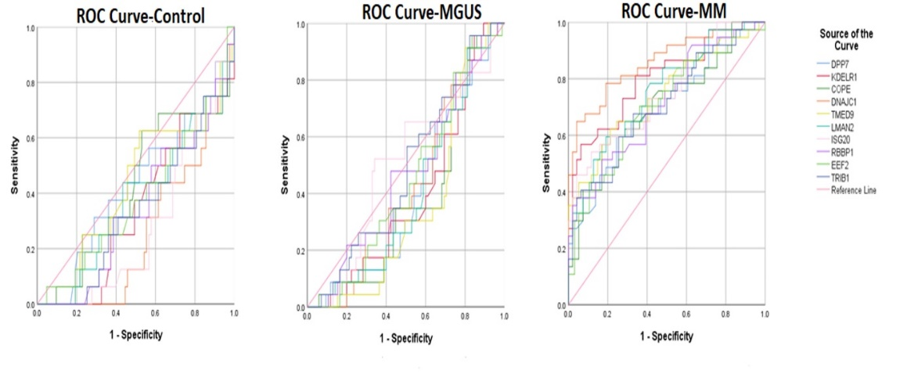
Supplementary Figure 1. ROC analyzes of 10 genes in Control-MGUS-MM groups.
The area under the curve (AUC) values shows that the expression of 10 genes have good discrimination ability in MM with control groups.
Supplementary Table S8. ROC analyzes of 10 genes in Control-MGUS-MM groups and AUC values
Genes/Group | AUC | Asymptotic Sig.^{b} | 95% Confidence Interval
Genes/Group | AUC | Asymptotic Sig.^{b} | Lower Bound | Upper Bound
DPP7-MM | .697 | .000 | .593 | .801
KDELR1-MM | .802 | .000 | .713 | .891
COPE-MM | .706 | .000 | .602 | .810
DNAJC1-MM | .859 | .000 | .781 | .937
TMED9-MM | .744 | .000 | .642 | .845
LMAN2-MM | .753 | .000 | .659 | .847
ISG20-MM | .746 | .000 | .648 | .845
RBBP1-MM | .714 | .000 | .613 | .815
EEF2-MM | .706 | .000 | .604 | .808
TRIB1-MM | .708 | .000 | .606 | .811
DPP7-MGUS | .396 | .049 | .298 | .493
KDELR1-MGUS | .393 | .043 | .295 | .490
COPE-MGUS | .385 | .030 | .287 | .483
DNAJC1-MGUS | .430 | .188 | .332 | .528
TMED9-MGUS | .356 | .007 | .262 | .450
LMAN2-MGUS | .400 | .059 | .302 | .497
ISG20-MGUS | .506 | .916 | .402 | .609
RBBP1-MGUS | .464 | .494 | .362 | .565
EEF2-MGUS | .440 | .259 | .342 | .538
TRIB1-MGUS | .481 | .725 | .381 | .582
DPP7-CONTROL | .431 | .187 | .328 | .533
KDELR1-CONTROL | .341 | .003 | .247 | .436
COPE-CONTROL | .433 | .202 | .329 | .537
DNAJC1-CONTROL | .255 | .000 | .173 | .338
TMED9-CONTROL | .428 | .173 | .325 | .532
LMAN2-CONTROL | .378 | .020 | .278 | .478
ISG20-CONTROL | .279 | .000 | .193 | .365
RBBP1-CONTROL | .349 | .004 | .254 | .444
EEF2-CONTROL | .379 | .021 | .278 | .480
TRIB1-CONTROL | .337 | .002 | .242 | .431

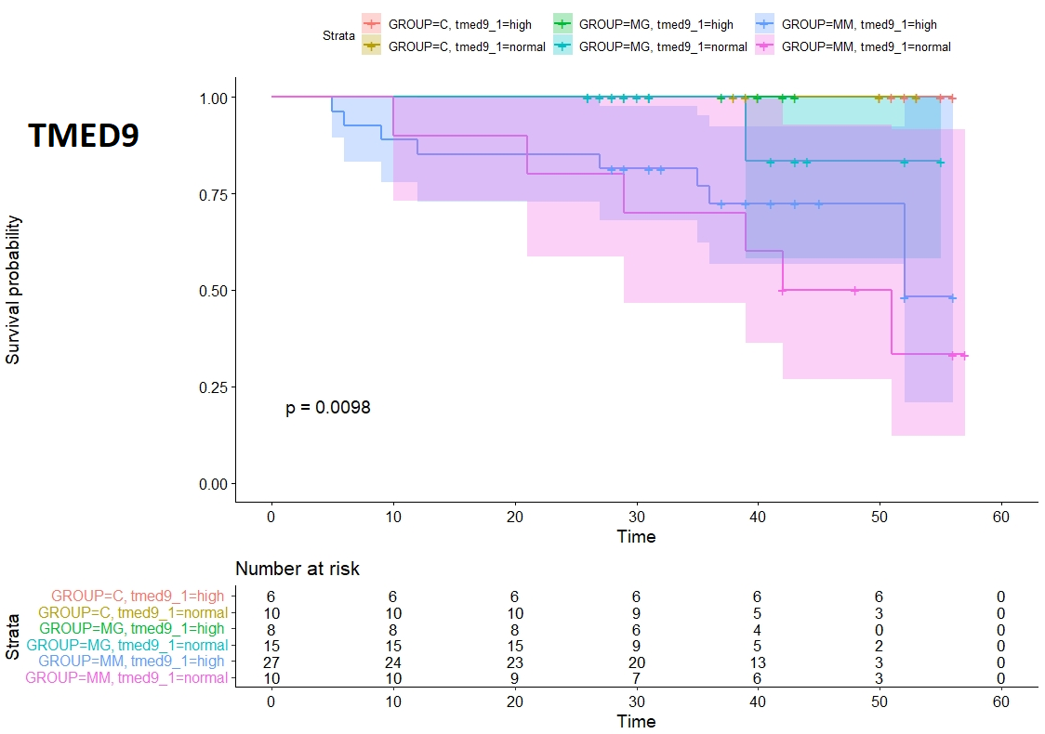

Supplementary Figure 2: Gene expression levels that TMED9 gene is high or normal compared with overall survival on MM and MGUS patients
Overall survival in patients with MM and MGUS has been shown to be independent. p<0.05. There appears to be a lower expected median survival probability between TMED9 high gene expression and normal gene expressing groups in the MM candidate gene group.

