Supplementary Material

Effective Connectivity in a Duration Selective Cortico-Cerebellar Network
Foteini Protopapa, Shrikanth Kulashekhar, Masamichi J. Hayashi, Ryota Kanai and Domenica Bueti

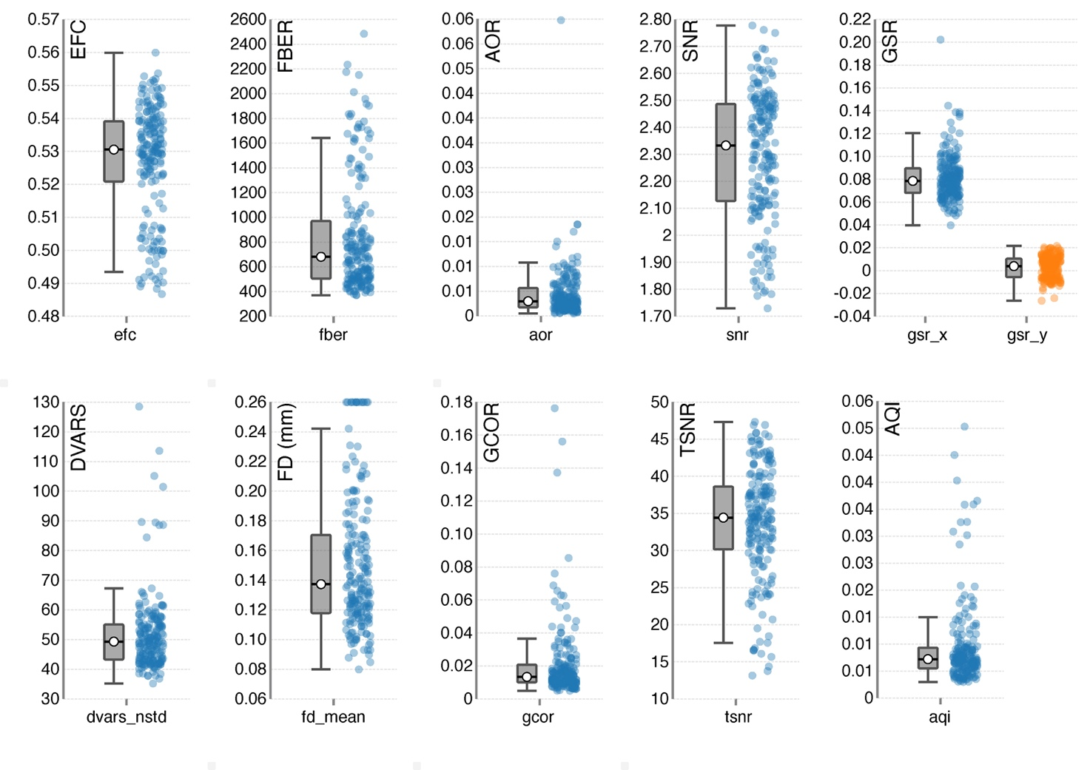
Supplementary Figure 1 Image Quality Control. The quality control measures were estimated individually for each subject and each fMRI run using MRIQC tool. The figure shows the average value of the metric for each of the subject and run. The boxplots shown are Tukey boxplots, with median and interquartile range. Whiskers extend to the farthest point that is within 1.5 * IQR of the upper (or lower) quartile. Entropy-Focus Criterion (EFC) indicates blurring, and ghosting caused by head motion. Foreground-Background Energy Ratio (FBER) is the mean energy of image values within the head, relative to the energy of the image values in the air mask. AFNI’s outlier ration (AOR) represents the mean fraction of outliers in each volume. Static Signal to Noise Ratio (SNR) is the mean intensity within the gray matter divided by the standard deviation of the values outside the brain. Ghost to signal ratio (GSR) is the ratio between the mean signal intensity in areas with apparent ghosting and the signal intensity of the brain. DVARS (D: Temporal Derivative of Time Courses, Vars is the Root Mean Square (RMS) Variance Over Voxels) shows the rate of change of BOLD signal across the entire brain at each timepoint. Framewise Displacement (FD) is defined as the sum of the absolute values of six realignment parameters at each timepoint, after converting rotational displacements from degrees to millimeters. Global correlation (GCOR) is the average correlation between every voxel and every other voxel over a given mask. Temporal signal to noise ratio (tSNR) is the ratio between mean signal of time series and the temporal standard deviation. AFNI’s quality index (AQI) is the mean distance between each volume and the median volume.

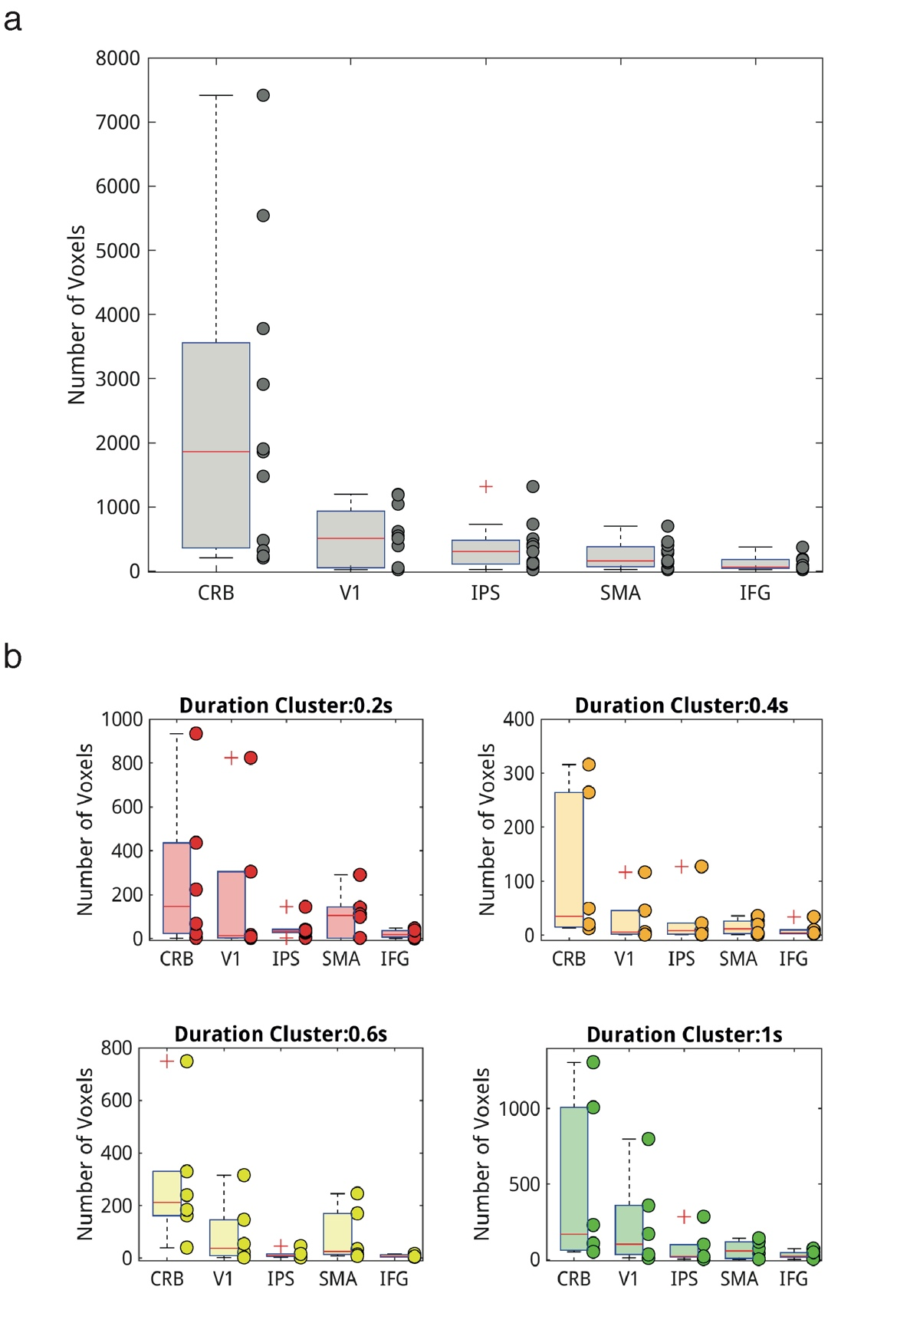
Supplementary Figure 2. Number of voxels used in the 5-nodes and 20-nodes DCM analyses.
In the boxplot, the central red mark indicates the median, and the bottom and top edges of the box indicate the 25th and 75th percentiles, respectively. The whiskers represent the most extreme data points without the outliers, while the '+' symbol represents the outlier. (a) The voxel sizes of the 5 ROIS (mean ± standard error): CRB (2375.8±714.0), V1 (513.5±139.3), IPS (374.5±114.6), SMA (245.0±63.6) and IFG (115.5±32.5). (b) The voxel sizes of the durations clusters for the 5 ROIs. The voxel sizes for the clusters of the duration 0.2s: CRB (280.8±108.1), VI (193.0±99.9), IPS (47.2±14.9), SMA (108.0±32.2) and IFG (21.0±5.4). The sizes for the clusters of the duration 0.4: CRB (113.2±41.8), V1 (29.7±13.9), IPS (28.5±14.7), SMA (15.0±4.4) and IFG (9.8±3.7). The number of voxels for the clusters of the duration 0.6s: CRB (284.7±74.5), V1 (91.7±36.7), IPS (15.7±4.7), SMA (82.0±30.4) and IFG (9.0±1.6).The voxel sizes for the clusters of the duration 1s: CRB (459.5±166.3), V1 (233.7±92.4), IPS (72.8±32.7), SMA (63.2±17.3) IFG (29.0±7.7).

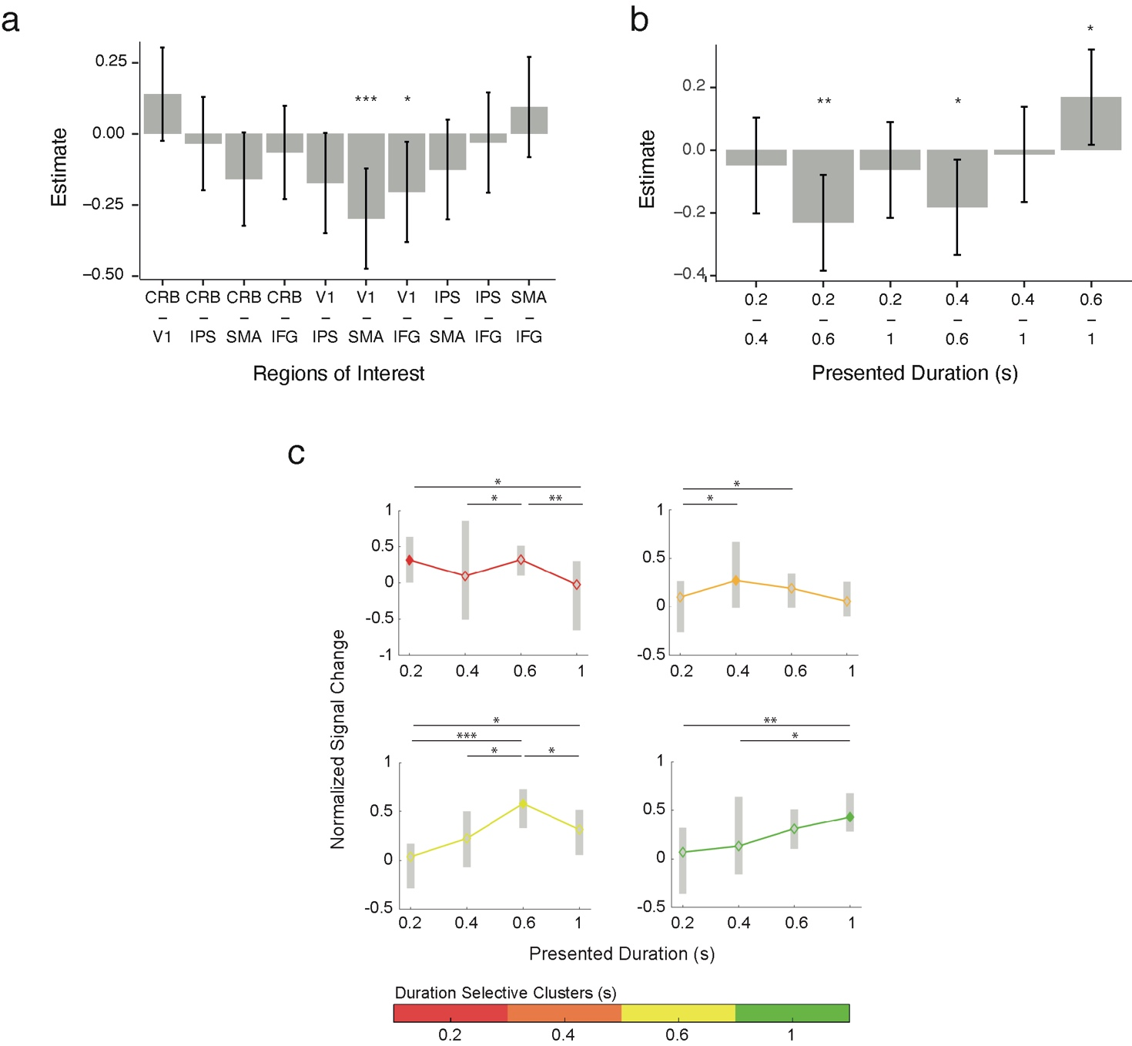

Supplementary Figure 3 Cross-validated tuning. (a) Plot of the differences between estimated BOLD response (y axis) in the different ROIs (x axis). In (b) is the plot of the differences between estimated BOLD response (y-axis) in the different duration selective clusters averaged across ROIs. The estimated BOLD comes from a linear mixed model ran on the normalized BOLD responses. The model was defined as follow: BOLD ~ duration selective cluster * presented duration * region of interest + (1|subject). Legend: CRB=cerebellum, V1= primary visual cortex 1, IPS= intraparietal sulcus, SMA=supplementary motor area, IFG= inferior frontal gyrus.
(c) Plot of the estimated BOLD response averaged across all ROIs (y axis) in different duration selective clusters of voxels (colored lines in different subplots) in response to different presented durations (x axis). The shaded grey area in the plots is the BOLD distribution across subjects (averaged across the 9 runs).

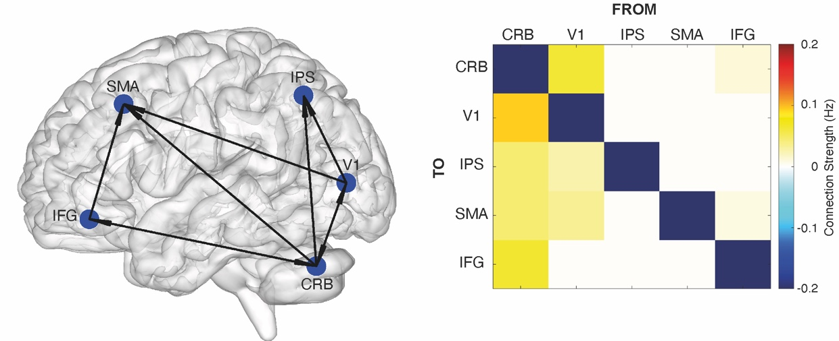

Supplementary Figure 4. On the left-hand side is a graph representation of the network architecture (A-matrix) as resulted from the 5-nodes cross-validated PEB analysis. The directionality of connections is depicted with arrows. On the right-hand side is the matrix of the strength of the survived connections after the pruning of the parameters done by PEB. Values are in Hz (see colorbar). In the cross-validated PEB for each subject we used 9 fMRI runs to define the ROIs and the other 9 to run the PEB. Legend: CRB= cerebellum, V1=primary visual cortex, IPS= intraparietal sulcus, SMA=supplementary motor area, IFG= inferior frontal gyrus.

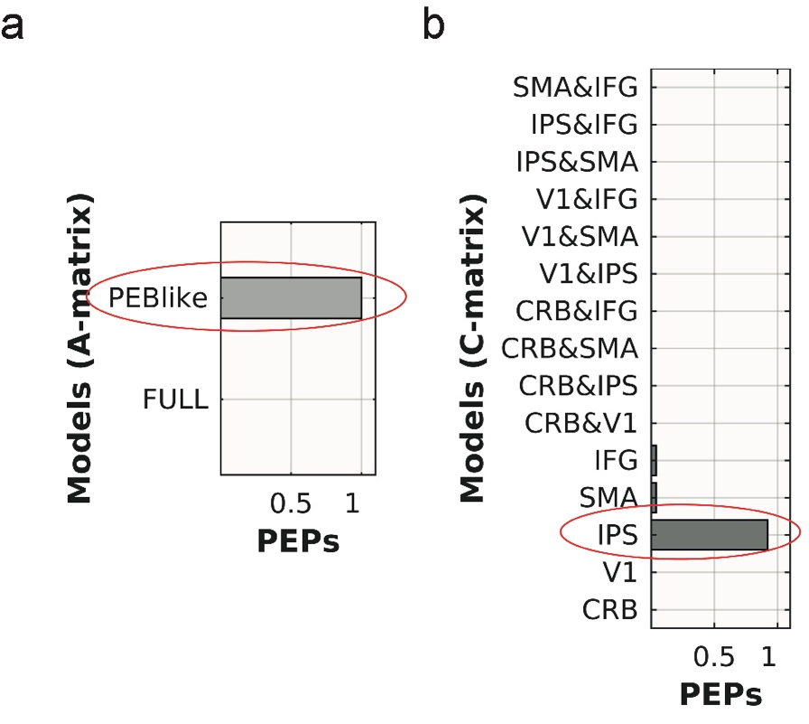

Supplementary Figure 5. Bayesian model selection (BMS) and Bayesian model comparison results of the 20-nodes network.
(a) BMS among three families of models that differ according to the modulatory effect of stimulus duration on the activity of IPS duration selective clusters (i.e., C-matrix that could be: stimulus duration independent, neighboring dependent, or stimulus duration dependent). Bar plot shows their protected exceedance probabilities (PEPs). Each family consists of 36 models. The red ellipse highlights the winning family i.e., family of models where the modulation by S1 stimulus duration on IPS activity is stimulus duration dependent. (b) Bayesian model comparison (BMC) across the 36 models of the winning family. Bar plot depicts the protected exceedance probabilities (PEPs). The 36 models have C-matrix stimulus duration dependent and an A and B matrix “PEB-like” that could be stimulus duration independent, neighboring dependent, or stimulus duration dependent within and between ROIs. The red ellipse highlights the winning model.

Supplementary Figure 6 Bayesian model averaging (BMA) results of the winning model. BMA averages the A-B-C-parameters of the winning model across subjects and sessions. (a) The matrix represents the strength of connections (A-matrix) between duration selective clusters of voxels. The color scale represents the parameter’s values. These values range from -0.4 to 0.4 Hz. (b) The four matrices represent the modulation on the connectivity strength (B-matrix) between the different duration selective clusters at the offset of the four S1 durations. x and y-axes are as in (a). (c) Bar-plot of the activity within each IPS duration selective cluster (C-matrix). Each bar shows the neuronal change (y-axis) for each of the four durations specific clusters while a specific duration was presented (x-axis). Duration specific clusters and stimulus durations are color coded as follow: red= 0.2, orange=0.4, yellow=0.6, and green= 1 s.

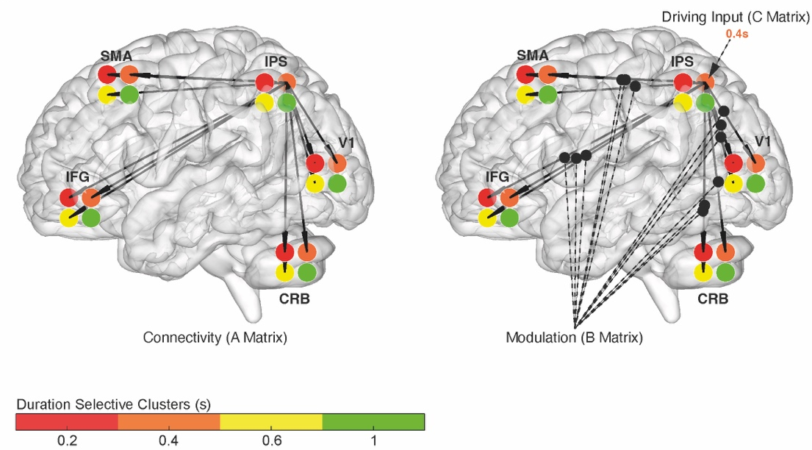
Supplementary Figure 7 Winning cross-validated model of the DCM 20-nodes network. Graph representation of the winning model conducted on half of the dataset (9 runs were used to define the ROIs and on the other 9 we ran the DCM). On the left-hand side is the A-matrix, on the right-hand side the B and C matrices. The network architecture and the modulatory effect of stimulus presentation on connectivity strength are both neighboring dependent while the driving input in IPS is duration dependent.

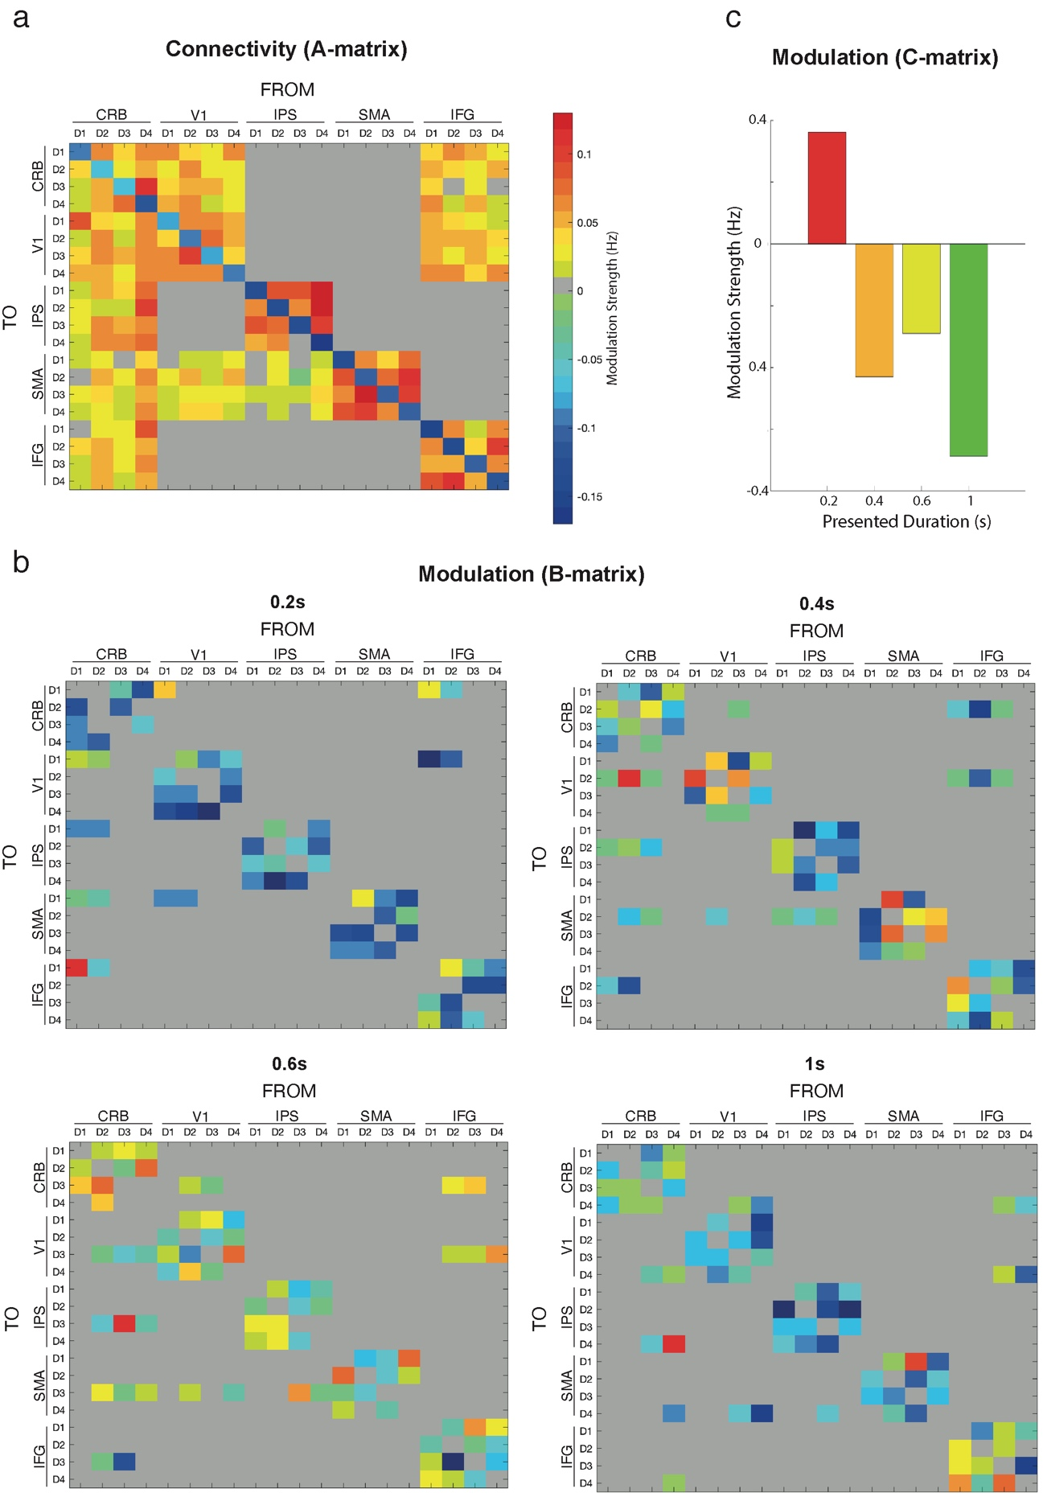

Supplementary Figure 8 Bayesian model averaging (BMA) results of the winning model in the cross-validated 20-nodes DCM. BMA averages the A-B-C-parameters of the winning model across subjects and sessions. (a) The matrix represents the strength of the connections (A-matrix) between duration selective clusters of voxels. The color scale represents the parameter’s values. (b) The four matrices represent the modulation on the connectivity strength (B-matrix) between the different duration selective clusters at the offset of the four S1 durations. x and y-axes are as in (a). (c) Bar-plot of the activity within each IPS duration selective cluster (C-matrix). Each bar shows the neuronal change (y-axis) for each of the four durations specific clusters while a specific duration was presented (x-axis). Duration specific clusters and stimulus durations are color coded as follow: red= 0.2, orange=0.4, yellow=0.6, and green= 1 s.

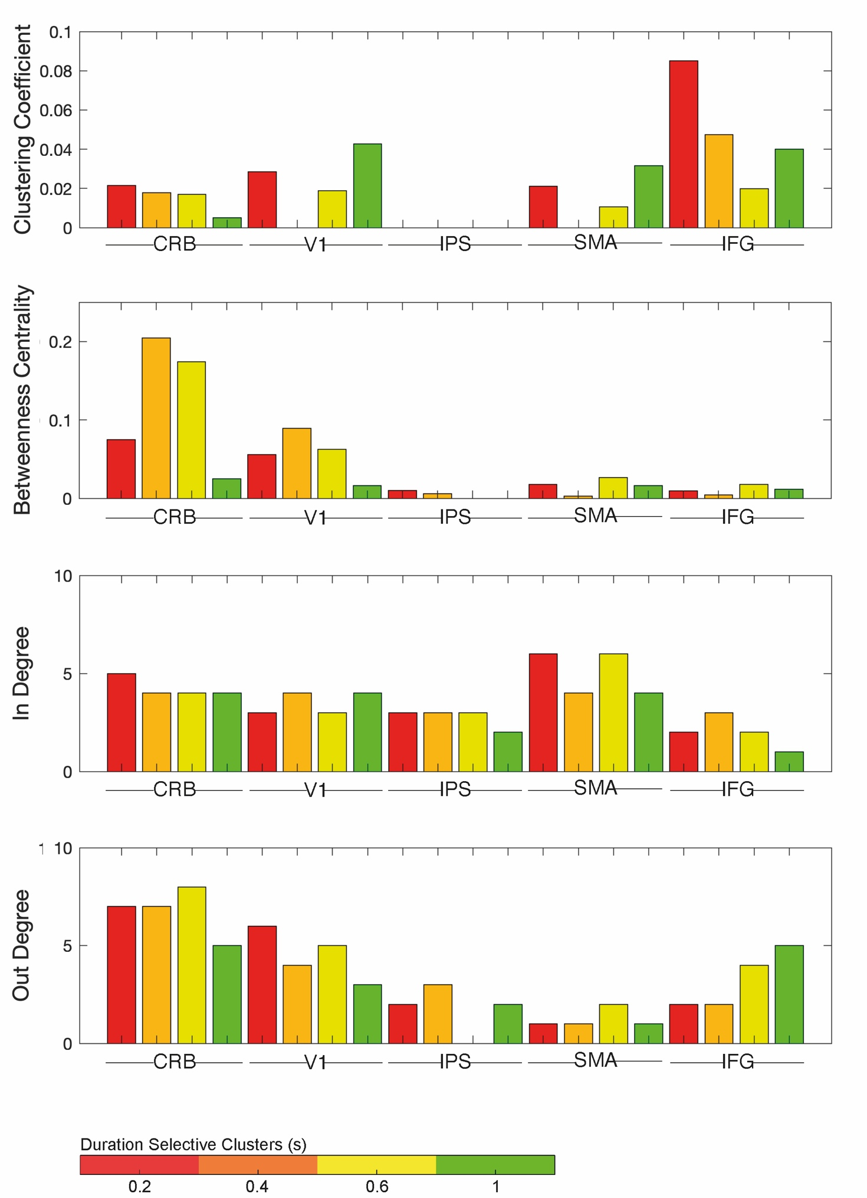

Supplementary Figure 9. Graph analysis output. Graph metrics from the estimated effective connectivity A matrix of the 20-nodes DCM. The clustering coefficient is a measure of the presence of clusters in a graph. Betweenness centrality indexes the influence of a node over the flow of information in a graph. In-degree is a measure of the number of connections that arrive at a given node, whereas out-degree is the number of connections that leaves the node. The x-axis refers to the four duration selective clusters of the five ROIs.

Anatomical Regions | DARTEL coordinates (mm) |  |  | Cluster size | p_{FWE} | T
Left Inferior Parietal Lobule | -40 | -40 | 40 | 2524 | < 0.001 | 7.93
Left Supplementary Motor Area | -2 | 9 | 46 | 699 | < 0.001 | 7.50
Right Mid-Occipital Gyrus | 21 | -98 | 12 | 152 | 0.002 | 6.63
Right Lateral Cerebellum | 32 | -51 | -20 | 433 | < 0.001 | 6.43
Left Inferior Frontal Gyrus | -50 | 4 | 10 | 736 | < 0.001 | 6.42
Right Cerebellar Vermis | 9 | -72 | -14 | 305 | < 0.001 | 5.89
Right Lingual Gyrus | 18 | -45 | 2 | 264 | < 0.001 | 5.86
Right Frontal Eye Fields | 27 | -6 | 52 | 122 | 0.009 | 5.59
Left Calcarine Sulcus | -14 | -64 | 15 | 242 | < 0.001 | 5.42
Right Middle Occipital Gyrus | 48 | -69 | 8 | 125 | 0.008 | 5.13
Right Intraparietal Sulcus | 44 | -36 | 50 | 156 | 0.002 | 5.10
Left Frontal Eye Fields | -24 | -6 | 46 | 219 | < 0.001 | 4.98

Supplementary Table 1
Stereotaxic Dartel-11 coordinates (mm) for brain areas activated at the offset of the four S1 durations. Voxels activated at p<0.05, FWE cluster-level corrected for multiple comparisons across the whole brain volume.

Networks | Analysis | A-matrix | B-matrix | C-matrix | N models
5-nodes | PEB | all | all | all | -
5-nodes | DCM | all | all | all | 1
5-nodes | DCM | PEB-like | all | all | 1
5-nodes | DCM | PEB-like | all | 1 or 2 ROIs | 15
20-nodes | DCM | PEB-like  I,N,D | I,N,D | I,N,D | 108
20-nodes | DCM | PEB-like  I,N,D | I,N,D | D | 36

Supplementary Table 2 Summary of the analyses performed.
Legend: PEB = Parametric Empirical Bayesian, DCM=Dynamic Causal Modelling, I=duration independent, N=neighboring dependent, D=duration dependent

