Supporting Information for
Spin Dynamics Modulated by Rashba States in Ferroelectric α-GeTe

Xu Yang^{1,3,7}, Liang Qiu^{2,7}, Hao-pu Xue^{1,3}, Jin Tang⁴, Hai-feng Du^{4,5}, Rui Sun^{1,3}, Qing-lin Yang^{1,3}, Jia-nan Liu^{1,3}, Yan-sheng Wei^{1,3}, Xiang–qun Zhang¹, Wei He¹, Y. S. Hou^{2,*} and Zhao-hua Cheng^{1,3,6,*}

¹Beijing National Laboratory for Condensed Matter Physics, Institute of Physics, Chinese Academy of Sciences, Beijing 100190, China
²School of Physics, Sun Yat-Sen University, Guangzhou 510275, China and Center for Neutron Science and Technology, School of Physics, Sun Yat-Sen University, Guangzhou, 510275, China
³School of Physical Sciences, University of Chinese Academy of Sciences, Beijing 100049, China
⁴Anhui Province Key Laboratory of Condensed Matter Physics at Extreme Conditions, High Magnetic Field Laboratory of the Chinese Academy of Sciences, and University of Science and Technology of China, Hefei 230031, China;
⁵Institute of Physical Science and Information Technology, Anhui University, Hefei 230601, China
⁶Songshan Lake Materials Laboratory, Guangdong 523808, China

⁷X. Yang and L. Qiu contributed equally to this work.
* Corresponding authors: zhcheng@iphy.ac.cn or houysh@mail.sysu.edu.cn

Content
S1. Ge_{1-x}Bi_{x}Te and Fe thin film quality
S2. The ARPES results of other sample not shown in the papers.
S3. Sum up the parameters changes with Bi concentration
S4. FMR signal fitted by Kittle equation
S5. Spin-pumping effect in Fe/GBT bilayer

S1. Ge_{1-x}Bi_{x}Te and Fe thin film quality
Fig. S1a is the HRTEM of GeTe/Si thin film. It shows a good epitaxy interface. Fig. S1b show the RHEED pattern and low-energy electron diffraction (LEED) spots of Fe thin film. The LEED pattern of Fe has three bright diffraction spots and three dark diffraction spots, which proves the surface of Fe thin film is Fe (111). Combined with Fig. 1b in main text, the epitaxy relation of the bilayer is $Fe⟨\overline{1}10⟩||\text{GBT}⟨\overline{1}100⟩||\text{Si}⟨\overline{2}11⟩$. To clarify the quality of Fe layer on GBT, Fig. S1c is HRTEM picture near Fe and GeTe intersection. It shows the epitaxy interface between Fe and $α$-GeTe, and the lattice of Fe can be observed clearly. It means the good quality of Fe thin film on $α$-GeTe layer.
The TEM of other doping ratio samples are shown in Figure S2. All the results shows the doping doesn’t kill the space group of the GeTe sample. Besides that, the Bi atoms are uniform in the GBT.
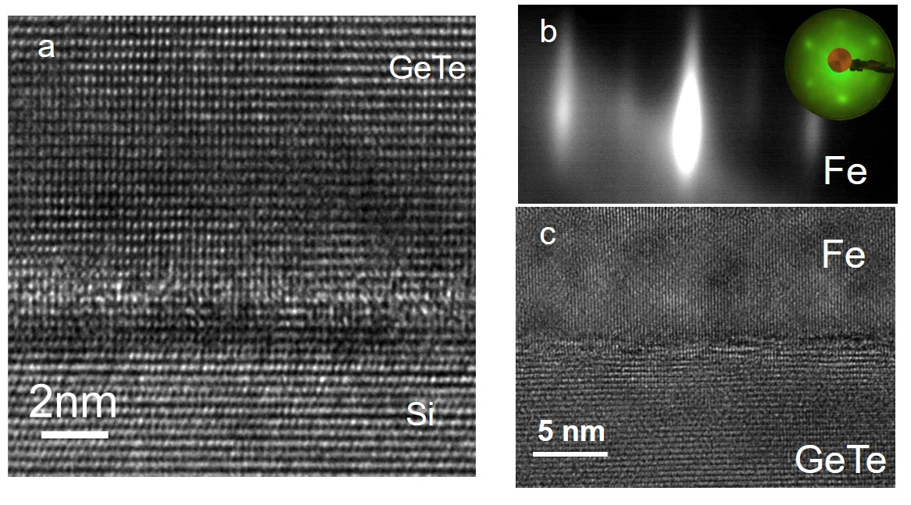
Figure S1 Structure character of GeTe and Fe thin films. a. HRTEM of $α$-GeTe /Si thin film. b. RHEED and LEED pattern of Fe thin film. c. HRTEM image of Fe and $α$-GeTe bilayer.

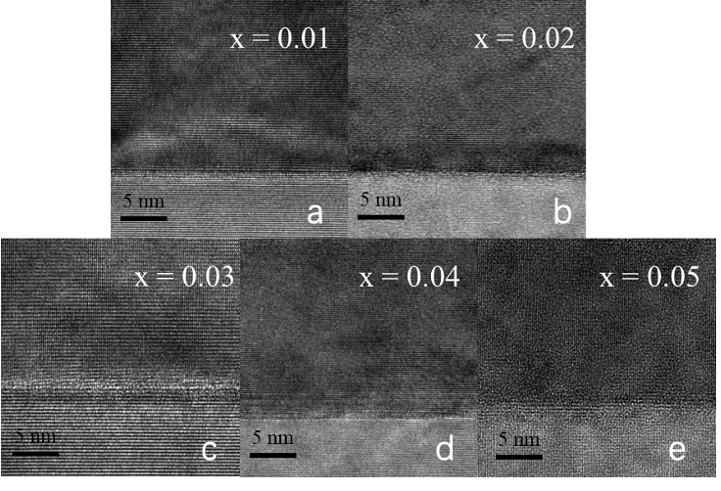
Figure S2 The TEM results of x = 0.01-0.05 samples.
S2. The ARPES results of other sample not shown in the papers.
To investigate the dispersion of surface Rashba, we take a high Bi concentration sample, $x=0.10$. The phase of x = 0.10 sample is checked by XRD shown in Figure S3. The ARPES result of Ge_{0.9}Bi_{0.1}Te only shows the band structure of $α$-GeTe. At the same time, its Fermi level high enough to see the whole dispersion of the surface states.
Fig. S4a shows the spectrum cutting along $\overline{M}-\overline{Γ}-\overline{M}$ and divided Fermi-Dirac function. Between room temperature and 80K, there is no difference except for the spectral broadening¹.
Fig. S4b is the MDCs at $-0.40 eV<E_{B}<0.02 eV$, we fitting these MDCs to get the peaks of surface Rashba dispersion. Fig. S4c is an example of the fitting results.
Figure S3 The XRD results of the reference sample (x = 0.10).
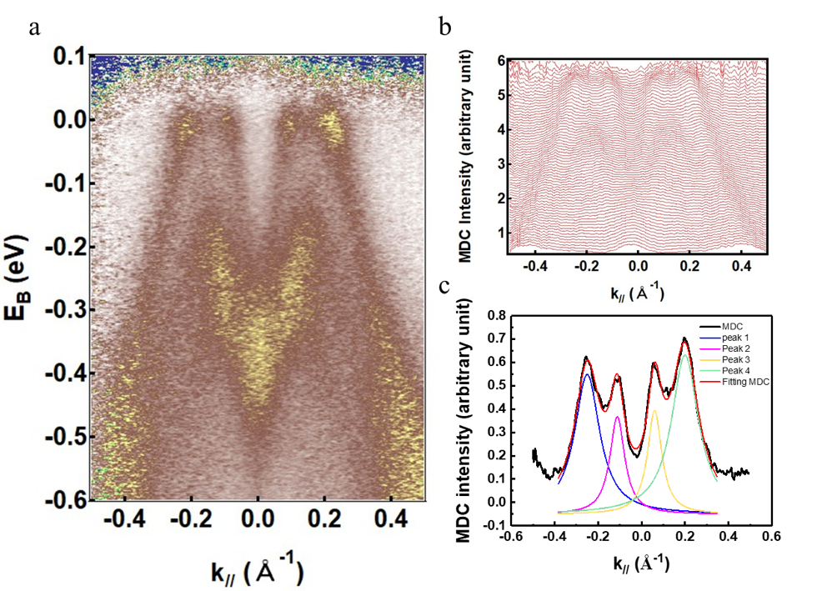
Fig. S4. Spectrum of Ge_{0.9}Bi_{0.1}Te sample. a. Spectrum of Ge_{0.9}Bi_{0.1}Te sample cutting along $\overline{M}-\overline{Γ}-\overline{M}$ at 10K. b. Stacking MDCs cutting from -0.40 eV to 0.01eV. c. A representative example of the fitting MDC by multi-Lorentz function.

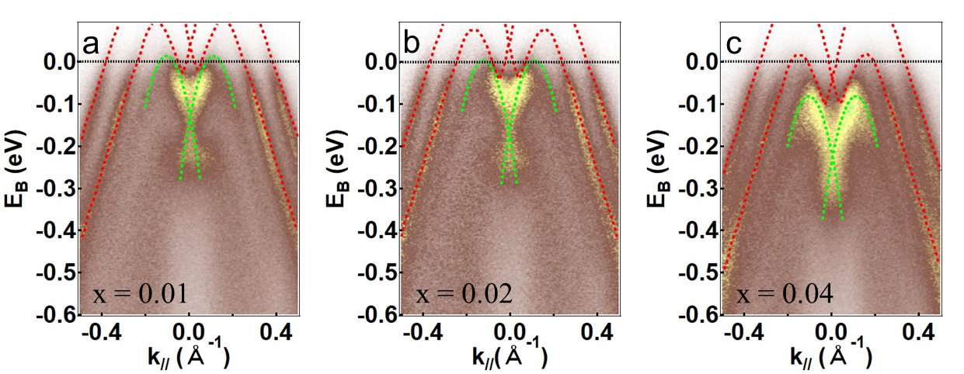
Figure S5 The ARPES results of x = 0.01, 0.02 and x = 0.04 samples. The dashed red and light green lines are the MDCs peaks, represented the surface states and bulk states of GBT.
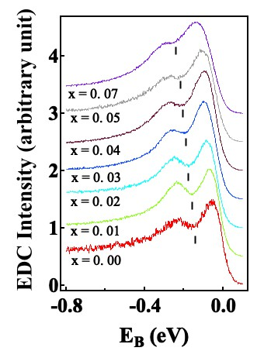
Figure S6 The EDCs cut at the $\overline{Γ}$ point. The short vertical black line represents the bulk Rashba point.
S4 Sum up the parameters changes with Bi concentration
Table S1 The parameters of all GBT samples.
x | $$ΔE_{R}^{s}$$  $$(eV)$$ | $$Δk$$  $$(Å^{-1})$$ | $$ΔE_{R}^{B}$$  $$(eV)$$ | $$α_{R}$$  $$(eV Å)$$ | $$A_{Total}^{GBT}$$  $$(×10^{-2})$$ | $$A_{SSs}^{GBT}$$  $$(×10^{-2})$$ | $$A_{BSs}^{GBT}$$  $$(×10^{-2})$$
0.00 | -0.022 | 0.123(5) | 0.130 | 4.4(1) | 0.80(6) | 0.34(3) | 0.46(3)
0.01 | -0.017 | 0.125(4) | 0.144 | 4.7(2) | 0.76(5) | 0.35(2) | 0.41(3)
0.02 | -0.014 | 0.121(1) | 0.169 | 4.5(1) | 0.72(5) | 0.42(3) | 0.29(1)
0.03 | 0.002 | 0.120(7) | 0.174 | 4.7(2) | 0.74(4) | 0.71(3) | 0.03(1)
0.04 | 0.035 | 0.123(16) | 0.212 | 4.5(2) | 0.66(4) | 0.66(4) | --
0.05 | 0.038 | 0.125(12) | 0.214 | 4.3(1) | 0.50(3) | 0.50(3) | --
0.07 | 0.068 | 0.124(20) | 0.278 | 4.6(1) | 0.46(3) | 0.46(3) | --

S5. FMR signal fitted by Kittel equation
Figure S8 presents the frequency dependence of resonance fields $H_{res}$ for all Fe/GBT samples and Fe reference sample. The $H_{res}$ is fitted by the follwing equation ²,
$$ReS_{21}\left(H\right)=S_{0}+L\frac{ΔH^{2}}{{\left(H-H_{res}\right)}^{2}+ΔH^{2}}-D\frac{ΔH\left(H-H_{res}\right)}{{\left(H-H_{res}\right)}^{2}+ΔH^{2}}$$
Here $ReS_{21}$ is the real part of transmission parameter, $S_{0}$ is the offset, $H$ is the applied magnetic field, $L$ and $D$ are the symmetric and antisymmetric magnitude, respectively.
To account for the FMR results, an effective field $H_{eff}$ is added to the Kittel equation³,
$$\begin{aligned}f=\frac{γ}{2π}\sqrt{\left(H+H_{eff}\right)\left(H+H_{eff}+4πM_{eff}\right)}\#\left(S1\right)\end{aligned}$$
where $γ$ is gyromagnetic ratio, $H$ is the magnetic field and $M_{eff}$ is the effective magnetization of Fe layer. The best fitting results are shown in Fig. S8 by using Eq. (S1), meanwhile the $4πM_{eff}$ of Fe/GBT/Si and the reference sample Fe/Si are summarized in Figure S9. The effective anisotropy field is defined as $4πM_{eff}=4πM_{s}+H_{an}+H_{int}≈4πM_{eff}^{Fe}+H_{int}$⁴, where $4πM_{s}$ is demagnetization field; $H_{an}$ is magnetocrystalline anisotropy field of Fe; $H_{int}$ is interfacial anisotropy field induced by GBT and $4πM_{eff}^{Fe}$is effective anisotropy field of Fe. The $4πM_{eff}$ of Fe/GBT samples decreases before reaching a minimum at x = 0.03 and increases slightly at the higher Bi concentration. Then we calculated the interfacial magnetic anisotropy $H_{int}$ shown in the inset of Figure S9. Except the $x=0.03$ sample having $H_{int}<0$, all the other samples behave as an in-plane magnetic anisotropy ($H_{int}>0$). Therefore, the coupling between Fe and GBT at interface cannot be neglected.
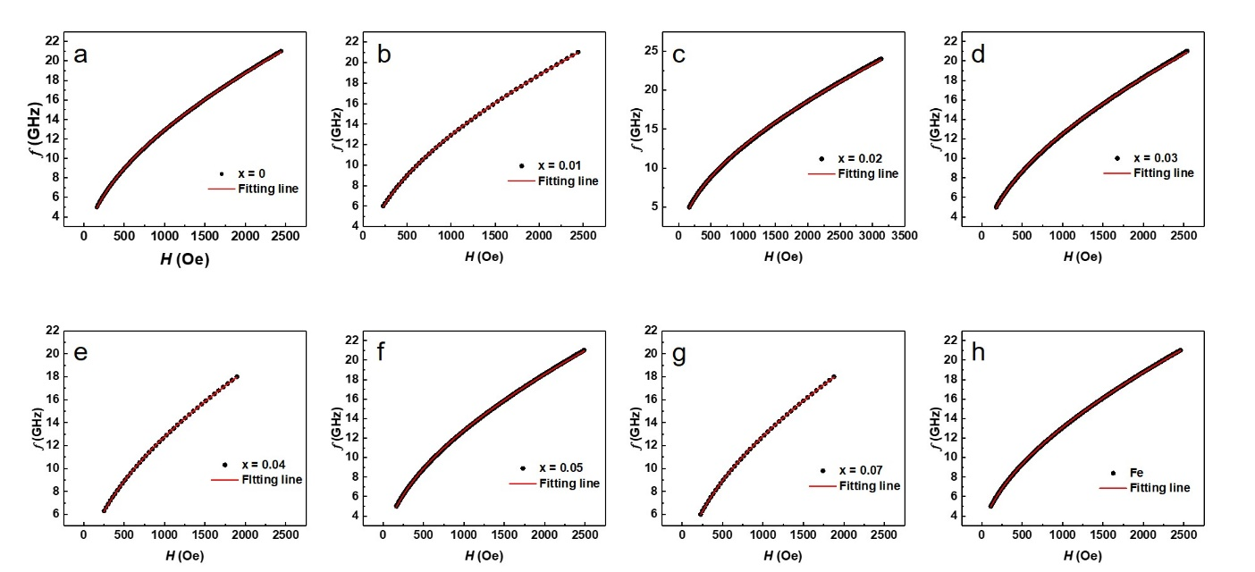
Fig. S10a gave the S₂₁ spectrum of all samples at 12GHz, which can be fitted by a single Lorentzian function. The best fitting results of resonance fields $H_{res}$ are listed in Fig. S10b. As more and more SSs of GBT cross over Fermi level, the $H_{res}$ rises up firstly and reach to the largest value 930 Oe at $x=0.03$ then stable between 880 Oe and 890 Oe. It implies the effective saturation magnetization of Fe vary with Bi concentration due to the interlayer coupling.
Fig. S8 The frequency dependence of resonance fields $H_{res}$. a-g. The function of $H_{res}$ with frequency for Fe/GBT bilayers. The red lines are the fitting lines using Kittle function in main text. h. The function of $H_{res}$ with frequency for Fe reference sample.
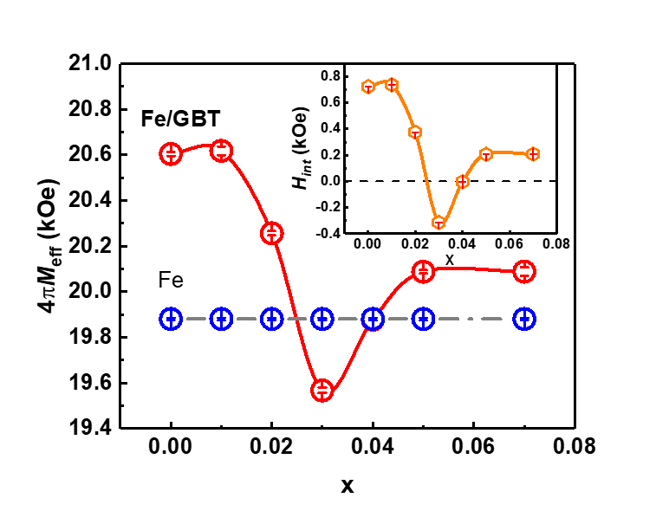
Figure S9 Bi concentration (x) or FL dependent effective anisotropy field $4πM_{eff}$ obtained from the Kittel equation. The blue dashed line is the interfacial anisotropy field of Fe reference field. The insert image shows the effective anisotropy field changes with the Bi concentration (x) or FL.

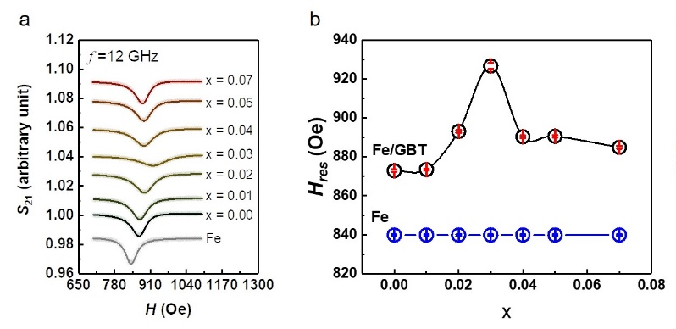
Fig. S10 The resonance fields with Bi concentration. a. Normalized FMR signal S₂₁ at 12 GHz for Fe/GBT samples with different Bi concentration and Fe reference sample. b. Bi concentration (x) or Fermi level dependence of the resonance fields $H_{res}$ at 12 GHz extracted from a fitting by Lorentz function. The blue line represents the resonance fields of Fe reference sample at12 GHz.

S5. Spin-pumping effect in Fe/GBT bilayer
To prove the spin-pumping effect in Fe/GBT bilayer, we verified the thickness of Fe thin films. Then we did FMR experiments the same with that in main text. We found that the damping behavior with Bi concentration of 5.5 nm and 10.0 nm Fe is the same with 12.0 nm Fe in the main text. Fig. S11a and Fig. S11b present the damping constant of 5.5 nm and 10.0 nm Fe change with Bi concentration. Fig. S11c shows the function between effective spin mixing conductance and Bi concentration with 12.0 nm Fe. It implies the spin-pumping effect at Fe/GBT interface.
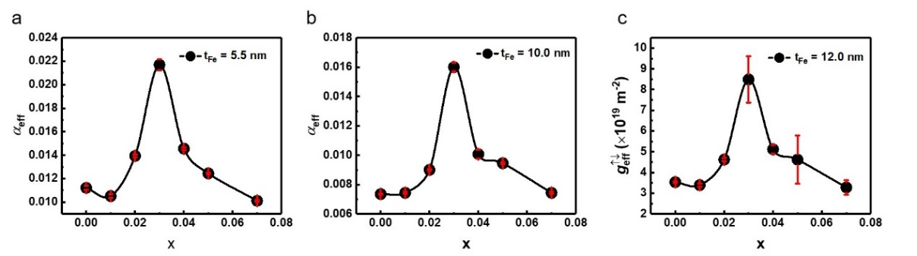
Fig. S11 Effective damping $α_{eff}$ with Bi concentration in different magnetic layer thickness. a and b are the effective damping in Fe/GBT bilayer for 5.5 nm and 10.0 nm Fe, respectively. c. The function of effective spin mixing conductance with Bi concentration with 12.0 nm Fe thickness.
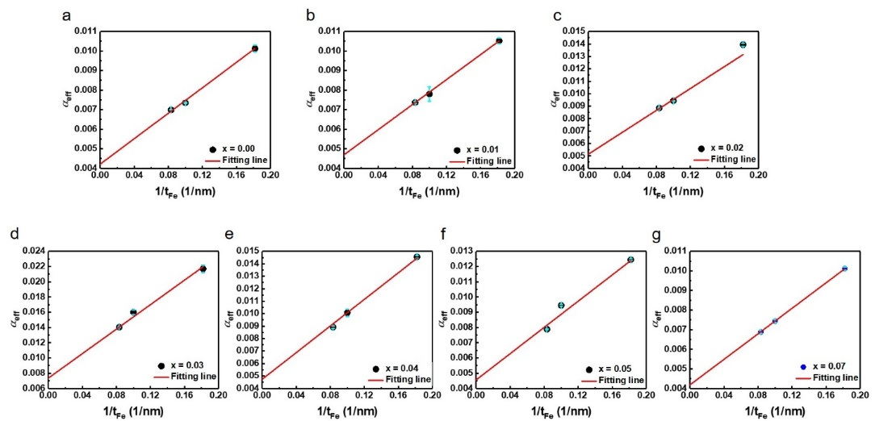
Fig. S12 The magnetic layer thickness dependence of effective damping $α_{eff}$. a-g. The function of $α_{eff}$ with $1/t_{Fe}$ for Fe/GBT bilayers. The red lines are the fitting lines using linear function, the intercepts in a-g are the $α_{Fe-GBT}$.
Fig. S12 a-g are the liner fitting of different Bi concentration samples with different Fe thickness. In this way, the intercept at $t_{Fe}→∞$ is the Gilbert damping of pure Fe film including the contribution of coupling by GBT, the behavior of $α_{Fe-GBT}$ is shown in Fig. 3c in the main text.

References
1 Liebmann, M. et al. Giant Rashba-Type Spin Splitting in Ferroelectric GeTe(111). Adv Mater 28, 560-565, (2016).
2 Kalarickal, S. S. et al. Ferromagnetic resonance linewidth in metallic thin films: Comparison of measurement methods. J. Appl. Phys 99, 093909, (2006).
3 Farle, M. Ferromagnetic resonance of ultrathin metallic layers. Rep. Prog. Phys. 61, 755, (1998).
4 Fanchiang, Y. T. et al. Strongly exchange-coupled and surface-state-modulated magnetization dynamics in Bi₂Se₃/yttrium iron garnet heterostructures. Nat. Commun. 9, 223, (2018).

