Extended Data and Supplementary information

An ATP-sensitive phosphoketolase regulates carbon fixation in cyanobacteria

Methods

Extended Data Figures 1-10
Supplementary Tables 1-3
Supplementary Figures 1-8
Legends for Supplementary Files 1-2
Supplementary References

Methods

Recombinant protein expression and purification
S. elongatus PCC7942 XPK (Synpcc7942_2080) was constructed under a pDC vector harboring a lac promoter, and its N-terminus was in-framed with a 6His-tag for nickel column purification. H706R, H710A, and Y710A S. elongatus mutants were generated via QuickChange II Site-Directed Mutagenesis Kit (Agilent). B. longum XPK (BIL_11880) and Metylomonas sp. DH-1 XPK (AMY39_18755) were also constructed by using the above plasmid. SeXPK, its mutant variants, and B. longum XPK were individually transformed in E. coli DH5αDE3.1 strain. Recombinant XPK proteins were expressed by adding 1 mM IPTG in 5L LB culture supplied with 250 µg/mL spectinomycin, and incubated in 30 °C, 150 rpm, for 16-20 h. The purification procedure followed Suzuki et al. ¹ with some modifications. The cell pellets were resuspended in buffer A, containing 20 mM HEPES-NaOH (pH 7.2), 0.2 mM thiamine pyrophosphate (TPP), 1mM MgCl₂, and cOmplete™ protease inhibitor cocktail tablets (Roche). The suspended cells were disrupted with a homogenizer (Avestin EmulsiFlex-C3), then centrifuged at 20,000 rpm, 4 °C for 30 min to remove cell debris. The supernatant was applied to an open column stuffed with cOmplete His-Tag purification resin (Roche). The resin was equilibrated with buffer A before loaded with protein sample. The sample-loaded resin was subjected to washing steps with buffer A supplemented with 10 mM imidazole and increased concentration of NaCl (from 0.1 M, 0.4 M to 1 M NaCl). Before protein elution, the resin was further washed with the buffer A to reduce the salt content, and subsequently washed with the buffer A supplemented with 0.25 M imidazole to elute proteins. The eluted protein sample was concentrated and loaded into a 5 mL-Q Sepharose column (GE Healthcare), pre-equilibrated with buffer A. The protein sample was eluted with a NaCl gradient in the buffer A supplemented with 1 M NaCl. The collected fraction sample was applied to a HiLoad 16/600 SuperdexTM 200 pg column (GE Healthcare) pre-equilibrated with a buffer containing 20 mM HEPES-NaOH (pH 7.2), 0.1 M NaCl, 0.2 mM TPP, and 1 mM MgCl₂. The eluted protein was examined with SDS-PAGE for purity as well its identity with mass spectrometry.

Kinetic assay
XPK enzymatic velocity was determined by measuring the formation of acetyl-phosphate (AcP) using a colorimetric method ². The 50 µL enzymatic reaction solutions contained 30 mM sodium phosphate (pH 6.4), 1 mM TPP, 1 mM MgCl₂, and different concentrations of fructose-6-phosphate (F6P) or sodium phosphate (Pi). The reaction began by adding 8 µg of purified XPK. Forty µL was taken from each reaction at serial time points (30 seconds to 2 h), and the reaction was stopped by adding 60 µL of 2 M hydroxylamine (pH 6.5) in a 96-well plate. After incubating for 10 min at room temperature, the coloring reagents including 40 µL of 15% trichloroacetic acid, 40 µL of 4 M HCl, and 40 µL of 3% FeCl₃ in 0.1 M HCl were added sequentially. Absorbance at 505 nm was then recorded on a plate reader. A standard curve using commercial lithium potassium AcP was used to relate absorbance to concentration, which showed a linear relationship between 0.3125 to 100 mM in the conditions described. The OD₅₀₅ values were converted to the product AcP in µmole and used to establish kinetic curves (Fig. 1 and Extended Data Fig. 1) and calculate the initial velocity (µmoleAcP.mgXPK⁻¹.min⁻¹, or simply µmole mg⁻¹ min⁻¹). V_{max} and K_{m} values were determined by varying the concentration of one substrate with another substrate held constant at a saturating level (30 mM Pi or 150 mM F6P) (Extended Data Fig. 1 and Supplementary Table 1).

Cyanobacteria strains and growth condition
Synechococcus elongatus PCC7942 wild type and the Δxpk strain³ were respectively grown in the 50 ml BG11 medium⁴ pH 8, supplemented with 50 mM NaHCO₃, under 12 h/12 h light/dark cycle (12 h L/D cycle). The incubation condition: 30 °, light intensity 50 µmole m⁻² s⁻¹ and shaking speed at 150 rpm. Gentamycin (10 µg mL⁻¹) was added to the Δxpk culture to ensure the growth of the xpk knockout genotype. The cell growth was monitored by the optical density at 730 nm (OD₇₃₀). The average dry-cell weight (DCW) 384 mg/L was calibrated for the culture with OD₇₃₀ = 1, used for experimental calculation.

¹⁴C incorporation experiment
For the ¹⁴C incorporation experiments (Fig. 2a), WT and Δxpk cultures (triplicates for individual culture) were grown in the BG11 medium containing 50 mM NaHCO₃, under 12h L/D cycle (light intensity: 50 µmole m⁻² s⁻¹, 30°C, shaking speed: 150 rpm). Then, after 5-6 h during the light period, the cultures were respectively refreshed with BG11. 0.8 mL from individual culture (OD₇₃₀ = 1) was transferred to a 24-well petri dish under light. The ¹⁴C labeling was initiated (time 0) by adding 0.2 mL of 10 mM NaH¹⁴CO₃ (containing 113 µCi of total ¹⁴C) to the cultures. After 10 min, the light was switched off. Then, the cultures were harvested at the time points (under darkness): 5, 10, 11, 13, 15, and 20 min, and further subjected to the ¹⁴C incorporation analyses⁴. 40 µL of each labelled culture was transferred to Costar Spin-X centrifuge tube filters, spun at full speed for 10 s to separate cells from the medium. The cell pellet was immediately resuspended with 200 µL of 0.1 M NaOH, then transferred to a scintillation vial. The cell-free medium (~40 µL) was supplemented with 160 µL BG11 and transferred to another vial. The Ultima Gold scintillation cocktail (5 mL) was then added to each vial for liquid scintillation counting analyses. The ¹⁴C incorporation % (y-axis) was calculated by ¹⁴C_{cell} / (¹⁴C_{cell} + ¹⁴C_{medium})×100 (n = 3, mean± SE). For the experiments shown in Fig. 2b-c, the WT and Δxpk cultures (triplicate batches) were grown under 10 min L/D cycle or 250 min L/D cycle. The cultures were refreshed with BG11 and adjusted to the cell density (OD₇₃₀ = 1) in the dark. Then, 0.8 mL of the starting culture (OD₇₃₀ = 1) was added with 0.2 mL of 50 mM NaH¹⁴CO₃ upon switched to light (set as time 0 min). The following samples were harvested at different time points from two continuous L/D cycles. To analyze the ¹⁴C incorporation at the high cell density, (Fig. 4 b-d), the WT and Δxpk cultures (triplicate batches) were grown under 12 h L/D cycle till OD₇₃₀ reached to 1 or 2. The cultures were refreshed with BG11 and adjusted OD₇₃₀ to 1, 2 or 5. After 5-6 h illumination, 0.8 mL of the cultures (OD₇₃₀ =1, 2, or 5) was added with 0.2 mL of 10 mM NaH¹⁴CO₃ (set as time 0 min).

ATP measurements
The following procedure was based on Rust et al. ⁵ with modifications. 0.4 mL of WT and Δxpk cultures (triplicate batches for both) were transferred to 1.5 mL tubes containing 0.14 mL of 3M HClO₄ and 77 mM EDTA. The mixture was then frozen with liquid N₂ to stop reactions and lyse cells. Next, the samples were defrosted and neutralized with 0.26 mL solution, containing 1 M KOH, 0.5 M Tris, and 0.5M KCl, to adjust pH to 7. After 14000g centrifugation at 4°C for 30 min, the supernatant was collected for ATP measurements. 38 µL of supernatant was diluted with 62 µL of buffer containing 100 mM HEPES pH 7.4, 25 mM KCl, and 50 mM MgSO₄. To plot ATP standard curve, 1 nM to 1 µM ATP solutions were prepared in parallel. 100 µL sample and ATP solutions were transferred to an opaque 96-well plate. 100 µL luciferase based BacTiter-Glo™ assay solution was added to each sample well. The luminescence signals from each reaction and standard were measured and then the ATP amount was quantified as showed in Fig. 2 lower panel and Fig. 4a.

The measurement of O₂ evolution and consumption
The amount of O₂ evolution and consumption in cells was analyzed using a Clark-type oxygen electrode along with a water-jacket cell⁶. The cell cultures (grown under light intensity: 50μmole m² s⁻¹) containing10 μg Chla were mixed with 2 mM potassium ferricyanide and 2,6-dichloro-p-benzoquinone (an artificial electron acceptor) in 1 mL reaction. The reaction mixture was then placed in a stirred water-jacket cell under dark. The O₂ consumption of the cell culture was quantified by measuring the decreased amount of O₂ (μmole Chla mg⁻¹ h⁻¹). To quantify the amount of O₂ evolution from water split during photosynthesis, the cell culture was supplied with saturated light (Supplementary Table 2).

Quantification of the ¹³C-labelled sugar phosphates and acetyl-CoA
The WT and Δxpk cultures (50 mL, three batches for each) were firstly grown under continuous light, and then refreshed with BG11 medium before ¹³C-labelling. At the time 0, the cultures were added with 2 mM NaH¹³CO₃, and simultaneously, the light was switched off. Samples (2ml, OD₇₃₀ adjusted to 1) were harvested from individual culture at different time points before (-5, 0 min) and after dark (1, 3, 5, and so on). The harvested cultures were then subjected to 14000g centrifuge for 10 sec. The pelleted cells were immediately frozen with liquid N₂. The following metabolite extraction procedure was based on Dempo et al. ⁷ and Lunn et al. ⁸ with modification. The frozen cell pellets were firstly mixed with 200 µL solution (methanol: chloroform: water in 5:2:2 ratio (v/v)), and then subjected to freeze- vortex- thaw steps for three rounds to disrupt the cell wall. Next, samples were placed in -30 °C for 2 h and subsequently mixed with 150 µL cold water before centrifuged at 400g for 15min to isolate aqueous phase from protein and nonpolar phase. This cold-water extraction step was repeated once. Then, the aqueous phase was dried by speedVac at 30 °C before adding 100 - 200 µL water to resuspend the samples. To remove macromolecules, the sample solutions were applied to 10 kDa Ultracel centrifugation tubes. After 10 min centrifugation at 14000g, the flow-through solution containing phosphosugars and soluble metabolites was isolated for following LCMS/MS analyses. Each sample (10 µL) was loaded to triple quadrupole Shimadzu LC-MS 8045 with YMC-Triart C18 ExRS [metal free column] (150 mm × 2.1 mm, 1.9 µm, Product number: TAR08SP9-15Q1PTP) at 0.40 mL/min flow rate. Separation was performed as described in Campos et al.⁹, starting with 100% solvent A. Solvent B was increased linearly to 7.5% over 10 min after starting point. From 10-13 min, solvent B was increased to 52.6% linearly and was maintained till 15 min. From 15-25 min, 98% solvent B was used to remove remnant. From 25-30 min, solvent B was decreased to 0% for column equilibration. The column temperature was maintained at 50 °C. Liquid chromatography-tandem mass spectrometry (LCMS/MS) was set in the negative mode with spectra acquired over a mass range of 50-1000 m/z. The acquisition parameters were as follows: interface temperature, 250 °C; desolvation line temperature, 200 °C; heat block temperature, 400 °C; desolvation gas, nitrogen; nebulizing gas flow rate, 3.0 L/min; drying gas, nitrogen; drying gas flow rate, 5 L/min. All metabolites and their labeling patterns were measured by multiple reaction monitoring (MRM) in the negative mode. Each peak area of ¹²C- and ¹³C-incoroporated metabolite was quantified. The ¹³C-incorporated % of individual metabolite was calculated as (¹³C-compound / ¹²C-compound) and showed in Fig. 3 and Supplementary Fig. 1. Statistical significance difference of the ¹³C-incorporated % between the WT and Δxpk was analyzed by one-way ANOVA (n=3 biological repeats, mean ± SE).
Sugar and biomass composition measurements
To obtain high cell density cultures, both WT and Δxpk cultures were grown till OD₇₃₀ reached 2-3, and then refreshed with BG11 medium before adjusted OD₇₃₀ to 4. Equal volume of individual culture was supplemented with 100 mM NaHCO₃ and inoculated in the Corning® 75 cm² cell culture flask for 4 days under shaking at 70 rpm. Two aliquots of 1 mL culture from WT and Δxpk were harvested and placed to Costar Spin-X centrifuge tube filters, spun at 15000g for 1 min, to separate cell and medium. The medium sample (2mL) was collected for extracellular sugar content analyses (Fig. 4g). The equal amount of the cell pellet was respectively used for glycogen and intracellular sucrose measurements (Extended Data Fig. 2; Fig. 4g). The metabolite extraction method was described above. For extracellular sugar content measurements, 100 μL of the medium samples were firstly mixed with known amount of lactate as internal control and then subjected to 3kDa Ultrcel centrifuge tubes to remove macroparticles. 10 μL of the clear flowthrough was then analyzed by the UHPLC Agilent 1290 infinity II system at 50°C, using Hi-Plex H hydrogen 8 µm, 300 × 6.5 mm column. By isocratic elution with 30mM sulfuric acid at 0.4 mL/min flow rate, the glucose and sucrose contents were separated and detected by the refractive index detector. The amount of lactic acid was detected by the diode array detector at UV wavelength 210 nm. For intracellular sucrose and glucose measurements, the sample extracts were quantified by monitoring the NADH production using colorimetric method. The concentrations of the standard NADH samples were prepared from 0.125 mM to 1 mM. The extracts containing sucrose and glucose were digested to glucose and fructose by mixing with 200 mM sodium acetate pH 4.8, containing 6U invertase (from baker’s yeast, Sigma-Aldrich), at 55°C for 1h. The cell pellet for glycogen measurement was mixed with 200 μL of KOH 30% (v/v) then boiled for 30 min. Acetic acid was added to the sample for adjusting pH to 7 at room temperature. The sample was then mixed with the enzymatic digesting reagent, containing 50 mM sodium acetate pH4.8, 6U/mL amyloglucosidase, and 50U/mL alpha-amylase. The reactions were held at 37°C for 2 h to catalyze glycogen to glucose, and then stopped by heated at 99°C for 10 min. Then, 50 μL of the digested samples were transferred to a 96 well plate, and mixed with 100 μL solution containing 100 mM HEPES, pH 7.5, 1 mM MgCl₂, 1 mM ATP, 1 mM NAD, and 0.6 U hexokinase (from baker’s yeast, Sigma-Aldrich) to convert glucose to glucose-6-phosphate. The absorption reading of NADH at OD₃₄₀ was used as a blank. Subsequently, 0.9 μL of glucose-6-phosphate dehydrogenase (from Leuconostoc mesenteroides, Roche) was added to each reaction that converted glucose-6-phosphate and NAD to phosphogluconate and NADH. The OD₃₄₀ reading was recorded per minute till the values reached plateau. The method above was also used to quantify intracellular glucose content without invertase reactions. Thus, the sucrose content was calculated by subtracting the glucose content. For biomass measurements (Extended Data Fig. 2a-b), 2 mL of the cultures were transferred to pre-weighted Costar Spin-X centrifuge tubes. After centrifugation and freeze-dry overnight, the dry cell weight (DCW) of the cultures was quantified. The carbon content of the biomass was calculated using the formula of CH_{1.81}N_{0.17}O_{0.20}P_{0.013}S_{0.009}¹⁰. The total protein contents (Extended Data Fig. 2d) of the freeze-dry samples were quantified using PierceTM BCA protein assay kit (ThermoFisher).

Net carbon fixation and respiratory CO₂ release measurements
For net carbon fixation measurement, 0.5 mL of the culture sample above was harvested at the end of day and night for four days. The harvested sample was transferred to a 20 mL glass screw top vial. Equal volume of 37% HCl was then injected to the sample to release CO₂ into the headspace of the vial. The headspace was loaded into the Agilent Technologies 7890 gas chromatography equipped with a 5977B mass spectrometer. A DB-FFAP column (Agilent Technologies, 0.32 mm × 30 m × 0.25 μm) was used to detect the amount of CO₂ released from the sample (Fig. 4e-f). The NaHCO₃ standard curve was prepared using 0 mM to 100 mM NaHCO₃.

RNA-seq
5 mL of WT and Δxpk cultures (OD₇₃₀~1, three cultures for each genotype) were harvested at 4 time points (Light 1 h: 1 h after switching to light; Light 12 h: 12 h illumination; Dark 1 h: 1h after switching to dark; Dark 12 h: 12h darkness). Cells were pelleted by full-speed centrifugation for 10 s, frozen with liquid N₂, and then stored in -80 °C till samples were harvested from all time points. Cell pellets were washed once with 300 μL Qiagen RNAprotect® cell reagent, and centrifuged to remove the supernatant. Cells were frozen with liquid N₂ and then thawed by adding 350 μL RLT solution, provided by the Qiagen RNeasy kit. After 3 rounds of freeze-thaw-vortex steps, the samples were centrifuged at 15000g for 10 min. Supernatant was transferred to the tubes and mixed with equal volume of 100% ethanol. The mixture was then transferred to the RNeasy mini-spin columns. The following procedure was based on the Qiagen RNeasy kit and the Invitrogen TURBO DNA-free™ kit. For RNA-seq experiments, RNA quality control was done by Agilent fragment analyzer 5200. Library preparation and rRNA depletion were performed by using Illumina Ribo-Zero Plus rRNA depletion kit. All sequencing was performed on Illumina Nextseq 2000 with P2 flowcell, 300 cycles, and pair end 150 bp. Data was processed using CLC genomics workbench 21. Differential gene expression between WT and XPK was examined across all conditions (across group, ANOVA-like), with TMM normalization. The Volcano plot y-axis showed p-value (-log10) between WT and Δxpk (Extended Data Fig. 3a). Heat map was plotted with TMM-normalized CPM values, with Kmeans clustering k = 4 for gene clustering (Extended Data Fig.3b).

Frequency-dependent phenotype experiments
To observe the growth phenotype of WT and Δxpk mutant under different frequency L/D cycles, the cell cultures (six batches for both genotypes) were firstly grown under continuous light until OD₇₃₀ reading reached or just over 1. The starting cultures (1mL) of the WT and Δxpk cells were adjusted with culture medium to obtain the same cell density with OD₇₃₀ = 1 (the 10⁰ culture in Fig. 5a). Ten-fold serial dilutions were made from the starting culture to obtain three additional cultures annotated as 10⁻¹, 10⁻² and 10⁻³. Six aliquots (10 μL/each) of the individual culture were simultaneously dropped onto the same BG11 plates to give six replicated cell dots. After dots drying under continuous light, the plates were imaged (day 0), and then subjected to different L/D frequency cycles for four days. The images of the plates were taken every 24 h. The autofluorescence images were taken by Fujifilm LAS-4000 at 520 nm excitation and 575DF20 emission filter. The mean autofluorescence intensity of each cell-dot (from 10⁻¹) and the mean background intensity were analyzed by ImageJ. The calibrated autofluorescence of each cell-dot was obtained (Fig. 5b), after subtraction of the background intensity.

Cryo-EM specimen preparation and data collection
Cryo-EM samples were prepared by applying 4 µL freshly purified SeXPK (~0.4 mg/mL, equivalent to 2.2 µM of dimer, protein buffer: 20 mM HEPES-NaOH (pH 7.2), 0.1 M NaCl, 0.2 mM TPP, and 1 mM MgCl₂) to a glow-discharged holey carbon grid (Quantifoil R 1.2/1.3, 300 mesh). For the bound form, AMPPNP was added to the protein sample at a final concentration of 2 mM. The mixture was incubated on ice for at least 30 min before applying to the cryo-grids. After sample application, the grids were subsequently blotted for 4 s at 4 °C in a 95% humidity controlled chamber, followed by plunge freezing in liquid ethane using a Vitrobot Mark IV (Thermo Fisher Scientific). To obtain top-viewed orientation of XPK particles, the grid surface was pre-modified with 0.1 mg/mL poly-L-lysine (Sigma-Aldrich) right after glow-discharge. Cryo-EM specimen grids were imaged on a Titan Krios (Thermo Fisher Scientific) operated at 300 kV. Dose-fractionated image stacks were recorded on a Direct Electron Detector (Thermo Fisher Scientific) at 165,000x nominal magnification in the counting mode. The dose rate was 0.98 e⁻/pixel sec with 60 frames in 4.5 s collected for a total exposure of 30 s, resulting in a total dose for each exposure of ~59 e⁻/Å². The datasets containing ~3500 to 4000 movies were obtained with nominal defocus values ranging from 1.5–2.5 µm, and data collection parameters were controlled in an automated manner using EPU (Thermo Fisher Scientific). The data collection parameters of individual datasets are listed in Supplementary Table 3.

Cryo-EM data processing
The individual dataset was corrected for beam-induced motion by MotionCor2 ¹¹ and contrast transfer function (CTF) estimation was performed with Gctf ¹² on the non-dose-weighted, aligned micrographs. Initial particle picking was carried out using cisTEM ¹³ to obtain the particle stacks, which were then exported to RELION 3.0 ¹⁴ for 2D classification. After expelling the indistinguishable particle classes by multiple rounds of 2D classification, the particles were extracted from the retained 2D classes. These particles were used to generate a de novo initial 3D model by cisTEM ¹³, which was then imported into RELION 3.0 for further 3D classification and 3D auto-refine with C6 (for SeXPK) or C4 (for B. longum XPK) symmetry. After CTF refinement and Bayesian polishing, the polished shiny particles were imported into cryoSPARC ¹⁵ for further 2D classification. Particles from the good 2D classes were extracted for further 3D homogeneous refinement. Through the 3D homogeneous refinement with D6 (for SeXPK) and D4 (for B. longum XPK) symmetry, the resolution of the 3D density map was further refined. Next, focus refinement strategy was performed to further improve the density of a single dimer. Symmetry expansion (C1) and a soft mask were applied to locally refine one single dimer. The Fourier shell correlation (FSC) = 0.143 standard was used to estimate the overall resolution, and the local resolution was calculated by cryoSPARC ¹⁵. UCSF Chimera ¹⁶ was used to visualize the 3D density map. The detailed refinement statistics for both the dodecamer/octamer and the focus-refined dimer of individual datasets are listed in Supplementary Table 3.

Atomic modelling, refinement and validation
The initial model was derived from a homology modelling by SWISS MODEL¹⁷, based on SeXPK amino acid sequence and the published crystal structures of XPK. The derived homology model was fit as a rigid body into the C1-symmetrized 3D map with applied local resolution-filtering using UCSF Chimera ¹⁶. The crystal structure of B. longum XPK (pdb 3AI7)¹⁸ was used as an initial model for reconstructing octamer assembly of the protein. Initial rounds of rigid body and real-space refinement were performed using PHENIX¹⁹. Some local discrepancy of model fitting was rebuilt manually using Coot²⁰ based on the densities from both dimer subunits. Each subunit maybe clearer at different residues. The refined dimer was further fit into the D6 (SeXPK) or D4 (B. longum XPK)-symmetrized 3D map for obtaining the dodecamer or octamer assembly, respectively. Initial iterations of refinement were performed using real-space refinement in PHENIX¹⁹. Several iterations of manual adjustment of the protein model in Coot ²⁰ followed by real-space refinement in Rosetta²¹, were performed while monitoring model quality with MolProbity²². AMPPNP and TPP molecules were manually built into the cryo-EM density with Coot²⁰. Several iterations of real-space refinement on the entire model were completed until refinement statistics converged. The detailed statistics of data process, model refinement, and validation was listed in Supplementary Table 3.
Figures were prepared using PyMOL Molecular Graphics System, Version 2.4.1 Schrödinger, LLC and Chimera¹⁶.

Protein Data Bank structural search procedures. Structures complexed with ATP or 5 ATP analogs (ANP, ACP, APC, ZAN, AGS) were obtained from the Protein Data Bank ²³. There were a total number of 3063 structures (April 2021). The structures that match all of the following criteria were selected for analysis: (1) a distance of ≤ 5 Å between the atom C5 of the adenine ring and the atom CG (gamma carbon) of paired aromatic residues (Y, W, F, and H), and (2) a distance of ≤5 Å between the phosphorus atom PG of the gamma phosphate group and the atom CZ of a nearby arginine residue. Another search only focusing on the criterion (1) with additional 2870 structures complexed with ADP or AMP was also performed. The corresponding protein names of the matched structures are listed in Supplementary File 1. Abbreviations for the molecules in this search: ANP: AMP-PNP, phosphoaminopgosphonic acid-adenylate ester; ACP: AMP-PCP, phosphomethylphosphonic acid adenylate ester; APC: AMP-CPP, diphosphomethylphonic acid adenosyl ester; ZAN: AMP-NPP, adenosine-5’-(α, β)-imido triphosphate; AGS: ATPgammaS, phosphothiophosphoric acid-adenylate ester; ADP: adenosine-5’-diphosphate; AMP: adenosine monophosphate. ATP: adenosine-5’-triphosphate.

Protein database search and alignment
The conservation of ATP binding sequence motif in the phosphoketolase family was investigated using SeXPK protein sequence as a query to search in a non-reductant NCBI protein BLAST database ²⁴, including GeneBank CDS translations, PDB and SwissProt, with a total number of 369802622 sequences (2021/April/05). The BLASTP was used as search algorithm and the alignment score was assigned based on Matrix BLOSUM62. The number of target search sequence was 5000. Among the 5000 sequences, 4930 sequences share at least 60% identity to the query sequence. These sequences were subjected to multiple sequence alignment ²⁵.
Additional searches were performed for the specific genera listed in Fig. 7a (rows 9-12) but with < 60% identity to the SeXPK, particularly in Bifidobacterium (taxid: 1678), Lactococcus (taxid:1357), and Lactobcilius (taxid:1578). None was found in the non ATP-regulated Bifidobacterium (total 112 sequences, with sequence identity >50%) or Lactobacillius (462 sequences with sequence identity >40%). Finally, Lactococcus was also examined since it is representative of homofermenative bacteria used in synthetic biology, and the XPK structure from L. lactis has been reported^{18,26,27}. No ATP regulatory site was found from 93 sequences with >40% identity to S. elongatus.

Data availability statement
Protein structural coordinates and maps have been deposited in the Protein Data Bank (PDB) and the Electron Microscopy Data Bank (EMDB), with the following accession codes: AMPPNP bound SeXPK: EMD-32124, PDB 7VTU; free SeXPK: EMD-32123, PDB 7VTT; free B. longum XPK: EMD-32122, PDB 7VTS. They are also listed in Supplementary Table 3. The 3D volume maps of both the oligomer and the focus-refined dimer are deposited in PDB/EMDB under the same code. The validation reports of the corresponding coordinates files are provided. All other original data not described in Methods or Supplementary Information will be available upon reasonable request.

Extended Data Figures

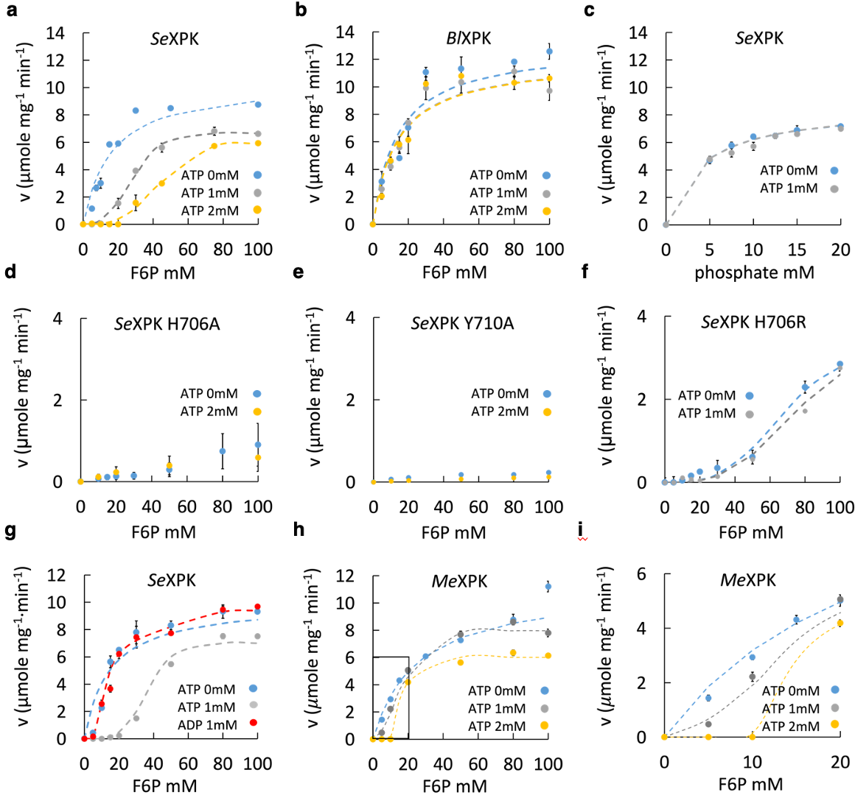

Extended Data Fig. 1. Steady-state kinetic analysis of XPK. a. SeXPK (V_{max} 10.8±0.1 µmole mg⁻¹ min⁻¹; K_{m} 19±1.5 mM) is inhibited by 1 or 2 mM of ATP, in the presence of 30 mM phosphate. b. Under the same condition, B. longum XPK (BlXPK) displays no inhibition by ATP. c. SeXPK is not inhibited by phosphate substrate in the presence of saturating F6P (150 mM). d. H706A mutant of SeXPK lost most activity. e. Y710A mutant of SeXPK lost most activity. f. H706R mutant of SeXPK shows only minor effect by ATP. g. ADP does not affect SeXPK activity. The inhibition curve with ATP is included for comparison. h. Methylomonas sp. XPK (MeXPK) is also inhibited by ATP, though to a lesser extent than SeXPK. An enlarged view of the inset is shown in i. Data represent n = 3 individual reactions, mean ± SE. Each plot represents one of the three experimental repeats.

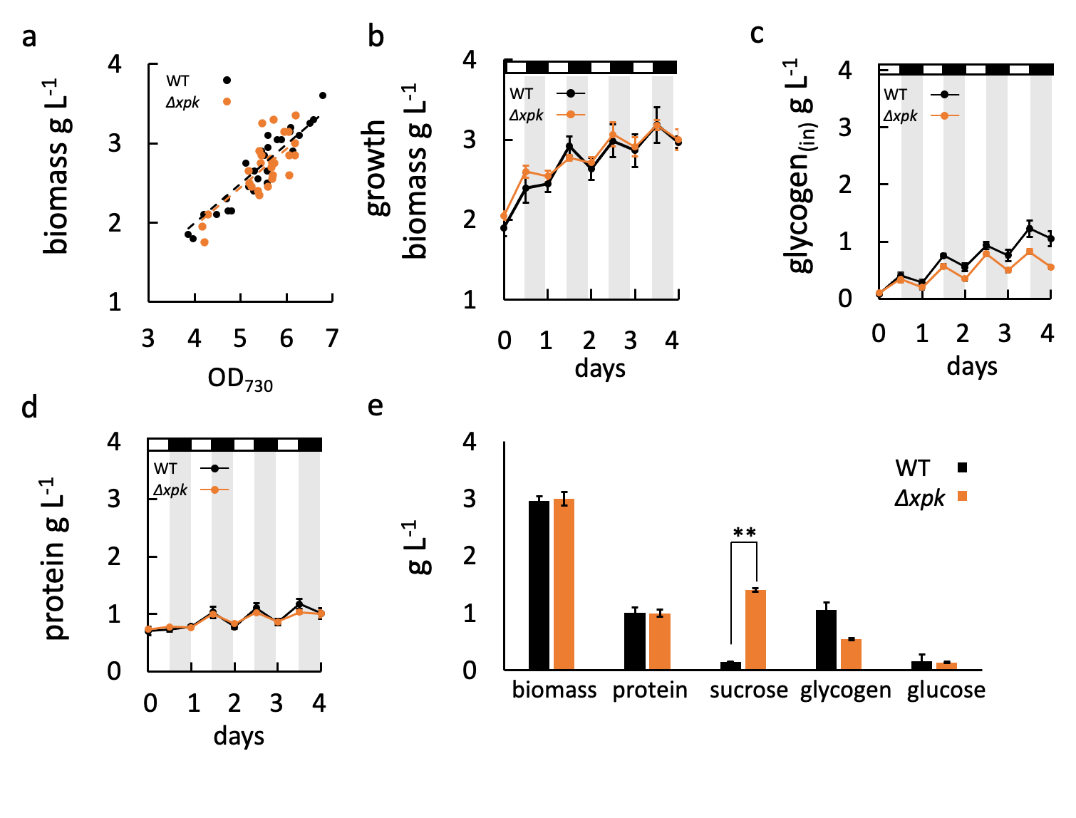
Extended Data Fig. 2. Deletion of SeXPK enhanced sucrose production but did not alter biomass. a-b. Biomass and the cell optical density (OD₇₃₀) increase approximately equally in WT and Δxpk cultures in four days. c. Glycogen content from equal volume of WT or Δxpk culture was measured in four days. d. protein content of WT and Δxpk in four days. e. The weight of biomass, protein, sucrose, glycogen, and glucose were measured from WT and Δxpk culture after four days.

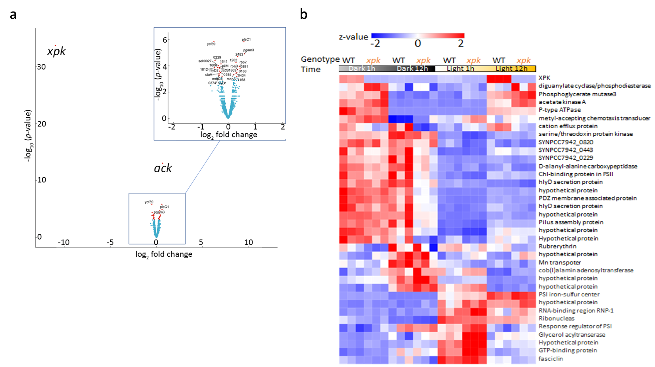

Extended Data Fig. 3. Transcriptional differences between WT and Δxpk across 4 time points. WT and Δxpk were grown under 12 h L/D cycle till OD₇₃₀ reached 2. The samples were harvested 1 h after dark, at the end of dark, 1h after light, and at the end of light. Equal amount of RNA was extracted from both culture for RNA-seq analysis. a. Volcano plot between WT and Δxpk (n = 3, mean ± SE). A few genes showed significant changes (red dots, p<0.05). Their expressional fold change was less than 2 (x-axis, enlarged plot), except XPK and its downstream ACK. Thus, no global changes due to absence of XPK. b. The heatmap showed the comparison of the 36 genes that appeared different in expression levels between WT and Δxpk (ANOVA-like statistical analysis by CLC) at 4 different time points. XPK was peaked at the end of light as an evening gene. However, the transcriptional differences are small as the z-values are ± 2.

Extended Data Fig. 4. Cryo-EM structures of free forms of SeXPK and B. longum XPK. a. SeXPK dodecamer and its dimer unit, with its N-, middle, and C-subdomains colored in light blue, marine and dark blue in one subunit, while the other subunit is colored in grey for differentiation. The distribution of the residues (shown in magenta spheres) involved in the dimer-dimer interface of the dodecamer XPK are primarily located at the C-terminal subdomain. The coenzyme TPP/Mg²⁺ is shown in yellow/ green spheres. b. B. longum XPK octamer and its dimer unit. The dimer is shown in orange and grey for each monomer. The residues involved in the dimer-dimer interface of octamer XPK are highlighted in magenta spheres. They are predominantly located at the N-terminal subdomain, in contrast to the SeXPK dodecamer.

Extended Data Fig. 5. Representative cryo-EM density maps of the AMPPNP, and the key elements involved in the allosteric regulation of SeXPK. a. The representative electron density for AMPPNP modeling (residue from B subunit is labeled with a prime). b. The modelling of residues YPW in the free- and AMPPNP-bound XPK. In free-XPK, the density can merely accomendate one W703 from either A or B subunit. Therefore, the two W703 residues are alternatively positioned downwards and upwards. Conversely, upon AMPPNP binding, the individual W703 can be modelled in two conformers, giving a dynamic swing-like motion. c. Cryo-EM density map for modeling the active site loop region (V534-S546) of AMPPNP-bound SeXPK. d. The electron density for modelling Y492 in free- and AMPPNP-bound XPK.

Extended Data Fig. 6. Structural comparison of the C-terminal domain interface in S. elongatus and B. longum XPKs in the free form. a. Left: structural superimposition of the dimer form between S. elongatus (dark/light blue) and B. longum (orange/grey) with RMSD 1.046 Å from 1291 C⍺ atoms of the respective dimer shows the C-terminal domain (in cartoon cylindrical presentation) interface of the subunits, mainly constituted of two helices from individual subunits. Middle: the approximate distance between the helices is 10 Å in S. elongatus, wider than 7.7 Å measured in B. longum XPK. Right: the view of the interface from above (circled with red dash lines). b. Stereo view showing the different residues and distances at the ATP-binding interface in the two XPKs. In addition to the narrower space between the helices compared to the S. elongatus, B. longum XPK has an Arg replacing H706 of SeXPK, Asn replacing R721, and Met replacing R753. Therefore, B. longum is unfavorable for ATP binding.

Extended Data Fig. 7. Stereo view of the expanded views of the ATP allosteric site of SeXPK. a. The free state, providing the combined views of Fig.3g,i,k. b. Bound with AMPPNP, providing combined views of Fig. 3h,j,l. Comparison between the free and bound structures here and in the main text provides detailed information on the effect of ATP binding, for all 8 residues in the conserved motif P702, W703, H706, Y’710, R’711, H719, R721, R753 as well as the key helices α24 and α19. Since the main text focuses more on the interaction with α24, here we provide detailed explanation for the interaction with α24, which also involves dynamic features of W703 (density maps in Extended Data Fig. 5b). P702 resides at a turn connecting the helix α24 and the loop where W703 and Y701 respectively reside. Therefore, it provides certain degree of flexibility to the local region. In the free XPK, the W703 from one subunit can reside at two positions, swinging upwards and downwards, but alternates with the other W703. When the W703 sidechain swings upwards, it partially occupies the ATP binging space. In the AMPPNP-bound structure, both W703 residues swing downwards and show subtle side chain movement (side-to-side), which is stabilized by the cation-pi interaction with K707 and an H-bond between C=O of Y701 and NH of W703. Such interaction is also likely facilitated by P702. The three residues form a beta-turn like configuration to keep W703 side chain pointing downwards and interact with D551 or N555 from helix α19. In addition, the dynamic feature of W703, assisted by its neighboring residue P702, could function as a regulatory switch in response to ATP binding.

Extended Data Fig. 8. Structure-based PDB searches. a. The PDB search criteria: (1) The distances (Å) between the atom C5 of the adenine ring and the atom CG of the Y710/H706 side chain. The tyrosine and histidine are from different subunits. (2) The distance between the phosphorous atom PG of the gamma phosphate group and the atom CZ of a neighboring arginine. These distances were relaxed to ≤5 Å in the search. The two subunits of a dimer are designated as A and B. b-d. Nucleotide binding modes of the three closest search hits. The cases (b-c) are the same protein crystalized with ADP and AMPPNP²⁸. In all three cases^{28,29}, the nucleotide binds to the dimer interface, and interacts with the aromatic residues from different protein chains of the dimer. However, only one aromatic residue forms base stacking with the adenine ring. Details of the search data are shown in Supplementary File 1.

Extended Data Fig. 9. Sequence alignment of phosphoketolase from the non-bacteria groups. These include Fungi species (no. 3-no. 28) and one Archaea (no. 2) identified in our NCBI protein sequence search. The residue locations of the ATP regulatory motif (PWX₂H_{a}X₃Y’R’_{a}X₇H_{b}XR_{b}X₃₁R_{c}) in the sequence are marked with stars. The bracket shows that K is as prevalent as R when included in the search for fungi species, as also included in File SII. The C. neoformans_var.grubii_H99 XPK (with a K in the R’_{a} position) was shown to be allosterically inhibited by ATP ³⁰. The accession code of the individual sequence: 1. WP_011244323.1; 2. TMA00651.1; 3. XP_012048352.1; 4. XP_007002465.1 ; 5. KIR51125.1; 6. KIY30858.1; 7. KIR44508.1; 8. KIR57564.1; 9. XP_5657776.1; 10. XP_772632.1; 11. OXB38196.1; 12. OWZ52886.1; 13. OWZ64871.1; 14. OXC65605.1; 15. OWT40626.1; 16. OXG51936.1; 17. XP_007841480.1; 18. KAF3025032.1; 19. KAF7515066; 20. XP_024673765.1; 21. XP_007722306.1; 22. XP_009159227.1; 23. XP_013267806.1; 24. KAF2007887.1; 25. XP_033675732.1; 26. XP_033574715.1; 27. KAF2267372.1; 28. 2205034.1.

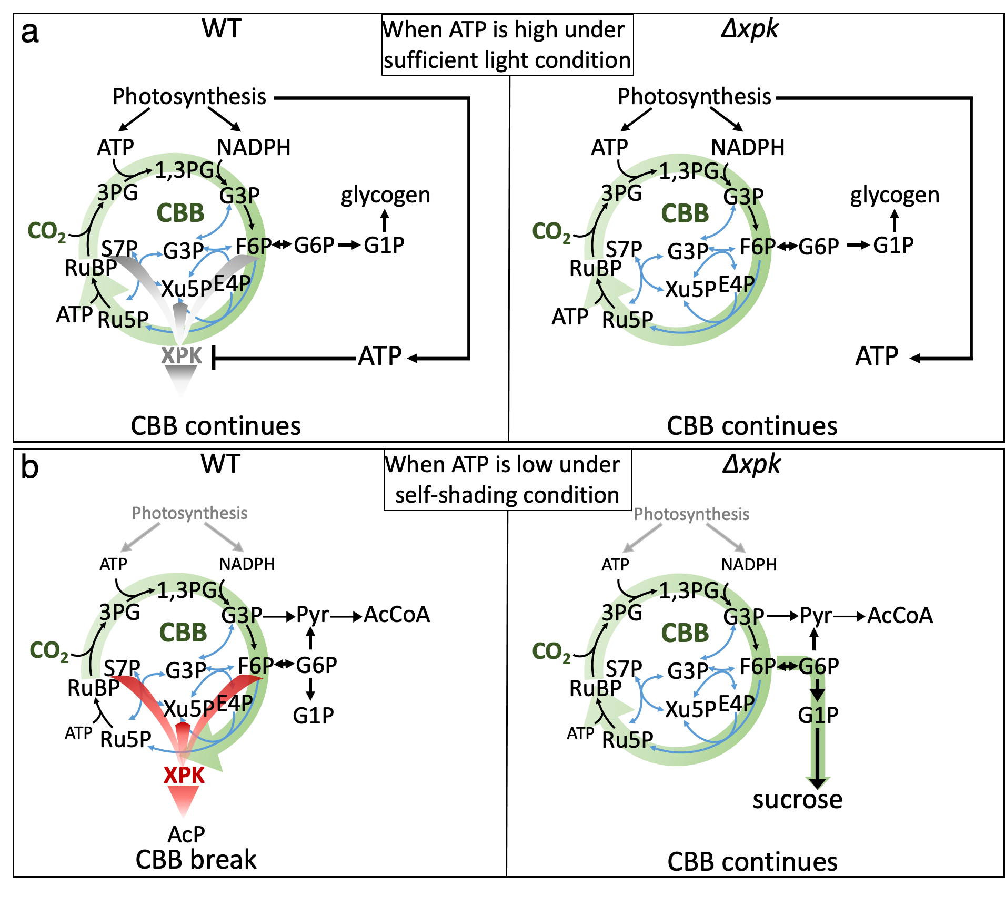

Extended Data Fig. 10. Scheme of WT and Δxpk under high ATP or low ATP condition. a. When light-driving ATP is sufficient, SeXPK is inhibited in WT and carbon fixation via CBB is continued. Deletion of SeXPK has no effect. The fixed carbons are stored as glycogen. b. When ATP level is low under self-shaded condition, XPK in WT metabolizes sugar phosphates to interrupt carbon fixation. In Δxpk, CO₂ is continuously incorporated via CBB to form hexose-phosphates, followed by sucrose synthesis and excretion.

Supplementary Tables
Supplementary Table 1. Data from steady-state kinetics^{b}
XFPK species  Substrate | Vmax (umol [XPK mg⁻¹] min⁻¹) | K_{m} (mM) | k_{cat} (s⁻¹)
S. elongatus7942 XPK
F6P | 10.8±0.1 | 19±1.5 | 18.2±0.1
pi | 7.7±0.2 | 4.2±0.6 | 12.8±0.3
B. longum XPK
F6P | 10.7±1.2 | 10.6±1.3 | 17.9±2.0
S. elongatus7942 XPK H706R
F6P | 3.9±0.08 | 61.3±1.6 | 3.2±0.1
S. elongatus7942 XPK H706A
F6P | >1ª | >80ª
S. elongatus7942 XPK Y710A
F6P | 0.2±0.0 | 18±1.2 | 0.2±0.0
ªBecause this mutant reduced the enzyme activity and dramatically increased the K_{m}, its Michaelis-Menten kinetic curve was difficult to reach the V_{max}.
^{b}Each value was calculated from three repeats of kinetic assays. n=3, mean ± SE.

Supplementary Table 2. Deletion of SeXPK shares the same photosynthesis and respiration rate as WT.
 | WT | Δxpk
photosynthesis  (O₂ evolution 𝜇mole Chla mg⁻¹ h⁻¹) | 262.4 ± 8.2 | 248.2 ± 8.9
respiration  (O₂ consumption 𝜇mole Chla mg⁻¹ h⁻¹) | 36.5 ± 1 | 35.7 ± 1.4

Supplementary Table 3. Cryo-EM data collection, refinement and validation statistics for the XPK structures

 | AMPPNP-bound SeXPK  (EMDB-32124)  (PDB 7VTU) | SeXPK  (EMDB-32123)  (PDB 7VTT) | B. longum XPK  (EMDB-32122)  (PDB 7VTS)
Data collection and processing
Magnification | 165,000 | 165,000 | 165,000
Voltage (kV) | 300 | 300 | 300
Electron exposure (e–/Å²) | 50 | 50 | 42
Defocus range (μm) | -0.5 ~-2.9 | -0.5 ~-2.9 | -0.5 ~-2.9
Pixel size (Å) | 0.82 | 0.82 | 0.83
Symmetry imposed | D6 (C1) | D6 (C1) | D4 (C1)
Initial particle images (no.) | 183,256 | 228,398 | 1,261,048
Final particle images (no.) | 59,127 | 42,652 | 590,627
Map resolution (Å)  FSC threshold | 2.36 (2.17)  0.143 | 2.86 (2.63)  0.143 | 2.68 (2.62)  0.143
Map resolution range (Å) | 2.30-7.0 (2.0-5.8) | 2.5-7.0(2.5-7.0) | 2.5-9.0(2.5-7.5)
Refinement
Initial model used (PDB code) | 3AI7 | 7VTU | 3AI7
Model resolution (Å)  FSC threshold | 2.36(2.17)  0.143 | 2.86(2.63)  0.143 | 2.68(2.62)  0.143
Model resolution range (Å) | 2.30-7.0 (2.0-5.8) | 2.5-7.0(2.5-7.0) | 2.5-9.0(2.5-7.5)
Map sharpening B factor (Å²) | -61.5(-49.0) | -88.6(-74.3) | -85.5(-83.4)
Model composition  Non-hydrogen atoms  Protein residues  Ligands | 75,744 (12,624)  9,456(1,576)  AMPPNP:12 (2)  TPP/Mg²⁺:12 (2) | 75,420(12,570)  9,456(1,576)  TPP/Mg²⁺:12 (2) | 51,504(12,876)  6,448(1,612)  TPP/Mg²⁺:12 (2)
B factors (Å²)  Protein  Ligand | 84.77(56.91)  80.84 (83.65) | 134.98(101.99)  174.58(132.99) | 37.57 (99.97)  26.32 (95.22)
R.m.s. deviations  Bond lengths (Å)  Bond angles (°) | 0.006 (0.006)  1.025(0.981) | 0.007 (0.009)  1.036(1.074) | 0.008(0.006)  1.116(0.978)
Validation  MolProbity score  Clashscore  Poor rotamers (%) | 1.92 (1.54)  14.74 (9.72)  0.15(0.15) | 2.09(1.82)  20.33 (13.49)  0.08 (0) | 1.82 (1.85)  8.22 (10.47)  0.2 (0)
Ramachandran plot  Favored (%)  Allowed (%)  Disallowed (%) | 96.34(97.96)  3.66(2.04)  0(0) | 95.87(96.18)  4.13(3.82)  0(0) | 96.49(96.83)  3.37(3.05)  0.14(0.12)
The statistics of the focus-refined dimer coordinates are shown in parentheses. The focus-refined map of the individual dimer is deposited together with the corresponding dodecamer or octamer map and coordinates under the same PDB and EMDB codes.

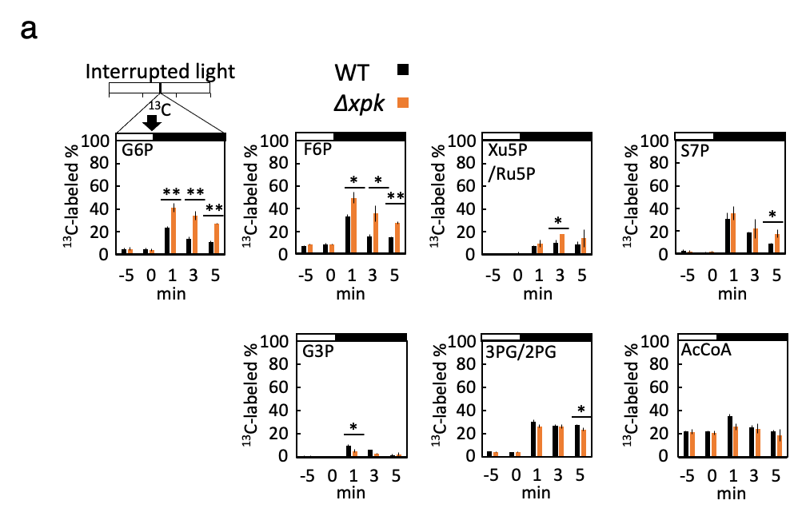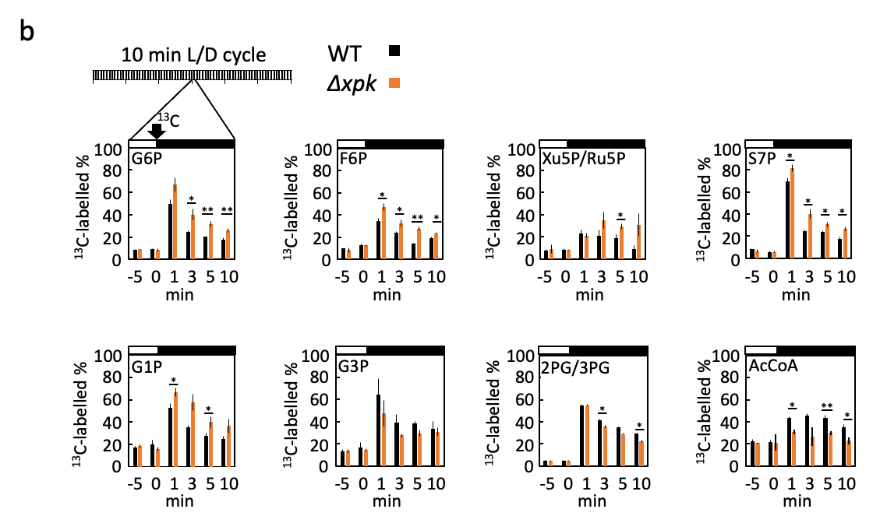
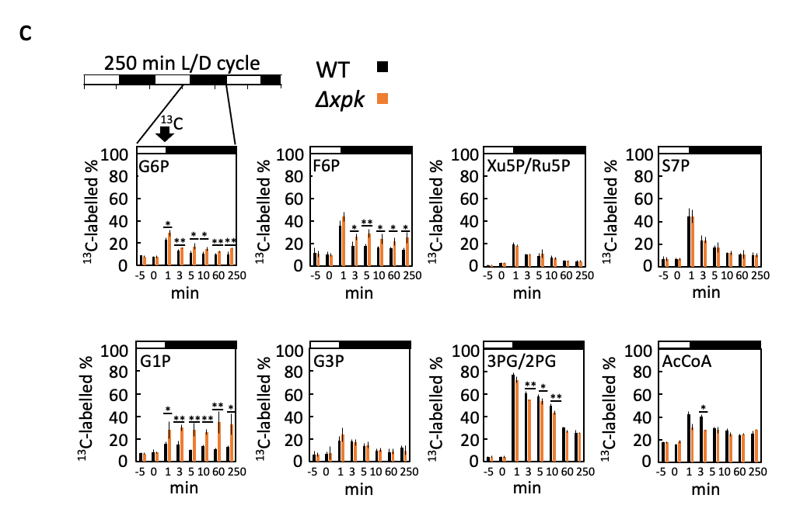
Supplementary Fig. 1. The % of ¹³C-labeled metabolite in WT and Δxpk after transition to darkness. The ¹³C-labeled % was analyzed as the % of ¹³C / ¹²C. The ¹³C-labeled and unlabelled ¹²C-metabolites were analyzed by MRM using LC-MSMS, as described in the Method. The sum of the peak area from the ¹³C-labeled metabolite (¹³C) was divided by the total peak area consisting of the area from the unlabeled ¹²C metabolite (¹²C) and the sum area from labelled ¹³C. n = 3, mean ± SE. Asterisk indicated significant difference between WT and Δxpk using one-way Anova. * indicated p-value <0.05 and ** indicated p-value <0.01. a. WT and Δxpk cultures were grown under 12h L/D cycle till OD₇₃₀ reached 1. Equal amount of NaH¹³CO₃ was added to WT and Δxpk in the middle of the light as 0 min (arrow), and the light was turned off (black bar). b. Cultures were grown under 10 min L/D cycle till OD₇₃₀ reached 1. NaH¹³CO₃ was added to the culture while the light is switching off as 0 min. c. Cultures were grown under 250 min L/D cycle till OD₇₃₀ reached 1. NaH¹³CO₃ was added to the culture as described in b.

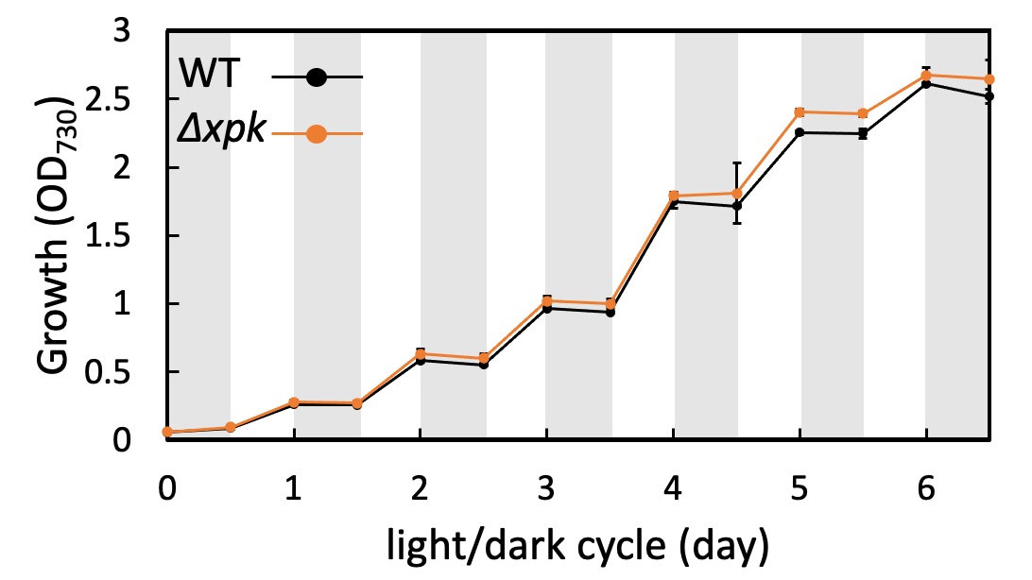

Supplementary Fig. 2. Growth and carbon incorporation of WT and Δxpk in 12h L/D cycle. Diurnal growth in a week from OD₇₃₀ of 0.1.

Supplementary Fig. 3. Structure-based alignment of the XPK proteins. Sequences are SeXPK (this study), L. lactis (XPK-Ll, ²⁷), B. breve (XPK-Bb ²⁶, and B. longum (XPK-Bl, this study). The sequence alignment was prepared with program Clustal Omega ³², and this final figure was produced with program ESPript 3.0 ²⁵ using default setting. Residue numbering is based on the SeXPK. The secondary structure elements (helices: ⍺-helices; arrow: β-strands) of SeXPK (PDB ID: 7VTU; EMDB ID: EMD-32124) and XPK-Bl (PDB ID: 7VTS; EMDB ID: EMD-32122) are illustrated above and under the sequence alignment, respectively. Sequences highlighted with red box and framed with blue lines indicate identical and conserved residues, correspondingly. The ⍺19 and ⍺24 helices of SeXPK, which include key residues involved in the allosteric mechanism, are specifically marked with black stars.

Supplementary Fig. 4. Flow chart of the cryo-EM structure determination process and resolution assessment of AMPPNP-bound SeXPK. a. The steps for structural determination. Representative cryo-EM raw micrographs and 2D class averages show particle quality and orientation. After initial model building and 3D classification, sub-classes with higher resolution were selected for further 3D refinement. CtfRefine and particle polish were performed to produce a 3D volume model, which was further processed with D6 symmetry to improve average resolution. Finally, symmetry expansion (C1) and focus refinement were performed on a masked dimer to achieve a better resolution map for a single dimer. b. The FSC curves with the gold standard algorithm (FSC= 0.143) of the unmasked D6 symmetry map (colored in red), masked D6 symmetry map (colored in blue), and the masked C1 symmetry map (colored in green) were calculated in cryoSPARC ¹⁵.

Supplementary Fig. 5. Flow chart of the cryo-EM structure determination process and resolution assessment of SeXPK without ATP. The procedure is the same as that of the bound form. a. The steps for structural determination. Representative cryo-EM raw micrographs and 2D class averages show particle quality and orientation. After initial model building and 3D classification, sub-classes with higher resolution were selected for further 3D refinement. CtfRefine and particle polish were performed to produce a 3D volume model, which was further processed with D6 symmetry to obtain improved average resolution. Finally, symmetry expansion (C1) and focus refinement were performed on a masked dimer to achieve a better resolution map for a single dimer. b. The FSC curves with the gold standard algorithm (FSC= 0.143) of the unmasked D6 symmetry map (colored in red), masked D6 symmetry map (colored in blue), and the masked C1 symmetry map (colored in green) were calculated in cryoSPARC.

Supplementary Fig. 6. Flow chart of the cryo-EM structure determination process and resolution assessment of B. longum XPK. a. A representative cryo-EM raw micrograph and representative 2D class averages are presented to show particle quality and orientation. The 3D volume reconstruction steps were performed as described. Application of D4 symmetry and focus refinement (C1) with symmetry expansion were performed to improve the 3D volume map of the octamer and the single dimer, respectively. b. The FSC curves with the gold standard algorithm (FSC= 0.143) of the unmasked D4 symmetry map (colored in red), masked D4 symmetry map (colored in blue), and the masked C1 symmetry map (colored in green) were calculated in cryoSPARC¹⁵.

Sequence alignment of phosphoketolases, with sequence identity ≥ 70% to SeXPK. The 8 major residues are marked with black stars.
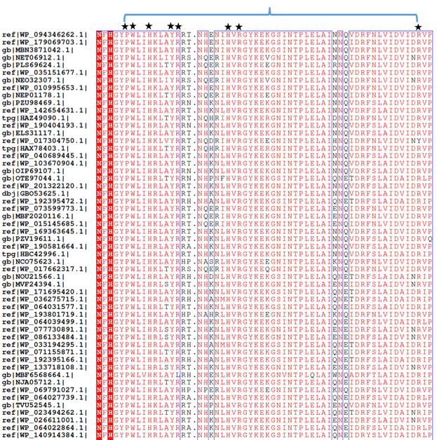

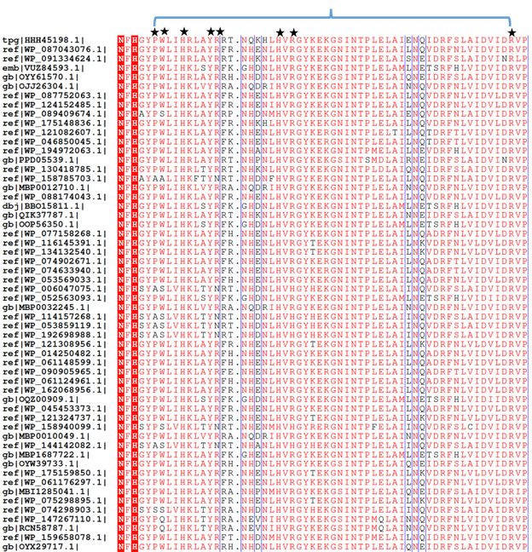

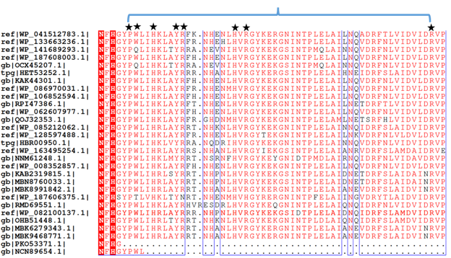

Supplementary Fig. 7. Multiple-sequence alignment of phosphoketolase sequences with identity ≥70%. The alignment only shows the region containing the ATP regulatory motif. Of the 289 sequences listed, 256 meet the criterion of 100% identity with the motif PWX₂H_{a}X₃Y’R’_{a}X₇H_{b}XR_{b}X₃₁R_{c}, where a,b,c designate histidine or arginine at different positions and the prime sign indicates residues from the reciprocal subunit.

Supplementary Fig. 8. The representative subsets of ATP-regulatory motif containing XPKs. These phylogenetic trees were manipulated using iTOL³¹. Details of these subsets and other categorized ones are documented in Supplementary File 2.

Legends for Supplementary Files (large excel files with thousands of items each)

Supplementary File 1. Protein Data Bank search. The file contains A-sheet: the PDB structures that match criterion (1), and B-sheet: the PDB structures that match both criteria. All listed structures are qualified without taking consideration of distinct protein chains. In the A-sheet: structures labelled in red match the criterion (1) but not (2). The structures listed in the B-sheet match both criteria in the requirement of specific atom distance (< 5 Å), but all have the histidine and tyrosine from the same protein chain. C-sheet: listed structures are qualified from the search data that not only embrace alternative aromatic residues, including F, W, Y, and H, but match both criteria. D-sheet: listed PDB ID ²³ and the count of the structures are included in the search pool.

Supplementary File 2. NCBI protein BLAST search. The 3190 phosphoketolase sequences containing the ATP regulatory motif are sorted into 14 categories based on species and specific properties, including cyanobacteria, photo(auto)troph, methanotroph, sulfur-oxidizing bacteria, nitrogen-fixation bacteria, thermophilic bacteria, iron-oxidizing bacteria, human pathogen, planctomycetes, actinobacteria, fungi, archeae, proteobacteria and others. The accession code (with NCBI weblink) and relevant information of the 3190 phosphoketolase sequences are listed in the file. Fifteen fungi sequences have a Lys replaced with an Arg right after the Tyr in the motif, equivalent to the C. neo grubii–H99 phosphoketolase, which was inhibited by ATP ³⁰. Therefore, these sequences are intentionally included here.

Supplementary References

1. Suzuki, R., et al. Overexpression, crystallization and preliminary X-ray analysis of xylulose-5-phosphate/fructose-6-phosphate phosphoketolase from Bifidobacterium breve. Acta Crystallogr Sect F Struct Biol Cryst Commun 66, 941-943 (2010).
2. Bogorad, I.W., Lin, T.S. & Liao, J.C. Synthetic non-oxidative glycolysis enables complete carbon conservation. Nature 502, 693-697 (2013).
3. Chuang, D.S. & Liao, J.C. Role of cyanobacterial phosphoketolase in energy regulation and glucose secretion under dark anaerobic and osmotic stress conditions. Metab Eng 65, 255-262 (2021).
4. Li, X., Shen, C.R. & Liao, J.C. Isobutanol production as an alternative metabolic sink to rescue the growth deficiency of the glycogen mutant of Synechococcus elongatus PCC 7942. Photosynth Res 120, 301-310 (2014).
5. Rust, M.J., Golden, S.S. & O'Shea, E.K. Light-driven changes in energy metabolism directly entrain the cyanobacterial circadian oscillator. Science 331, 220-223 (2011).
6. Huang, J.Y., et al. Mutations of Cytochrome b559 and PsbJ on and near the QC Site in Photosystem II Influence the Regulation of Short-Term Light Response and Photosynthetic Growth of the Cyanobacterium Synechocystis sp. PCC 6803. Biochemistry 55, 2214-2226 (2016).
7. Dempo, Y., Ohta, E., Nakayama, Y., Bamba, T. & Fukusaki, E. Molar-based targeted metabolic profiling of cyanobacterial strains with potential for biological production. Metabolites 4, 499-516 (2014).
8. Lunn, J.E., et al. Sugar-induced increases in trehalose 6-phosphate are correlated with redox activation of ADPglucose pyrophosphorylase and higher rates of starch synthesis in Arabidopsis thaliana. Biochem J 397, 139-148 (2006).
9. Campos, C.G., et al. New Protocol Based on UHPLC-MS/MS for Quantitation of Metabolites in Xylose-Fermenting Yeasts. J Am Soc Mass Spectrom 28, 2646-2657 (2017).
10. Paquette, A.J., Vadlamani, A., Demirkaya, C., Strous, M. & De la Hoz Siegler, H. Nutrient management and medium reuse for cultivation of a cyanobacterial consortium at high pH and alkalinity. Front Bioeng Biotechnol 10, 942771 (2022).
11. Zheng, S.Q., et al. MotionCor2: anisotropic correction of beam-induced motion for improved cryo-electron microscopy. Nat Methods 14, 331-332 (2017).
12. Zhang, K. Gctf: Real-time CTF determination and correction. J Struct Biol 193, 1-12 (2016).
13. Grant, T., Rohou, A. & Grigorieff, N. cisTEM, user-friendly software for single-particle image processing. Elife 7(2018).
14. Zivanov, J., et al. New tools for automated high-resolution cryo-EM structure determination in RELION-3. Elife 7(2018).
15. Punjani, A., Rubinstein, J.L., Fleet, D.J. & Brubaker, M.A. cryoSPARC: algorithms for rapid unsupervised cryo-EM structure determination. Nat Methods 14, 290-296 (2017).
16. Pettersen, E.F., et al. UCSF Chimera--a visualization system for exploratory research and analysis. J Comput Chem 25, 1605-1612 (2004).
17. Waterhouse, A., et al. SWISS-MODEL: homology modelling of protein structures and complexes. Nucleic Acids Res 46, W296-W303 (2018).
18. Takahashi, K., et al. Crystal structure of Bifidobacterium Longum phosphoketolase; key enzyme for glucose metabolism in Bifidobacterium. FEBS Lett 584, 3855-3861 (2010).
19. Afonine, P.V., et al. Real-space refinement in PHENIX for cryo-EM and crystallography. Acta Crystallogr D Struct Biol 74, 531-544 (2018).
20. Emsley, P. & Cowtan, K. Coot: model-building tools for molecular graphics. Acta Crystallogr D Biol Crystallogr 60, 2126-2132 (2004).
21. Wang, R.Y., et al. Automated structure refinement of macromolecular assemblies from cryo-EM maps using Rosetta. Elife 5(2016).
22. Chen, V.B., et al. MolProbity: all-atom structure validation for macromolecular crystallography. Acta Crystallogr D Biol Crystallogr 66, 12-21 (2010).
23. Berman, H.M., et al. The Protein Data Bank. Nucleic Acids Res 28, 235-242 (2000).
24. Johnson, M., et al. NCBI BLAST: a better web interface. Nucleic Acids Res 36, W5-9 (2008).
25. Robert, X. & Gouet, P. Deciphering key features in protein structures with the new ENDscript server. Nucleic Acids Res 42, W320-324 (2014).
26. Suzuki, R., et al. Crystal structures of phosphoketolase: thiamine diphosphate-dependent dehydration mechanism. J Biol Chem 285, 34279-34287 (2010).
27. Scheidig, A.J., Horvath, D. & Szedlacsek, S.E. Crystal structure of a xylulose 5-phosphate phosphoketolase. Insights into the substrate specificity for xylulose 5-phosphate. J Struct Biol 207, 85-102 (2019).
28. Alcorlo, M., Straume, D., Lutkenhaus, J., Havarstein, L.S. & Hermoso, J.A. Structural Characterization of the Essential Cell Division Protein FtsE and Its Interaction with FtsX in Streptococcus pneumoniae. mBio 11(2020).
29. Liu, J., et al. Crystal structures of an NAD kinase from Archaeoglobus fulgidus in complex with ATP, NAD, or NADP. J Mol Biol 354, 289-303 (2005).
30. Glenn, K., Ingram-Smith, C. & Smith, K.S. Biochemical and kinetic characterization of xylulose 5-phosphate/fructose 6-phosphate phosphoketolase 2 (Xfp2) from Cryptococcus neoformans. Eukaryot Cell 13, 657-663 (2014).
31. Letunic, I. & Bork, P. Interactive Tree Of Life (iTOL) v5: an online tool for phylogenetic tree display and annotation. Nucleic Acids Res 49, W293-W296 (2021).
32. Sievers, F., et al. Fast, scalable generation of high-quality protein multiple sequence alignments using Clustal Omega. Mol Syst Biol 7, 539 (2011).

