Supplementary Information for
Assessing the impact of MSR on market stability and green-investment incentives of EU-ETS
Libo Wu^{1,2,3,4, *}, Yanran Gong², Chujun Wang⁵, Weiqi Tang^{4,6*}
1. School of Economics, Fudan University, Shanghai, 200433, China
2. School of Data Science, Fudan University, Shanghai, 200433, China
3. Institute for Big Data, Fudan University, Shanghai, 200433, China
4. Shanghai Institute for Energy and Carbon Neutrality Strategy, Fudan University, Shanghai, 200433, China
5. Department of Environmental Science and Engineering, Fudan University, Shanghai, 200433, China
6. Fudan Development Institute, Fudan University, Shanghai, 200433, China

*Corresponding author: Libo Wu (wulibo@fudan.edu.cn)Weiqi Tang (tangwq@fudan.edu.cn)

Supplementary Method: Background
MSR was discussed as an option for resolving EUA’s price issue by European Commission as early as 2012, and the first formal proposal for the scheme came out in January 2014. A preceding allowance quantity control measure called backloading was first implemented, but such one-off post-hoc adjustment does not satisfy regulation need in the long term. Thus, a scheme that is pre-defined and that automatically balances the supply of allowances in cases of allowance structural surplus is constructed. In October 2015, the European Commission announced the decision on the implementation of MSR, along with its basic rules. Then in March 2018, less than one year before the kickoff of the scheme, some major revisions to the rules of MSR were introduced as part of the arrangements for Phase Ⅳ. The revision included the doubling of the reserve rate of excess TNAC during 2019 -2023, and a cancellation mechanism starting in 2023. The yearly TNAC started to be published every May since 2017, and the consequent decision on the reserve began to be published since May 2018. MSR was officially implemented in EU ETS in January 2019. During 2018 – 2022, the five publications of TNAC all exceeded the upper bound of 833 million, and together around 1722 million allowances have been placed in MSR during the time. In July 2021, in line with the “Fit for 55” package, MSR extended the implementation of 24% reserve rate to 2030.
Supplementary Table 1. Timeline of MSR
Date | Event | Content
JAN 2014 | MSR proposal
OCT 6 2015 | Formal decision on MSR | - Implementing since January 1 2019  - 900 million allowances from Backloading to be placed in MSR  - If TNAC exceeds 833 million, 12% will be placed in MSR  - If TNAC falls under 400 million, 1 million allowances will be released from MSR, until it is empty
MAR 19 2018 | 1st revision | - During 2019-2023, the reserve rate for TNAC is 24%  - After 2023, the number of allowances in MSR that exceeds the total amount of last year’s EUA auction will be canceled
MAY 15 2018 | 1st publication of number of allowances to be placed in MSR | - 265 million allowances to be reserved during JAN to AUG 2019
JAN 1 2019 | Implementation day
MAY 15 2019 | 2nd publication of number of allowances to be placed in MSR | - 397 million allowances to be reserved during SEP 2019 to AUG 2020
MAY 8 2020 | 3rd publication of number of allowances to be placed in MSR | - 333 million allowances to be reserved during SEP 2020 to AUG 2021
MAY 12 2021 | 4th publication of number of allowances to be placed in MSR | - 379 million allowances to be reserved during SEP 2021 to AUG 2022
JUL 14 2021 | 2nd revision | - During 2019-2030, the reserve rate for TNAC is 24%
MAY 13 2022 | 5th publication of number of allowances to be placed in MSR | - 348 million allowances to be reserved during SEP 2021 to AUG 2022
Since the first introduction of MSR, the European Union also passed a number of other policies, in the form of regulations, directives, decisions, recommendations, and communications, to deal with climate-related issues. The content and time of the publishment of those policies need to be identified, as they are potential confounding variables to our study subject. Based on three policy datasets (i.e., LSE’s CCLW Database, IEA’s Policies Database, The Climate Policy Database), we sorted out the major climate-related policies of the EU during 2015-2021 (Supplementary Table 2).
Supplementary Table 2. The summary of climate-related policies
Category |  | Document | Institution | Date
Framework | Climate target | INDC | European Commission | 6-Mar-15
Framework | Climate target | NDC | Council of the European Union | 17-Dec-20
Framework | General governance | Regulation on the Governance of the Energy Union and Climate Action | European Parliament and the Council | 11-Dec-18
Framework | Policy initiatives | European Green Deal | European Commission | 11-Dec-19
Framework | Long-term strategy | Long-Term Low Greenhouse Gas Emissions Development Strategy | European Commission | 1-Mar-20
Framework | Law | European Climate Law | European Parliament and the Council | 30-Jun-21
Framework | Adopted proposals | 'Fit for 55'- delivering the EU's 2030 climate target on the way to climate neutrality | European Commission | 14-Jul-21
EU ETS |  | Establishing market stability reserve | European Parliament and the Council | 6-Oct-15
EU ETS |  | Post-2020 EU-ETS Reform | European Parliament and the Council | 27-Feb-18
Sectoral policy | Energy | A European Strategy for Low-Emission Mobility | European Commission | 20-Jul-16
Sectoral policy | Energy | Clean Energy for All Europeans Package | European Commission | 30-Nov-16
Sectoral policy | Energy | Reducing national emissions of certain atmospheric pollutants | European Parliament and the Council | 14-Dec-16
Sectoral policy | Energy | Energy labelling | European Parliament and the Council | 4-Jul-17
Sectoral policy | Energy | Enhancing cost-effective emission reductions and low-carbon investments | European Parliament and the Council | 14-Mar-18
Sectoral policy | Energy | Energy Efficiency | European Parliament and the Council | 11-Dec-18
Sectoral policy | Energy | Promoting the use of energy from renewable sources | European Parliament and the Council | 11-Dec-18
Sectoral policy | Energy | Rules for Internal Market for Electricity | European Parliament and the Council | 5-Jun-19
Sectoral policy | Energy | Hydrogen Strategy | European Commission | 8-Jul-20
Sectoral policy | Energy | Energy System Integration Strategy | European Commission | 8-Jul-20
Sectoral policy | Energy | EU Renewable Energy Financing Mechanism | European Commission | 15-Sep-20
Sectoral policy | Energy | Strategy on Offshore Renewable Energy | European Commission | 19-Nov-20
Sectoral policy | Industry | A New Industrial Strategy for Europe | European Commission | 10-Mar-20
Sectoral policy | Transport | Setting CO2 Emission Performance Standards for New Passenger Cars and for New Light Commercial Vehicles (Vans) | European Parliament and the Council | 17-Apr-19
Sectoral policy | Transport | Reducing CO2 Emissions from Heavy-duty Vehicles | European Parliament and the Council | 20-Jun-19
Sectoral policy | Transport | Sustainable and Smart Mobility Strategy | European Commission | 9-Dec-20
Sectoral policy | Transport | European Partnership for Clean Aviation |  | 23-Feb-21
Sectoral policy | Building | Guidelines for the Promotion of Nearly Zero-energy Buildings | European Commission | 29-Jul-16
Sectoral policy | Building | EU Heating and Cooling Strategy | European Parliament | 13-Sep-16
Sectoral policy | Building | Revised Energy Performance of Buildings Directive (EPBD) | European Parliament and the Council | 26-Apr-18
Sectoral policy | Building | Renovation Wave | European Commission | 14-Oct-20
Sectoral policy | Circular economy | Circular Economy Action Plan | European Commission | 11-Mar-20
Sectoral policy | Agriculture | Farm to Fork Strategy | European Commission | 20-May-20
Sectoral policy | LULUCF | Inclusion of LULUCF in the 2030 climate and energy framework | European Parliament and the Council | 30-May-18
Finance | Finance Plan | Action Plan: Financing Sustainable Growth | European Commission | 8-Mar-18
Finance | Finance Plan | Sustainable Europe Investment Plan | European Commission | 14-Jan-20
Finance | Finance Plan | Temporary Framework for State aid measures | European Commission | 19-Mar-20
Finance | Public funding | Innovation Fund | European Commission | 26-Feb-19
Finance | Public funding | Modernisation Fund | European Commission | 9-Jul-20
Finance | Public funding | 2021-2027 long-term EU budget & NextGenerationEU | European Parliament and the Council | 17-Dec-20
Finance | Public funding | Recovery and Resilience Facility | European Parliament and the Council | 12-Feb-21
Finance | Public funding | InvestEU Fund | European Parliament and the Council | 24-Mar-21
Finance | Public funding | Programme for the Environment and Climate Action (LIFE) | European Parliament and the Council | 29-Apr-21
Finance | Public funding | Just Transition Fund | European Parliament and the Council | 24-Jun-21
Finance | Financial disclosure requirement | Sustainability‐related disclosures in the financial services sector | European Parliament and the Council | 27-Nov-19
Finance | Finance Taxonomy | Sustainable Finance EU Taxonomy | European Parliament and the Council | 22-Jun-20

Supplementary Method: Variables construction
Supplementary Table 3. Variables List
Variable | Specification | Unit
Dependent variable
EUA futures price | settlement prices of year-ahead EUA December futures price in ICE | Euro/ton
Control variables:
Oil price | ICE Futures Europe month-ahead futures contract of Brent crude oil | Euro/BBL
Coal price | ICE futures contract settled based upon the price of coal delivered into the Amsterdam, Rotterdam region in the Netherlands, and Antwerp region in Belgium (priced against Argus/McCloskey's API2 index) | Euro/ton
Gas price | Physical Forward Prices for natural gas delivered to Virtual Trading Point Netherlands Title Transfer Facility (TTF) | Euro/Therm
Electricity price | Epex Spot Germany Day-Ahead Auction (prices for 4 different hours, namely 00-01, 07-08, 12-13, 18-19, were chosen for better coverage) | Euro/MWh
Weather | WSI/ CW Weather Regional Average Country Germany | /

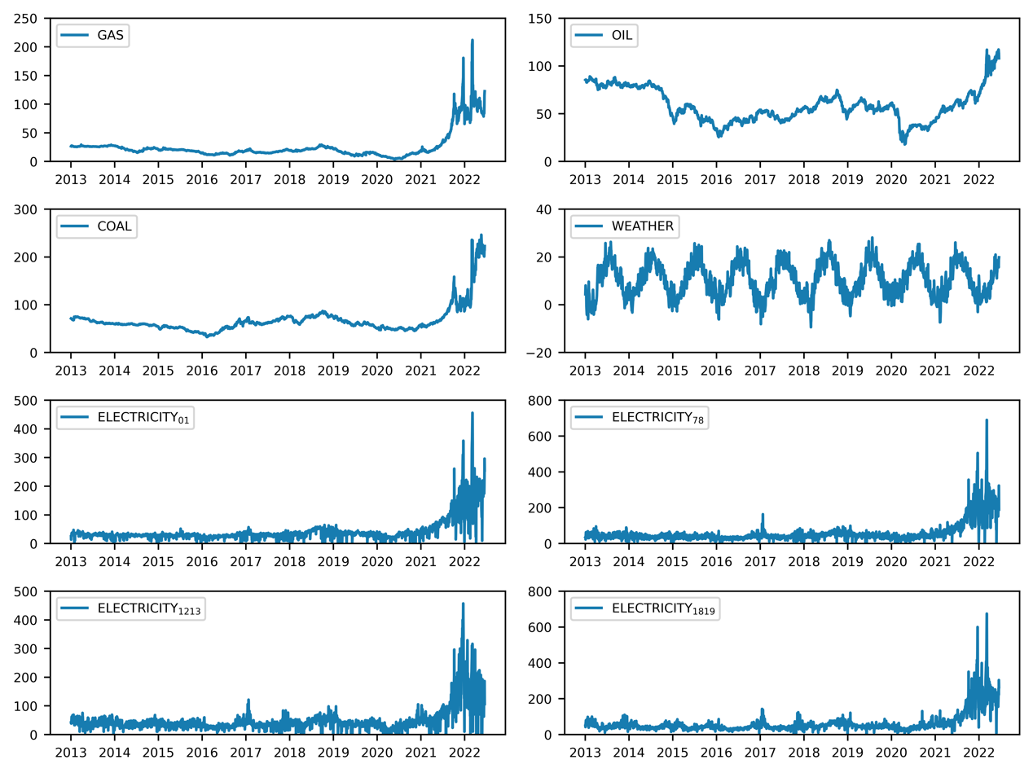
Supplementary Fig. 1 Time series of control variables
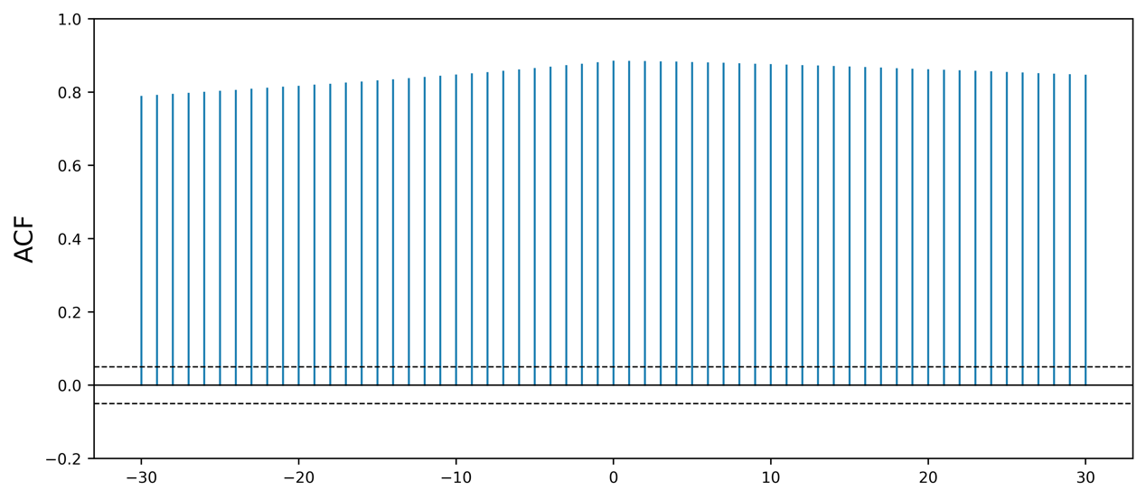
Supplementary Fig.2 Correlation between green-stock index and EUA price

Supplementary Method: Descriptive statistics
Supplementary Table 4. Descriptive statistics: EU-ETS Phase III & Phase IV
EU-ETS Phase III
VARIABLES | N | Mean | Sd | Min | Max | Skewness | Kurtosis
EUA | 1,887 | 10.74 | 7.950 | 2.720 | 33.29 | 1.135 | 2.694
GAS | 1,887 | 19.16 | 4.866 | 9.150 | 29.35 | 0.134 | 2.027
OIL | 1,887 | 58.17 | 15.16 | 25.52 | 89.03 | 0.298 | 2.040
COAL | 1,887 | 60.26 | 10.58 | 32.43 | 86.84 | -0.169 | 2.849
WEATHER | 1,887 | 10.33 | 7.090 | -9.400 | 28.14 | 0.0212 | 2.209
$$ELECTRICITY_{01}$$ | 1,887 | 30.27 | 9.809 | -19.98 | 64.75 | -0.333 | 5.361
$$ELECTRICITY_{78}$$ | 1,887 | 43.81 | 14.76 | -60 | 163.5 | 0.282 | 7.368
$$ELECTRICITY_{1213}$$ | 1,887 | 38.15 | 13.84 | -75.90 | 121.6 | 0.363 | 7.557
$$ELECTRICITY_{1819}$$ | 1,887 | 47.23 | 15.66 | -59.94 | 143.1 | 1.065 | 7.452
Oil/Coal | 1,887 | 0.971 | 0.213 | 0.577 | 1.458 | 0.476 | 2.092
Gas/Coal | 1,887 | 0.321 | 0.0707 | 0.159 | 0.483 | 0.119 | 2.011
EU-ETS Phase IV
VARIABLES | N | Mean | Sd | Min | Max | Skewness | Kurtosis
EUA | 377 | 62.91 | 17.61 | 31.54 | 96.48 | 0.0483 | 1.798
GAS | 377 | 63.35 | 38.58 | 15.58 | 212 | 0.612 | 3.320
OIL | 377 | 71.29 | 19.13 | 41.70 | 117.2 | 0.859 | 2.620
COAL | 377 | 109.1 | 54.06 | 52.88 | 246.5 | 1.074 | 2.919
WEATHER | 377 | 9.631 | 6.628 | -7.360 | 26.07 | 0.0801 | 2.194
$$ELECTRICITY_{01}$$ | 377 | 114.0 | 74.14 | 2.020 | 456.0 | 1.293 | 5.003
$$ELECTRICITY_{78}$$ | 377 | 154.9 | 98.73 | -0.0900 | 690 | 1.282 | 5.703
$$ELECTRICITY_{1213}$$ | 377 | 118.9 | 82.18 | -50.73 | 457.3 | 1.032 | 4.037
$$ELECTRICITY_{1819}$$ | 377 | 159.6 | 101.6 | 6.980 | 674.9 | 1.279 | 5.504
Oil/Coal | 377 | 0.721 | 0.157 | 0.431 | 1.015 | -0.160 | 1.848
Gas/Coal | 377 | 0.559 | 0.229 | 0.272 | 1.599 | 1.085 | 4.166

Supplementary Table 5. Descriptive statistics: EU-ETS Phase III & pre-annunciation of MSR
VARIABLES | N | Mean | Sd | Min | Max | Skewness | Kurtosis
EUA | 555 | 5.396 | 1.177 | 2.720 | 8.680 | 0.362 | 2.907
GAS | 555 | 23.65 | 3.520 | 15.35 | 29.35 | -0.614 | 2.083
OIL | 555 | 75.74 | 11.53 | 39.53 | 89.03 | -1.927 | 5.645
COAL | 555 | 61.47 | 6.639 | 41.60 | 75.36 | -0.142 | 3.828
WEATHER | 555 | 9.826 | 6.920 | -6.040 | 26.30 | -0.0575 | 2.173
$$ELECTRICITY_{01}$$ | 555 | 28.87 | 6.952 | -0.100 | 47.43 | -1.488 | 6.449
$$ELECTRICITY_{78}$$ | 555 | 44.10 | 14.18 | -16.59 | 95.43 | -0.241 | 3.799
$$ELECTRICITY_{1213}$$ | 555 | 39.40 | 12.36 | -0.980 | 75.50 | 0.239 | 2.922
$$ELECTRICITY_{1819}$$ | 555 | 49.06 | 15.58 | 11.01 | 110.2 | 1.017 | 4.381
Oil/Coal | 555 | 1.230 | 0.140 | 0.790 | 1.458 | -1.158 | 3.843
Gas/Coal | 555 | 0.385 | 0.0468 | 0.268 | 0.483 | -0.482 | 2.704

Supplementary Table 6. Descriptive statistics: EU-ETS Phase III & post-annunciation of MSR
VARIABLES | N | Mean | Sd | Min | Max | Skewness | Kurtosis
EUA | 1,332 | 12.96 | 8.493 | 3.930 | 33.29 | 0.634 | 1.766
GAS | 1,332 | 17.29 | 4.060 | 9.150 | 29.33 | 0.372 | 2.620
OIL | 1,332 | 50.86 | 9.389 | 25.52 | 74.94 | -0.179 | 2.564
COAL | 1,332 | 59.75 | 11.81 | 32.43 | 86.84 | -0.0743 | 2.417
WEATHER | 1,332 | 10.54 | 7.152 | -9.400 | 28.14 | 0.0454 | 2.204
$$ELECTRICITY_{01}$$ | 1,332 | 30.86 | 10.73 | -19.98 | 64.75 | -0.287 | 4.779
$$ELECTRICITY_{78}$$ | 1,332 | 43.68 | 15.00 | -60 | 163.5 | 0.469 | 8.551
$$ELECTRICITY_{1213}$$ | 1,332 | 37.63 | 14.39 | -75.90 | 121.6 | 0.424 | 8.531
$$ELECTRICITY_{1819}$$ | 1,332 | 46.47 | 15.64 | -59.94 | 143.1 | 1.098 | 8.802
Oil/Coal | 1,332 | 0.862 | 0.127 | 0.577 | 1.247 | 0.351 | 2.618
Gas/Coal | 1,332 | 0.294 | 0.0607 | 0.159 | 0.438 | 0.480 | 2.626

Supplementary Table 7. Descriptive statistics: EU-ETS Phase III & pre-publication of MSR
VARIABLES | N | Mean | Sd | Min | Max | Skewness | Kurtosis
EUA | 1,547 | 7.537 | 4.350 | 2.720 | 25.19 | 2.103 | 6.764
GAS | 1,547 | 20.21 | 4.563 | 10.77 | 29.35 | -0.00110 | 2.049
OIL | 1,547 | 59.14 | 16.13 | 25.52 | 89.03 | 0.208 | 1.755
COAL | 1,547 | 60.49 | 11.17 | 32.43 | 86.84 | -0.223 | 2.718
WEATHER | 1,547 | 10.42 | 7.185 | -9.400 | 26.99 | -0.0546 | 2.170
$$ELECTRICITY_{01}$$ | 1,547 | 29.73 | 9.702 | -19.98 | 64.75 | -0.144 | 5.492
$$ELECTRICITY_{78}$$ | 1,547 | 43.47 | 14.99 | -16.59 | 163.5 | 0.580 | 6.469
$$ELECTRICITY_{1213}$$ | 1,547 | 37.89 | 13.87 | -16.70 | 121.6 | 0.772 | 5.319
$$ELECTRICITY_{1819}$$ | 1,547 | 47.00 | 16.19 | 0.0700 | 143.1 | 1.263 | 6.222
Oil/Coal | 1,547 | 0.983 | 0.225 | 0.577 | 1.458 | 0.378 | 1.853
Gas/Coal | 1,547 | 0.338 | 0.0643 | 0.217 | 0.483 | 0.0897 | 1.752

Supplementary Table 8. Descriptive statistics: EU-ETS Phase III & post-publication of MSR
VARIABLES | N | Mean | Sd | Min | Max | Skewness | Kurtosis
EUA | 340 | 25.30 | 2.440 | 18.71 | 33.29 | 0.375 | 4.049
GAS | 340 | 14.39 | 2.987 | 9.150 | 22.90 | 0.722 | 3.387
OIL | 340 | 53.80 | 8.280 | 32.17 | 66.82 | -1.166 | 3.400
COAL | 340 | 59.22 | 7.256 | 45.24 | 76.62 | 0.202 | 2.493
WEATHER | 340 | 9.901 | 6.637 | -4.740 | 28.14 | 0.427 | 2.519
$$ELECTRICITY_{01}$$ | 340 | 32.75 | 9.925 | -1.720 | 64.63 | -1.224 | 6.235
$$ELECTRICITY_{78}$$ | 340 | 45.33 | 13.62 | -60 | 99.07 | -1.456 | 14.28
$$ELECTRICITY_{1213}$$ | 340 | 39.36 | 13.64 | -75.90 | 98.33 | -1.583 | 19.43
$$ELECTRICITY_{1819}$$ | 340 | 48.29 | 12.95 | -59.94 | 121.5 | -0.637 | 20.36
Oil/Coal | 340 | 0.912 | 0.131 | 0.647 | 1.247 | 0.124 | 2.534
Gas/Coal | 340 | 0.243 | 0.0411 | 0.159 | 0.339 | -0.0581 | 2.035

Supplementary Method: Driving factors of EUA price
We test and verify the relationship between the response variable and control variables by setting up the following two model specifications:
$EUA_{t}=β_{0}+β_{1}Electricity_{t}+β_{2}Oil_{t}+β_{3}Gas_{t}+β_{4}Coal_{t}+β_{5}Weather_{t}+ε_{t}$ (1)
$EUA_{t}=β_{0}+β_{1}Electricity_{t}+β_{2}{\left(\frac{Oil}{Coal}\right)}_{t}+β_{3}{\left(\frac{Gas}{Coal}\right)}_{t}+β_{4}Coal_{t}+β_{5}Weather_{t}+ε_{t}$ (2)
The two equations only differ with term $Oil_{t}$ and $Gas_{t}$. One uses the real price, the other uses the relative price ${\left(\frac{Oil}{Coal}\right)}_{t}$and ${\left(\frac{Gas}{Coal}\right)}_{t}$to avoid multicollinearity. We conduct an empirical analysis using data of Phase III. First, the Breusch-Godfrey sequence correlation test was performed for the two equations, and the F-test values are 1720.532 and 1720.493 respectively. The corresponding P-values are 0.0000 and 0.0000. The test results confirm that there is a sequence correlation. Next, the ARCH-LM test was conducted, for which the F-test values were 1218.472 and 1192.584 respectively, and the P-values are 0. 0000 and 0. 0000. Through the test, GARCH (1,1) will be used here as the variance equation (Model 1 and Model 2). Similarly, the Phase IV data are also empirically analyzed with the above methods and we report the results: the F-test values obtained by the Breusch-Godfrey sequence correlation test were 286.501 and 317.978 respectively; the corresponding P-values are 0.0000 and 0.0000. Through the test, there is a sequence correlation. The F-test values obtained from ARCH-LM test results are 156.004 and 211.042 respectively. The P-values are 0. 0000 and 0. 0000. Similarly, GARCH (1,1) will be used here as the variance equation (Model 3 and Model 4).
The OLS estimation regression results of the two stages are shown in Supplementary Table 9. The results show that the two equations have very high explanatory ability, and that the selection of control variables is reasonable, which lays a solid foundation for further studies in this paper.
Supplementary Table 9. Estimation results of Model 1-Model 4
OLS Estimation
VARIABLES | Phase III |  | Phase IV
VARIABLES | Model 1 | Model 2 | Model 3 | Model 4
GAS | -1.019*** |  | 0.273***
 | (0.0477) |  | (0.0299)
Oil | 0.0311** |  | 0.794***
 | (0.0145) |  | (0.0691)
Coal | 0.232*** | -0.0737*** | -0.112*** | 0.379***
 | (0.0189) | (0.0166) | (0.0254) | (0.0216)
Weather | -0.0196 | -0.0202 | 0.171** | 0.217***
 | (0.0236) | (0.0236) | (0.0751) | (0.0734)
$$ELECTRICITY_{01}$$ | 0.208*** | 0.207*** | -0.0240 | -0.0123
 | (0.0213) | (0.0213) | (0.0155) | (0.0152)
$$ELECTRICITY_{78}$$ | -0.0206 | -0.0196 | -0.0600*** | -0.0469***
 | (0.0190) | (0.0190) | (0.0171) | (0.0165)
$$ELECTRICITY_{1213}$$ | -0.0308 | -0.0326 | 0.111*** | 0.0659***
 | (0.0208) | (0.0208) | (0.0135) | (0.0134)
$$ELECTRICITY_{1819}$$ | 0.109*** | 0.109*** | -0.0421*** | -0.0349***
 | (0.0175) | (0.0175) | (0.0139) | (0.0129)
Oil/Coal |  | 0.898 |  | 48.56***
 |  | (0.861) |  | (6.777)
Gas/Coal |  | -58.64*** |  | 50.21***
 |  | (2.712) |  | (3.063)
Observations | 1,887 | 1,887 | 377 | 377
R-squared | 0.334 | 0.334 | 0.769 | 0.782
Variance Equation
L.arch | 0.625*** | 0.586*** | 0.445*** | 0.708***
 | (0.0706) | (0.0712) | (0.0918) | (0.154)
L.garch | 0.361*** | 0.401*** | 0.553*** | 0.338***
 | (0.0459) | (0.0510) | (0.0529) | (0.0927)
Constant | 1.334*** | 1.244*** | 2.043** | 1.972***
 | (0.153) | (0.193) | (0.922) | (0.694)

Supplementary Method: The choice of cutoff point
To analyze the price change of EUA in response to the outbreak of Covid-19, we use the government stringency data from Oxford University’s Covid-19 Government Response Tracker (OxCGRT) to choose the cutoff point of Covid-19 in our model. OxCGRT contains information on various lockdown measures, such as school and workplace closings, travel restrictions, bans on public gatherings, and stay-at-home requirements¹. It also provides a unique index that combines the indicators above. In our model, we choose the date on which the stringency index of top carbon emitting countries of EU ETS become positive as the cutoff point for Covid-19². For this purpose, we used CO₂ emission of year 2019 for each member state of EU-28 as a foundation to determine each country’s level of involvement in EU ETS. By January 24, 2020, the cumulative CO₂ emissions of lockdown countries account for 64% of the total emissions (Supplementary Table 10). Hence, we will take 2020-01-24 as the cutoff point.
Supplementary Table 10. EU28 lockdown date and carbon emission
Country | Lockdown date | 2019 CO₂ emission (Mt) | Cumulative emission ratio of lockdown countries
United Kingdom | 2020-01-20 | 115.857 | 7.72%
France | 2020-01-22 | 94.304 | 14.00%
Italy | 2020-01-23 | 140.943 | 23.39%
Poland | 2020-01-23 | 183.691 | 35.63%
Czech Republic | 2020-01-24 | 62.519 | 39.79%
Germany | 2020-01-24 | 363.315 | 64.00%
Malta | 2020-01-25 | 0.739 | 64.04%
Portugal | 2020-01-26 | 21.603 | 65.48%
Croatia | 2020-01-27 | 7.515 | 65.98%
Romania | 2020-01-27 | 36.546 | 68.42%
Slovakia | 2020-01-27 | 19.904 | 69.74%
Finland | 2020-01-27 | 23.242 | 71.29%
Belgium | 2020-01-28 | 44.627 | 74.27%
Spain | 2020-01-31 | 109.523 | 81.56%
Latvia | 2020-01-31 | 2.493 | 81.73%
Sweden | 2020-02-01 | 18.771 | 82.98%
Bulgaria | 2020-02-03 | 29.194 | 84.92%
Ireland | 2020-02-04 | 14.179 | 85.87%
Austria | 2020-02-24 | 29.562 | 87.84%
Greece | 2020-02-25 | 40.476 | 90.53%
Lithuania | 2020-02-26 | 6.067 | 90.94%
Denmark | 2020-02-27 | 12.041 | 91.74%
Netherlands | 2020-02-27 | 83.744 | 97.32%
Hungary | 2020-02-28 | 19.531 | 98.62%
Slovenia | 2020-03-04 | 6.254 | 99.04%
Cyprus | 2020-03-05 | 4.472 | 99.34%
Luxembourg | 2020-03-05 | 1.496 | 99.43%
Estonia | 2020-03-12 | 8.486 | 100.00%

Supplementary Method: Robustness check
We check the robustness of the model in three aspects, namely the duration of MSR, the choice of cutoff points and alternative control variables.
Firstly, we replace the beginning time and ending time of the benchmark model. The results of Scenario A and Scenario B show significant positive causal effects (Supplementary Table 11). Modifying the ending time has little influence on the relative effect, showing a raise from 23% to 25%. And modifying the beginning time changes the relative effect sharply, from 23% to 14%. In general, time duration checks confirm the robustness of our main results.
Supplementary Table 11. Causal impact of different time duration model
Model | Period | Obs. value | Pred. value | Abs. effect | 95% CI | Rel. effect | Post. Prob
Benchmark | 2013-01-01 to 2020-12-31 | 24 | 20 | 4.5 | [2.2, 6.8] | 23% | 99.98%
Scenario A | 2013-01-01 to 2020-08-31 | 25 | 20 | 5 | [2.4, 7.7] | 25% | 99.98%
Scenario B | 2020-01-25 to 2020-12-31 | 26 | 23 | 3.2 | [2.1, 4.4] | 14% | 99.98%

Secondly, cutoff points are important factors for the BSTS model. In our model, we use one cutoff point for Covid-19 and one for MSR announcement. We first test alternative cutoff points for Covid-19. From the results in Supplementary Table 12, choosing either 2020-01-23 or 2020-01-22 as the cutoff point, the causal impact stays in a negative direction at 95% significance. We also used the same date in 2019 as the cutoff point for the test and found that there was no significant effect. Combined with the above conclusions, we believe that Covid-19 did bring significant negative causal effects to EUA prices.
Supplementary Table 12. Causal impact of different cutoff point of Covid-19
Model | Cutoff Point | Obs. value | Pred. value | Abs. effect | 95% CI | Rel. effect | Post. Prob. | Causal impact
Benchmark | 2020-01-24 | 22 | 24 | -2.7 | [-4.7, -0.64] | -11% | 99.54% | Y
Scenario C | 2019-01-24 | 22 | 23 | -0.64 | [-2.4, 1.1] | -2.8% | 77.00% | N
Scenario D | 2020-01-23 | 22 | 24 | -2.6 | [-4.6, 0.64] | -11% | 99.45% | Y
Scenario E | 2019-01-23 | 22 | 23 | -0.6 | [-2.3, 1.1] | -2.6% | 76.00% | N
Scenario F | 2020-01-22 | 22 | 24 | -2.5 | [-4.5, -0.46] | -10% | 99.26% | Y
Scenario G | 2019-01-22 | 22 | 23 | -0.23 | [-1.9, 1.5] | -1% | 61.00% | N
Then, we test alternative cutoff points for MSR. We choose the date of publication of TNAC in each year as the cutoff point to identify the causal effects (Supplementary Table 13). In Scenario C, the TNAC publication had a significantly positive effect on EUA price in the short term. But the relative effect is only 6.2%, which is less than the effect in 2020 (23%). It had no significant effect on EUA price in the long term in 2019. In Scenario D, the effect is not statistically significant in both the short-term and long-term. However, the result here could be influenced by the choice of the period, as it includes both Phase III and Phase IV. A longer time window could capture a more profound effect as the market participants slowly adapt to the new phase.
Supplementary Table 13. Causal impact of different cutoff points of MSR
Model | Cutoff Point | Period | Obs. value | Pred. value | Abs. effect | 95% CI | Rel. effect | Post. Prob.
Benchmark | 2020-05-08 | Short-term | 24 | 20 | 4.5 | [2.2, 6.8] | 23% | 99.98%
Benchmark | 2020-05-08 | Long-term | 26 | 21 | 5.6 | [2, 9.1] | 27% | 99.85%
Scenario A | 2019-05-14 | Short-term | 27 | 25 | 1.6 | [-0.38, 3.5] | 6.2% | 95%
Scenario A | 2019-05-14 | Long-term | 25 | 25 | 0.39 | [-4.4, 5.1] | 1.6% | 56%
Scenario B | 2021-05-12 | Short-term | 53 | 53 | 0.25 | [-2.5, 3] | 0.46% | 57%
Scenario B | 2021-05-12 | Long-term | 70 | 65 | 4.6 | [-1.7, 11] | 7% | 92%
Notes: short-term means 60 days; long-term means till the next cutoff point

Thirdly, we add futures position data of different institutions as the control variables to identify the causal effects. The Commitment of Traders Report of EUA begins from Jan, 2018. Five types of position holders are included, namely Investment Firms or Cred, Investment Funds, Other Financial Institutions, Commercial Undertakings, and Directive Compliance Obligations. Supplementary Table 14 shows the detailed results, which are consistent with the benchmark results.
Supplementary Table 14. Causal impact of alternative control variables
Market event | Variable | Period | Obs. value | Pred. value | Abs. effect | 95% CI | Rel. effect | Post. Prob.
Covid-19 | EUA price | Short-term | 22 | 24 | -2.3 | [-5.4, 0.9] | -9.6% | 92%
Covid-19 | EUA price | Long-term | 21 | 24 | -2.5 | [-5.9, 1] | -10% | 92%
MSR | EUA price | Short-term | 24 | 20 | 4.4 | [0.72, 8.1] | 22% | 98%
MSR | EUA price | Long-term | 26 | 22 | 4.6 | [-1.3, 11] | 21% | 94%
Notes: short-term means 60 days; long-term means till the next cutoff point

Supplementary Discussion: Quebec-California Carbon Market
Supplementary Table 15. Causal impact of Quebec-California Carbon Market
Market event | Variable | Period | Obs. value | Pred. value | Abs. effect | 95% CI | Rel. effect | Post. Probability:  Non-zero causal impact
Covid-19 | Price Index | Short-term | 106 | 117 | -12 | [-14, -10] | -10% | 99%
Covid-19 | Price Index | Long-term | 106 | 120 | -14 | [-17, -12] | -12% | 99%
Auction | Price Index | Short-term | 113 | 116 | -3.1 | [-7.6, 5.1] | -2.7% | 90%
Auction | Price Index | Long-term | 113 | 112 | 1.3 | [-4.1, 6.7] | 1.1% | 68%
Notes: short-term means 60 days; long-term means till the next cutoff point

Supplementary Table 16. Explained variable and control variables
Explained Variable | Specification | Unit
CAA price index | ICE CCA Carbon Futures Index (Excess Return) | /
Control Variable
Price floor | CA annual auction reserve price published by California Air Resources Board | USD
Oil price | US Crude Oil WTI Cushing OK Spot price | USD/barrel
Gas price | Henry Hub futures contract price | USD/MMBtu
Electricity price | On-Peak Day Ahead Electricity Spot Price/Mid-Columbia | USD/MWh
CA temperature | Mean temperature from Los Angeles California US Actual Weather Data; source: Weather Services International | Fahrenheit
QC temperature | Mean temperature from Montreal-Dorval Quebec Canada Actual Weather Data; source: Weather Services International | Celsius

SI References:
1. Hale, T. et al. A global panel database of pandemic policies (Oxford COVID-19 Government Response Tracker). Nat Hum Behav 5, 529–538 (2021).
2. Dang, H.-A. H. & Trinh, T.-A. Does the COVID-19 lockdown improve global air quality? New cross-national evidence on its unintended consequences. Journal of Environmental Economics and Management 105, 102401 (2021).

