Supplementary Information
Impact of molecular symmetry on Ostwald's step rule
Yong Chan Cho¹, Soohyeong Lee^{1,2}, Lei Wang¹, Yun-Hee Lee¹, Seongheun Kim³, Hyun Hwi Lee³, Jonghyun Lee⁴, Geun Woo Lee^{1,2*}
¹ Division of Industrial Metrology, Korea Research Institute of Standards and Science, Daejeon 34113, Republic of Korea
² Applied Measurement Science, University of Science and Technology, Daejeon, Daejeon 34113, Republic of Korea
³Pohang Accelerator Laboratory, POSTECH, Pohang 37673, Republic of Korea
⁴Department of Mechanical Engineering, Iowa State University, Ames, IA 50011, United States of America
*e-mail: gwlee@kriss.re.kr

Table of contents :

Supplementary Section-1: In situ X-ray scattering experiments on highly supersaturated solution
Solution sample preparation
x-ray scattering experiment and data acquisition:
Levitation of solution droplets
concentration Monitoring of droplets
Caption for Supplementary Movie 1 : rapid crystallization of ADP solution
Supplementary Section-2: The cluster-based reverse Monte-Carlo calculation for H₂PO₄⁻ dimer
Calculation of Δs(q) from experimentally obtained s(q)
Coordination of (H₂PO₄⁻)₂ dimeric unit block model
Calculation of s_{cal} for cluster modeling of H₂PO₄⁻
Section-1: In situ X-ray scattering experiments on highly supersaturated solution

Solution sample preparation: In this containerless environment, the levitated solutions are extremely supersaturated up to S=4.1 and S=3.6 for KDP and ADP solutions, respectively. In order to avoid the unwanted crystallization before experiment, the initial concentration of solutions are fixed to S= 0.72 and S=0.75 for ADP and KDP solution, respectively. Aqueous solutions are prepared by dissolving KDP of purity 99.99% (Aldrich INC) and ADP of purity 99.9% (Aldrich INC) in deionized water (ρ = 18.2 MΩ-cm). For homogeneous mixture, the initial solution is stirred for 6 hours and kept 6 hours at room temperature and filtered with a pore size of 220nm (BIOFIL). The filtered solution was finally delivered to the solution injection needle equipped at bottom electrode.

x-ray scattering experiment and data acquisition: The ESL components is installed at Pohang Light Source II (PLS II) (Fig. S1), which is used to measure the x-ray scattering pattern in stable and metastable states. In situ x-ray scattering experiment is performed at the undulator insertion device beamline at Pohang Light Source II (BL5A and 1C) ^{S1-S3}. Monochromatized 18-KeV X-rays from a cryogenically cooled silicon (111) double crystal monochromator is delivered to the sample chamber through a delivery-pipe filed with helium gas. The x-ray detector (Pilatus-300KW, 1475 x 195 pixels with a pixel size of 172 um x 172 um) is just placed behind the ESL chamber to collect the scattered signals from solution droplet. Only when the supersaturation of droplet reaches at the targeted value, x-ray scattering x-ray beam is irradiated on droplet and scattering 2D image is recorded on Pilatus 300KW. The conversion of the 2D image to 1D data were carried out by using Fit2D and Dioptas programs. Subsequently, the s(q) and G(r) were obtained by using Pdfgetx2 program.

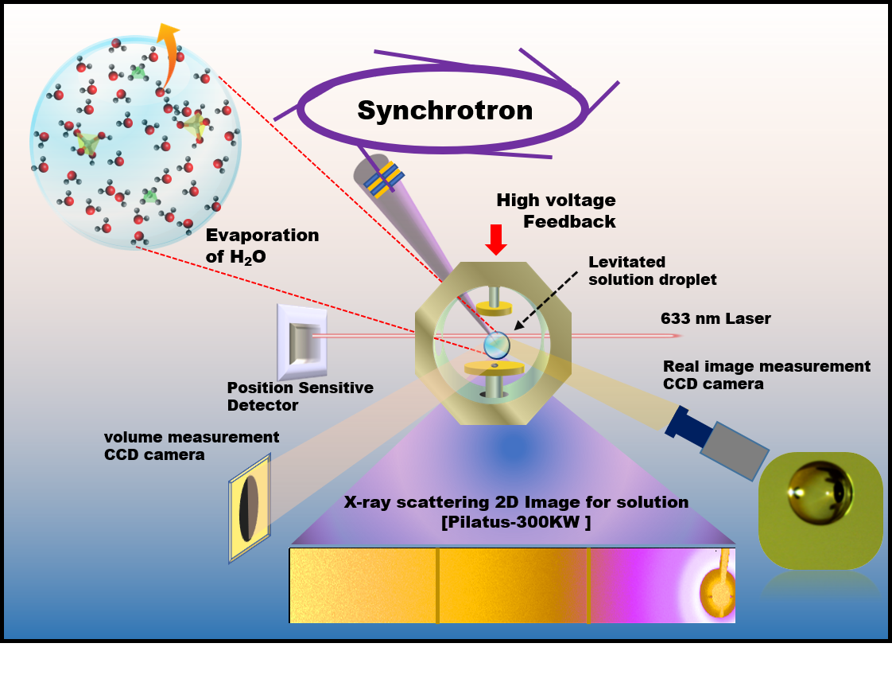
Figure S1: The schematic diagram on ESL system for aqueous solution droplet
Levitation of solution droplets: The droplet is levitated at the position between top and bottom electrodes. A high voltage amplifier (Trek 10/10B-HS) provide a high electric voltage (1~5kV, 300-500 Hz) to the top electrode. The He-Ne laser (1mW λ=633 nm) incidents on droplet with casting the shadow of droplet on a position sensitive detector (PSD, Hamamatsu Photonics C10443-03) to maintain the droplet position within ~±20 um. Temperature and relative humidity inside the sample chamber are maintained at 25.5 ºC and 42 ± 2%, respectively.
Concentration monitoring of droplets: Initial size of the levitated solution droplet has a diameter between 2 ~ 3 mm, and its size and shape are monitored by two CCD camera. The droplet shape is recorded every 5 sec through the size measurement CCD camera. The 6th order Legendre polynomial fitting is applied on the recorded droplet images^{S4} to calculate the volume in real-time. We also monitor whether any crystallization event occurs or not through the other CCD camera observing the droplet inside and outside in different direction.

Since the solute molecule (KDP or ADP) is non-volatile, the decrease of solution volume is assumed to be attributed to the decrease of water molecules in droplet. Table S1 and S2 show the summary of concentration, density, average number of H₂O per each solute ion (n), and the number ratio of water to solution atoms (water and solute atoms, except hydrogen atoms) (α) for X-ray intensity in the KDP and ADP solutions, respectively. The initial concentration of solutions was fixed to S= 0.72 and S=0.75 for ADP and KDP solution, respectively. The density of initial solution is measures before experiment. The α is obtained by calculating the number ratio of water molecules to total atoms. For example, each solute ion has 21 water molecules (at S=1) in average. Therefore, the ratio α per solute molecules is given by 0.87 (= 42/(6+42), where 6 comes from the number of atoms in solute molecules (i.e., P+4O+K(or N) =6). Here, hydrogen atoms are omitted because of its negligible scattering by X-ray.

Table S1: Summary of concentration (c (KDP mass (g) / H₂O volume(cm³)) and M(molarity)), solution density, the number of water molecules per solute ion (n), the number ratio of water molecules to total solution atoms (α) for the KDP solution droplet. The solubility limit of the KDP solution (S=1) is 25g/100ml.
- volume contraction  - Ratio | - Concentration |  |  | - solution density | - The number of H₂O per ion (n) | - The number ratio of water to solution atoms for calculation of X-ray scattering (except hydrogen atoms)  - (α)
- V(t)/V(t=0) | - Initial concentration  - m(KDP)/V(Water)  - [g/cm³] | - molarity  - M  - [mol/L] | - Supersaturation | - [g/cm³] | - The number of H₂O per ion (n)
- 1 | - 0.18 | 1.240 | 0.72 | 1.11 | 21.0 | 0.87
- 0.60 | - 0.18 | 2.066 | 1.2 | 1.18 | 12.1 | 0.80
- 0.48 | - 0.18 | 2.583 | 1.5 | 1.22 | 9.4 | 0.76
- 0.36 | - 0.18 | 3.444 | 2 | 1.30 | 6.7 | 0.69
- 0.29 | - 0.18 | 4.305 | 2.5 | 1.38 | 5.1 | 0.63
- 0.23 | - 0.18 | 5.510 | 3.2 | 1.48 | 3.7 | 0.55
- 0.22 | - 0.18 | 5.682 | 3.3 | 1.50 | 3.5 | 0.54
- 0.21 | - 0.18 | 6.027 | 3.5 | 1.53 | 3.3 | 0.52
- 0.18 | - 0.18 | 7.060 | 4.1 | 1.62 | 2.6 | 0.46

Table S2: Summary of concentration (c(ADP mass (g) / H₂O volume(cm³)))and M(molarity)), density, n and α values for the ADP solution droplet. The solubility limit of the ADP solution (S=1) is 40g/100ml.
- volume contraction  - Ratio | - Concentration |  |  | - solution density | - The number of H₂O per ion (n) | - The number ratio of water to solution atoms for calculation of X-ray scattering (except hydrogen atoms)  - (α)
- V(t)/V(t=0) | - Initial concentration  - m(KDP)/V(Water)  - [g/cm³] | - molarity  - M  - [mol/L] | - Supersaturation | - [g/cm³] | - The number of H₂O per ion (n)
- 1 | - 0.30 | - 2.271 | - 0.75 | - 1.13 | - 10.7 | - 0.78
- 0.63 | - 0.30 | - 3.634 | - 1.2 | - 1.21 | - 6.1 | - 0.67
- 0.42 | - 0.30 | - 5.451 | - 1.8 | - 1.32 | - 3.6 | - 0.54
- 0.34 | - 0.30 | - 6.662 | - 2.2 | - 1.39 | - 2.6 | - 0.47
- 0.31 | - 0.30 | - 7.268 | - 2.4 | - 1.43 | - 2.3 | - 0.43
- 0.29 | - 0.30 | - 7.873 | - 2.6 | - 1.47 | - 2.0 | - 0.40
- 0.27 | - 0.30 | - 8.479 | - 2.8 | - 1.50 | - 1.7 | - 0.36
- 0.25 | - 0.30 | - 9.084 | - 3.0 | - 1.54 | - 1.5 | - 0.33
- 0.23 | - 0.30 | - 9.690 | - 3.2 | - 1.57 | - 1.3 | - 0.30
- 0.22 | - 0.30 | - 10.296 | - 3.4 | - 1.61 | - 1.2 | - 0.28
- 0.21 | - 0.30 | - 10.901 | - 3.6 | - 1.65 | - 1.0 | - 0.25

Caption for Supplementary Movie 1 : Rapid crystallization of ADP solution. The video shows the rapid crystallization of the highly supersaturated ADP solution of S= ~3.5, which is corresponding to n (number of H2O per ion) ~ 1.1.

Section-2: The cluster-based reverse Monte-Carlo calculation for H2PO4- dimer
Calculation of Δs(q) from experimentally obtained s(q): Coherent scattering from the supersaturated KDP and ADP solution is mostly contributed by the H₂PO₄⁻ molecules since they are likely the most well-ordered structures in the solution. We expect relatively strong coherent scattering from the H₂PO₄⁻ molecules, especially in a higher supersaturated solution. It is also assumed that the cations (K⁺ or NH₄⁺) are randomly distributed in the solution^{S5- S8}. Therefore, the change of the ΔI(q) for solutes can be obtained from experimentally obtained I(q) by Eq. S1

$∆I\left(q\right)={I(q)}_{solution}-α×{I(q)}_{water}$ (Eq. S1)

Here, the α indicates scattering ratio from water molecules in the solution (see also Supplementary Section-1). Using the ΔI(q), Δs(q) and ΔG(r) were obtained by using Pdfgetx2 program.

Coordination of (H₂PO₄⁻)₂ dimeric unit block model: Atomic positions for P and O_{p} are given in spherical coordinates (Fig. S2). For the monomer, the atomic coordinates of a PO₄ tetrahedron are set by spherical coordinates (Fig. S2a). The dimer was composed by two monomers. One monomer place at origin and the translated another monomer with a distance (Figure S2b). Rotation operation is performed to every monomer at origin and translated to P₂ position.
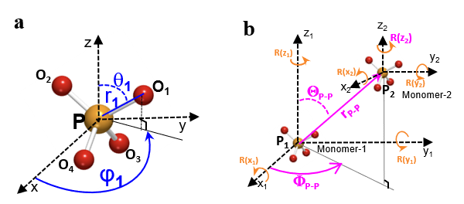
Figure S2: a. Spherical coordinates for a H₂PO₄ monomer (H atom is omitted); A phosphorus atom (orange sphere) is placed at origin and the coordination of 4 oxygen atoms (red sphere) are presented by using cylindrical coordinates (r, θ, φ) (blue color). b Spherical coordinates for dimer composed of two monomers: the position of P₂ is translated from origin to (r_{P-P} , Θ_{P-P} , Φ_{P-P}) (magenta). The rotation (R(x), R(y), R(z)) (orange) operation is applied to both two H₂PO₄⁻ monomers.

Calculation of s_{cal} for cluster modeling of H₂PO₄⁻ : The s_{cal}(q) for the H₂PO₄⁻ molecule model is calculated using Eq. S2 ^{S9-S11},

$s_{cal}\left(q\right)= \left(\frac{1}{\sum_{j=1}^{N}{f_{j}^{2}}} \sum_{j=1}^{N}{\sum_{k=1}^{N}{f_{j}f_{k}\frac{sin⁡(qr_{jk})}{qr_{jk}}}}-1\right)×e^{-2DWF×q^{2}}+1$ (Eq. S2)

where N is the number of particles, q is wave vector, DWF is Debye Waller factor f_{j}, f_{k} are atomic form factors, r_{jk} is atomic distance between j^{th} and k^{th} atoms. Atomic positions for P, O_{p}, are given in spherical coordinates Previously, this method was successfully applied to explain SRO in liquid metals^{S5-S7}. In this modeling, the hydrogen atoms are omitted
Here, s_{cal}(q) is calculated to fit the experimentally obtained Δs(q) within the q ranges (3.5 Å⁻¹~ 8.5 Å⁻¹) by optimizing the geometry of monomer and dimer. The deviation between s_{cal} and Δs(q) is minimized by using non-linear least-squares minimization and curve-fitting routine provided in Python program language (Lmfit package).

$χ^{2}=\sum_{i}^{N}{{(S_{cal}\left(q_{i}\right)-ΔS(q_{i}))}^{2}}$ (Eq. S3)

Within the constraint condition for its symmetry, the geometry parameters of two monomers and Debye-Weller factors was optimized up to minimize χ², which is given Eq. S3.

Table S3 and S4 show the summary of calculated results for KDP and ADP solution, respectively. In the dilute KDP and ADP solutions, the H₂PO₄⁻ anion has the C_{2v} molecular symmetry which is used to set the initial constraint conditions with r, θ and φ (see Fig. S2). In this calculation, we fix φ values of those of a right tetrahedron. The constraint for the P-O distance is given by the FWHM of the g1 peak of Fig. 2. The calculated s_{cal}(q) is fitted to experimental structure factor of solute (Δs(q)) between q=3.5Å⁻¹ and 8.5 Å⁻¹ where corresponds to short ranges of the solute. The constrain condition corresponding its symmetry is provided by changing P-O distances or/with O-P-O angles. The initial symmetry for PO₄ is C_{2v} (type-1 presented at Fig. 3b in main text). The initial dimer model is composed of same geometry monomers (SM) with C_{2v} symmetry (SM-C_{2v}). C_{s} symmetry has only one mirror symmetry (σ_{v}) by breaking 2- fold symmetry. The breakage of the σ_{v} symmetry results in C₁. Depending on the symmetry of monomer (C_{2v}, C_{s}, C₁) and geometry condition (same monomer (SM) of different monomer (DM)), the suitable constraint conditions are used. The models are sequentially tested for SM-C_{s} (the dimer with SM with C_{s} symmetry), DM-C_{s} (the dimer composed of DM with C_{s} symmetry) and finally DM-C₁ (the dimer with DM with C₁ symmetry). In this calculation, we accepted the model having the least deviation (χ² < 0.05). After calculation, the result of unphysical dimer geometry (e.g., too close O-O and P-O distance) was excluded out. Here, hydrogen atoms are omitted in calculation.

Table S3: Summary of the calculated results for the optimized (H₂PO₄⁻)₂ dimeric unit block in KDP solution: The light-yellow color presents the dimer composed of same monomer with C_{2v} symmetry (SM-C_{2v}). The dark-yellow color presents the dimer composed of same monomer with C_{s} symmetry (SM-C_{s}). The blue color depicts the dimer composed of different monomer with C₁ symmetry (SM-C₁). Comparison between the optimized results is presented by the dark gray color.
KDP  S  (n) | Symmetry of  Monomers | Dimer geometry |  |  |  | DWF | χ²
KDP  S  (n) | Symmetry of  Monomers | P-O_{P}  [Å] | θ  [º] | P-P  [Å] | Ave.  O_{P}-O_{P}  [Å] | DWF | χ²
0.72  (21.0) | SM-C_{2v} | r₁ = r₂ = 1.30  r₃ = r₄=1.70 | θ₁= θ₂ = 51.75  θ₃= θ₄ = 125.6 | 3.80 | 2.46 | 0.0169 | 0.0463
1.2  (12.1) | SM- C_{2v} | r₁ = r₂ = 1.30  r₃ = r₄ = 1.70 | θ₁= θ₂=52.14  θ₃= θ₄= 125.28 | 3.84 | 2.45 | 0.0172 | 0.0208
1.5  (9.4) | SM-C_{s} | r₁ = r₂ = 1.30  r₃ = r₄=1.70 | θ₁=θ₂=60.26  θ₃=132.40  θ₄=121.23 | 3.63 | 2.45 | 0.0169 | 0.0374
2.0  (6.7) | SM-C_{s} | r₁ = r₂ = 1.30  r₃ = r₄= 1.70 | θ₁= θ₂=57.9  θ₃=123.74  θ₄=133.25 | 3.63 | 2.45 | 0.0182 | 0.0069
2.5  (5.1) | SM-C_{s} | r₁ = r₂ = 1.30  r₃ = r₄= 1.70 | θ₁= θ₂=53.94  θ₃=124.15  θ₄=133.25 | 3.64 | 2.45 | 0.0179 | 0.0058
3.2  (3.7) | SM-C_{s} | r₁ = r₂ = 1.50  r₃ = 1.30  r₄ = 1.70 | θ₁= θ₂=51.75  θ₃=127.88  θ₄=129.68 | 3.71 | 2.45 | 0.0201 | 0.0800
3.2  (3.7) | DM-Cs | r₁ = r₂ = 1.70  r₃= r₄=1.30 | θ₁= θ₂=51.75  θ₃=133.25  θ₄=124.42 | 3.70 | 2.47 | 0.0108 | 0.0369
3.2  (3.7) | DM-Cs | r₁ = r₂ = 1.53  r₃= 1.30  r₄=1.70 | θ₁= θ₂=51.75  θ₃=128.25  θ₄= 130.47
3.3  (3.5) | SM-C_{s} | r₁ = r₂ = 1.45  r₃ = 1.30  r₄=1.70 | th₁= th₂=51.75  th₃=123.99  th₄=132.85 | 3.71 | 2.41 | 0.0203 | 0.0953
3.3  (3.5) | DM-C_{s} | r₁ = r₂ = 1.30  r₃= 1.70  r₄=1.30 | θ₁= θ₁=51.75  θ₁=133.25  θ₁= 122.56 | 3.71 | 2.44 | 0.0160 | 0.0368
3.3  (3.5) | DM-C_{s} | r₁ = r₂ = 1.70  r₃ = 1.30  r₄ =1.62 | θ₁ = θ₂=51.75  θ₃ =131.65  θ₄ = 126.61
3.3  (3.5) | SM-C₁ | r₁ = r₂ = 1.70  r₃ = 1.31  r₄ =1.70 | θ₁= th₂=51.75  θ₃=133.24  θ₄= 124.01 | 3.70 | 2.46 | 0.0154 | 0.0642
3.3  (3.5) | DM-C₁ | r₁ ₌ r₂ ₌ 1.30  r₃= 1.70  r₄=1.30 | θ₁=51.75  θ₂=53.85  θ₃=133.25  θ₄=123.62 | 3.71 | 2.44 | 0.0156 | 0.0367
3.3  (3.5) | DM-C₁ | r₁ ₌ 1.70  r₂ ₌ 1.70  r₃= 1.63  r₄=1.30 | θ₁=51.75  θ₂=51.85  θ₃=130.4  θ₄=127.56
3.5  (3.3) | SM-C_{s} | Could not fitted, the result give only Non-physical situation
3.5  (3.3) | DM-C_{s} | r₁ = r₂ = 1.36  r₃ = r₄ = 1.30 | θ₁= θ₂ = 53.75  θ₃=133.25  θ₄=127.29 | 3.70 | 2.40 | 0.017 | 0.0525
3.5  (3.3) | DM-C_{s} | r₁ = r₂ = 1.69  r₃= 1.67  r₄=1.38 | θ₁= θ₂=51.75  θ₃=130.08  θ₄= 129.52
3.5  (3.3) | SM-C₁ | r₁ = 1.30  r₂ = 1.70  r₃ =1.31  r₄ = 1.70 | θ₁=51.76,  θ₂=53.29  θ₃=133.25  θ₄=127.37 | 3.70 | 2.46 | 0.0154 | 0.0518
3.5  (3.3) | DM-C₁ | r₁ ₌ 1.30  r₂ ₌ 1.31  r₃₌ 1.70  r₄ ₌ 1.71 | θ₁=51.75  θ₂=56.49  θ₃=133.25  θ₄=127.36 | 3.70 | 2.45 | 0.0155 | 0.0213
3.5  (3.3) | DM-C₁ | r₁ ₌ 1.30  r₂ ₌ 1.70  r₃ ₌ 1.30  r₄ ₌ 1.70 | θ₁=51.75  θ₂=51.75  θ₃=129.11  θ₄=130.53
4.1  (2.6) | DM-C₁ | r₁ ₌ 1.30  r₂ ₌ 1.32  r₃= 1.68  r₄=1.70 | θ₁=51.75  θ₂=51.75  θ₃=133.25  θ₄=123.87 | 4.2 | 2.47 | 0.0163 | 0.0306
4.1  (2.6) | DM-C₁ | r₁ ₌ 1.30  r₂ ₌ 1.43  r₃ ₌ 1.69  r₄ ₌ 1.68 | θ₁=51.75  θ₂=51.75  θ₃=133.25  θ₄=132.99

Table S4: Summary of the calculated results for the optimized (H₂PO₄⁻)₂ dimeric unit block in ADP solution: The light-yellow color presents the dimer composed of same monomer with C_{2v} symmetry (SM-C_{2v}).

ADP  S  (n) | Symmetry of  Monomers | Dimer geometry |  |  |  | DWF | χ²
ADP  S  (n) | Symmetry of  Monomers | P-O_{P} [Å] | θ [º] | P-P  [Å] | Ave.  O_{P}-O_{P}  [Å] | DWF | χ²
0.75 (10.7) | SM-C_{2v} | r₁ = r₂ =1.30  r₃ = r₄ = 1.70 | θ₁ = θ₂ =51.75  th₃ = th₄ = 130.37 | 3.68 | 2.45 | 0.0077 | 0.0391
1.2  (6.1) | SM-C_{2v} | r₁ = r₂ =1.30  r₃ = r₄ = 1.69 | θ₁= θ₂ = 51.75  θ₃= θ₄ = 129.12 | 3.62 | 2.45 | 0.0121 | 0.0175
1.8  (3.6) | SM-C_{2v} | r₁ = r₂ =1.32  r₃ = r₄ = 1.67 | θ₁= θ₂ = 51.75  θ₃ = θ₄ = 129.72 | 3.83 | 2.46 | 0.0154 | 0.0412
2.2  (2.6) | SM-C_{2v} | r₁ = r₂ =1.32  r₃ = r₄ = 1.69 | θ₁ = θ₂ = 51.75  θ₃ = θ₄ = 131.35 | 3.82 | 2.45 | 0.0128 | 0.0338
2.4  (2.3) | SM-C_{2v} | r₁ = r₂ =1.32  r₃ = r₄ = 1.68 | θ₁ = θ₂ = 51.75  θ₃ = θ₄ = 133.25 | 4.00 | 2.45 | 0.0128 | 0.0369
2.6  (2.0) | SM-C_{2v} | r₁ = r₂ =1.30  r₃ = r₄ = 1.69 | θ₁ = θ₂ = 51.75  θ₃ = θ₄ = 133.25 | 4.02 | 2.44 | 0.0122 | 0.0283
2.8  (1.7) | SM-C_{2v} | r₁ = r₂ =1.30  r₃ = r₄ = 1.69 | θ₁ = θ₂ = 51.75  θ₃ = θ₄ =133.25 | 4.00 | 2.44 | 0.0125 | 0.0293
3.0  (1.5) | SM-C_{2v} | r₁ = r₂ =1.30  r₃ = r₄ = 1.69 | θ₁ = θ₂ = 51.75  θ₃ = θ₄ = 133.25 | 3.96 | 2.44 | 0.0125 | 0.0319
3.2  (1.3) | SM-C_{2v} | r₁ = r₂ =1.30  r₃ = r₄ = 1.69 | θ₁ = θ₂= 51.75  θ₃ = θ₄ = 133.25 | 3.95 | 2.44 | 0.0124 | 0.0253
3.4  (1.2) | SM-C_{2v} | r₁ = r₂ =1.30  r₃ = r₄ = 1.69 | θ₁ = θ₂ = 51.75  θ₃ = θ₄ = 133.16 | 3.95 | 2.44 | 0.0128 | 0.0222
3.6  (1.0) | SM-C_{2v} | r₁ = r₂ =1.30  r₃ = r₄ = 1.69 | θ₁ = θ₂ = 51.75  θ₃ = θ₄ = 133.05 | 3.95 | 2.44 | 0.0134 | 0.0204

References
S1. Lee, S. et al. Multiple pathways of crystal nucleation in an extremely supersaturated aqueous potassium dihydrogen phosphate (KDP) solution droplet. Proc. Nat. Acad. Sci. USA 113, 13618-13623 (2016).
S2 Hwang, H. et al. Hydration breaking and chemical ordering in a levitated NaCl solution droplet beyond metastable zone width limit: Evidence for early stage of the two-step nucleation. Chemi. Sci. 12, 179-187 (2021)
S3 Lee, S., Jo, W., Cho, Y. C., Lee, H. H. & Lee, G. W. Solution electrostatic levitator for measuring surface properties and bulk structures of an extremely supersaturated solution drop above metastable zone width limit. Rev. Sci. Instrum. 88, 055101 (2017).
S4 Yoo, H. B., Park, C., Jeon, S. Lee, S., Lee, G. W. Uncertainty evaluation for density measurements of molten Ni, Zr, Nb and Hf by using a containerless method. Metrologia 52, 677-684 (2016).
S5. Preston, C. M. & Adams, W. A. A laser Raman spectroscopic study of aqueous orthophosphate salts. J Phys Chem 83, 814–821 (1979).
S6. Rudolph, W. W. Raman- and infrared-spectroscopic investigations of dilute aqueous phosphoric acid solutions. Dalton T 39, 9642–9653 (2010).
S7. Syed, K. A., Pang, S.-F., Zhang, Y. & Zhang, Y.-H. Micro-Raman observation on the H2PO4− association structures in a supersaturated droplet of potassium dihydrogen phosphate (KH2PO4). J Chem Phys 138, 024901 (2013).
S8. Lu, G. W. et al. Cluster Formation in Solid–Liquid Interface Boundary Layers of KDP Studied by Raman Spectroscopy. Phys Status Solidi 188, 1071–1076 (2001).
S9 Lee, G. W., Gangopadhyay, A. K., Hyers, R. W., Rathz, T. J., Rogers, J. R., Robinson, D. S., Goldman, A. I. & Kelton, K. F. Local structure of equilibrium and supercooled Ti-Zr-Ni liquids, Phys. Rev. B 77, 184102 (2008)
S10 Lee, G. W., Gangopadhyay, A. K., Kelton, K. F., Hyers, R.W., Rathz, T. J., Rogers J. R., and Robinson, D. S. Difference in Icosahedral Short-Range Order in Early and Late Transition Metal Liquids, Phys. Rev. Lett. 93, 037802 (2003)
S11 Paradis, P. -F., Ishikawa, T., Lee, G. W., Holland-Moritz, D., Brillo, J., Rhim, W. -K., Okada, J. T. Materials properties measurements and particle beam interactions studies using electrostatic levitation. Materials Science & Engineering R 76, 1–53 (2014).

