Wastewater-based epidemiology predicts COVID-19-induced hospital and ICU admission numbers in over 100 USA counties

Xuan Li ª, Huan Liu ª, Li Gao ^{b}, Samendra P. Sherchan ^{c,d}, Ting Zhou ª, Stuart J. Khan ^{e}, Mark C.M. van Loosdrecht ^{f}, Qilin Wang ^{a,g,*}

ª Centre for Technology in Water and Wastewater, School of Civil and Environmental Engineering, University of Technology Sydney, Ultimo, NSW, 2007, Australia.
^{b} South East Water, 101 Wells Street, Frankston, VIC 3199, Australia
^{c} Department of Biology, Morgan State University, Baltimore, MD, USA.
^{d} Department of Environmental Health Sciences, School of Public Health and Tropical Medicine, Tulane University, New Orleans, LA, USA.
^{e} Water Research Centre, School of Civil and Environmental Engineering, University of New South Wales, Sydney, NSW 2052, Australia
^{f} Department of Biotechnology, Delft University of Technology, Julianalaan 67, 2628 BC Delft, the Netherlands.
^{g} Department of Environmental Microbiology, Helmholtz Centre for Environmental Research – UFZ, Leipzig, Germany

*Corresponding author:
E-mail: Qilin.Wang@uts.edu.au
Text 1 Wastewater analytical protocols in Biobot
Two protocols were used for the wastewater process. Before February 2022, for each wastewater sample, 15 mL of wastewater were concentrated using Amicon Ultra-15 centrifugal ultrafiltration units (Millipore UFC903096). The viral particles in the concentrate were lysed using viral lysis (AVL) buffer containing carrier RNA (Qiagen 19073) and incubated in a 96-well 2 mL block for more than 10 min. The lysate was adjusted using 100% ethanol for suitable binding conditions before being transferred into RNeasy Mini columns or RNeasy 96 cassettes (Qiagen 74106 or 74181) as per the manufacturer’s instructions and eventually eluted in a total of 75 μL of nuclease-free water. After February 2022, viral particles were captured using Ceres NanoTrap particles (SKU 44202) from 9.6 mL of wastewater and lysed with MagMAX Lysis Solution (Applied Biosystems A52606), and 400μL of the resulting lysate is used for nucleic acid isolation with MagMAX DNA/RNA binding beads, as per manufacturer's instructions. The change of wastewater process protocol was confirmed not to introduce a systematic bias by evaluating the sample-to-sample variability ¹. After the wastewater process, 3 μL per reaction of eluted RNA sample was subjected to one-step reverse transcription-quantitative polymerase chain reaction (RT-qPCR) analysis (ThermoFisher 4444436) in triplicate for N1, N2, and pepper mild mottle virus (PMMoV) amplicons. The SARS-CoV-2 RNA concentration quantified through the RT-qPCR was normalized using PMMoV concentration in the sample to reduce the noise caused by the dilution, population size, and wastewater flow. The sampling, wastewater process, and RT-qPCR protocols have been extensively validated with a machine-based and manual-aid quality check to ensure the data quality.
Text 2 random forest models
The construction of random forest models in the R package RandomForest, briefly follows the following steps, for a given training set, a subset of the training data (usually 2/3, so-called in-bag) is selected with replacement, while the other 1/3 of the training, so-called out-of-bag (OOB) set, is kept out of training for evaluating the goodness of fit. From each subset of the training dataset (in-bag set) with k variables, a subset of variable m (m<k) is randomly selected as a subset to create a decision tree. In an individual decision tree, splitting continues until a maximum tree depth is reached. The final result is obtained by averaging the predictions from all individual trees.

Tables
Table S1. Counties involved, with their state and population size used for the modeling of COVID-19-induced hospitalization and ICU admission numbers (102 counties in total).
FIPS code | State | County | Population size ª
01089 | Alabama | Madison | 372,909
04019 | Arizona | Pima | 1,047,279
04025 | Arizona | Yavapai | 235,099
05007 | Arkansas | Benton | 279,141
05119 | Arkansas | Pulaski | 391,911
06053 | California | Monterey | 434,061
06061 | California | Placer | 398,329
06065 | California | Riverside | 2,470,546
06067 | California | Sacramento | 1,552,058
06073 | California | San Diego | 3,338,330
06097 | California | Sonoma | 494,336
08005 | Colorado | Arapahoe | 656,590
09001 | Connecticut | Fairfield | 943,332
09003 | Connecticut | Hartford | 891,720
09007 | Connecticut | Middlesex | 162,436
09009 | Connecticut | New Haven | 854,757
10003 | Delaware | New Castle | 558,753
12009 | Florida | Brevard | 601,942
12057 | Florida | Hillsborough | 1,471,968
12086 | Florida | Miami-Dade | 2,716,940
12095 | Florida | Orange | 1,393,452
12099 | Florida | Palm Beach | 1,496,770
12117 | Florida | Seminole | 471,826
13185 | Georgia | Lowndes | 117,406
16001 | Idaho | Ada | 481,587
16057 | Idaho | Latah | 40,108
17091 | Illinois | Kankakee | 109,862
17143 | Illinois | Peoria | 179,179
17201 | Illinois | Winnebago | 282,572
18057 | Indiana | Hamilton | 338,011
18089 | Indiana | Lake | 485,493
18157 | Indiana | Tippecanoe | 195,732
19153 | Iowa | Polk | 490,161
20091 | Kansas | Johnson | 602,401
20173 | Kansas | Sedgwick | 516,042
21111 | Kentucky | Jefferson | 766,757
21117 | Kentucky | Kenton | 166,998
22033 | Louisiana | East Baton Rouge | 440,059
23001 | Maine | Androscoggin | 108,277
23005 | Maine | Cumberland | 295,003
23011 | Maine | Kennebec | 122,302
23019 | Maine | Penobscot | 152,148
23021 | Maine | Piscataquis | 16,785
23027 | Maine | Waldo | 39,715
23029 | Maine | Washington | 31,379
23031 | Maine | York | 207,641
25003 | Massachusetts | Berkshire | 124,944
25009 | Massachusetts | Essex | 789,034
25015 | Massachusetts | Hampshire | 160,830
25017 | Massachusetts | Middlesex | 1,611,699
25025 | Massachusetts | Suffolk | 803,907
26089 | Michigan | Leelanau | 21,761
27037 | Minnesota | Dakota | 429,021
27053 | Minnesota | Hennepin | 1,265,843
28049 | Mississippi | Hinds | 231,840
29031 | Missouri | Cape Girardeau | 78,871
30067 | Montana | Park | 16,606
32003 | Nevada | Clark | 2,266,715
32007 | Nevada | Elko | 52,778
32031 | Nevada | Washoe | 471,519
33013 | New Hampshire | Merrimack | 151,391
34013 | New Jersey | Essex | 798,975
34023 | New Jersey | Middlesex | 825,062
34025 | New Jersey | Monmouth | 618,795
34039 | New Jersey | Union | 556,341
36059 | New York | Nassau | 1,356,924
37051 | North Carolina | Cumberland | 335,509
39153 | Ohio | Summit | 541,013
40109 | Oklahoma | Oklahoma | 797,434
41017 | Oregon | Deschutes | 197,692
41051 | Oregon | Multnomah | 812,855
41071 | Oregon | Yamhill | 107,100
42029 | Pennsylvania | Chester | 524,989
42043 | Pennsylvania | Dauphin | 278,299
42049 | Pennsylvania | Erie | 269,728
42055 | Pennsylvania | Franklin | 155,027
42063 | Pennsylvania | Indiana | 84,073
42069 | Pennsylvania | Lackawanna | 209,674
42079 | Pennsylvania | Luzerne | 317,417
42091 | Pennsylvania | Montgomery | 830,915
42129 | Pennsylvania | Westmoreland | 348,899
44007 | Rhode Island | Providence | 638,931
44009 | Rhode Island | Washington | 125,577
45007 | South Carolina | Anderson | 202,558
45045 | South Carolina | Greenville | 523,542
45077 | South Carolina | Pickens | 126,884
47065 | Tennessee | Hamilton | 367,804
47157 | Tennessee | Shelby | 937,166
48453 | Texas | Travis | 1,273,954
49011 | Utah | Davis | 355,481
49035 | Utah | Salt Lake | 1,160,437
50007 | Vermont | Chittenden | 163,774
51013 | Virginia | Arlington | 236,842
51107 | Virginia | Loudoun | 413,538
51155 | Virginia | Pulaski | 34,027
51179 | Virginia | Stafford | 152,882
51510 | Virginia | Alexandria City | 159,428
51660 | Virginia | Harrisonburg City | 53,016
53005 | Washington | Benton | 204,390
53057 | Washington | Skagit | 129,205
54069 | West Virginia | Ohio | 41,411
55073 | Wisconsin | Marathon | 135,692
ª: Based on the census data in 2019.

Table S2 Random Forest model structures
Using WBE
 | Hos_7d | Hos_14d | Hos_21d | Hos_28d | ICU_7d | ICU_14d | ICU_21d | ICU_28d
mtry | 6 | 4 | 5 | 3 | 4 | 5 | 4 | 4
ntree | 400 | 400 | 400 | 200 | 300 | 400 | 400 | 200
Using Case_w
 | Hos_7d | Hos_14d | Hos_21d | Hos_28d | ICU_7d | ICU_14d | ICU_21d | ICU_28d
mtry | 12 | 4 | 4 | 5 | 5 | 4 | 4 | 5
ntree | 200 | 200 | 300 | 300 | 200 | 200 | 300 | 300

Table S3 Performance of models using WBE with selective explanatory factors

 | Training |  |  | Validation |  |  | Test |  |  | All
 | R | NRMSE | MAE | R | NRMSE | MAE | R | NRMSE | MAE | R | NRMSE | MAE
The 4 explanatory factors included for each target are marked in tringles in Fig.4 of the main text
Hos_7d | 0.98 | 0.25 | 2.54 | 0.94 | 0.46 | 5.32 | 0.89 | 0.49 | 5.17 | 0.96 | 0.32 | 3.35
Hos_14d | 0.98 | 0.24 | 4.85 | 0.95 | 0.43 | 9.51 | 0.91 | 0.44 | 10.11 | 0.97 | 0.30 | 6.34
Hos_21d | 0.99 | 0.18 | 7.31 | 0.94 | 0.39 | 14.82 | 0.85 | 0.64 | 17.84 | 0.96 | 0.32 | 10.02
Hos_28d | 0.99 | 0.19 | 10.04 | 0.94 | 0.37 | 18.87 | 0.88 | 0.54 | 23.26 | 0.96 | 0.29 | 13.36
ICU_7d | 0.97 | 0.24 | 2.56 | 0.92 | 0.37 | 4.67 | 0.81 | 0.64 | 5.87 | 0.94 | 0.34 | 3.38
ICU_14d | 0.96 | 0.38 | 1.79 | 0.93 | 0.33 | 2.81 | 0.86 | 0.43 | 3.25 | 0.94 | 0.38 | 2.17
ICU_21d | 0.98 | 0.39 | 2.15 | 0.94 | 0.49 | 3.67 | 0.83 | 0.54 | 5.36 | 0.93 | 0.36 | 2.98
ICU_28d | 0.99 | 0.32 | 2.79 | 0.90 | 0.53 | 5.36 | 0.87 | 0.48 | 7.58 | 0.94 | 0.33 | 3.89

Table S4 Performance of models using WBE with selective explanatory factors
 | Hos_14d |  | Hos_28d |  | ICU_14d |  | ICU_28d
 | Batch | Progressive | Batch | Progressive | Batch | Progressive | Batch | Progressive
R | 0.56 | 0.70 | 0.51 | 0.72 | 0.38 | 0.78 | 0.39 | 0.88
MAE | 31.85 | 9.22 | 72.07 | 18.84 | 6.23 | 1.24 | 12.92 | 1.91
RMSE | 39.45 | 12.80 | 85.39 | 25.32 | 6.82 | 1.38 | 13.95 | 1.70
NRMSE | 0.77 | 0.55 | 0.78 | 0.52 | 0.99 | 1.14 | 0.98 | 0.84

Table S5. The information about the four counties used for evaluating the model transferability

County | FIPS code | State | County | Population size ª
A | 21097 | Kentucky | Harrison | 18,886
B | 23003 | Maine | Aroostook | 67,055
C | 23009 | Maine | Hancock | 295,003
D | 48257 | Texas | Kaufman | 136,154
ª: Based on the census data in 2019.

Figures
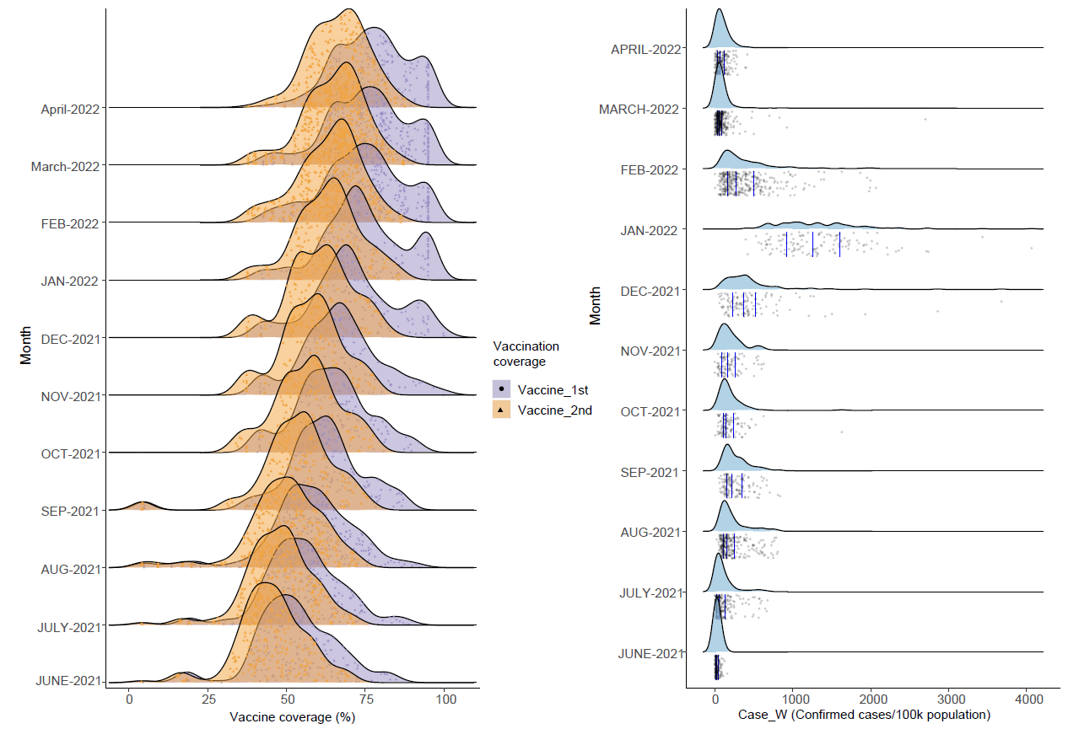
Figure S1. The progression of vaccination coverage and weekly average daily new COVID-19 cases (Case_w) in each county during the study period.
a. The coverage of the population received the 1st dose (Vaccine_1st, %) and the second dose (Vaccine_2nd, %) of vaccines in each county till Monday of the wastewater sampling week. b. The average daily new COVID-19 cases in the wastewater sampling week of these 102 counties.
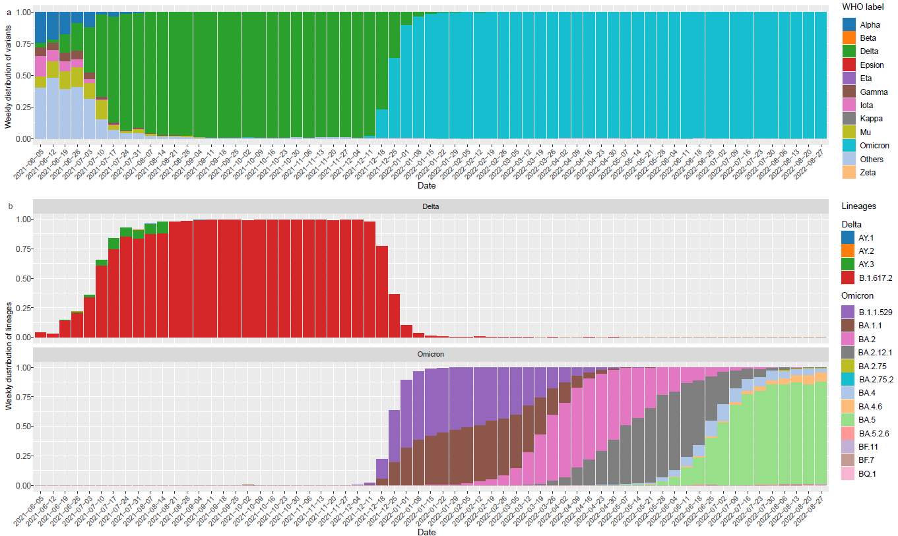
Figure S2. Weekly distribution of the different SARS-CoV-2 variants and subvariants in USA from June 2021 to August 2022 labelled in colors.
a Weekly distribution of different SARS-CoV-2 variants. b. Weekly distribution of different SARS-CoV-2 subvariants lineages during the study period.

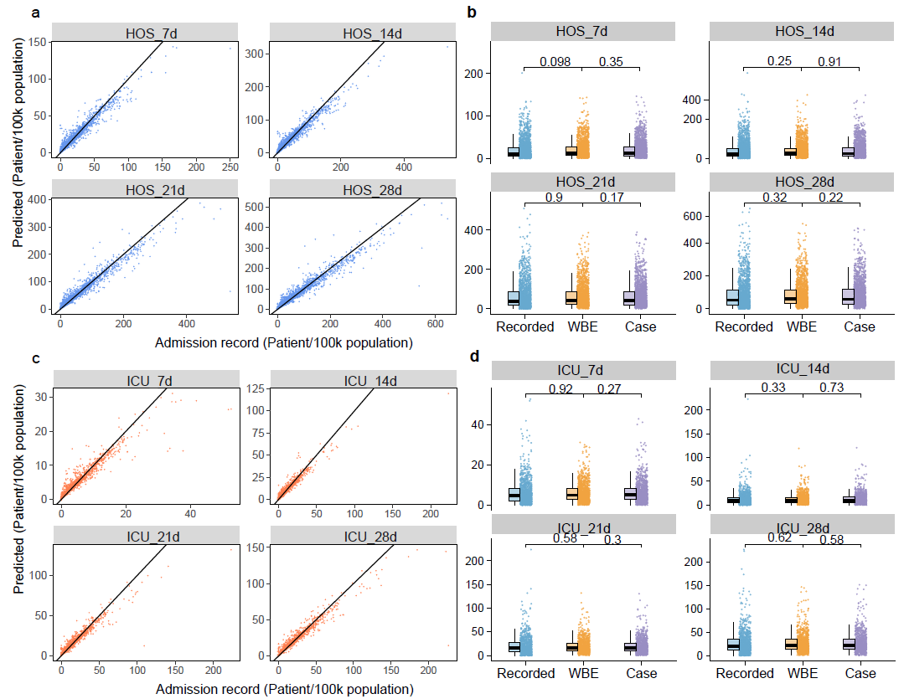
Figure S3. The WBE-based model prediction performance.
a. The WBE-based model prediction results verse the actual admission records for HOS_7d, HOS_14d, HOS_21d, and HOS_28d. b. Comparison between WBE-based prediction results and the actual admission records or cases-based prediction results for HOS_7d, HOS_14d, HOS_21d, and HOS_28d. The p values were obtained through paired t-tests. c. The WBE-based model prediction results verse the actual admission records for ICU_7d, ICU_14d, ICU_21d, and ICU_28d. d. Comparison between WBE-based prediction results and the actual admission records or cases-based prediction results for ICU_7d, ICU_14d, ICU_21d, and ICU_28d. The p values were obtained through paired t-tests.

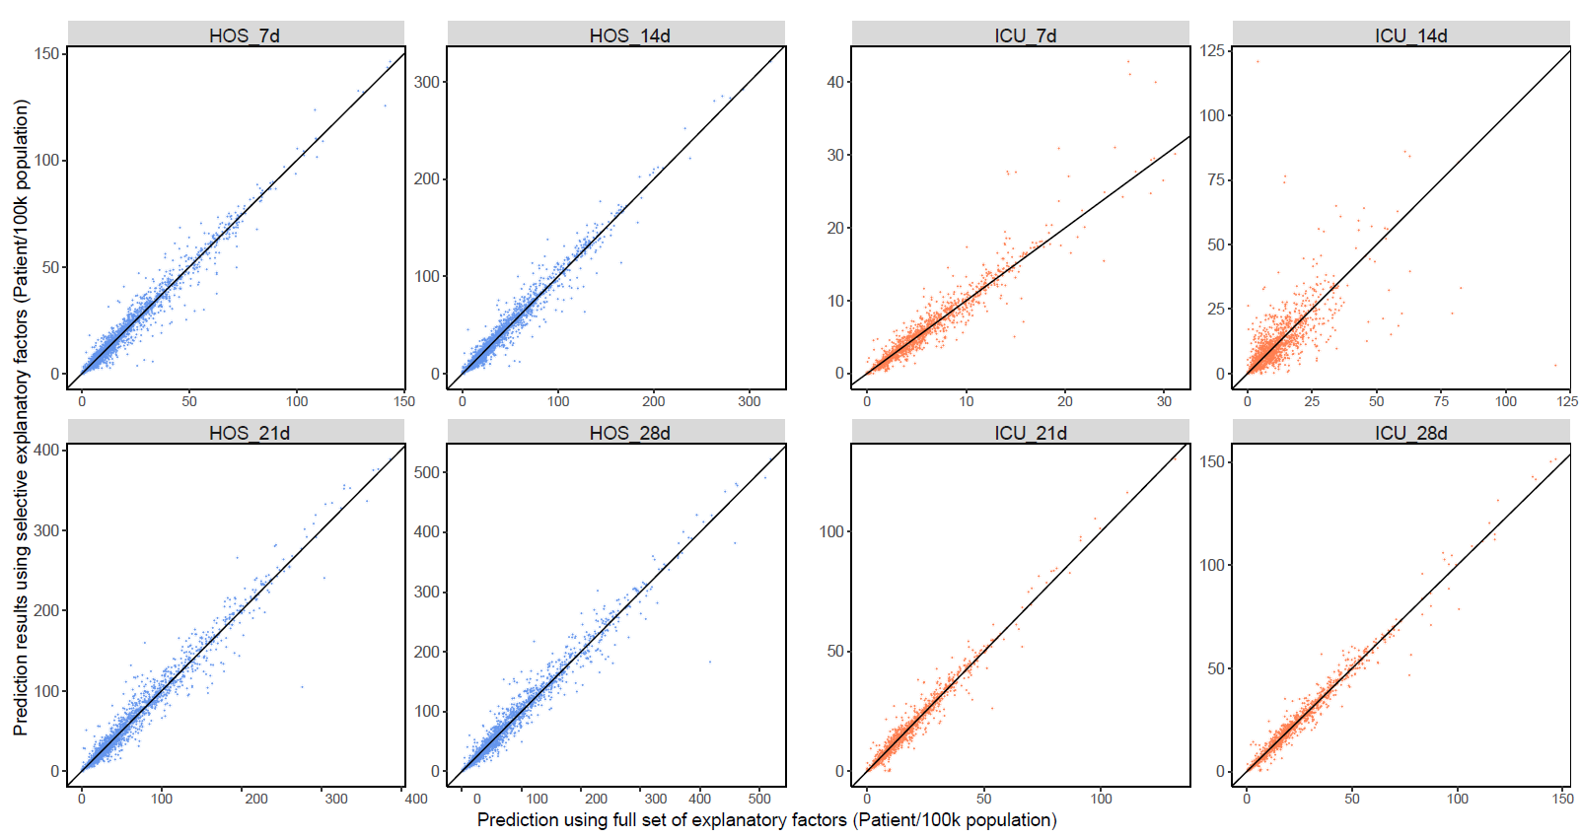
Figure S4. Comparison between the prediction results from WBE-based model using the full set of explanatory factors and the prediction results from WBE-based model using selective explanatory factors.
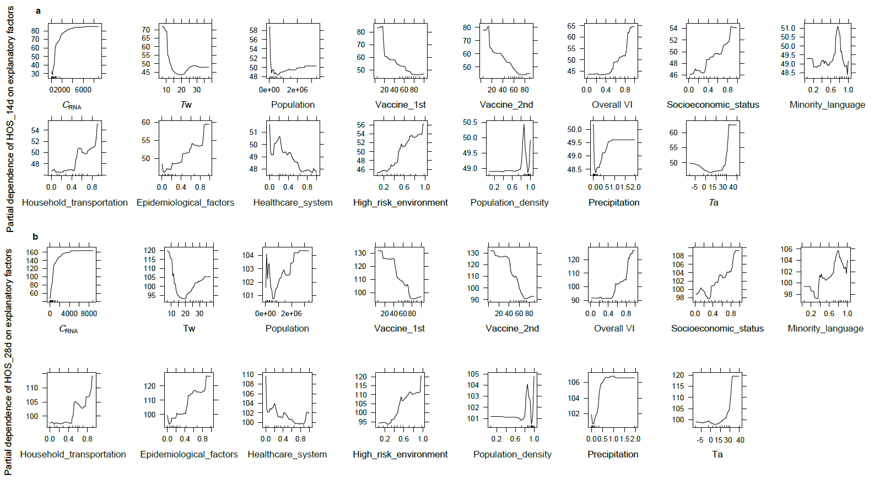
Figure S5. Partial dependence plot of HOS_14d (subfigure a) and HOS_28d (subfigure b) on the explanatory factors. The tick marks on the x-axis reflected the data density.
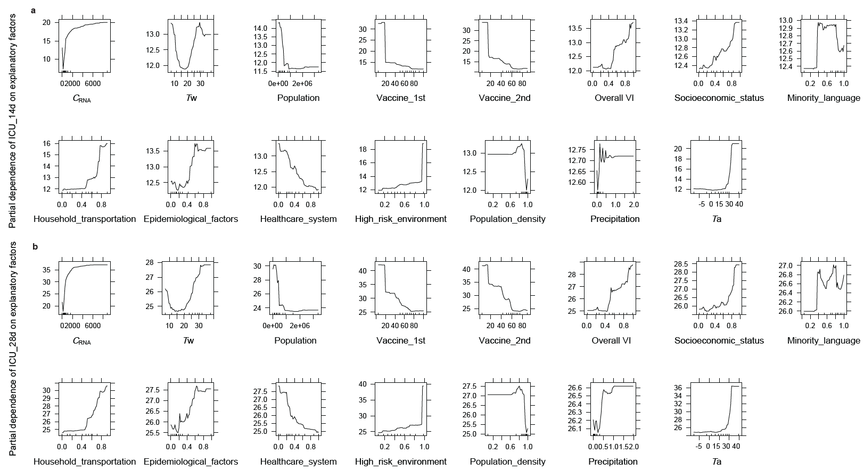
Figure S6. Partial dependence plot of ICU_14d (subfigure a) and ICU_28d (subfigure b) on the explanatory factors. The tick marks on the x-axis reflected the data density.
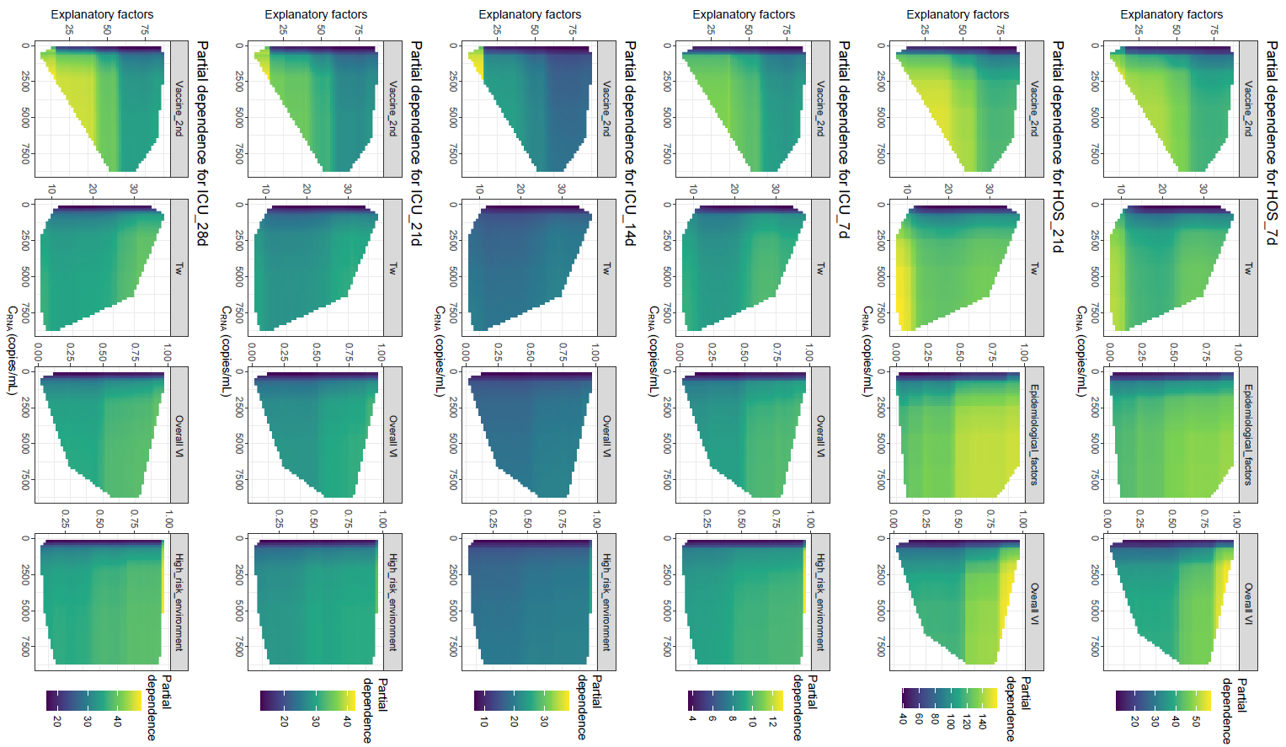
Figure S7. The partial dependence of HOS_7d, HOS_21d, ICU_7d, ICU_14d, ICU_21d, and ICU_28d on the 4 necessary factors for the models.

Reference
1. Duvallet C, et al. Nationwide Trends in COVID-19 Cases and SARS-CoV-2 RNA Wastewater Concentrations in the United States. ACS ES&T Water, (2022).

