Supporting Information
Tough and biodegradable polyurethane-silica hybrids with rapid sol-gel transition for bone repair
Su Jeong Park^{1,2}, Seung Hyuk Im¹, Donghak Kim^{1,2}, DoYeun Park², Youngmee Jung^{2,3}, Hyung-seop Han², Soo-Hyun Kim^{1,2,4}*, Justin J. Chung^{5,6}*
Figure S1. FTIR spectra of BPH0 (APTES functionalized polyurethane, black), PCL-diol (red), HDI (blue), and APTES (Green).

Figure S2. Rheology measurements of PCL-diol and hydrolyzed TEOS mixture (30 wt.% silica ratio) for 1 hours of mixing.
Figure S3. Representative uniaxial stress/strain curves of the 0, 10, 20, 30 40 wt. % silica hybrids (Sample size diameter: 11 mm, Thickness: 6.25 mm).

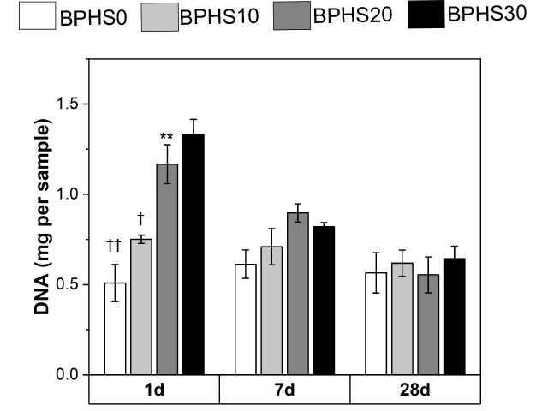
Figure S4. DNA quantification of MC3T3-E1 cells attached on the hybrid scaffolds (*p < 0.05, † p < 0.05, and ††p < 0.01 compared with 30 wt. % silica hybrid on day 1, n=3).

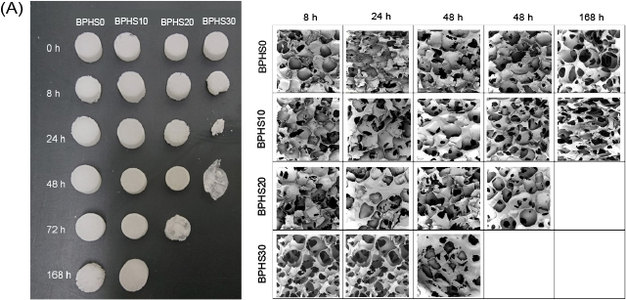
Figure S5. Accelerated degradation test on hybrid scaffolds. Samples were immersed in 1M NaOH at 25 ℃ for 0, 8, 24, 48, 72 and 168 h. Samples and SEM images of the degraded hybrid scaffold samples after accelerated degradation test.

Figure S6. Representative stress-strain curve of BPHS30 after 2 and 4 weeks of immersion in PBS.

Table S1. Mechanical properties of BPHS30 after 2 and 4 weeks of immersion in PBS (n=3).
 | 2 weeks |  | 4 weeks
 | Young’s modulus (KPa) | Ultimate strength (KPa) | Young’s modulus (KPa) | Ultimate strength (KPa)
BPHS30 | 980 ± 266.30 | 575.12 ± 128.51 | 666.67 ± 300.2 | 362.06 ± 76.60
Standard deviations are derived from the average values.

