Table 1. The raster data
Data type | Ortho-photo-map of the study area | 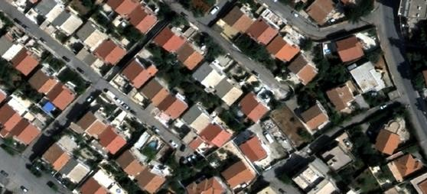
Number of Channels | 3
cell size (X, Y) | 0.18, 0.18
Source | National Institute of Cartography and Remote Sensing _ Algeria

Table 2. The vector data
Data type, name and size | An extracted Feature Dataset after a structured photogrammetric rendering in a multiuser Geodatabase | 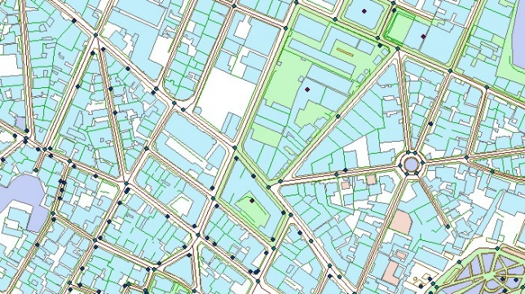
Spatial reference | UTM_Wgs84_31N
Source | National Institute of Cartography and Remote Sensing _ Algeria

Last name | Type of crime | Address
NAME (1) | Theft | 23 rue Mohamed Kheloufi HUSSEIN DEY
NAME (2) | First degree crime | 05 rue bouguennara tahar HUSSEIN DEY
NAME (3) | Car wrecking | 23 rue Douya mohamed DEY HUSSEIN
NAME (4) | Drug trafficking | 86 rue Boudjemaa Moghni HUSSEIN DEY
NAME (5) | Drug trafficking | 53 rue Boudjemaa Moghni HUSSEIN DEY
NAME (6) | Theft | 10 rue Mohamed Gharbi HUSSEIN DEY
NAME (7) | First degree crime | 09 Rue Mohamed Gharbi HUSSEIN DEY
NAME (8) | Theft | 48 rue Boudjemaa Moghni HUSSEIN DEY
Table 3. List of criminal groups

