Supporting Material to

Synthesis, X-ray crystallography, spectroscopic characterization, electronic structure investigation and molecular docking studies of single Cobalt (II) metal complex against
Afef Gannouni ª, Hitler Louis ^{b,c}, Thierry Roisnel ^{d}, Ernest E. Ekereke ^{e}, Destiny E. Charlie ^{b}, Elizabeth Ukwenya ^{b}, Riadh Kefi ª

ª Laboratoire de Chimie des Matériaux, Faculté des Sciences de Bizerte, 7021 Zarzouna, Tunisie
^{b} Computational and Bio-Simulation Research Group, University of Calabar, Calabar, Nigeria
^{c} Department of Pure and Applied Chemistry, Faculty of Physical Sciences, University of Calabar, Calabar, Nigeria
^{d} Centre de Diffractométrie X, UMR 6226 CNRS, Institut Sciences Chimiques de Rennes,
Université de Rennes I, 263 Avenue du Général Leclerc, 35042 Renne, France.
^{e} Department of Mathematics, Faculty of Physical Sciences, University of Calabar, Calabar, Nigeria

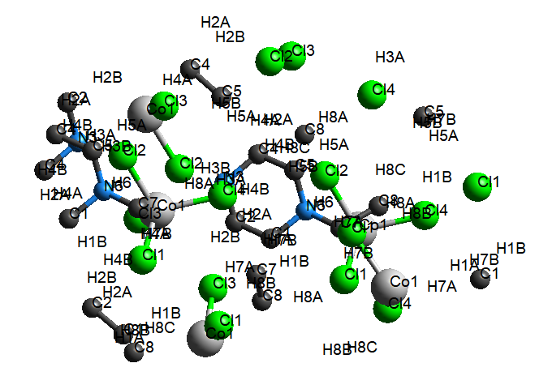
Figure S - 1 : Molecular visualization of the crystal structure (C₆H₁₆N₂)[CoCl₄]
with omitted hydrogen bond and numbers for purpose clarity

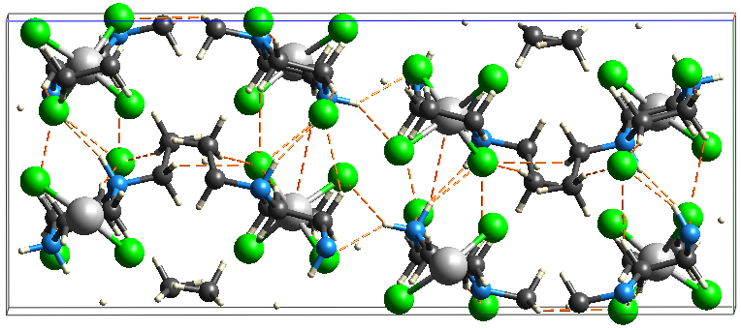
Figure S 2 : Intermolecular Interaction of (C₆H₁₆N₂)[CoCl₄] (Co₂)

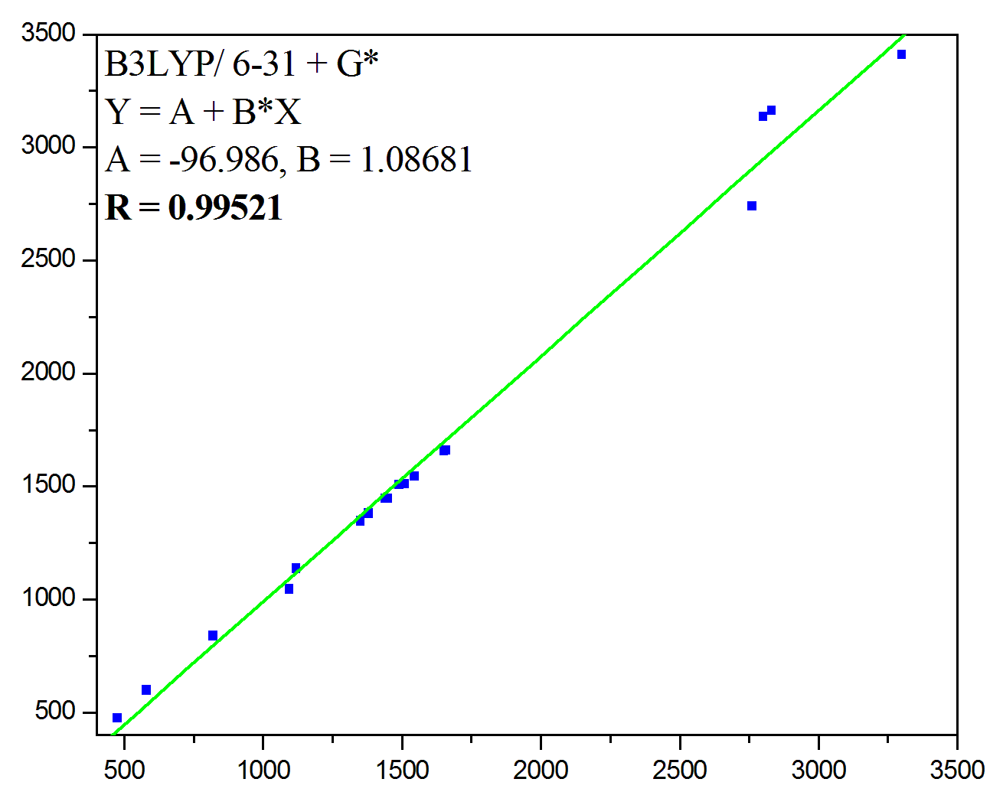
Figure S - 3: Correlation graph between the experimental and calculated
wavenumbers (cm⁻¹) of 2EPCO
Figure S - 4: Correlation graph between the experimental
and calculated wavelength (nm) of (C₆H₁₆N₂)[CoCl₄]

Figure S - 5: (a): The diffuse reflectance spectra and (b): the Kubelka-Munk absorption spectra of (C₆H₁₆N₂)[CoCl₄]

Figure S - 6: Optical transmittance spectrum of 2EPCO

Figure S - 7: Molecular electrostatic potential surface (between -4.191 and 0.290)
Of title compound
Figure S - 8: Representation of different types of interactions in the monomer (a). Graph of the reduced density gradient vs. sign (λ2) ρ of (C₆H₁₆N₂)[CuCl₄] (b).
Figure S - 9: Atoms represented by Colors of calculated atomic charge values from the Mulliken population analysis of 2EPCO
Figure S - 10: Simultaneous curves of thermogravemetric analysis
and differential thermal analysis of 2EPCO

Figure S - 11: Pymol of the target receptors (6PXZ, 6RK2) with the title compound (a)
and with the conventional Drug (Cycloserine) (b)

Table S – 1: Assignments of IR vibrational modes in (C₆H₁₆N₂)[CoCl₄]
Frequency (cm⁻¹) Attribution
IR Experimental IR Theoretical
3300 - 2987 3410, 3126 ν_{s} (-NH)
2830 3177, 3175, 3167, 3157 ν_{s} (CH2)
3091, 3075, 3052, 3151, 3082
3049, 3162, 3121, 3090, 3083
2800 3167, 3135 ν_{as} (CH2)
2760 - 2720 3121, 2727, 2740 ν_{s} (-NH2)
2723 3135 ν_{s} (CH3)
1660 1661 δ_{s} (NH2)
1650 1658 δ_{as} (NH2)
1545 1546, 1545, 1544, 1527, 1509 δ_{s} (CH2)
1522, 1548, 1531, 1534, 1535
1512, 1459
1510 1531, 1512, 1458, 1381, 1341 τ_{as}(HCCN)
1490 1509, 1459 δ_{as} (CH2)
1450 1467, 1446, 1442, 1312, 982 δ_{s} (HCC)
1441, 1341, 1281, 1198, 1083, 1372,
1447, 1313, 1343, 1279, 1196, 985
1440 1447, 1467 δ_{as} (HCC)
1380 1381, 1279, 1020, 825, 248, 1168 τ_{s}(HCCN)
1123, 236, 1196, 985, 1343
1167, 1123, 1019
1350 1347, 1196 τ_{s}(HCHCl)
1120 1137, 1046, 909, 1068, 1032 ν_{s} (CC)
1123, 1083, 860, 840, 826, 372
1095 1137, 1123, 1046, 909, 894, 825 ν_{s} (CN)
820 839 τ_{s}(HCCH)
580 761, 598, 477, 452, 597 δ_{s} (CCN)
475 476, 284 δ_{as} (CCN)
-- 380, 377, 249, 247, 223 ν_{s} (CoCl)
-- 281 ν_{as} (CoCl)
-- 249 τ_{s}(NCCN)
-- 223, 163 ν_{s} (ClH)
-- 173, 159, 147, 109, 103, 97, 95, 60 δ_{s} (ClCoCl)
-- 140, 113, 112, 109 γ_{s}(ClClClCu)
-- 132, 60, 9 τ_{s}(ClCoClH)
-- 113 δ_{s} (ClHN)
-- 74 δ_{s} (CoClH)
-- 36 τ_{s}(NHClCo)
-- 32 τ_{s}(ClHNC)

Table S 2: QTAIM table for the studied compounds calculated at DFT/PBE0/Gen/6-311++G(d,p)/LanL2DZ method
Complex | Bonds | BCP | 𝛒(r) | $$∇^{2}(r)$$ | G(r) | K(r) | V(r) | H(r) | ELF | Ɛ
 | Co₂₅Cl₂₆ | 46 | 0.737 | 0.165 | 0.578 | 0.165 | 0.743 | 0.165 | 0.293 | 0.091
 | Co₂₅Cl₂₇ | 65 | 0.569 | 0.145 | 0.488 | 0.124 | 0.612 | 0.124 | 0.197 | 0.008
2EPCO | Co₂₅Cl₂₈ | 46 | 0.737 | 0.165 | 0.578 | 0.165 | 0.743 | 0.165 | 0.293 | 0.091
 | Co₂₅Cl₂₉ | 51 | 0.921 | 0.255 | 0.876 | 0.238 | 0.111 | 0.238 | 0.276 | 0.157

Table S 3: Mulliken Atomic Charge and Natural Population Analysis at PBE0/6-311++G(d,p) basis set of title compound
Atoms | Mulliken Charges | NPA
C1 | 0.050743 | -0.25761
C2 | -0.04451 | -0.33882
C3 | -0.41323 | 1.99913
C4 | 0.092784 | 1.99914
H5 | 0.234869 | 0
H6 | 0.182533 | 0
H7 | -0.87328 | 0
H8 | 0.143124 | 0
H9 | 0.164585 | 0
H10 | 0.147013 | 0
H11 | 0.174972 | 0
H12 | 0.104991 | 0
H13 | 0.134661 | 0
H14 | -0.05328 | 0
N15 | -0.14223 | 1.99944
N16 | -0.14223 | 1.99942
H17 | 0.126889 | 0
C18 | 0.25636 | 1.99913
C19 | -0.43106 | 1.99927
H20 | -0.065 | 0
H21 | 0.142811 | 0
H22 | 0.145007 | 0
H23 | 0.130322 | 0
H24 | 0.074114 | 0
Co25 | -0.64009 | 17.99771
Cl26 | -0.22094 | 9.99963
Cl27 | 0.506821 | 9.99914
Cl28 | -0.03297 | 9.99959
Cl29 | -0.2179 | 9.99962

