Supplementary materials
A new protective gel to facilitate ulcer healing in artificial ulcers following esophageal endoscopic submucosal dissection: A multicenter, randomized trial

Tianyu Zhou, Xinli Mao, Lei Xu, Haifeng Jin, Li Cen, Caijuan Dong, Linying Xin, Jiali Wu, Weimiao Lin, Bin Lv, Feng Ji, Chaohui Yu, and Zhe Shen

Table of contents
1. Figure S1

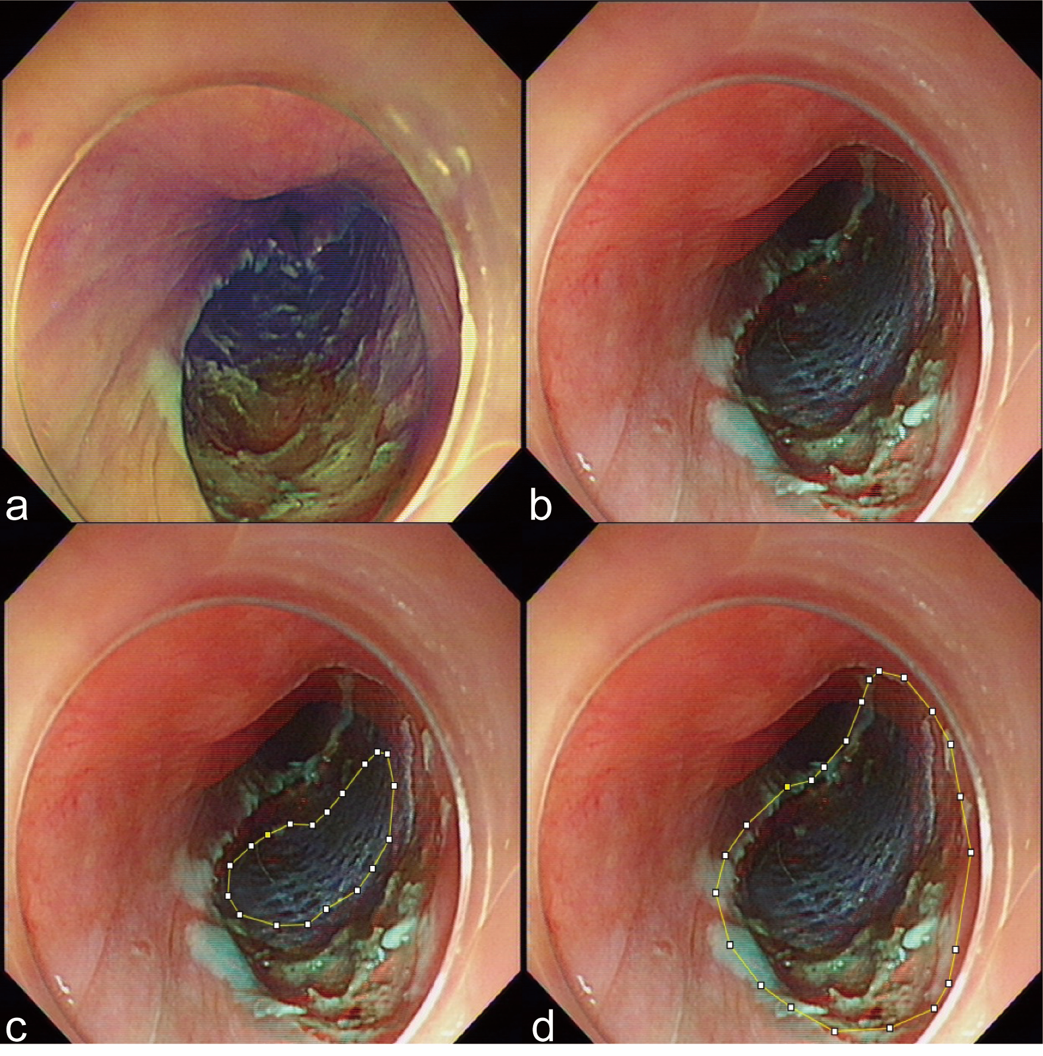
Figure S1. Protocol of measuring the ulcer area by ImageJ 1.53 analysis system. (a) The wound after esophageal ESD. (b) Put the same kind of reference on the ulcer surface. (c) Measure the area of reference detected from endoscopy. (d) Measure the area of the wounds detected from endoscopy. The real ulcer area was then calculated using the following formula: (The area of wound detected from endoscopy) / (The area of reference detected from endoscopy) * (The real area of the reference).

