Supporting Information

Preparation of some new pyrazolo[1,5-a]pyrimidines and evaluation of their antioxidant, antibacterial (MIC and ZOI) activities, and cytotoxic effect on MCF-7 cell line
Mohammad Mehdi Vahedi,ª Sakineh Asghari,^{*a} Mahmood Tajbakhsh,ª and Mojtaba Mohseni^{b}
ªDepartment of Organic Chemistry, Faculty of Chemistry, University of Mazandaran, Babolsar, 47416-95447, Iran;
^{b}Department of Microbiology, Faculty of Science, University of Mazandaran, Babolsar, 47416-95447, Iran
*Corresponding author e-mail: s.asghari@umz.ac.ir

Chemistry

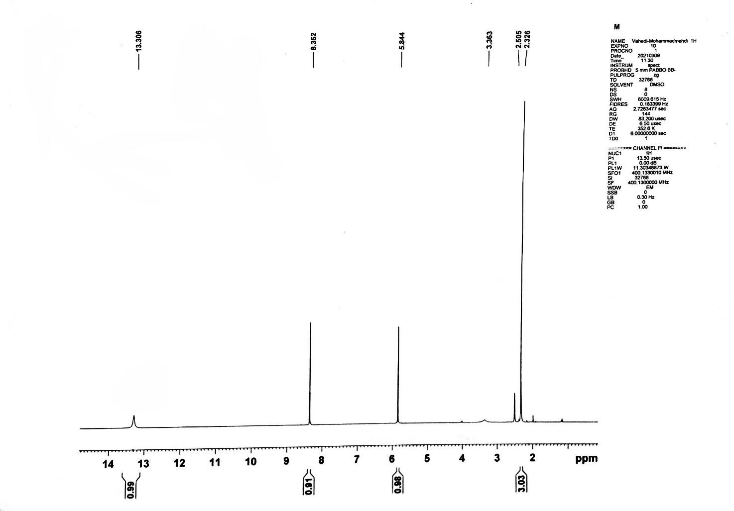

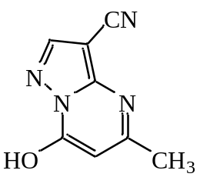

Figure (S1): ¹H NMR spectrum of compound 3a

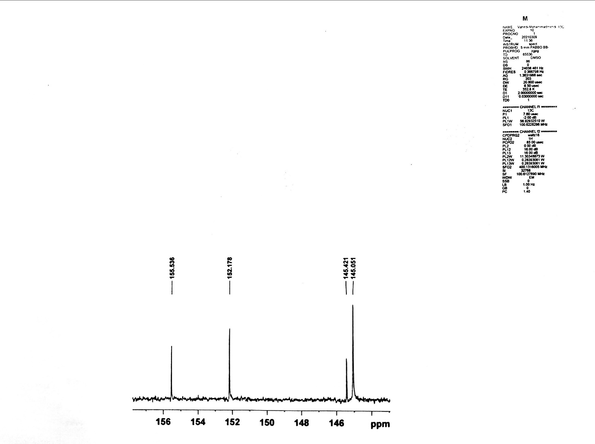

Figure (S2): ¹H NMR spectrum of compound 3a (Expand)

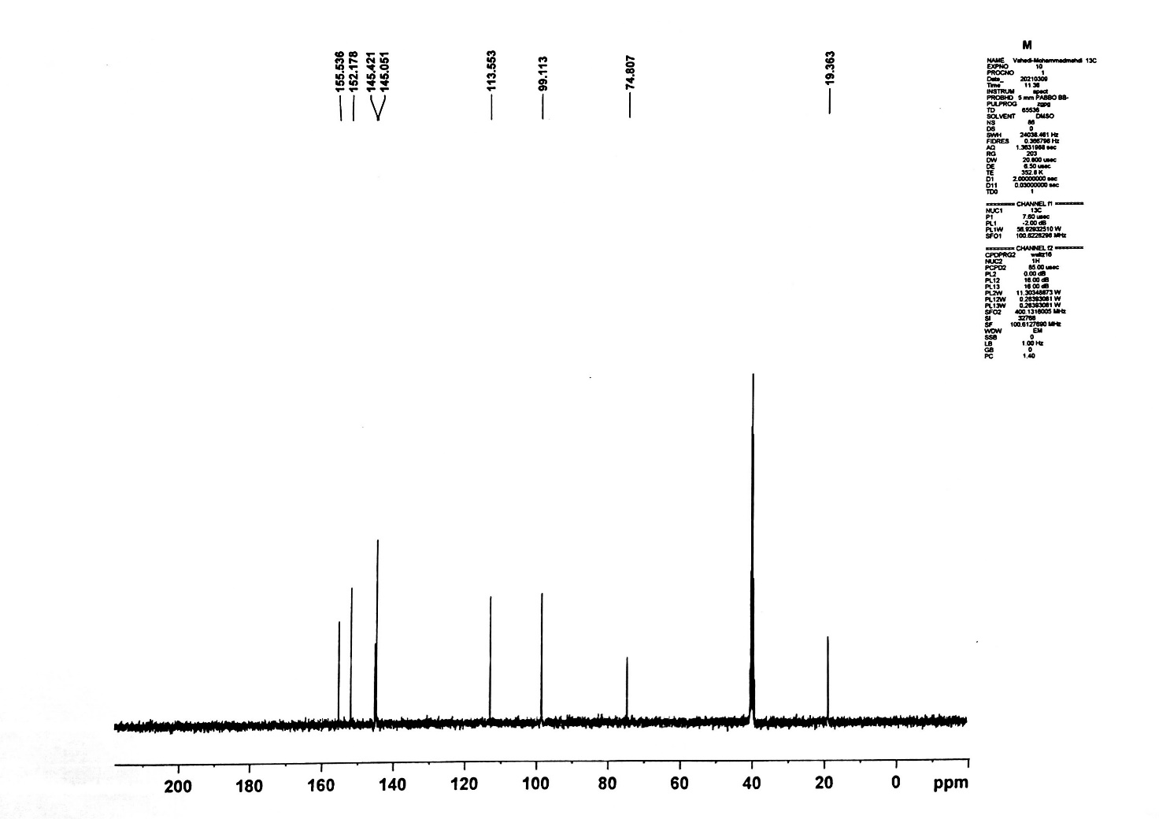

Figure (S3): ¹³C NMR spectrum of compound 3a

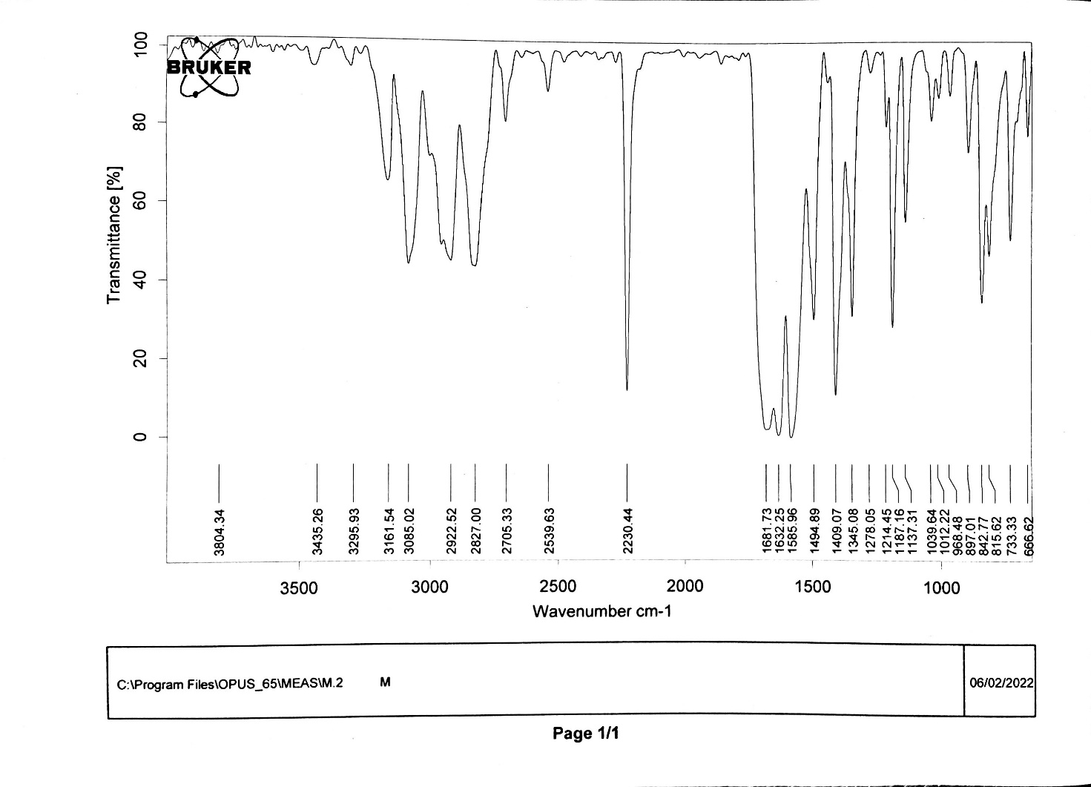

Figure (S4): FT-IR spectrum of compound 3a

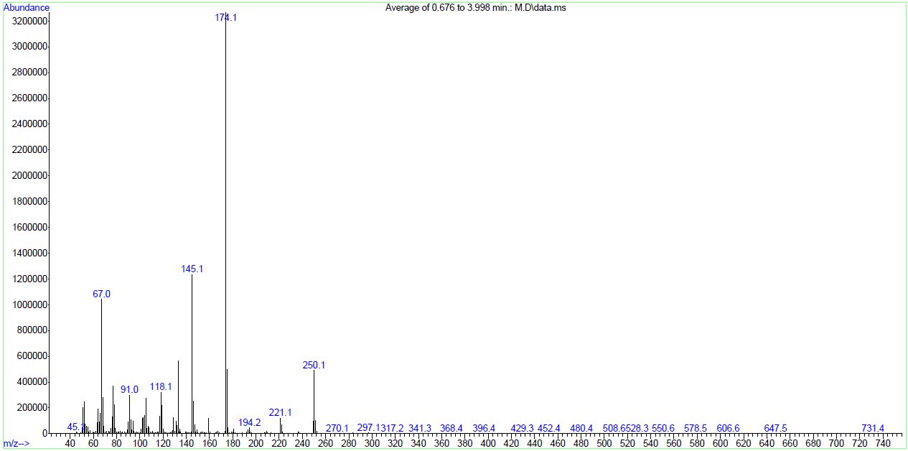

Figure (S5): Mass spectrum of compound 3a

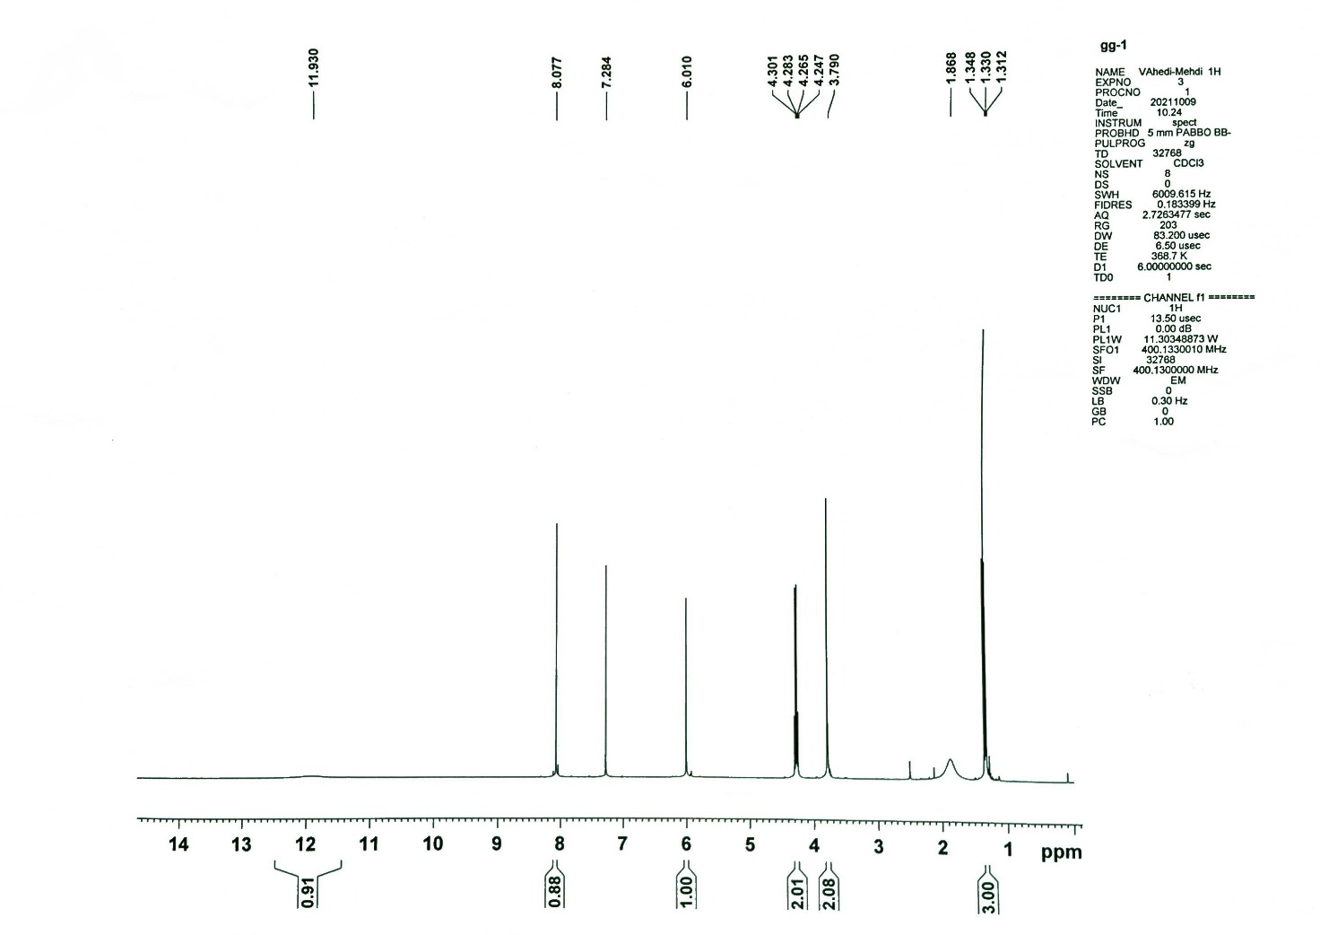

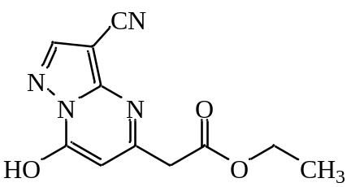

Figure (S6): ¹H NMR spectrum of compound 3b

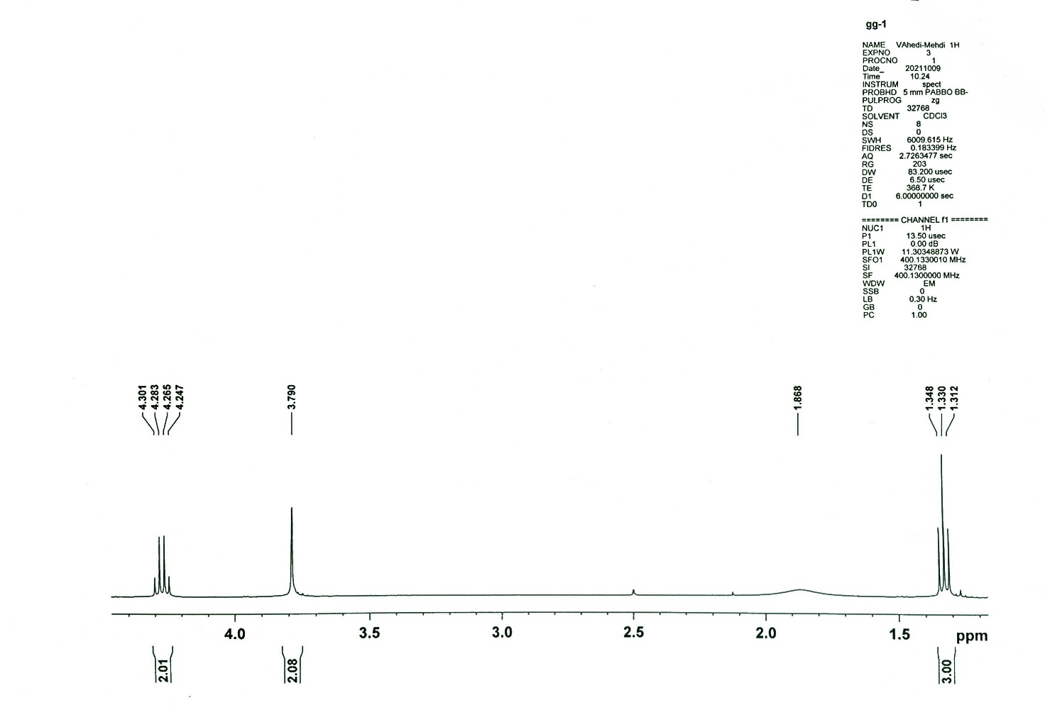

Figure (S7): ¹H NMR spectrum of compound 3b (Expand)

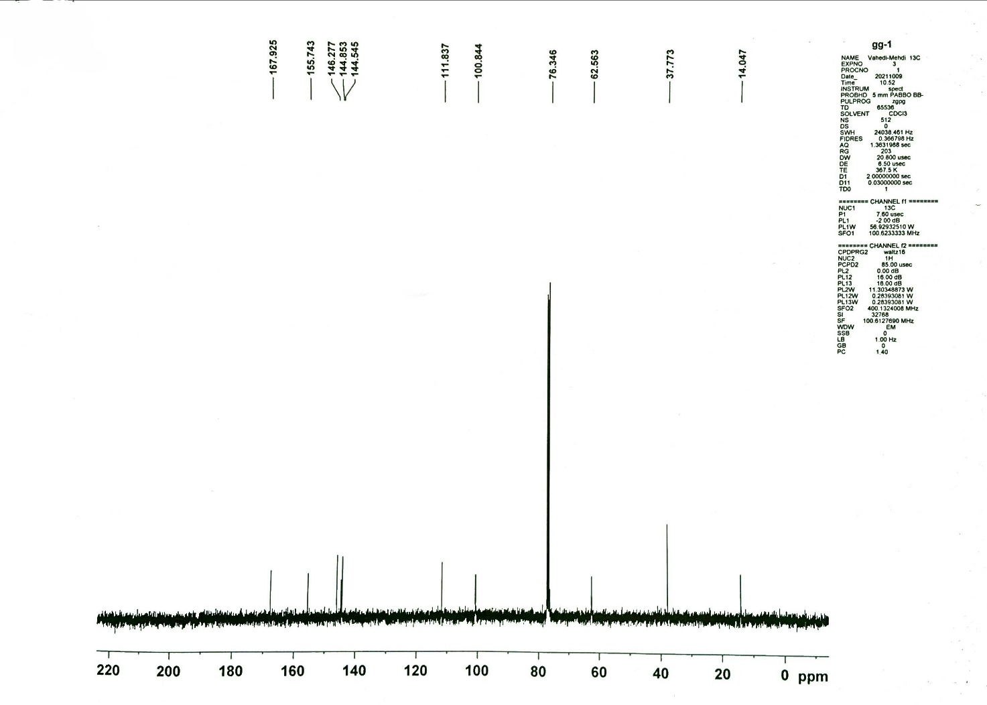

Figure (S8): ¹³C NMR spectrum of compound 3b

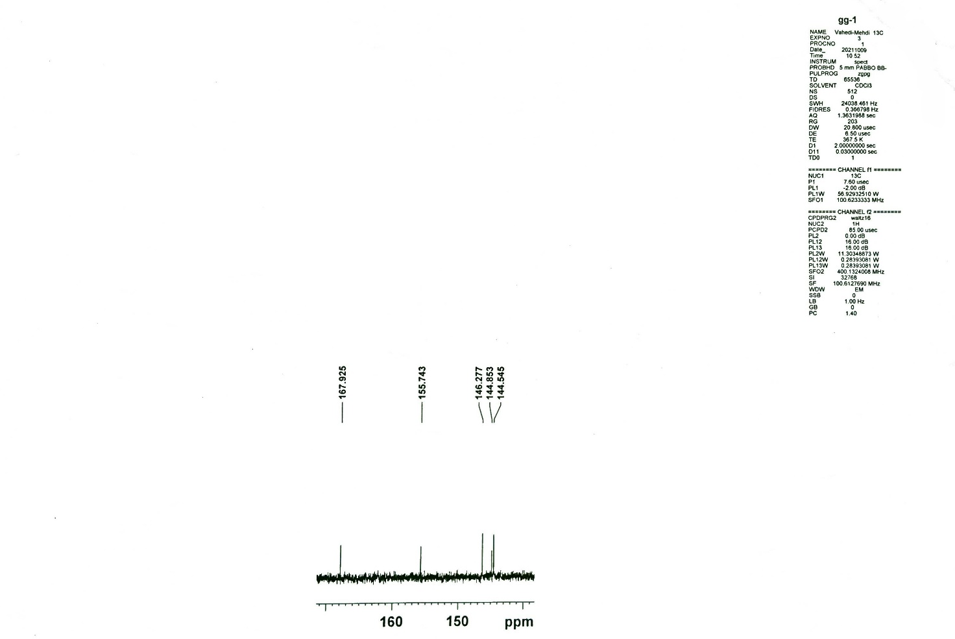

Figure (S9): ¹³C NMR spectrum of compound 3b (Expand)

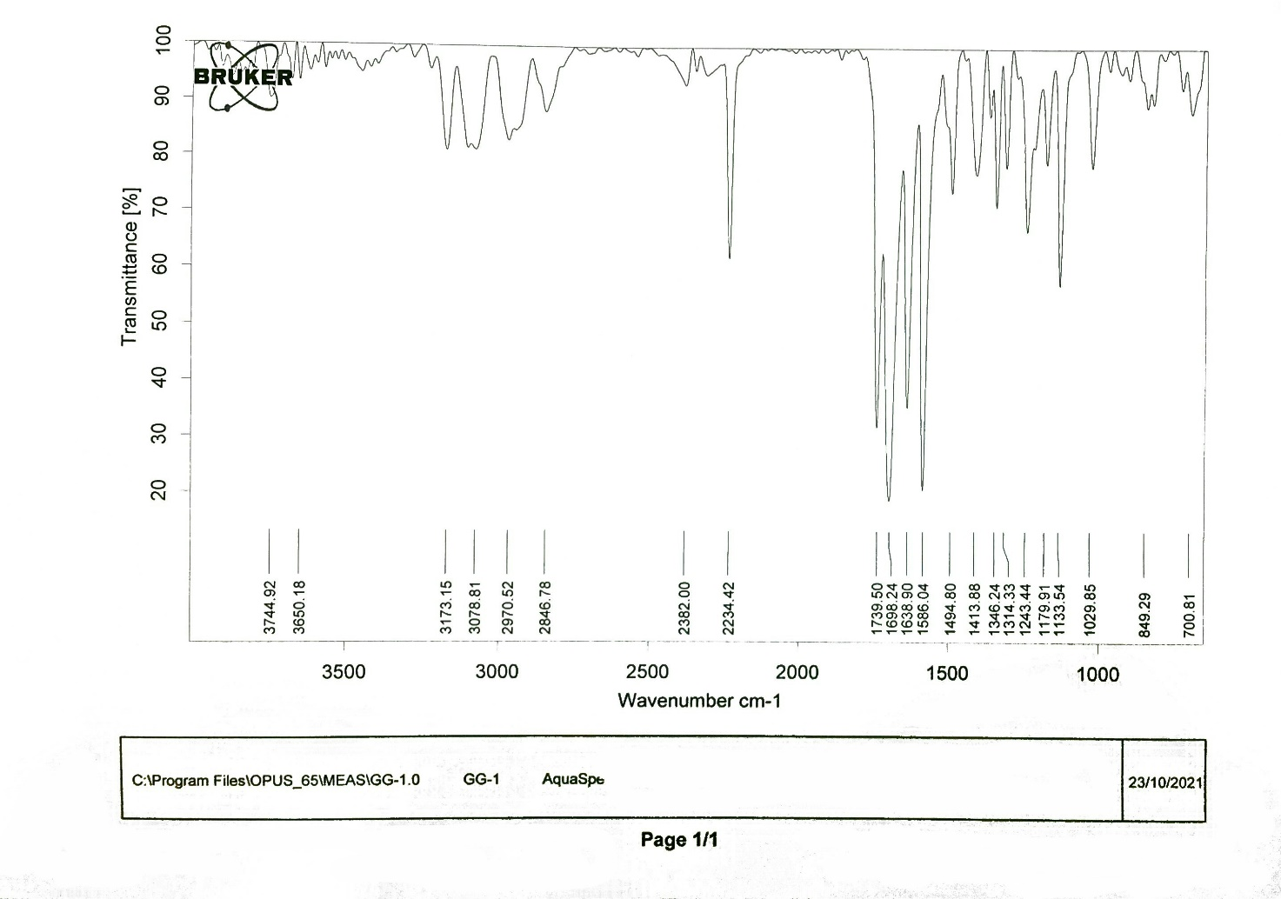

Figure (S10): FT-IR spectrum of compound 3b

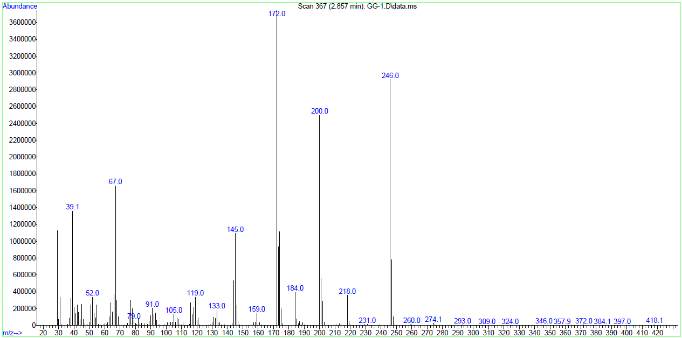

Figure (S11): Mass spectrum of compound 3b

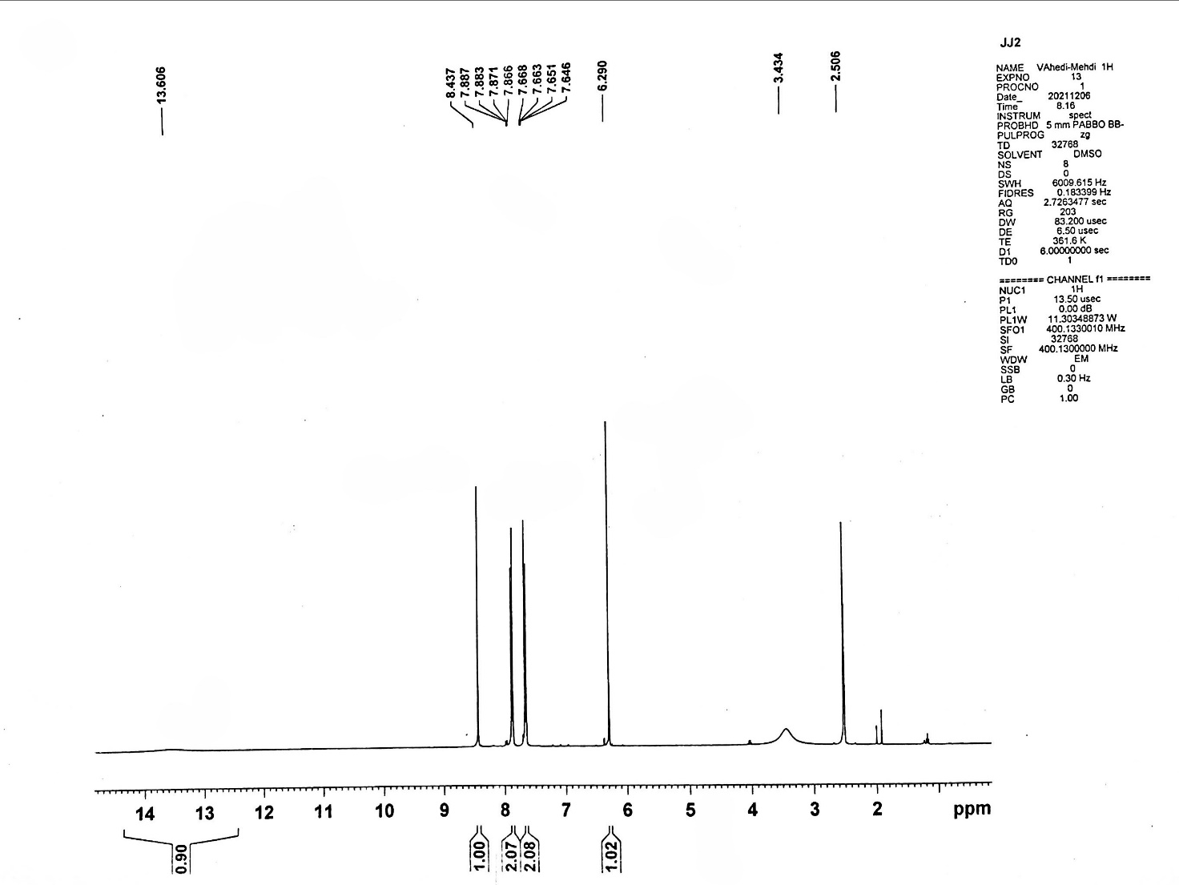

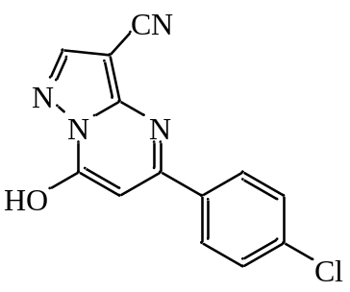

Figure (S12): ¹H NMR spectrum of compound 3c

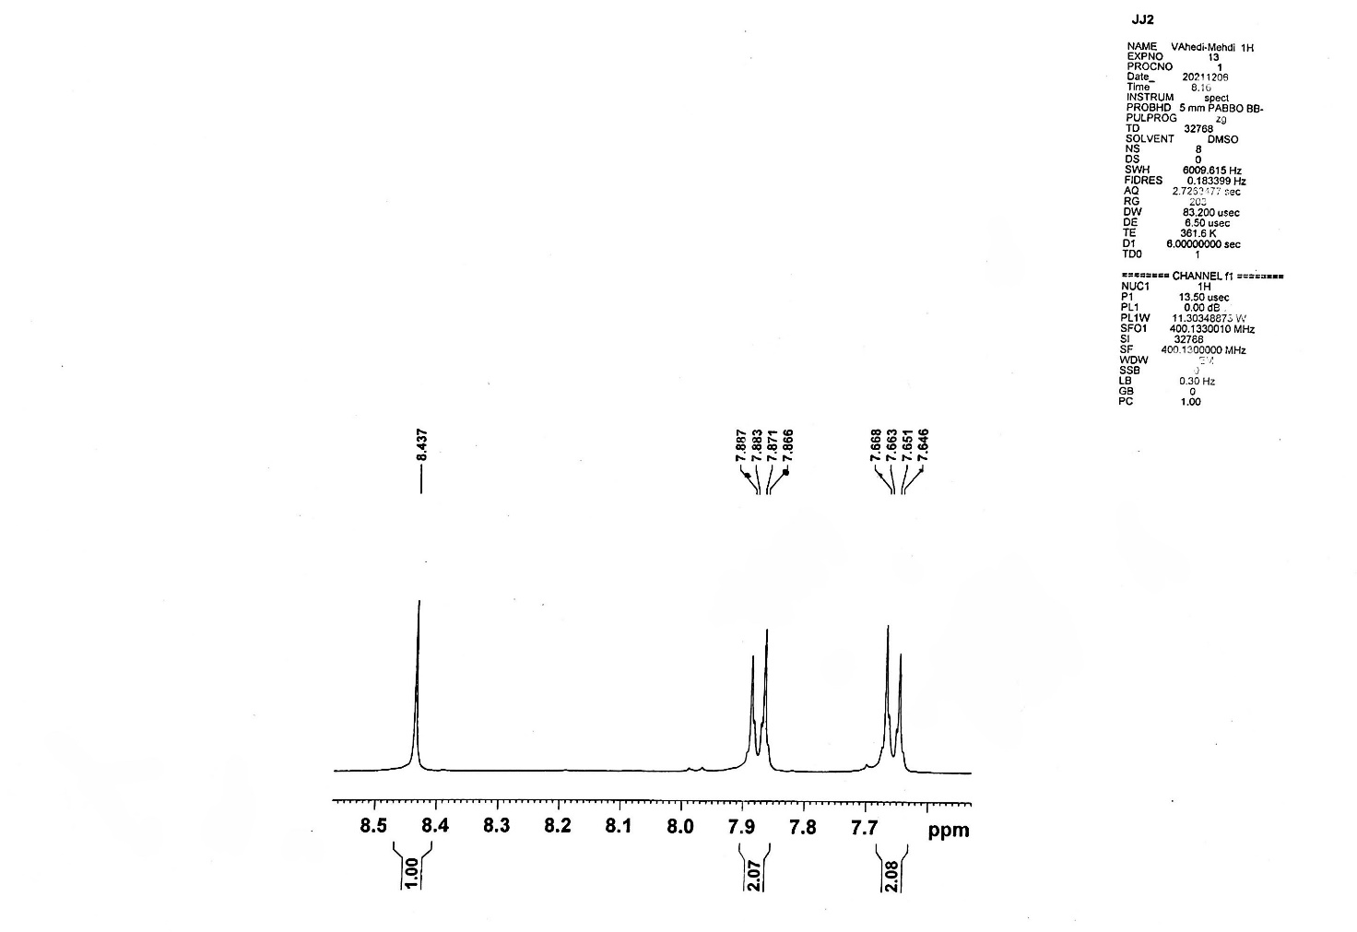

Figure (S13): ¹H NMR spectrum of compound 3c (Expand)

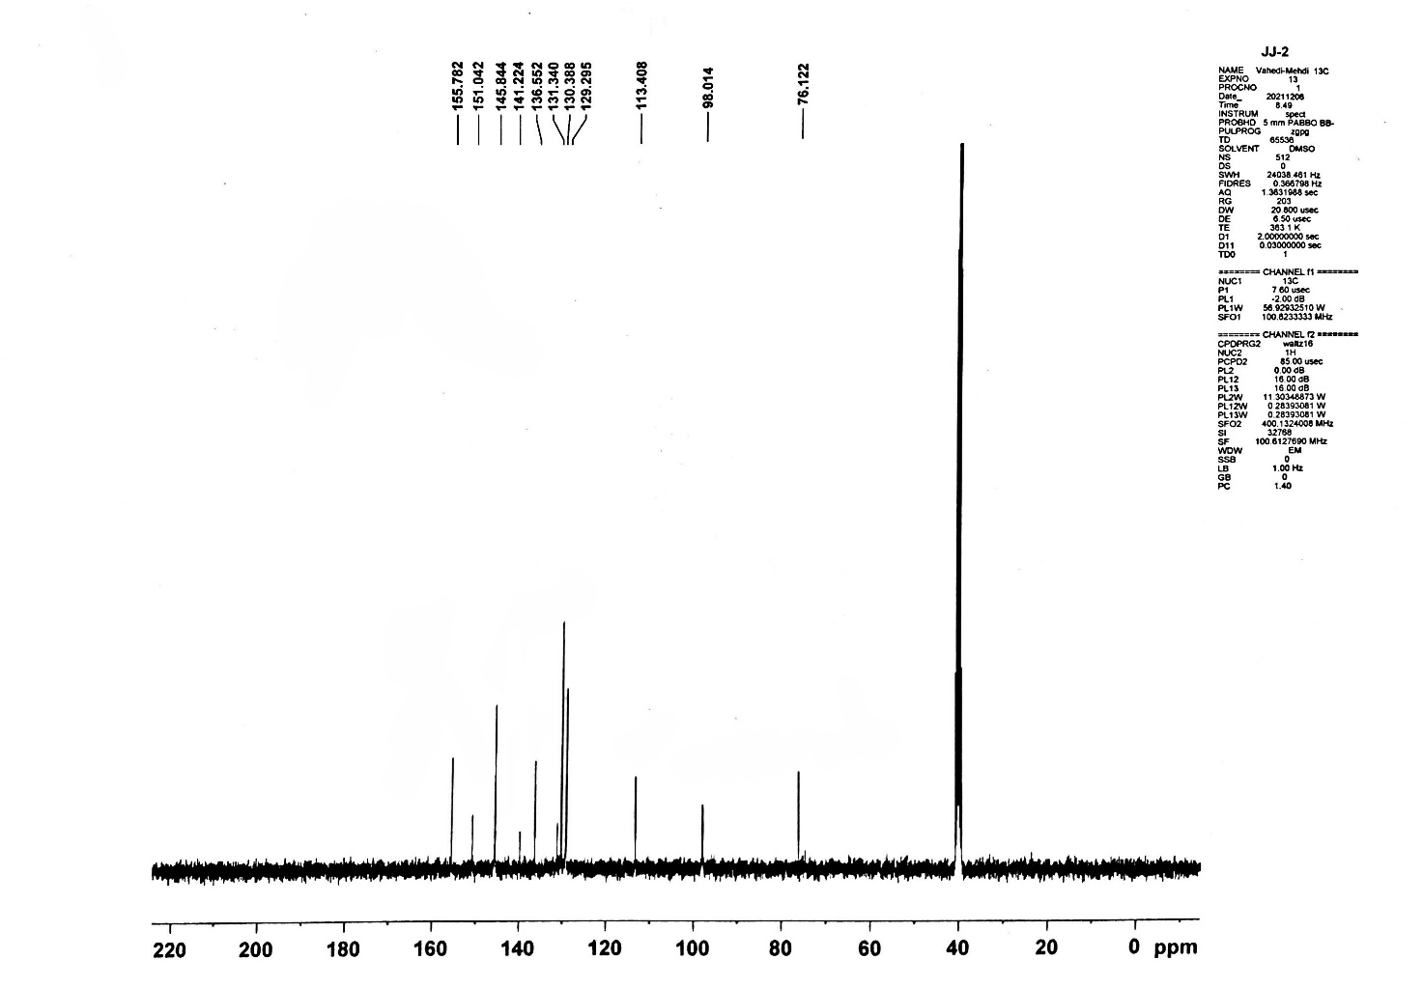

Figure (S14): ¹³C NMR spectrum of compound 3c

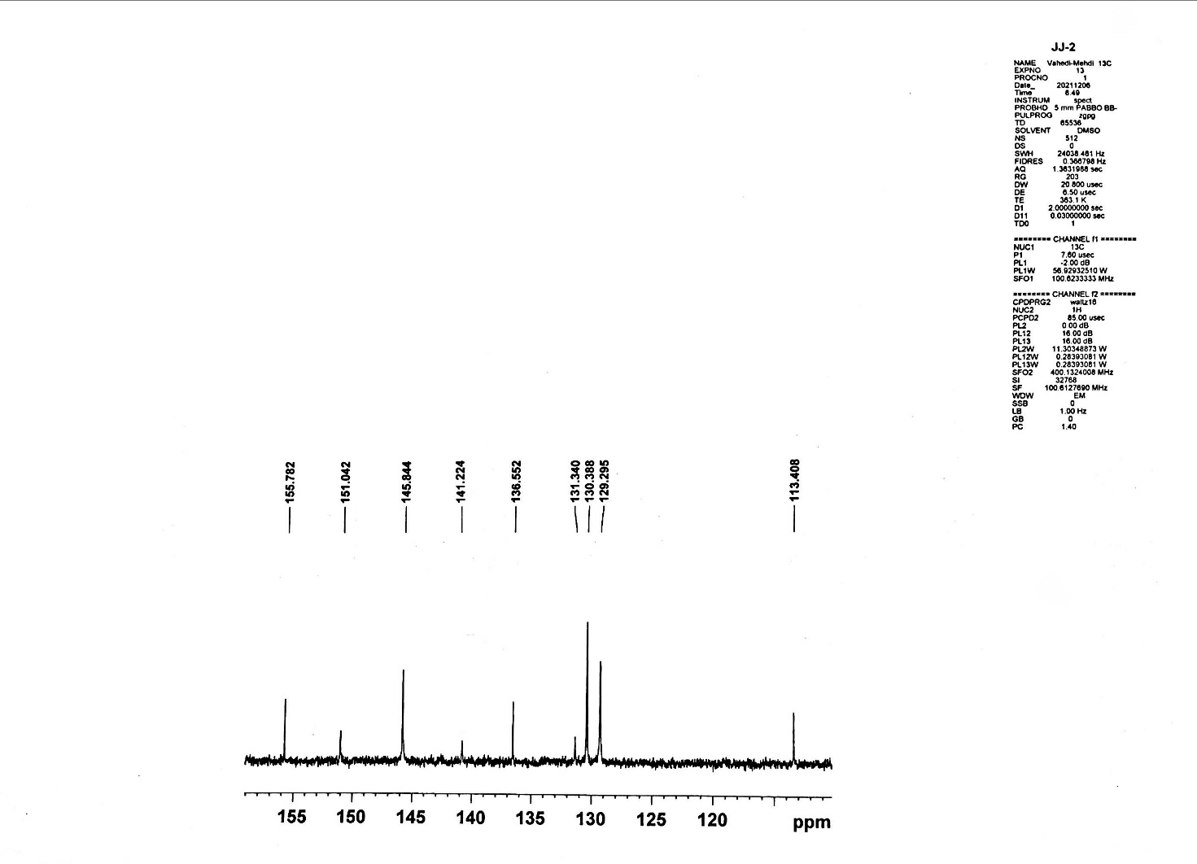

Figure (S15): ¹³C NMR spectrum of compound 3c (Expand)

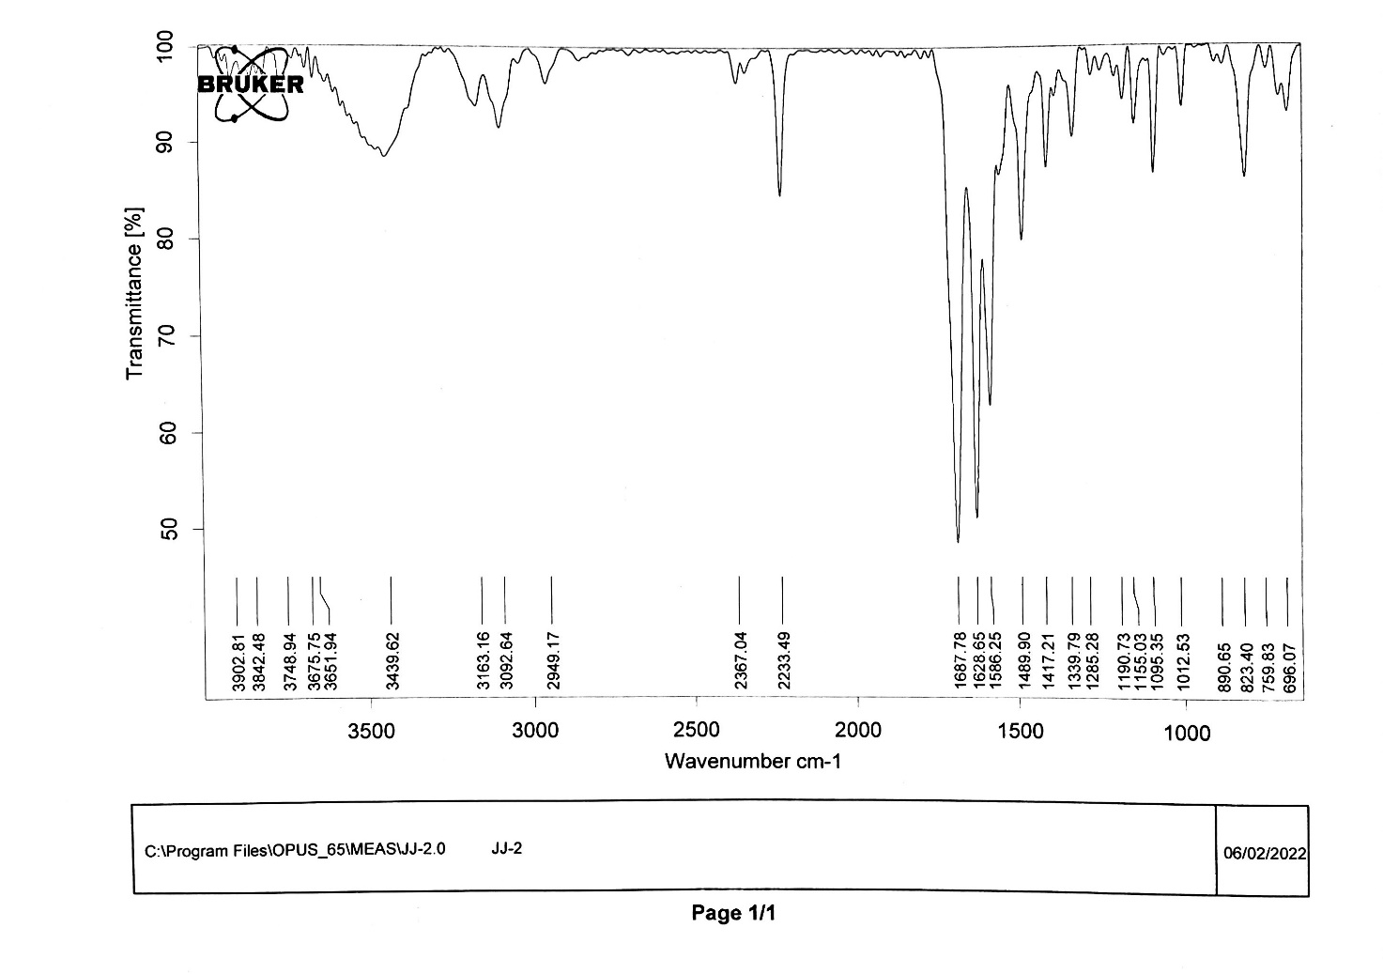

Figure (S16): FT-IR spectrum of compound 3c

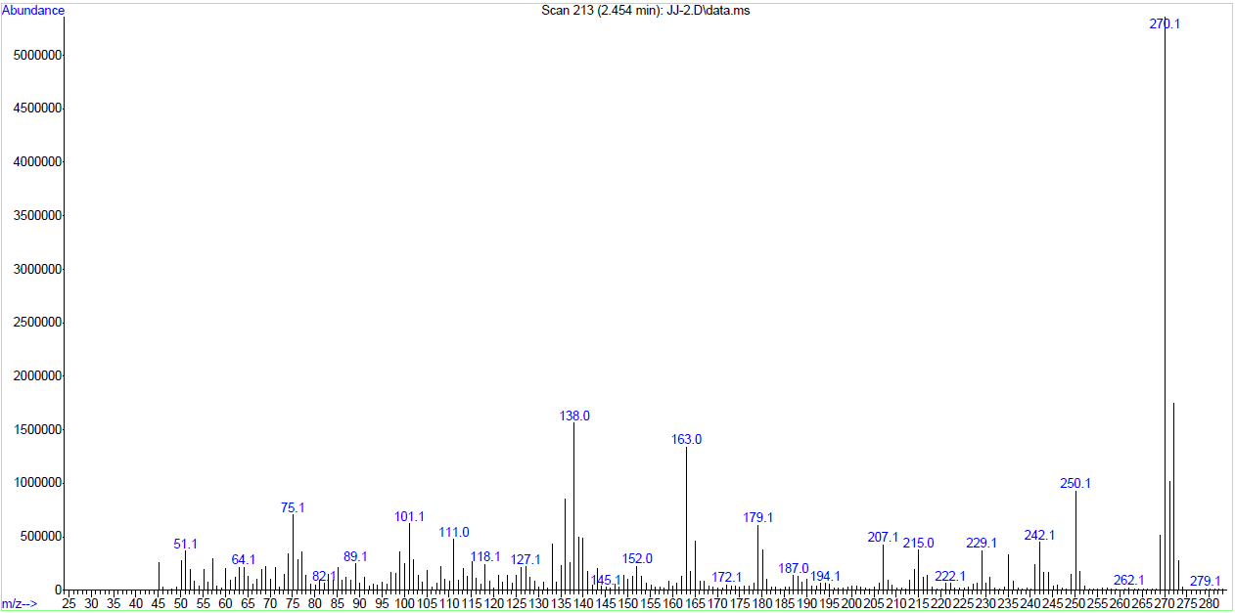

Figure (S17): Mass spectrum of compound 3c

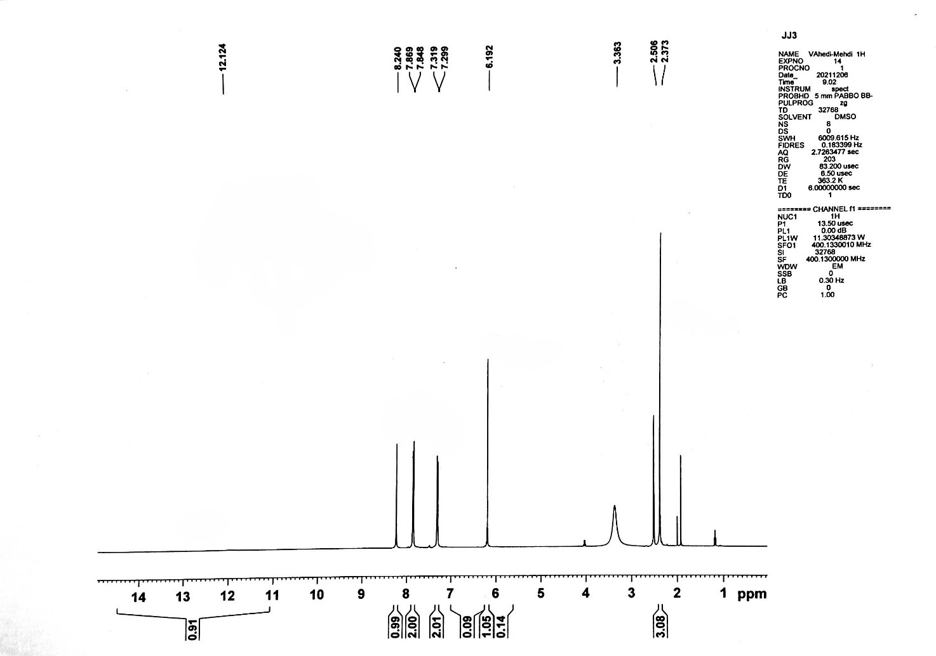

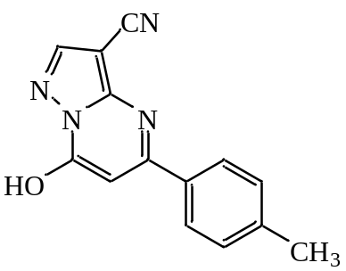

Figure (S18): ¹H NMR spectrum of compound 3d

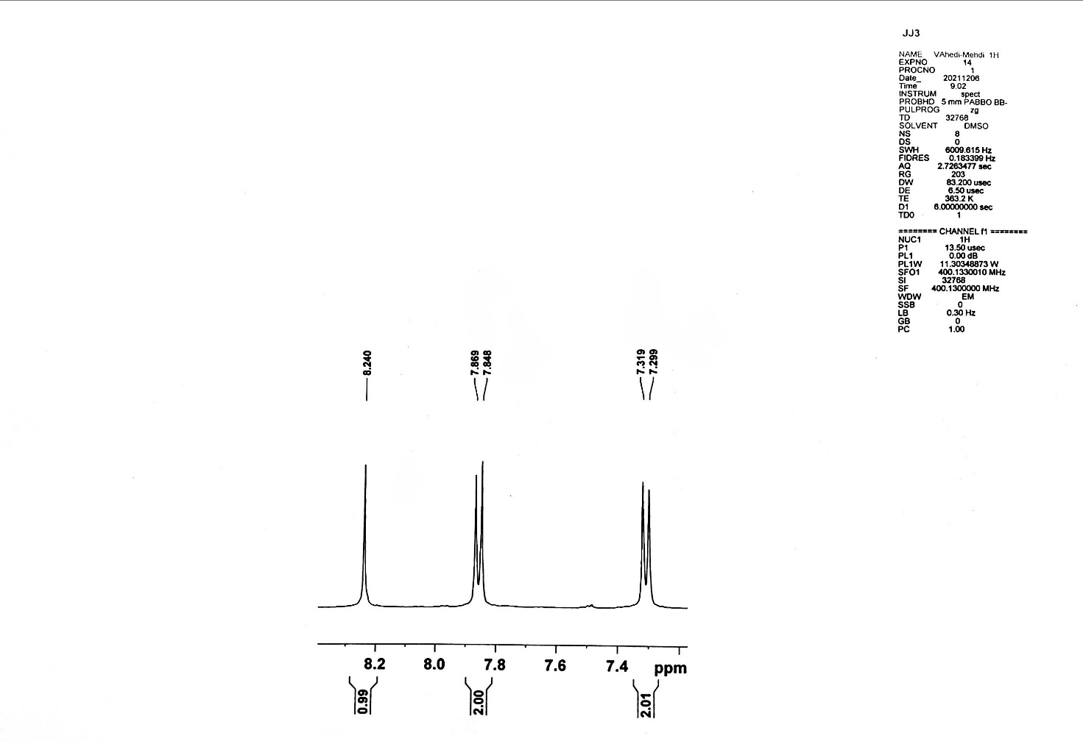

Figure (S19): ¹H NMR spectrum of compound 3d (Expand)

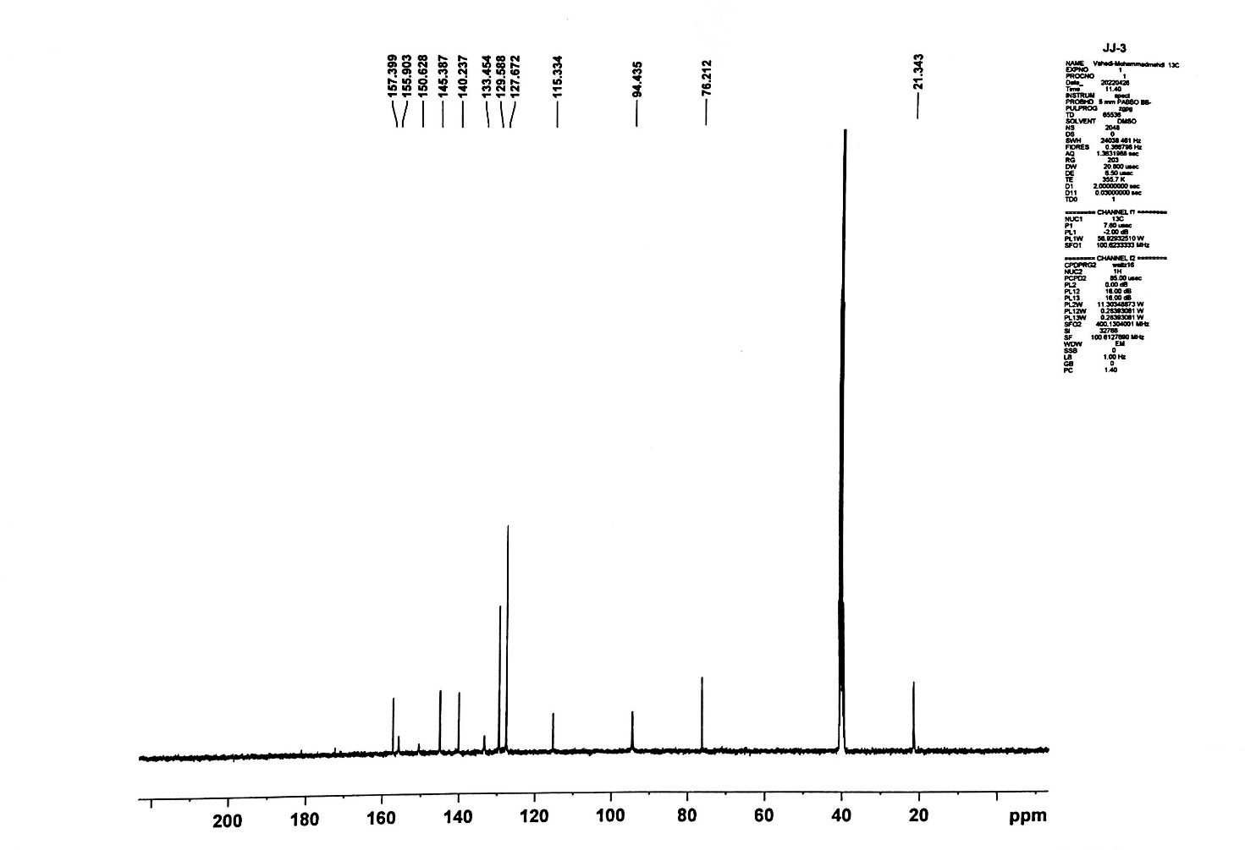

Figure (S20): ¹³C NMR spectrum of compound 3d

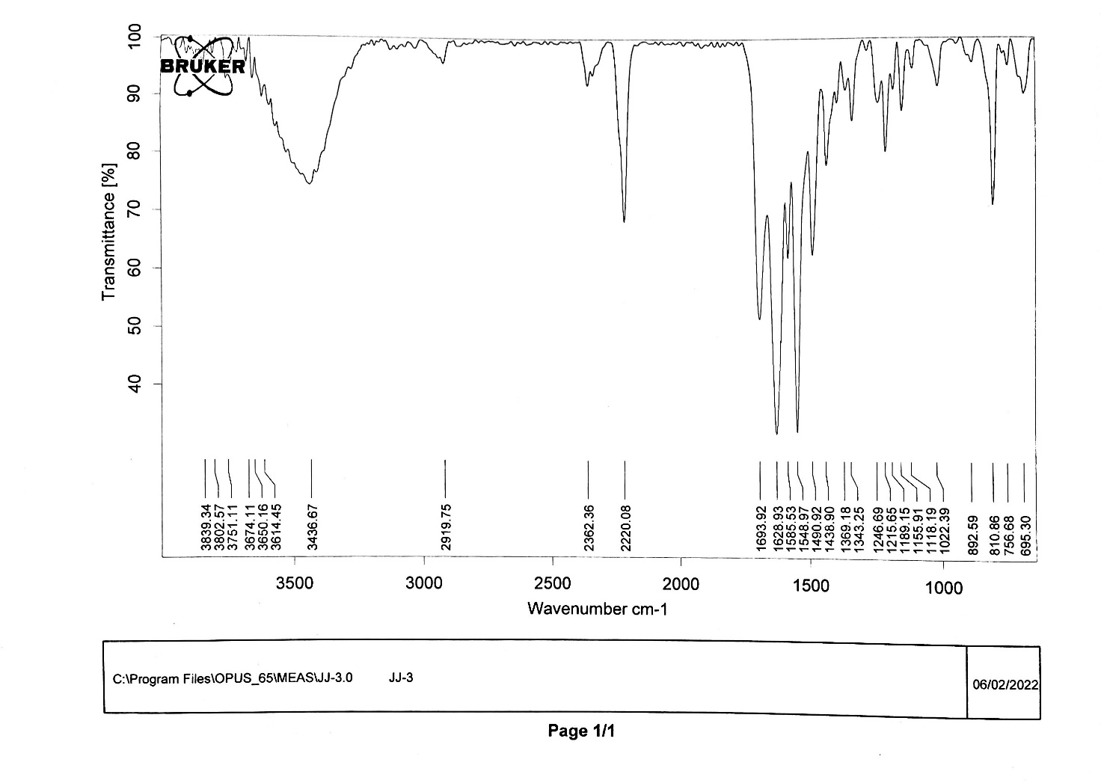

Figure (S21): FT-IR spectrum of compound 3d

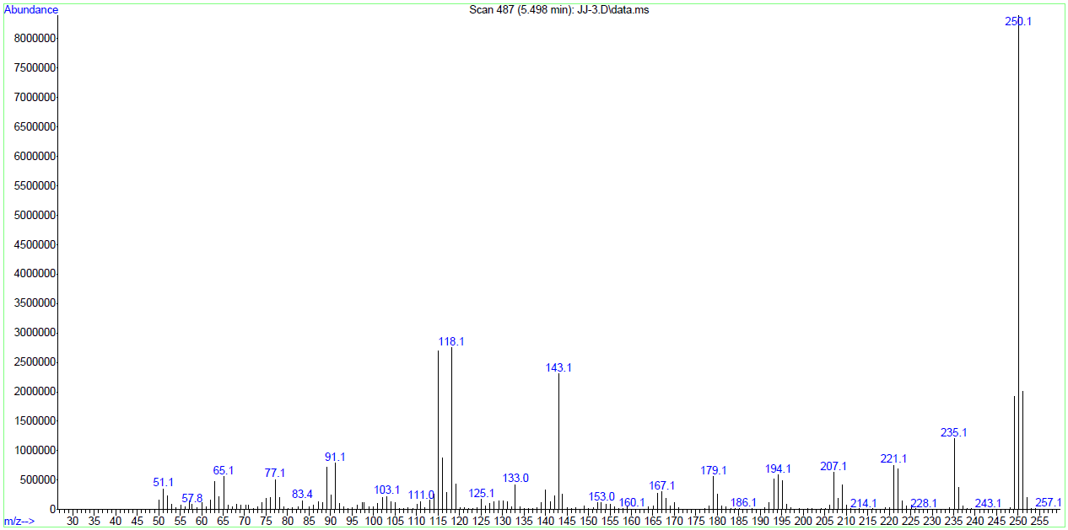

Figure (S22): Mass spectrum of compound 3d

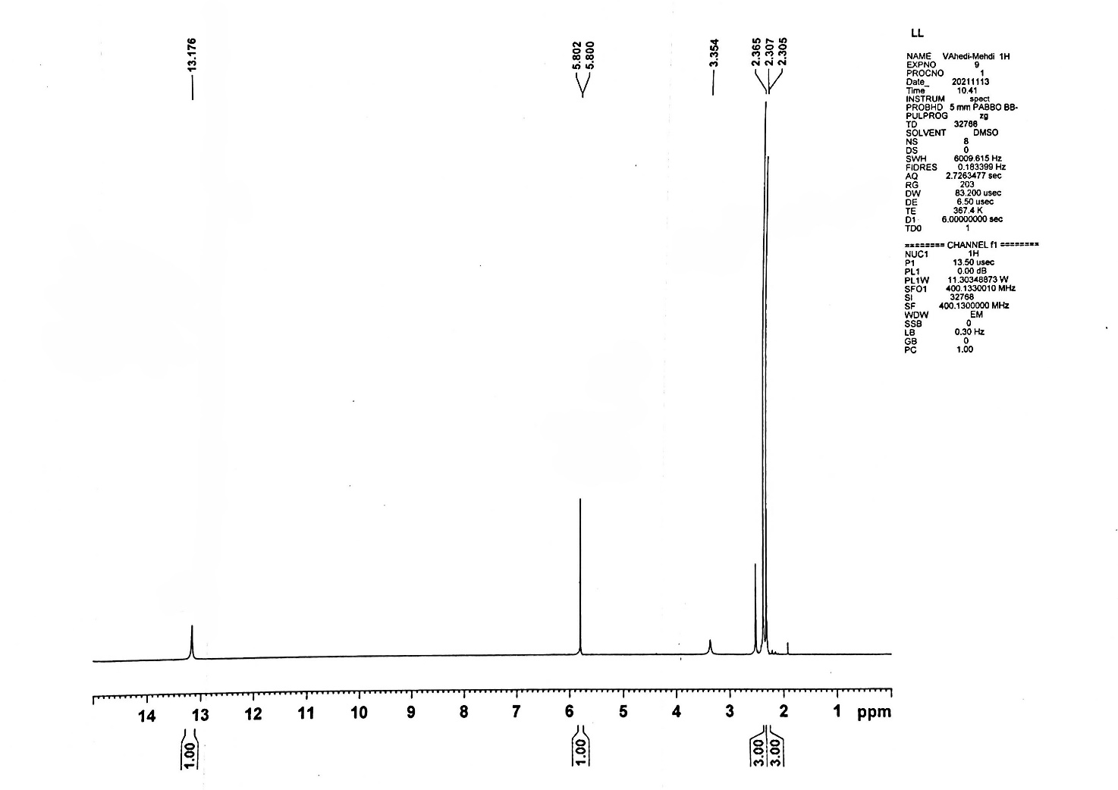

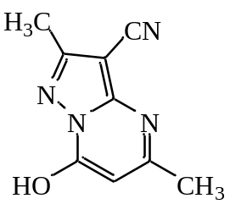

Figure (S23): ¹H NMR spectrum of compound 3e

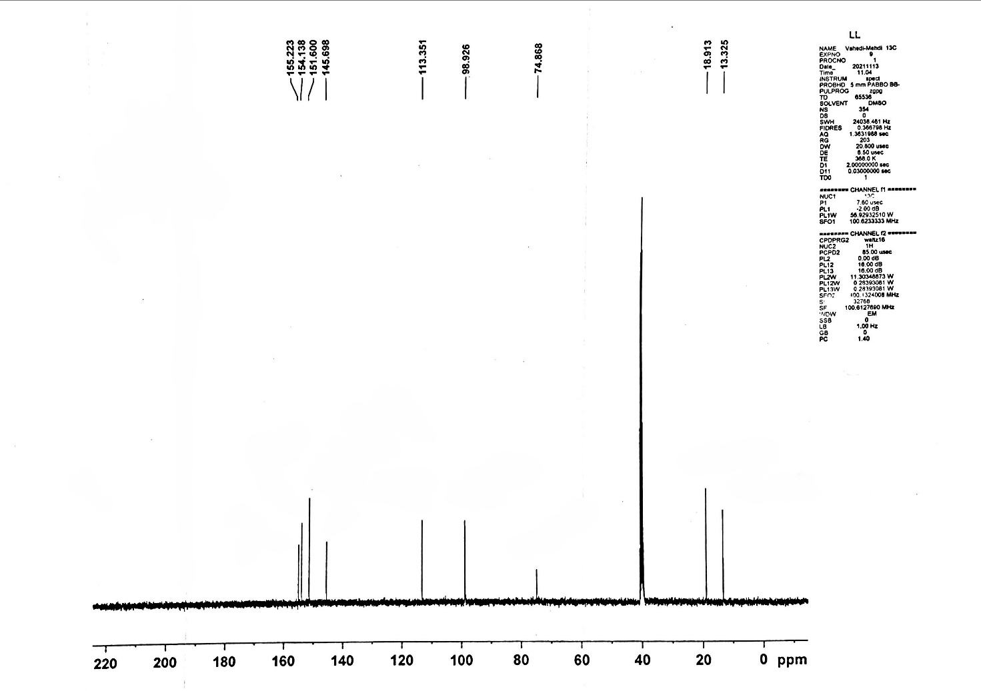

Figure (S24): ¹³C NMR spectrum of compound 3e

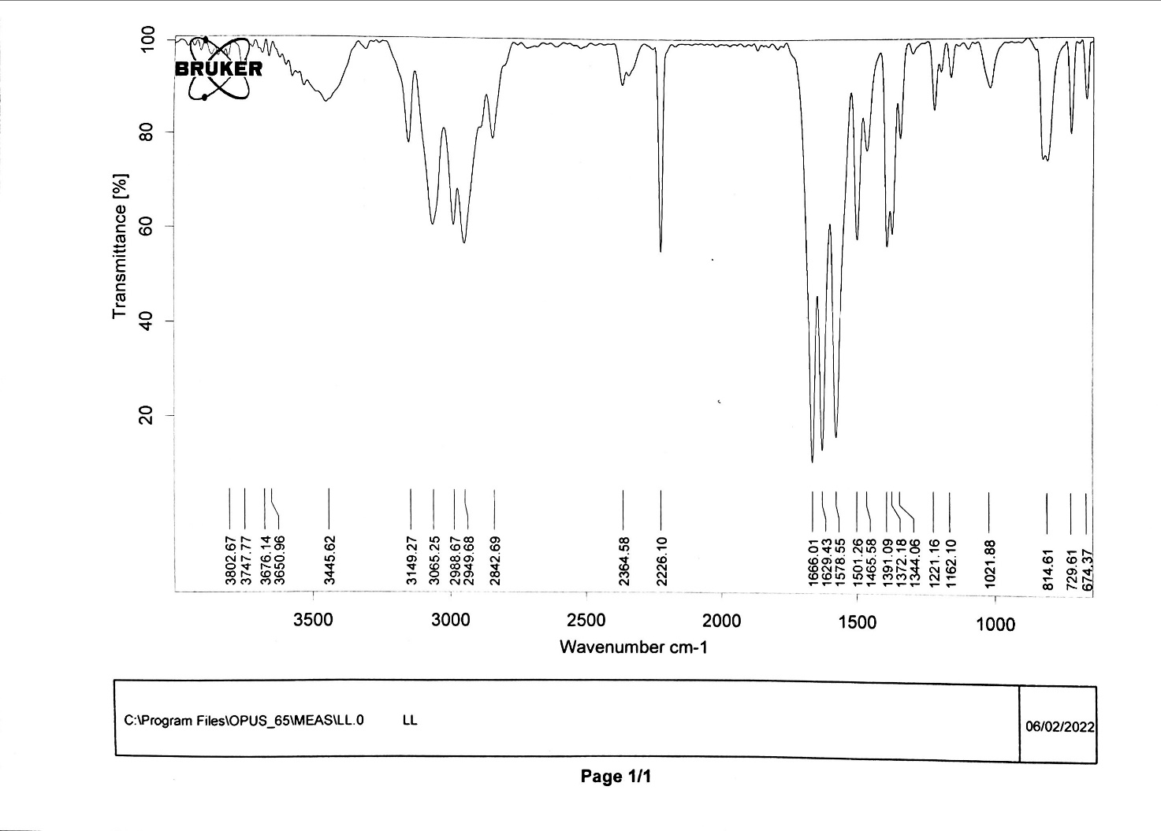

Figure (S25): FT-IR spectrum of compound 3e

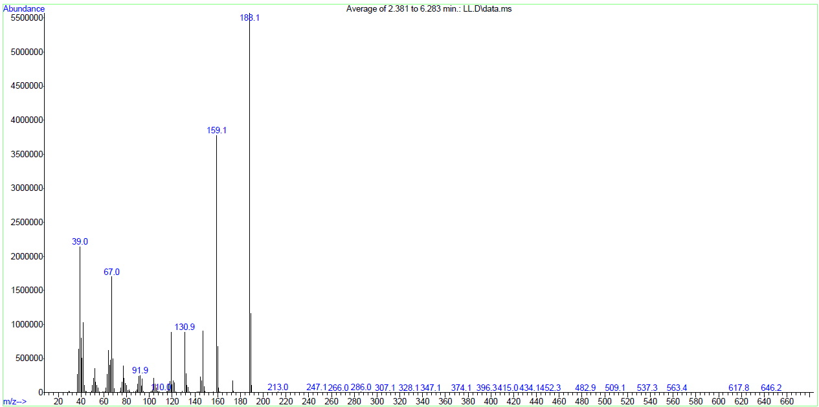

Figure (S26): Mass spectrum of compound 3e

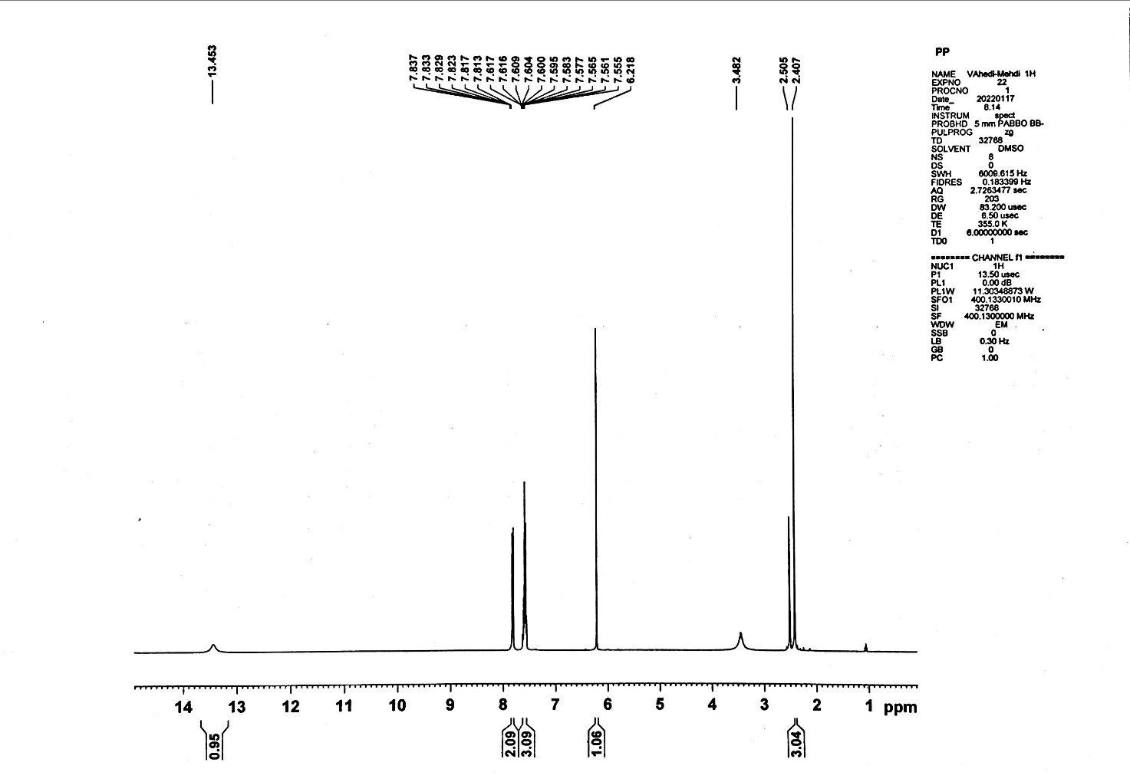

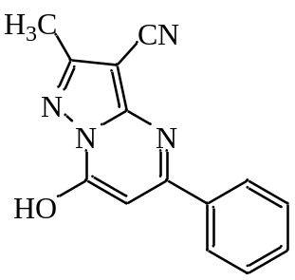

Figure (S27): ¹H NMR spectrum of compound 3f

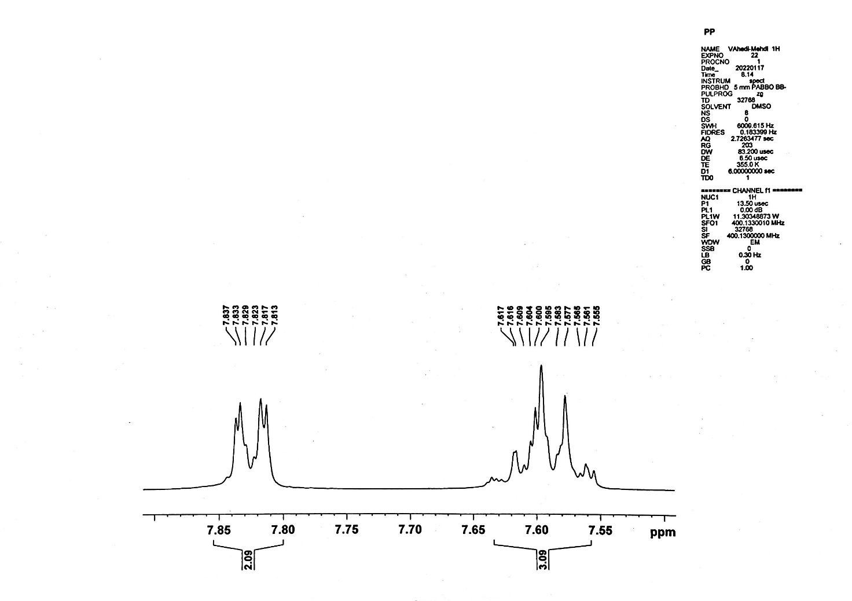

Figure (S28): ¹H NMR spectrum of compound 3f (Expand)

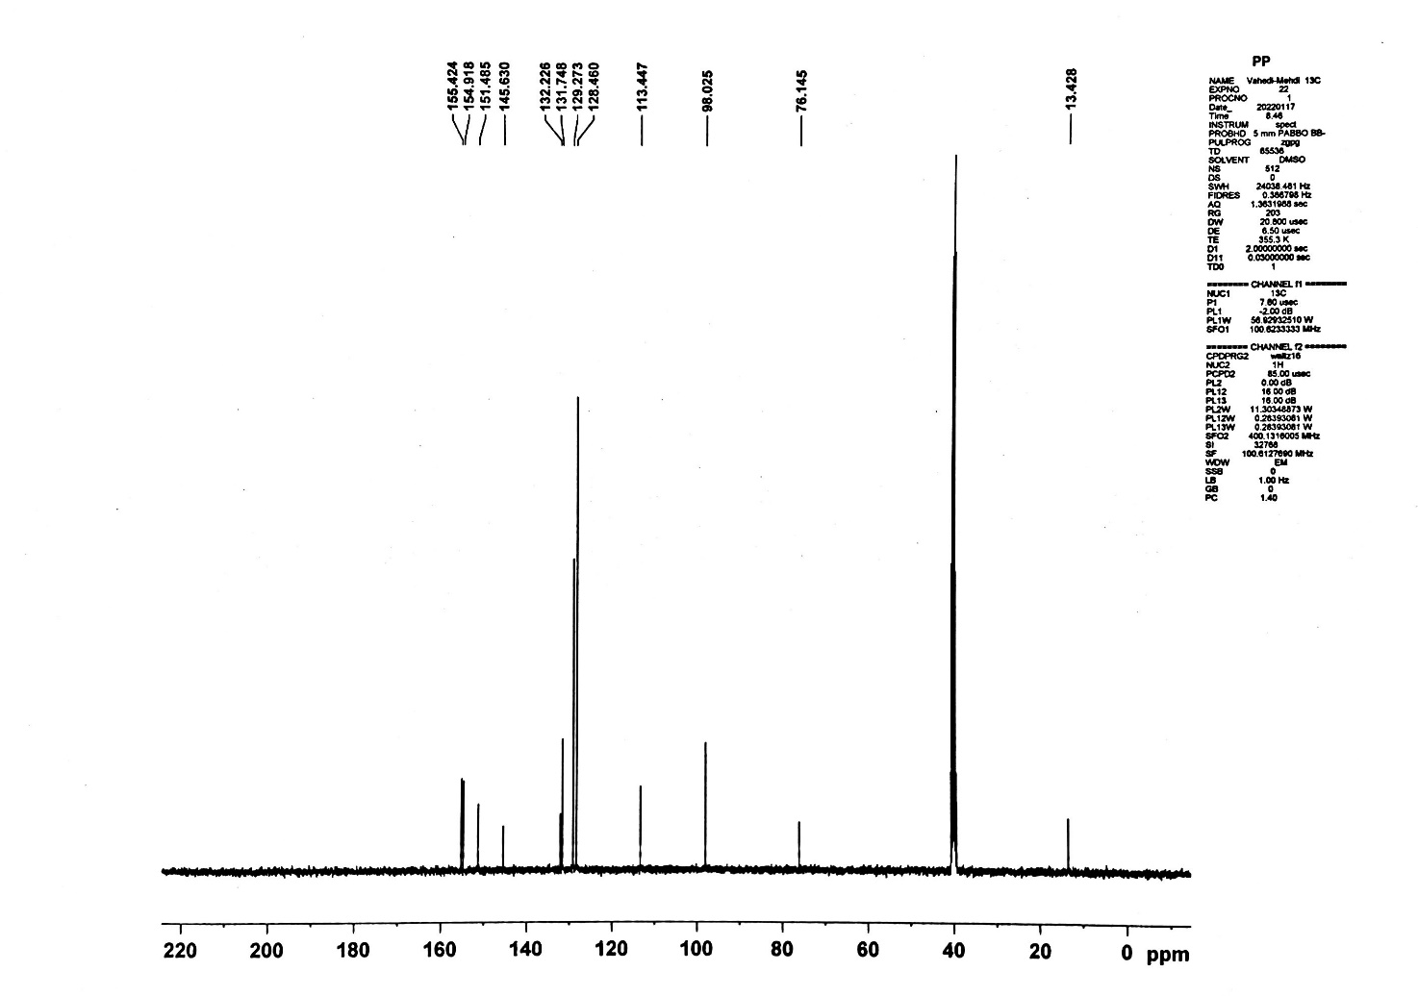

Figure (S29): ¹³C NMR spectrum of compound 3f

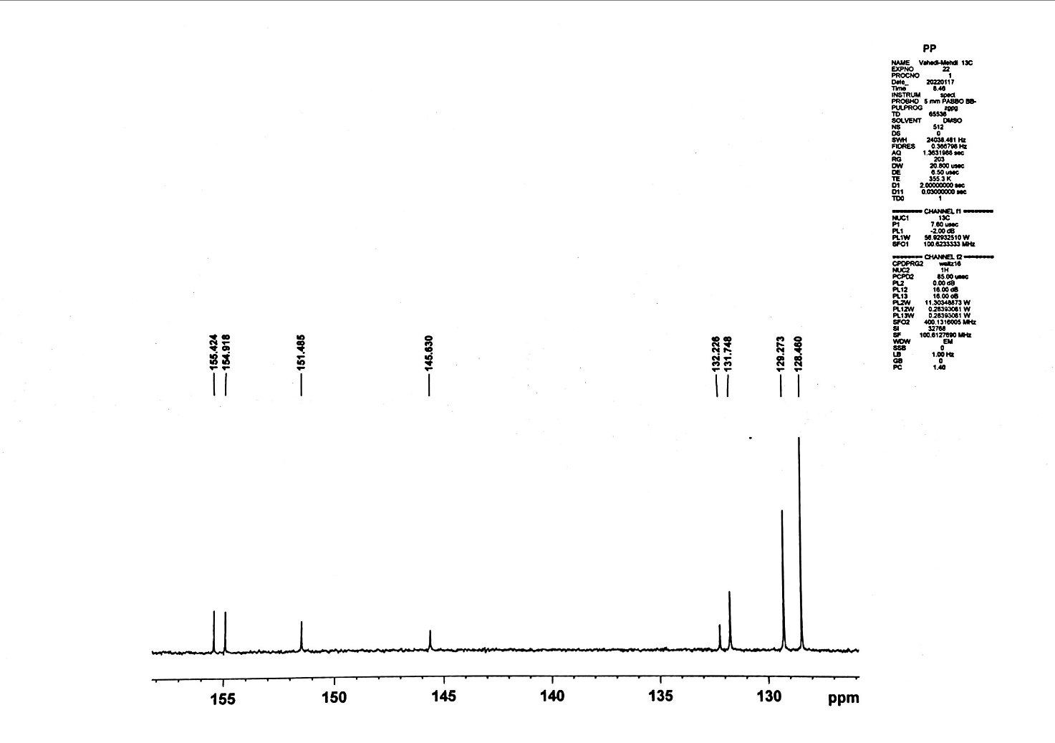

Figure (S30): ¹³C NMR spectrum of compound 3f (Expand)

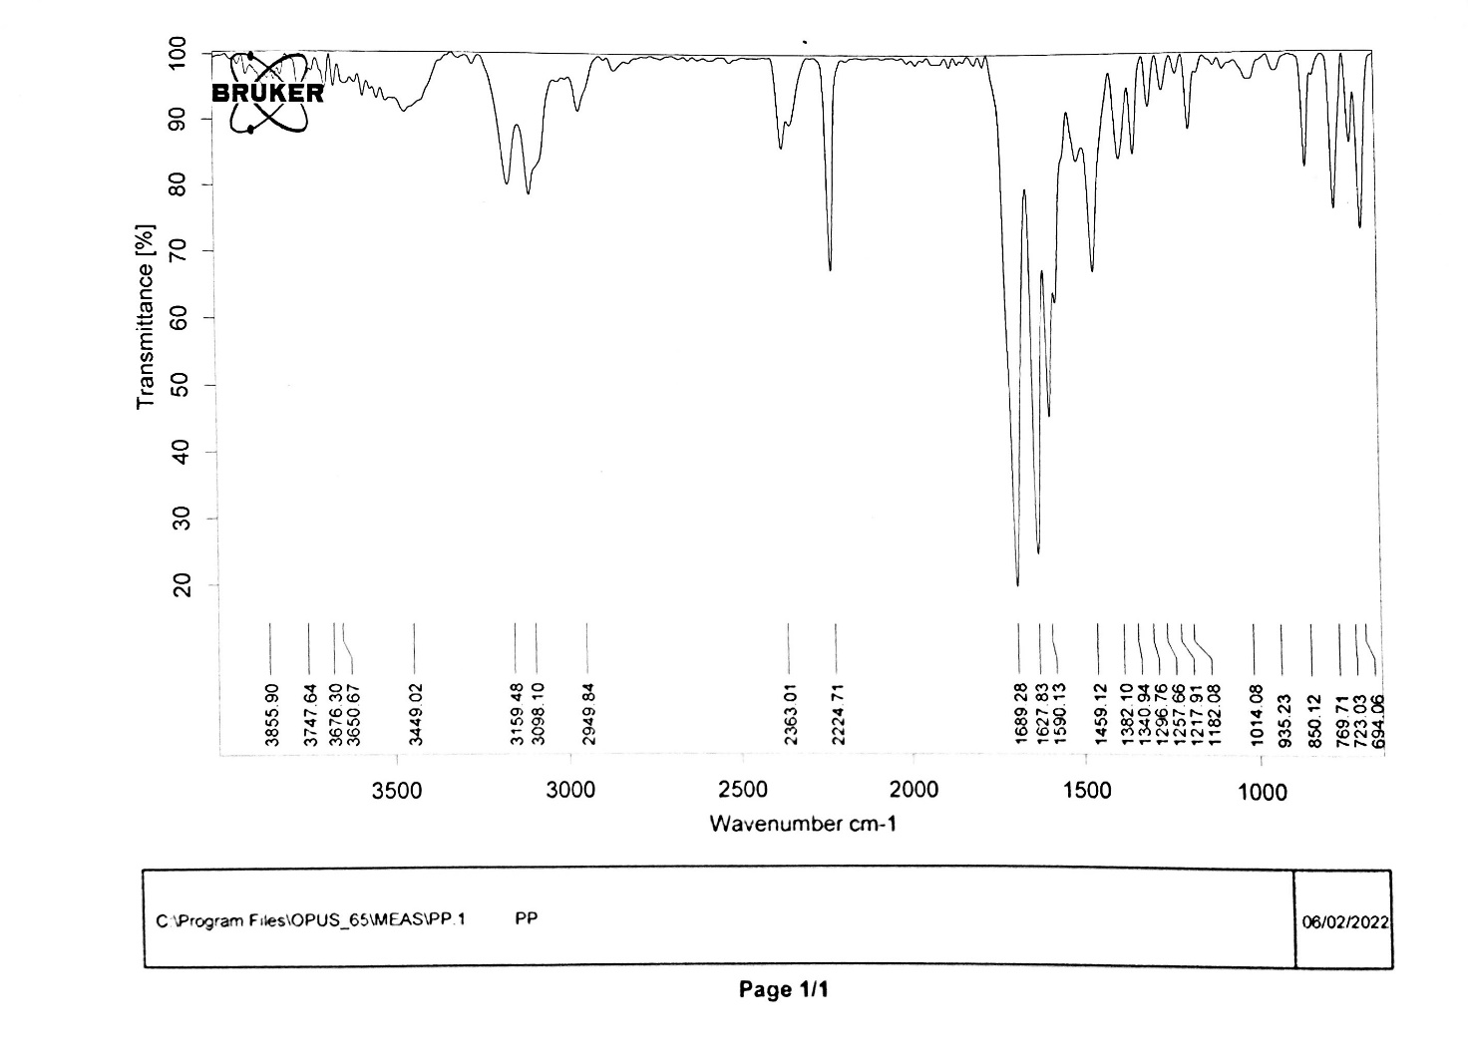

Figure (S31): FT-IR spectrum of compound 3f

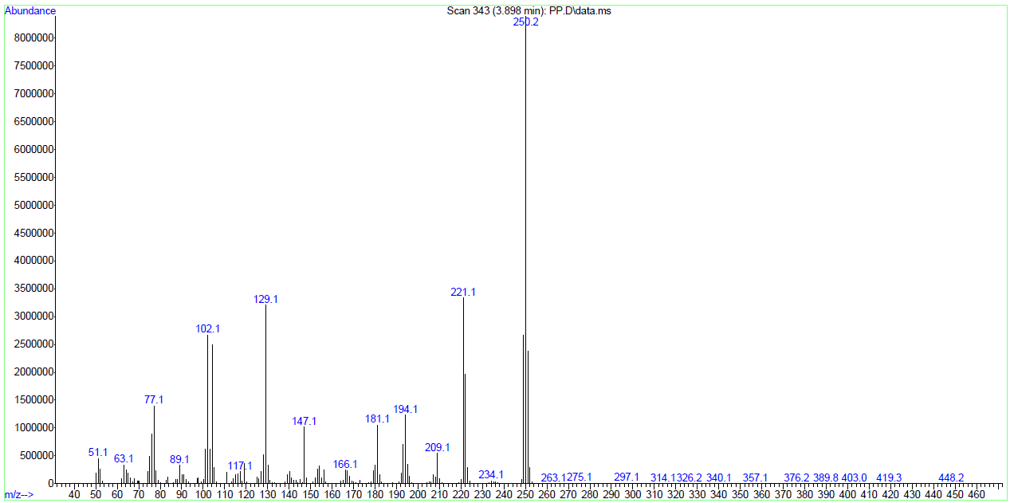

Figure (S32): Mass spectrum of compound 3f

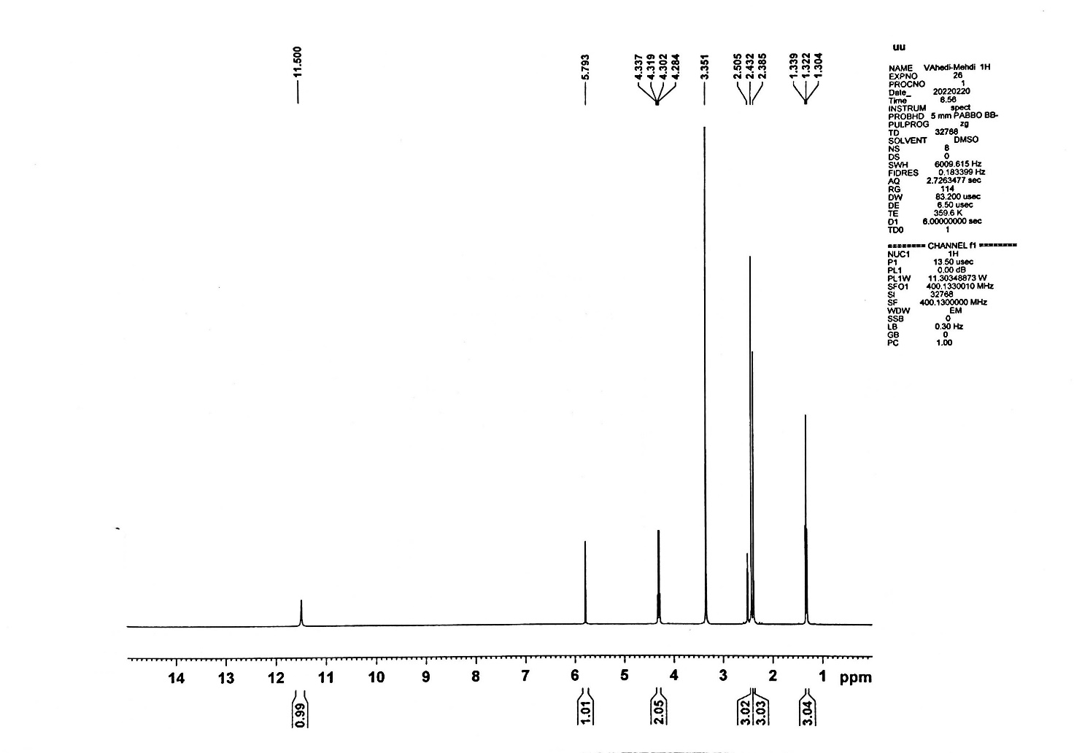

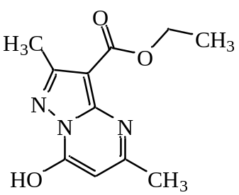

Figure (S33): ¹H NMR spectrum of compound 3g

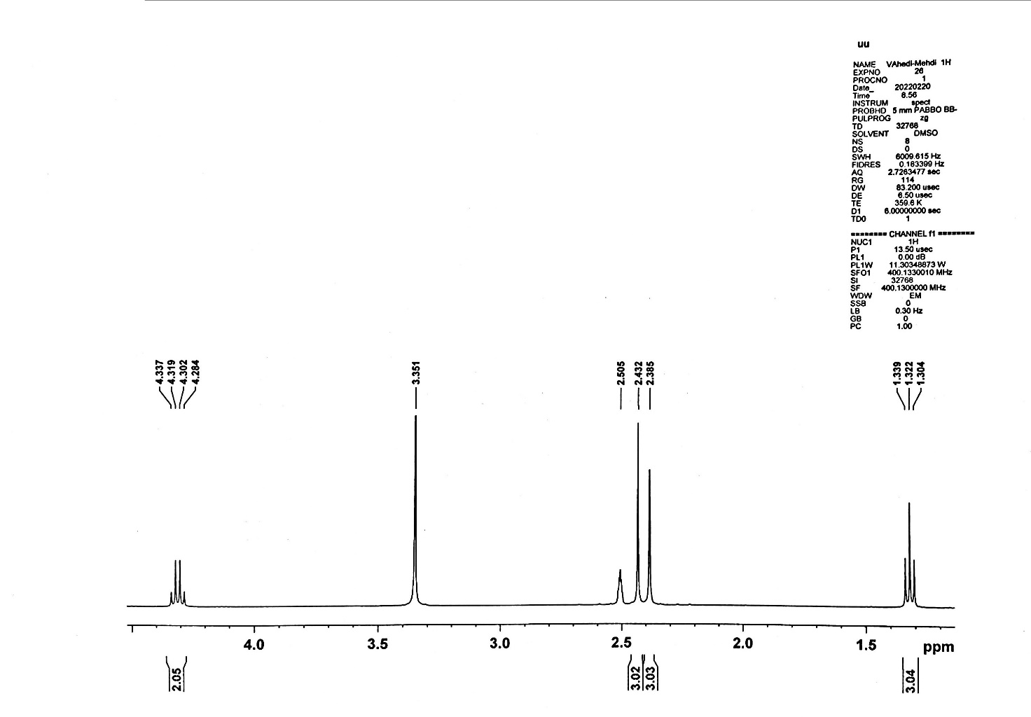

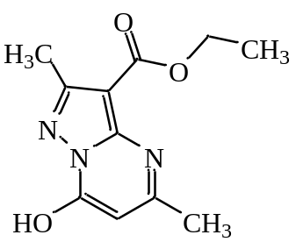

Figure (S34): ¹H NMR spectrum of compound 3g (Expand)

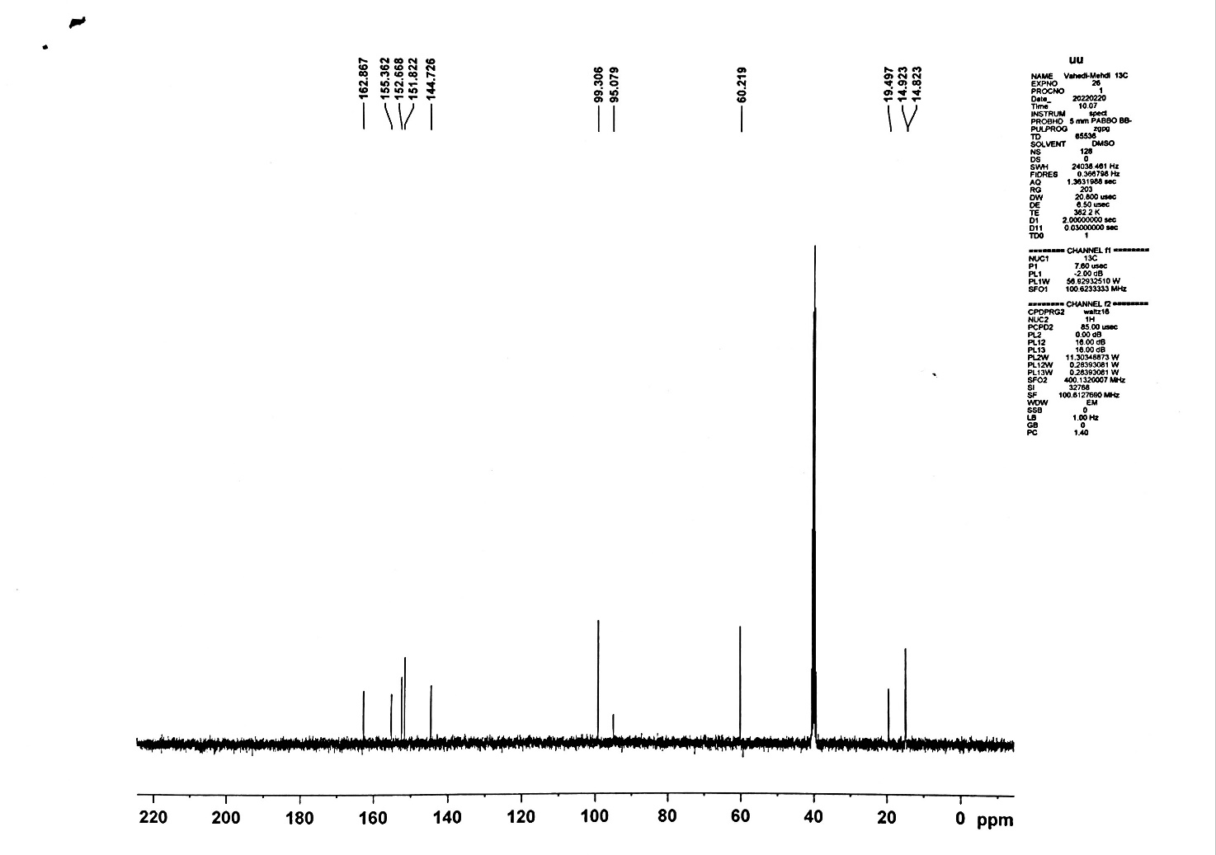

Figure (S35): ¹³C NMR spectrum of compound 3g

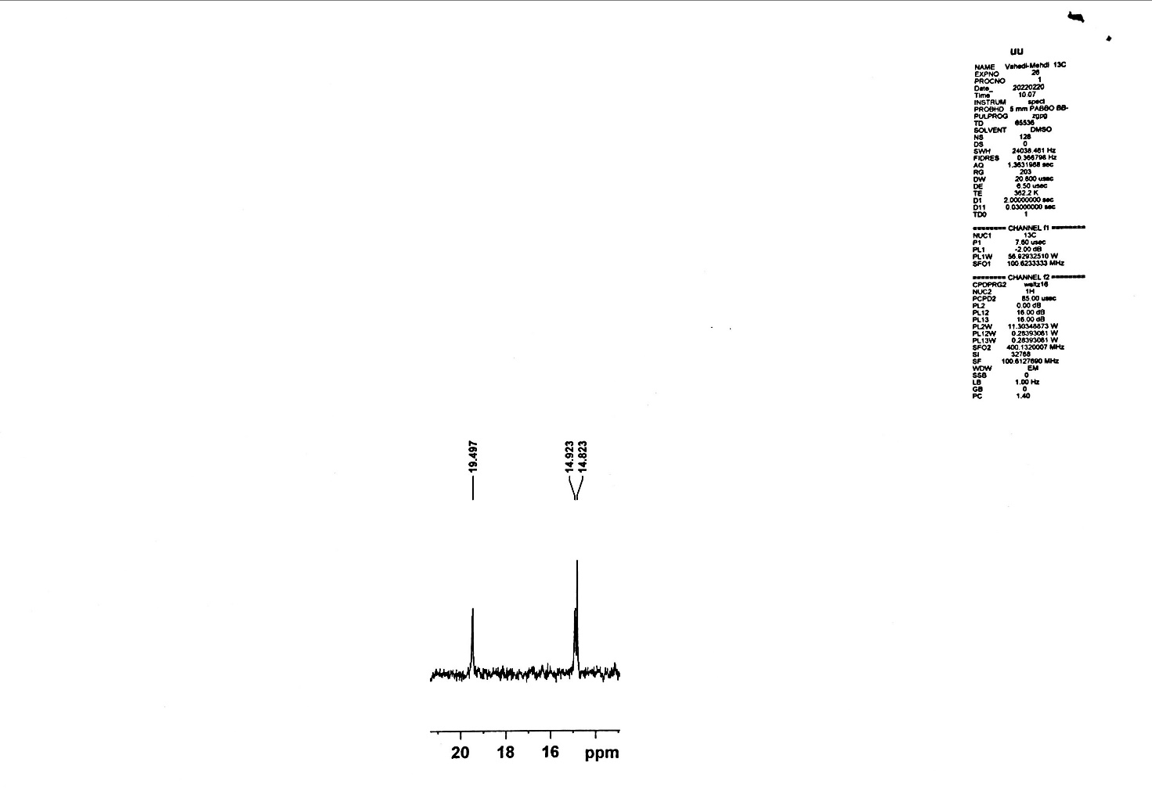

Figure (S36): ¹³C NMR spectrum of compound 3g (Expand)

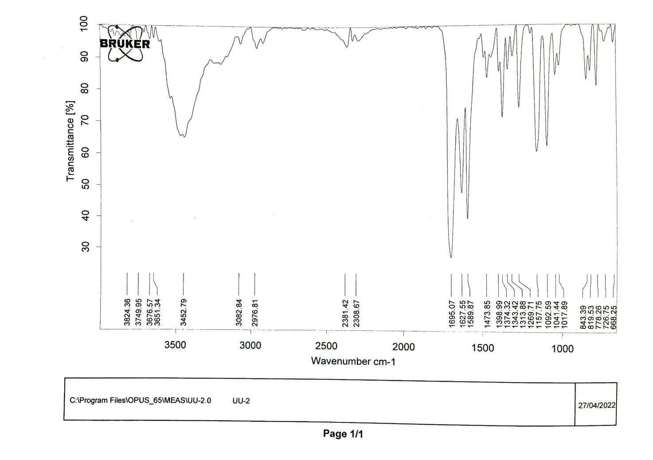

Figure (S37): FT-IR spectrum of compound 3g

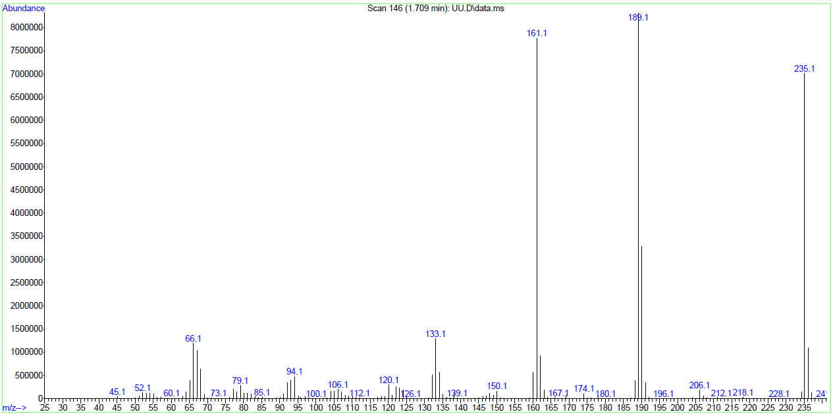

Figure (S38): Mass spectrum of compound 3g

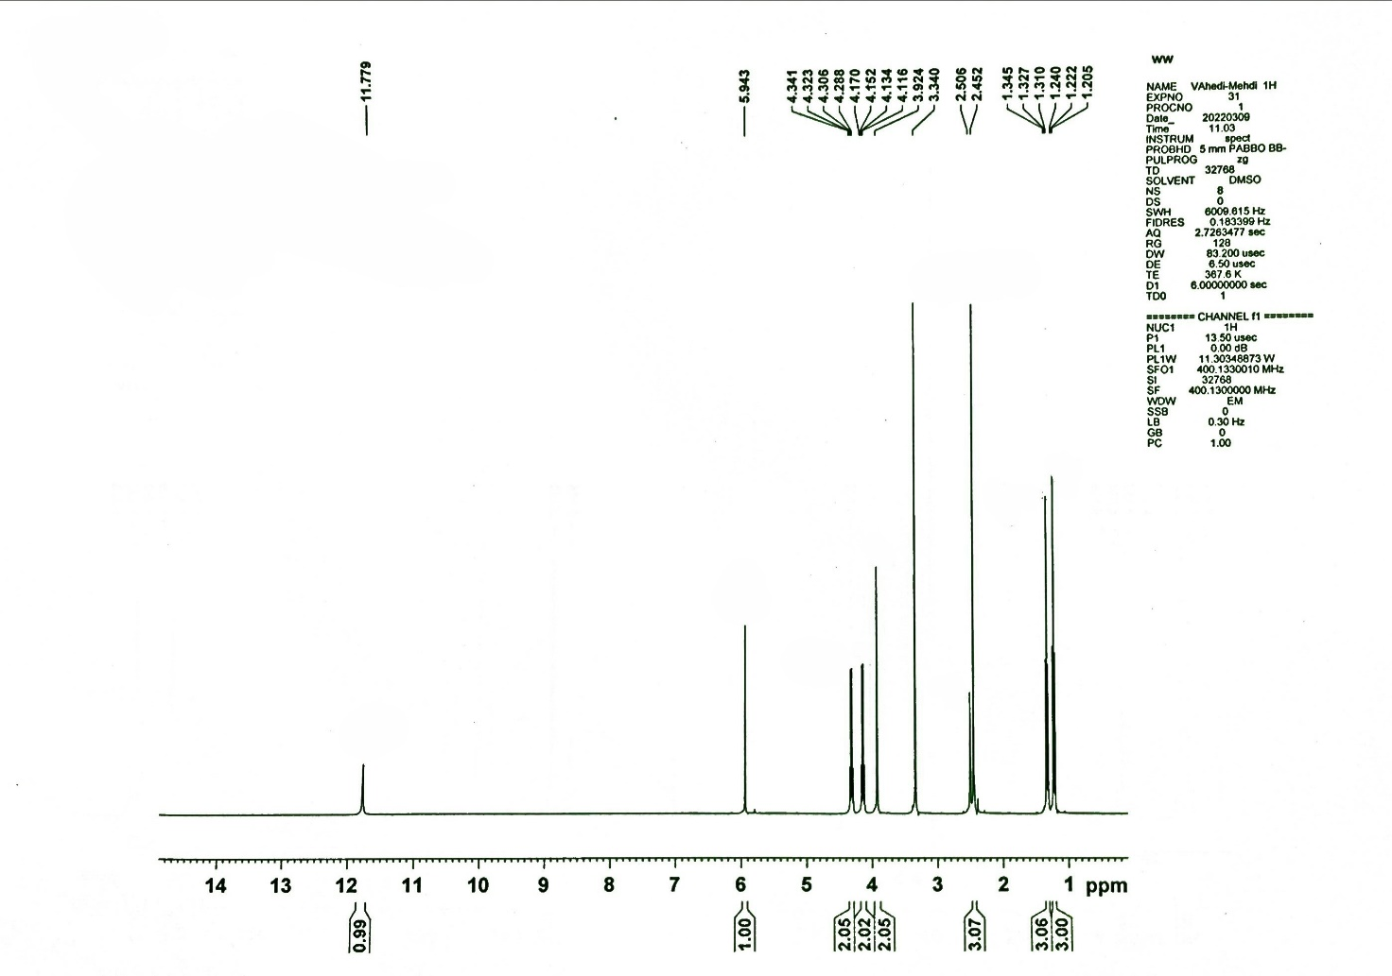

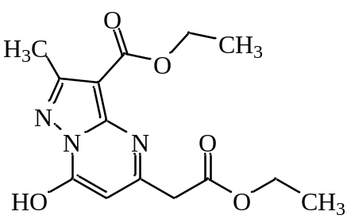

Figure (S39): ¹H NMR spectrum of compound 3h

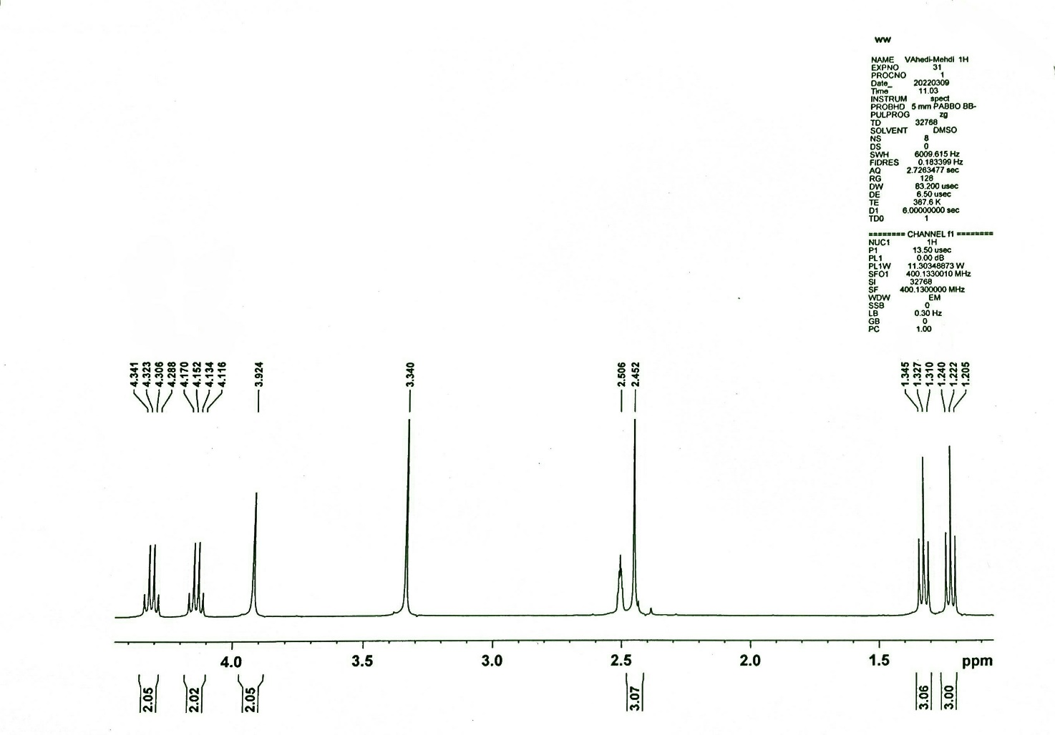

Figure (S40): ¹H NMR spectrum of compound 3h (Expand)

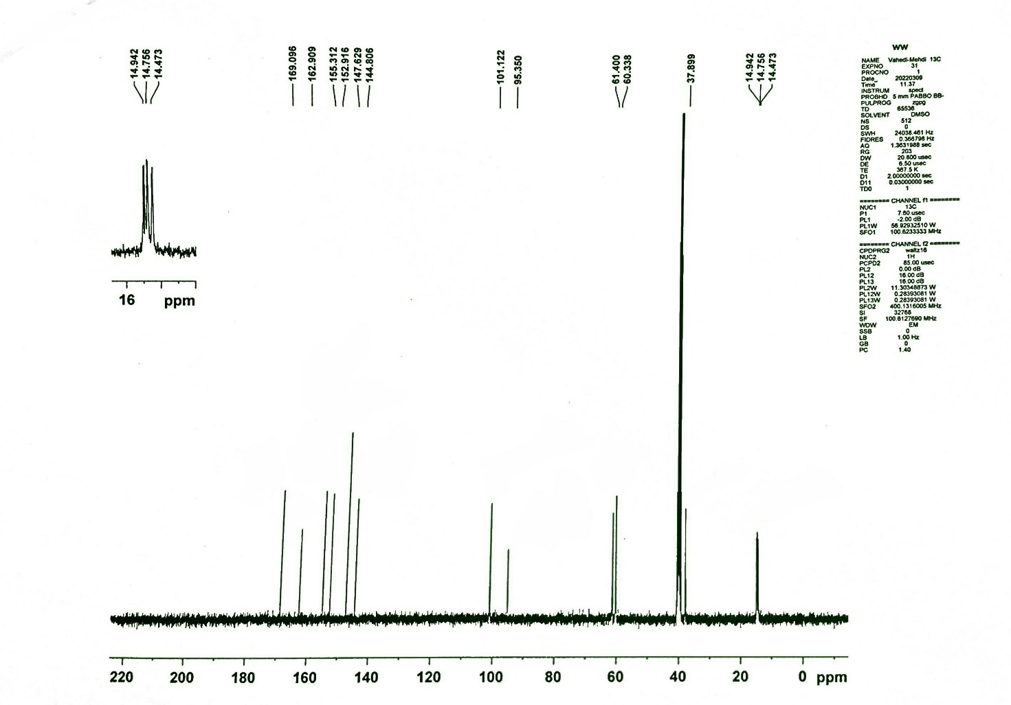

Figure (S41): ¹³C NMR spectrum of compound 3h

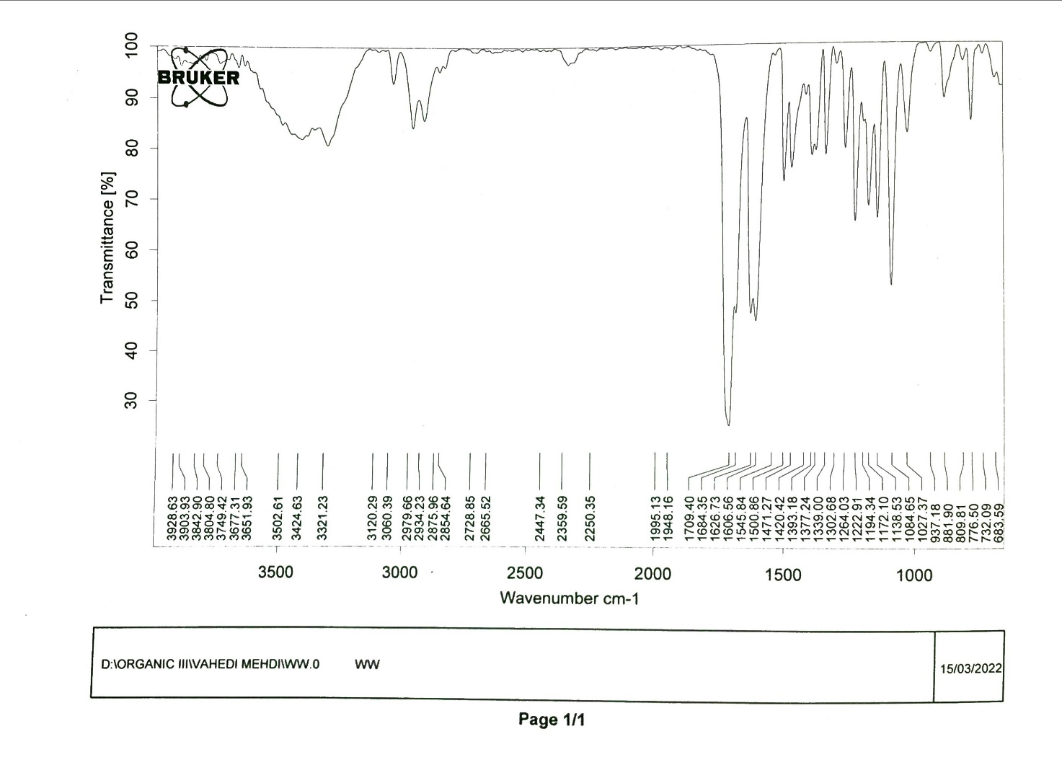

Figure (S42): FT-IR spectrum of compound 3h

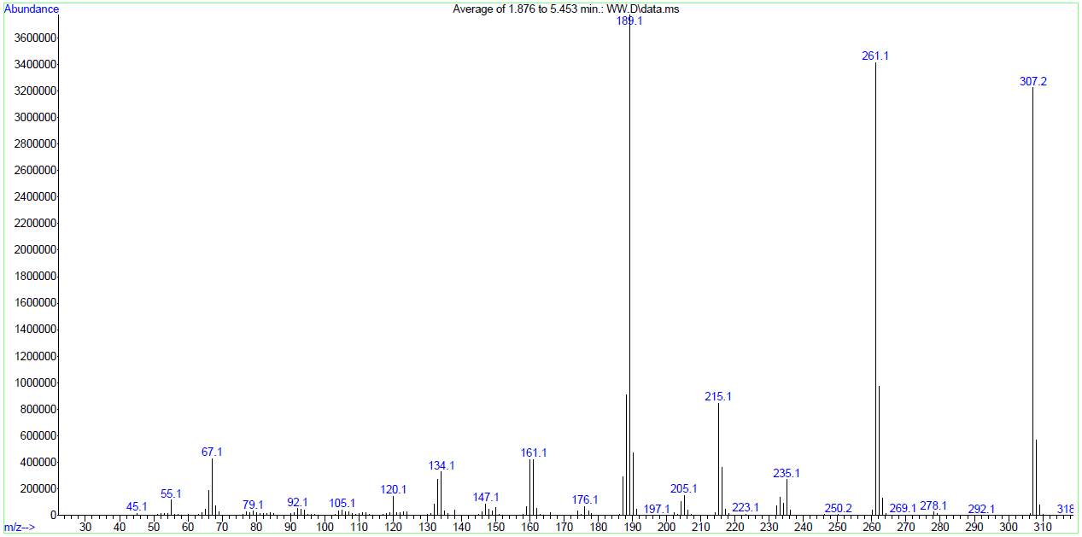

Figure (S43): Mass spectrum of compound 3h

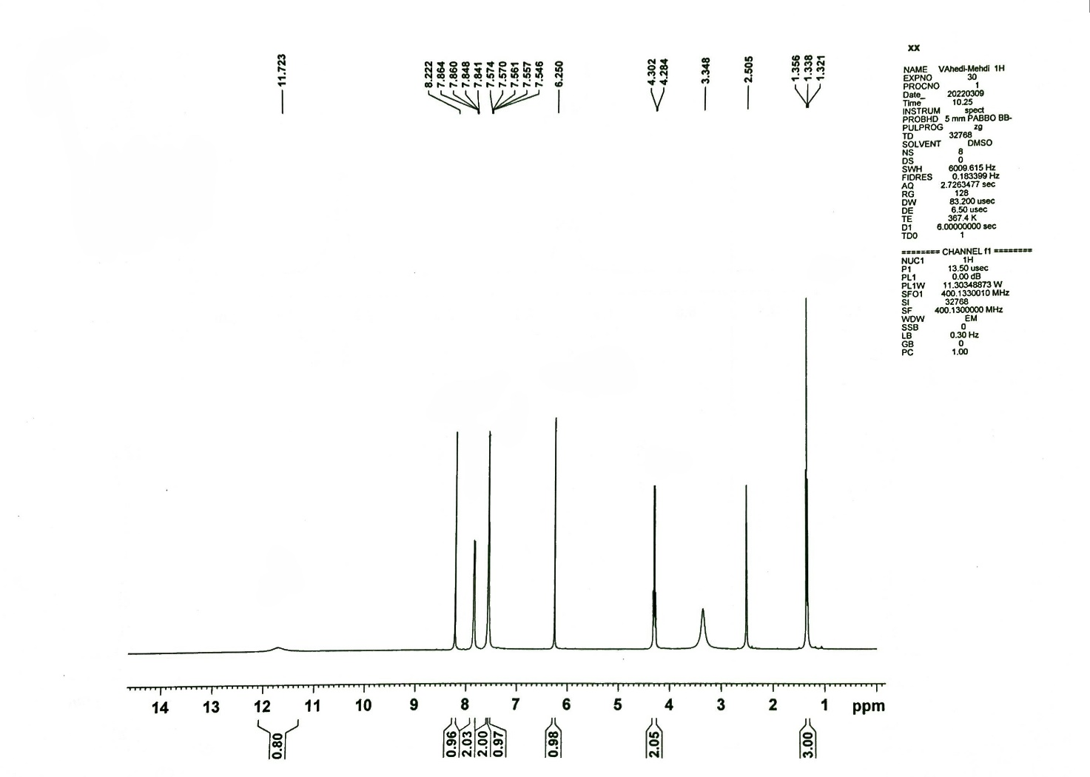

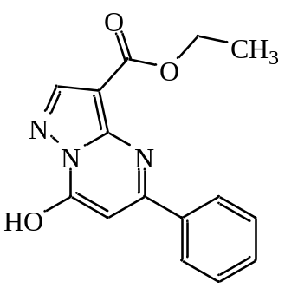

Figure (S44): ¹H NMR spectrum of compound 3i

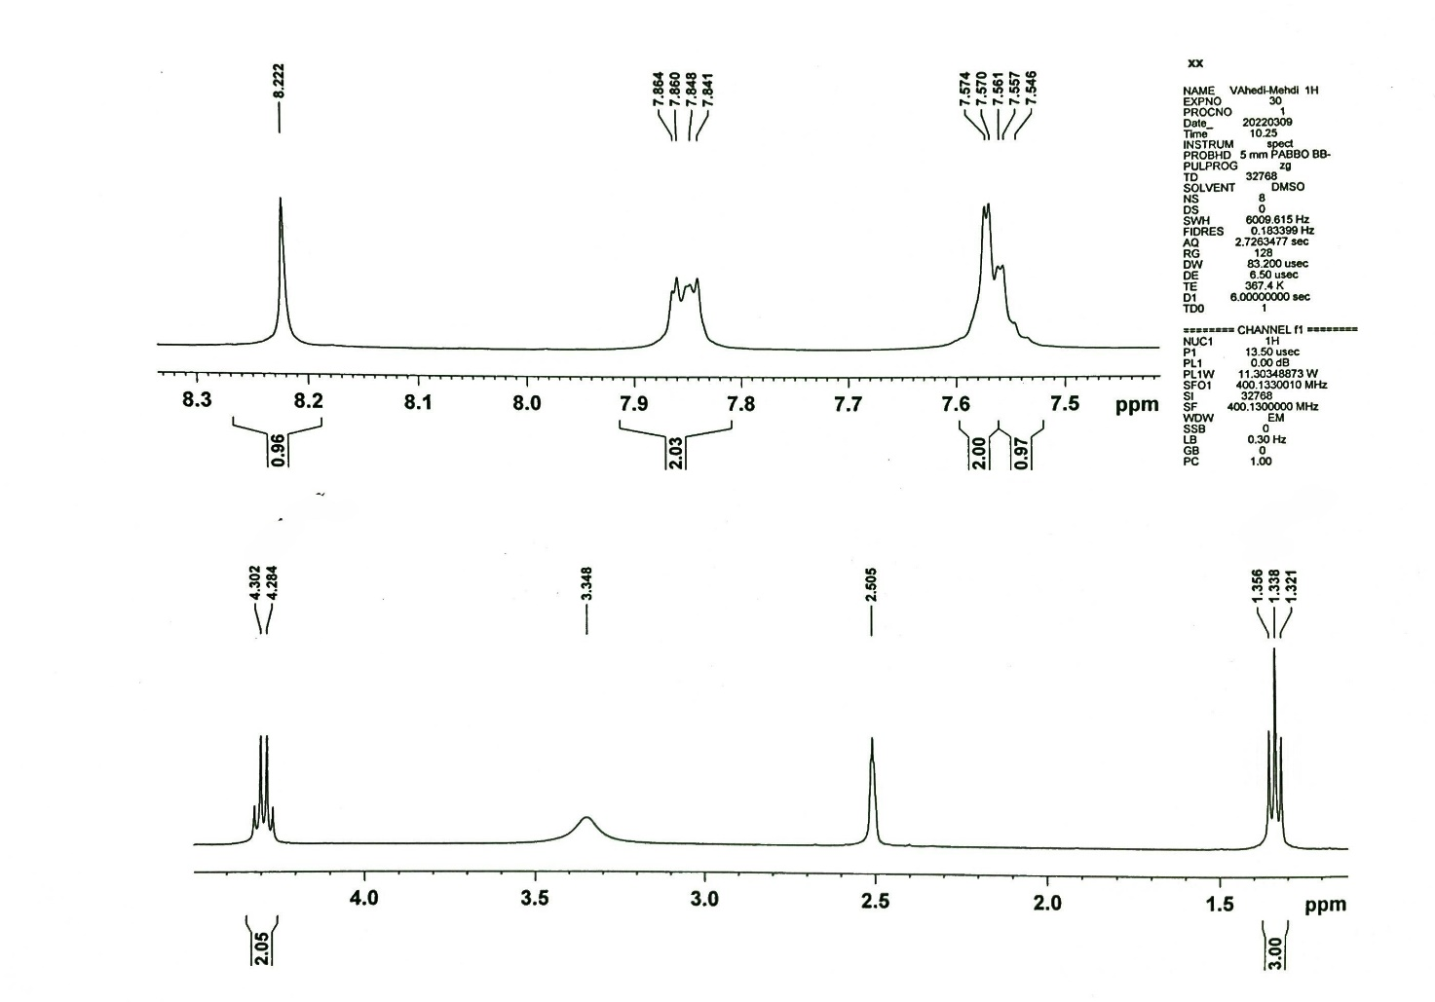

Figure (S45): ¹H NMR spectrum of compound 3i (Expand)

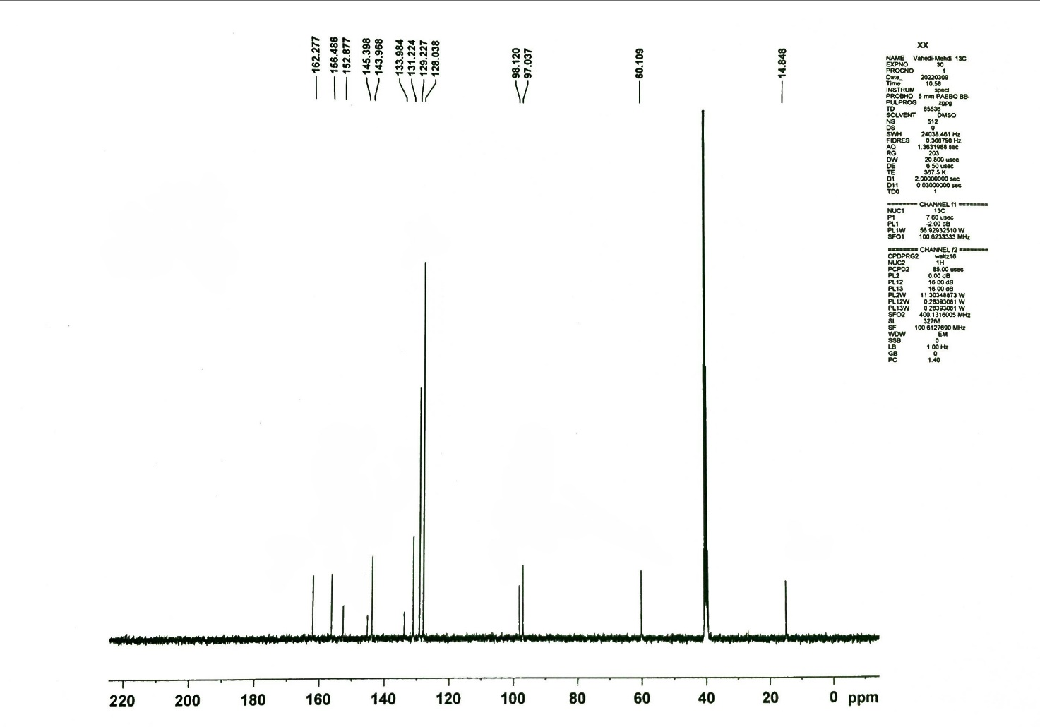

Figure (S46): ¹³C NMR spectrum of compound 3i

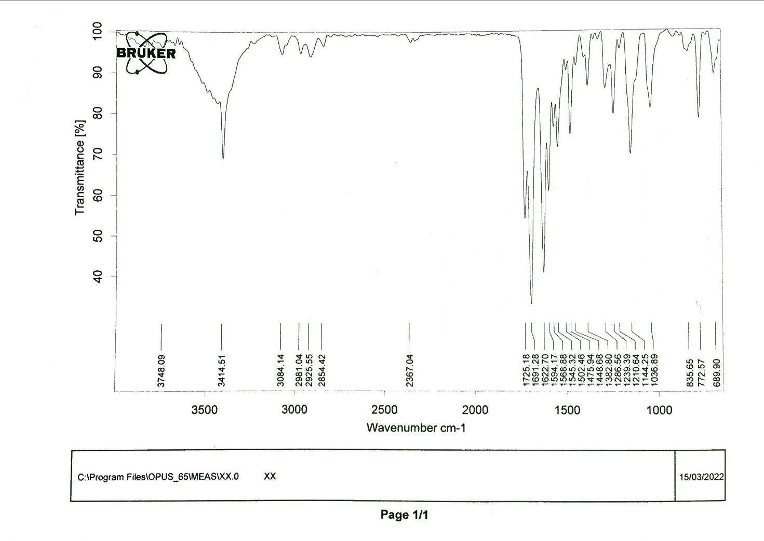

Figure (S47): FT-IR spectrum of compound 3i

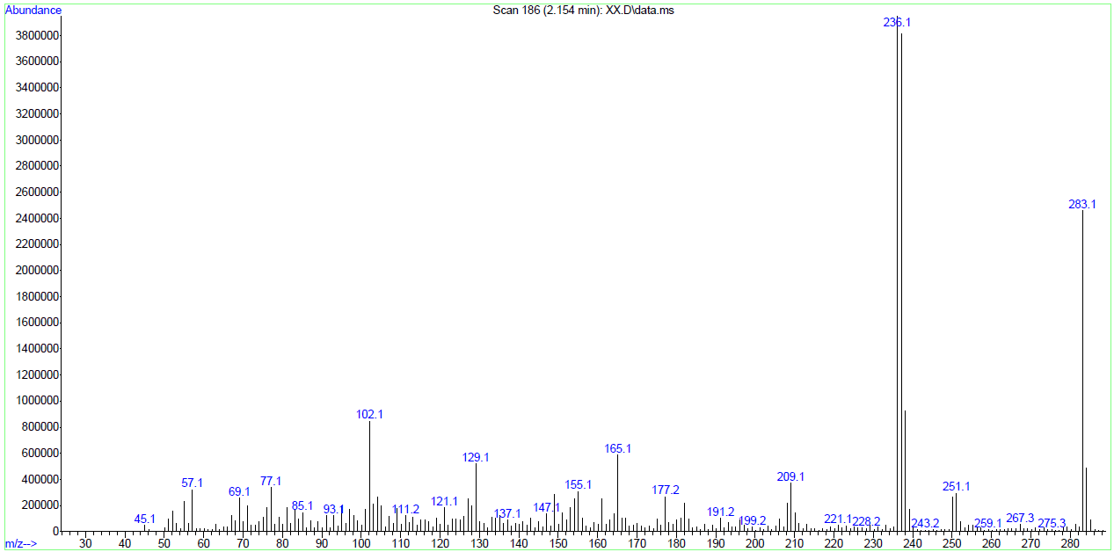

Figure (S48): Mass spectrum of compound 3i

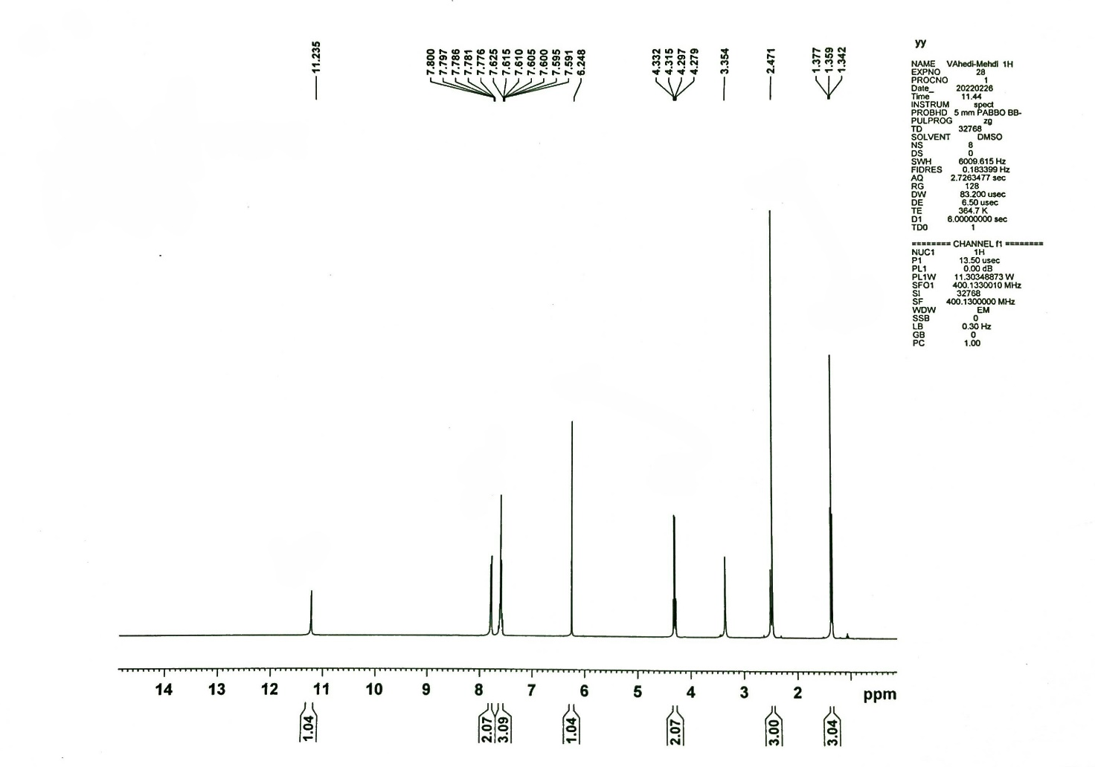

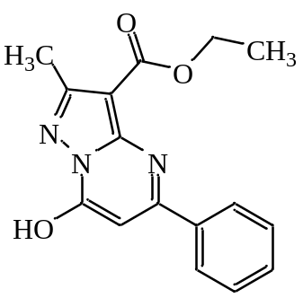

Figure (S49): ¹H NMR spectrum of compound 3j

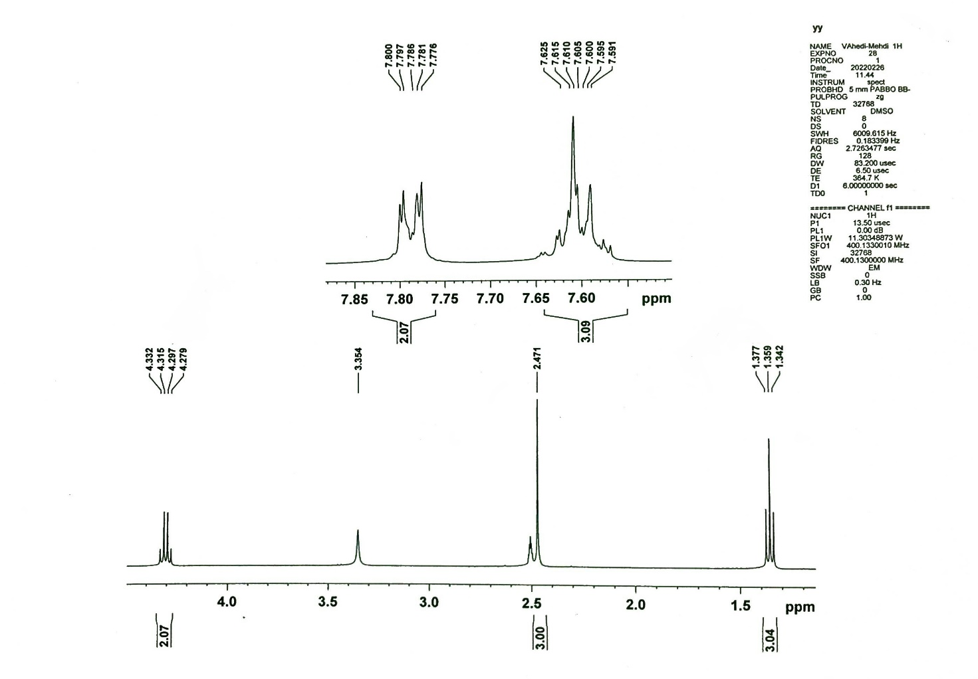

Figure (S50): ¹H NMR spectrum of compound 3j (Expand)

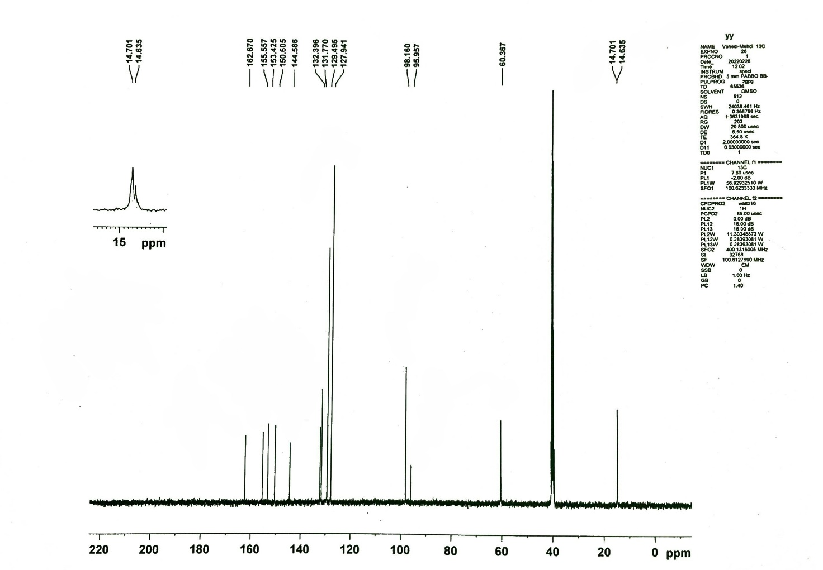

Figure (S51): ¹³C NMR spectrum of compound 3j

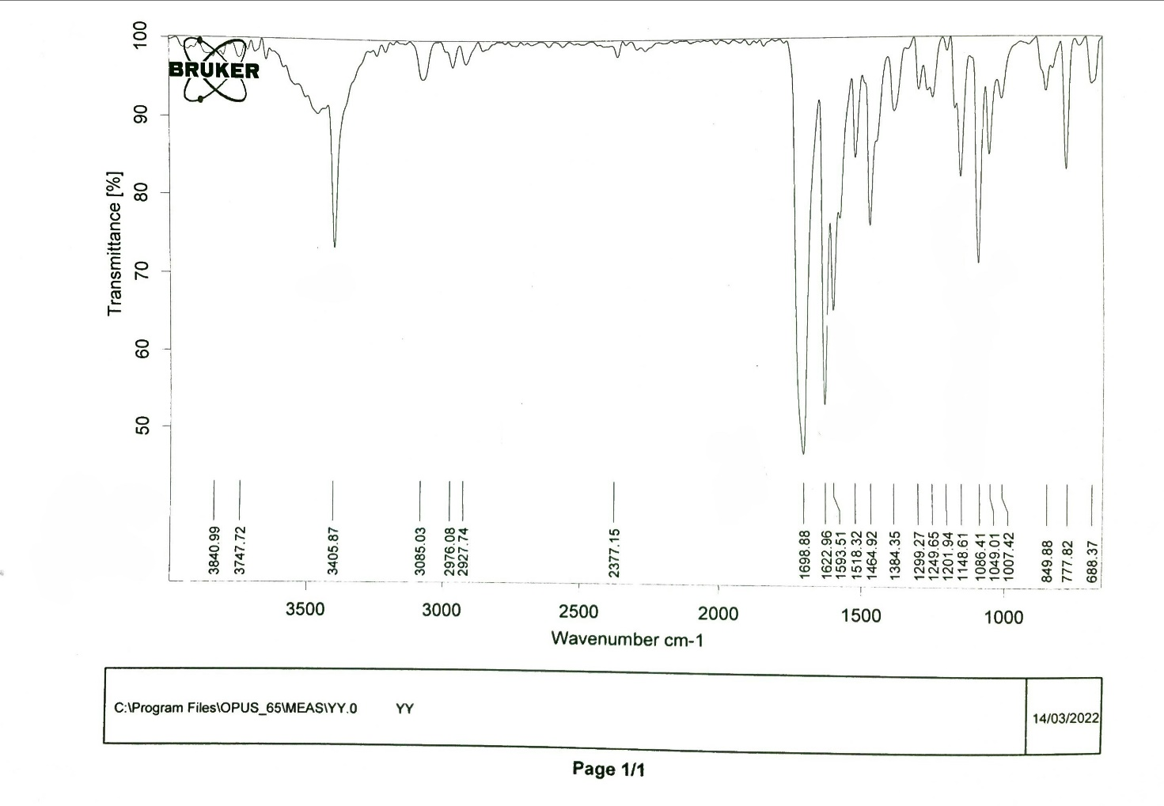

Figure (S52): FT-IR spectrum of compound 3j

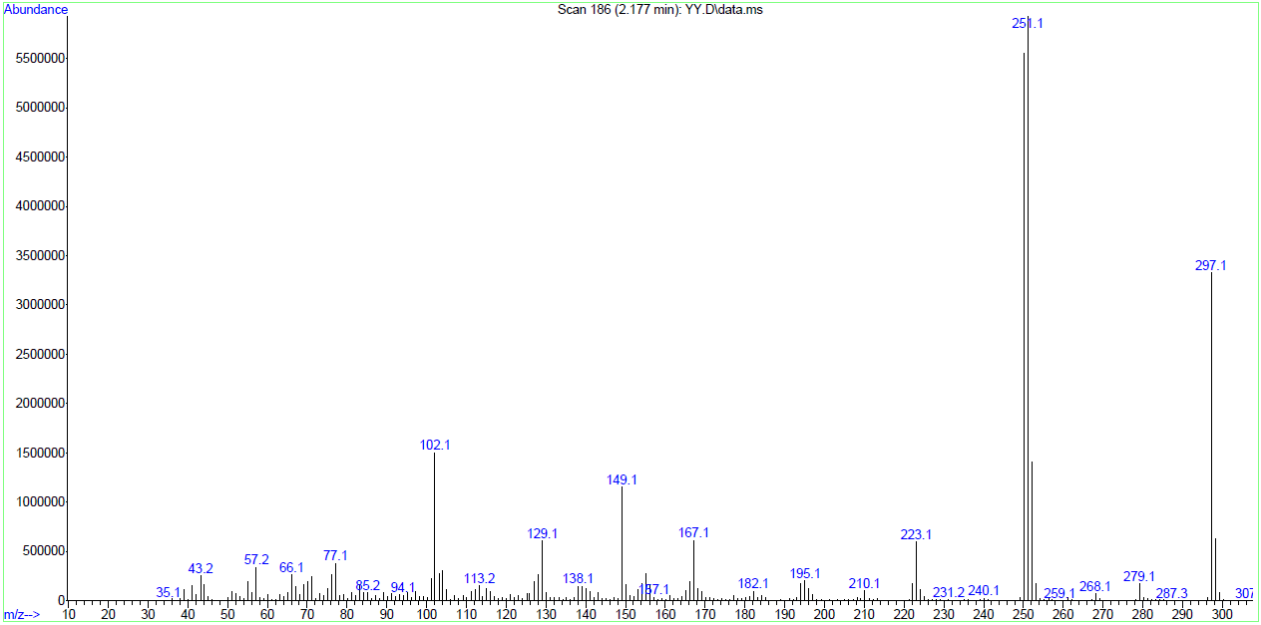

Figure (S53): Mass spectrum of compound 3j

Table (S1). Synthesis of pyrazaolo[1,5-a]pyrimidines (3a-j).
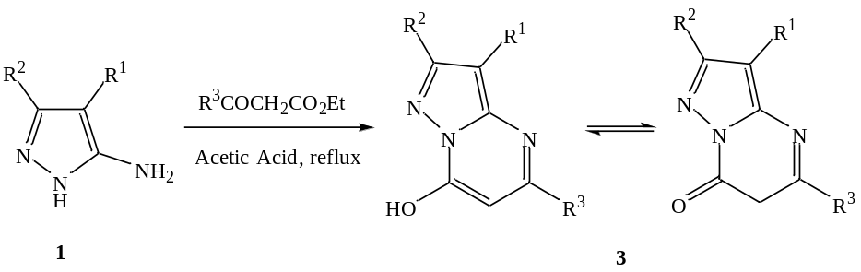
Products | R¹ | R² | R³ | Time (h) | Yield (%)ª
3a | CN | H | CH₃ | 4 | 93
3b | CN | H | CH₂CO₂Et | 10 | 87
3c | CN | H | 4-Cl-C₆H₄ | 8 | 90
3d | CN | H | 4-CH₃-C₆H₄ | 10 | 73
3e | CN | CH₃ | CH₃ | 6 | 86
3f | CN | CH₃ | C₆H₅ | 10 | 81
3g | CO₂Et | CH₃ | CH₃ | 6 | 88
3h | CO₂Et | CH₃ | CH₂CO₂Et | 10 | 82
3i | CO₂Et | H | C₆H₅ | 10 | 78
3j | CO₂Et | CH₃ | C₆H₅ | 10 | 75
ªIsolated yield

Antioxidant

Table (S2). The DPPH radical scavenging ability of compounds 3a-j.
Compounds | IC₅₀ (μM)
3a | 30.16
3b | 18.09
3c | 21.54
3d | 25.81
3e | 33.99
3f | 24.25
3g | 27.77
3h | 15.34
3i | 19.06
3j | 23.06
Ascorbic acid | 13.53

In vitro cell viability

Table (S3). The cytotoxic effect of compounds 3a-j.
Compounds | IC₅₀ (μg/mL)
3a | 197.5
3b | NE*
3c | 122.2
3d | 131.2
3e | 194.8
3f | 55.97
3g | 228.9
3h | NE
3i | 95.92
3j | 87.28
*NE: No Effect

Antibacterial activity

Table (S4). In vitro antibacterial activities of the synthesized compounds (3a-j) via the Kirby-Bauer Disk Diffusion method (ZOI, mm).
Compounds | Bacteria Strain
Compounds | E. coli | P. aeruginosa | S. aureus | B. subtilis
3a | 7.5±0.7 | 7.5±0.7 | 8.5±0.7 | 11.0±1.4
3b | 10.0±1.4 | 7.5±0.7 | 9.0±1.4 | 10.5±0.7
3c | NE | 9.0±1.4 | 10.0±1.4 | 13.5±0.7
3d | NE | 8.0±1.4 | 9.5±0.7 | 12.0±1.4
3e | 7.5±0.7 | 8.0±1.4 | 8.0±1.4 | 9.5±0.7
3f | NE | 9.0±1.4 | 9.5±0.7 | 17.5±0.7
3g | NE | NE | NE | 7.5±0.7
3h | 8.5±0.7 | 7.5±0.7 | 12.0±1.4 | 8.5±0.7
3i | NE | NE | 17.0±1.4 | 23.0±1.4
3j | NE | NE | 8.0±1.4 | 11.0±1.4
Gentamicin  (10 μg/disc) | 19.6±1.1 | 15.6±0.5 | 20.3±1.5 | 26.0±1.7
Chloramphenicol  (30 μg/disc) | 20.7±1.5 | NE | 21.7±0.6 | 22.3±1.2
Concentration of compound: 20 mg.mL⁻¹
NE: No Effect

Figure (S54). Inhibition zone bar graphs of compounds 3a-j.

Table (S5). In vitro antibacterial activities of the synthesized compounds 3a-j via the minimum inhibitory concentration method (mM).
Compounds | Bacteria Strain
Compounds | E. coli | B. subtilis
3a | 1.25 | 1.25
3b | 1.25 | 1.25
3c | 2.5 | 1.25
3d | 2.5 | 1.25
3e | 1.25 | 2.5
3f | 2.5 | 0.625
3g | >2.5 | 2.5
3h | 1.25 | 2.5
3i | 2.5 | 0.312
3j | 2.5 | 1.25
Cefixime | 0.02 | 0.01

