The role of neutrophil extracellular traps in pathological mineralisation
Mei-chen Wan^{†,1}, Kai Jiao^{†,1}, Yi-na Zhu^{†,1}, Qian-qian Wan^{†,1}, Long-zhang Niu¹, Chen Lei¹, Jing-han Song¹, Wei-cheng Lu¹, Hua-jie Liu¹, Franklin Tay², Li-na Niu^{1,}*

† Equal contributors
¹ The Fourth Military Medical University, Xi’an, Shaanxi, 710032, China
² The Dental College of Georgia, Augusta University, Augusta, GA, 30912, USA

*Corresponding authors: Dr. Li-na Niu, The Fourth Military Medical University, Xi’an, Shaanxi, China. Email: niulina831013@126.com

Table of Contents

Supplementary Figures
Supplementary Figure 1: Flow chart depicting the sequence of experiments conducted in the present study
Supplementary Figure 2: Characteristics of human dental calculus
Supplementary Figure 3: Characteristics of neutrophils which were isolated from human peripheral blood
Supplementary Figure 4: There was a tendency for NETs to reside on rough and loose surfaces
Supplementary Figure 5: Isolated neutrophils were stimulated or inhibited to release NETs
Supplementary Figure 6: NETs induce pathological mineralisation under physiological conditions
Supplementary Figure 7: NETs induced mineralisation of calcium carbonate in vitro
Supplementary Figure 8: DNase I could inhibit NET-induced mineralisation in vitro when co-cultured with immature bacteria
Supplementary Figure 9: DNase I failed to degrade the NETs in mature biofilms
Supplementary Figure 10: Existence of Z-form NETs in human dental calculus
Supplementary Figure 11: Existence of Z-form NETs in human pathological mineralisation
Supplementary Figure 12: Cerium chloride (CeCl₃) converts B-from NETs to nuclease-resistant Z-form in vitro.
Supplementary Figure 13: Biocompatibility of chloroquine
Supplementary Table

Supplementary Figure 1. Flow chart depicting the sequence of experiments conducted in the present study.

Supplementary Figure 2. Characteristics of human dental calculus. a, Stereomicroscope images of human dental calculus (scale bar, 1 mm). b, H&E staining of dental calculus (scale bar of low magnification: 1 mm; scale bar of high magnification: 200 μm). c, SEM images of dental calculus (scale bar, 1 μm). d, Element analysis of dental calculus via energy dispersive X-ray spectroscopy.
Supplementary Figure 3. Characteristics of neutrophils which were isolated from human peripheral blood. a, SEM image of neutrophils (scale bar, 5 μm). b, CLSM images taken from isolated neutrophils (scale bar, 50 μm). Neutrophil elastase is the characteristic marker of neutrophils.

Supplementary Figure 4. There was a tendency for NETs to reside on rough and loose surfaces. a, Schematic depicting the design of the ex vivo experiments. Enamel was sectioned into slices. Nail varnish was used to cover one-half of an enamel slice to prevent that half from being acid-etched. The non-varnished part of the slice was etched with 30% (v/v) phosphoric acid for 2 minutes. The acid-etched part of enamel slice was used as the experimental group, to simulate the rough and loose surface of pathological calcified nodules. The enamel slice was treated with acetone to dissolve the nail varnish and then autoclaved. Neutrophils were seeded to release NETs on the surface of the prepared enamel slice. b, SEM images of the enamel surface that was seeded with NET-releasing neutrophils (scale bar, 10 μm). There was a tendency for the NETs to reside on the rough and loose surfaces that resembled the surfaces of pathological calcified nodules.

Supplementary Figure 5. Isolated neutrophils were stimulated or inhibited to release NETs. CLSM images of isolated neutrophils (scale bar, 50 μm). The neutrophils were treated with phorbol 12-myristate 13-acetate (PMA; 50 nM) to stimulate the release of NETs. Cl-amidine (200 μM) was used as inhibitors of NET release by the neutrophils. In the group treated with PMA, signals derived from cell nuclei were weak because of the extrusion of nucleosome. Wire-like and reticulate extracellular DNA, which was co-localized with cit H3, was obvious in PMA group.

Supplementary Figure 6. NETs induce pathological mineralisation under physiological conditions. Alizarin red S staining of neutrophils (fixed with paraformaldehyde) cultured with artificial saliva for 7 days.

Supplementary Figure 7. NETs induced mineralisation of calcium carbonate in vitro. a, Stereomicroscope images of NET-induced calcium carbonate mineralisation after 7 days (scale bar, 200 μm). b, Representative Alizarin red S-stained images of NET-induced calcium carbonate mineralisation in vitro. c, Semi-quantitative analysis of Alizarin red S staining in (b). Means ± standard deviations (n = 6, p < 0.0001). The percentage of Alizarin Red S area of PMA group was significantly higher than that of control (p < 0.0001) and Cl-amidine group (p < 0.0001). d, Cubiform calcium carbonate (red arrow) could be identified around the reticulate NETs in the PMA group (scale bar, 1 μm). e, Co-localization of calcified nodules, DNA and cit H3 in the high magnification images of the white rectangle (scale bar, 10 μm).
Supplementary Figure 8. DNase I could inhibit NET-induced mineralisation in vitro when co-cultured with immature bacteria. a, Schematic illustrating the design of the in vitro model. After co-culturing the NETs with Streptococcus mutans for 6 h, signals representative of Ca, reticular DNA and cit H3 was barely detected in the DNase I treated subgroup (b). Conversely, in the group that co-cultured with bacteria for 12 h, part of the NET markers and the associated calcified nodules still existed despite the use of DNase I (c) (scale bar, 10 μm).

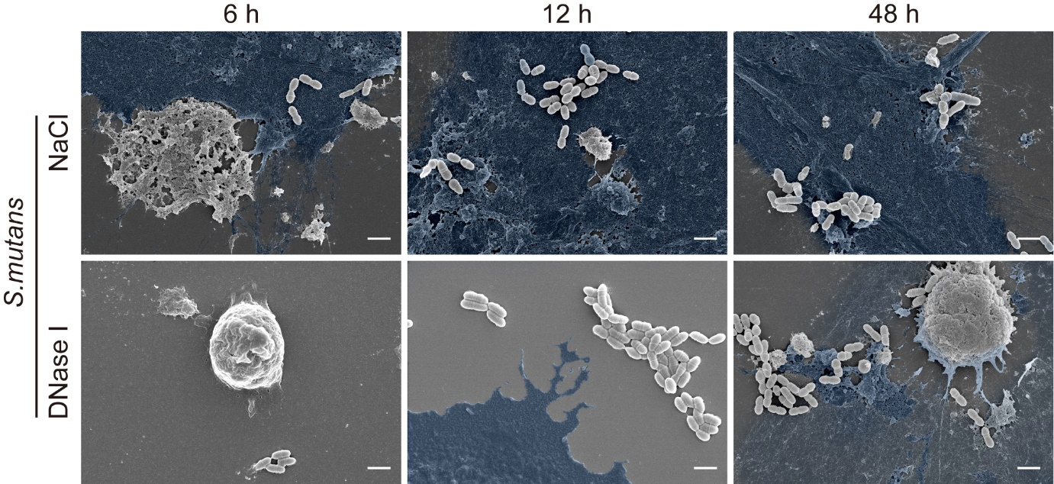
Supplementary Figure 9. DNase I failed to degrade the NETs in mature biofilms. Obvious reticular structure could be detected in the NaCl group (control group) after co-culturing the NETs (pseudo-colored for clarification) with S. mutans for 6 h, 12 h and 48 h. DNase I could degrade almost all the NETs after co-culturing the NETs with S. mutans for 6 h. In the 12 h group, a little of undegraded NETs were observed after the treatment of DNase I. Nevertheless, the effect of DNase I on the clearance of NETs was not significant after they were co-cultured with S. mutans for 48 h (scale bar, 1 μm).

Supplementary Figure 10. Existence of Z-form NETs in human dental calculus. Scattered Z-form DNA and co-localized cit H3 could be found in the calcified human dental calculus nodules (scale bar, 50 μm).

Supplementary Figure 11. Existence of Z-form NETs in human pathological mineralisation. Scattered Z-form DNA and co-localized cit H3 could be found in human gallstones (a) and kidney stones (b) (scale bar, 200 μm).

Supplementary Figure 12. Cerium chloride (CeCl₃) converts B-from NETs to nuclease-resistant Z-form in vitro. Cerium chloride (CeCl₃) was used to stimulate the transformation of NET-B-DNA into NET-Z-DNA. DNase I was used to evaluate the nuclease-resistance of NETs. The effects of DNase I on mineralisation were subsequently investigated. a, CLSM images of transformation of NET configuration and its related pathological mineralisation (scale bar, 10 μm). Co-localization of calcified nodules and the Z-form NET markers (Z-DNA and cit H3) was identified in the CeCl₃ group, with or without the use of DNase I. Conversely, NETs were easily degraded by DNase I in the group without the use of CeCl₃; the calcified nodules in this group were barely visible. b, Semi-quantitative analysis of the relative fluorescence area of Z-DNA in (a). The expression of Z-DNA in CeCl₃ groups with or without use of DNase I was significantly higher than that in the control group. Means ± standard deviations (n = 6, p < 0.0001). c, Semi-quantitative analysis of the relative fluorescence area of Ca in (a). The signals of Ca in CeCl₃ groups with or without use of DNase I was significantly higher than that in the control group. Means ± standard deviations (n = 6, p < 0.0001). d, SEM images of the Z-form of NETs and their resistance to nuclease (scale bar, 10 μm). NETs were pseudo-colored for clarification. The reticular NETs were difficult to be removed by DNase I in the CeCl₃-treated group. e, SEM images of the Z-form of NETs and their associated mineralisation (scale bar, 10 μm). Calcified nodules were pseudo-colored for clarification. The Z-form of NETs in the CeCl₃-treated group were heavily mineralised. Microscopical calcified clusters were identified in the CeCl₃ and DNase I-treated group. f, Alizarin red S-stained images of the mineralisation associated with the Z-form of NETs (scale bar, 100 μm). Positively-stained nodules were extensive in the CeCl₃-treated group irrespective of DNase I treatment, which was consistent with the SEM data. g, Semi-quantitative analysis of Alizarin red S staining in (f). Means ± standard deviations (n = 6, p < 0.0001).

Supplementary Figure 13. Biocompatibility of chloroquine. CCK-8 assay testing cell viability of human gingival fibroblast under the stimulation of chroloquine (n = 6).
Supplementary Table 1
Reagent or resource | Source | Identifier
Andibodies
Rabbit Anti-Neutrophil Elastase | Abcam | Ab131260
Rabbit Anti-Z-DNA [Z22] | Absolute Antibodies | Ab00783-23.0
Murine Anti-Z-DNA [Z22] | Absolute Antibodies | Ab00783-3.0
Murine Anti-B-DNA | Abcam | ab27156
Rabbit Anti-Citrullinated histone H3 | Abcam | Ab1503
Goat Anti-Rabbit IgG H&L (Alexa Fluor® 647) | Abcam | Ab150079
Goat Anti-Rabbit IgG H&L (Alexa Fluor® 405) | Abcam | ab175652
Goat Anti-Rabbit IgG H&L (FITC) | Abcam | ab6717
Goat Anti-Mouse IgG H&L (Alexa Fluor® 405) | Abcam | ab175660
Goat Anti-Mouse IgG H&L (FITC) | Abcam | ab6785
Bacterial strains
S. mutans strain UA159 | ATCC | 700610
Chemicals
SYTOXTM Green | Thermo Fisher | S7020
DAPI | Sigma Merck | 28718-90-3
Alizarin Red S | Sigma-Aldrich | A5533
Lipopolysaccharide | Sigma-Aldrich | L2630
DNase I | Solarbio | 9003-98-9
Phorbol 12-myristate 13-acetate | Sigma-Aldrich | 16561-29-8
Cl-amidine | MedChemExpress | HY-100574
Cerium Chloride | Aladdin | 7790-86-5
Chloroquine | Aladdin | 54-05-7

