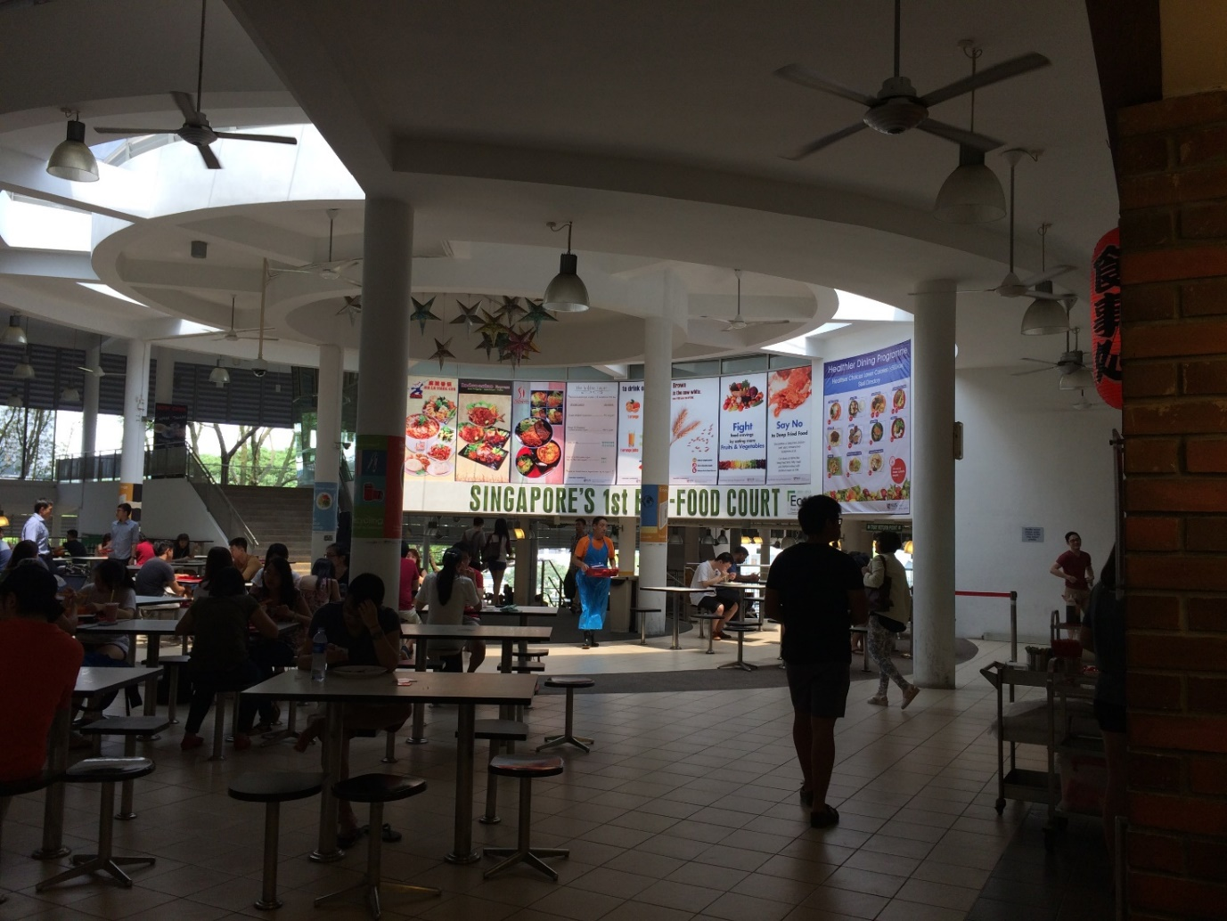
Supplementary figure 3: Example of posters and stall directory placement at one of the intervention centers

