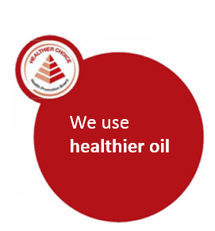
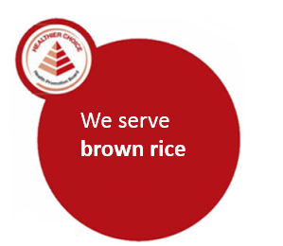
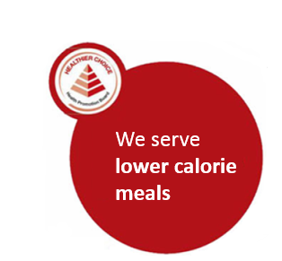

Supplementary figure 2: Healthier Choice Symbol decals placed on point-of-purchase standees featuring the lower-calorie dish(s) at intervention stall

