Supplementary Information for

Anthropogenic impact on the severity of compound extreme high temperature and drought/rainy events in China
Wanling Li¹, Bo Sun^{1,2,3*}, Huijun Wang^{1,2,3}, Botao Zhou¹, Huixin Li^{1,2,3}, Rufan Xue¹, Mingkeng Duan^{1,2}, Xiaochun Luo⁴, Wenwen Ai⁴
1 Collaborative Innovation Center on Forecast and Evaluation of Meteorological Disasters/Key Laboratory of Meteorological Disasters, Ministry of Education/Joint International Research Laboratory of Climate and Environment Change, Nanjing University of Information Science and Technology, Nanjing, China
2 Southern Marine Science and Engineering Guangdong Laboratory, Zhuhai, China
3 Nansen Zhu International Research Centre, Institute of Atmospheric Physics, Chinese Academy of Sciences, Beijing, China
4 Meteorological Service Center of Jiangsu Province, Nanjing, China
Corresponding author: Bo Sun
Email: sunb@nuist.edu.cn
Tel: 18851606582
This file includes:
Supporting Notes S1–S2
Supporting Figure S1–S9
Supporting Table S1–S3

Supporting Note S1

DATA

The high-quality observational data of daily mean surface temperature and total precipitation on 0.25°×0.25° grids for the period 1961–2014 are extracted from the CN05.1 dataset^{1,2}, which is constructed based on measurements collected at more than 2400 national observation stations in China³. This dataset has been widely used in studies of extreme weather events and climate characteristics in China^{4,5}.

To conduct detection and attribution analysis, daily mean surface temperature and total precipitation dataset from CMIP6 are used⁶. As a sub-project of the CMIP6, the Detection and Attribution Model Intercomparison Project (DAMIP) provides simulation outputs of preindustrial unforced control simulation experiments (CTL) and hist-ALL climate experiments (including anthropogenic and natural forcings simultaneously). In addition, the Tier-1 experiments of DAMIP consider different external forcings, including experiments driven by hist-NAT, hist-AER and hist-GHG. Outputs of these experiments are used to investigate influences of individual forcing and combination forcings on CHTDE and CHTRE in the present study⁷. The 12 models listed in Table S1 are used, and the results of external forcings simulation experiments over the period from 1961 to 2014 are used for analysis. The CTL involves 89 chunks of nonoverlapping 54-year data (a total of 4806 years).

For convenience, both the observational data and multi-model simulation data of daily mean surface temperature and daily total precipitation are remapped to 1°×1° grids using the bilinear interpolation algorithm.

Supporting Note S2

METHODS

The details of CHTDE index (CHTDEI) and CHTRE index (CHTREI).
- For the definition of potential CHTDE and CHTRE, various combinations of multiple thresholds (95th, 90th, 80th and 75th) have been used for the calculation, and all of them yield similar results. Eventually, the concurrence of daily temperature greater than the 90th percentile and daily total precipitation greater than the 75th percentile (less than 25th percentile) in the summers (June, July and August) of 1961–2014 is defined as a potential CHTRE (CHTDE). The selected threshold has been widely used in the study of compound extreme events^{8–10}.
- The empirical Gringorten plotting formula $P(x_{i})=(m_{i}−0.44)/(n+0.12)$ ¹¹ is used to estimate marginal distributions of frequency and duration, while n is sample size and $m_{i}$ is the number of $x_{t}≤x_{i}(1≤t≤n)$.
- The severity index of compound extreme events is $PI=P(X>x, Y>y)=1−F_{X}(x)−F_{Y}(y)+C(F_{X}(x), F_{Y}(y))$. Here, the x and y represent the thresholds of X and Y¹².
- According to the definations and properties of Archimedean copulas proposed by Genest and Markay^{13,14}, the bivariate Archimedean copula can be expressed as follows: $C:{[0,1]}^{2}→[0,1], C(u,v)=φ^{[−1]}(φ(u)+φ(v))$. $φ$ is a generator of C. And $φ^{[−1]}$ is the pseudo inverse of $φ$.
- The three widely accepted Archimedean copulas are applied in this study ^{12,15,16}:
- For Frank copula, the generator is $φ(t)=−ln(\frac{e^{−θ_{f}t}−1}{e^{−t}−1}),θ_{f}>0$, and the copula $C_{θ_{f}}(u,v)$ is $−\frac{1}{θ_{f}}ln (1+\frac{{(e}^{−θ_{f}u}−1){(e}^{−θ_{f}v}−1)}{e^{−θ_{f}}−1})$;
- For Gumbel copula, the generator is $φ(t)=({−ln t)}^{θ_{g}},θ_{g}≥1$, and the copula $C_{θ_{g}}(u,v)$ is $exp\left\{{−\left[{\left(−ln u\right)}^{θ_{g}}+{\left(−ln v\right)}^{θ_{g}}\right]}^{1/θ_{g}}\right\}$;
- For Clayton copula, the generator is $φ(t)=\frac{1}{θ_{c}}(t^{−θ_{c}}−1),θ_{c}>0$, and the copula $C_{θ_{c}}(u,v)$ is ${\left(u^{−θ_{c}}{+u}^{−θ_{c}}−1\right)}^{−1/θ_{c}}$.

Note that the copula function is a model based on the correlation between variables. After calculation, u and v show a strong correlation. So it would be a reasonable choice to estimate the parameter of copula function based on the correlation index method. The link between Archimedean copulas and Kendall Tau rank correlation coefficient $τ$ is as follows¹⁷: $τ=1−\frac{1}{θ_{g}}$, $τ=\frac{θ_{c}}{{2+θ}_{c}}$ and $τ=1+\frac{4}{θ_{f}}\left[\frac{1}{θ_{f}}\int_{0}^{θ_{f}}{\frac{x}{e^{x}−1}}dx−1\right]$.

Evaluation method of copula model.

In this paper, in order to determine the optimal fitting copulas for calculating multivariate joint distribution, we use several criteria to compare the performance of different copulas, including the Akaike Information Criterion (AIC) information criterion method, the Bayesian Information Criterion (BIC) rule method and the Root Mean Square Error (RMSE) criterion. These criteria are based on the empirical joint distribution of observed sample points¹⁸. More specifically, the empirical joint distribution is expressed as

$F\left(x_{i},y_{i}\right)=P(x≤x_{i}, y≤y_{i})=\frac{\sum_{l=1}^{i}{\sum_{k=1}^{i}{N_{lk}−0.44}}}{n+0.12}$ (1)

where $N_{lk}$ is the number of $x≤x_{i}$ and $y≤y_{i}$ in the joint observation samples of size n.

The AIC information criterion method considers both the over-regulation due to the complexity of model and minimization of error residuals, which is a relatively robust indicator to measure model effect. The formula is written as:

$MSE=\frac{1}{n}\sum_{i=1}^{n}{{\left(F\left(x_{i},y_{i}\right)−C(u_{i},v_{i})\right)}^{2}}$ (2)

$AIC=nln MSE+2m$ (3)

Where m is the number of copula model parameters. Same as AIC, the BIC is expressed as follow:

$BIC=nln MSE+mln n$ (4)

In addition, the

$RMSE=\sqrt{\frac{1}{n}\sum_{i=1}^{n}{{\left(F\left(x_{i},y_{i}\right)−C(u_{i},v_{i})\right)}^{2}}}$ (5)

is also used in this study. Although RMSE only considers the minimization deviation of copula fit, its model evaluation ability is recognized by previous studies¹⁹. More importantly, a lower AIC, BIC and RMSE are associated with a better fit of copula model.

The optimal fingerprint method.

In this paper, the optimal fingerprint method, which is widely used in global and regional climate change research, is applied for detection and attribution in CHTDE and CHTRE. To perform full-ranked estimation of internal covariance and avoid using empirical orthogonal functions truncation, the regularized optimal fingerprint method based on the total least squares²⁰ is applied to quantify the consistency between model simulated responses of CHTDE and CHTRE and observations in China^{21,22}. The total least squares method considers the fact that the simulated response may deviate from real response due to the random error caused by internal variability and limited pattern of multi-model ensemble. If different external forcing signals can be linearly superimposed, the statistical model of optimal fingerprint method can be written as:

$y=\sum_{i=1}^{n}{β_{i}\left(x_{i}−ε_{i}\right)+ε}$ (6)

Where y is the observation vector of CHTDEI and CHTREI. Since $x_{i}$ is the response pattern simulated by finite models for i^{th} forcing, the real climate response contains a random term $ε_{i}$, which represents the internal variability within sampling noise or climate model simulation. n is the number of signal from single external forcing or combined external forcings and $ε$ is the internal variability in the observation, which is represented by CTL. Here it is assumed that the distributions of $ε_{i}$ and $ε$ both are Gaussian and they have a same covariance structure. However, due to the model limitation, it is necessary to reduce the dimension of spatial and temporal scales to ensure the estimability of covariance. Therefore, in this paper the anomaly time series of model and observation data with a length of 18 can be obtained by processing the original dataset into a non-overlapping three-year-mean sample series. The 89 chunks of CTL are also separately processed into non-overlapping three-year-mean sample series. In addition, the treatment of non-overlapping three-year-mean is excepted to suppress natural variability and detect the effects of natural forcing such as short-lived response to volcanic activity²³.

The key information of the optimal fingerprint method is the scaling factor $β_{i}$, which quantifies the amplitude of the external forcing response to the observation. If the probability of observed change that occurs randomly due to the internal variability is smaller than 10%, it is called detection, that is, the 90% (5%–95%) confidence interval of scaling factor is greater than zero²⁴. If the 5%–95% margin of scaling factor is greater than zero and includes unit, it can further confirm the most likely cause of detected changes of CHTDE and CHTRE at a certain confidence level, which is called attribution. In addition, if the optimal scaling factor is greater than unit, the response is underestimated; if it is less than unit, the response is overestimated. Finally, in order to ensure that the residual covariance is consistent with the internal variability of the model, CTL is divided into two parts, one is used for pre-whitening the data, the other is used to calculate the confidence interval of the scaling factor and implement the residual consistency test^{20,21}. Meanwhile, the CHTDEI and CHTREI simulated with different external forcings are multiplied by corresponding best estimate of scaling factor (5%–95% margin of scaling factor) and further multiplied by the time period of the time series to investigate the attributable changes in CHTDEI and CHTREI^{4,5,22}.

Ensemble Empirical Mode Decomposition (EEMD).

In this paper, the EEMD method is applied to divide CHTDEI and CHTREI at different timescales²⁵ into interannual-to-decadal variability and long-term nonlinear trend. The EEMD method is an adaptive filter which decomposes the signal based on itself without basis function and can solve the mode mixing. It is suitable for nonlinear and non-stationary time series decomposition.

Specifically, the EEMD method can be divided into the following steps:
- Add the white noise with normal distribution to CHTDEI and CHTREI.
- Decompose the time series and obtain each intrinsic mode functions (IMFs), whose extreme points and zeros points are equal or differ at most by one.
- Add a new white noise each time and repeat step (1) and (2).
- Obtain the final IMFs $c_{j}(t)$ from the averaged IMFs each time. The $r_{n}(t)$ is the residual component of time series $x(t)$ after filtering out IMFs (size of m). The variance contribution of $c_{j}(t)$ is the ratio of the variance of $c_{j}(t)$ to the sum of the variances of m components²⁶. Then the time series is written as follow:

$x(t)=\sum_{j=1}^{m}{c_{j}(t)+}r_{n}(t)$ (7)

Here, the interannual-to-decadal variability is obtained by summing the first several components while the last component is long-term nonlinear trend.

Supporting Figures

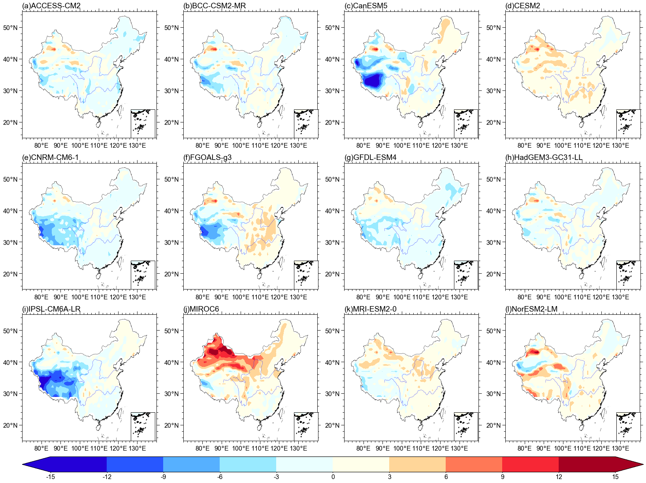

Supplementary Fig. 1: Differences (units: ℃) in the climatological spatial pattern of mean temperature in the summers of 1961–2014 between the historical simulations of 12 CMIP6 models and observations. The corresponding model is indicated in the upper left corner of each panel.

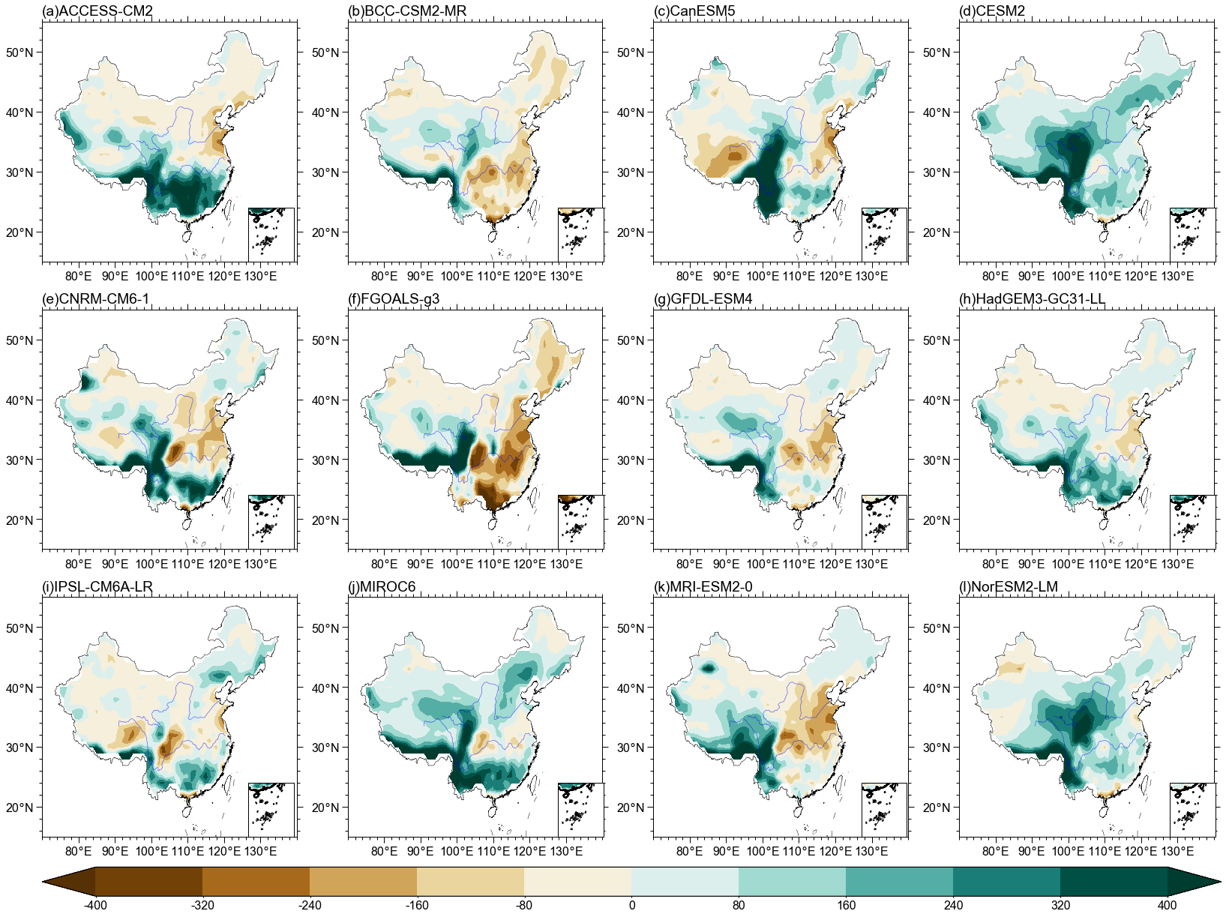

Supplementary Fig. 2: Same as Figure S1, but for the total precipitation in summer (units: mm).

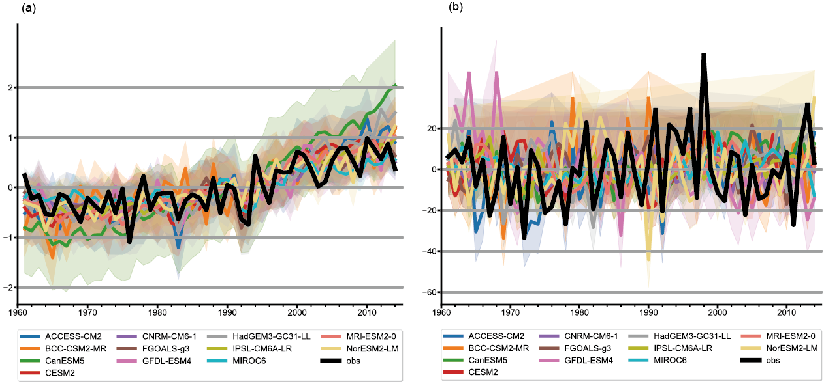

Supplementary Fig. 3: Temporal evolutions of (a) mean temperature and (b) total precipitation in the summers of 1961–2014 from historical simulations and observations. The black line shows the observation. Different colors represent simulations from different models, and the corresponding shadings indicate the one standard deviation range.

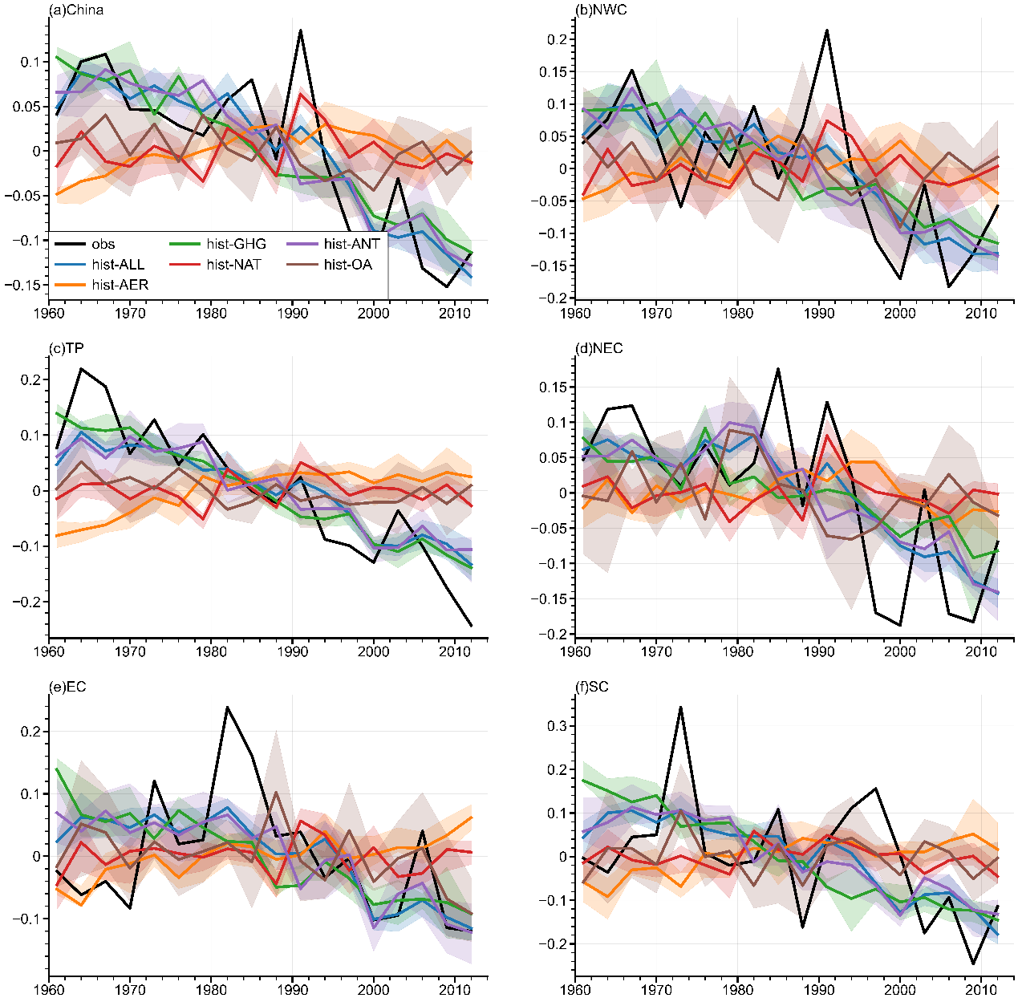

Supplementary Fig. 4: Temporal evolution of non-overlapping three-year-mean CHTDEI during 1961–2014 from historical simulations and observations. The black line shows the observation. The shadings denote the 25th–75th percentile range for the distribution and the lines of different colors show the average.

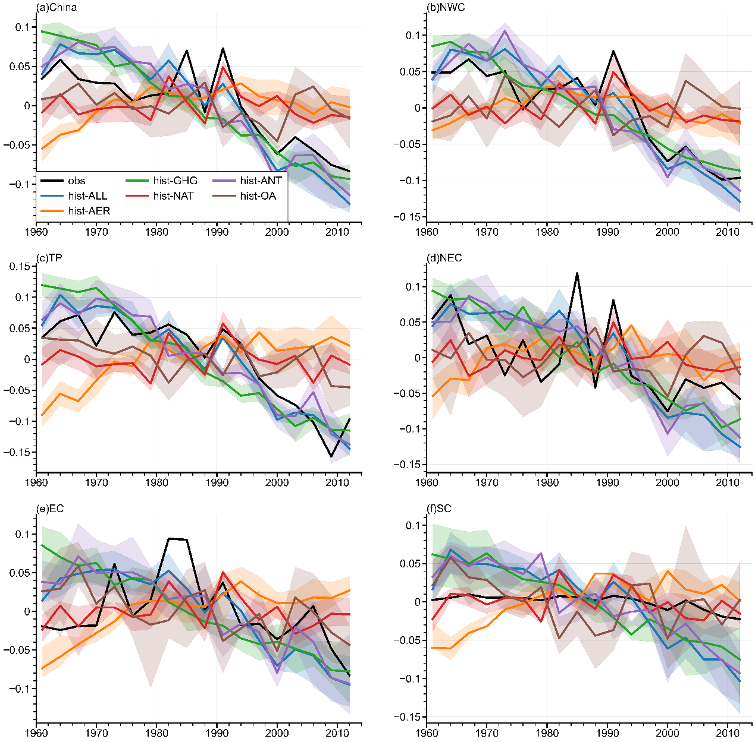

Supplementary Fig. 5: Same as Figure S4, but for the CHTREI.

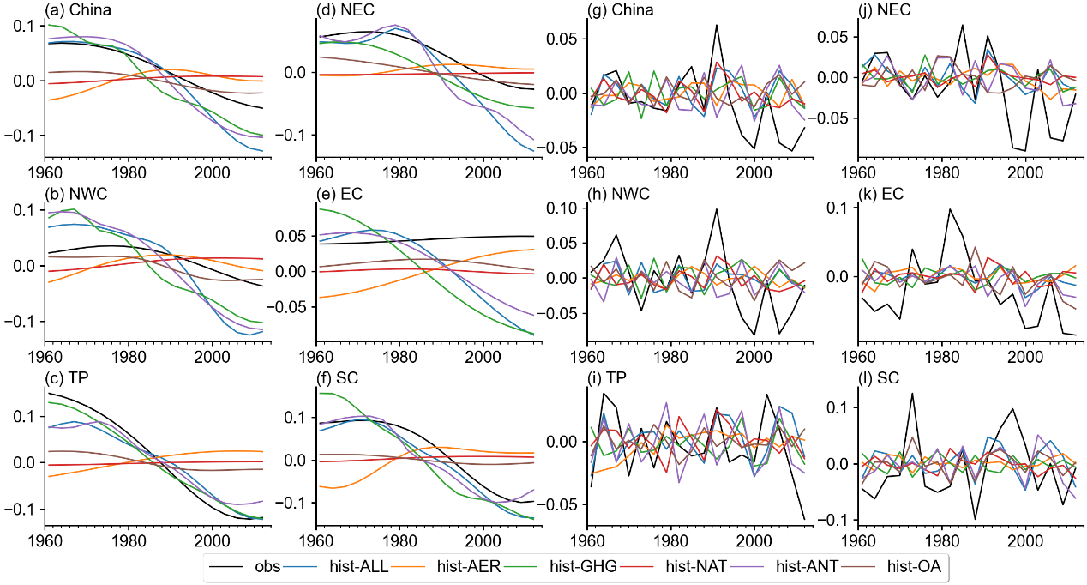

Supplementary Fig. S6: Temporal series of (a–f) nonlinear trend and (g–l) interannual-to-decadal variability of observed and simulated CHTDEI based on the MME of the seven models over different sub-regions and across China for the period of 1961–2014.

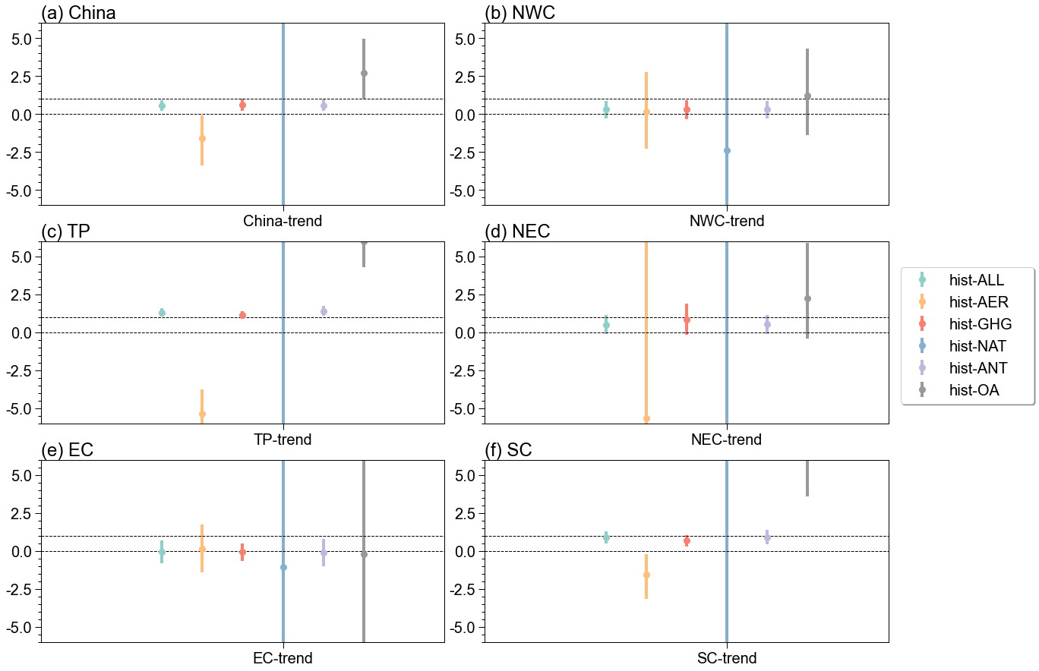

Supplementary Fig. 7: Best estimates of the scaling factors (dot) and their 5–95% uncertainty ranges (error bars) from single-signal (hist-ALL, hist-AER, hist-GHG, hist-NAT, hist-ANT and hist-OA) analysis for nonlinear long-term trend of CHTDEI (a) across China and (b–f) in different subregions from EEMD method. The two dashed lines parallel to the horizontal axis represent zero and unit respectively.

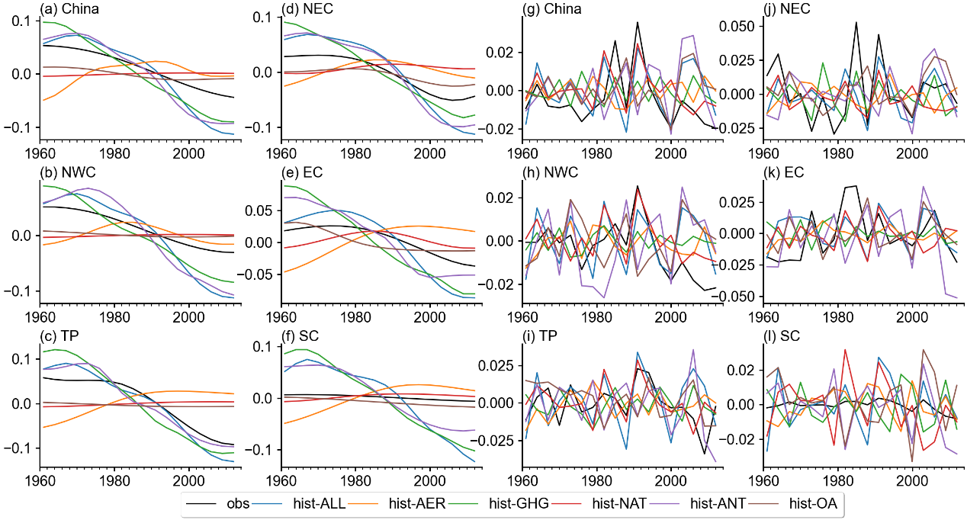

Supplementary Fig. 8: Same as Figure S6, but for the CHTREI.

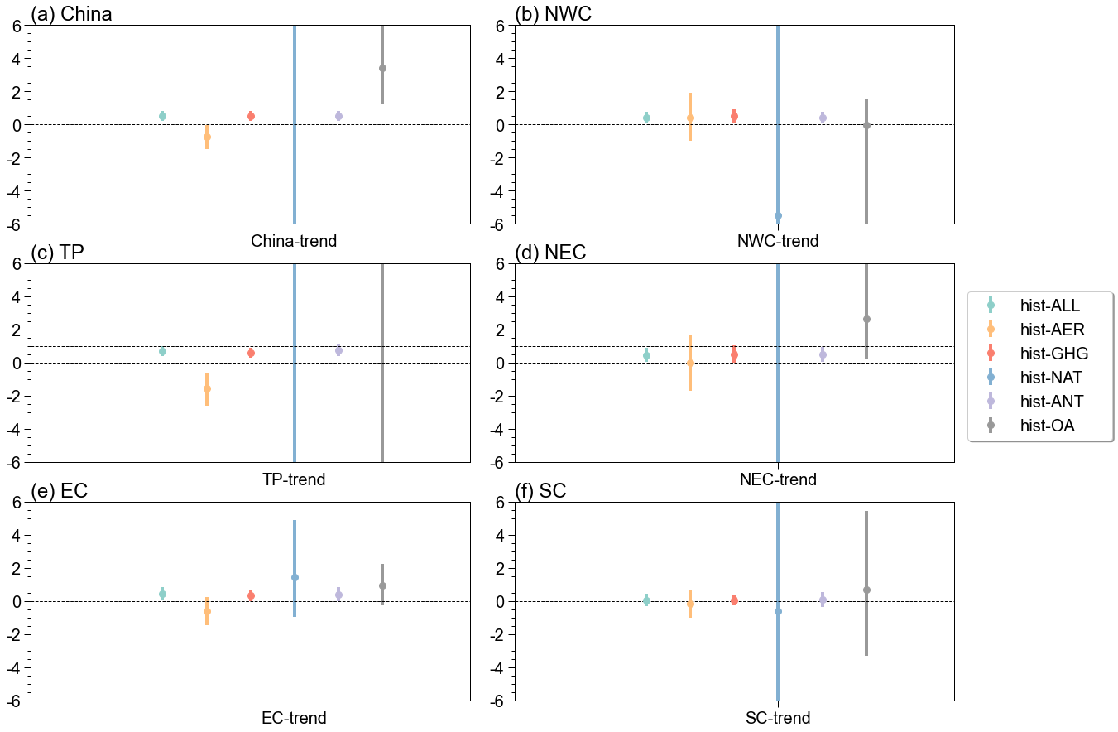

Supplementary Fig. 9: Same as Figure S7, but for the CHTREI.

Supporting Tables

Supplementary Table 1: List of simulations by CMIP6 models employed in this study. The numbers indicate the numbers of ensemble members (runs) for hist-ALL, hist-AER, hist-GHG and hist-NAT simulations and the corresponding numbers of 54-year nonoverlapping chunks for CTL. The models with bold font and the runs in parentheses represent the preferred models selected after evaluating the model performance.
Model | hist-ALL | hist-AER | hist-GHG | hist-NAT | CTL
ACCESS-CM2 | 5 | 3 | 3 | 3 | 9
BCC-CSM2-MR | 2 | 3 | 3 | 3 | –
CanESM5 | 10 | – | – | – | 18
CESM2 | 9 | 2 | 2 | 2 | 5
CNRM-CM6-1 | 10 | – | – | – | –
FGOALS-g3 | 5 | – | – | – | –
GFDL-ESM4 | 3 | 1 | 1 | 1 | 9
HadGEM3-GC31-LL | 5 | 5 | 5 | 5 | 9
IPSL-CM6A-LR | 10 | – | – | – | 18
MIROC6 | 10 | – | – | – | 9
MRI-ESM2-0 | 10 | 5 | 5 | 5 | 3
NorESM2-LM | 3 | 3 | 3 | 30 | 9
Sum | 82 (37) | 22 | 22 | 22 | 89

Supplementary Table 2: Evaluation of Archimedean copula. Evaluation of Frank, Gumbel and Clayton Archimedean copula based on the AIC, BIC and RMSE criteria on CHTDEI.
 | Clayton | Gumbel | Frank
AIC | –457.85 | –409.90 | –388.37
RMSE | 0.0148 | 0.0228 | 0.0274
BIC | –455.86 | –407.91 | –386.38

Supplementary Table 3: Same as Table S2, but for the CHTREI.
 | Clayton | Gumbel | Frank
AIC | –491.89 | –493.01 | –415.76
RMSE | 0.0387 | 0.0165 | 0.0220
BIC | –489.90 | –491.02 | –413.77

References in the supplementary
- Wu, J., Gao, X., Giorgi, F. & Chen, D. Changes of effective temperature and cold/hot days in late decades over China based on a high resolution gridded observation dataset. Int. J. Climatol. 37, 788–800 (2013).
- Gao, X. A gridded daily observation dataset over China region and comparison with the other datasets (in Chinese). Chinese. J. Geophys. 56, 1102–1111 (2013).
- Xu, Y. et al. A daily temperature dataset over China and its application in validating a RCM simulation. Adv. Atmos. Sci. 26, 763–772 (2009).
- Li, H., Chen, H., Sun, B., Wang, H., & Sun, J.A detectable anthropogenic shift toward intensified summer hot drought events over northeastern China. Earth. Space. Sci. 7, e2019EA000836 (2020).
- Li, W., Jiang, Z., Li, L. Z., Luo, J. J. & Zhai, P. Detection and attribution of changes in summer compound hot and dry events over northeastern China with CMIP6 models. J. Meteorol. Res. 36, 1–12 (2022).
- Eyring, V. et al. Overview of the coupled model intercomparison project phase 6 (CMIP6) experimental design and organization. Geosci. Model. Dev. 9, 1937–1958 (2016).
- Qian, C. & Zhang, W. Short commentary on CMIP6 Detection and Attribution Model Intercomparison Project (DAMIP) (in Chinese). Clim. Chang. Res. 15, 469–75 (2019).
- Olmo, M., Bettolli, M. L. & Rusticucci, M. Atmospheric circulation influence on temperature and precipitation individual and compound daily extreme events: Spatial variability and trends over southern South America. Weather. Clim. Extremes. 29, 100267 (2020).
- Tencer, B., Bettolli, M. L. & Rusticucci, M. Compound temperature and precipitation extreme events in southern South America: associated atmospheric circulation, and simulations by a multi-RCM ensemble. Clim. Res. 68, 183–199 (2016).
- Tencer, B., Weaver, A. & Zwiers, F. Joint occurrence of daily temperature and precipitation extreme events over Canada. J. Appl. Meteorol. Climatol. 53, 2148–2162 (2014).
- Gringorten, I. I. A plotting rule for extreme probability paper. J. Geophys. Res. 68, 813–814 (1963).
- Zscheischler, J. & Seneviratne, S. I. Dependence of drivers affects risks associated with compound events. Sci. Adv. 3, e1700263 (2017).
- Genest, C. & MacKay, R. J. Copules archimédiennes et families de lois bidimensionnelles dont les marges sont données. Can. J. Stat. 14, 145–159 (1986).
- Genest, C. & MacKay, R. J. The joy of copulas: Bivariate distributions with uniform marginals. Amer. Stat. 40, 280–283 (1986).
- Aihaiti, A., Jiang, Z., Zhu, L., Li, W. & You, Q. Risk changes of compound temperature and precipitation extremes in china under 1.5℃ and 2℃ global warming. Atmos. Res. 264, 105838 (2021).
- Nelsen, R. B. Dependence and order in families of Archimedean copulas. J. Multivar. Anal. 60, 111–122 (1997).
- Hofert, M., Mächler, M. & McNeil, A. J. Likelihood inference for Archimedean copulas in high dimensions under known margins. J. Multivar. Anal. 110, 133–150 (2012).
- Sadegh, M., Ragno, E. & AghaKouchak, A. Multivariate Copula Analysis Toolbox (MvCAT): Describing dependence and underlying uncertainty using a Bayesian framework. Water. Resour. Res. 53: 5166–5183 (2017).
- Willmott, C. J. Some Comments on the Evaluation of Model Performance. Bull. Amer. Meteor. Soc. 63, 1309–1313 (1982).
- Allen, M. R. & Stott, P. A. Estimating signal amplitudes in optimal fingerprinting, Part I: Theory. Clim. Dyn. 21, 477–491 (2003).
- Ribes, A. & Terray, L. Application of regularised optimal fingerprinting to attribution. Part II: application to global near-surface temperature. Clim. Dyn. 41, 2837–2853 (2013).
- Ribes, A., Planton, S. & Terray, L. Application of regularised optimal fingerprinting to attribution. Part I: method, properties and idealised analysis. Clim. Dyn. 41, 2817–2836 (2013).
- Sun, Y., Zhang, X., Ren, G., Zwiers, F. W. & Hu, T. Contribution of urbanization to warming in China. Nat. Clim. Chang. 6, 706–709 (2016).
- Hasselmann, K. Multi-pattern fingerprint method for detection and attribution of climate change. Clim. Dyn. 13, 601–611 (1997).
- Wu, Z. & Huang, N. Ensemble empirical mode decomposition: a noise-assisted data analysis method. Adv. Adapt. Data. Anal. 1, 1–41 (2009).
- Qian, C. & Zhou, T. Multidecadal variability of North China aridity and its relationship to PDO during 1900–2010. J. Clim. 27, 1210–1222 (2014).

